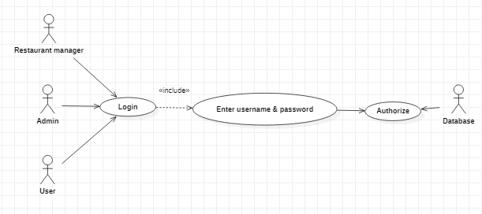

|  |  |
| --- | --- |
| **Login** | |
| Actors | Admin, Restaurant manager, User |
| Description | Both actors send login request and enter username and password to the database with command authorize that Is this account exist?. |
| Data | User name & password |
| Stimulus | Interface that include login form and submit button |
| Response | Message that: login successful or fail (wrong username or password ) |
| Comments | Each actor have different account types. |