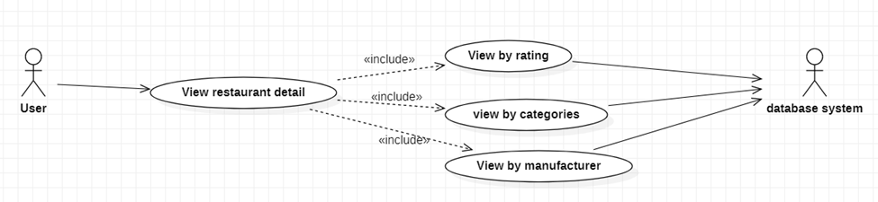

|  |  |
| --- | --- |
| **View restaurant detail** | |
| Actors | User, database system |
| Description | Send request to application to view item detail about restaurant, rating, price, images and description. |
| Data | Id of restaurant. |
| Stimulus | Interface that include images of restaurant, price, favourite, booking and add to booking cart button. |
| Response | Message that: restaurant detail page |
| Comments |  |