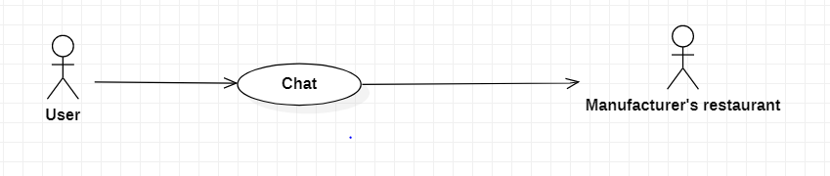

|  |  |
| --- | --- |
| **Chat** | |
| Actors | User, manufacturer’s restaurant |
| Description | Form to chat customer and restaurant. |
| Data | Id and username of user and id of manufacturer’s restaurant. |
| Stimulus | Interface that include message box and send button. |
| Response |  |
| Comments | Must sign in. |