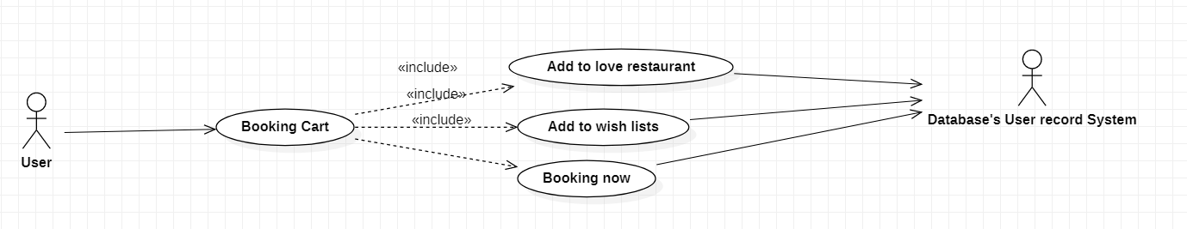

|  |  |
| --- | --- |
| Booking cart | |
| Actors | User, database system |
| Description | Send request to application to view cart detail to checkout. |
| Data | User id |
| Stimulus | Interface that include list chosen items, quantity, total cost and add to wish list and checkout button. |
| Response | List chosen items |
| Comments | Must sign in to get booking cart |