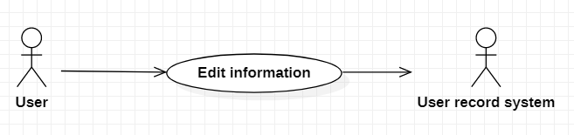

|  |  |
| --- | --- |
| Edit information | |
| Actors | User, user record system |
| Description | Send new information to database with command that update user. |
| Data | Information of user (Id, name, password, address, phone… ) |
| Stimulus | Interface that include information form with Update button. |
| Response | Message that: update successful or fail (kind of error) |
| Comments | Must sign in to change the information. |