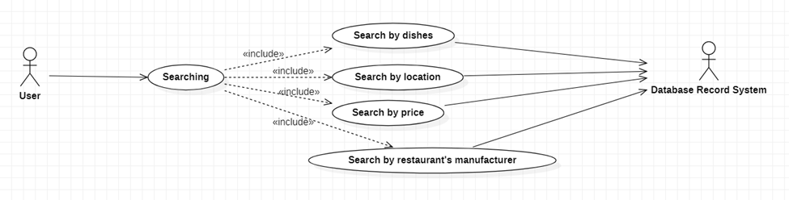

|  |  |
| --- | --- |
| **Searching** | |
| Actors | User, database system |
| Description | Send keyword about item looking for to database system with command find item related. |
| Data | String Keyword |
| Stimulus | Interface that include search text box and button. |
| Response | Items relate the keyword(price, restaurant name, location) |
| Comments |  |