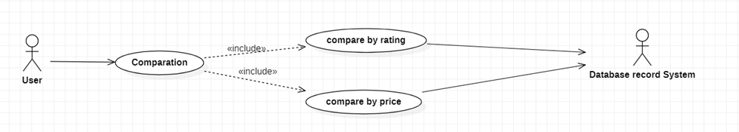

|  |  |
| --- | --- |
| **Comparation** | |
| Actors | User, database system |
| Description | Send request to database to arrange items by rating or price. |
| Data |  |
| Stimulus | Interface that include arrange by price and rating button. |
| Response | List arranged items |
| Comments |  |