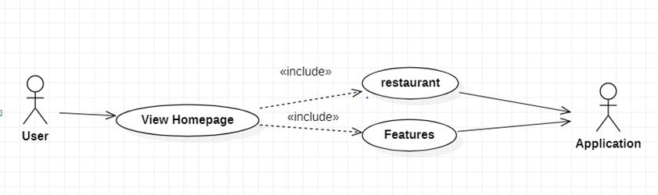

|  |  |
| --- | --- |
| **View homepage** | |
| Actors | User |
| Description | Send request to application to view home page with item element and features. |
| Data |  |
| Stimulus | Interface that include feature columns, list items, search bar, categories and about us section. |
| Response | Message that: home page |
| Comments |  |