10/21/2023

dell

[company name]

Lab-03

Mohamed-Ayman

# **Question One**

#include <stdio.h>

#include <stdlib.h>

#include<windows.h>

#include <time.h>

void delay(int number_of_seconds);

void Read_Write_Array();

//C Program to take an array elements from user, then print them out "using 2 for loops". (Print Array)

//C Program to find the minimum & maximum value of array elements. (Min_Max Array)

int main()

{

int size =0, row=1, col=0,value=1;

printf("Enter Array Length\n");

scanf("%d",&size);

;

while(size%2==0){

printf("Please Enter an odd number\n");

scanf("%d",&size);

}

col=(size+1)/2;

do{

gotoxy(col*5,row);

printf("%5d",value);

delay(1);

if(value%size==0){

row++;

}

else{

row--;

col--;

}

if(row==0){

row=size;

}

if(col==0){

col=size;

}

value++;

}while(value<=size*size);

return 0;

}

void gotoxy(int x,int y)

{

COORD coord= {0,0};

coord.X=x;

coord.Y=y;

SetConsoleCursorPosition(GetStdHandle(STD_OUTPUT_HANDLE),coord);

}

void delay(int number_of_seconds)

{

// Converting time into milli_seconds

int milli_seconds = 1000 * number_of_seconds;

// Storing start time

clock_t start_time = clock();

// looping till required time is not achieved

while (clock() < start_time + milli_seconds)

;

}

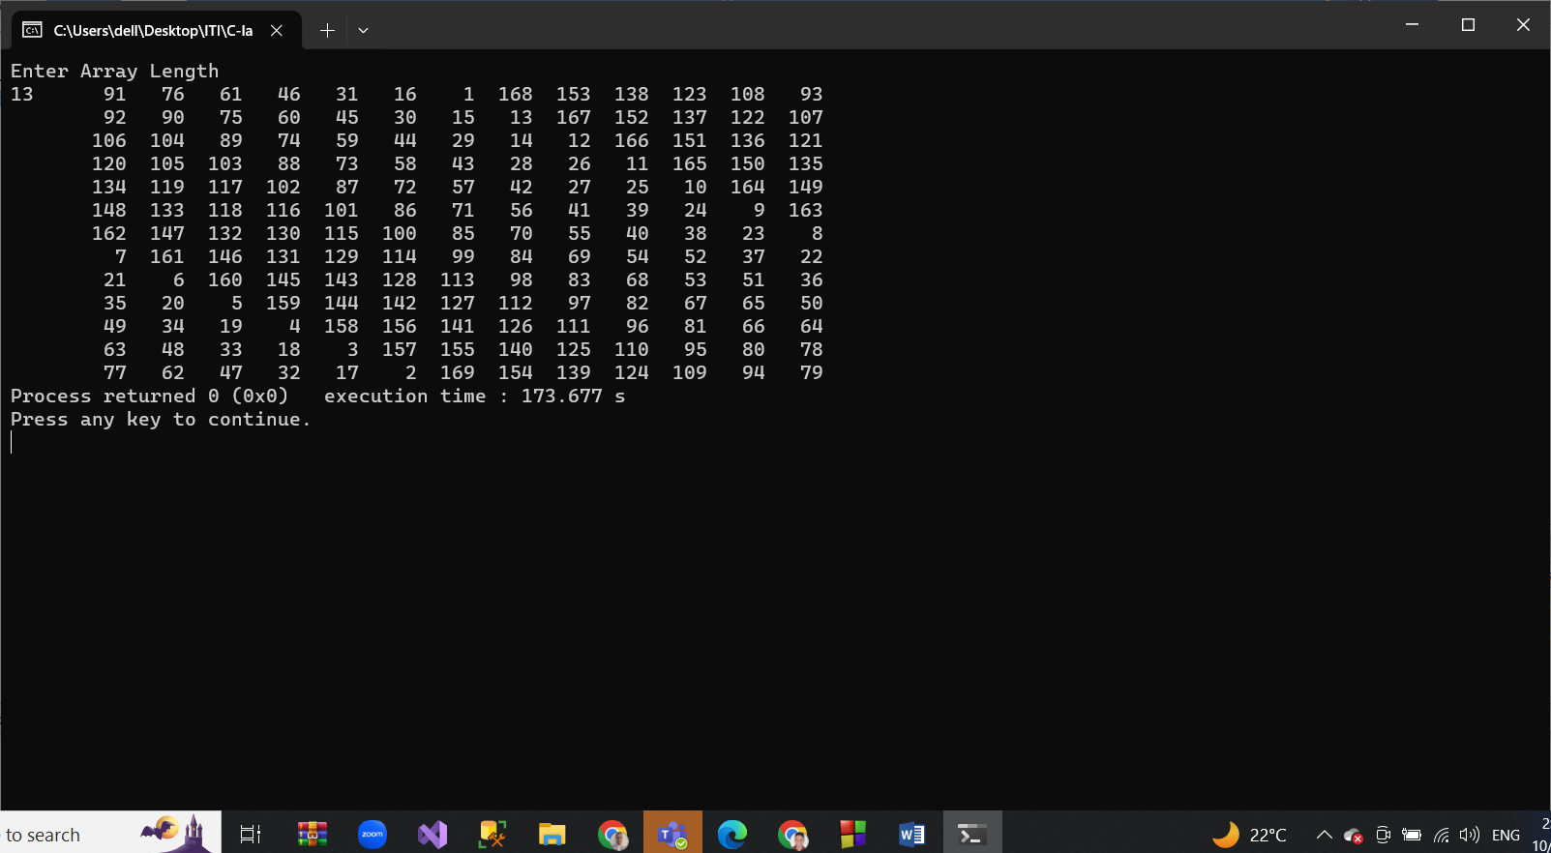

# **Question Two**

void Read_Write_Array(){

int arr[100];

int size=0;

printf("Please Enter an array length");

scanf("%d",&size);

while(size>100){

printf("Please Enter a size less than or equal 100\n");

scanf("%d",&size);

}

printf("Please Enter array numbers");

for(int i=0;i<size;i++){

scanf("%d",&arr[i]);

}

for(int i=0;i<size;i++){

printf("%d\n",arr[i]);

}

}

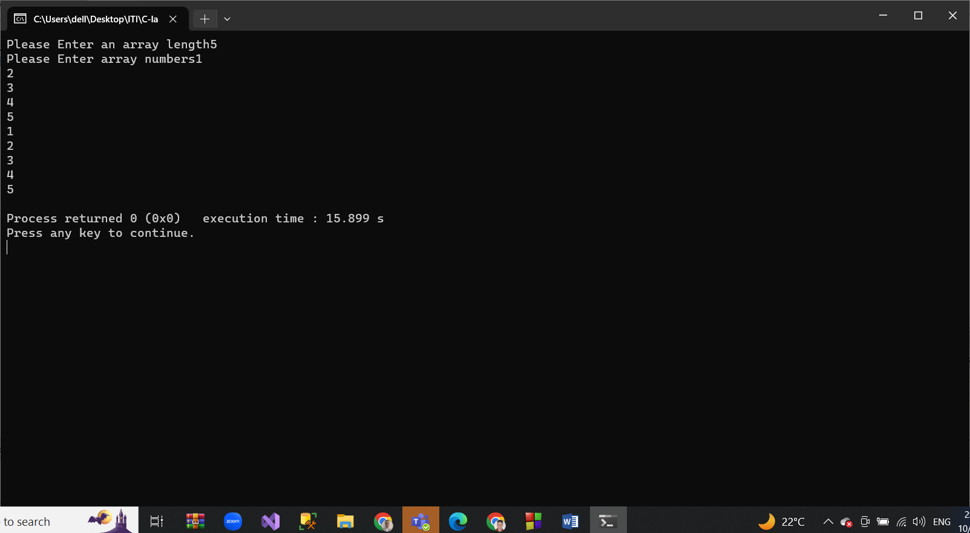

# **Question Three**

#include <stdio.h>

#include <stdlib.h>

int main()

{

Int arr[5]={1,-10,2,5,4};

Max_Min_number(arr,5);

return 0;

}

void Max_Min_number(int arr[100],int number){

int Max=0,Min=0;

for(int i=0;i<number;i++){

if(Max<arr[i]){

Max = arr[i];

}

if(Min>arr[i]){

Min=arr[i];

}

}

printf("Max number is %d and Min number is %d",Max,Min);

}

