Business Requirements Document (BRD)
Business Management Solutions (BMS) System
Alpha Iota: Business Units, Operations, PR & Marketing

Item | Detail
Version | 1.0 (Draft for review)
Date | 11 November 2026
Prepared by | Business Analysis
Source | Discovery meeting recording, 11 Nov 2026 (about 50 minutes)
Interviewees | Fatimah Alqahtani (Business Unit Coordinator); Alpha Delta Director; Alpha Gen Director (May); Afnan Alshahri (PR & Marketing Manager)
Status | Draft. Requires validation by interviewees. See Section 17 for open points

Table of Contents
1. Document Purpose and How to Read It
2. Executive Summary
3. Business Background and Problem Statement
4. Business Objectives and Success Criteria
5. Scope, Assumptions, Constraints, Dependencies
6. Stakeholders and Roles
7. Business Units and Context
8. As-Is Processes (by stakeholder)
9. Solution Overview (To-Be)
10. Business Process Flows (diagrams)
11. Functional Requirements
12. Data Requirements
13. Dashboard and Reporting Requirements
14. Roles, Permissions, Access
15. Non-Functional Requirements
16. Action Items (What Must Be Done)
17. Open Questions and Risks
18. Proposed Phasing
19. Requirements Traceability Matrix
20. Glossary

1. Document Purpose and How to Read It
This BRD captures, in full, the business needs discussed in the discovery meeting for the Business Management Solutions (BMS) System. It converts the conversation into structured, traceable requirements, process flows and action items.
- Every requirement has an ID (BR/FR/NFR), a priority (MoSCoW) and a source (who raised it).
- Every business flow is drawn as a diagram (Section 10).
- Where the recording was unclear or the speaker did not give a detail, this is marked as an assumption or an open question. Nothing is invented as fact.
- Items described as "Proposed" are the analyst's recommendation and need business approval.

2. Executive Summary
The business units, Operations, PR & Marketing and the Business Unit Coordinator currently run daily, weekly and monthly work through email, a shared Excel sheet and manual reports. Information is scattered, status is hard to retrieve, and reporting takes time. The BMS System will be one platform that centralises unit tasks, opportunities and tenders, products, leads and partnerships, meetings and minutes, recruitment, procurement, PR events, branded documents and the employee directory, with filterable dashboards and role-based access.
Headline needs by stakeholder:
- Coordinator: one dashboard replacing the shared Excel and email updates; weekly follow-up of every unit, opportunity and product (Kraken, Argus); meeting scheduling with minutes; recruitment tracking; monthly report.
- Alpha Delta Director: project/RFP intake and review, RFP and financial proposal work, certifications and compliance, capability-building programs, weekly Sunday report and 90-day KPI reporting.
- Alpha Gen Director: database of prospective entities (leads, partners), lab staff database with certificates, lead stages with meeting history, task follow-up, minutes of key meetings, data export.
- PR & Marketing Manager: central repository of latest branded files and templates per company and unit, unit profiles, employee directory (name, title, photo), procurement request to Finance, PR event/protocol procedure, six-month social media report.

3. Business Background and Problem Statement
Work volume and the number of opportunities keep growing. Staff spend time locating data across Excel sheets and emails before they can report. In the words of the project lead, even when people know what was completed last week, it takes time to retrieve the data, and reporting to managers takes the same effort.
# | Problem | Impact | Raised by
P1 | Unit/tender/product updates arrive by email and are copied into a shared Excel sheet manually | Delay, errors, no live view | Coordinator
P2 | No single view of opportunities, tenders and tasks across units | Missed follow-ups, hard weekly manager meeting | Coordinator
P3 | Monthly performance report built manually | Time consuming | Coordinator
P4 | Multiple versions of marketing files (e.g. Company Profile); staff keep asking for the latest copy | Inconsistent brand, wasted time | PR & Marketing
P5 | Staff photos, names and job titles not held in one place | Search effort for every design | PR & Marketing
P6 | Leads, partners and collaboration opportunities tracked only in Excel, no stage or meeting history | Cannot see who was contacted and what happened | Alpha Gen
P7 | Weekly task/progress follow-up of staff is not structured | No visibility of progress | Alpha Gen / Coordinator
P8 | Procurement, onboarding and event procedures are handled informally across departments | Knowledge not captured; new staff unaware | PR & Marketing

4. Business Objectives and Success Criteria
ID | Objective | Success criterion (proposed, to be agreed)
BO-1 | One source of truth for unit work, opportunities, products and leads | Excel tracker retired; all updates entered in BMS
BO-2 | Real-time visibility for the Coordinator and management | Weekly manager meeting runs from the dashboard, not Excel
BO-3 | Reduce reporting effort | Weekly and monthly reports generated from the system
BO-4 | Enforce a single brand identity | Staff download latest file only from the Document Hub
BO-5 | Structured, auditable cross-department requests (hiring, procurement, onboarding, events) | Each request has an owner, status and history
BO-6 | Preserve institutional knowledge (minutes, procedures) | Minutes and procedures searchable in the system

5. Scope, Assumptions, Constraints, Dependencies

5.1 In scope
- Meetings scheduling and Minutes of Meeting (MoM)
- Unit weekly plans, tasks, progress and support requests
- Opportunities and tenders, project/RFP intake and go/no-go decision
- Product tracking (Kraken, Argus, extensible)
- Leads, partners and ecosystem database with stages and meeting history
- Recruitment request and tracking, new-employee onboarding
- Procurement requests with quotations to Finance
- PR events and protocol procedures
- Document and brand hub; unit profiles
- Employee directory
- Dashboards, filters, export; weekly, monthly, quarterly and six-month reporting
- Roles and permissions

5.2 Out of scope (this release)
- Building or operating the genetic laboratory itself (the system only tracks plans, entities and data about it)
- Bioinformatics data storage of genomic results (the lab's cloud data platform is a separate initiative)
- Replacing HR, IT or Finance internal systems (BMS only raises and tracks requests to them)
- Details of how other departments (HR, Finance, IT, Operations) work internally. Not yet discussed

5.3 Assumptions
- The shared Excel sheet will be sent by email to the BA and is the baseline for data structure and migration.
- The BMS covers four business units (Alpha X, Alpha Gen, Alpha Omega, Alpha Delta) under Alpha Iota; naming to be confirmed (see Section 17).
- Operations team (about four people) remains responsible for all incoming opportunities, internal or external.
- Initial products are Kraken and Argus; more may be added later.
- The company works with Arabic and English content (names, titles).

5.4 Constraints and dependencies
- Dependency: the Excel sheet and sample data from the Coordinator.
- Dependency: other departments (Operations, Finance, HR, IT) to confirm their workflows and participate in sessions.
- Alpha Gen is in planning/establishment phase, so lab-specific content is limited now and will grow.
- Compliance sensitivity: data governance requirements (SDAIA) and ISO certifications are relevant to the company.

6. Stakeholders and Roles
Stakeholder | Role | Interest in BMS
Fatimah Alqahtani | Business Unit Coordinator (liaison between management and units) | Primary user; dashboards, follow-up, meetings, recruitment, reports
Alpha Delta Director | Head of Alpha Delta (data management, compliance, capability building) | Project intake, RFP/financial proposal, certifications, weekly and quarterly reporting
Alpha Gen Director (May) | Head of Alpha Gen (genetic lab initiative) | Lead/partner database, lab staff DB, task follow-up, MoM
Afnan Alshahri | PR & Marketing Manager (company wide) | Document hub, brand, employee directory, events, procurement
Operations team (about 4) | Handle every incoming opportunity (tenders, new clients) | Opportunity registration; shared tracker today
Alpha X and Alpha Omega leads | Unit heads | Weekly updates (not interviewed; to be validated)
HR / IT / Finance | Service departments | Receive hiring, onboarding, procurement requests (not interviewed)
Management | Weekly manager meeting and reports | Dashboards and reports
Mohamed Magdi | Business Analyst / project lead | Owner of this BRD

7. Business Units and Context
Unit / item | What was said | Notes
Alpha Delta | Data management opportunities (via Etimad platform), data governance and SDAIA compliance, ISO certifications (company wide), product development with Argus (data labelling platform, shared with Alpha Omega), capability-building platform launched "yesterday", CDMP program supervision, RFPs and Financial Proposals | Main time use: meetings, emails, project review, RFP/financial proposals
Alpha Gen | Genetic lab initiative: two scenarios (partner with King Saud University and restructure, or build from scratch). Staff today: director plus one employee (Sarah). Will grow: physicians, technicians, PhD/Master holders | Planning and establishment phase
Alpha X | Mentioned as one of four units (linked to a museum context in the recording) | Not interviewed
Alpha Omega | Shares Argus with Alpha Delta | Not interviewed
Products | Kraken and Argus today; more may be added | Tracked by phase, data needs and support needs
Operations team | About four people; every opportunity (tender, new client) goes through them | Share Excel tracker with Coordinator, updated weekly

8. As-Is Processes (by stakeholder)

8.1 Business Unit Coordinator (Fatimah)
- Daily: checks calendars of directors and staff, finds available time, sends invitations for internal and external meetings.
- Writes and archives minutes for selected meetings (meeting name, attendees, etc.).
- Weekly: follows up each unit (Alpha X, Gen, Omega, Delta): opportunities, team development (courses), weekly plan, what was achieved, task completion, support needs.
- Weekly: follows up opportunities and tenders under Alpha Iota and products (Kraken, Argus): phase, delay, data and support needs.
- Weekly (end of week): sits with Operations team to update the shared Excel sheet: what was done, what is missing, what needs follow-up or support.
- Monthly: produces performance report: unit progress, achievements, support needs, products status.
- Recent: HR coordination. Receives hiring needs from units, reviews CVs from HR, contacts and interviews candidates, tracks from CV to first day.
- Pain point: receives director updates by email and wants a faster, structured way.

8.2 Alpha Delta Director
- Daily: meetings, emails, reviewing projects and requirements sent by Operations (go/no-go), RFPs and Financial Proposals.
- Currently: certifications and their requirements (company compliance), employee development and capacity building (training plans, awareness sessions, CDMP program).
- Weekly (every Sunday): emails a report to Fatimah: tasks done last week and tasks in progress.
- Every 90 days: presents KPIs to management. No monthly update.

8.3 Alpha Gen Director (May)
- Weekly: sends Fatimah the progress of the previous week (achievements only, no plan for next week).
- Keeps a personal agenda but does not share "what to do next".
- Needs: database of prospective entities and employees/certifications; follow-up of staff tasks; minutes of important meetings; lead progress with stages.

8.4 PR & Marketing Manager (Afnan)
- Daily: shares files and designs (Company Profile, Proposal, templates). Problem: staff repeatedly ask for the latest version.
- Maintains brand identity per company and per unit (each unit has its own identity).
- Finance link: finds vendors/printers, gets price quotations (notebooks, tissues, cups), sends to Finance who confirm suitability to budget.
- IT link: for each new employee, prepares official email and laptop needs.
- PR events: agreement signing ceremonies need photographers, announcement plan, visitor protocol (entry, parking, exit).
- Every six months: social media report (followers, posts, engagement).

9. Solution Overview (To-Be)
BMS is one web platform with eleven modules, a common data model, role-based access and dashboards. Figure 1 shows the context.
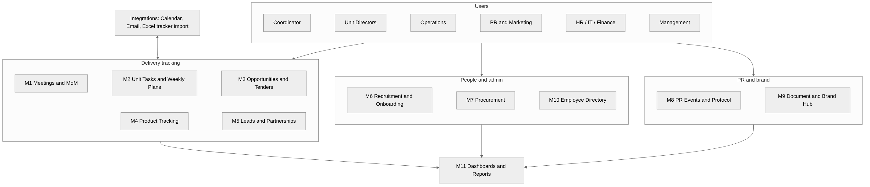
Figure 1: BMS modules, users and integrations
Module | Purpose | Primary users
M1 Meetings and MoM | Schedule against availability, invite, record minutes | Coordinator, directors
M2 Unit Tasks and Weekly Plans | Weekly plan, tasks, progress, support requests per unit | Directors, Coordinator
M3 Opportunities and Tenders | Register and track opportunities; go/no-go; RFP and financial proposal stages | Operations, Alpha Delta, Coordinator
M4 Product Tracking | Phases and status of Kraken, Argus and future products | Coordinator, unit owners
M5 Leads and Partnerships | Database of prospective entities with stages and meeting history | Alpha Gen, Operations
M6 Recruitment and Onboarding | Hiring requests, CV/interview tracking, onboarding checklist | Coordinator, HR, IT, PR
M7 Procurement Requests | Request, quotations, Finance approval | PR, Finance
M8 PR Events and Protocol | Event requests and procedures knowledge base | PR, all units
M9 Document and Brand Hub | Latest branded files and templates, unit profiles | PR (upload), all staff
M10 Employee Directory | Name, job title, photo, certificates | PR, HR, Alpha Gen
M11 Dashboards and Reports | Filters, exports, weekly, monthly, quarterly and six-month reports | All, management

10. Business Process Flows
Each flow below shows the proposed To-Be process. Decision diamonds are choices; the start and end are rounded. Source references are in the requirements (Section 11).

Flow 0: Update and reporting, As-Is versus To-Be
Today directors email updates and the Coordinator copies them to Excel. In BMS directors update the system directly; reports are generated live. Source: Coordinator (6:18, 48:30), Project lead (49:39).
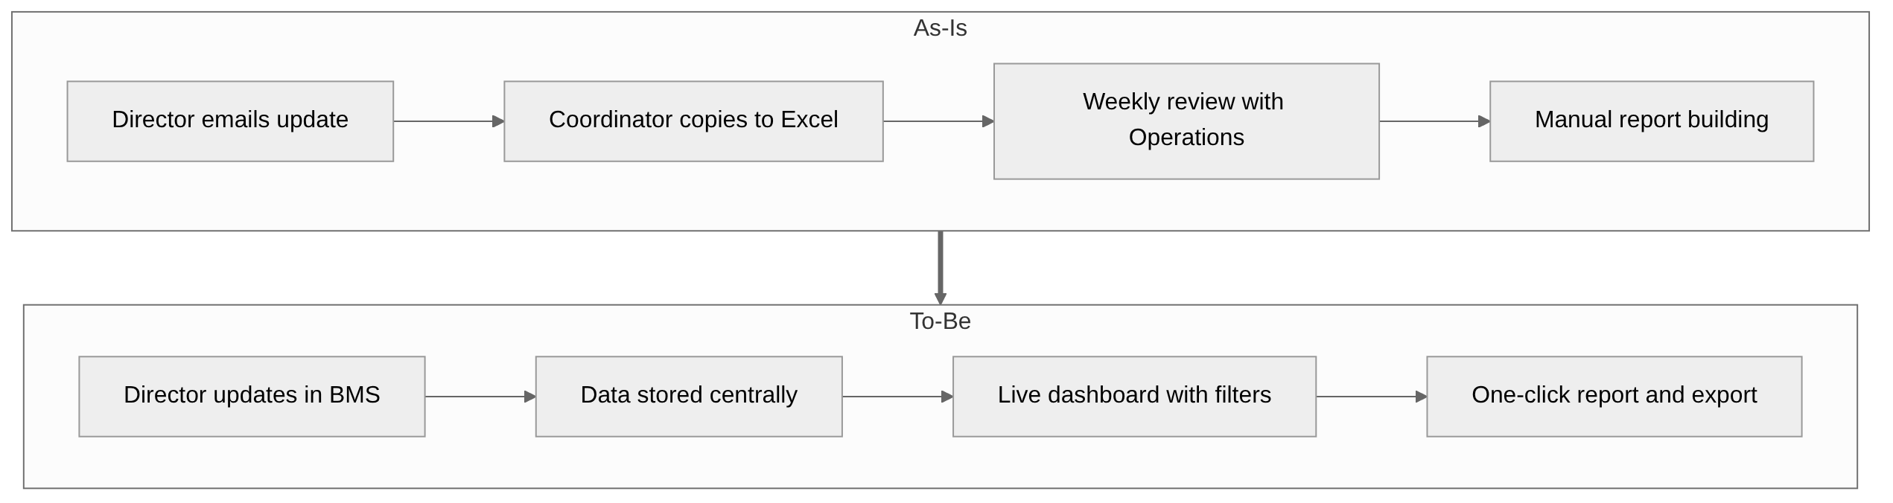
Flow 0: Update and reporting, As-Is versus To-Be

Flow 1: Meeting scheduling and Minutes of Meeting
Coordinator checks calendars, sends invitations (internal or external) and, for important meetings, records minutes with name and attendees. Source: Coordinator (1:05), Alpha Gen (30:06).
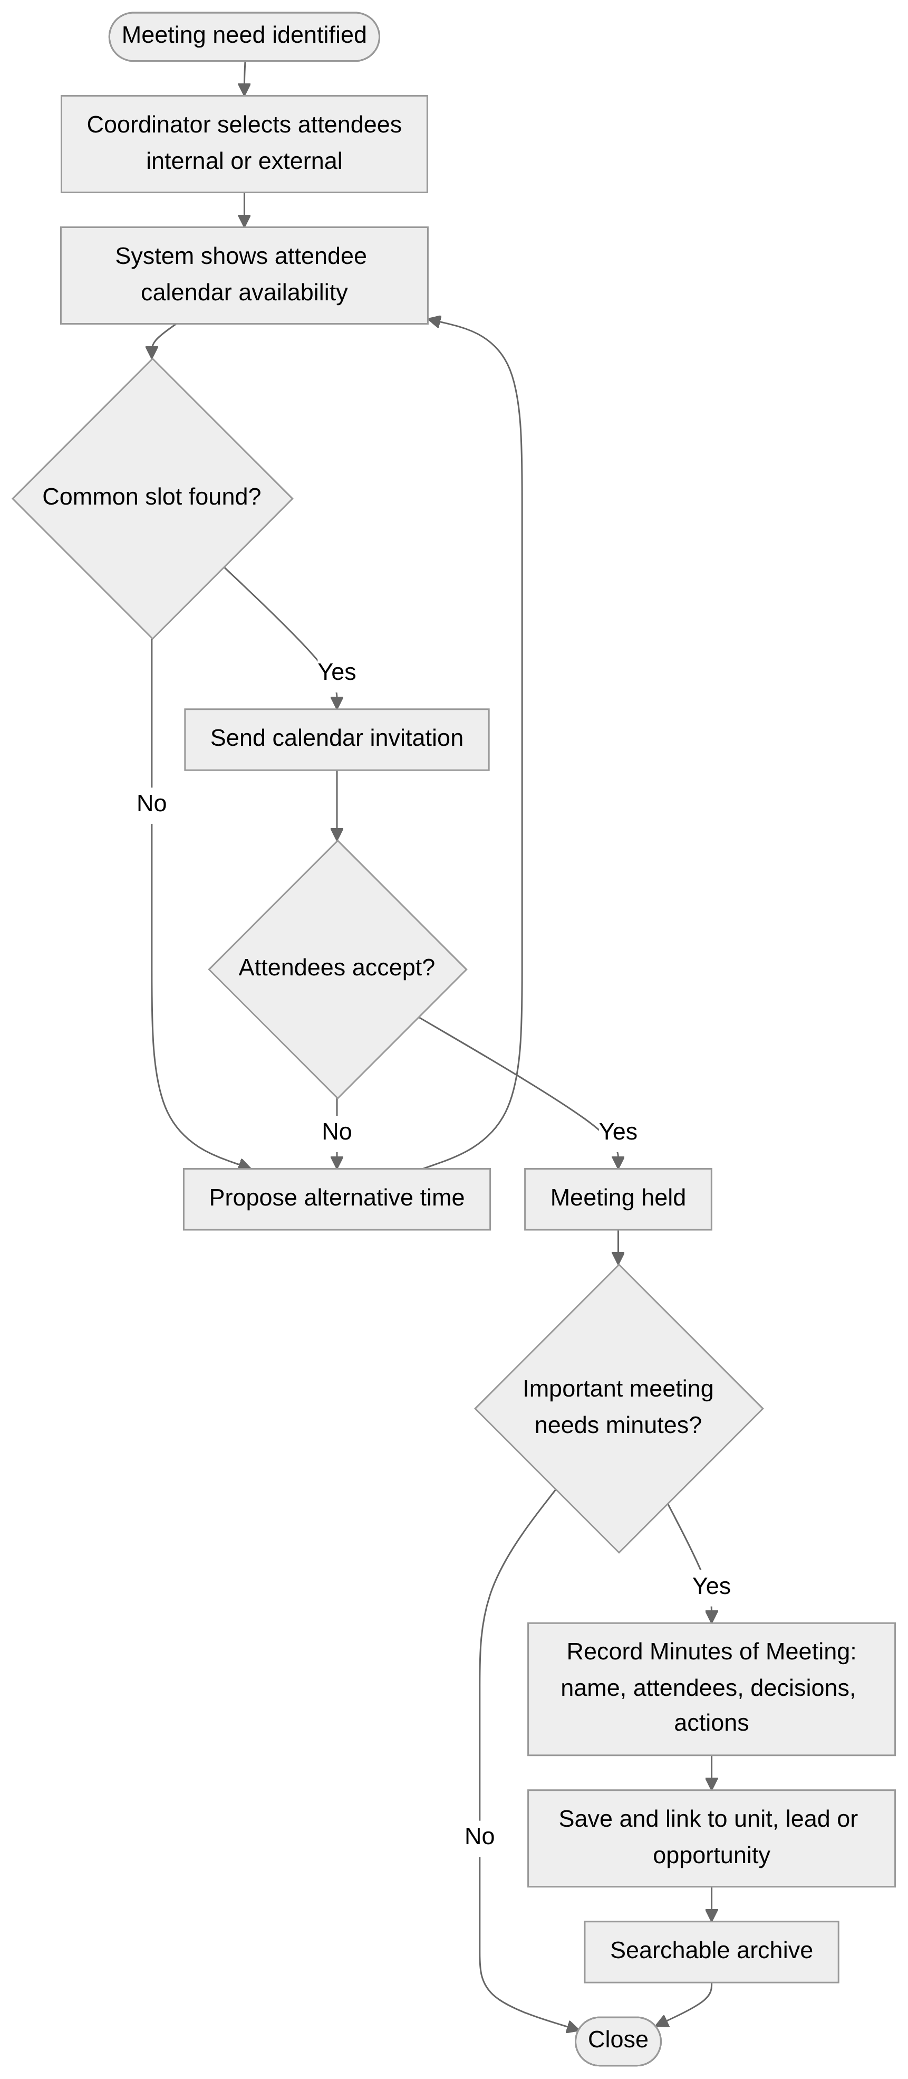
Flow 1: Meeting scheduling and Minutes of Meeting

Flow 2: Weekly unit follow-up (plan, progress, support)
Directors enter the plan at the start of the week and progress at the end (Alpha Delta sends it on Sunday). The Coordinator reviews all units, handles support needs and uses the dashboard for the manager meeting. Source: Coordinator (2:52, 3:33, 3:40), Alpha Delta (20:20).
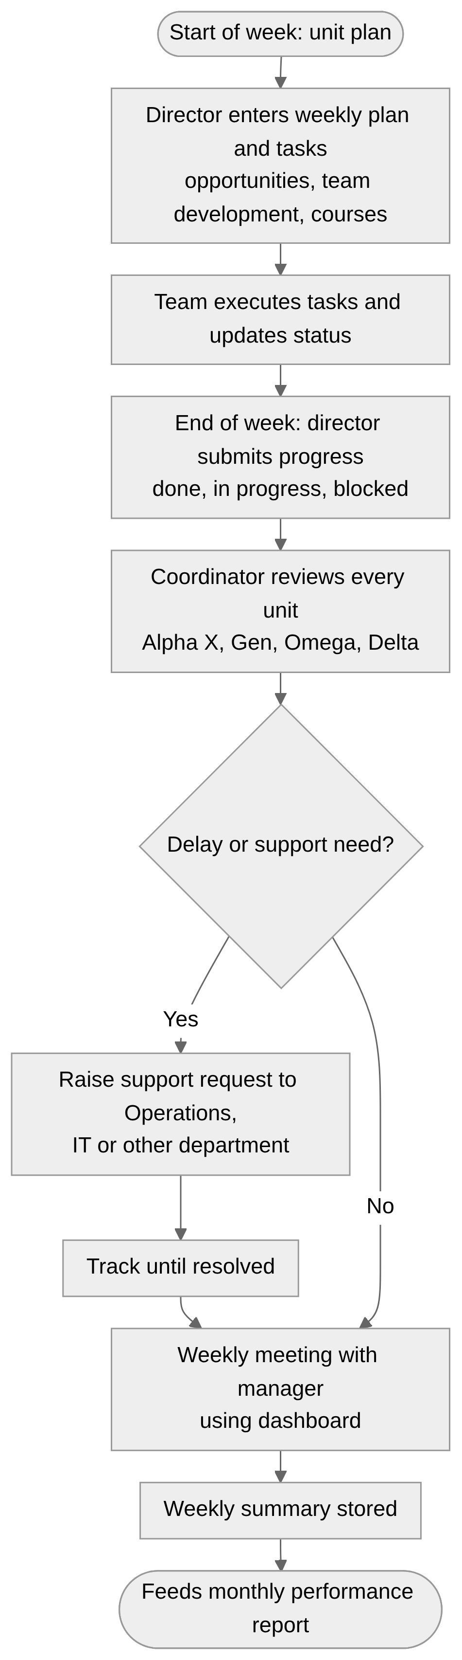
Flow 2: Weekly unit follow-up (plan, progress, support)

Flow 3: Opportunity and tender lifecycle
Operations registers every opportunity; owners update status; the Coordinator monitors delays and support needs. Source: Coordinator (4:35, 5:29, 9:21).
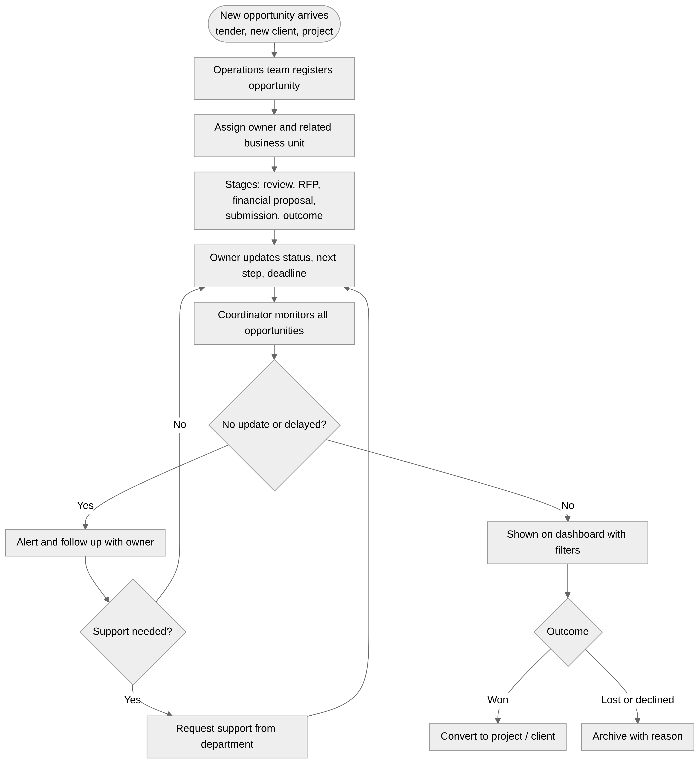
Flow 3: Opportunity and tender lifecycle

Flow 4: Project / RFP intake and go/no-go (Alpha Delta)
Operations sends projects and requirements to the Alpha Delta Director who decides whether to enter and then prepares RFP and Financial Proposal. Source: Alpha Delta (17:38, 18:11).
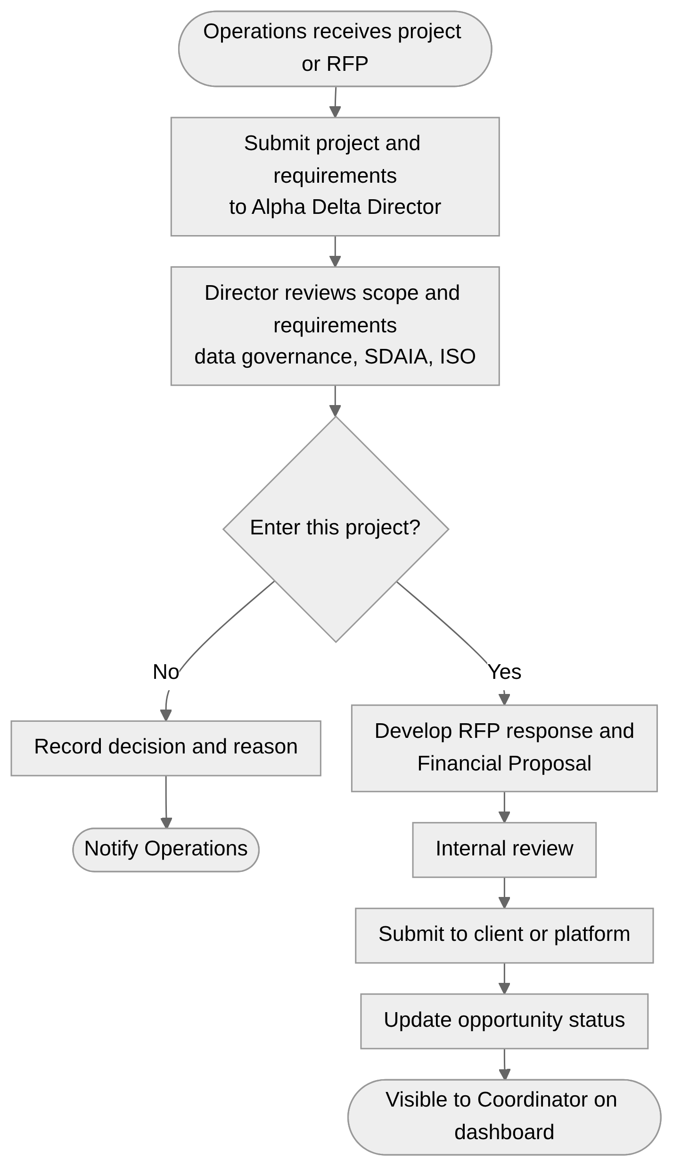
Flow 4: Project / RFP intake and go/no-go (Alpha Delta)

Flow 5: Product tracking (Kraken, Argus)
Each product has an owner, phases, blockers, data needs and support needs; the Coordinator reviews and reports monthly. Source: Coordinator (11:23, 11:39).
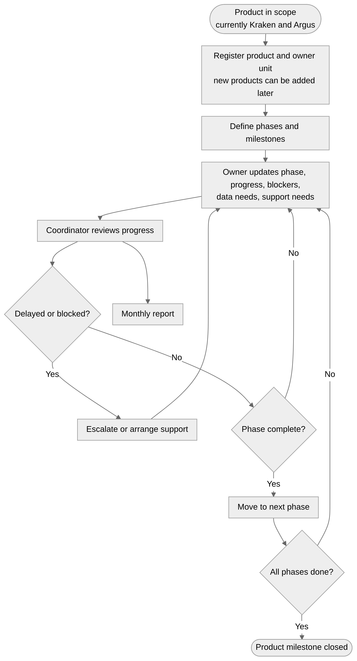
Flow 5: Product tracking (Kraken, Argus)

Flow 6: Recruitment request and tracking
Units raise hiring needs; the Coordinator routes to HR, reviews CVs, interviews, and tracks until the first working day. Source: Coordinator (12:27, 12:49, 13:05).
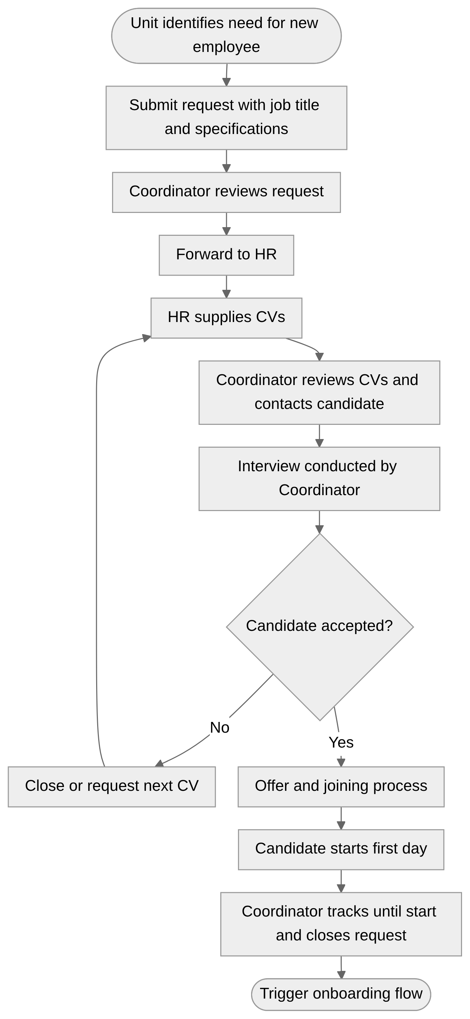
Flow 6: Recruitment request and tracking

Flow 7: New employee onboarding
After hiring, parallel tasks: directory entry by PR, email and laptop by IT, records by HR. Source: PR (44:11, 41:44).
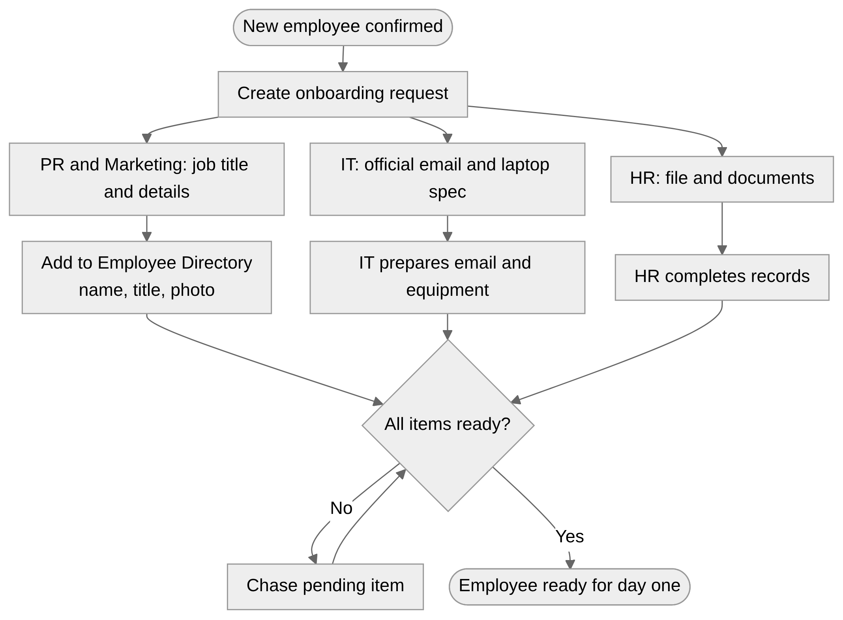
Flow 7: New employee onboarding

Flow 8: Leads, partners and collaboration tracking (Alpha Gen)
Record entity, set stage, log contacts and meeting outcomes, link to opportunities, filter and export. Source: Alpha Gen (23:23, 28:01, 31:32, 32:19).
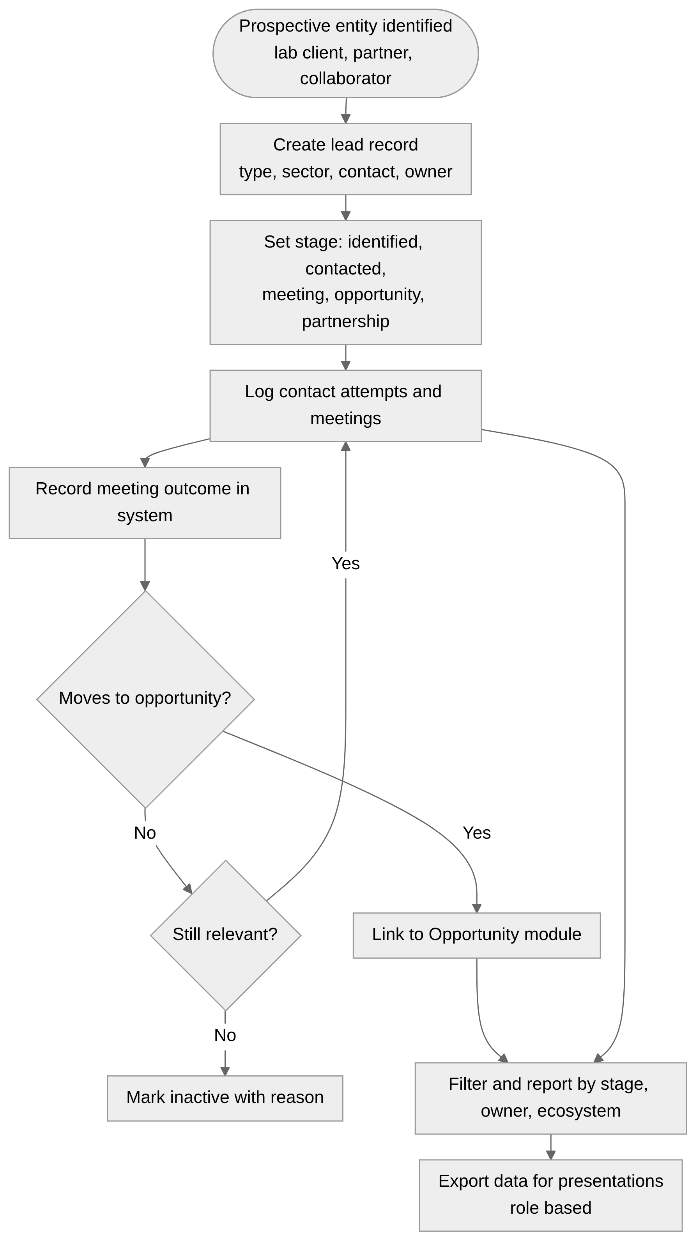
Flow 8: Leads, partners and collaboration tracking (Alpha Gen)

Flow 9: Genetic lab planning scenarios (Alpha Gen)
Scenario 1: partner with King Saud University, assess and restructure. Scenario 2 (weaker): build from scratch. The system tracks the plan and the related entities and staff. Source: Alpha Gen (26:20, 27:16).
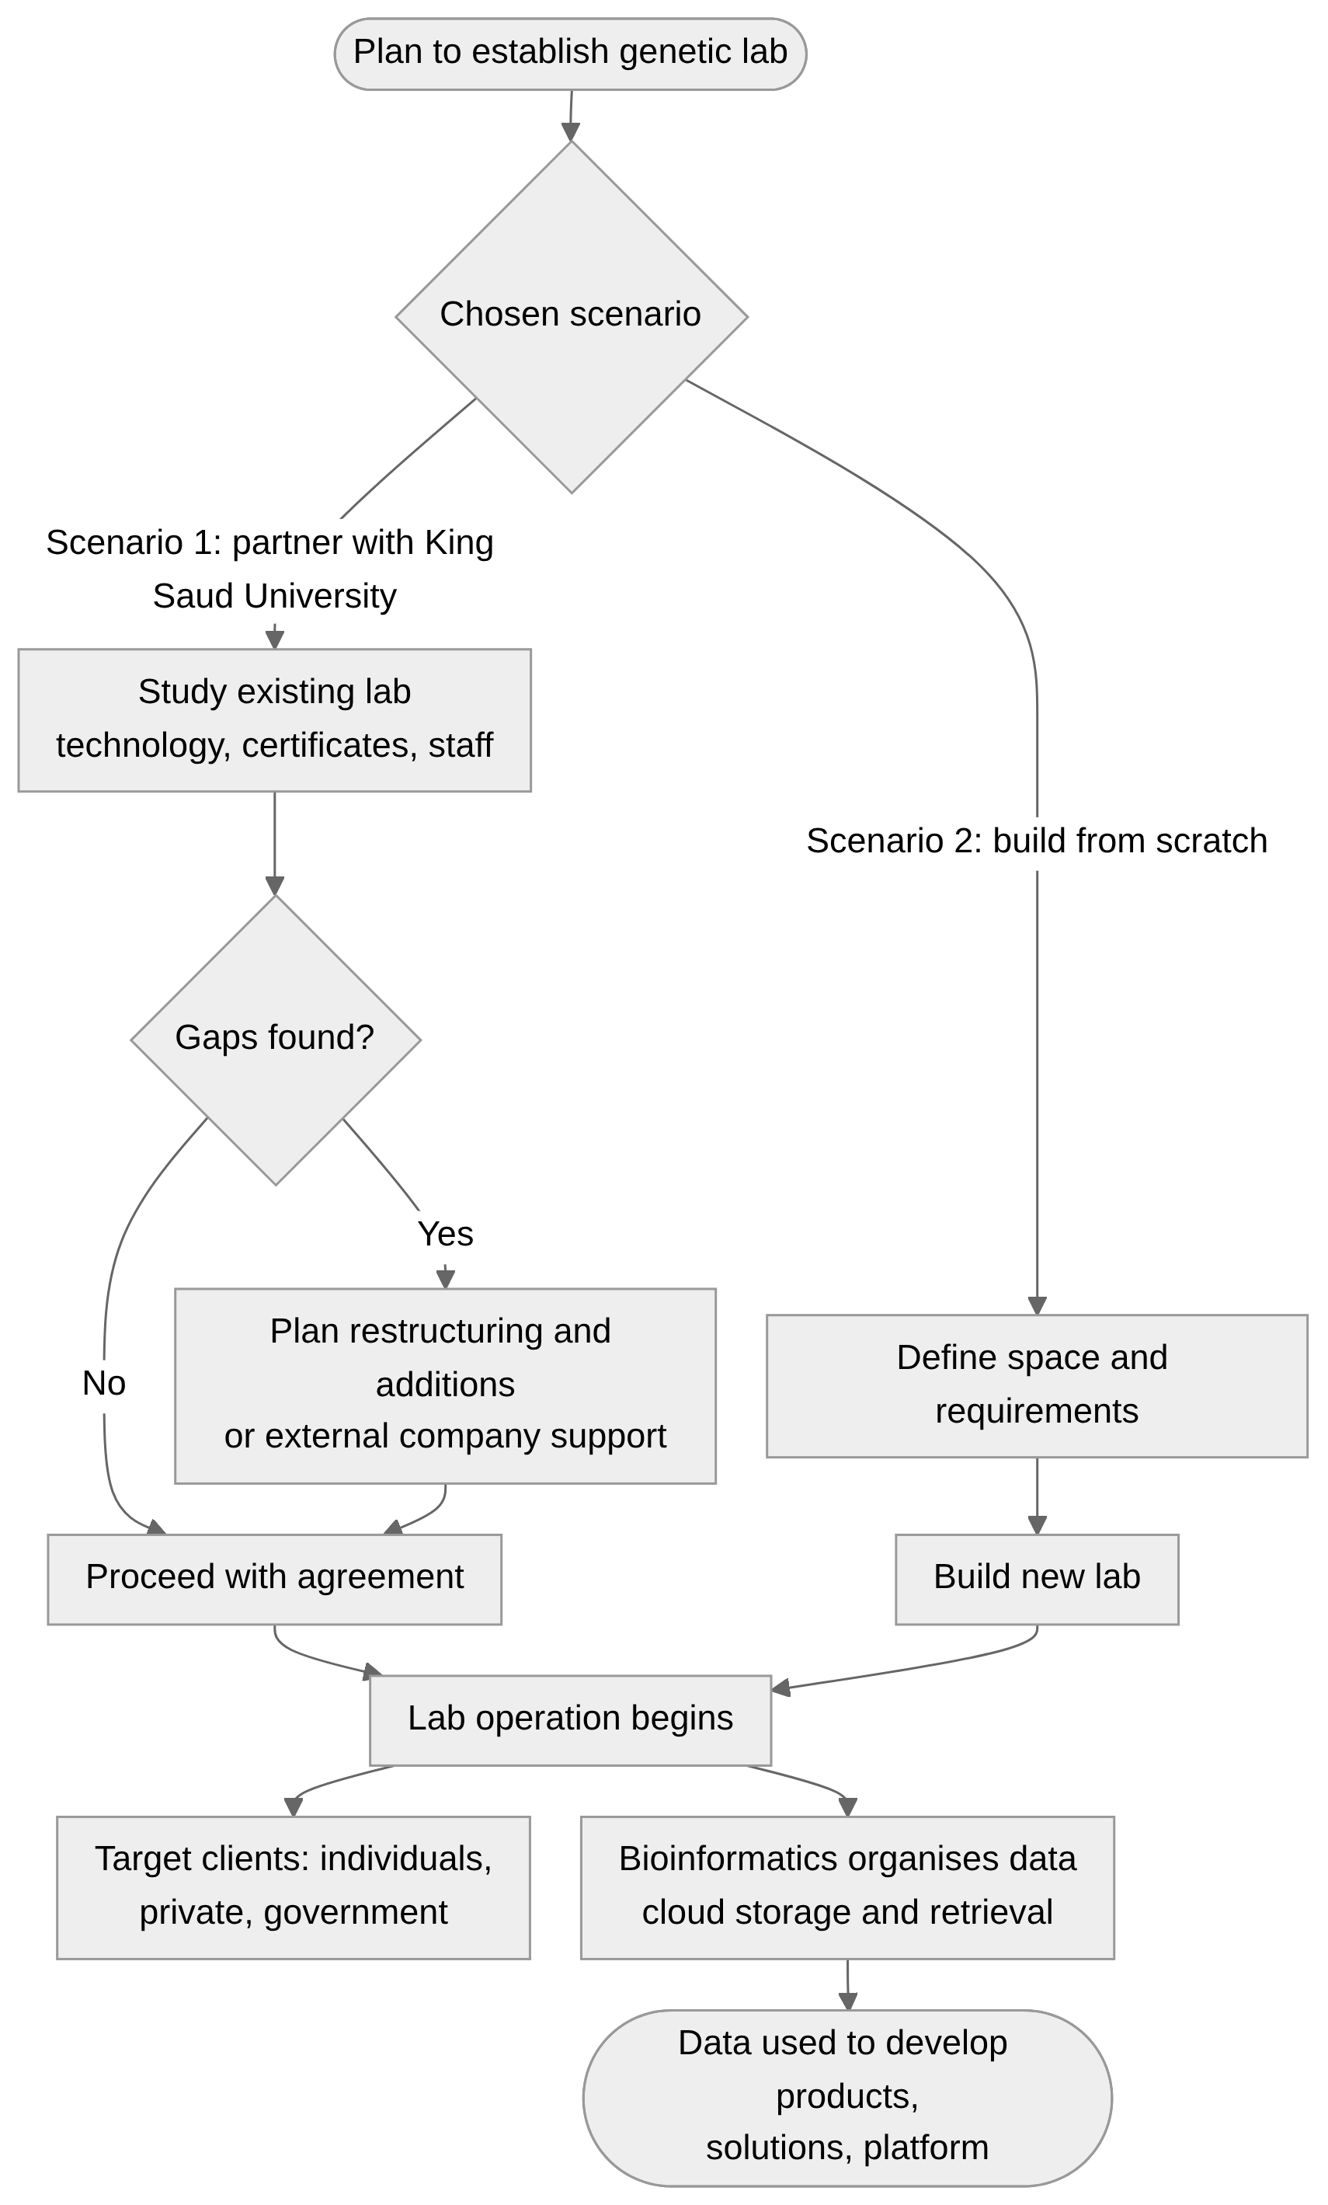
Flow 9: Genetic lab planning scenarios (Alpha Gen)

Flow 10: Document and brand hub (latest version)
Marketing uploads and publishes the latest branded files; all staff download from one place. Source: PR (38:16, 39:24).
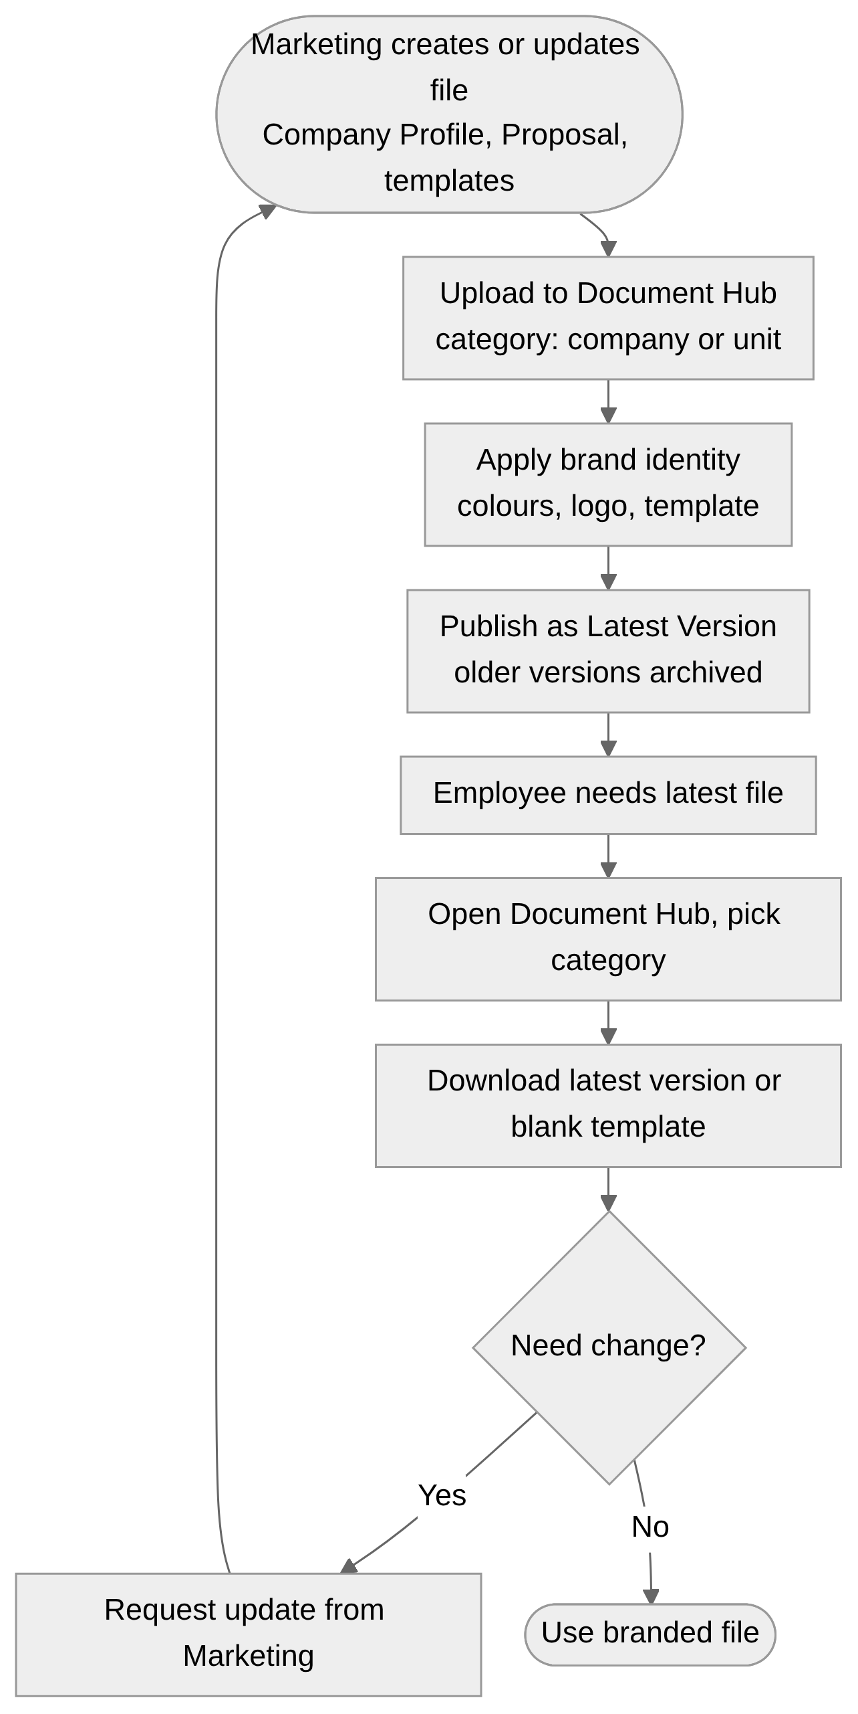
Flow 10: Document and brand hub (latest version)

Flow 11: Procurement request with Finance
PR collects vendor quotations and submits to Finance, who confirm budget suitability. Source: PR (42:49, 43:31, 43:47).
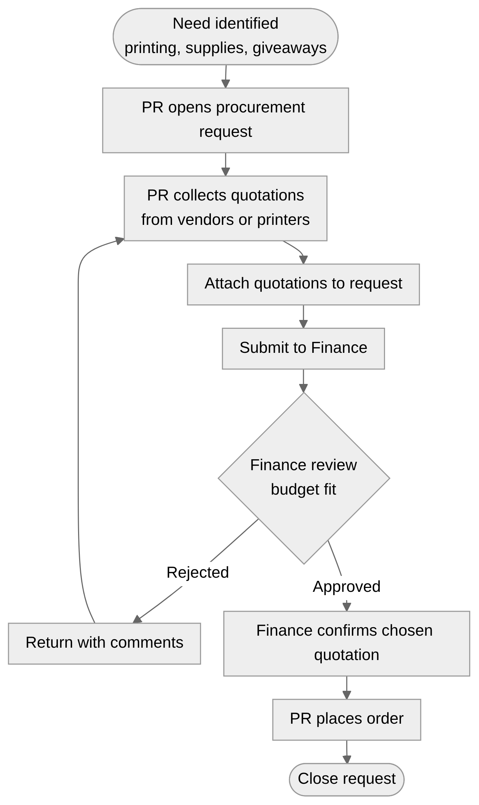
Flow 11: Procurement request with Finance

Flow 12: PR event / agreement signing protocol
Requests reach PR, who arrange photography, announcement content and visitor protocol, then save the procedure for new staff. Source: PR (44:36, 45:11, 45:57).
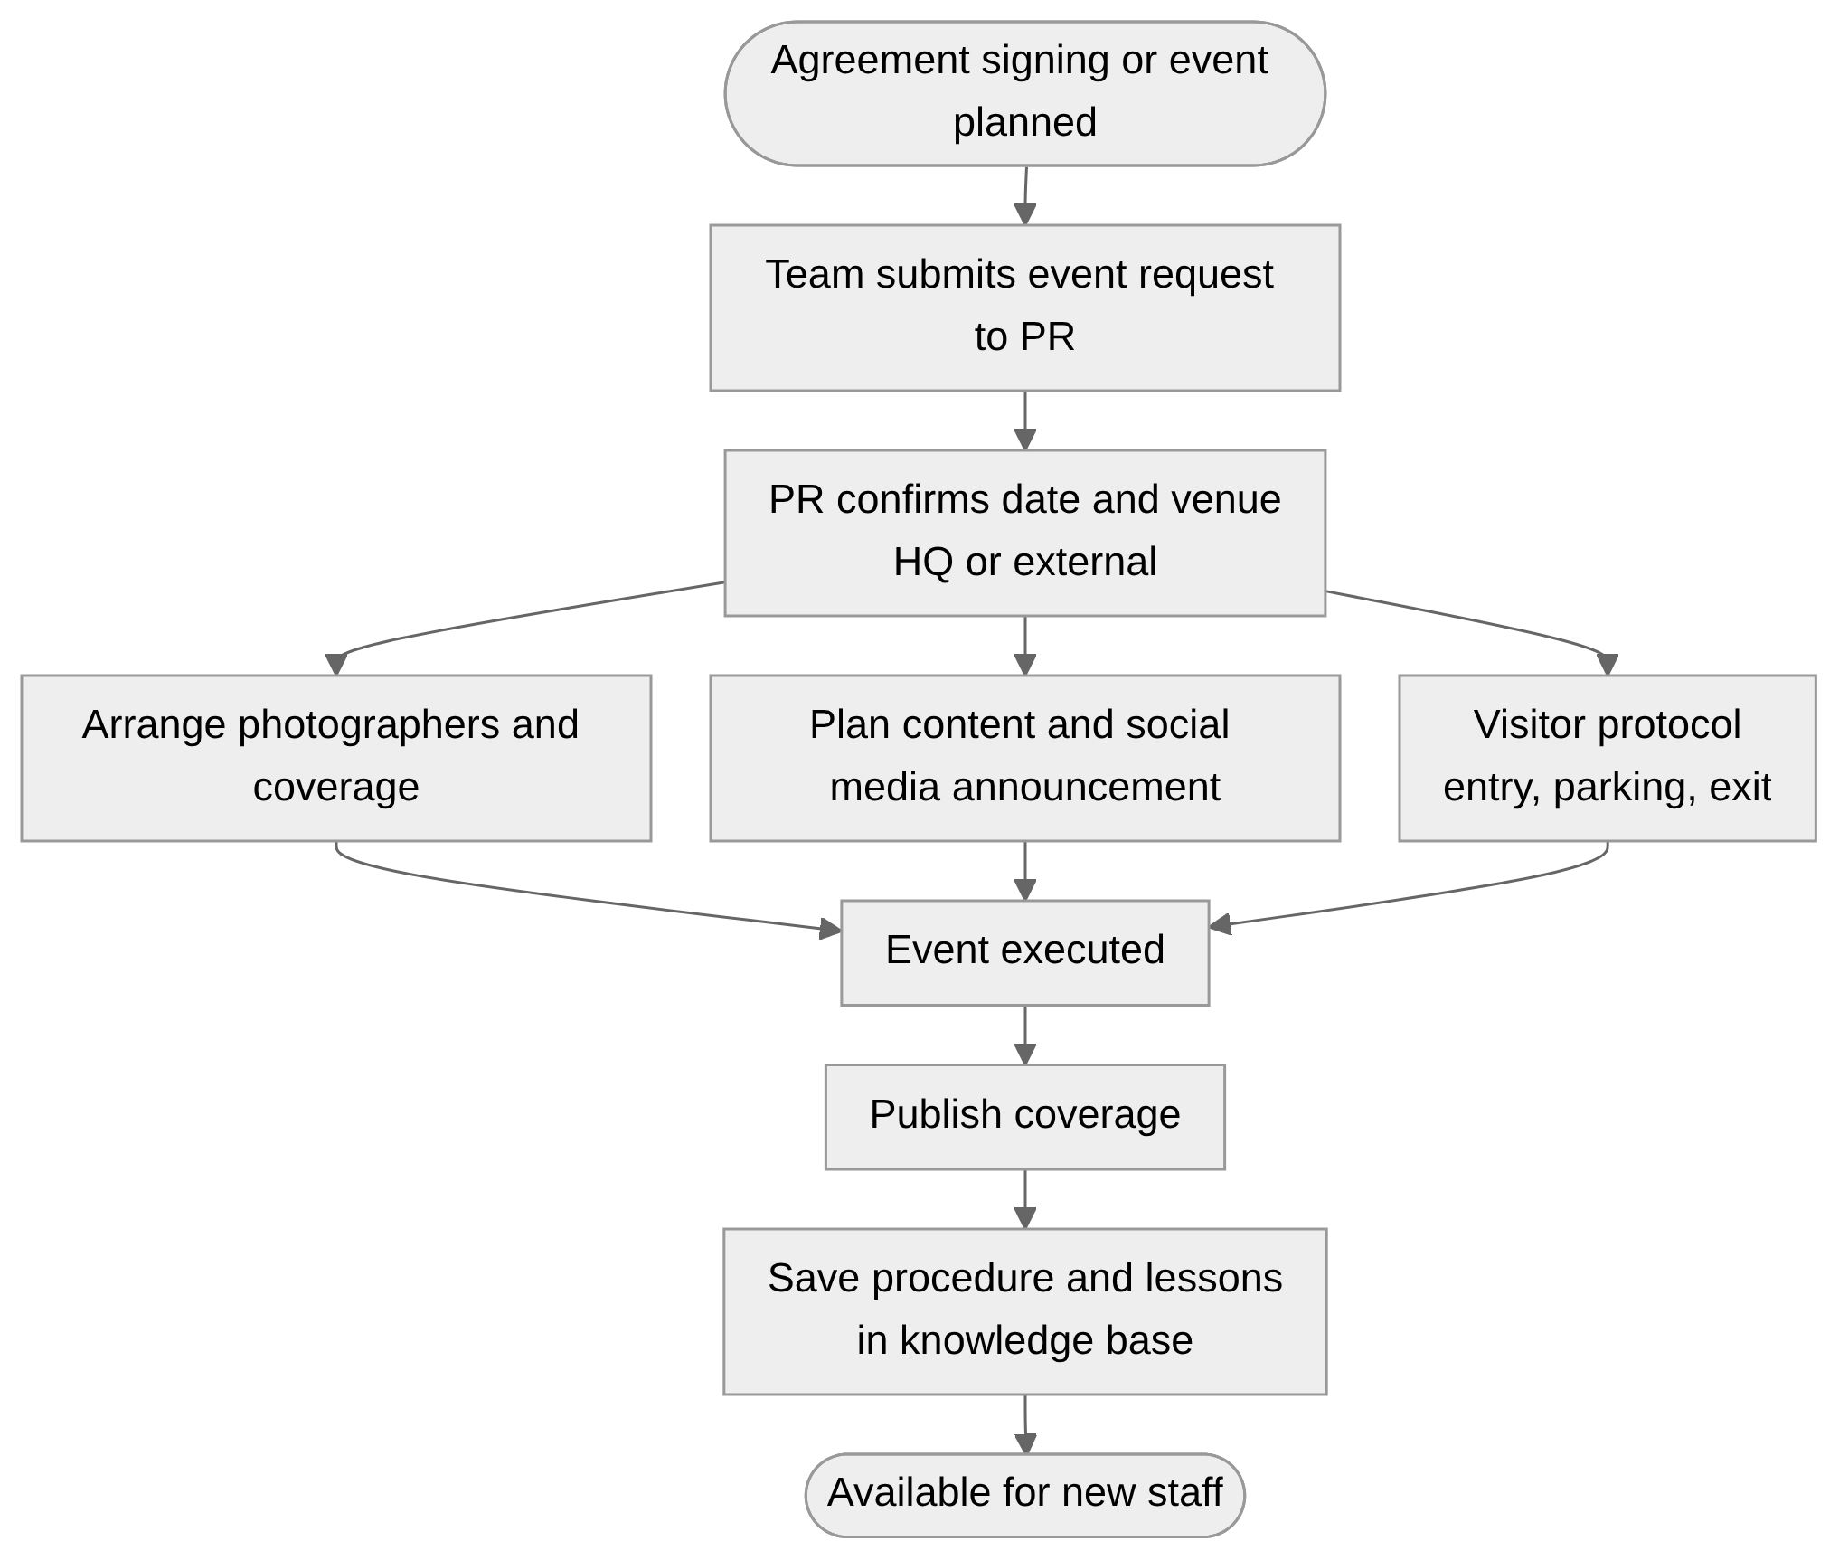
Flow 12: PR event / agreement signing protocol

Flow 13: Reporting cadence
Weekly (directors, tracker), monthly (Coordinator performance report), every 90 days (Alpha Delta KPIs), every six months (social media report). Source: Coordinator, Alpha Delta, PR.
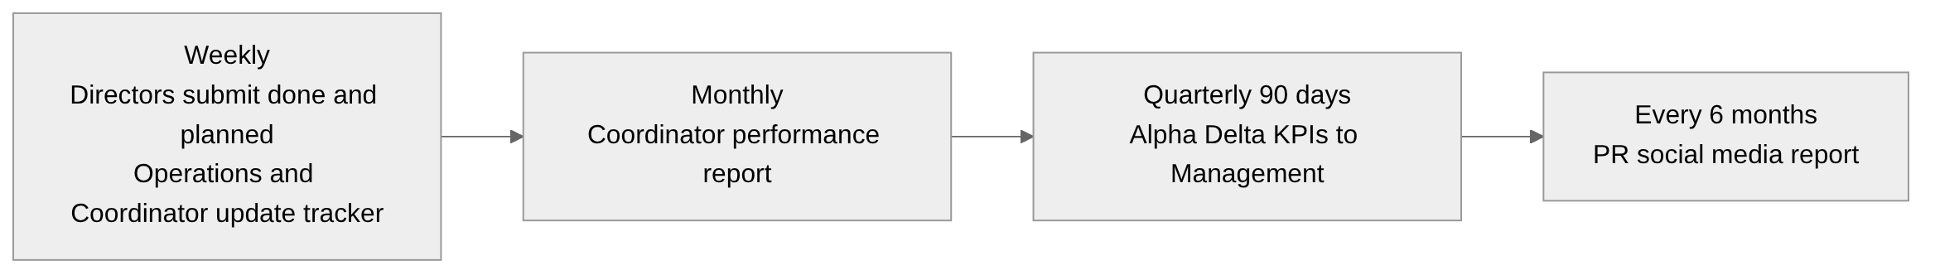
Flow 13: Reporting cadence

11. Functional Requirements
Priority: M = Must, S = Should, C = Could. Source codes: CO = Coordinator, AD = Alpha Delta Director, AG = Alpha Gen Director, PR = PR & Marketing, PL = Project lead (BA).
ID | Mod | Requirement | Pri | Source | Acceptance criterion
FR-MTG-01 | M1 | View availability of attendees (directors, employees) from their calendars before proposing a meeting | M | CO | Availability shown for selected attendees; conflicts flagged
FR-MTG-02 | M1 | Send meeting invitations for internal and external meetings from the system | M | CO | Invitation delivered by calendar/email; response tracked
FR-MTG-03 | M1 | Create Minutes of Meeting with meeting name, date, attendees, discussion, decisions, actions | M | CO, AG | MoM saved and searchable; created only for chosen meetings
FR-MTG-04 | M1 | Link minutes and meetings to a unit, lead, opportunity or product | S | AG, CO | Linked records show meeting history
FR-MTG-05 | M1 | Archive and retrieve past minutes by search and filter | S | CO | Search by name, attendee, date, linked record
FR-UNT-01 | M2 | Each unit director records a weekly plan and tasks (at start of week) | M | CO, AD | Plan visible to Coordinator and manager
FR-UNT-02 | M2 | Record progress: what was achieved, in progress, not done, blockers | M | CO, AD, AG | Status per task; weekly submission captured with date
FR-UNT-03 | M2 | Track team development items (courses, training plans) per unit | S | CO, AD | Development items with status per unit
FR-UNT-04 | M2 | Raise a support request to another department (Operations, IT, etc.) and track until resolved | M | CO | Request has owner, status, history
FR-UNT-05 | M2 | Task follow-up for employees: assign tasks, view progress and completion | M | AG, CO | Director sees per-employee tasks and progress
FR-UNT-06 | M2 | Optionally record next-week plan (currently only done items are shared by Alpha Gen) | C | AG | Next-week plan field optional per unit
FR-UNT-07 | M2 | Replace weekly email reports: weekly report generated from entered tasks | S | AD, CO | Sunday report equals system data without email
FR-OPP-01 | M3 | Operations team registers every opportunity (tender, new client, project, internal or external) | M | CO | Mandatory fields: title, client, type, unit, owner, deadline, stage
FR-OPP-02 | M3 | Assign each opportunity to owner and business unit | M | CO | Filterable by unit and owner
FR-OPP-03 | M3 | Track stages: review, RFP, financial proposal, submission, outcome (won, lost, declined) | M | CO, AD | Stage history with dates
FR-OPP-04 | M3 | Show opportunities with no update or delay; notify owner and Coordinator | M | CO | Alert after defined no-update period (to be agreed)
FR-OPP-05 | M3 | Alpha Delta go/no-go decision on projects received from Operations, with reason | M | AD | Decision, date, reason stored; Operations notified
FR-OPP-06 | M3 | Attach RFP and Financial Proposal documents to the opportunity | S | AD | Documents versioned and linked
FR-OPP-07 | M3 | Import existing Excel tracker data | M | CO, PL | Existing rows migrated with validation report
FR-OPP-08 | M3 | Link customer appointments and trainings related to the product/opportunity | C | PL | Items shown in opportunity timeline
FR-PRD-01 | M4 | Register products (Kraken, Argus) and allow adding new products | M | CO | Admin can add a product without development
FR-PRD-02 | M4 | Define phases per product (first phase, second phase, ...) and current phase | M | CO | Phase and percent/status visible
FR-PRD-03 | M4 | Record blockers, data requirements and support needs per product | M | CO | Blocker list with owner and date
FR-PRD-04 | M4 | Show shared products across units (e.g. Argus: Alpha Delta and Alpha Omega) | S | AD | Product linked to multiple units
FR-LED-01 | M5 | Maintain a database of prospective entities, partners, collaborators (government, private, individuals) | M | AG | Entity record with type, sector, contacts
FR-LED-02 | M5 | Define pipeline stages per lead and move leads between stages | M | AG, PL | Stage list configurable; history kept
FR-LED-03 | M5 | Record whether and when the entity was contacted, meeting details and outcomes | M | AG, PL | Contact log per lead
FR-LED-04 | M5 | Track ecosystem and expansion plans: which entities are in which plan | S | AG | Tag leads by plan/ecosystem
FR-LED-05 | M5 | Convert a lead to an opportunity | S | PL | Lead data carried into opportunity
FR-LED-06 | M5 | Filter and search leads; access restricted by permission | M | PL | Users see leads according to access rights
FR-LED-07 | M5 | Export lead data for presentations | M | AG, PL | Export respects permissions (Excel/PDF)
FR-LED-08 | M5 | Track genetic lab planning (scenario, status, tasks) as a project | C | AG | Scenario 1 and 2 captured with study items
FR-HR-01 | M6 | Units submit a hiring request with job title and specification | M | CO | Request routed to Coordinator
FR-HR-02 | M6 | Coordinator forwards to HR; HR CVs attached to request | M | CO | Request status: with HR, CV received
FR-HR-03 | M6 | Schedule and record interviews and outcome | M | CO | Interview notes and decision stored
FR-HR-04 | M6 | Track hiring from CV to first day of work | M | CO | Status timeline with dates
FR-HR-05 | M6 | Onboarding checklist: IT email and laptop, PR directory entry, HR records | S | PR | Checklist items with owners and status
FR-PRC-01 | M7 | PR opens a procurement request (item, quantity, purpose) | S | PR | Request created with required fields
FR-PRC-02 | M7 | Attach vendor quotations (several vendors) to the request | S | PR | Multiple quotations stored and comparable
FR-PRC-03 | M7 | Finance reviews and approves/rejects, with budget confirmation | S | PR | Decision and comment recorded
FR-EVT-01 | M8 | Event/agreement-signing request is submitted to PR | S | PR | Request routed to PR
FR-EVT-02 | M8 | Event checklist: photographers, social media announcement, visitor protocol (entry, parking, exit) | S | PR | Checklist per event type
FR-EVT-03 | M8 | Procedure knowledge base for before and after signing events for new staff | C | PR | Published guide accessible to all
FR-DOC-01 | M9 | Central repository for company files: Company Profile, Proposal, presentation templates (blank branded) | M | PR | Files organised by category
FR-DOC-02 | M9 | Latest-version control: a clear "latest" entry per file, older versions archived | M | PR | One click to latest; history kept
FR-DOC-03 | M9 | Only PR/Marketing can upload and publish; all staff can download | M | PR | Upload rights restricted by role
FR-DOC-04 | M9 | Separate section per unit (each unit has own identity) with its files | M | PR | Unit section with its branded files
FR-DOC-05 | M9 | Unit profile page: what the unit is, services, key messages | S | PR | Editable text per unit
FR-DOC-06 | M9 | Brand identity assets (logo, colours) available for reuse | S | PR | Asset list per company and unit
FR-EMP-01 | M10 | Employee directory: name, job title, profile photo (company-wide) | M | PR | Searchable list with photos
FR-EMP-02 | M10 | Lab staff database with details and certificates (Alpha Gen) | M | AG | Certificates attached per person; quick retrieval
FR-EMP-03 | M10 | New employees added through onboarding | S | PR | Record created at onboarding
FR-DSH-01 | M11 | Overall dashboard for the company with filter by unit (Alpha X, Gen, Omega, Delta), product, opportunity | M | CO, PL | Filtering returns all data for the choice
FR-DSH-02 | M11 | Dashboard shows tenders: submitted, no update, delayed | M | CO | Status and age visible
FR-DSH-03 | M11 | Dashboard shows unit progress (what is happening, progress, tasks) | M | CO | Per-unit view
FR-DSH-04 | M11 | Dashboard shows product progress (Kraken, Argus) | M | CO | Per-product view
FR-DSH-05 | M11 | Live view and downloadable report instead of manual updates | M | PL, CO | Report downloadable on demand
FR-DSH-06 | M11 | Dashboard usable in the weekly meeting with the manager | M | CO | Presentable view without Excel
FR-RPT-01 | M11 | Monthly performance report: unit progress, achievements, support needs, products | M | CO | Generated from system data
FR-RPT-02 | M11 | Quarterly (90-day) KPI view for Alpha Delta | S | AD | KPI list agreed and shown
FR-RPT-03 | M11 | Six-monthly social media report (followers, posts, engagement) | C | PR | Fields entered or imported; report printable
FR-RPT-04 | M11 | Weekly report per unit (done / in progress) | M | AD, AG, CO | Auto weekly report
FR-RPT-05 | M11 | Export data (Excel/PDF) from any list or dashboard, subject to access | M | AG, PL | Export available per role

12. Data Requirements
Entity | Key attributes
Business Unit | Name, identity/brand assets, director, profile text, services
Employee | Name, job title, photo, unit, certificates, email
Weekly Plan / Task | Unit, owner, description, week, status, progress, blocker, support need, completion date
Opportunity / Tender | Title, client, type (tender, client, project), unit, owner, stage, deadline, decision, reason, documents, last update
Product | Name (Kraken, Argus...), owner unit(s), phases, current phase, blockers, data needs, support needs
Lead / Entity | Name, type (government, private, individual), sector, contacts, stage, contact status, ecosystem/plan tag, owner
Meeting | Title, date, attendees, internal/external, linked record
Minutes of Meeting | Meeting, attendees, discussion, decisions, actions
Hiring Request | Unit, job title, specification, HR status, CV, interview result, first working day
Onboarding Checklist | Employee, IT items, PR directory, HR records, status
Procurement Request | Item, quantity, vendors, quotations, Finance decision
PR Event | Type, date, venue, photography, announcement plan, visitor protocol
Document | Name, category, unit, version, latest flag, uploader, date
Report | Type (weekly, monthly, quarterly, six-monthly), period, content

13. Dashboard and Reporting Requirements
Dashboard / report | Content | Audience | Frequency
Overall dashboard (Alpha Iota) | All units, tenders, products with filters | Coordinator, management | Live; weekly manager meeting
Unit view | Plan, tasks, progress, support needs | Coordinator, director | Weekly
Opportunity / tender view | Stage, delay, no-update, outcome | Coordinator, Operations | Live
Product view | Phase, blockers, data and support needs (Kraken, Argus) | Coordinator | Live; monthly
Leads view | Pipeline by stage, last contact, meetings | Alpha Gen | Live
Monthly performance report | Units, achievements, support needs, products | Management | Monthly
Alpha Delta KPIs | KPIs list (to be defined) | Management | Every 90 days
Social media report | Followers, posts, engagement | PR, management | Every 6 months

14. Roles, Permissions, Access
Role | Permissions (proposed)
Administrator | Configure lists, stages, products, users, permissions
Coordinator | View all units; manage meetings, minutes, hiring; generate reports
Unit Director | Edit own unit plans, tasks, leads; view own unit data; export own data
Operations user | Register and update opportunities
PR & Marketing | Upload/publish documents; manage directory, events, procurement requests
Finance / HR / IT | Process requests addressed to them
Management | View dashboards and reports
Employee | Download latest files, view directory

Alpha Gen asked whether she can extract her data at any time (e.g. for a presentation); the project lead confirmed this is applicable. Access to leads depends on user permissions (the lead can only be seen by those with access).

15. Non-Functional Requirements
ID | Category | Requirement | Pri
NFR-01 | Security | Role-based access; sensitive lead and employee data restricted | M
NFR-02 | Audit | Track who changed what and when (status, decisions) | S
NFR-03 | Usability | Simple filters and one-click access to latest files; bilingual (Arabic/English) data | M
NFR-04 | Performance | Dashboards load with filters quickly with data of all units (target to be agreed) | S
NFR-05 | Availability | Accessible for weekly manager meetings during working hours (target to be agreed) | S
NFR-06 | Scalability | Add units, products and users without redevelopment | M
NFR-07 | Integration | Calendar and email integration; Excel import/export | M
NFR-08 | Compliance | Align with company data governance and SDAIA expectations | S
NFR-09 | Backup | Regular backup and recovery of all data | M

16. Action Items (What Must Be Done)
# | Action | Owner | Source | Status
A1 | Send the shared Excel tracker (structure and sample/dummy data) by email | Fatimah | 7:59, 49:48 | Open
A2 | Share the Excel sheet with the BA and review all units and opportunities in it | Fatimah / BA | 50:04 | Open
A3 | Study the Excel and define the data model and migration | BA | 13:59 | Open
A4 | Ask other departments (Operations, Finance, HR) to show how they currently work or share their request process | Fatimah / BA | 48:19, 48:30 | Open
A5 | Design the system so Coordinator receives director updates directly (no email) | BA | 48:30, 49:39 | Open
A6 | Define the unit/tender/product dashboard with filters | BA | 9:50, 11:04 | Open
A7 | Define the monthly performance report content | BA / Fatimah | 8:47, 9:14 | Open
A8 | Define lead stages and database fields for Alpha Gen | BA / Alpha Gen | 31:32 | Open
A9 | Confirm the data export capability and permissions | BA | 32:19, 32:43 | Open
A10 | Define Document Hub structure (company and per unit) and latest-version rules | BA / PR | 38:16, 40:55 | Open
A11 | Collect unit profile content (what unit does, services) | PR / units | 41:34 | Open
A12 | Define employee directory fields (name, title, photo) and Alpha Gen certificates | BA / PR / Alpha Gen | 41:44, 23:23 | Open
A13 | Document PR event/protocol procedure | PR | 45:11 | Open
A14 | PR to send any additional requirements via Fatimah | Afnan | 46:25, 47:16 | Open
A15 | Hold a follow-up session if needed (all stakeholders available) | BA | 14:10, 50:10 | Open
A16 | Interview Alpha X and Alpha Omega leaders and Operations team (not covered) | BA | Gap | Proposed
A17 | Validate this BRD with the interviewees | BA | n/a | Proposed

17. Open Questions and Risks
# | Question / risk | Why it matters
Q1 | Exact unit names: the recording is unclear on names (Alpha X, Alpha Gen, Alpha Omega, Alpha Delta and the parent Alpha Iota). Confirm spelling | Configuration and labels
Q2 | What does Alpha X do (the recording links it to a museum context)? | Unit profile, dashboard data
Q3 | Lead pipeline stages and mandatory fields | Alpha Gen database
Q4 | Which calendar and email systems are used (for integration)? | FR-MTG-01/02
Q5 | Which meetings require minutes and who approves them? | FR-MTG-03
Q6 | Alert thresholds for "no update" on tenders | FR-OPP-04
Q7 | Approval chain and budget limits for procurement | FR-PRC-03
Q8 | KPI list for Alpha Delta 90-day report | FR-RPT-02
Q9 | Whether Alpha Gen will share next-week plans (currently only achievements) | FR-UNT-06
Q10 | Whether HR, Finance, IT will use BMS directly or only receive requests | Scope of M6, M7
Q11 | Hosting, security and data residency expectations | NFR
Q12 | Audio quality: some parts of the recording were unclear (names, platforms such as the tender portal). Confirm items marked as assumptions | Accuracy
R1 | Risk: user adoption; people may continue to use email and Excel | Mitigate with training and retiring Excel
R2 | Risk: other departments not yet interviewed; flows may change | Validate before design freeze
R3 | Risk: heavy scope; many modules | Use phasing (Section 18)

18. Proposed Phasing
This is a proposal for discussion; it is not from the meeting.
Phase | Content | Reason
1 (core) | M2 Unit tasks, M3 Opportunities, M4 Products, M11 Dashboard, Excel import | Coordinator core pain, replaces Excel and email
2 | M1 Meetings and MoM, M5 Leads, M10 Directory | Alpha Gen and Coordinator needs
3 | M9 Document Hub, M6 Recruitment/Onboarding | Brand and HR processes
4 | M7 Procurement, M8 PR Events, six-month reports | Cross-department processes after validating with Finance

19. Requirements Traceability Matrix
Stakeholder need | Objective | Requirements | Flow
Replace Excel and email updates with a live dashboard | BO-1, BO-2, BO-3 | FR-DSH-01..06, FR-OPP-07 | 0, 2, 3
Weekly unit follow-up | BO-2 | FR-UNT-01..07 | 2
Tender and opportunity tracking | BO-1, BO-2 | FR-OPP-01..08 | 3, 4
Product tracking (Kraken, Argus) | BO-2 | FR-PRD-01..04 | 5
Meetings and minutes | BO-5, BO-6 | FR-MTG-01..05 | 1
Recruitment and onboarding | BO-5 | FR-HR-01..05 | 6, 7
Lead and partner database | BO-1, BO-6 | FR-LED-01..08 | 8, 9
Latest files and brand identity | BO-4 | FR-DOC-01..06 | 10
Employee directory | BO-4, BO-6 | FR-EMP-01..03 | 7
Procurement | BO-5 | FR-PRC-01..03 | 11
PR events and protocol | BO-5, BO-6 | FR-EVT-01..03 | 12
Monthly, quarterly, six-month reports | BO-3 | FR-RPT-01..05 | 13

20. Glossary
Term | Meaning
BMS | Business Management Solutions System
BRD | Business Requirements Document
MoM | Minutes of Meeting
RFP | Request for Proposal
Kraken / Argus | Products of Alpha Iota; Argus is a data labelling platform shared by Alpha Delta and Alpha Omega
SDAIA | Saudi Data and Artificial Intelligence Authority (data governance requirements)
CDMP | Certified Data Management Professional program (as mentioned by Alpha Delta)
ISO | International standards certifications pursued by the company
Etimad | Platform referred to in the recording as a source of data management opportunities (name as heard)
MoSCoW | Must, Should, Could prioritisation

