Task1:

Binary search:

Analysis:

* I will try to solve the binary search problem, first I take some array of strings.
* Next loop the array of strings.
* If the I value is match with target value return the string and it position.

Flow Chart:

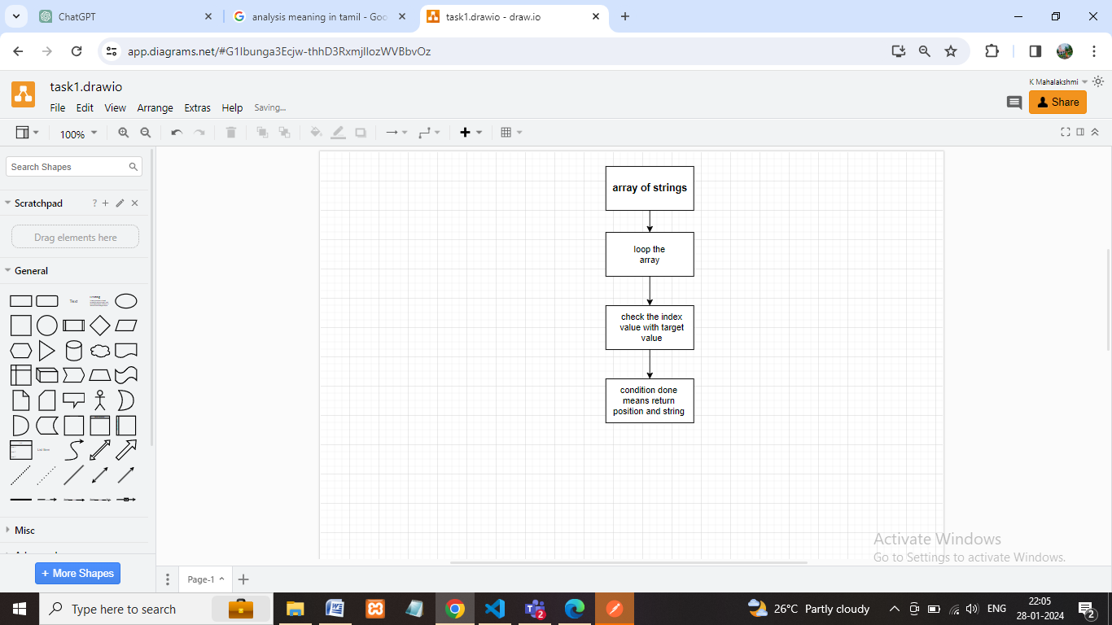

Output

