Task3:

function task3(array, target) {

    let index = 0;

    while (index < array.length && array[index] < target) {

        index++;

    }

    return index;

}

const array = [1, 4, 5, 7, 9, 0, 2, 3, 6];

const target = 8;

const index = task3(array, target);

array.splice(index, 0, target);

console.log(`The target index value is ${index}`);

console.log("Add the target value to the array:", array);

output:

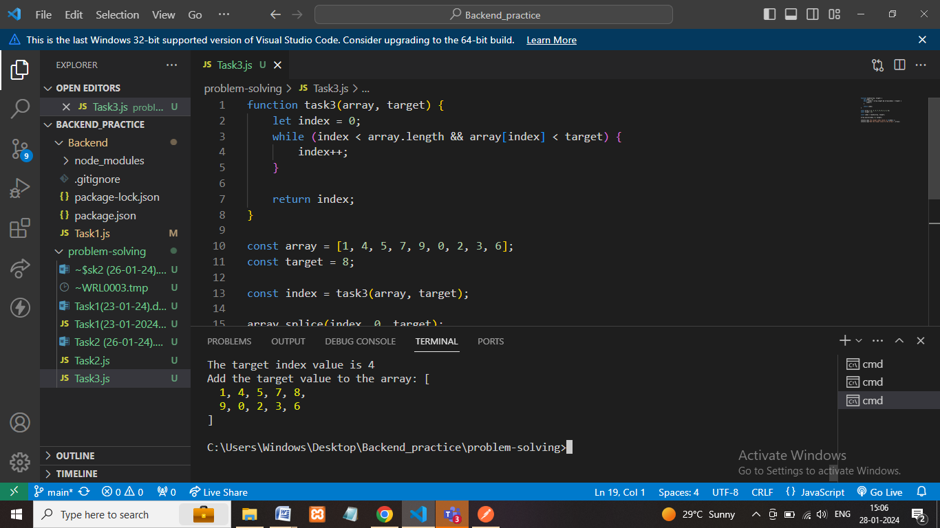

Description:

* Functions take two parameters, next find the current index, index=0.
* Using while loop to find the target value in the array or not.
* The target value is unavailable in the array incre the index++.
* After add the new value into the array (array.splice(index,0,target)) we can view it.

**Architecture**:

