Task 6:

Q: Given a non-negative integer x, return the square root of x rounded down to thenearest integer. The returned integer should be non-negative as well.

**Analysis:**

* This function aim to find the integer square root of the input value x
* the square of the current integer value is equal to x, its returns the integer
* If the square of the current integer value x, it returns the previous integer which is the largest integer less than or equal to the square root of x.
* The input x = 4, the function correctly returns 2.

**Flow Chart:**

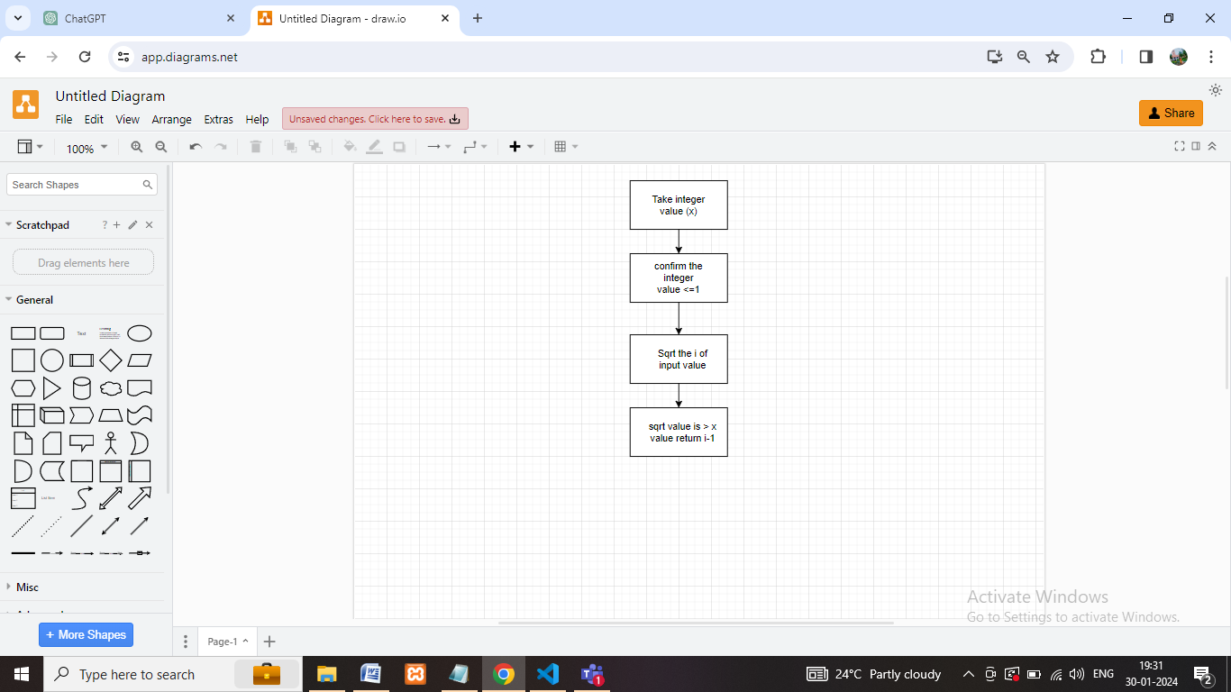

**Coding:**

var task6 = function(x)

{

    if(x <= 1)

    {

        return x;

    }

    for(let i=2; i<= x; i++)

    {

        if(i * i ===x)

        {

            return i;

        }

        if(i * i > x)

        {

            return i-1;

        }

    }

};

x=4;

console.log("result:", task6(x) );

x=8;

console.log("result:", task6(x) );

x=9;

console.log("result:", task6(x) );

**Output:**

