**Overview:**

The purpose of application is a game where the computer, **secret-keeper**, randomly selects a word from a word bank. The user, **guesser**, then has to guess the word. The guesser can choose to guess the word one letter at a time or the whole word. The guesser will be allowed six incorrect guesses before the game is over.

The **secret-keeper** will reveal one letter at a time as the guesser correctly guesses. At the end of the game, if the **guesser** has not guessed all the correct words then the **secret-keeper** will reveal the remaining letters.

In short, the game needs the following:

* Get a random word.
* User guesses one letter at a time or the entire word.
* The user will have six wrong guesses. Each wrong guess results in one less guess.
* If the user runs out of guesses, then game will reveal the entire word.

**User Interface:**

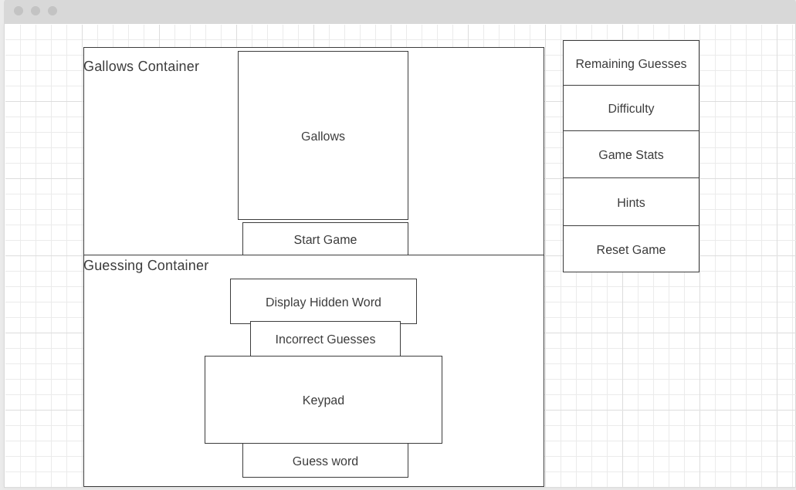

* Gallows Container
  + Gallows – Shows the hangman images as the user gets wrong guesses.
  + Start Game
    - Allow user to select difficulty then start game. Difficulty scale from 1-10. Will affect request to word bank.
    - Transitions to a spinner while the app makes an API request to the word bank. Then disappears.
    - At end of game, reappears allowing player to start another game.
* Guessing Container – Appears after user clicks start game.
  + Display Hidden Word – Represent hidden word as underscores. Each correct guess reveals one character. If user correctly guesses entire word then the entire word is shown. Entire word is revealed at the end.
  + Incorrect Guesses – Display incorrect letters and word guesses.
  + Keypad
    - Lists all 26 alphabetical letters.
    - Allow user to click on letters to make their guess.
    - Each clicked letter is disabled to avoid repetitive clicking.
    - Letter is also disabled if the user guesses just one letter in the Guess Word section. Entire keypad is disabled at the end of game.
  + Guess Word
    - Form input field where user can guess the entire word.
    - Single letters will also work and is respectively disabled in the keypad section.
    - Automatically convert input to uppercase.
    - Input validation – Cannot submit duplicate guesses, numbers, special characters, etc. Alphabetical characters only.
    - Disable at end of game.
* Sidebar – Contains game information
  + Remaining Guesses – Begins at 6 and decrements by 1 for each wrong guess. Resets to 6 for each new game.
  + Difficulty – Shows difficulty level selected at beginning of game.
  + Game Stats – Shows # of wins, # of losses, and current winning streak during the game session.
  + Hints
    - Only appears after the user selects a difficulty level and select game.
    - Has button inside to toggle whether to show hints or not. Has to toggle “show hints” for each new game.
    - After toggling “show hints”, display number of unique vowels and unique letters. This is because some vowels and letters are repeated.
  + Reset Game
    - Only appears after the user selects a difficulty level and select game.
    - This resets the game to the very beginning where the user has to select a difficulty level and start game.
    - Erases everything including game stats and any data related to the current game session.