Lab Assignment-1

MANPREET SINGH , 102303357 , 2C25

A class with 10 students wants to produce some information from the results of the four standard,tests in Maths, Science, English and IT. Each test is out of 100 marks. The information output should be the highest, lowest and average mark for each test and the highest, lowest and average mark overall. Write a program in Python to complete this task.

Results = {

'Maths': [87, 92, 78, 85, 90, 88, 76, 81, 95, 89],

'Science': [80, 85, 82, 88, 91, 84, 79, 83, 87, 86],

'English': [78, 82, 85, 88, 91, 84, 81, 79, 80, 86],

'IT': [92, 88, 91, 87, 85, 89, 86, 83, 84, 90]

}

test_stats = {}

for subject, marks in results.items():

test_stats[subject] = {

'highest': max(marks),

'lowest': min(marks),

'average': sum(marks) / len(marks)

}

all_marks = [mark for marks in results.values() for mark in marks]

overall_stats = {

'highest': max(all_marks),

'lowest': min(all_marks),

'average': sum(all_marks) / len(all_marks)

}

print("Test Statistics:", test_stats)

print("Overall Statistics:", overall_stats)



2)Write a Python Program to input basic salary of an employee and calculate its Gross salary

according to following: Basic Salary <= 10000 : HRA = 20%, DA = 80% Basic Salary <= 20000

: HRA = 25%, DA = 90% Basic Salary > 20000 : HRA = 30%, DA = 95%.

basic_salary = float(input("Enter the basic salary: "))

if basic_salary <= 10000:

hra = basic_salary * 0.20

da = basic_salary * 0.80

elif basic_salary <= 20000:

hra = basic_salary * 0.25

da = basic_salary * 0.90

else:

hra = basic_salary * 0.30

da = basic_salary * 0.95

gross_salary = basic_salary + hra + da

print("Gross Salary:", gross_salary)



3)Write a Python program to check the validity of password input by users.

Validation:

• At least 1 letter between [a-z] and 1 letter between [A-Z].

• At least 1 number between [0-9].

• At least 1 character from [$#@].

• Minimum length 6 characters.

• Maximum length 16 characters.

password = input("Enter the password: ")

is_length_valid = 6 <= len(password) <= 16

has_lower = False

has_upper = False

has_digit = False

has_special = False

for char in password:

if 'a' <= char <= 'z':

has_lower = True

elif 'A' <= char <= 'Z':

has_upper = True

elif '0' <= char <= '9':

has_digit = True

elif char in "$#@":

has_special = True

if not is_length_valid:

print("Password length must be between 6 and 16 characters.")

if not has_lower:

print("Password must contain at least one lowercase letter.")

if not has_upper:

print("Password must contain at least one uppercase letter.")

if not has_digit:

print("Password must contain at least one digit.")

if not has_special:

print("Password must contain at least one special character ($, #, @).")

if is_length_valid and has_lower and has_upper and has_digit and has_special:

print("Password is valid.")



4)Create a List L that is defined as= [10, 20, 30, 40, 50, 60, 70, 80].

(i) WAP to add 200 and 300 to L.

(ii) WAP to remove 10 and 30 from L.

(iii) WAP to sort L in ascending order.

(iv) WAP to sort L in descending order.

L = [10, 20, 30, 40, 50, 60, 70, 80]

L.append(200)

L.append(300)

L.remove(10)

L.remove(30)

L_ascending = sorted(L)

L_descending = sorted(L, reverse=True)

print(L)

print(L_ascending)

print(L_descending)

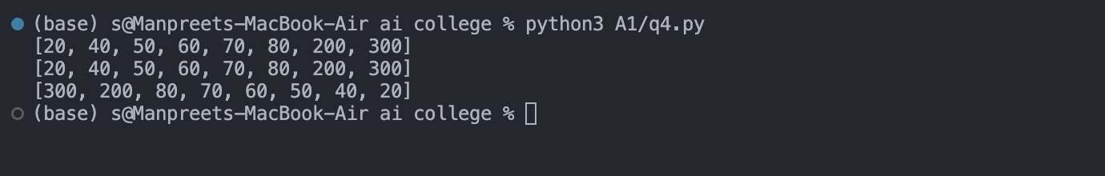

5) D is a dictionary defined as D= {1:”One”, 2:”Two”, 3:”Three”, 4: “Four”, 5:”Five”}.

(i) WAP to add new entry in D; key=6 and value is “Six”

(ii) WAP to remove key=2.

(iii) WAP to check if 6 key is present in D.

(iv) WAP to count the number of elements present in D.

(v) WAP to add all the values present D.

D = {1: "One", 2: "Two", 3: "Three", 4: "Four", 5: "Five"}

D[6] = "Six"

D.pop(2)

key_present = 6 in D

element_count = len(D)

values_combined = sum(D)

print(D)

print(key_present)

print(element_count)

print(values_combined)

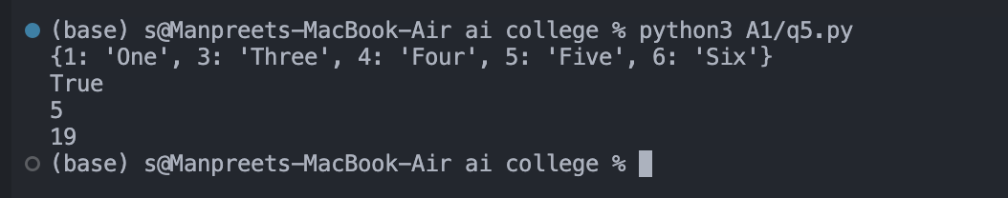

6) WAP to create a list of 100 random numbers between 100 and 900. Count and print the:

(i) All odd numbers

(ii) All even numbers

(iii) All prime numbers

import random

def is_prime(n):

if n <= 1:

return False

for i in range(2, int(n ** 0.5) + 1):

if n % i == 0:

return False

return True

numbers = [random.randint(100, 900) for _ in range(100)]

odd_numbers = [num for num in numbers if num % 2 != 0]

even_numbers = [num for num in numbers if num % 2 == 0]

prime_numbers = [num for num in numbers if is_prime(num)]

print("Odd numbers:", odd_numbers)

print("Even numbers:", even_numbers)

print("Prime numbers:", prime_numbers)

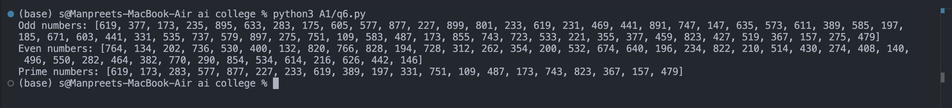

7) Write a function which takes principal amount, interest rate and time. This function returns

compound interest. Call this function to print the output.

(ii) Save this function (as a module) in a python file and call it in another python file.

from comp_int import calculate_compound_interest

principal = float(input("Enter the principal amount: "))

rate = float(input("Enter the interest rate: "))

time = float(input("Enter the time in years: "))

interest = calculate_compound_interest(principal, rate, time)

print(f"The compound interest is: {interest}")

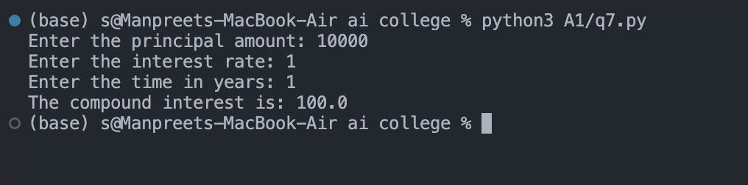

8) A) Make a class called Restaurant. The init () method for Restaurant should store two attributes: a restaurant_name and a cuisine_type. Make a method called describe_restaurant() that prints these two pieces of information, and a method called open_restaurant() that prints a message indicating that the restaurant is open. Make an instance called restaurant from your class. Print the two attributes individually, and then call both methods. B) Make a class called User. Create two attributes called first_name and last_name, and then create several other attributes that are typically stored in a user profile. Make a method called describe_user() that prints a summary of the user’s information. Make another method called greet_user() that prints a personalized greeting to the user. Create several instances representing different users, and call both method for each user.

class Restaurant:

def __init__(self, restaurant_name, cuisine_type):

self.restaurant_name = restaurant_name

self.cuisine_type = cuisine_type

def describe_restaurant(self):

print(f"Restaurant Name: {self.restaurant_name}")

print(f"Cuisine Type: {self.cuisine_type}")

def open_restaurant(self):

print(f"{self.restaurant_name} is now open!")

restaurant = Restaurant("abc", "italian")

print(restaurant.restaurant_name)

print(restaurant.cuisine_type)

restaurant.describe_restaurant()

restaurant.open_restaurant()

class User:

def __init__(self, first_name, last_name, age, location):

self.first_name = first_name

self.last_name = last_name

self.age = age

self.location = location

def describe_user(self):

print(f"User: {self.first_name} {self.last_name}")

print(f"Age: {self.age}")

print(f"Location: {self.location}")

def greet_user(self):

print(f"Hello, {self.first_name} {self.last_name}! Welcome!")

user1 = User("Manp", "Singh", 20, "jalandhar")

user2 = User("xyz", "abc", 31, "delhi")

user1.describe_user()

user1.greet_user()

user2.describe_user()

user2.greet_user()

