I am doing some comparison research, looking for someone to provide web scraping / data mining services from employment, work or job opportunity websites (that don’t require registration or create accounts to search) like the following:

1. Indeed.com
2. Monster.com
3. Dice.com
4. CareerBuilder.com
5. ZipRecruiter.com

For the purpose of this specific ***project, we can begin with ONE WEBSITE, use Indeed.com.

***depending on results, outputs, work relationship and price for deliverables, I would consider expanding to other websites with selected/hired Coder at a later time in the future

The Data I would like to be EXTRACTED / SCRAPED / MINED for each individual job posting is as follows:

Using this URL as of this posting:

<https://www.indeed.com/jobs?q=%22network%20engineer%22&sort=date&vjk=46d9a2371ede35e8>

It represents Job Title of “Network Engineer”, with results sorted by Date only!!!

No other input, filters, restrictions, etc. necessary. Looking to acquire ALL AVAILABLE DATA at once.

As of today, Tuesday, May 17, 2022 @ 840am – the above link for me shows following results (files attached, same results):

network engineer jobs

Sort by: relevance - date

Page 1 of 9,436 jobs

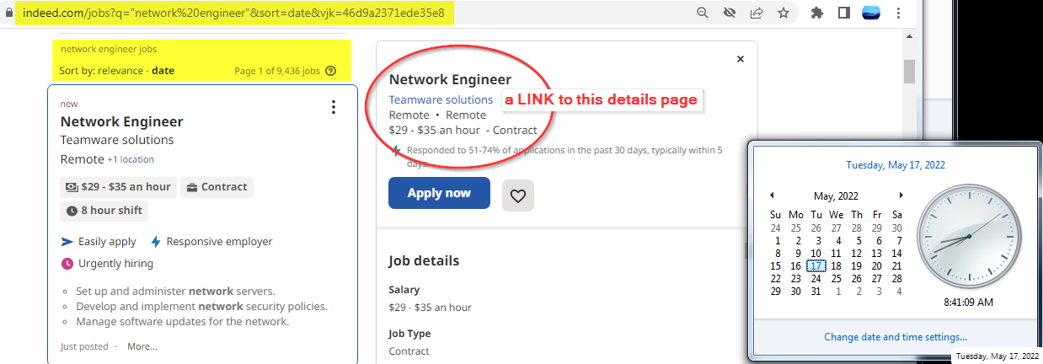

Further filtering, limitations, restrictions can be applied by me AFTER ATTAINING/RECEIVING the results output Excel file.

**See FILES ATTACHED FOR REFERENCE:**

2022.05.17_02_indeed.com_page_1_findings_copy_paste_for_example.txt = Page 1, Copy/Paste MANUALLY for Excel File

2022.05.17_03_indeed.com_jobs_EXAMPLE.xlsx = EXAMPLE output file for completed project (will need to be verified)

AND also including 4 JPG/Images – showing results for first page of my samples

I would like have the data extracted, placed into a simple EXCEL SPREADSHEET (ending with .xlsx extension, for Excel 2016)

The following are the COLUMNS of data, where EACH ROW of the data represents the single, unique job posting information.

The “fields” of Data, for all records, I would like to have extracted, using the ABOVE AS SAMPLE are:

1. Job_ID # = First Column, Auto inserted for DATE_Job_Number, formatted as 2022.05.17_00001 (last should be 2022.05.17_09436 this equals the amount of jobs, all extracted and included for confirmation/verification purposes
2. Job_Title = Network Engineer (or Network Engineer I, II, II, Sr. Network Engineer, Jr. Network Engineer, etc.)
3. Company = Teamware Solutions (or Microsoft, Zillow, Amazon, FaceBook, etc.)
4. Location = Remote (or Los Angeles, CA. or Houston, TX., or United States, etc.)
5. Salary = $29 - $35 an hour (or $50,000 - $100,000 a year, or $75,000 Annual, etc.) – Or NONE-Not Avail if empty
6. Job_Type = Contract (or Part Time, Full Time, Project, etc.)
7. Posted = Just Posted (or 1 day ago, 2 days ago, 5 days ago, 1 week ago, 3 weeks ago, 30 days or more, etc.)
8. Job_Details_Link = Lastly, a clickable URL/Link to the same job – but specifically to it’s “Job Details Page”

The “included/attached” spreadsheet is the final output results I seek, ultimately by chosen coder for ALL RECORDS available.

The provided data to me, by the chosen/selected Coder, will need to be verified/confirmed, for record information accuracy and link details double checked.

This is part of the final/approval/last steps of the project.

I will require, me to RANDOMLY confirm and verify a “minimum” of 20 records before accepting the job is complete, accurate and done. And this will be required for approval and before payment will be released, then the project will be closed.