**Technical Solution**

**Classes**

Layer Class

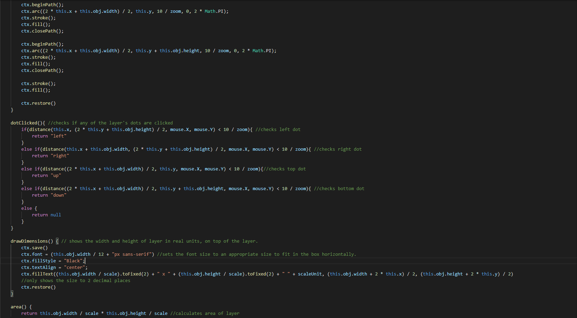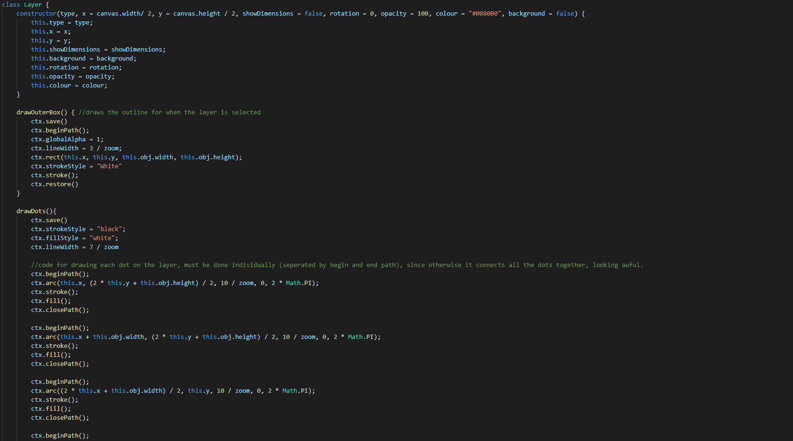

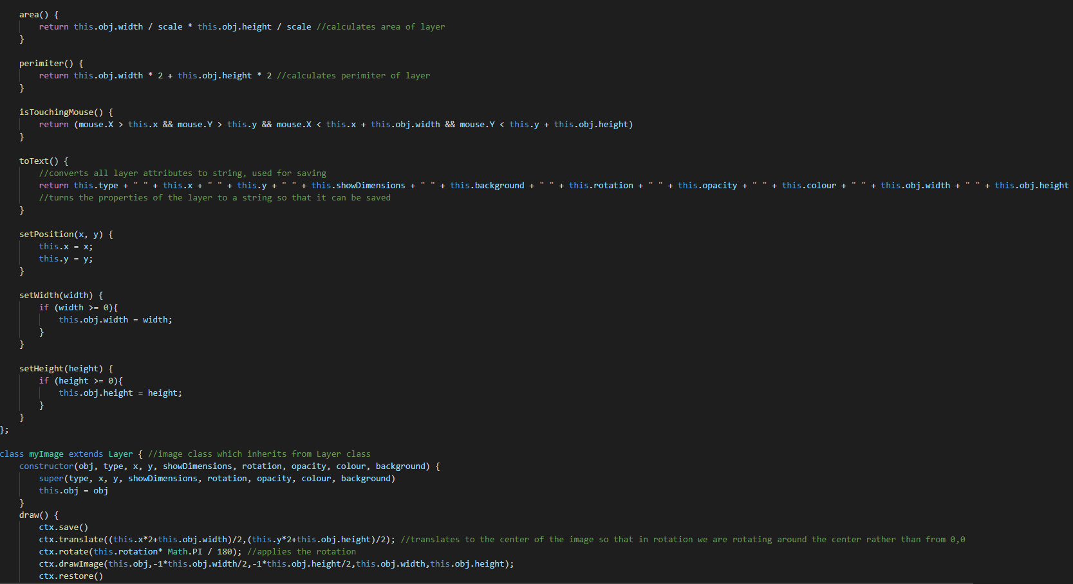

The layer class is inherited by the other classes, it forms the base for a layer, with tools like area() and toText(), this means that if a developer wants to add their own type of layer, they cannot forget an essential feature in their class, which could break the program, for instance a developer cannot forget to include a showDimensions() in their own layer as it is built into the parent class.

myImage Class

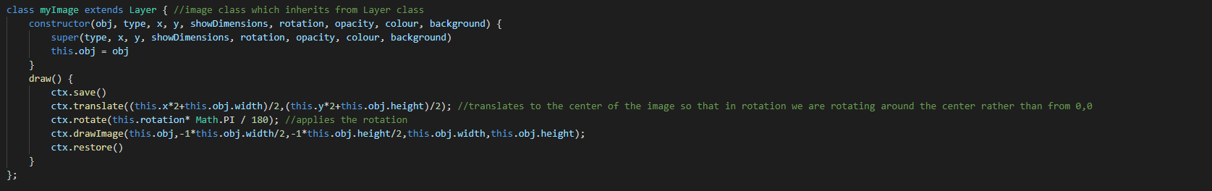

The myImage class provides the capability for using images as a layer, I could not name the class Image as there is already a JS class with this name which I am using. It controls what it has to draw and includes rotation.

Rectangle Class

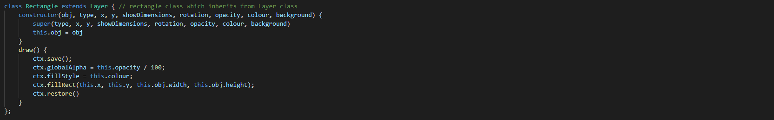

The rectangle class unsurprisingly handles the drawing of rectangles, which needs to have an option for opacity and colour.