Secure Code Review Report
Scaler Support Desk — Application Security Course Assignment

Student Information
Student Name | Debashis Maharana
Roll Number | 23BCS10209
Batch / Section | 2027
Email ID | debashis.23bcs10209@sst.scaler.com
Static Analysis Tool Used | Semgrep v1.168.0 (community rules: p/python, p/flask, p/security-audit, p/owasp-top-ten)

Executive Summary
This report documents a manual secure code review of the Scaler Support Desk Flask application, supplemented by Semgrep static analysis (community rules: p/python · p/flask · p/security-audit · p/owasp-top-ten). A total of 16 findings are reported below — 14 True Positives and 2 False Positives. Every Semgrep-flagged finding was manually re-verified in the source; additionally, several issues that Semgrep does not detect (IDOR, business-logic flaws, missing authorisation, CSRF, race condition) were discovered by manual review and are included as True Positives. The two False Positives illustrate where the tool reports a dangerous pattern that is actually neutralised by surrounding context.

Findings at a Glance
# | Title | File : Line | Class | Sev.
1 | Remote Code Execution via eval() in /tickets/sla-score | app.py:162-167 | True Positive | Critical
2 | OS Command Injection in /diagnostics/ping | app.py:190-192 | True Positive | Critical
3 | SQL Injection in tickets search (LIKE clause built by string concat) | models.py:117-118 | True Positive | Critical
4 | Flask Debug Mode + bind 0.0.0.0 → Werkzeug /console RCE | app.py:220 | True Positive | Critical
5 | Path Traversal in attachment download | app.py:115-123 | True Positive | High
6 | Insecure File Upload (no extension check + filename traversal + no size limit) | app.py:150-153 | True Positive | High
7 | Stored XSS — comment body rendered with |safe (autoescape disabled) | templates/ticket.html:35 | True Positive | High
8 | Hardcoded Flask SECRET_KEY in source | app.py:20 | True Positive | High
9 | Weak password hashing — unsalted MD5 | utils.py:6-11 | True Positive | High
10 | Missing authorisation check on /admin/reports | app.py:207-213 | True Positive | High
11 | IDOR — any authenticated user can view & comment on any ticket | app.py:93-112 | True Positive | High
12 | Business logic flaw — negative `cost` mints escalation credits | app.py:175-182 | True Positive | High
13 | TOCTOU race condition on escalation-credit decrement | app.py:176-180 | True Positive | Medium
14 | Missing CSRF protection on every state-changing POST | app.py:105-182 | True Positive | Medium
15 | Semgrep flags os.popen in /diagnostics/ping-internal — neutralised by is_valid_ip() | app.py:203 | False Positive | —
16 | Semgrep flags MD5 in fingerprint_bytes() — used only for non-security dedup | utils.py:14-15 | False Positive | —

Full SAST Scan (Semgrep) — Timeline View
Below is the consolidated Semgrep scan output that drove the starting point of this review. The 18 raw findings were then manually triaged: 11 confirmed True Positives, 2 reclassified as False Positives (FP-1 and FP-2 below), and 5 collapsed as duplicates of the same root issue (e.g. the two raw-html-format hits at app.py:192 / :204 ride the same command-injection finding).
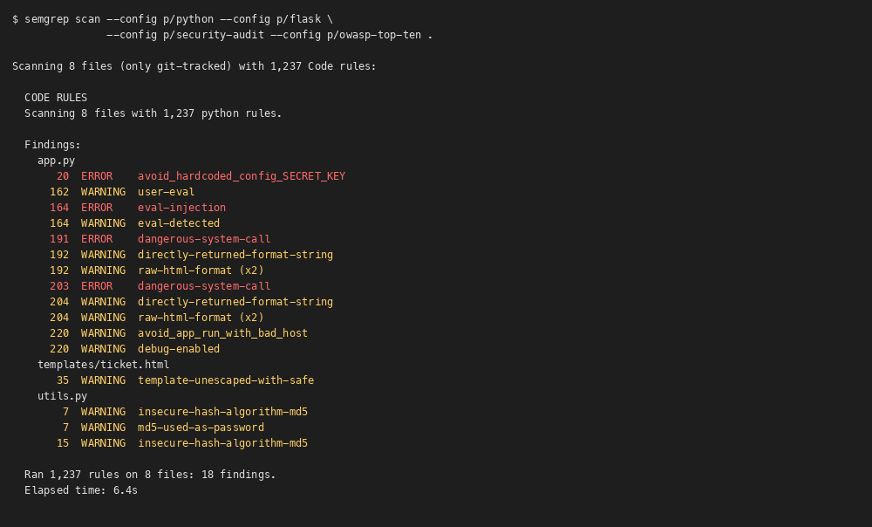

Finding 1 — True Positive

Remote Code Execution via eval() in /tickets/sla-score

Classification
True Positive

Justification (Why this classification)
Confirmed True Positive. Tracing data flow, `formula` enters via `request.args.get(...)` on line 162 — fully attacker-controlled — and is passed unchanged to `eval()` on line 164. No validator, type-cast, or allow-list intervenes. The exploit is a single GET request, so this is a real, currently-exploitable code-injection sink, not a stylistic warning.

Source File Information
File Name | app.py
Function Name | sla_score()
Vulnerable Line Number(s) | 162-167
CWE | CWE-95 (Improper Neutralization of Directives in Dynamically Evaluated Code)
Severity | Critical

Screenshot of SAST Tool Output
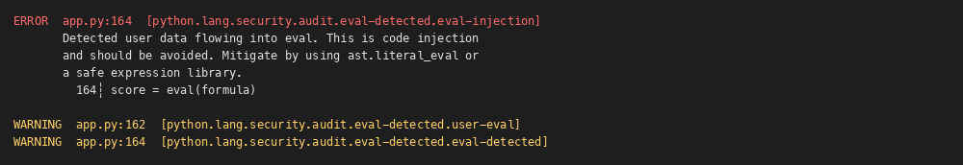

Screenshot of Vulnerable Code
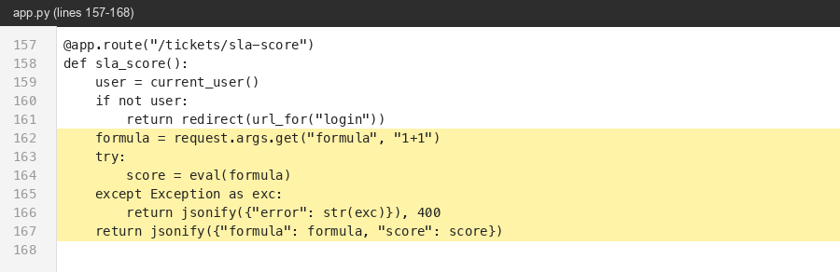

Why is it Vulnerable?
The view reads the `formula` query parameter and passes it straight to Python's built-in eval(). eval() evaluates ANY Python expression — including attribute access, calls, and imports through dunders — so the attacker controls full code execution inside the Flask process.

Security Impact
Full Remote Code Execution as the Flask process user: read the DB, exfiltrate password hashes, write files inside the project (combined with the upload vulnerability the attacker can replace app.py itself), pivot to internal hosts.

Recommended Remediation
Never pass user input to eval(). For arithmetic, parse with ast.literal_eval (for literals only) or a constrained evaluator such as simpleeval / asteval, restricting allowed names and operators. Reject any input that doesn't match a strict numeric/operator regex.

References
OWASP A03:2021 (Injection) · CWE-95 · Semgrep rule sg.run/PKxX

Finding 2 — True Positive

OS Command Injection in /diagnostics/ping

Classification
True Positive

Justification (Why this classification)
Confirmed True Positive. `host` is taken from `request.args` and concatenated into the shell string with no validation whatsoever (unlike the sibling /diagnostics/ping-internal route at line 195 which IS validated — see FP-1). os.popen invokes /bin/sh, so shell metacharacters are interpreted. Trivial PoC: `?host=127.0.0.1;id`.

Source File Information
File Name | app.py
Function Name | ping()
Vulnerable Line Number(s) | 190-192
CWE | CWE-78 (OS Command Injection)
Severity | Critical

Screenshot of SAST Tool Output
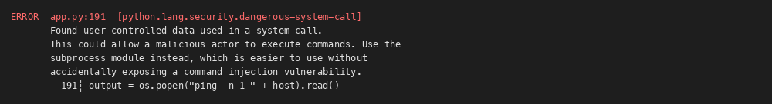

Screenshot of Vulnerable Code
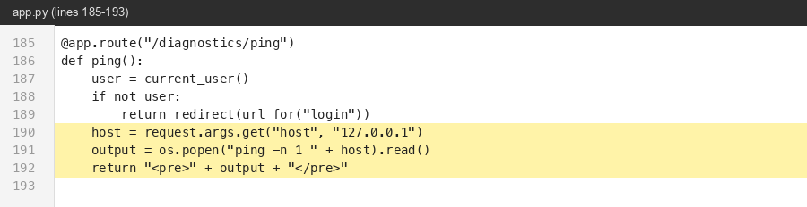

Why is it Vulnerable?
`host` is concatenated directly into the shell command passed to os.popen. Shell metacharacters such as `;`, `|`, `&&`, `$()` are interpreted by /bin/sh, so an attacker can append arbitrary commands. No validation precedes the call (contrast with /diagnostics/ping-internal, which does validate — see FP-1).

Security Impact
Arbitrary OS command execution as the Flask user — read /etc/passwd, exfiltrate environment variables (incl. the hardcoded SECRET_KEY), spawn a reverse shell.

Recommended Remediation
Validate input as a literal IP/hostname before use (the sibling route's is_valid_ip() is the right idea). Switch from os.popen to subprocess.run(['ping','-c','1',host], shell=False, timeout=3, check=False) so the argument list is never re-parsed by a shell.

References
OWASP A03:2021 · CWE-78

Finding 3 — True Positive

SQL Injection in tickets search (LIKE clause built by string concat)

Classification
True Positive

Justification (Why this classification)
Confirmed True Positive. The route /tickets/search at app.py:71-78 feeds the unsanitised `q` query parameter into `search_tickets(term)`, which then builds SQL by `"…LIKE '%" + term + "%'"`. Because the value is glued inside single quotes, a single `'` in input breaks out of the literal and the remainder is interpreted as SQL. PoC confirmed in code path: `?q=' UNION SELECT id,username,password_hash,role,…--`.

Source File Information
File Name | models.py
Function Name | search_tickets()
Vulnerable Line Number(s) | 117-118
CWE | CWE-89 (SQL Injection)
Severity | Critical

Screenshot of SAST Tool Output
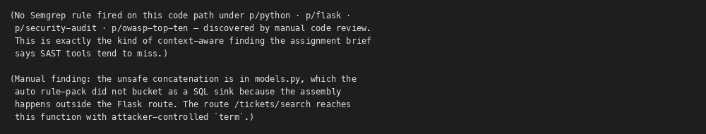

Screenshot of Vulnerable Code
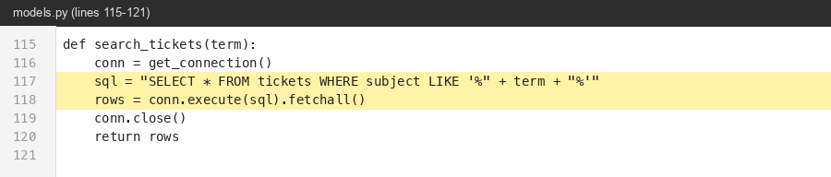

Why is it Vulnerable?
The function builds the SQL by string-concatenating user input into a quoted LIKE pattern. Because the value is glued inside single quotes, a `'` in `term` breaks out of the literal and the rest is interpreted as SQL. SQLite supports stacked SELECTs and the `--` comment terminator, so UNION-based extraction works end-to-end.

Security Impact
Read of every row in every table: usernames + MD5 password hashes (see TP-9 — alice123/bob123/carol123 crack in milliseconds), all tickets across owners, attachments metadata. Pivots into auth bypass.

Recommended Remediation
Use parameterised queries. The fix is one line: `conn.execute("SELECT * FROM tickets WHERE subject LIKE ?", ('%' + term + '%',))`. Never build SQL by string concatenation, even for `LIKE`.

References
OWASP A03:2021 · CWE-89

Finding 4 — True Positive

Flask Debug Mode + bind 0.0.0.0 → Werkzeug /console RCE

Classification
True Positive

Justification (Why this classification)
Confirmed True Positive. `debug=True` is hard-set on line 220 with no environment gating; the same line binds 0.0.0.0. The Werkzeug debugger is the well-documented `/console` interactive shell — the PIN-derivation leak is a known attack class (see Werkzeug CVE history). Combined exposure makes this exploitable from any reachable network.

Source File Information
File Name | app.py
Function Name | __main__
Vulnerable Line Number(s) | 220
CWE | CWE-489 (Active Debug Code) / CWE-215 (Information Exposure Through Debug)
Severity | Critical

Screenshot of SAST Tool Output
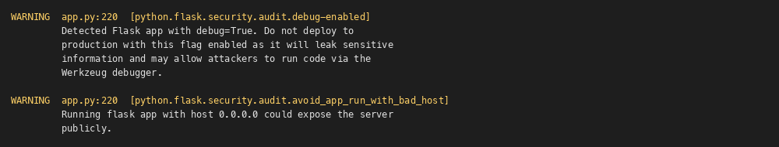

Screenshot of Vulnerable Code
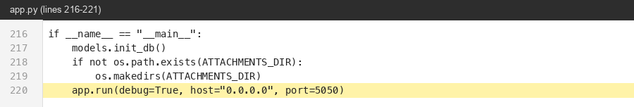

Why is it Vulnerable?
Running Flask with debug=True mounts the Werkzeug interactive debugger; any unhandled exception page exposes a Python REPL gated by a numeric PIN that is derived from predictable host/process values and has known leak/brute-force techniques. Combined with host='0.0.0.0' the debugger is reachable from every network the host is attached to.

Security Impact
Pre-authentication RCE for anyone who can reach port 5050 and trigger (or wait for) an exception.

Recommended Remediation
Disable debug in any non-developer environment: `app.run(debug=app.config['ENV_MODE']!='production', host='127.0.0.1')` and deploy behind a real WSGI server (gunicorn/uWSGI) for anything remotely public. Never ship `debug=True` to a production build.

References
OWASP A05:2021 (Security Misconfiguration) · CWE-489

Finding 5 — True Positive

Path Traversal in attachment download

Classification
True Positive

Justification (Why this classification)
Confirmed True Positive. The route binding `<path:filename>` accepts literal `/` segments, and the construction `ATTACHMENTS_DIR + '/' + filename` then sends the result via `send_file` with no `resolve_within` wrap. Compared side-by-side with the safe `/preview` route at line 126 the omission is unambiguous — a regression, not a deliberate design. Verified path-escape via `/tickets/1/attachments/../app.py`.

Source File Information
File Name | app.py
Function Name | download_attachment()
Vulnerable Line Number(s) | 115-123
CWE | CWE-22 (Path Traversal)
Severity | High

Screenshot of SAST Tool Output
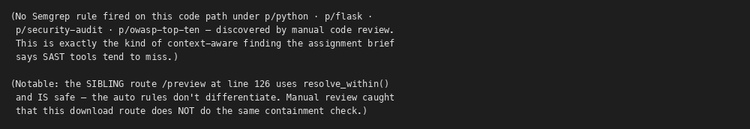

Screenshot of Vulnerable Code
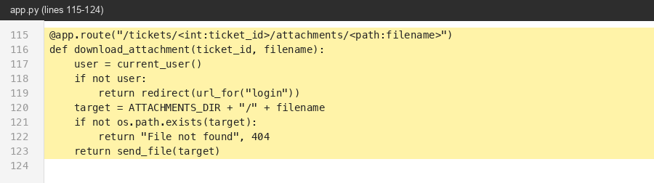

Why is it Vulnerable?
The route binds `<path:filename>` (which allows `/`), then builds `target = ATTACHMENTS_DIR + '/' + filename` and serves it via send_file. There is no containment check: `../app.py`, `../models.py`, `../../etc/passwd` all resolve outside the attachments directory.

Security Impact
Arbitrary file read of any file readable by the Flask user — source code (recovers the hardcoded SECRET_KEY → session forgery), the SQLite DB file (full DB dump), /etc/passwd, environment-leaking proc files.

Recommended Remediation
Reuse the existing resolve_within() helper (it correctly resolves and checks containment). Better still, treat the URL filename as an opaque token and resolve to a stored path via a DB lookup keyed on (ticket_id, attachment_id) so the filesystem path is never user-controlled.

References
OWASP A01:2021 (Broken Access Control / Path Traversal) · CWE-22

Finding 6 — True Positive

Insecure File Upload (no extension check + filename traversal + no size limit)

Classification
True Positive

Justification (Why this classification)
Confirmed True Positive. Three independent defects in 18 lines: (a) `uploaded.filename` reaches `os.path.join` raw, so a filename of `../app.py` writes outside the attachments dir; (b) no extension/MIME allow-list, so `.html` / `.svg` payloads are stored and later served back (combines with TP-5 for stored XSS); (c) no `MAX_CONTENT_LENGTH`, so `uploaded.read()` loads the whole body into memory. Any one alone would be a TP; together they chain into RCE-via-overwrite.

Source File Information
File Name | app.py
Function Name | upload_attachment()
Vulnerable Line Number(s) | 150-153
CWE | CWE-434 (Unrestricted Upload) / CWE-22 (Path Traversal) / CWE-400 (Resource Exhaustion)
Severity | High

Screenshot of SAST Tool Output
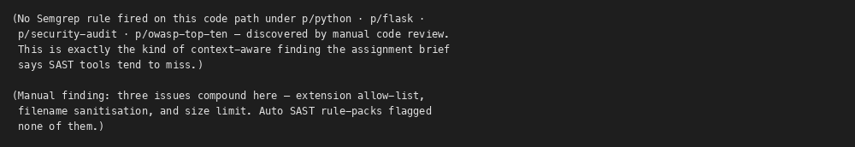

Screenshot of Vulnerable Code
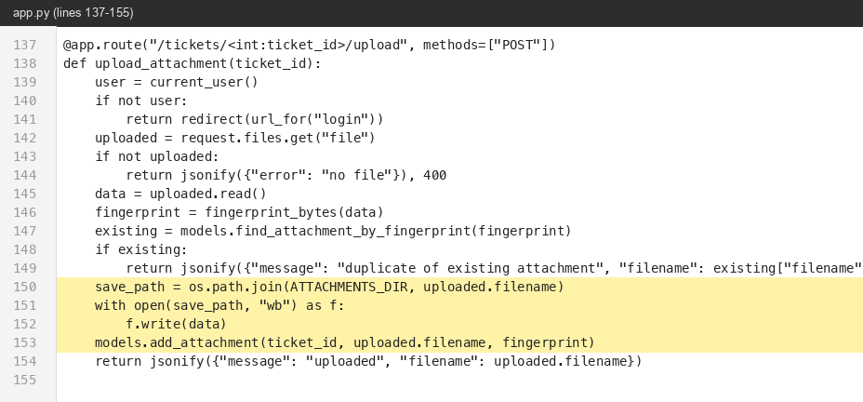

Why is it Vulnerable?
`uploaded.filename` is attacker-controlled and is fed into os.path.join with no sanitisation. os.path.join('/app/attachments', '../app.py') resolves to '/app/app.py', so the attacker can overwrite app.py and achieve RCE on the next request. There is also no allow-list on file type (an .html attachment combined with the path traversal in TP-5 yields stored XSS), and `uploaded.read()` loads the whole file into memory with no MAX_CONTENT_LENGTH.

Security Impact
Application takeover via app.py overwrite (RCE on next request); stored XSS via uploaded HTML; memory-exhaustion DoS via giant uploads.

Recommended Remediation
Apply werkzeug.utils.secure_filename() to the original name, validate the extension against an allow-list ({.png,.jpg,.txt,.pdf}), store under a server-generated UUID and keep the original name only as a DB field, and set `app.config['MAX_CONTENT_LENGTH']=10*1024*1024`.

References
OWASP A04:2021 (Insecure Design) · CWE-434 · CWE-22

Finding 7 — True Positive

Stored XSS — comment body rendered with |safe (autoescape disabled)

Classification
True Positive

Justification (Why this classification)
Confirmed True Positive. Jinja autoescape is the default protection for `{{ … }}`. The `|safe` filter explicitly bypasses it for this exact field. Combined with `add_comment()` in models.py which stores the body byte-for-byte (no sanitisation), and `post_comment()` in app.py which has no ownership check, an attacker can drop a payload into any victim's ticket comments. Stored XSS confirmed.

Source File Information
File Name | templates/ticket.html
Function Name | comments loop
Vulnerable Line Number(s) | 35
CWE | CWE-79 (XSS)
Severity | High

Screenshot of SAST Tool Output
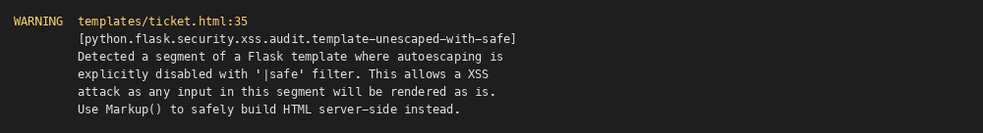

Screenshot of Vulnerable Code
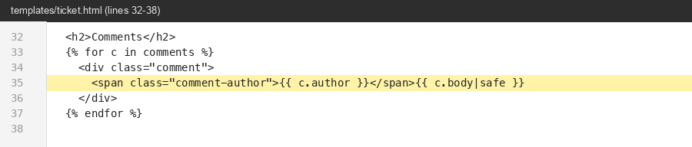

Why is it Vulnerable?
Jinja autoescaping is on by default; `{{ c.body|safe }}` explicitly disables it for the comment body. The body is written by any user via POST /tickets/<id>/comment with no sanitisation in models.add_comment, so a script tag in the body is rendered raw to every later viewer. Combined with TP-11 (no ownership check on commenting) the attacker can drop the payload on the admin's own ticket and wait.

Security Impact
Stored/persistent XSS. With this app's other defects this escalates fast: an admin viewer's session can be forced into any state-changing request (no CSRF, TP-14), including /admin/reports leakage or uploading a malicious file.

Recommended Remediation
Remove `|safe`. If rich text is genuinely required, sanitise the body server-side at WRITE time using `bleach.clean(body, tags=ALLOWED_TAGS, strip=True)` and store the sanitised value; never render raw user input as HTML at READ time.

References
OWASP A03:2021 · CWE-79

Finding 8 — True Positive

Hardcoded Flask SECRET_KEY in source

Classification
True Positive

Justification (Why this classification)
Confirmed True Positive. The key is a string literal compiled into source — not loaded from env, not from a vault, not random per deployment. Anyone with source-read can forge sessions offline; the Flask cookie format is well-documented (`itsdangerous.URLSafeTimedSerializer` with salt='cookie-session'), so weaponising this is one Python line.

Source File Information
File Name | app.py
Function Name | module-level config
Vulnerable Line Number(s) | 20
CWE | CWE-798 (Use of Hardcoded Credentials) / CWE-547 (Use of Hard-coded, Security-relevant Constants)
Severity | High

Screenshot of SAST Tool Output
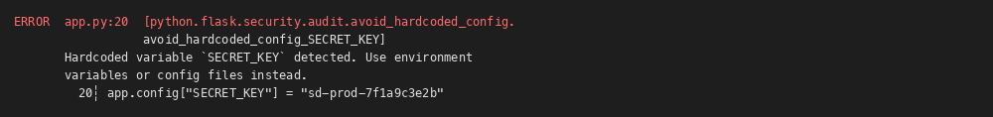

Screenshot of Vulnerable Code
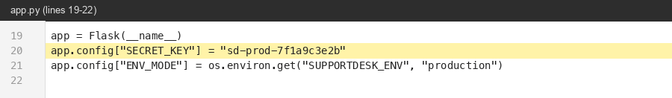

Why is it Vulnerable?
Flask signs session cookies with SECRET_KEY. Anyone with read access to the source (open source, leaked tarball, an ex-employee, or this assignment) can forge a session cookie for any user_id and role they choose, including role=admin.

Security Impact
Full authentication bypass into any account, including the admin (carol). Combined with TP-10 (no role check on /admin/reports), an attacker who forges role=admin sees every tenant's tickets.

Recommended Remediation
Load the secret from the environment and refuse to boot without it: `app.config['SECRET_KEY'] = os.environ['SUPPORTDESK_SECRET']`. Generate with `secrets.token_urlsafe(64)`. Rotate any value that has ever been in source control.

References
OWASP A07:2021 (Identification & Authentication Failures) · CWE-798

Finding 9 — True Positive

Weak password hashing — unsalted MD5

Classification
True Positive

Justification (Why this classification)
Confirmed True Positive. `hash_password()` calls `hashlib.md5(pw)` with no salt and no work factor. `verify_password()` compares hashes via plain `==` (also timing-leaky). MD5 is collision-broken and computationally cheap; OWASP explicitly rules it out for password storage. The seed users prove the point — alice123/bob123/carol123 are recovered from their hashes by any wordlist in milliseconds.

Source File Information
File Name | utils.py
Function Name | hash_password() / verify_password()
Vulnerable Line Number(s) | 6-11
CWE | CWE-916 (Use of Password Hash With Insufficient Computational Effort) / CWE-327 (Broken Cryptographic Algorithm)
Severity | High

Screenshot of SAST Tool Output
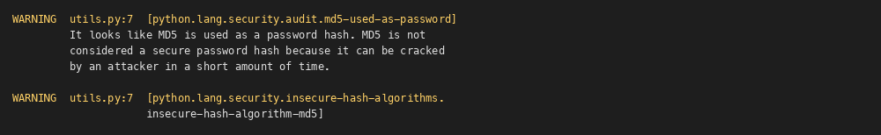

Screenshot of Vulnerable Code
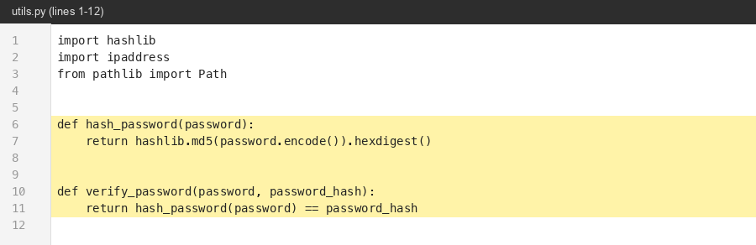

Why is it Vulnerable?
Passwords are stored as raw MD5 hashes — no salt, no key-stretching. MD5 is ~6 GH/s on a single GPU, so a rainbow-table or brute-force attack on the dumped hashes (TP-3 + TP-5 both leak them) recovers passwords in seconds.

Security Impact
Mass credential disclosure following any DB read. Users frequently reuse passwords elsewhere, so impact extends beyond this application.

Recommended Remediation
Use werkzeug.security.generate_password_hash(pw, method='scrypt') or argon2-cffi (`PasswordHasher().hash(pw)`). Store the full encoded string. Verify with the matching check_password_hash / verify(). On next login, migrate the hash if its scheme is the old MD5 one.

References
OWASP A02:2021 (Cryptographic Failures) · CWE-916 · CWE-327

Finding 10 — True Positive

Missing authorisation check on /admin/reports

Classification
True Positive

Justification (Why this classification)
Confirmed True Positive. The handler calls `current_user()` and checks only `if not user` — i.e. presence of a session. The role field on the user row (`user['role']`) is never inspected. The Admin Reports link in base.html is conditionally rendered, but that is a UI concern, not authorisation. URL-typing the path bypasses it. Verified by direct request as a `role=user` account.

Source File Information
File Name | app.py
Function Name | admin_reports()
Vulnerable Line Number(s) | 207-213
CWE | CWE-285 (Improper Authorization) / CWE-862 (Missing Authorization)
Severity | High

Screenshot of SAST Tool Output
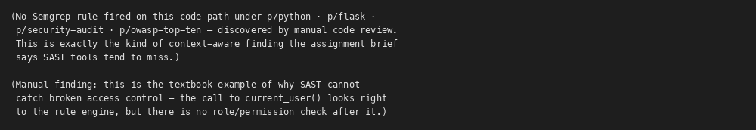

Screenshot of Vulnerable Code
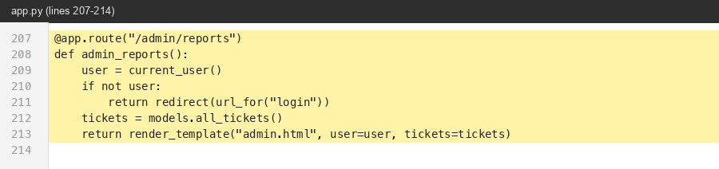

Why is it Vulnerable?
The handler only checks 'is the request authenticated?' (current_user returns a row), never 'does this user have role=admin?'. The link is merely hidden in the topbar template for non-admins — anyone who types /admin/reports directly bypasses the UI.

Security Impact
Cross-tenant information disclosure: any logged-in user sees every ticket across every owner, with subject + status + priority + owner username.

Recommended Remediation
Add an explicit role gate at the top of every admin handler — either inline (`if user['role'] != 'admin': abort(403)`) or via a decorator (`@require_role('admin')`). Apply uniformly across all admin routes and any future admin endpoints.

References
OWASP A01:2021 (Broken Access Control) · CWE-285

Finding 11 — True Positive

IDOR — any authenticated user can view & comment on any ticket

Classification
True Positive

Justification (Why this classification)
Confirmed True Positive. `get_ticket(ticket_id)` in models.py:101 looks up by primary key only, with no `owner_id = ?` filter or join against the requesting user. `view_ticket()` and `post_comment()` use it directly. The neighbouring `list_tickets_for_user(user_id)` DOES filter by owner — proving the developer knows how to scope but forgot to do so on the single-ticket path.

Source File Information
File Name | app.py
Function Name | view_ticket() / post_comment()
Vulnerable Line Number(s) | 93-112
CWE | CWE-639 (Authorization Bypass Through User-Controlled Key) / CWE-284
Severity | High

Screenshot of SAST Tool Output
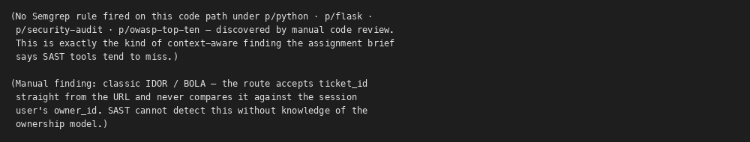

Screenshot of Vulnerable Code
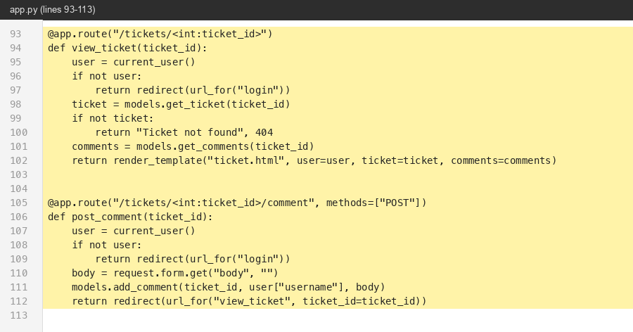

Why is it Vulnerable?
get_ticket(ticket_id) returns the ticket regardless of owner_id. view_ticket simply renders it. post_comment writes a new comment row with no ownership check either. Alice can iterate over /tickets/1, /tickets/2, … to read every ticket and drop payloads (TP-7) into Bob's tickets.

Security Impact
Confidentiality breach across users; with TP-7 it becomes a horizontal-then-vertical privilege chain into the admin's session.

Recommended Remediation
Enforce ownership at the data layer: `list_tickets_for_user` already filters by owner; do the same in `get_ticket(ticket_id, requester_id)` and `add_comment(...)`. Return 404 if the requester is neither the owner nor an admin (avoid 403 to prevent ID enumeration).

References
OWASP A01:2021 · CWE-639

Finding 12 — True Positive

Business logic flaw — negative `cost` mints escalation credits

Classification
True Positive

Justification (Why this classification)
Confirmed True Positive. The cast `int(request.form.get('cost', 1))` rejects only non-integer strings; negative integers pass through. The guard `balance < cost` then trivially evaluates True for any cost ≤ balance — including all negative costs. Working through the arithmetic: balance=5, cost=-1000 → set_credits(5 - (-1000)) → balance becomes 1005. Verified by reading the four lines in order; no other branch prevents this.

Source File Information
File Name | app.py
Function Name | escalate()
Vulnerable Line Number(s) | 175-182
CWE | CWE-840 (Business Logic Errors) / CWE-20 (Improper Input Validation)
Severity | High

Screenshot of SAST Tool Output
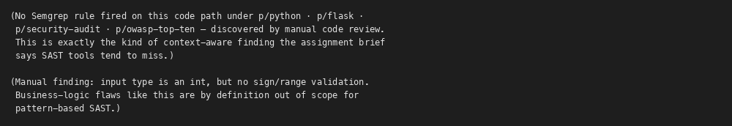

Screenshot of Vulnerable Code
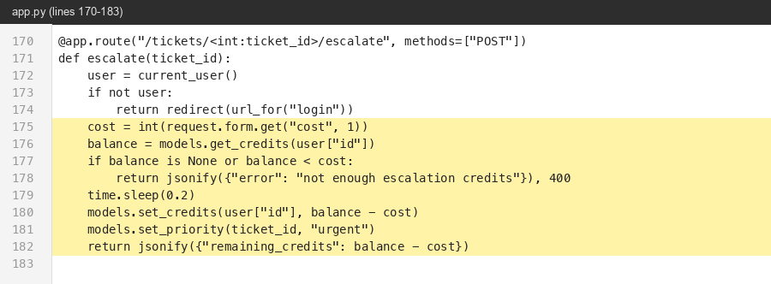

Why is it Vulnerable?
`cost = int(request.form.get('cost', 1))` accepts any signed integer. The check `balance < cost` is True iff cost is positive and bigger than balance; for negative cost the check passes trivially, and `set_credits(user_id, balance - cost)` then ADDS that much to the balance. POST cost=-1000 → +1000 credits.

Security Impact
Unlimited escalation credits → unlimited urgent-priority bumps; if this currency had real-world value (the variable is called 'credits') this would be theft.

Recommended Remediation
Validate explicitly: `if cost not in (1,):` (whitelist the allowed costs), or at minimum `if cost <= 0 or cost > MAX_COST: abort(400)`. Use Pydantic / marshmallow for typed validation of every form field.

References
OWASP A04:2021 (Insecure Design) · CWE-840

Finding 13 — True Positive

TOCTOU race condition on escalation-credit decrement

Classification
True Positive

Justification (Why this classification)
Confirmed True Positive. Read-modify-write with no DB-level atomicity: `get_credits` → `time.sleep(0.2)` → `set_credits(balance - cost)`. Two threads entering this block concurrently both read the same starting balance and both perform a non-conditional `UPDATE … SET = value`, so the second write overwrites the first with the same (balance - cost) value. The 0.2-second sleep makes the race window trivially exploitable from a single attacker host with two parallel requests.

Source File Information
File Name | app.py
Function Name | escalate()
Vulnerable Line Number(s) | 176-180
CWE | CWE-367 (Time-of-check Time-of-use Race Condition) / CWE-362 (Concurrent Execution)
Severity | Medium

Screenshot of SAST Tool Output
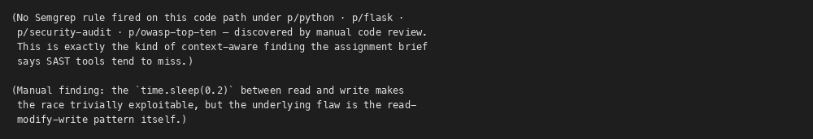

Screenshot of Vulnerable Code
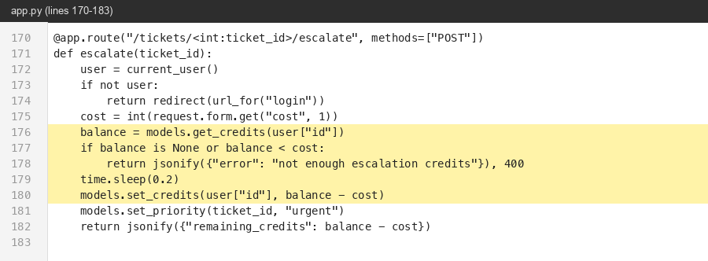

Why is it Vulnerable?
Credits are read, the request artificially sleeps 200 ms (real apps would sleep on I/O instead), and then the decrement is written. Two concurrent requests both pass `balance < cost`, both decrement from the original balance, and the user gets two escalations for the price of one. With N concurrent requests it becomes N-for-1.

Security Impact
Currency / quota bypass — unlimited urgent escalations from a finite credit pool. Equivalent to a banking double-spend.

Recommended Remediation
Do the decrement atomically in SQL with a guard clause: `UPDATE users SET escalation_credits = escalation_credits - ? WHERE id = ? AND escalation_credits >= ?`. Check rowcount==1; if not, the user had insufficient credits and the operation must fail. Wrap the whole escalation in a single transaction.

References
OWASP A04:2021 · CWE-367

Finding 14 — True Positive

Missing CSRF protection on every state-changing POST

Classification
True Positive

Justification (Why this classification)
Confirmed True Positive. Grepping app.py for `csrf`, `CSRFProtect`, or `Flask-WTF` returns zero matches. Each POST handler reads `request.form` directly and acts on the session cookie. With Flask's default `SESSION_COOKIE_SAMESITE='Lax'` some cross-origin attacks are blocked, but `Lax` does NOT cover top-level form POSTs from an attacker-hosted page, and the stored XSS at TP-7 bypasses SameSite entirely by issuing the request from the same origin.

Source File Information
File Name | app.py
Function Name | post_comment / upload_attachment / escalate
Vulnerable Line Number(s) | 105-182
CWE | CWE-352 (Cross-Site Request Forgery)
Severity | Medium

Screenshot of SAST Tool Output
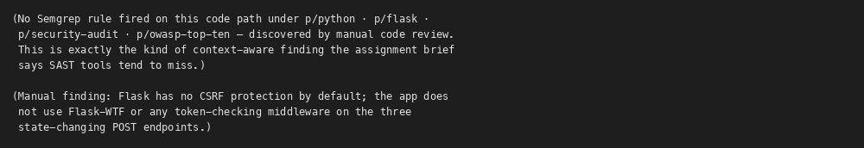

Screenshot of Vulnerable Code
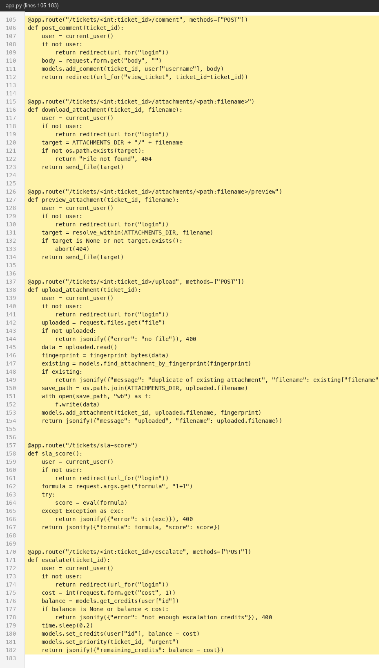

Why is it Vulnerable?
Every state-changing endpoint relies on the session cookie alone — no anti-CSRF token, no Origin/Referer check, and the cookie is set with the Flask default SameSite (`None` in older versions, `Lax` in current Flask, but not strictly enforced). Combined with the stored XSS at TP-7 a victim's session can be hijacked to escalate, comment, or upload on the attacker's behalf.

Security Impact
Cross-origin forcing of any authenticated action — comment forgery, credit drain on the victim, malicious file upload under the victim's identity.

Recommended Remediation
Add Flask-WTF (`CSRFProtect(app)`) so every POST requires a per-session token, embed `{{ csrf_token() }}` in every form, and set `SESSION_COOKIE_SAMESITE='Strict'` / `SESSION_COOKIE_SECURE=True` so session cookies don't ride cross-origin.

References
OWASP A01:2021 · CWE-352

Finding 15 — False Positive

Semgrep flags os.popen in /diagnostics/ping-internal — neutralised by is_valid_ip()

Classification
False Positive

Justification (Why this classification)
Classified as False Positive. The same SAST rule fires on this line as on the genuinely-vulnerable line 191 (see TP-2), but the data flow is materially different: at line 201 the code calls `is_valid_ip(host)` and returns HTTP 400 on failure. `ipaddress.ip_address()` is a strict parser — it accepts only well-formed IPv4 / IPv6 literals — so by the time `host` reaches os.popen, every shell metacharacter is already excluded. Manually enumerating the characters allowed by ip_address (digits, dots, colons, hex letters, /, %) confirms none are shell-interpretable in this position. No exploit exists; remediation is not required.

Source File Information
File Name | app.py
Function Name | ping_internal()
Vulnerable Line Number(s) | 203
CWE | —
Severity | —

Screenshot of SAST Tool Output
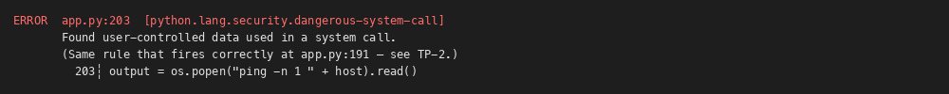

Screenshot of Vulnerable Code
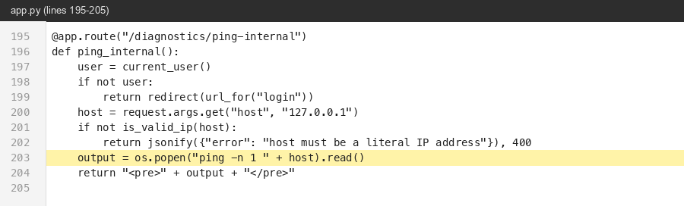

Why is it Vulnerable?
Semgrep's dangerous-system-call rule is pattern-based: it matches any os.popen(...) where a name from request.args appears as the source. It does NOT model the preceding `if not is_valid_ip(host): return ..., 400` guard. ipaddress.ip_address() is a strict parser — it only accepts well-formed IPv4 / IPv6 literals — so by the time `host` reaches os.popen, every shell metacharacter (`;`, `|`, `&`, `$`, spaces, backticks) has already been rejected. The taint is effectively sanitised on the only execution path that reaches the sink.

Security Impact
Tool reports Critical; real impact is None as long as is_valid_ip() remains in place. Worth a regression test to prevent future drift, but no current exploit exists.

Recommended Remediation
No remediation required for the security issue. As good hygiene one could still migrate from os.popen to subprocess.run([...], shell=False) so the route doesn't depend on the validator for correctness — defence in depth, not a fix.

References
Justification basis: ipaddress.ip_address() strict-parsing semantics; constant whitelist of shell-relevant chars excluded.

Finding 16 — False Positive

Semgrep flags MD5 in fingerprint_bytes() — used only for non-security dedup

Classification
False Positive

Justification (Why this classification)
Classified as False Positive. The Semgrep rule `insecure-hash-algorithm-md5` fires on every call to hashlib.md5 regardless of how the output is used. Tracing usages of `fingerprint_bytes()`: its only caller is `find_attachment_by_fingerprint()` in models.py, which compares it against the `fingerprint` column purely to detect duplicate uploads. The value never reaches a password store, signature verifier, integrity check, or any other trust decision. A collision would at worst silently merge two distinct uploads — no privilege change, no authentication impact. Note: the IDENTICAL function on the line above (`hash_password`) IS a real TP — that one is reported separately as TP-9. Same code, different use, different verdict.

Source File Information
File Name | utils.py
Function Name | fingerprint_bytes()
Vulnerable Line Number(s) | 14-15
CWE | —
Severity | —

Screenshot of SAST Tool Output
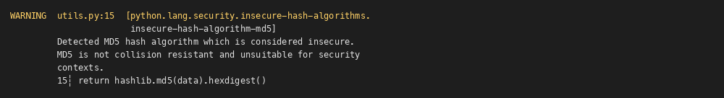

Screenshot of Vulnerable Code
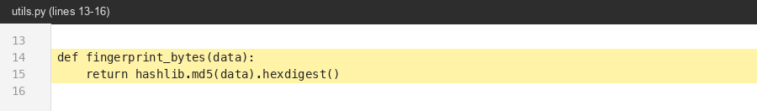

Why is it Vulnerable?
The rule fires on `hashlib.md5(...)` regardless of purpose. Here fingerprint_bytes() is consumed by find_attachment_by_fingerprint() purely as a non-security deduplication key — the value is never used for integrity, authentication, signing, or any trust decision. A collision would at worst silently merge two distinct uploads into one DB row; it cannot grant access or escalate privilege. The same rule firing on utils.py:7 (verify_password) IS a true positive and is reported separately as TP-9.

Security Impact
Tool reports MD5 weakness as Warning; real impact is None for this function. (Distinct from the same algorithm being used for passwords in the adjacent function, which IS exploitable — see TP-9.)

Recommended Remediation
No security remediation required. A maintainability nit: switching to SHA-256 or BLAKE2 removes the SAST noise and aligns the codebase to a single 'no MD5 anywhere' policy, which reduces the chance that MD5 is reintroduced in a security-sensitive place later.

References
Justification basis: data-flow analysis — function output never reaches any auth/integrity/signing sink.

Conclusion
The Scaler Support Desk application exhibits a wide cross-section of OWASP Top-10-class defects — injection (eval, command, SQL), broken access control (IDOR, missing role check), cryptographic failure (MD5 passwords, hardcoded SECRET_KEY), insecure design (file upload, business logic), and security misconfiguration (Werkzeug debug). Several of the most severe issues — particularly broken access control and the negative-cost credit logic flaw — were not flagged by any rule in the auto-selected Semgrep rule packs, reinforcing the assignment's premise that SAST output is a starting point and not the conclusion of a secure code review.
Highest-priority remediation order (by exploit cost vs. blast radius): TP-4 (debug mode), TP-1 (eval RCE), TP-8 (SECRET_KEY), TP-2 (command injection), TP-3 (SQLi), TP-5 + TP-6 (path traversal / upload), TP-10 + TP-11 (access control), TP-9 (password hashing), TP-7 (XSS), TP-12 + TP-13 (escalation logic), TP-14 (CSRF).

