Software Requirements Specification

for

Blood Donation System, Release 1.0
Version 1.0 approved
Prepared by Group 2
Process Impact
June 26, 2025

Table of Contents

Revision History 3
1. Introduction 4
1.1 Purpose 4
1.2 Document Conventions 4
1.3 Project Scope and Product Features 5
1.4 References 6
2. Overall Description 7
2.1 Product Perspective 7
2.2 User Classes and Characteristics 8
Donor 8
Recipient 8
Medical Staff 8
System Administrator 8
External Systems (Inventory and Blood Bank Systems) 9
2.3 Operating Environment 9
2.4 Design and Implementation Constraints 10
2.5 Assumptions and Dependencies 10
3. System Features 11
3.1 Use-case Diagram 11
3.2 Use-Case 12
3.3 COS Business Rules 31
4. Data Requirements 36
4.1 Logical Data Model 36
4.2 Data Dictionary 37
4.2.1 Account Table 37
4.2.2 Staff Table 38
4.2.3 Donor Table 38
4.2.4 Recipient Table 38
4.2.5 Appointment Table 39
4.2.6 DonationProcess Table 39
4.2.7 BloodUnit Table 40
4.2.8 BloodRequest Table 40
4.2.9 BloodInventory Table 41
4.2.10 BloodTransfusions Table 41
4.2.11 MedicalFacility Table 42
4.2.12 Articles Table 42
4.2.13 Comment Table 43
4.2.14 MedicalDocument Table 43
4.3 User Story 43
5. External Interface Requirements 46
5.1 User Interfaces (UI) 46
5.2 System Interfaces (SI) 47
5.3 Communication Interfaces (CI) 47
5.4 Hardware Interfaces (HI) 47
6. Quality Attributes 48
6.1 Usability 48
6.2 Performance 49
6.3 Security 50
6.4 Safety 51
6.5 Availability 51
6.6 Robustness 52
7. Diagram 53
7.1. Swimlane 53
7.2. State Chart 56

Revision History

Name | Date | Reason For Changes | Version
Kiệt | 18/6/2025 | Update data | v1.0
Phong | 14/5/2025 | Change context diagram | v1.0
Duy | 17/5/2025 | Change use case diagram | v1.0
Giang | 13/6/2025 | Update use case | v1.0
Khải | 19/6/2025 | Fix Quality | v1.0

1. Introduction

1.1 Purpose
This document provides a complete specification of the software requirements for the Blood Donation Support System (BDSS). The purpose of the system is to digitally manage and streamline all activities related to blood donation and transfusion, improving the efficiency and reliability of blood supply for both healthcare providers and the community.
The BDSS serves the following goals:
- Connect donors and recipients through an intelligent and accessible platform.
- Enable donors to register, schedule, and monitor their donation history.
- Allow recipients or medical representatives to submit and track blood transfusion requests.
- Support medical staff in screening donors, managing appointments, and recording transfusion results.
- Integrate with external systems (e.g., blood bank and inventory systems) for real-time availability and compatibility tracking.
- Facilitate communication via notifications, reminders, and alerts, especially in urgent cases involving rare blood types.
This document is intended for developers, testers, project managers, domain experts, and stakeholders, providing a common understanding of system behavior and constraints.

1.2 Document Conventions
To ensure clarity and standardization, the following conventions are used:
- Functional Requirements are labeled as: FR-XX (e.g., FR-01, FR-02).
- Non-Functional Requirements are labeled as: NFR-XX (e.g., NFR-01, NFR-02).
- Bold text is used to emphasize major modules, features, or critical terms.
- The keywords MUST, SHOULD, and MAY follow definitions in [RFC 2119], indicating the level of requirement compliance:
  - MUST: Absolute requirement.
  - SHOULD: Strong recommendation but not mandatory.
  - MAY: Optional or conditional requirement.
All diagrams, tables, and requirements follow the format recommended by ISO/IEC/IEEE 29148:2018 for systems and software requirements specifications.

1.3 Project Scope and Product Features
The Blood Donation Support System is a web and mobile application intended to support:
- Individual Donors:
  - Register and manage their donor profile.
  - Schedule blood donations and receive reminders.
  - View donation history and screening results.
  - Get notified in case of urgent blood needs (e.g., rare blood types).
- Medical Staff:
  - Access and manage donor and recipient information.
  - Perform and record medical screening results.
  - Schedule appointments and confirm donations or transfusions.
  - Monitor blood inventory, transfusion history, and audit logs.
- Recipients and Hospital Representatives:
  - Submit and track blood transfusion requests.
  - View transfusion history (with proper access control).
- System Administrators:
  - Manage user roles, system settings, security controls, and external integrations.
- Community Use:
  - Locate the nearest donation centers.
  - Encourage participation and build a network of regular blood donors.
Key Features of the system include:
- Centralized user authentication and role-based dashboards.
- Support for appointment scheduling, inventory updates, and transfusion tracking.
- Integration with external APIs for SMS/email notifications and real-time inventory data.
- Logging, backup, and auditing for critical operations.
- Compliance with data security, availability, and safety standards.
By offering these features, the system aims to improve public health coordination, optimize medical resource use, and enhance the efficiency and transparency of blood donation workflows.

1.4 References
- [1] World Health Organization (WHO), Guidelines on Blood Donation, Version 2020
- [2] Vietnam National Institute of Hematology and Blood Transfusion (NIHBT) – www.nihbt.org.vn
- [3] RFC 2119 – Key Words for Use in RFCs to Indicate Requirement Levels
- [4] ISO/IEC/IEEE 29148:2018 – Systems and Software Engineering — Life Cycle Processes — Requirements Engineering
- [5] OWASP Foundation – Security Design Principles for Web Applications
- [6] FHIR HL7 Standard – Fast Healthcare Interoperability Resources

2. Overall Description

2.1 Product Perspective
The Blood Donation System (BDS) is a centralized, web-based application designed to digitize and automate the processes involved in blood donation, transfusion request handling, and blood inventory management. It acts as an intermediary platform connecting four major actors: Donors, Recipients, Medical Staff, and External Systems such as Inventory and Blood Bank Systems.
The system enables donors to register, update their health screening data, schedule donations, and receive screening results and reminders. Recipients submit blood requests and track transfusion status. Medical staff manage donor/recipient data, update medical records, verify compatibility, and confirm transfusions. The system also integrates with backend services for inventory tracking and notification delivery.
The BDS will operate as a web application accessible via browser or mobile device, hosted on hospital or government infrastructure. It integrates with existing hospital services via RESTful APIs and adheres to healthcare data exchange standards.

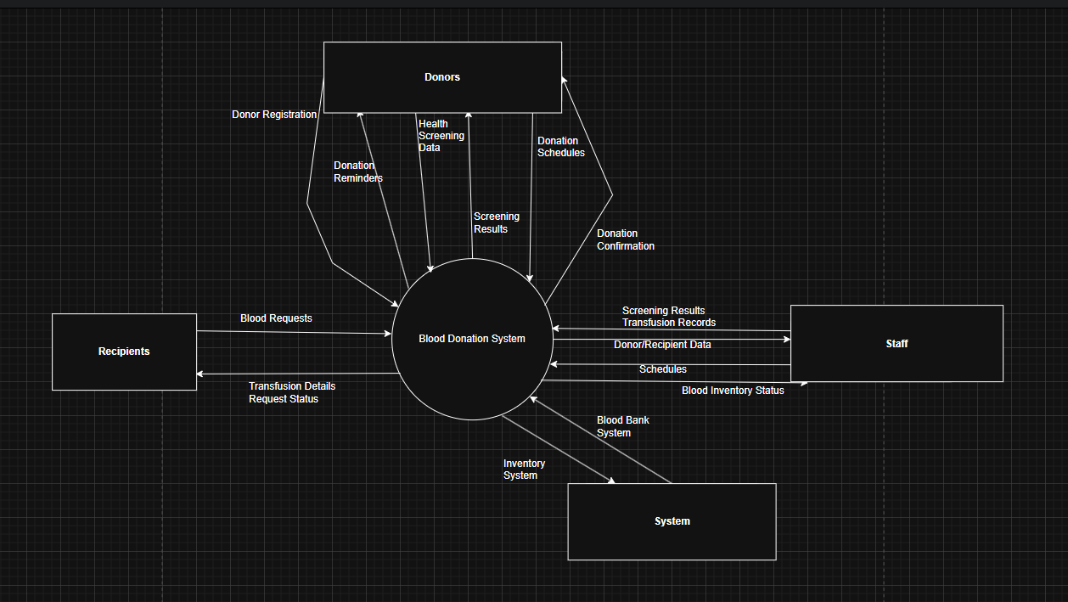
Figure 1. Context diagram for release 1.0 of the Blood Donation System.

2.2 User Classes and Characteristics

Donor
A Donor is a volunteer who registers to donate blood. Donors provide their personal information, medical history, and health screening data before confirming their eligibility. They can view available donation schedules, receive reminders, and check screening results post-donation.
There are approximately 10,000 potential donors nationwide. Around 30% are active at any given time, with many donating at least twice a year.
About 65% access the system via mobile phones or tablets, and the rest use desktop computers at home or in medical facilities. Donors are typically non-technical users, so the system must be intuitive, with accessible forms and guided processes.

Recipient
A Recipient is a patient, hospital representative, or authorized third party who submits a transfusion request. Recipients can view transfusion details and track request status in real time.
Roughly 15% of monthly interactions are initiated by recipients, often through authorized hospital workstations. Most requests are submitted during medical procedures or post-operative recovery periods.
The interface for recipients must be read-only and medically compliant, ensuring patient data confidentiality and request integrity.

Medical Staff
Medical Staff includes doctors, nurses, and lab technicians responsible for managing donation records, reviewing screening results, updating transfusion records, and scheduling appointments.
An estimated 500 staff users will access the system daily in hospitals and clinics. Staff members will also interact with the Blood Bank System and access donor/recipient history.
Staff may use desktop systems or tablets in clinical environments. While technically literate, they require minimal training focused on system workflows and medical data handling protocols.

System Administrator
System Administrators manage user accounts, access control, integration endpoints, backups, and security configurations.
Only 5–10 admin users are expected, all operating from secure internal environments. Admins will also maintain logs, enforce access policies, and manage system uptime.
They require advanced privileges, including control over system services, audit logs, and configuration files.

External Systems (Inventory and Blood Bank Systems)
These include backend or third-party systems that handle blood unit inventory, availability, donor-recipient matching, and supply status.
These systems communicate with BDS through secure RESTful APIs, pushing inventory data and receiving status updates. They operate autonomously and are assumed to be online and synchronized in real time.

2.3 Operating Environment
OE-1: The Blood Donation System shall operate correctly on the following browsers:
- Google Chrome (v90+),
- Mozilla Firefox (v88+),
- Microsoft Edge (Chromium-based, v90+),
- Apple Safari (iOS 13+ and macOS 10.14+).
OE-2: The server environment shall run on:
- Red Hat Enterprise Linux 8 or Ubuntu LTS (20.04+),
- Apache HTTP Server or NGINX as reverse proxy,
- PostgreSQL 13+ or Oracle 19c as the database.
OE-3: The system must support access via:
- Hospital Intranet and secured workstations,
- Internet (VPN + HTTPS),
- Smartphones and tablets running Android 10+ or iOS 13+.
OE-4: All system services must support UTF-8 encoding and timezone configuration (UTC+7 default) to handle regional deployments.
OE-5: Backend services shall be written in Python (Flask/Django) or Java (Spring Boot), with client-side interfaces using HTML5, CSS3, JavaScript/TypeScript frameworks (e.g., React or Vue.js).

2.4 Design and Implementation Constraints
CO-1: The system design and documentation shall conform to the HealthTech National Information System Standards, Version 2.1.
CO-2: RESTful APIs must be compatible with HL7 FHIR (Fast Healthcare Interoperability Resources) where applicable for health data exchange.
CO-3: All front-end components shall conform to the WCAG 2.1 Level AA accessibility standard.
CO-4: The database schema shall follow third normal form (3NF) and include triggers for audit logging.
CO-5: The UI must be responsive and support Right-to-Left (RTL) language settings for regional use if required.
CO-6: Data must be retained and retrievable for at least 5 years in accordance with local health data regulations.

2.5 Assumptions and Dependencies
Assumptions
AS-1: Donors, recipients, and staff have regular access to internet-connected devices.
AS-2: External inventory and blood bank systems are available and responsive through well-defined APIs.
AS-3: All users are authenticated via secure credentials or integrated OAuth2/SSO systems.
AS-4: Notification services (email, SMS) are functional via trusted providers.

Dependencies
DE-1: The system depends on integration with the Blood Bank Inventory System to determine real-time availability and eligibility for donation/transfusion.
DE-2: Operation depends on a national scheduling service or internal calendar system to manage appointment slots and prevent overlap.
DE-3: Payment or incentive systems (if present) must be synchronized with the Payroll or Reimbursement Management System.
DE-4: The success of the system rollout assumes training workshops are completed for medical staff and admin personnel.

3. System Features

3.1 Use-case Diagram

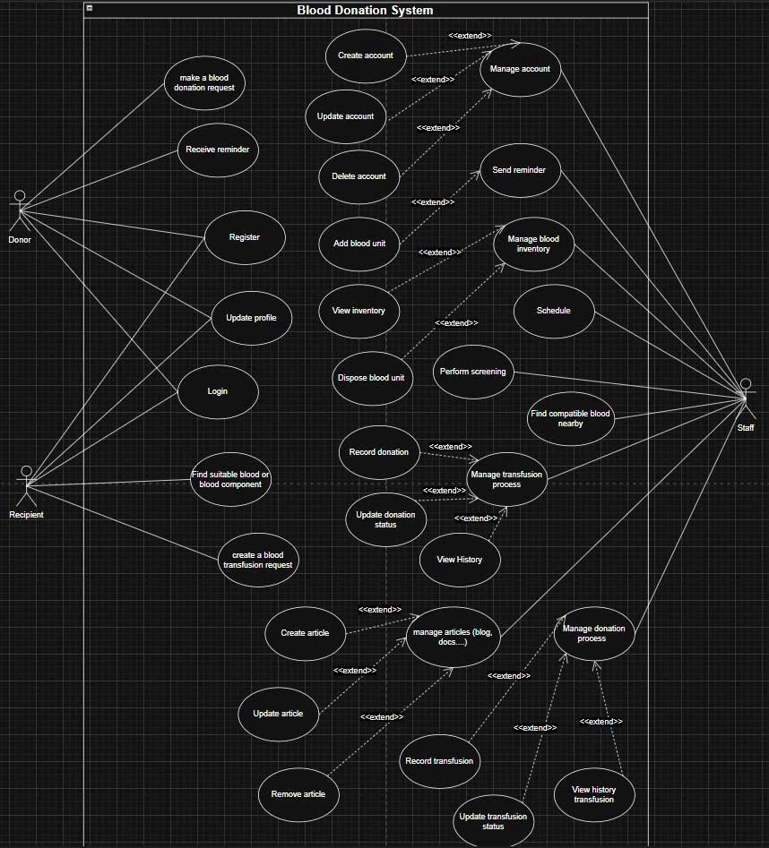
Figure2: Use-case Diagram

3.2 Use-Case

The various user classes identified the following primary actors and use cases for the Blood Donation System:
Primary Actor | Use Cases
Donor | - Login  - Register  - Make a blood donation request  - Update Profile  - Receive Reminder
Recipient | - Login  - Register  - Update Profile  - Create a blood transfusion request  - Find suitable blood type or blood component
Staff | - Create account  - Update account  - Delete account  - Add blood unit  - View blood inventory  - Dispose blood unit  - Schedule  - Perform screening  - Find compatible blood  - Record donation status  - View donation history  - Create article  - Update article  - Remove article  - Record transfusion  - Update transfusion status  - View transfusion history

ID and Name: | UC-1 Login for Donor and Recipient
Created By: | Bảo Duy | Date Created: | 15/6/25
Primary Actor: | Donor, Recipient | Secondary Actors: | Authentication System
Description: | A Donor or Recipient accesses the Blood Donation System to authenticate using credentials, enabling access to features of system
Trigger | A Donor or Recipient initiates login.
Preconditions: | PRE-1: User has valid credentials
Postconditions: | POST-1: User is logged in with role-based access (Donor or Recipient).
Exceptions: | 1.E1 Account locked after multiple failed attempts  1. System informs user and terminates use case.  1.E2 Session timeout after 15 minutes of inactivity.  2. System logs user out and requires re-login.
Priority: | High
Frequency of Use: | Frequent
Business Rules: | BR-1, BR-2, BR-3, BR-4
Other Information: | Users are prompted to reset passwords every 6 months
Assumptions: | ASS-1: The Blood Donation System is operational and accessible 24/7.  ASS-2: User credentials are stored securely and accessible by the authentication system.  ASS-3: Internet connection is available.

ID and Name: | UC-2 Register for Donor and Recipient
Created By: | Bảo Duy | Date Created: | 15/6/25
Primary Actor: | Donor, Recipient | Secondary Actors: | Authentication System, Blood Donation System
Description: | A Donor or Recipient have to register by providing personal information to have full permission to access features of Blood Donation System
Trigger | A Donor or Recipient initiates the registration process.
Preconditions: | PRE-1: User has not yet registered an account.  PRE-2: User provides valid personal information and credentials.
Postconditions: | POST-1: User account is created with role-based access (Donor or Recipient).  POST-2: User receives confirmation of successful registration.
Exceptions: | 2.E1 Invalid or duplicate personal information.  1 System informs user and requests correction.  2.E2 System error during registration.  2 System informs user and terminates process.
Priority: | High
Frequency of Use: | Occasional
Business Rules: | BR-5, BR-6, BR-7
Other Information: | Users may be required to verify email or phone number post-registration.
Assumptions: | ASS-1: Users have access to a device and internet connection.  ASS-2: The Blood Donation System is operational during registration. ASS-3: Users understand the registration requirements.

ID and Name: | UC-3 Update Profile for Donor and Recipient
Created By: | Bảo Duy | Date Created: | 15/6/25
Primary Actor: | Donor, Recipient | Secondary Actors: | Blood Donation System
Description: | A Donor or Recipient updates their profile information in the Blood Donation System, including personal details or role-specific data, to ensure consistent information.
Trigger | A Donor or Recipient initiates the profile update process.
Preconditions: | PRE-1: User is logged in with a valid account.  PRE-2: User has permission to modify their profile.
Postconditions: | POST-1: User profile is updated with the new information.  POST-2: System confirms the successful update to the user.
Exceptions: | 3.E1 Invalid or incomplete data entered.  1 System prompts user to correct the information.  3.E2 System error during update.  2 System informs user and reverts to previous profile.
Priority: | Medium
Frequency of Use: | Occasional
Business Rules: | BR-8,BR-9
Other Information: | Users may need to re-authenticate for significant changes (e.g., email or phone).
Assumptions: | ASS-1: Users have a stable internet connection.  ASS-2: The Blood Donation System is operational during the update.  ASS-3: Users have access to their current profile details.

ID and Name: | UC-4 Make a blood donation request
Created By: | Bảo Duy | Date Created: | 15/6/25
Primary Actor: | Donor | Secondary Actors: | Blood Donation System, Staff
Description: | A Donor submits a request to donate blood in the Blood Donation System, providing necessary details to schedule a donation session.
Trigger | A Donor initiates the creation of a donation request.
Preconditions: | PRE-1: Donor is logged in with a valid account.  PRE-2: Donor’s profile contains up-to-date health and contact information.
Postconditions: | POST-1: Donation request is created and submitted to the system.  POST-2: Donor receives a confirmation with a scheduled donation date and time.
Exceptions: | 4.E1 Incomplete or invalid health information.  1 System prompts Donor to update profile.  4.E2 Scheduling conflict detected.  2 System informs Donor and suggests alternative dates.
Priority: | High
Frequency of Use: | Occasional
Business Rules: | BR-10, BR-11
Other Information: | Donors may be notified via email or SMS about the scheduled session.
Assumptions: | ASS-1: Donor has a stable internet connection.  ASS-2: The Blood Donation System is available for scheduling.  ASS-3: Donor understands the eligibility requirements.

ID and Name: | UC-5 Receive reminder
Created By: | Bảo Duy | Date Created: | 15/6/25
Primary Actor: | Donor | Secondary Actors: | Blood Donation System
Description: | A Donor receives a reminder notification from the Blood Donation System indicating eligibility to donate blood again after a recovery period of 84 days from the last donation.
Trigger | The system detects that 84 days have passed since the Donor’s last donation.
Preconditions: | PRE-1: Donor has a recorded previous donation.  PRE-2: Donor’s contact information (e.g., email or phone) is up-to-date.  PRE-3: 84 days have elapsed since the last donation.
Postconditions: | POST-1: Donor receives a reminder to schedule a new donation.  POST-2: Donor can initiate a new donation request if eligible.
Exceptions: | 5.E1 Outdated contact information.  1 System prompts Donor to update profile.  5.E2 Less than 84 days since last donation.  2 System informs Donor and delays reminder.  5.E3 Notification system failure.  3 System logs the error and retries later.
Priority: | Medium
Frequency of Use: | Occasional
Business Rules: | BR-12, BR-13, BR-14
Other Information: | Donors can opt out of reminders but must acknowledge the 84-day recovery rule.
Assumptions: | ASS-1: Donor has access to the notification method (email or phone).  ASS-2: The Blood Donation System accurately tracks donation history.  ASS-3: Donor is aware of the 84-day recovery period.

ID and Name: | UC-9 Create blood transfusion request
Created By: | Bảo Duy | Date Created: | 15/6/25
Primary Actor: | Recipient | Secondary Actors: | Blood Donation System, Staff
Description: | A Recipient submits a request for a blood transfusion in the Blood Donation System, providing necessary medical details to arrange a transfusion session.
Trigger | A Recipient initiates the creation of a blood transfusion request.
Preconditions: | PRE-1: Recipient is logged in with a valid account.  PRE-2: Recipient’s profile contains up-to-date medical and contact information.
Postconditions: | POST-1: Blood transfusion request is created and submitted to the system.  POST-2: Recipient receives a confirmation with a scheduled transfusion date and time
Exceptions: | 9.E1 Incomplete or invalid medical information.  1 System prompts Recipient to update profile.  9.E2 Insufficient blood supply detected.  2 System informs Recipient and suggests alternatives.
Priority: | High
Frequency of Use: | Occasional
Business Rules: | BR-24, BR-25
Other Information: | Recipients may be notified via email or SMS about the approval status.
Assumptions: | ASS-1: Recipient has a stable internet connection.  ASS-2: The Blood Donation System tracks available blood supply.  ASS-3: Recipient understands the request process.

ID and Name: | UC-10 Find Suitable Blood Type or Blood Component for Recipient
Created By: | Bảo Duy | Date Created: | 15/6/25
Primary Actor: | Recipient | Secondary Actors: | Blood Donation System, Staff
Description: | A Recipient searches for suitable blood types or components in the Blood Donation System to meet their transfusion needs, based on medical compatibility.
Trigger | A Recipient initiates a search for suitable blood types or components.
Preconditions: | PRE-1: Recipient is logged in with a valid account.  PRE-2: Recipient’s medical profile (e.g., blood type, transfusion history) is up-to-date.
Postconditions: | POST-1: System returns a list of suitable blood types or components available.  POST-2: Recipient can proceed with a transfusion request if suitable blood is found.
Exceptions: | 10.E1 No suitable blood or component available.  1 System informs Recipient and suggests alternatives.  10.E2 System error during search.  2 System logs the error and retries.
Priority: | High
Frequency of Use: | Occasional
Business Rules: | BR26, BR-27
Other Information: | Recipients may be notified if suitable blood becomes available later.
Assumptions: | ASS-1: Recipient has a stable internet connection.  ASS-2: The Blood Donation System maintains an accurate inventory of blood stocks.  ASS-3: Recipient understands their blood type and compatibility requirements.

ID and Name: | UC-11 Create account
Created By: | Bảo Duy | Date Created: | 15/6/25
Primary Actor: | Staff | Secondary Actors: | Blood Donation System, Donor, Recipient
Description: | A Staff member creates an account on behalf of a Donor or Recipient using the information provided by them, and assigns appropriate permissions and roles to allow access to the Blood Donation System’s features.
Trigger | A Staff member receives sufficient user information and initiates the account creation process.
Preconditions: | PRE-1: Staff is logged in with valid credentials and has permission to manage user accounts.  PRE-2: Donor or Recipient provides necessary personal and contact information.
Postconditions: | POST-1: A new user account (Donor or Recipient) is created and stored in the system.  POST-2: The account is assigned the appropriate role and permissions.  POST-3: The new user may receive login information or instructions for first-time access.
Exceptions: | 11.E1: Missing or invalid required information.  1. System prompts Staff to complete or correct the form.  11.E2: Email or phone number already exists in the system.  2. System notifies Staff to check for duplication or update existing account.  11.E3: System/database error during creation.  3. System logs the error and notifies Staff.
Priority: | High
Frequency of Use: | Occasional
Business Rules: | BR-28, BR-29, BR-30
Other Information: | Staff may optionally fill in preliminary medical information if available during account creation.
Assumptions: | ASS-1: Staff has verified the identity and consent of the user  ASS-2: System has the ability to notify the user via email or SMS if needed.  ASS-3: The Blood Donation System enforces proper data validation and access control.

ID and Name: | UC-12 Update account
Created By: | Bảo Duy | Date Created: | 15/6/25
Primary Actor: | Staff | Secondary Actors: | Blood Donation System, Donor, Recipient
Description: | A Staff member updates the account information of a Donor or Recipient in the Blood Donation System, such as contact details, personal data, or assigned roles, based on updated or corrected information provided by the user.
Trigger | A Staff member receives a request or detects a need to update a user’s account information.
Preconditions: | PRE-1: Staff is logged in with valid credentials and has permission to manage user accounts.  PRE-2: The account to be updated already exists in the system.
Postconditions: | POST-1: The updated information is saved and reflected in the user’s profile.  POST-2: A record of the update is logged for audit purposes.
Exceptions: | 12.E1: Provided data is incomplete or invalid.  1. System prompts Staff to review and correct the data.  12.E2: Attempt to update a non-existent or deactivated account.  2. System notifies Staff and aborts the update process.  12.E3: System/database error during update.  3. System logs the error and informs the Staff member.
Priority: | Medium
Frequency of Use: | Occasional
Business Rules: | BR-63, BR-64, BR-65, BR-66
Other Information: | Some updates, such as medical data or role upgrades, may trigger additional system processes or notifications.
Assumptions: | ASS-1: Staff confirms the accuracy of the information before submitting changes.  ASS-2: The system logs changes with timestamp and Staff ID for traceability.  ASS-3: System provides necessary UI forms and validations for safe data editing.

ID and Name: | UC-13 Delete account
Created By: | Bảo Duy | Date Created: | 15/6/25
Primary Actor: | Staff | Secondary Actors: | Blood Donation System
Description: | A Staff member deletes an existing user account (Donor or Recipient) from the Blood Donation System based on request, policy compliance, or account deactivation due to inactivity or violations.
Trigger | A Staff member initiates the deletion of a user account from the system.
Preconditions: | PRE-1: Staff is logged in with appropriate administrative privileges.  PRE-2: The account to be deleted exists in the system and is not already deactivated.
Postconditions: | POST-1: The user account is marked as deleted or removed from active access.  POST-2: Related data is archived or handled based on data retention policies.
Exceptions: | 13.E1: Account is linked to active medical or donation records.  1. System prevents deletion and notifies Staff with reason.  13.E2: System/database error during deletion.  2. System logs the error and informs the Staff member.  13.E3: Attempt to delete a non-existent account.  3. System shows appropriate error message.
Priority: | Medium
Frequency of Use: | Rare
Business Rules: | BR-67
Other Information: | Deleting an account may restrict the user from accessing services but not necessarily remove all historical records (e.g., donation or transfusion history remains).
Assumptions: | ASS-1: Staff confirms deletion with proper authority and justification.  ASS-2: The system enforces safeguards to prevent accidental or unauthorized deletion.  ASS-3: Backup or archiving procedures are in place for long-term data integrity.

ID and Name: | UC-14: Add Blood Unit
Created By: | Bảo Duy | Date Created: | 15/6/25
Primary Actor: | Staff | Secondary Actors: | Blood Donation System
Description: | A Staff member adds a new blood unit to the Blood Donation System after a successful donation, recording key details such as blood type, component, volume, collection date, and storage location.
Trigger | A Staff member completes a blood collection session and proceeds to record the blood unit in the system.
Preconditions: | PRE-1: Staff is logged in with permissions to manage blood inventory.  PRE-2: The blood unit has been collected, labeled, and verified according to medical protocols.
Postconditions: | POST-1: A new blood unit is recorded in the system with a unique identifier.  POST-2: The blood unit becomes available in the system's blood inventory.
Exceptions: | 14.E1: Incomplete or inconsistent information about the blood unit.  1. System prompts Staff to review and complete the required fields.  14.E2: Blood unit fails quality or safety checks.  2. System logs the issue and marks the unit as unusable.  14.E3: System/database error during entry.  3. System logs the error and notifies the Staff member.
Priority: | High
Frequency of Use: | Frequent
Business Rules: | BR-31, BR-32
Other Information: | Blood units may be categorized by type (whole blood, RBCs, plasma, platelets) and assigned expiration dates based on standard medical guidelines.
Assumptions: | ASS-1: The blood unit has passed initial screening for storage.  ASS-2: Storage and refrigeration systems are functioning properly.  ASS-3: The system integrates with blood labeling and tracking systems.

ID and Name: | UC-15: View Blood Inventory
Created By: | Bảo Duy | Date Created: | 15/6/25
Primary Actor: | Staff | Secondary Actors: | Blood Donation System
Description: | A Staff member views the current blood inventory in the Blood Donation System to check available blood units, their types, components, volumes, expiration dates, and storage statuses.
Trigger | A Staff member navigates to the blood inventory module in the system.
Preconditions: | PRE-1: Staff is logged in with permissions to access the inventory module.  PRE-2: Blood units have been previously recorded in the system.
Postconditions: | POST-1: The system displays a list or dashboard of all available blood units.  POST-2: Staff can filter, search, or sort inventory by criteria such as blood type, component, or expiry date.
Exceptions: | 15.E1: No blood units available in the system.  1. System displays an appropriate message indicating zero availability.  15.E2: System/database error while retrieving data.  2. System logs the error and shows a notification to the Staff member.
Priority: | High
Frequency of Use: | Frequent
Business Rules: | BR-33, BR-34, BR-35
Other Information: | Staff may use this feature to support blood matching, plan for restocking, or manage logistics.
Assumptions: | ASS-1: The inventory is updated in real-time with every donation, disposal, or transfusion.  ASS-2: System supports pagination and performance optimization for large data sets.  ASS-3: Blood units are traceable via unique IDs and storage locations.

ID and Name: | UC-16: Dispose Blood Unit
Created By: | Bảo Duy | Date Created: | 15/6/25
Primary Actor: | Staff | Secondary Actors: | Blood Donation System
Description: | A Staff member disposes of a blood unit that is expired, contaminated, or otherwise deemed unusable, and updates the inventory status accordingly in the Blood Donation System.
Trigger | A Staff member identifies a blood unit that must be disposed of due to expiry, contamination, or manual review, and initiates the disposal process.
Preconditions: | PRE-1: Staff is logged in with valid disposal permissions.  PRE-2: The blood unit exists in the system and is marked as eligible for disposal.
Postconditions: | POST-1: The blood unit is marked as disposed in the inventory system.  POST-2: The disposal action is logged for audit and compliance purposes.
Exceptions: | 16.E1: Attempt to dispose of a unit that is still valid or reserved.  1. System blocks the action and prompts for confirmation or review.  16.E2: System/database error during disposal update.  2. System logs the error and alerts the Staff member.  16.E3: Blood unit not found in the system.  3. System displays an error message.
Priority: | Medium
Frequency of Use: | Occasional
Business Rules: | BR-18, BR-19, BR-20
Other Information: | This use case supports regulatory compliance and safety standards for blood handling and storage.
Assumptions: | ASS-1: Staff follows proper medical waste disposal protocols.  ASS-2: The system is synced with storage expiration tracking.  ASS-3: Disposal records are retained for future audits and inspections.

ID and Name: | UC-17: Schedule
Created By: | Bảo Duy | Date Created: | 15/6/25
Primary Actor: | Staff | Secondary Actors: | Blood Donation System, Donor, Recipient
Description: | A Staff member schedules an appointment for a Donor or Recipient in the Blood Donation System, specifying the date, time, location, and type of appointment (e.g., blood donation, blood transfusion, health screening).
Trigger | A Staff member receives a request or proactively sets an appointment for a user.
Preconditions: | PRE-1: Staff is logged in with access to appointment scheduling.  PRE-2: The user (Donor or Recipient) exists in the system.  PRE-3: Scheduling calendar and medical facility availability are accessible
Postconditions: | POST-1: The appointment is saved and linked to the corresponding user.  POST-2: The user may receive a notification (e.g., email or SMS) about the scheduled appointment.
Exceptions: | 17.E1: Selected time slot is unavailable or conflicts with another appointment.  1. System prompts Staff to choose a different time.  17.E2: Required information (date, location, purpose) is incomplete.  2. System highlights missing fields and prevents submission.  17.E3: System/database error while saving the appointment.  3. System logs the error and notifies Staff.
Priority: | High
Frequency of Use: | Frequent
Business Rules: | BR-21, BR-22, BR-23
Other Information: | Staff may view, update, or cancel scheduled appointments through a calendar interface or appointment list.
Assumptions: | ASS-1: The scheduling module is synchronized with the system calendar and facility availability.  ASS-2: Users are notified in a timely manner after the appointment is created.  ASS-3: Appointments can be filtered and searched by date, user, or type.

ID and Name: | UC-18: Perform Screening
Created By: | Bảo Duy | Date Created: | 15/6/25
Primary Actor: | Staff | Secondary Actors: | Blood Donation System, Donor
Description: | A Staff member performs a health screening for a Donor before a blood donation to assess eligibility based on factors such as vital signs, medical history, and risk factors. The screening results are recorded in the Blood Donation System.
Trigger | A Donor arrives for a scheduled donation or walk-in, and Staff initiates the screening process.
Preconditions: | PRE-1: Staff is logged in with permissions to perform and record screenings.  PRE-2: The Donor has a registered account in the system.  PRE-3: Screening forms and equipment are available and operational.
Postconditions: | POST-1: Screening results are saved and associated with the Donor’s medical record.  POST-2: System determines whether the Donor is eligible to proceed with donation based on the results.
Exceptions: | 18.E1: Donor refuses to participate or is unable to complete screening.  1. Staff logs the incomplete screening and the reason.  18.E2: Abnormal screening result detected.  2. System flags the issue and advises Staff to halt the donation process.  18.E3: System/database error while saving results.  3. System logs the error and notifies Staff.
Priority: | High
Frequency of Use: | Frequent
Business Rules: | BR-33, BR-34, BR-35
Other Information: | Staff may view, update, or cancel scheduled appointments through a calendar interface or appointment list.
Assumptions: | ASS-1: The scheduling module is synchronized with the system calendar and facility availability.  ASS-2: Users are notified in a timely manner after the appointment is created.  ASS-3: Appointments can be filtered and searched by date, user, or type.

ID and Name: | UC-19: Find Compatible Blood
Created By: | Bảo Duy | Date Created: | 15/6/25
Primary Actor: | Staff | Secondary Actors: | Blood Donation System
Description: | A Staff member searches the Blood Donation System to find blood units that are compatible with a specific Recipient, based on blood type and required components (e.g., red cells, plasma, platelets), to prepare for transfusion or request fulfillment.
Trigger | Staff initiates a compatibility search for a Recipient who requires a transfusion.
Preconditions: | PRE-1: Staff is logged in with valid permissions.  PRE-2: Recipient's medical profile, including blood type and transfusion requirements, is available in the system.  PRE-3: The blood inventory contains up-to-date information on available units and components.
Postconditions: | POST-1: System returns a list of compatible blood units or components.  POST-2: Staff may proceed to reserve, request, or schedule transfusion for the Recipient.
Exceptions: | 19.E1: No compatible blood or component is available.  1. System notifies Staff and suggests closest alternatives or alerts the need for urgent collection.  19.E2: Recipient’s medical data is incomplete or outdated.  2. System requests profile update before proceeding.  19.E3: System error during search operation.  3. System logs the error and notifies Staff.
Priority: | High
Frequency of Use: | Occasional
Business Rules: | BR-36, BR-37, BR-38
Other Information: | Staff may filter or prioritize units by location, urgency, or component type.  The system may suggest automated matching based on stored rules or compatibility matrix.
Assumptions: | ASS-1: Blood typing and component data are accurate and validated.  ASS-2: Staff understands compatibility logic or system recommendations.  ASS-3: The system synchronizes inventory in real time across facilities (if applicable).

ID and Name: | UC-20: Record Donation Status
Created By: | Bảo Duy | Date Created: | 15/6/25
Primary Actor: | Staff | Secondary Actors: | Blood Donation System, Donor
Description: | A Staff member records the status of a donation session, indicating whether the donation was completed successfully, deferred, or failed, along with relevant notes or observations.
Trigger | Staff completes or ends a donation session and updates the corresponding status in the system.
Preconditions: | PRE-1: Staff is logged in with access to donor and donation records.  PRE-2: The donation session has been scheduled or initiated in the system.
Postconditions: | POST-1: The donation status is updated in the Donor’s history.  POST-2: The system reflects the correct outcome for inventory or follow-up purposes.
Exceptions: | 20.E1: Donation record not found or not properly initialized.  1. System notifies Staff and prevents update.  20.E2: System error during update.  2. System logs the error and alerts Staff.  20.E3: Incomplete or missing required fields (e.g., status, notes).  3. System prompts Staff to complete necessary fields.
Priority: | High
Frequency of Use: | Frequent
Business Rules: | BR-39,BR-40,BR-41
Other Information: | Deferred donors may be scheduled for re-evaluation or notified of deferral duration.  Status records support analytics, donor tracking, and quality assurance.
Assumptions: | ASS-1: The donation session was conducted and monitored by certified medical staff.  ASS-2: The system timestamps and links each status with the donor ID and session ID.  ASS-3: Staff follows standard operating procedures for documentation and deferral.

ID and Name: | UC-21: View Donation History
Created By: | Lê Giang | Date Created: | 15/6/25
Primary Actor: | Staff | Secondary Actors: | Blood Donation System, Donor
Description: | A Staff member views the donation history of a specific Donor in the Blood Donation System, including past donation dates, volumes, types, and any deferral reasons, to assess eligibility or provide donor information.
Trigger | Staff initiates a search for a Donor's donation history.
Preconditions: | PRE-1: Staff is logged in with permissions to access donor records and donation history.  PRE-2: The Donor has a registered account and at least one recorded donation.
Postconditions: | POST-1: The system displays a chronological list of the Donor’s past donations.  POST-2: Staff can view details of each donation, including status and relevant notes.
Exceptions: | 21.E1: Donor account not found or no donation history available.  - System informs Staff and indicates no records found.  21.E2: System/database error while retrieving history.  - System logs the error and notifies Staff.
Priority: | Medium
Frequency of Use: | Occasional
Business Rules: | BR-42,BR-43,BR-44
Other Information: | This feature aids in managing donor retention and ensures compliance with donation frequency guidelines.
Assumptions: | ASS-1: The system accurately archives and retrieves historical donation data.  ASS-2: Staff understands the implications of donation history on donor eligibility.

ID and Name: | UC-22: Create Article
Created By: | Lê Giang | Date Created: | 15/6/25
Primary Actor: | Staff | Secondary Actors: | Blood Donation System
Description: | A Staff member creates new informational articles or news updates within the Blood Donation System, such as blood drive announcements, health tips, or policy changes, for publication to Donors and Recipients.
Trigger | A Staff member decides to publish new content to the system's public or internal portal.
Preconditions: | PRE-1: Staff is logged in with appropriate content management or administrative privileges.  PRE-2: Content for the article (text, images) is prepared.
Postconditions: | POST-1: The new article is saved in the system and marked for publication.  POST-2: The article becomes visible to target users (Donors, Recipients, or public) as intended.
Exceptions: | 22.E1: Incomplete or missing required content fields (e.g., title, body).  - System prompts Staff to complete the missing information.  22.E2: System/database error during article creation.  - System logs the error and notifies Staff.
Priority: | Medium
Frequency of Use: | Occasional
Business Rules: | BR-45,BR-46,BR-47
Other Information: | Articles can be scheduled for future publication or have an expiry date.
Assumptions: | ASS-1: The system provides a user-friendly interface for content creation and formatting.  ASS-2: Articles can be categorized and tagged for easier search and filtering.

ID and Name: | UC-23: Update Article
Created By: | Lê Giang | Date Created: | 15/6/25
Primary Actor: | Staff | Secondary Actors: | Blood Donation System
Description: | A Staff member modifies an existing informational article or news update in the Blood Donation System to correct information, add new details, or reflect updated policies.
Trigger | A Staff member identifies an existing article that requires modification.
Preconditions: | PRE-1: Staff is logged in with appropriate content management or administrative privileges.  PRE-2: The article to be updated exists in the system.
Postconditions: | POST-1: The article's content is updated and saved in the system.  POST-2: The updated version of the article is immediately visible or set for re-publication.
Exceptions: | 23.E1: Article not found or no permission to edit.  - System notifies Staff and prevents the update.  23.E2: Incomplete or invalid data entered during update.  - System prompts Staff to correct the information.  23.E3: System/database error during update.  - System logs the error and notifies Staff.
Priority: | Medium
Frequency of Use: | Occasional
Business Rules: | BR-48,BR-49,BR-50
Other Information: | A version history of articles may be maintained for auditing purposes.
Assumptions: | ASS-1: The system allows Staff to preview changes before saving.  ASS-2: Updates can be reverted if necessary.

ID and Name: | UC-24: Remove Article
Created By: | Lê Giang | Date Created: | 15/6/25
Primary Actor: | Staff | Secondary Actors: | Blood Donation System
Description: | A Staff member removes an outdated, irrelevant, or incorrect informational article from the Blood Donation System, effectively unpublishing it from public view.
Trigger | A Staff member identifies an article that needs to be removed from the system.
Preconditions: | PRE-1: Staff is logged in with appropriate content management or administrative privileges.  PRE-2: The article to be removed exists in the system.
Postconditions: | POST-1: The article is marked as removed or unpublished from the system.  POST-2: The article is no longer visible to Donors and Recipients.
Exceptions: | 24.E1: Article not found or no permission to remove.  - System notifies Staff and prevents the action.  24.E2: System/database error during removal.  - System logs the error and notifies Staff.
Priority: | Medium
Frequency of Use: | Rare
Business Rules: | BR-51,BR-52,BR-53
Other Information: | Removed articles may be archived rather than permanently deleted for historical reference.
Assumptions: | ASS-1: The system provides a confirmation step before permanent removal.  ASS-2: Archiving policies are in place for removed content.

ID and Name: | UC-25: Record Transfusion
Created By: | Lê Giang | Date Created: | 15/6/25
Primary Actor: | Staff | Secondary Actors: | Blood Donation System, Recipient, Blood Unit
Description: | A Staff member records the details of a blood transfusion administered to a Recipient in the Blood Donation System, including the blood unit(s) used, date, time, and any observed reactions.
Trigger | A Staff member completes a blood transfusion and proceeds to record the event in the system.
Preconditions: | PRE-1: Staff is logged in with permissions to record medical procedures.  PRE-2: The Recipient has a registered account and a transfusion request (if applicable).  PRE-3: The blood unit(s) used are identified and available in the inventory.
Postconditions: | POST-1: The transfusion details are saved and linked to the Recipient’s medical record.  POST-2: The status of the used blood unit(s) is updated to "transfused" or "consumed" in the inventory.
Exceptions: | 25.E1: Missing or invalid required transfusion details.  - System prompts Staff to complete or correct the information.  25.E2: Blood unit not found or already marked as used.  - System alerts Staff and requests verification.  25.E3: System/database error during recording.  - System logs the error and notifies Staff.
Priority: | High
Frequency of Use: | Frequent
Business Rules: | BR-54,BR-55,BR-56
Other Information: | This use case is critical for patient safety, blood traceability, and inventory management.
Assumptions: | ASS-1: Staff follows standard medical protocols for transfusion and documentation.  ASS-2: The system accurately tracks blood unit consumption.  ASS-3: Integration with patient medical records is possible for comprehensive care.

ID and Name: | UC-26: Update Transfusion Status
Created By: | Lê Giang | Date Created: | 15/6/25
Primary Actor: | Staff | Secondary Actors: | Blood Donation System, Recipient
Description: | A Staff member updates the status of an ongoing or completed blood transfusion for a Recipient in the Blood Donation System, such as marking it as completed, cancelled, or noting any complications.
Trigger | A Staff member needs to modify the status of a previously recorded or pending transfusion.
Preconditions: | PRE-1: Staff is logged in with permissions to modify transfusion records.  PRE-2: The transfusion record for the Recipient exists in the system.
Postconditions: | POST-1: The transfusion status is updated in the Recipient’s record.  POST-2: Any associated blood unit statuses are adjusted if necessary (e.g., if cancelled).
Exceptions: | 26.E1: Transfusion record not found or no permission to update.  - System notifies Staff and prevents the update.  26.E2: Invalid status transition (e.g., trying to mark a completed transfusion as pending).  - System prompts Staff for correct status or reason.  26.E3: System/database error during update.  - System logs the error and notifies Staff.
Priority: | Medium
Frequency of Use: | Occasional
Business Rules: | BR-57,BR-58,BR-59
Other Information: | This helps in managing active transfusion cases and auditing outcomes.
Assumptions: | ASS-1: Staff has accurate information regarding the transfusion's progress.  ASS-2: The system maintains an audit trail of all status changes.

ID and Name: | UC-27: View Transfusion History
Created By: | Lê Giang | Date Created: | 15/6/25
Primary Actor: | Staff | Secondary Actors: | Blood Donation System, Recipient
Description: | A Staff member views the complete transfusion history of a specific Recipient in the Blood Donation System, including details of past transfusions, blood units received, dates, and any reactions or outcomes.
Trigger | Staff initiates a search for a Recipient's transfusion history.
Preconditions: | PRE-1: Staff is logged in with permissions to access recipient records and medical history.  PRE-2: The Recipient has a registered account and at least one recorded transfusion.
Postconditions: | POST-1: The system displays a chronological list of the Recipient’s past transfusions.  POST-2: Staff can view detailed information for each transfusion event.
Exceptions: | 27.E1: Recipient account not found or no transfusion history available.  - System informs Staff and indicates no records found.  27.E2: System/database error while retrieving history.  - System logs the error and notifies Staff.
Priority: | High
Frequency of Use: | Frequent
Business Rules: | BR-60,BR-61,BR-62
Other Information: | This feature is vital for medical assessment, tracking patient care, and ensuring future transfusion compatibility.
Assumptions: | ASS-1: The system accurately stores and retrieves historical transfusion data.  ASS-2: Staff understands the medical implications of a Recipient’s transfusion history.

3.3 COS Business Rules
Function | ID Business Rule | Rule Definition
Login | BR-1 | Users must provide valid credentials (username and password) to log in.
 | BR-2 | User accounts will be locked after multiple failed login attempts.
 | BR-3 | Token expired after 60 minutes.
 | BR-4 | Users are required to reset their passwords every 6 months.
Register | BR-5 | The system shall permit account registration only if the user does not already have an existing account associated with the same email address, phone number, or government-issued ID (e.g., national ID or citizen ID).
 | BR-6 | All required personal information fields (e.g., full name, date of birth, national ID, contact details) must be complete, syntactically valid (correct format), and must not match any existing active user account in the system.
 | BR-7 | After successful submission of registration data, the system MAY require users to verify their email address or phone number using a One-Time Password (OTP) before granting full access to system features.
Update Profile | BR-8 | Only authenticated users can update their profile.
 | BR-9 | Sensitive changes (e.g., email or phone number) may require re-authentication.
Make Blood Donation Request | BR-10 | Donors must have up-to-date health and contact information before submitting a request.
 | BR-11 | Scheduling conflicts must be resolved before confirming the request.
Receive Reminder | BR-12 | Reminders are sent only after 84 days have passed since the last donation.
 | BR-13 | Donors may opt out of reminders but must still observe the 84-day rule.
 | BR-14 | Valid contact information is required to receive reminders.
View Blood Inventory | BR-15 | Only authorized staff can access blood inventory data.
 | BR-16 | The inventory must display blood type, component, volume, expiration date, and storage location.
 | BR-17 | Filtering and sorting options must be available for inventory browsing.
Dispose Blood Unit | BR-18 | Blood units that are expired, contaminated, or invalid must be properly disposed of.
 | BR-19 | Units that are still valid or reserved cannot be disposed of.
 | BR-20 | Disposal actions must be logged for compliance and auditing.
Schedule | BR-21 | Appointments must include clear information: date, time, location, and purpose.
 | BR-22 | Time slot conflicts are not allowed.
 | BR-23 | Donors and Recipients must receive appointment notifications.
Create Transfusion Request | BR-24 | Recipients must provide valid medical and contact information.
 | BR-25 | Requests may be denied if blood supply is insufficient.
Find Suitable Blood | BR-26 | Recipients must have an up-to-date medical profile.
 | BR-27 | Only compatible and available blood units should be returned by the system.
Create Account | BR-28 | Staff must verify user identity and information before account creation.
 | BR-29 | Email and phone number must be unique in the system.
 | BR-30 | Role assignment (Donor or Recipient) must be accurate during account creation.
Add Blood Unit | BR-31 | Each new blood unit must be assigned a unique identifier.
 | BR-32 | Only blood that passes safety and quality checks may be added to inventory.
Perform Screening | BR-33 | All health screenings shall be performed exclusively by authorized medical personnel assigned with screening privileges within the system. Unauthorized users must be restricted from accessing or performing this function.
 | BR-34 | The screening result (including blood pressure, hemoglobin level, temperature, etc.) MUST be fully recorded in the system and linked to the corresponding donor’s medical record. The timestamp, screener ID, and location must also be captured.
 | BR-35 | If any health screening metric falls outside of medically accepted thresholds (e.g., low hemoglobin, high blood pressure), the system MUST prevent continuation of the donation process and notify medical staff for further action.
Find Compatible Blood | BR-36 | Compatibility is determined based on the Recipient’s medical profile and blood inventory.
 | BR-37 | The system must suggest alternatives if compatible blood is unavailable.
 | BR-38 | Compatibility search requires current and complete recipient data.
Record Donation Status | BR-39 | Each donation session must have a recorded outcome (success, deferred, failed).
 | BR-40 | Notes are mandatory for deferred or failed donations.
 | BR-41 | Status changes must be logged for traceability.
View Donation History | BR-42 | Only authorized staff may access Donor donation history.
 | BR-43 | Full details must be available: date, volume, type, deferral reasons.
 | BR-44 | Searchable by Donor ID or date.
Create Article | BR-45 | Articles must contain a title and content to be published.
 | BR-46 | Only authorized staff can create and publish articles.
 | BR-47 | Articles can have a scheduled publication date and expiration.
Update Article | BR-48 | All article updates must be logged for version control.
 | BR-49 | Only staff with permissions can modify existing articles.
 | BR-50 | Changes must be confirmed before saving.
Remove Article | BR-51 | Removed articles are unpublished but retained for archival purposes.
 | BR-52 | Staff must confirm before deletion.
 | BR-53 | System should support article archiving post-removal.
Record Transfusion | BR-54 | Transfusion records must include Recipient and blood unit used.
 | BR-55 | Blood units used must be marked as “transfused” in inventory.
 | BR-56 | Any reactions or issues must be documented.
Update Transfusion Status | BR-57 | Only authorized staff may update transfusion status.
 | BR-58 | Invalid status transitions are not permitted (e.g., from completed to pending).
 | BR-59 | Updates must be logged in the Recipient’s medical record.
View Transfusion History | BR-60 | Transfusion history must include full details: units, dates, outcomes.
 | BR-61 | Only authorized staff may access a Recipient’s transfusion history.
 | BR-62 | The system must allow filtering and search for transfusion records.
Update Account | BR-63 | Only staff members with account management privileges are allowed to update user accounts.
 | BR-64 | All updated information must be valid and verified before being saved.
 | BR-65 | Each update must be logged with a timestamp and the staff member's ID for audit purposes.
 | BR-66 | Sensitive changes (e.g., role changes, medical data) may trigger additional system processes or notifications.
Delete Account | BR-67 | An account can only be deleted if it is not linked to active medical or donation records.
 | BR-68 | The system must verify authorization and justification before allowing account deletion.
 | BR-69 | Deletion marks the account as "deleted" or "inactive" rather than permanently removing all data.
 | BR-70 | All deletion actions must be logged with a timestamp and staff ID to ensure traceability.

4. Data Requirements

4.1 Logical Data Model

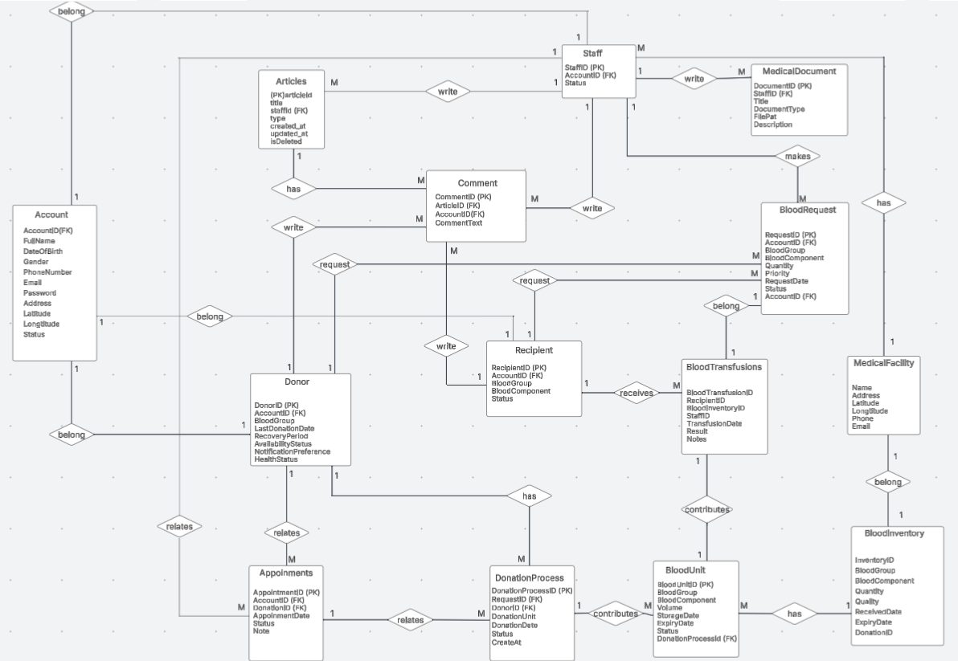
Figure 3: Logical diagram

4.2 Data Dictionary

4.2.1 Account Table

Data Element | Description | Composition or Data Type | Length | Values
AccountID | Unique identifier | String | 36
FullName | User's full name | String | 100
DateOfBirth | Date of birth | Date,MM/DD/YYYY
Gender | Gender of the user | String |  | Male, Female, Other
PhoneNumber | Contact number | String | 15
Email | Email address | String | 100
Password | Hashed password | String | 255
Address | Home address | String | 255
Latitude | Geo latitude | Float
Longitude | Geo longitude | Float
Status | Account activity status | Enum |  | Active, Inactive

4.2.2 Staff Table

Data Element | Description | Composition or Data Type | Length | Values
StaffID | Unique staff ID | String | 36
AccountID | Link to Account | String | 36
Status | Employment status | Enum |  | Active, Inactive

4.2.3 Donor Table

Data Element | Description | Composition or Data Type | Length | Values
DonorID | Unique donor ID | String | 36
AccountID | Link to Account | String | 36
BloodGroup | Blood type | Enum |  | A, B, AB, O
LastDonationDate | Last date of donation | Date,MM/DD/YYYY
RecoveryPeriod | Recovery days after donation | Integer
AvailabilityStatus | Donation availability status | Enum |  | Available, Unavailable
NotificationPreference | Whether to notify donor | Boolean |  | true, false
HealthStatus | Health condition status | String | 255

4.2.4 Recipient Table

Data Element | Description | Composition or Data Type | Length | Values
RecipientID | Unique recipient ID | String | 36
AccountID | Link to Account | String | 36
BloodGroup | Blood type | Enum |  | A, B, AB, O
BloodComponent | Type of needed blood product | String | 50
Status | Case status | Enum |  | Waiting, Transfused

4.2.5 Appointment Table

Data Element | Description | Composition or Data Type | Length | Values
AppointmentID | Unique appointment ID | String | 36
AccountID | Link to Account | String | 36
DonorID | Link to Donor | String | 36
AppointmentDate | Date of appointment | Date,  MM/DD/YYYY
Status | Appointment status | Enum |  | Scheduled, Completed, Cancelled
Note | Additional notes | String | 255

4.2.6 DonationProcess Table

Data Element | Description | Composition or Data Type | Length | Values
DonationProcessID | Unique donation process ID | String | 36
RequestID | Link to request | String | 36
DonorID | Link to donor | String | 36
DonationUnit | Quantity donated | Integer
DonationDate | Date of donation | Date,  MM/DD/YYYY
Status | Process status | Enum |  | In Progress, Completed
CreatedAt | Record creation timestamp | Timestamp

4.2.7 BloodUnit Table

Data Element | Description | Composition or Data Type | Length | Values
BloodUnitID | Unique blood unit ID | String | 36
BloodGroup | Blood type | Enum |  | A, B, AB, O
BloodComponent | Component type | String | 50
Volume | Volume in milliliters | Integer
StorageDate | Date stored | Date
ExpiryDate | Expiration date | Date
Status | Current state of unit | Enum |  | Stored, Used, Expired
DonationProcessID | Linked donation process | String | 36

4.2.8 BloodRequest Table

Data Element | Description | Composition or Data Type | Length | Values
RequestID | Unique request ID | String | 36
AccountID | Requester account ID | String | 36
BloodGroup | Requested blood group | Enum |  | A, B, AB, O
BloodComponent | Blood component needed | String | 50
Quantity | Units required | Integer
Priority | Urgency level | Enum |  | Low, Medium, High
RequestDate | Date of request | Date,MM/DD/YYYY
Status | Current status | Enum |  | Pending, Approved, Fulfilled
AccountID (FK) | Redundant or audit trail field | String | 36

4.2.9 BloodInventory Table

Data Element | Description | Composition or Data Type | Length | Values
InventoryID | Unique inventory ID | String | 36
BloodGroup | Blood type | Enum |  | A, B, AB, O
BloodComponent | Component type | String | 50
Quantity | Quantity available | Integer
Quality | Quality check result | String | 50
ReceivedDate | Date added to inventory | Date, MM/DD/YYYY
ExpiryDate | Expiry date | Date
DonorID | Linked donor | String | 36

4.2.10 BloodTransfusions Table

Data Element | Description | Composition or Data Type | Length | Values
BloodTransfusionID | Unique transfusion ID | String | 36
RecipientID | Transfusion recipient | String | 36
BloodUnitID | Transfused blood unit | String | 36
StaffID | Responsible staff | String | 36
TransfusionDate | Date of transfusion | Date, MM/DD/YYYY
Result | Outcome of transfusion | String | 255
Notes | Additional information | Text

4.2.11 MedicalFacility Table

Data Element | Description | Composition or Data Type | Length | Values
Name | Facility name | String | 100
Address | Physical address | String | 255
Latitude | Geo coordinate | Float
Longitude | Geo coordinate | Float
Phone | Contact number | String | 15
Email | Contact email | String | 100

4.2.12 Articles Table

Data Element | Description | Composition or Data Type | Length | Values
ArticleID | Unique article ID | String | 36
Title | Title of article | String | 255
StaffID | Author (Staff) | String | 36
Type | Article category | String | 50
Created_at | Creation timestamp | Timestamp
Updated_at | Last update timestamp | Timestamp
IsDeleted | Soft delete flag | Boolean |  | true, false

4.2.13 Comment Table

Data Element | Description | Composition or Data Type | Length | Values
CommentID | Unique comment ID | String | 36
ArticleID | Linked article | String | 36
AccountID | Comment author | String | 36
CommentText | Text content | Text

4.2.14 MedicalDocument Table

Data Element | Description | Composition or Data Type | Length | Values
DocumentID | Unique document ID | String | 36
StaffID | Creator of document | String | 36
DocumentType | Type of document | String | 50
FilePath | File storage path | String | 255
Description | Additional description | Text

4.3 User Story

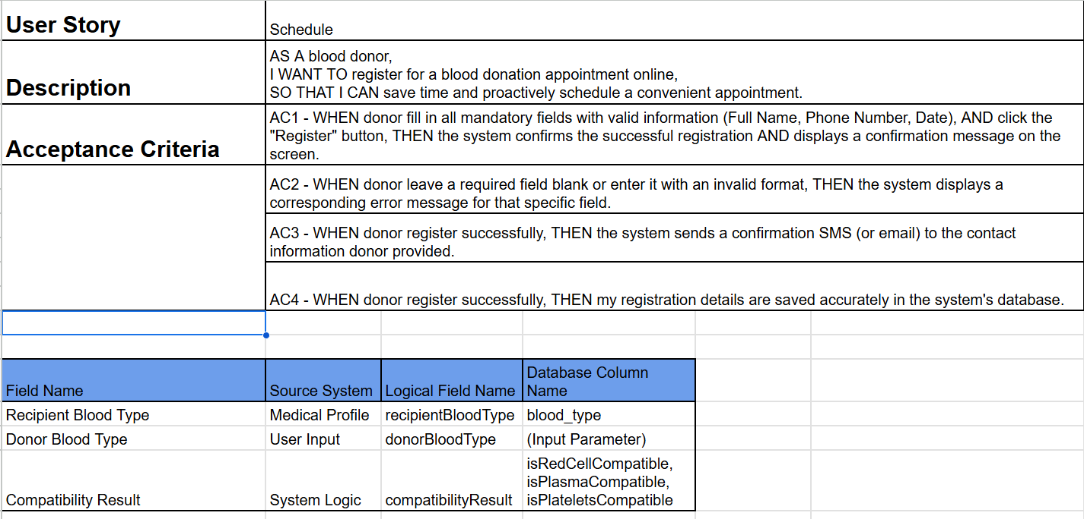
Figure 4: Schedule

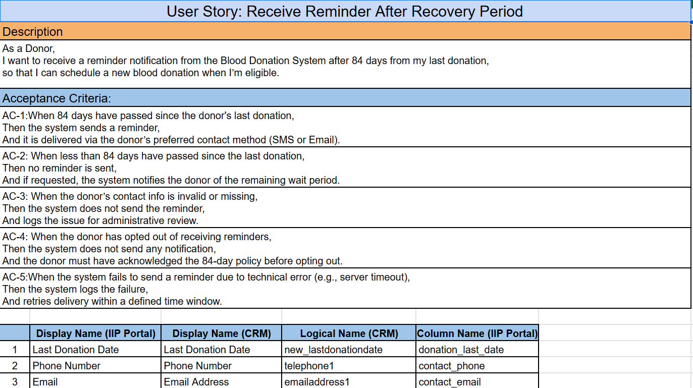
Figure 5: Receive Reminder After Recovery Period

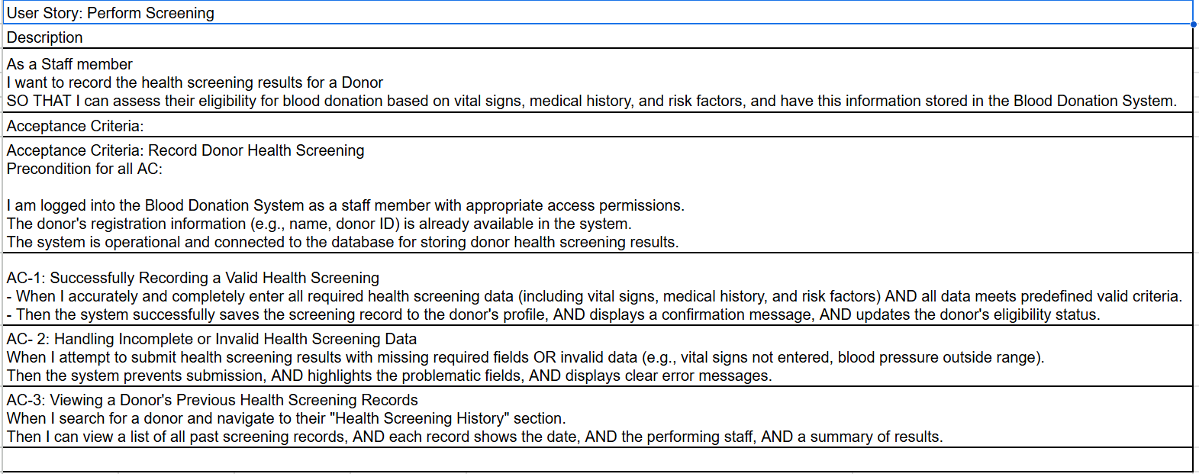

Figure 6: Perform Screening

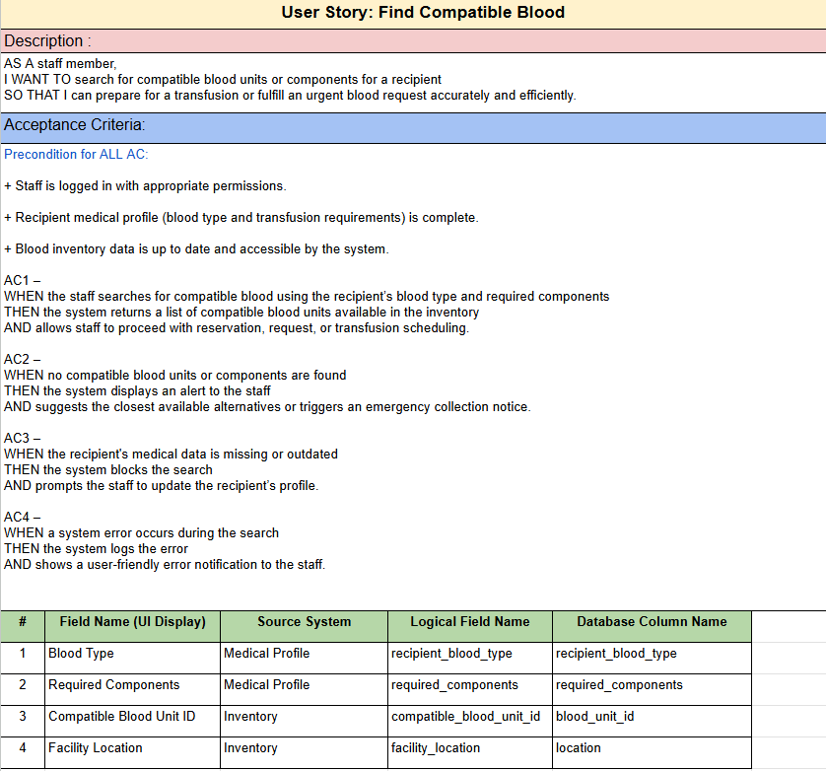
Figure 7: Find Compatible Blood

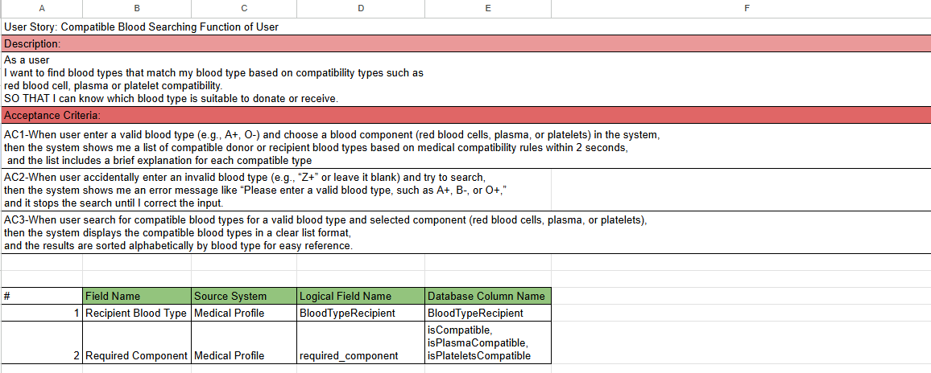

Figure 8: Compatible Blood Searching Function of User

5. External Interface Requirements
This section defines the system’s interaction with external entities including users, hardware devices, other systems, and communication channels. The goal is to ensure interoperability, usability, and seamless integration across diverse environments.

5.1 User Interfaces (UI)
The user interface plays a critical role in enabling seamless interaction with the system across devices and user roles.
- UI-1: The system must provide a modern web interface compatible with popular browsers such as Chrome, Firefox, and Microsoft Edge.
- UI-2: The UI shall employ responsive design principles to automatically adjust layout and content for desktops, tablets, and smartphones.
- UI-3: Each user shall be presented with a customized dashboard based on their role (Donor, Recipient, Medical Staff, Administrator).
- UI-4: Forms must be provided for account registration, profile management, blood donation/transfusion requests, and feedback submission.
- UI-5: System feedback and notifications should be shown via modals or toast messages to alert users of important updates.
- UI-6: Secure login/logout functionality must be supported, with session timeout indicators to alert users before session expiration.

5.2 System Interfaces (SI)
These interfaces define how the system integrates with third-party services and internal modules.
- SI-1: The system must support third-party authentication providers such as Google OAuth and institutional Single Sign-On (SSO) solutions.
- SI-2: Optional integration with email/SMS APIs (e.g., SendGrid, Twilio) should be supported to deliver reminders and transactional messages.
- SI-3: Internal services such as inventory, appointment scheduling, and health screening should expose RESTful APIs using standardized JSON formats.

5.3 Communication Interfaces (CI)
Reliable and secure communication protocols are essential for data integrity and operational efficiency.
- CI-1: All communication between client and server must use HTTPS to ensure encrypted transmission.
- CI-2: The system must support SMTP or third-party email APIs for sending password resets, confirmations, and notifications.
- CI-3: Integration with SMS gateways (e.g., Twilio, Viettel SMS Gateway) is required to deliver real-time alerts and reminders.

5.4 Hardware Interfaces (HI)
Hardware interfaces enable compatibility with typical user devices and medical tools.
- HI-1: The backend system shall be hosted on Linux-based servers or cloud infrastructure (e.g., AWS, GCP, Azure) to support scalability and reliability.
- HI-2: End-user devices such as laptops, tablets, and smartphones must have internet access and a modern browser to interact with the system.
- HI-3: Optional support for barcode scanners must be available to identify blood units and prevent human error during transfusion processes.

6. Quality Attributes
This section outlines the non-functional qualities the system must exhibit to operate reliably, efficiently, and securely in a real-world healthcare and blood donation environment. These attributes ensure long-term maintainability, user satisfaction, and operational stability.

6.1 Usability
The system must be intuitive, accessible, and user-friendly for a wide range of users, including administrative staff, medical professionals, and non-technical personnel. The goal is to ensure that users can efficiently navigate and interact with the application without extensive training or technical knowledge.
- USE-1: The User Interface (UI) must comply with the Web Content Accessibility Guidelines (WCAG) 2.1. This includes minimum font sizes (≥14pt), strong color contrast ratios (≥4.5:1), keyboard-navigable elements, clearly visible input fields, and accessible button sizes (≥44px) for touch interaction. These measures support users with visual impairments, motor limitations, and cognitive challenges.
- USE-2: The interface should adapt dynamically based on user roles. For example, a receptionist should only see check-in and scheduling functions, while an administrator can access system settings. Role-based UI personalization reduces cognitive overload and helps users focus on relevant actions without distraction or error.
- USE-3: All critical actions, such as submitting forms, confirming appointments, or updating records, must trigger real-time visual feedback. This includes spinners during processing, progress bars for long actions, success/failure banners, and dialog confirmations. Absence of feedback can lead to confusion or repeated submissions.
- USE-4: Error messages and system instructions should be written in clear, non-technical language. Avoid exposing backend exceptions (e.g., “Unhandled 500 Error”), and instead use messages like “There was an error processing your request. Please try again later.” Input validation errors should guide users constructively (“Please enter a valid phone number.”).

6.2 Performance
The system must maintain fast response times, efficient resource usage, and scalability under high user loads or large data sets. Performance issues directly impact user productivity and the ability to deliver healthcare services without delay.
- PER-1: Common operations such as login, search, and form submissions must complete within 2 seconds, with a target of <1 second under normal conditions (<100 concurrent users). Slow responses interrupt clinical workflows and reduce user trust in the system.
- PER-2: Data-intensive modules (e.g., blood inventory, patient medical history) must use asynchronous loading with techniques such as pagination and virtual scrolling. Avoid fetching or rendering large datasets (e.g., 10,000 records) at once to prevent UI freezing or browser crashes.
- PER-3: For large file uploads (e.g., scanned documents, lab reports, medical images):
  - Show a real-time progress bar and status messages.
  - Provide instant validation if a file exceeds allowed size (e.g., images ≤ 5MB, PDFs ≤ 10MB).
  - Support background uploading, allowing users to continue other actions while the file is being transferred.
- PER-4: The system must support a minimum of 200 concurrent users during peak hours without significant performance degradation. Server autoscaling, load balancing, and backend optimization strategies should be implemented to maintain responsiveness.
- PER-5: Performance testing must be scheduled regularly, including:
  - Stress testing to evaluate system limits under extreme load.
  - Load testing to verify expected usage patterns.
  - Soak testing to assess long-term system endurance.
These help identify performance bottlenecks and validate the underlying architecture.

6.3 Security
Given the system handles sensitive personal and medical information, a strong security model is essential to protect data confidentiality, integrity, and availability. Compliance with data protection regulations is mandatory.
- SEC-1: Role-Based Access Control (RBAC) must be enforced across all modules. Administrator-level accounts should have optional Two-Factor Authentication (2FA) using Time-based One-Time Passwords (TOTP) or external apps like Google Authenticator.
- SEC-2: User passwords must be stored using secure one-way hashing algorithms such as bcrypt or Argon2, with salt and high iteration counts. Passwords must never be stored in plaintext or easily reversible formats.
- SEC-3: All form inputs and API endpoints must be protected against common web attacks:
  - Cross-Site Scripting (XSS): Use input sanitization and output encoding.
  - Cross-Site Request Forgery (CSRF): Use CSRF tokens and same-site cookie policies.
  - Additional headers (e.g., Content-Security-Policy) are encouraged for hardening.
- SEC-4: All sensitive operations (e.g., record deletion, role changes, medical data access) must be logged in a secure audit trail with timestamps, IP addresses, user IDs, and event types. Logs should be tamper-proof and regularly reviewed.
- SEC-5: Sensitive data must be:
  - Encrypted at rest using AES-256 or equivalent.
  - Encrypted in transit using TLS 1.2 or higher.
  - Cryptographic key management should follow best practices, including rotation and secure storage.

6.4 Safety
The system must proactively prevent unintentional data loss, misconfigurations, or critical errors that could impact patient safety or disrupt clinical workflows.
- SAF-1: Risk-prone actions (e.g., account deletion, cancellation of confirmed appointments) must trigger double confirmation dialogs with clear warnings such as “This action is irreversible. Are you sure you want to proceed?”
- SAF-2: Validation logic must prevent incomplete or logically conflicting entries, particularly in critical workflows like blood transfusion compatibility. For example, a transfusion cannot proceed without verified blood type results.
- SAF-3: Access to health records must be strictly limited to authorized personnel. Enforcement of the principle of least privilege is required. Unauthorized access must be detectable through comprehensive logging and alerts.
- SAF-4: During multi-step operations, the system should preserve state checkpoints or autosave progress, allowing users to recover from interruptions (e.g., browser crash, network drop) without data loss.

6.5 Availability
High system availability is crucial, especially in emergency situations or high-demand periods such as mass donation campaigns. Downtime can directly interfere with service delivery.
- AVL-1: The system must maintain ≥99.9% uptime annually, which allows for no more than ~8.76 hours of unscheduled downtime per year (excluding planned maintenance windows).
- AVL-2: Critical services must be deployed in a highly available architecture, including:
  - Load-balanced application servers.
  - Redundant database clusters.
  - Automatic failover in case of infrastructure failure (multi-zone redundancy).
- AVL-3: Scheduled maintenance must be announced at least 24 hours in advance through email, SMS, and/or system notifications. Notices should include expected downtime duration and affected services.
- AVL-4: Integrate real-time monitoring tools such as Prometheus, Grafana, New Relic, or equivalent to detect anomalies early. Alerting systems should notify relevant personnel immediately upon service degradation or failure.

6.6 Robustness
The system must remain operational and recover gracefully from unexpected runtime errors, infrastructure failures, or data inconsistencies. Stability under adverse conditions is critical.
- REL-1: All system errors must be handled gracefully with user-friendly messages. For example, instead of showing “HTTP 500 – Internal Server Error”, display: “We’re experiencing a temporary issue. Please try again shortly.” Avoid exposing stack traces or sensitive server information to end-users.
- REL-2: Background jobs such as email sending, third-party API sync, and report generation must support automatic retries with exponential backoff in case of transient network or service failures. Implement job queues (e.g., RabbitMQ, Azure Queues) to ensure reliable delivery.
- REL-3: Medical operations (e.g., donation record creation, test result submission) must be executed in atomic transactions. Either all steps succeed, or none are applied. This prevents inconsistent data states such as partial record updates or duplicate entries.
- REL-4: Regular data backups must be performed:
  - Hourly for transactional data.
  - Daily for document storage.
  - Weekly for full system snapshots.
Backups must be stored off-site or in a separate cloud region. A documented and tested disaster recovery plan must enable full system restoration within 4 hours of a critical failure.

7. Diagram

7.1. Swimlane
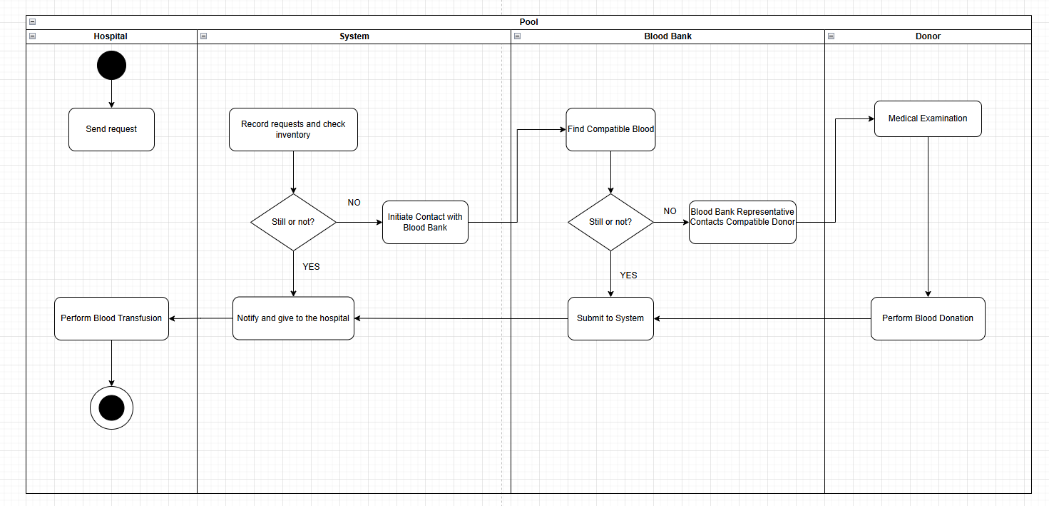

Figure 9 : Manage the blood donation process from the time of submitting a blood request until the blood donation is completed

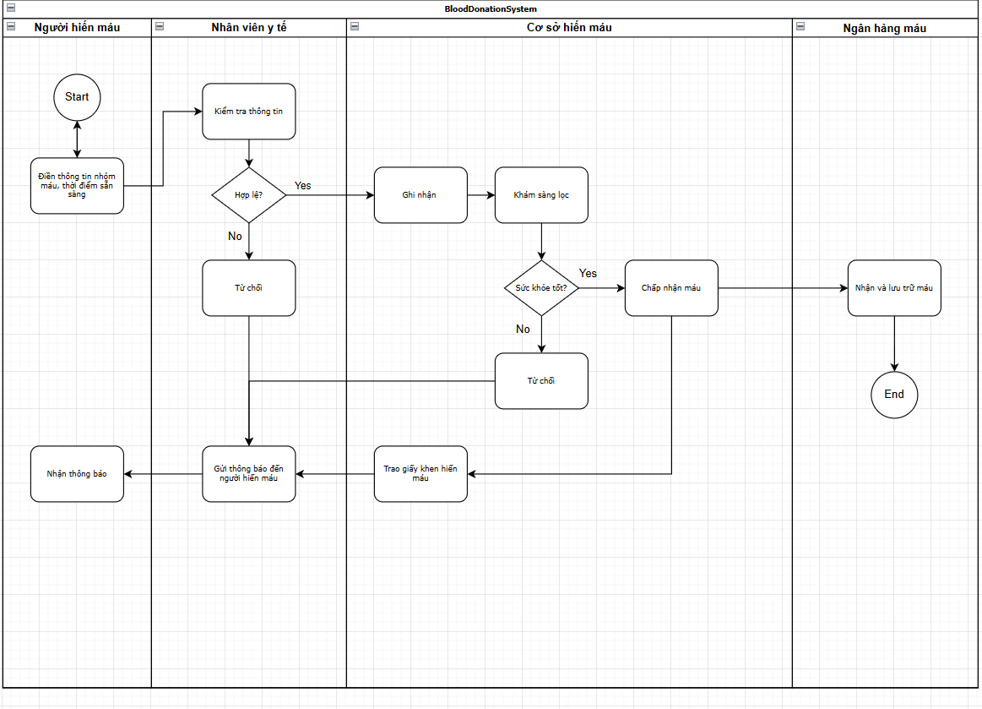

Figure 10: Reminder of blood recovery time
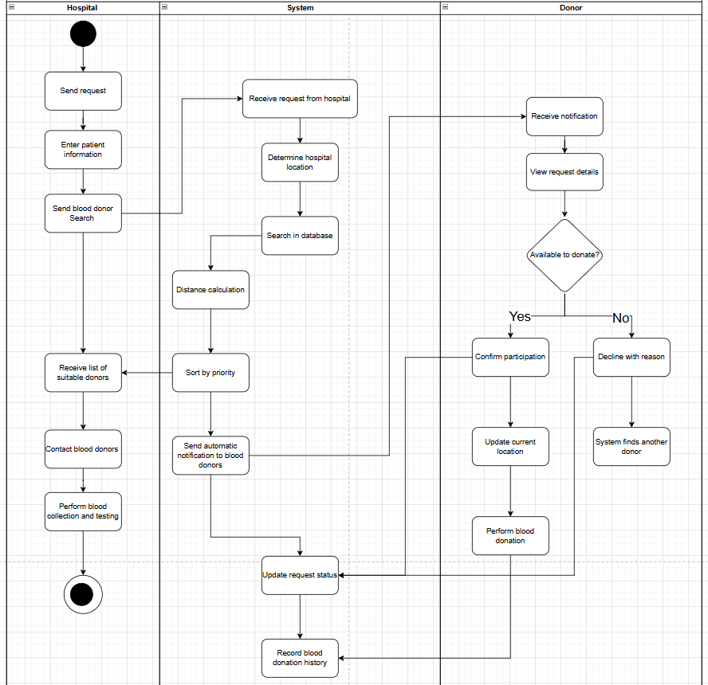

Figure 11: Searching for people needing blood and blood donors by distance.

7.2. State Chart
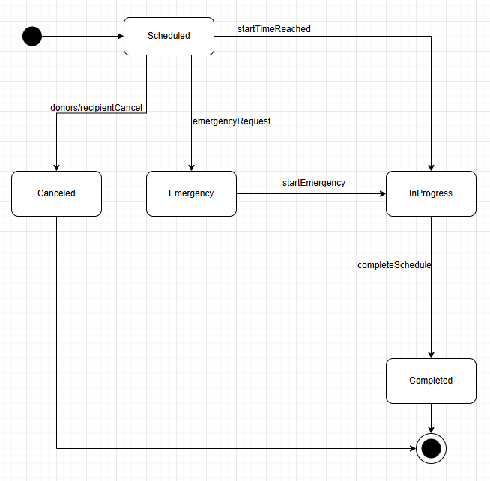

Figure 12: This diagram describes the main states and events that trigger state transitions of a blood donation schedule, especially handling cancellation and emergency situations.
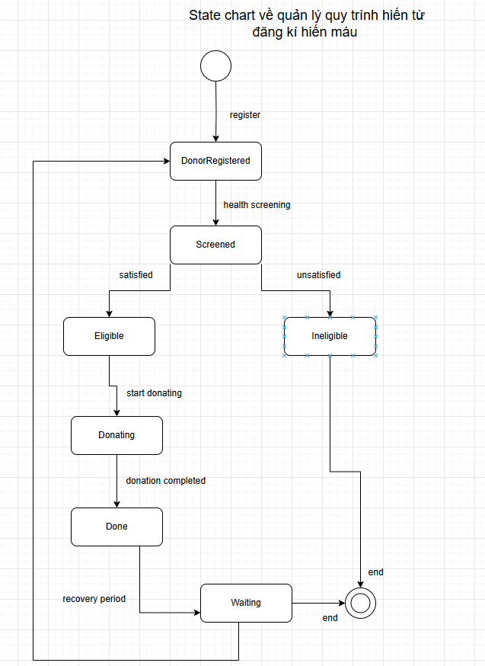
Figure 13: Manage the donation process from blood donation registration

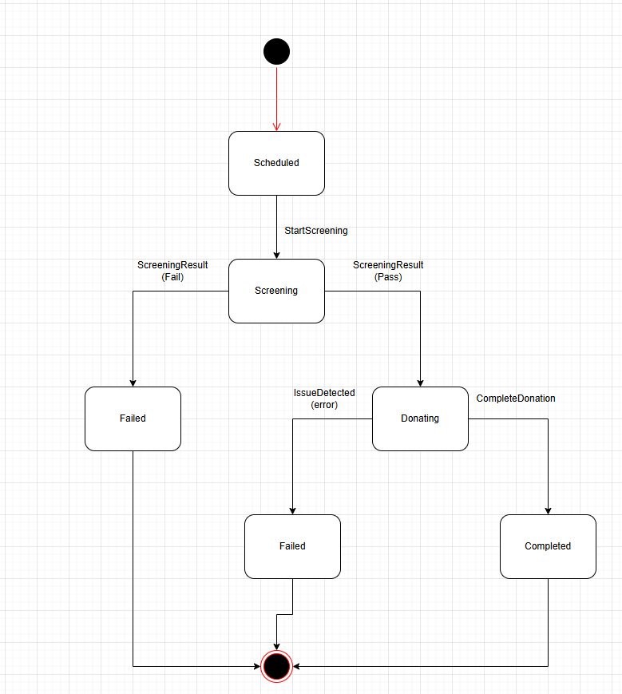
Figure 14: The states a blood donation session can go through, along with the event that triggers the transition between those states.

