

Drug Use Prevention Support System
Software Requirement Document

– HCM, July 2025–

Record of changeS
Date | A*  M, D | In charge | Change Description
13/Apr | A | LocTQ | Add Survey Result Function (Front End)
*A - Added M - Modified D - Deleted

Table of Contents
I. Overview.. 4
1. Introduction. 4
2. Existing Systems. 4
2.1 System name1. 4
2.2 System name2. 4
3. Business Process. 5
4. System Functions. 6
5. Entity Relationship Diagram.. 7
6. State transition diagram.. 7
II. Functional Requirements. 9
1. <<Feature Name 1>>. 9
a. <<Function Name 1>>. 9
b. <<Function Name 2>>. 9
2. <<Feature Name 2>>. 9
III. Database Design. 10
1. Database Schema. 10
2. Table Detail 10

I. Overview

1. Introduction
The Drug Use Prevention Support System is a web-based platform developed for a volunteer organization to combat drug use through education, risk assessment, and consultation. The system provides a centralized hub for users to access online training courses on drug awareness, refusal skills, and prevention strategies tailored to different age groups. It includes risk assessment surveys to evaluate drug use risk and recommend actions, online consultation scheduling with professionals, and management of community events. The system replaces manual processes, offering a scalable, user-friendly solution with future integration potential for external services like payment gateways. Key constraints include compliance with data protection regulations and support for Vietnamese language interfaces. Assumptions include reliable internet access for users and availability of consultants.
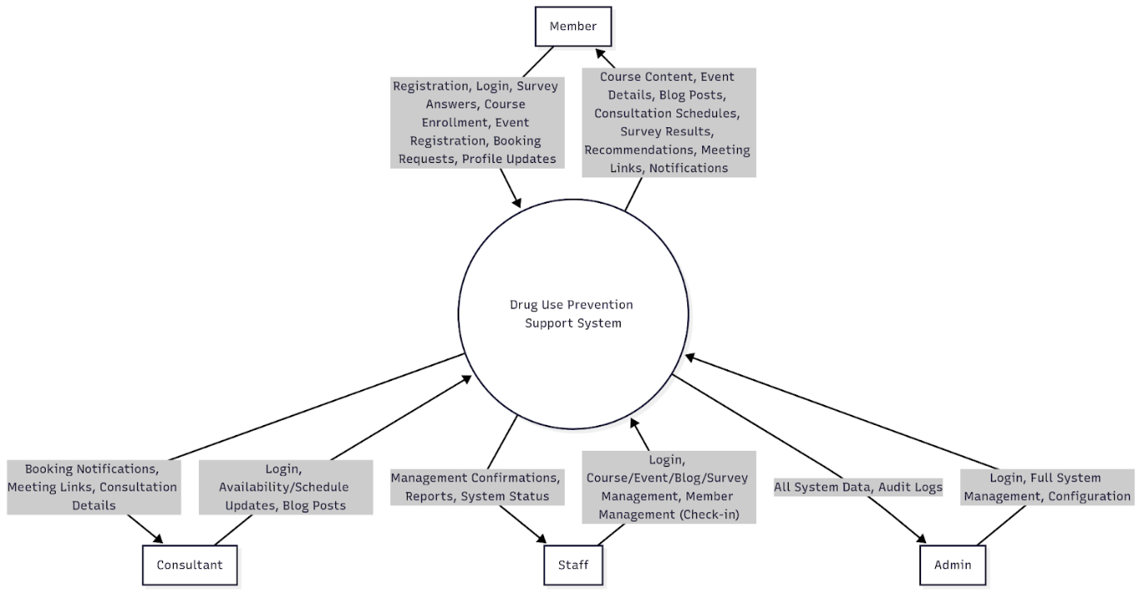

2. Existing Systems
[Add the system which might help solving the problems you listed above or the systems in which you can learn/refer the features for your system design]

2.1 System name1
[Write the brief descriptions of the system, the link, the system actors, features, pros, cons, etc.]

2.2 System name2
…

3. System Features

3.1 Use-case Diagram

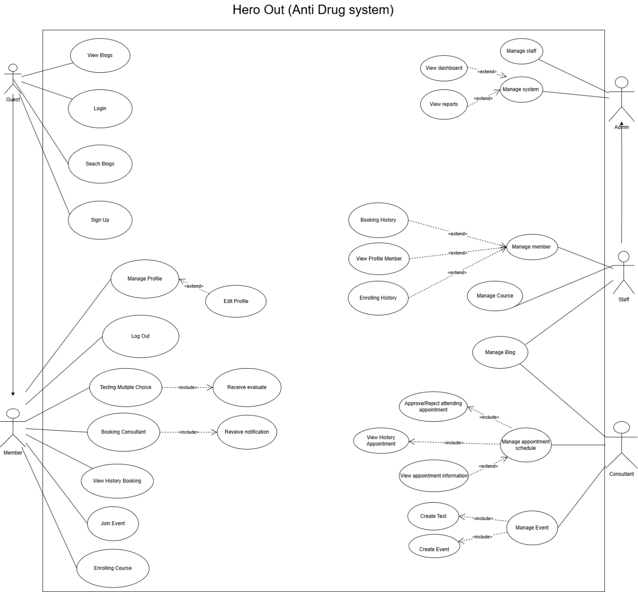
3.2 Use-Case

ID and Name: | UC-01: Register New Account
Created By: | Duynckse171155@fpt.edu.vn | Date Created: | 25/06/2025
Primary Actor: | Guest | Secondary Actors:
Description: | A guest who wants to use the system's personalized features
Trigger: | The Guest want to register to use all service of system
Preconditions: | None
Postconditions: | logs the user into their new account and redirects them to their HomePage.
Normal Flow: | 1.0 Register new account  1. Guest clicks the "Register" button.  2.System presents the new account registration form, requesting details such as Full Name, Email Address, and Password, Gender, Date Of Birth.  3. Guest completes and submits the form.  4. System validates the submitted data.
Alternative Flows:
Exceptions: | Invalid Data  1. In step 4 of the normal flow, if the submitted data fails validation (e.g., weak password, invalid email format).  2. System displays an error message indicating which fields are invalid.  3. The use case returns to step 3.  Account Already Exists  1. In step 4 of the normal flow, if the chosen email address already exists in the system.  2. System displays an error message: "This email is already taken."  3. The use case returns to step 3.
Priority: | High
Frequency of Use: | High. This is one of the most frequently used features, serving as the entry point for all visitors.
Business Rules:
Other Information: | This use case is crucial for providing essential information to potential new patients and the general public.
Assumptions: | 1. The Guest has a device with a compatible web browser and an active internet connection.

ID and Name: | UC-03: Login
Created By: | Duynckse171155 | Date Created: | 30/06/2025
Primary Actor: | Authenticated User | Secondary Actors:
Description: | A registered user provides their credentials to gain secure access to their role-specific functionalities and data within the system
Trigger: | An Auth User submits their username and password on the login page.
Preconditions: | PRE-1. The user has an active, registered account in the system
Postconditions: | POST-1. The System establishes a secure session for the user.  POST-2. The user is redirected to their role-specific dashboard.
Normal Flow: | Login into system  1. User navigates to login page.  2. User enters their email and password.  3. User clicks the "Login" button.  4. System validates the credentials against the user database.  5. System creates a user session and directs the user to their dashboard.
Alternative Flows: | None.
Priority: | High
Frequency of Use: | Very High. Used every time a registered user needs to access the system.
Business Rules: | None
Assumptions: | None

ID and Name: | UC-08: Booking Appointment
Created By: | Duynckse171155@fpt.edu.vn | Date Created: | 30/06/2025
Primary Actor: | MEMBER | Secondary Actors:
Description: | A MEMBER want to booking appointment to get consulation about risk level using drug
Trigger: | The member expresses a desire to schedule an appointment for HIV consultation with consultant.
Preconditions: | Member is logged into the System.  At least one consultant has a work schedule defined in the system.
Postconditions: | The appointment is stored in the System with a status of "Booked".  The consultant’s schedule is updated, marking the selected time slot as "Unavailable".  The new appointment is visible on the daily schedule view for relevant Staff members.
Normal Flow: | Book Consultation Appointment  1. Member requests to book an appointment.  2. System displays a consolidated calendar showing all dates with at least one available appointment slot across all Consultant.  3. Member selects an available date.  4. System displays all available time slots for that date from all Consultant.  5. Member selects a time slot.  7. System displays a summary screen with the appointment details (date, time).  8. System validates that the time slot is still available with at least one consultant.  9. System assigns an available consultant for that slot, creates the appointment record, and updates the assigned consultant's schedule.
Priority: | High
Frequency of Use: | Approximately 5-20 appointments are booked via the system daily
Other Information: | The Member shall be able to cancel an appointment. (This references use case UC-12: Cancel Appointment).
Assumptions: | 1. The work schedules for all doctors in the HTMS are accurate and up-to-date.

ID and Name: | UC-20: Create Course
Created By: | Duynckse171155@fpt.edu.vn | Date Created: | 30/6/2025
Primary Actor: | Staff | Secondary Actors: | None
Description: | A Staff create the new Course sort by age for member to join the course about Drug use.
Trigger: | The staff decided to add a new course to improve members' knowledge about drugs.
Preconditions: | PRE-1. Staff is logged into the system.
Postconditions: | POST-1. A new course is created and stored in the system as a draft or published article.
Normal Flow: | 1. Staff requests to create a new course.  2. System displays a blog entry form with fields title, content, age chapter ….  3. Staff enters the Course content and submits.  4. System saves the course and confirms creation.
Alternative Flows: | None
Exceptions: | 1.0.E1 Missing Course Content  System prompts the staff to complete required fields if any are empty.
Priority: | High
Other Information: | none
Assumptions | Staff have rights to create content.

ID and Name: | UC-27: Create Survey Question
Created By: | Duynckse171155@fpt.edu.vn | Date Created: | 30/6/2025
Primary Actor: | Staff | Secondary Actors: | None
Description: | staff create knowledge questions related to drugs and cocaine for users to take the quiz
Trigger: | Staff selects “Create Survey Question”.
Preconditions: | Staff is authenticated and authorized to access survey Question
Postconditions: | List Question have been created
Normal Flow: | 1. Staff go to Survey Question Function  2. Selects Create Survey Question.  3. Enters content.  4. Save and display for member to do multiple choice
Alternative Flows: | None
Priority: | Medium

4. System Functions

a. Screen Flow
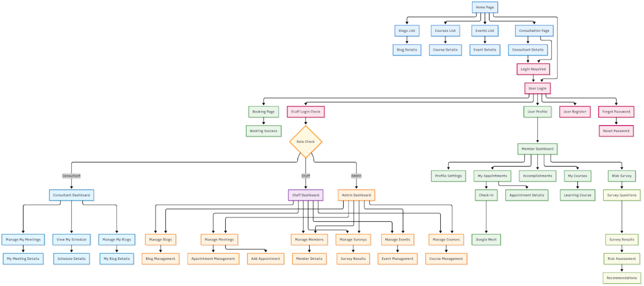

b. Screen Details
[Provide the descriptions for the screens in the Screens Flow above]

# | Feature | Screen | Description
1 | Booking | Choose Consultant
2 | Booking | Choose Date, Slot
3 | Booking | Confirm Appointment
4 | Manage Booking | View Appointment
5 | Register Slot Booking | View And Register Slot for Consultant

c. User Authorization
[Provide the system roles authorization to the system features (down to screens, and event to the screen activities if applicable) in the table form as below – replace Role1, Role2,… with the specific system user role names]
Screen | Member | Consultant | Staff | Admin
<<Course>> | X |  | X | X
View Course | X |  | X | X
View Detail Course | X
Join Course | X
View Learning Course | X
Add New Course |  |  | X | X
Delete Course |  |  | X | X
<<Event>> | X |  | X | X
View Event | X |  | X | X
Join Event | X
View Participants |  |  | X | X
CheckIn |  |  | X | X
CheckOut |  |  | X | X
Add New Event |  |  | X | X
Edit Event |  |  | X | X
Delete Event |  |  | X | X
<<Booking>> | X |  |  | X
View All Consultant Slot | X | X | X | X
View Own Slot |  | X | X | X
View Managed Appointment |  |  | X | X
Add New Slot |  | X | X | X
Update All Slot |  |  | X | X
Update Own Slot |  | X | X | X
In which:
· Role1: <<role1 description>>
· Role2: <<role2 description>>
· …

5. Entity Relationship Diagram
[Provide the entity relationship diagram and the entity descriptions in the table format as below]
Entities Description
# | Entity | Description
1 | ACCOUNT
2 | CONSULTANT
3 | Survey Result
4 | Appointment
5 | Slot
6 | Schedule
7 | Event
8 | Event Participation
9 | Course | Represents a course that includes details such as title, description, objectives, overview, status, and target age group. A course contains multiple chapters.
10 | Chapter | Represents a chapter within a course. Each chapter belongs to a single course and includes specific content.
11 | Enrollment | Represents a user’s enrollment in a specific course. It includes references to the account and course, enrollment date, and progress status.
12 | EnrollmentChapter | Tracks the learner’s progress for each chapter of an enrolled course. Each record links a learner (via account), a course enrollment, and a specific chapter.
13 | Blog

6. State transition diagram
[This part shows state transition of main entities in the system]
<<Sample: a state-transition diagram that shows the possible meal order statuses and the allowed changes in status.
>>
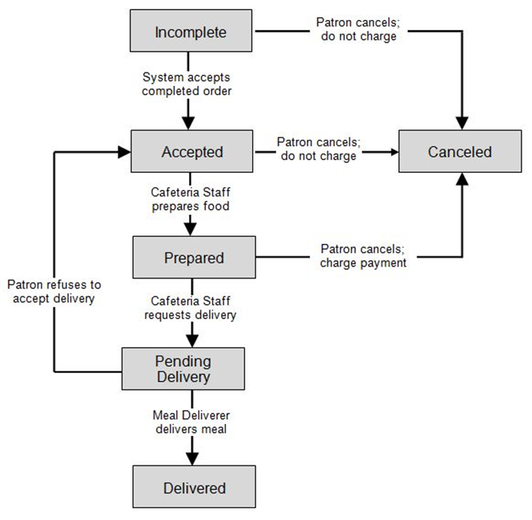

II. Functional Requirements

1. <<Authentication >>

a. <<Login>>
[A function can be a screen or a non-screen function (listed in the part I.2.d above). In this part, you need to provide the details on the related function, focus on mentioning below information
· Function trigger: how this function is triggered (navigation path, a timing frequency, etc.)
· Function description: actors/roles, purpose, interface, data processing, etc.
· Screen layout: mockup prototype of the screen, sample below is for Manage Products screen
· Function Details: provide explanation for the data, validation, business logics, functionalities (for both normal cases and abnormal cases), etc. of the function so that the reader can image how it work.

· Function trigger:
User click “Login” button at HomePage, this will be route to Login screen
· Function description:
actors/roles, purpose, interface, data processing, etc.
· Screen layout:
mockup prototype of the screen, sample below is for Manage Products screen
· Function Details:
provide explanation for the data, validation, business logics, functionalities (for both normal cases and abnormal cases), etc. of the function so that the reader can image how it work.

]

b. <<Sign - up>>
…

2. <<Event Participation>>

a. <<Event Registration>>:

✅ Function Trigger
- Navigation path:
From the Event List screen, the user clicks on an event → navigates to the Event Detail screen, where a "Register" button is available.
- Trigger condition:
When the user clicks the "Register" button on the event detail page.
- Timing:
On-demand (triggered manually by the user).

✅ Function Description
- Actors/Roles:
Logged-in User (role = MEMBER)
- Purpose:
Allow users to register their participation in a community event.
- Interface:
Web interface – button interaction on the event detail screen.
- Data processing:
  - Insert a new record into the eventPaticipation table linking the current user and the selected event.
  - Check for duplicate registration before inserting.
  - Return success/failure notification to the user.

✅ Function Details :
- Input: Logged-in user + event ID
- Validation:
  - User must be logged in
  - Event must exist and not expired
  - User has not already registered
- Business Logic:
  - Check for existing registration
  - If not exists → create new EventRegistration with timestamp
- Success:
  - Show message: "Registration successful"
- Failure:
  - Already registered → "You have already registered"
  - Not logged in → redirect to login
  - Invalid event → show error message
- Output: JSON or UI message confirming registration result

b. <<Event Check-in>>:

✅ Function Trigger
- Navigation path:
From the Event Attendee List screen, staff selects a member who registered → clicks the "Check-in" button.
- Trigger condition:
Staff clicks the "Check-in" button next to a member’s name in the list.
- Timing:
On event day, during member arrival.

✅ Function Description
- Actors/Roles:
Staff (role = STAFF or ADMIN)
- Purpose:
Confirm that a registered member is present at the event.
- Interface:
Web-based UI with check-in button per registered member.
- Data processing:
  - Update the corresponding EventRegistration record’s checkInTime or status.
  - Prevent duplicate check-ins.

✅ Function Details
- Input: Staff account + registered member ID + event ID
- Validation:
  - Member must be registered
  - Not already checked in
  - Staff must be authorized
- Business Logic:
  - Find EventRegistration record
  - Set status = CHECKED_IN, update checkInTime
- Success:
  - Show message: "Check-in successful"
- Failure:
  - Already checked in → "Member already checked in"
  - Not registered → show error
  - Unauthorized staff → access denied
- Output: UI or JSON response confirming check-in status

3. <<Course>>

a. <<Course Creation>>
✅ Function Trigger
- Navigation path:
From the Admin Dashboard, the admin clicks “Create New Course” button.
- Trigger condition:
When the admin fills the course creation form and clicks “Save”.
- Timing:
On-demand (triggered manually by admin).
✅ Function Description
- Actors/Roles:
Admin or Staff
- Purpose:
Allow admins to create a new course and (optionally) add chapters.
- Interface:
Web admin interface – form with title, description, objectives, overview, age group, chapter list.
- Data processing:
  - Insert new record into Course table
  - Auto-set status = ACTIVE and createdAt
  - If chapters exist → insert to Chapter table linked to course
  - Add default enrollment with null account and NOT_STARTED status (optional)
✅ Function Details
- Input:
CourseRequest DTO: title, description, objectives, overview, ageGroup, chapters
- Validation:
  - Required fields: title, ageGroup
  - Chapter title and content (if present) must not be empty
- Business Logic:
  - Save Course
  - Save Chapters (if any) with course reference
- Success:
Show message: “Course created successfully”
- Failure:
  - Validation failed → show field-specific message
  - DB error → show error message
- Output:
JSON CourseCreateResponse with course info and chapters

b. <<Course Detail Viewing>>
✅ Function Trigger
- Navigation path:
From Course List, user clicks on a course → navigates to detail screen
- Trigger condition:
User opens a course detail view
- Timing:
On-demand
✅ Function Description
- Actors/Roles:
Guest or Logged-in user
- Purpose:
Let users view course info before enrolling
- Interface:
Web interface
- Data processing:
  - Retrieve course by ID
  - Include chapter list
  - Count total enrollments (only with non-null account)
✅ Function Details
- Input:
courseId
- Validation:
Course must exist
- Business Logic:
  - Fetch course with chapters
  - Count enrollments
- Success:
Return full course details
- Failure:
Course not found → show error
- Output:
JSON CourseResponse

c. <<Course Status Update>>
✅ Function Trigger
- Navigation path:
Admin selects "Change Status" in Course List
- Trigger condition:
Admin selects a new status and confirms
- Timing:
On-demand
✅ Function Description
- Actors/Roles:
Admin
- Purpose:
Change course availability (ACTIVE/INACTIVE)
- Interface:
Admin web interface
- Data processing:
  - Update status field
  - Prevent updating to the same status
✅ Function Details
- Input:
courseId, status
- Validation:
  - Course must exist
  - Status must be valid and different
- Business Logic:
  - If valid → update status
- Success:
Show message: "Course status updated successfully"
- Failure:
  - Invalid status → "Invalid status"
  - Already same → "Course is already in status: X"
- Output:
JSON confirmation

d. <<Course Deletion>>
✅ Function Trigger
- Navigation path:
Admin clicks "Delete" in Course List
- Trigger condition:
Admin confirms deletion
- Timing:
On-demand
✅ Function Description
- Actors/Roles:
Admin
- Purpose:
Permanently delete a course and its dependencies
- Interface:
Admin interface
- Data processing:
  - Delete course by ID
  - Cascade delete: chapters, enrollments
✅ Function Details
- Input:
courseId
- Validation:
Course must exist
- Business Logic:
  - Delete course via repository.deleteById()
- Success:
Show message: “Course deleted successfully”
- Failure:
Not found → "Course not found"
- Output:
JSON or UI confirmation

e. <<View Not-Started Courses>>
✅ Function Trigger
- Navigation path:
User opens “Not Started Courses” tab
- Trigger condition:
Page load or refresh
- Timing:
On-demand
✅ Function Description
- Actors/Roles:
Logged-in User (role = MEMBER)
- Purpose:
Recommend courses user hasn't joined
- Interface:
Web course list
- Data processing:
  - Check account's age group
  - Filter: status = ACTIVE, not enrolled, ageGroup matched
✅ Function Details
- Input:
accountId
- Validation:
  - Account must exist
  - Account must have DOB
- Business Logic:
  - Get available courses for age group
  - Exclude courses user already enrolled in
- Success:
Return list of available courses
- Failure:
Missing DOB → error
- Output:
JSON list of CourseResponse

f. <<View In-Progress Courses>>
✅ Function Trigger
- Navigation path:
User opens “In Progress” tab
- Trigger condition:
Page load
- Timing:
On-demand
✅ Function Description
- Actors/Roles:
Logged-in User
- Purpose:
Let users track ongoing courses
- Interface:
Web dashboard or list
- Data processing:
  - Find user enrollments with status = INPROGRESS
  - Count completed chapters
✅ Function Details
- Input:
accountId
- Validation:
Account must exist
- Business Logic:
  - Find active enrollments
  - Compute progress by counting completed chapters
- Success:
Return progress info
- Failure:
No enrollments → empty list
- Output:
JSON list of InProgressCourseResponse

g. <<View Completed Courses>>
✅ Function Trigger
- Navigation path:
User opens “Completed Courses” tab
- Trigger condition:
Page load
- Timing:
On-demand
✅ Function Description
- Actors/Roles:
Logged-in User
- Purpose:
Let users view course history
- Interface:
Web UI
- Data processing:
  - Find enrollments with status = COMPLETED
  - Load course and chapter info
✅ Function Details
- Input:
accountId
- Validation:
Account must exist
- Business Logic:
  - Find enrollments completed
  - Count total chapters = completed chapters
- Success:
Return list of completed courses
- Failure:
No data → empty list
- Output:
JSON list of InProgressCourseResponse

4. <<Booking >>

a. <<Create Slot for Consultant>>
✅ Function Trigger
- Navigation path:
From the Admin Dashboard, the staff clicks “Manage Consultant” button. After that click “Create Slot for Consultant” Button.
- Timing:
On-demand (triggered manually by staff or Admin).
✅ Function Description
- Actors/Roles:
Admin or Staff
- Purpose:
Allow admin or staff to create a new booking slot for consultant.
- Interface:
The system show Selector List Consultant, Date, Slot .
- Data processing:
  - Insert new slot into Schedule table
✅ Function Details
- Input:
RegisterSlotDTO: date, consultantId, List slotIds.
- Validation:
  - Required fields: date, consultantId, slotId
  - Date must not be the day of history
- Business Logic:
  - Save Consultant Slot
- Success:
Show message: “Create Slot successfully”
- Failure:
  - Validation failed → show field-specific message
  - DB error → show error message
- Output:
JSON SlotDTO Date Consultant Id and List Slot ID.

b. <<Booking Appointment>>
✅ Function Trigger
- Navigation path:
From the HomePage, the member clicks “Booking Consultant” button. After that member choose “Consultant” and choose “Slot” .
- Timing:
On-demand (triggered manually by Member).
✅ Function Description
- Actors/Roles:
Member
- Purpose:
Allow Member Booking Appointment.
- Interface:
The system show Selector List Consultant, Date, Slot .
- Data processing:
  - Insert new appointment to table Appointment.
✅ Function Details
- Input:
AppointmentRequestDTO : appointmentDate , consultantId, Slot ID, description.
- Validation:
  - Required fields: appointmentDate, consultantId, slot ID.
  - Date must not be the day of history
- Success:
Show message: “Booking succesfully” and system will save Appointment to DB.
- Failure:
  - Validation failed → show field-specific message
  - DB error → show error message
- Output:
JSON AppointmentResponseDTO : appointmentDate, Consultant Id , Slot ID, schedule ID, description.

III. Database Design

1. Database Schema
Table Description
No | Table | Description
1 | <Account> | <Description of the table>
2 | <Consultant> | <Description of the table>
3 | <Slot>
4 | <Schedule>
5 | <Appointment>
6

2. Table Detail
<< Account >>
# | Field name | Type | Size | Unique | Not Null | PK/FK | Notes
1 | id | BIGINT | (auto - increment) |  | x | PK | Primary key, auto-incremented.
2 | address | VARCHAR | 255
3 | avatar | VARCHAR | 255
4 | date_of_birth | DATE
5 | email | VARCHAR | 255
6 | gender | ENUM
7 | name | VARCHAR | 255
8 | password | VARCHAR | 255
9 | phone | VARCHAR | 255
10 | role | ENUM
11 | status | ENUM |  |  | x

<<Event >>
# | Field name | Type | Size | Unique | Not Null | PK/FK | Notes
1 | id | BIGINT | (auto - increment) | x | x | PK | Primary key, auto-incremented.
2 | title | NVARCHAR | 200 |  | x |  | Event title, required field.
3 | description | NVARCHAR | 200 |  |  |  | Short description of the event (optional).
4 | location | NVARCHAR | 200 |  |  |  | Event location (optional).
5 | startTime | DATETIME |  |  | x |  | Event start time (required).
6 | endTime | DATETIME |  |  | x |  | Event end time (required), must be after startTime.

<< Consultant>>
# | Field name | Type | Size | Unique | Not Null | PK/FK | Notes
1 | id | BIGINT |  |  | x | PK | Primary key
2 | bio | VARCHAR | 255
3 | consultations | INT | 255 |  | x
4 | degree_level | VARCHAR | 255
5 | experience | VARCHAR | 255
6 | expiry_date | DATE
7 | field_of_study | VARCHAR | 255
8 | issued_date | DATE
9 | rating | FLOAT |  |  | x
10 | specialities | VARCHAR | 255
11 | account_id | BIGINT

<< Slot>>
# | Field name | Type | Size | Unique | Not Null | PK/FK | Notes
1 | id | BIGINT |  |  | x | PK | Primary key, auto-incremented.
2 | is_deleted | BIT | 1 |  | x
3 | label | INT | 255
4 | slot_end | TIME | 255
5 | slot_start | TIME | 255

<< Schedule>>
# | Field name | Type | Size | Unique | Not Null | PK/FK | Notes
1 | id | BIGINT |  |  | x | PK | Primary key, auto-incremented.
2 | date | DATE |  |  | x
3 | is_booked | BIT | 1
4 | recurrence | VARCHAR | 255
5 | consultant_id | BIGINT
6 | slot_id | BIGINT

<< Appointment>>
# | Field name | Type | Size | Unique | Not Null | PK/FK | Notes
1 | id | BIGINT |  |  | x | PK | Primary key,auto-incremented
2 | create_at | DATE
3 | status | ENUM
4 | account_id | BIGINT
5 | schedule_id | BIGINT | 255
6 | description | VARCHAR | 255
7 | checked_in | BIT | 1 |  | X
8 | meeting_link | VARCHAR | 255

<< Course>>
# | Field name | Type | Size | Unique | Not Null | PK/FK | Notes
1 | id | BIGINT | auto-increment |  | x | PK | Primary key,auto-incremented
2 | title | VARCHAR | 255 |  | x
3 | description | TEXT |  |  | x
4 | objectives | TEXT
5 | overview | TEXT
6 | status | ENUM |  |  | x
7 | age_group | ENUM
8 | created_at | DATETIME

<< Chapter >>
# | Field name | Type | Size | Unique | Not Null | PK/FK | Notes
1 | id | BIGINT | auto-increment |  | x | PK | Primary key,auto-incremented
2 | course_id | BIGINT |  |  | x | FK
3 | title | VARCHAR | 255 |  | x
4 | content | TEXT

<< Enrollment >>
# | Field name | Type | Size | Unique | Not Null | PK/FK | Notes
1 | id | BIGINT | auto-increment |  | x | PK | Primary key,auto-incremented
2 | account_id | BIGINT |  |  | x | FK
3 | course_id | BIGINT |  |  | x | FK
4 | status | ENUM |  |  | x
5 | created_at | DATETIME

<< EnrollmentChapter >>
# | Field name | Type | Size | Unique | Not Null | PK/FK | Notes
1 | id | BIGINT | auto-increment |  | x | PK | Primary key,auto-incremented
2 | enrollment_id | BIGINT |  |  | x | FK
3 | chapter_id | BIGINT |  |  | x | FK
4 | account_id | BIGINT |  |  | x | FK
5 | status | ENUM |  |  | X

