**Day 2 Assignments**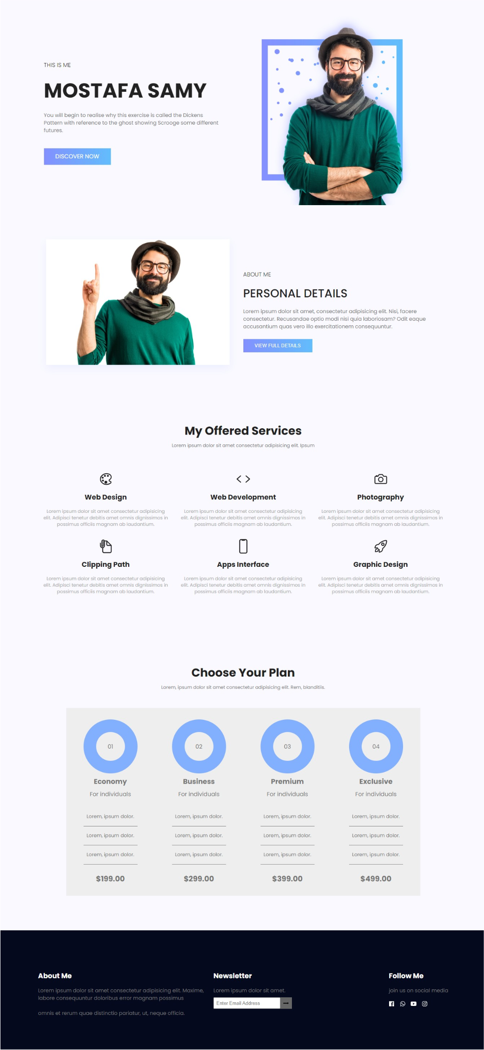

**<Thank>YOU </Thank>**