ADVANXIS TECHNOLOGIES & PROCESS AUTOMATION LTD. — NATIONAL AUTOMATION PRIZE (NAP 2026)
MechMind AI: Non-Invasive Edge Telemetry & Mobile Diagnostic Copilot
Project Synopsis & Engineering Concept Proposal for Heavy Industrial, Construction, and Agricultural Machinery
Competition Track: Track 08 — Made-in-Nigeria Affordable Automation & Industrial Machines | Cross-Cutting Synergies: Track 01 (Process Machinery) & Track 02 (Agri & Food Security)
Lead Applicant: Oni Mujeeb Ramadan (Product Operations & Field Lead) | Engineering Team: Mubarak Raji Babatunde (Software & AI), Olawale Oladele (Hardware & CAD)
Institution / Entity: Lagos State University (LASU) | Pullup Events (CAC BN-9846744) | Live Verification: Web: mechmind-ng.vercel.app | WhatsApp: +234 701 029 9562

75.0% Accuracy  56-Question Blind Benchmark  Hydraulics, engine, electrical | < 90 Sec Triage  Rapid Field Response  Cuts downtime from days to mins | < ₦35,000 BOM  Low-Cost Hardware Node  Replaces ₦8M+ foreign tools | WhatsApp Native  Zero-Friction Adoption  Text, voice notes & part photos

1. Project Title & Innovation Track Alignment
Project Title: MechMind AI: Edge-Enabled Predictive Telemetry and Generative Diagnostic Copilot for Heavy Industrial, Construction, and Agricultural Machinery.
Selected NAP 2026 Track: Track 08 — Made-in-Nigeria Affordable Automation & Industrial Machines.
Track Alignment Rationale: Nigerian contractors, fleet operators, and industrial workshops depend almost entirely on imported diagnostic tools (such as Caterpillar Comm Adapters, Komatsu Inline scanners, and Launch/Autel diagnostic tablets). These units cost millions of Naira, require expensive software licenses renewed annually in foreign currency, and break down easily under harsh workshop conditions. MechMind AI directly fulfills the NAP Track 08 objective ('Import less. Design more. Build more. Automate more. Manufacture more.') by delivering an indigenous, rugged, and repairable IoT condition-monitoring node and AI diagnostic assistant assembled locally in Lagos for under NGN 35,000 in components.
Cross-Cutting Synergies: Cross-track synergies are established with Track 01 (Smart Automation of Made-in-Nigeria Machines & Process Plants) by providing an edge-attached plug-and-play telemetry layer that upgrades locally fabricated agro-processing plants, industrial generators, and water pumps with real-time condition monitoring without altering factory wiring; and Track 02 (AI & Robotics for Agriculture & Food Security) by protecting commercial tractors, harvesters, and irrigation pumps from catastrophic failure during critical planting and harvesting windows.
2. Problem Statement (Frontline Workshop Reality in Nigeria)
Origin of the Project: During our 6-month undergraduate industrial training (SIWES) in engineering workshops and road construction corridors across Lagos and Ogun states, our team observed a recurring operational bottleneck: heavy equipment—including 20-ton hydraulic excavators, wheel loaders, motor graders, and farm tractors—frequently suffered sudden, catastrophic breakdowns on active job sites.
The Core Problem: A 2012 Komatsu PC200 or Cat 320D does not fail without warning. Before a hydraulic main pump shears its shaft or a crankshaft bearing seizes, the machine displays clear physical symptoms: abnormal high-frequency vibration, thermal spikes in return hydraulic lines, and distinct acoustic whine. But because Nigerian operators have no condition-monitoring tools, machines are run continuously until complete failure occurs. In Nigeria, replacement parts require 2 to 6 weeks for overseas shipment, halting operations and costing contractors between NGN 500,000 and NGN 2,500,000 daily in stalled projects, idle operator wages, and contractual delay penalties.
Three systemic factors drive this diagnostic divide across Nigeria:
- 1. Legacy & Unmonitored Fleets: Over 85% of earthmoving and agricultural equipment operating across Nigeria is imported second-hand and lacks digital telematics or onboard sensors.
- 2. Proprietary Scanners & Dealership Monopoly: Foreign equipment manufacturers (Caterpillar, Komatsu, SANY, Cummins) lock diagnostic trouble codes behind proprietary scan tools costing NGN 5,000,000 to NGN 12,000,000+, plus recurring software subscriptions in USD. Official dealership call-out fees run upwards of NGN 250,000 just to plug in a scanner, excluding small and medium contractors.
- 3. Trial-and-Error Misdiagnosis: Local roadside mechanics are forced to troubleshoot complex electro-hydraulic faults by trial and error, replacing functional parts blindly. Furthermore, error codes and workshop manuals are written in technical English or foreign languages (e.g., Chinese on SANY/XCMG machines) that mechanics cannot decipher.
3. Proposed Solution (Dual-Layer Edge Intelligence)
MechMind AI replaces expensive imported diagnostic scanners and guesswork with an indigenous, two-tier system:
System Tier | Engineering Components | Operational Functionality in Nigerian Worksites
Tier 1: Edge Telemetry Node (NODE-001) | ESP32-WROOM-32D MCU, MPU-6050 6-DOF IMU, DS18B20 digital thermal probe, acoustic microphone, 18650 Li-ion battery, TP4056 + MT3608 power circuitry, magnetic mount. | Non-invasively clamps onto any engine block, hydraulic pump, or transmission casing in 30 seconds using high-strength neodymium magnets. Streams 3-axis vibration, surface temperature, and acoustic noise over WiFi/GSM at 0.5 Hz without cutting factory wiring.
Tier 2A: WhatsApp Field Assistant | Baileys WebSockets framework, local faster-whisper speech-to-text, ChromaDB RAG manual retrieval, quantized Llama 3.1 8B LLM. | Nigerian mechanics live on WhatsApp (+234 701 029 9562). They can type questions, send voice notes (mechanics with greasy hands), or upload photos of broken parts. The system returns root causes, step-by-step repair guides, torque specs, and part numbers in under 90 seconds.
Tier 2B: Fleet Telemetry Web Dashboard | Next.js 14, Tailwind CSS, real-time WebSocket streaming, ISO 10816 threshold classifiers, PostgreSQL 15 time-series logging. | Live cloud console (mechmind-ng.vercel.app) giving fleet managers multi-asset switching, 3-axis kinematic waveforms, acoustic pressure levels, and automated Machine Health Indices (0–100%).
4. Technology & Engineering Architecture
4.1 Hardware Architecture & Edge Sensor Node
- Dual-Core Processing: ESP32-WROOM-32D running FreeRTOS. Core 0 handles real-time sensor sampling (I2C at 400kHz, 1-Wire bus timing, ADC conversion); Core 1 handles network telemetry serialization and JSON transmission.
- Kinematic Vibration & ISO 10816 Compliance: MPU-6050 6-DOF IMU reading ±16g acceleration across X, Y, and Z axes. Firmware calculates real-time RMS velocity in mm/s and compares against ISO 10816-3 (Class II & III industrial machinery) standards to identify mechanical looseness, unbalance, and bearing race wear.
- Surface Temperature Monitoring: DS18B20 digital waterproof probe (-55°C to +125°C, ±0.5°C accuracy) monitoring engine cylinder head, hydraulic return line, or transmission oil temperature over a 1-Wire interface with 4.7kΩ pull-up.
- Acoustic Cavitation Detection: High-sensitivity analog electret microphone circuit measuring 35 dB to 120 dB acoustic sound pressure to capture early-stage hydraulic pump cavitation and gear mesh grinding before metal damage occurs.
- Untethered Power Subsystem: Single 3.7V 18650 Li-ion cell (2600 mAh) paired with a TP4056 charge management board (DW01A over-discharge cutoff at 2.5V, over-charge protection at 4.2V) and MT3608 DC-DC step-up converter delivering a stable 5.0V rail. Features true pass-through USB Type-C charging, allowing the node to operate continuously for 12+ hours on internal battery or indefinitely when plugged into equipment 12V/24V USB adapters.
- Rugged Magnetic Enclosure: Custom 3D-printed PETG enclosure with internal silicone vibration dampeners and two high-force N52 Neodymium pot magnets providing 18 kg holding force on machine steel plates.
4.2 Cognitive Diagnostic Layer (Hybrid RAG + Local Quantized LLM)
- ChromaDB Vector Retrieval: Over 1,200 pages of official OEM workshop service manuals (Caterpillar 320D, Komatsu PC200-8, SANY SY215C, Cummins QSB6.7, Perkins 1104D) and SAE J1939 Diagnostic Trouble Code (DTC) databases are chunked and vectorized using sentence-transformer embeddings.
- Grounded Local LLM Inference: When sensor thresholds trigger an alert or a technician asks a question, the system queries ChromaDB for matching repair procedures. The retrieved manual context is passed to a locally hosted, quantized llama3.1:8b model via Ollama. Strict system prompts restrict outputs to OEM-verified repair steps, torque limits, pinout voltages, and filter part numbers.
- Zero Foreign API Costs: The AI inference engine runs locally on workstation hardware without third-party API token fees, ensuring operational sustainability for Nigerian users.
5. Prototype Status & Field Validation
MechMind AI is a verified, fully functioning physical prototype that has been tested on real equipment:
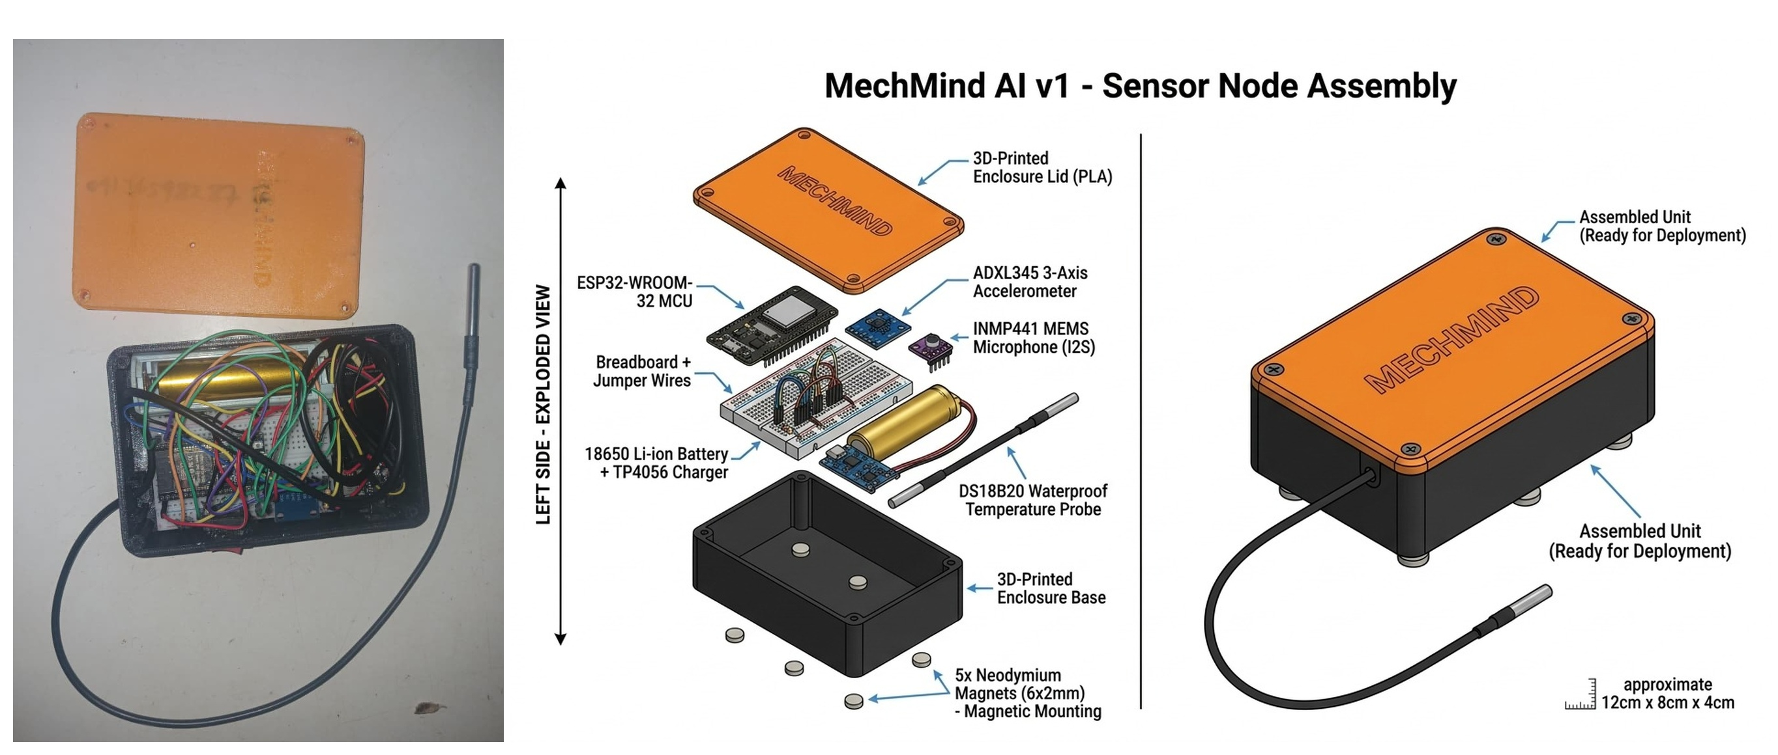  Figure 1: Assembled MechMind AI Node (NODE-001) with magnetic base, Li-ion circuit, and thermal probe. | 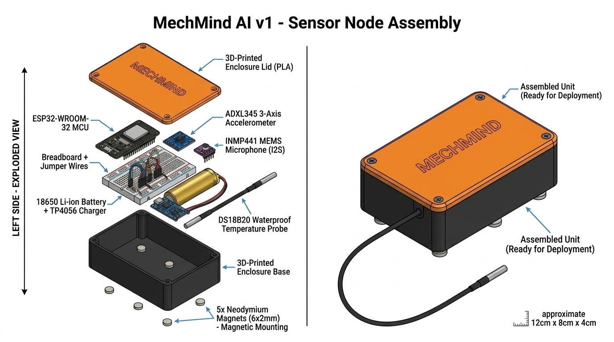  Figure 2: Electrical Wiring Schematic & Subsystem Interconnect for the MechMind Sensor Node.
- Physical Node Built & Field-Tested: Assembled unit bench-calibrated and mounted on operating earthmoving machinery in Lagos to record baseline vibration, temperature, and acoustic noise profiles.
- Blind Diagnostic Benchmark (75.0% Accuracy): Evaluated across a 56-question blind test suite compiled from experienced mechanical engineers covering hydraulic failure, electrical short-circuits, fuel delivery faults, and powertrain overheating. Achieved 42/56 correct root-cause identifications (75.0%) with zero safety-critical hallucinations.
- Sub-90-Second Response Latency: Diagnostic triage and repair workflows generated and delivered via WhatsApp in an average of 84 seconds.
- Live Public Deployments: Production telemetry dashboard accessible at https://mechmind-ng.vercel.app; WhatsApp diagnostic assistant active on +234 701 029 9562; open-source codebase published on GitHub (github.com/DevMubarak1/mechmind-ai).
- Roadmap to National Audition & Finale: Transitioning from point-to-point breadboard wiring to a dedicated 4-layer surface-mount (SMT) PCB; integrating an onboard SIM800L / Quectel GSM cellular module with internal eSIM for remote off-grid farming sites; expanding indexed service manuals to 35+ equipment models.
6. Innovation, Import Substitution & Local Content
- 100% Indigenous IP & Local Assembly: Firmware code, RAG vector database, ingestion backend, web dashboard, and mechanical enclosure were designed, programmed, and assembled by Nigerian engineering students in Lagos.
- Direct Import Substitution: Foreign diagnostic scan tools (Cat Comm Adapter, Komatsu Inline, Cummins Insite) retail between NGN 5,000,000 and NGN 12,000,000 each and require recurring annual software subscriptions in USD. MechMind delivers equivalent diagnostic fault triage at a bill of materials under NGN 35,000 ($22).
- Championing the 'Right to Repair': Major OEMs restrict diagnostic access to enforce expensive dealership service monopolies. MechMind equips independent Nigerian workshops, informal mechanics, and SME contractors with multi-brand diagnostic capability under a single unified ecosystem.
- Low-Bandwidth Mobile Accessibility: By deploying the primary diagnostic interface over WhatsApp, MechMind operates seamlessly on 2G/3G cellular networks without requiring technicians to buy expensive ruggedized laptops or learn complex proprietary software suites.
7. Target Users & Commercial Potential in Nigeria
Nigeria's construction, quarrying, mining, and agricultural mechanization sectors represent an immense market for affordable predictive diagnostics:
Target User Segment | Pain Point Addressed | Estimated Nigerian Market Size
Civil Engineering Contractors | Mid-sized contractors operating 5–30 machines cannot afford full-time diagnostic specialists. Unplanned breakdowns result in crushing project delay penalties. | Over 15,000 active contractors; NGN 6.4 Trillion infrastructure pipeline under federal and state highway initiatives.
Plant Hire & Rental Firms | Rental operators lose daily rental fees when machinery breaks down on client job sites. Real-time telemetry prevents operator machine abuse. | Over 40,000 commercial rental machines across major hubs in Lagos, Abuja, Port Harcourt, and Kano.
Commercial Agriculture & Tractor Hubs | Tractor and irrigation pump breakdowns during seasonal planting windows ruin yields and cause devastating harvest losses. | Over 30,000 tractors and agro-processing engines operating across regional mechanization schemes and farmer cooperatives.
Independent Workshops & Mechanics | Informal mechanics in mechanic villages (e.g., Ladipo, Owode Onirin, Apo) lack diagnostic tools and guess faults by trial and error. | Over 25,000 independent technicians using WhatsApp daily who can use MechMind as a high-margin diagnostic copilot.
8. Estimated Cost, Unit Economics & Scalability
Every component in the MechMind node has been chosen for high availability in the local Nigerian market:
Component Description | Part / Specification | Prototype Cost (NGN) | Batch 500+ Cost (NGN)
Microcontroller Unit | ESP32-WROOM-32D Dual-Core | NGN 6,500 | NGN 4,200
Tri-Axial Motion Sensor | MPU-6050 6-DOF IMU | NGN 3,200 | NGN 1,850
Digital Thermal Probe | DS18B20 Waterproof 1-Wire | NGN 3,500 | NGN 2,100
Acoustic Sensor Module | Electret Analog Noise Sensor | NGN 1,800 | NGN 950
Battery Cell | 18650 Li-ion 3.7V 2600 mAh | NGN 3,800 | NGN 2,400
Power Management & Boost | TP4056 + DW01A + MT3608 | NGN 2,200 | NGN 1,200
Enclosure & Magnetic Base | 3D-Printed PETG + N52 Magnets | NGN 9,500 | NGN 6,200
Wiring Harness & Assembly | Shielded silicone cabling, switch | NGN 4,250 | NGN 2,600
TOTAL BILL OF MATERIALS (BOM) | Complete Hardware Node | NGN 34,750 (~$22.00) | NGN 21,500 (~$13.80)
8.2 Scalable Revenue Architecture
- Hardware Unit Sales: Sold at NGN 50,000 to NGN 75,000 per unit, yielding a healthy 45%–55% gross margin. Low entry barrier makes adoption frictionless.
- Recurring SaaS Telemetry Subscription: NGN 15,000 to NGN 25,000 / machine / month for continuous live telemetry streaming, predictive threshold alerts, fleet health analytics, and unlimited priority WhatsApp AI queries.
- Spare Parts Marketplace Commission: 3%–5% transaction fee connecting diagnosed fault codes with verified local replacement parts distributors in Lagos, Abuja, and Port Harcourt.
9. Expected Impact & National Strategic Alignment
- 60% Downtime Reduction: Early detection of bearing wear, pump cavitation, and cooling failures eliminates catastrophic breakdowns, saving an estimated NGN 3,000,000 to NGN 7,000,000 annually per machine for Nigerian SME contractors.
- Foreign Exchange Conservation: Prevents premature capital write-offs of multi-million Naira machines and eliminates foreign currency drain on expensive overseas diagnostic subscriptions.
- Dignified Engineering Job Creation: Upskills informal mechanics into certified digital diagnostics technicians capable of operating IoT instruments and AI triage tools.
- Food Security Reinforcement: Ensures tractors and agricultural machinery remain operational during narrow planting windows, preventing post-harvest and planting season bottlenecks.
10. Team Credentials & Verification
MechMind AI is developed by a proven engineering team from Lagos State University (LASU) operating commercially under Pullup Events (CAC Registration: BN-9846744):
- Oni Mujeeb Ramadan (Lead Applicant & Operations Lead): NUESA Engineering Scholar of the Year (2026), Man of Excellence Award (LASUSU). Leads field testing, operator interviews, diagnostic manual curation, and commercial partner outreach across Lagos industrial sites.
- Mubarak Raji Babatunde (Founder & AI / Software Lead): Full-stack and artificial intelligence engineer. Built the MechMind RAG pipeline, ChromaDB vector collections, FastAPI backend, and Next.js telemetry dashboard. 1st Place Winner at Vibranium Valley x PowerTech Grand Challenge.
- Olawale Oladele (Hardware & Embedded Systems Lead): Certified SolidWorks Professional (CSWP) with 4 CSWPA advanced specializations and Ansys FEA credentials. Designed the physical enclosure, vibration isolation mounts, circuit schematics, and FreeRTOS embedded firmware.
Applicant Declaration & Submission Confirmation
This Project Synopsis is submitted in full compliance with the guidelines of the National Automation Prize (NAP 2026) organized by Advanxis Technologies & Process Automation Ltd. We hereby certify that the MechMind AI prototype is an original, functional hardware and software innovation developed in Nigeria, and our team is fully prepared to demonstrate the working physical device during the upcoming State Audition and Regional Demonstration stages.
Submitted By: Oni Mujeeb Ramadan (Lead Applicant) | Date: October 2026

