Class of Service (CoS) Configuration

Contents
- Introduction
- Using VLANs to Maximize the CoS Benefit
- Definitions
- Basic Operation
- Criteria for Prioritizing Outbound Packets
- Guidelines for Configuring CoS Priorities
- For More CoS Information
- Steps for Configuring CoS Priority

Introduction
Given that there will always be points in the network where multiple traffic streams merge or where network links will change speed and capacity, it is important to move traffic on the basis of relative importance. Without CoS prioritization, less important traffic can consume network bandwidth and slow down or halt the delivery of more important traffic. For example, without CoS, most traffic received by a switch is forwarded with the same priority it had upon entering the switch. In many cases, such traffic is ‘‘normal’’ priority and competes for bandwidth with all other normal-priority traffic, regardless of its relative importance to your organization’s mission. CoS helps to keep the most important network traffic moving at an acceptable speed, regardless of current bandwidth usage. This means you can manage available bandwidth so that the switch transmits the most important traffic first.
Note: The Quality of Service features available in HP TopTools for Hubs & Switches (version N.01.03 or later) includes the ability to set up consistent traffic prioritization (Class of Service) policies across the ProCurve switches in your network. The Class of Service features can also be configured on an individual switch using the switch's console or web browser interface. HP ProCurve documentation uses Quality of Service (QoS) to refer to TopTools (network-wide) prioritization, and Class of Service (CoS) to refer to prioritization configured on an individual switch (using the switch's web browser or console interface).

Using VLANs to Maximize the CoS Benefit
Without an 802.1Q tagged VLAN environment, CoS can prioritize only the movement of outbound traffic through individual ProCurve switches in your network. Using 802.1Q tagged VLANs provides the maximum advantage by allowing CoS to set priorities that are supported by downstream devices. This means that CoS can support improved performance for present traffic levels as well as future traffic growth while optimizing the use of existing resources and delaying the need for further investments in equipment and services. That is, CoS enables you to:
- Specify which traffic in the switch has higher or lower priority, regardless of current network bandwidth or the relative priority setting of the traffic when it is received on the switch.
- Change (upgrade or downgrade) the priority of outbound traffic.
- Override ‘‘illegal’’ packet priorities set by upstream devices or applications that use 802.1Q VLAN tagging with 802.1p priority tags.
- Avoid or delay the need to add higher-cost NICs (network interface cards) to implement prioritizing. (Instead, control priority through network policy administered by HP TopTools for Hubs & Switches.)

Definitions
Term | Definition
differentiated  services bits | The upper 6 bits of the Type of Service (ToS) field (the DS field) of an IP packet.
downstream device | A device linked directly or indirectly to an outbound switch port. That is, the switch sends traffic to downstream devices.
inbound port | Any port on a switch through which traffic enters the switch.
outbound port | Any port on a switch through which traffic leaves the switch.
outbound port queue | For any port, a buffer that holds outbound traffic until it can leave the switch through that port. There is a "high priority" queue and a "normal priority" queue for each port in the switch . Traffic in a port's high priority queue leaves the switch before any traffic in the port's normal priority queue.
precedence bits | The upper three bits in the Type of Service (ToS) field of an IP packet.
upstream device | A device linked directly or indirectly to an inbound switch port. That is, the switch receives traffic from upstream devices.
802.1p priority | A traffic priority setting carried only in packets in 802.1Q tagged VLANs. This setting can be from 0 to 7.
802.1Q tagged VLAN | A virtual LAN (VLAN) that complies with the 802.1Q standard and is configured as "tagged". (For more on VLANs, see the Management and Configuration Guide you received with your HP ProCurve switch.)

Basic Operation
Configuring a CoS policy in the switch affects switch internal traffic priorities at the outbound port, and (if 802.1Q VLANs are configured in your network) the priority settings in traffic leaving the switch. This enables control over traffic movement within the switch and control over the priority settings in packets going to downstream devices and applications that can use those settings.

Policy Option for Controlling Traffic Priorities at the Outbound Port
Each port in the switch has two outbound traffic queues; ‘‘normal’’ priority and ‘‘high’’ priority. (High-priority packets leave the switch port first. Normal-priority packets leave the switch port after the port’s high-priority queue is emptied.) With no CoS control, all traffic (with two exceptions) goes through the ‘‘normal’’ outbound port queues. However, with a CoS policy operating in your network, you can determine the outbound priority queue to which a packet is sent.

Policy Options for Extending Traffic Priority Control to Outbound Packets Traveling to Downstream Devices
If an outbound packet is in an 802.1Q tagged VLAN environment (that is, if the packet is assigned to a tagged VLAN on the outbound port), then the packet carries an 802.1p priority setting that was configured in the switch. This priority setting can range from 0 to 7, and can be used by downstream devices having up to eight queues. Thus, while packets within a switch move only at high or normal priority, they still can carry the 802.1p priority that can be used by downstream devices having more than two priority levels. Also, if the packet enters the switch with an 802.1p priority setting, CoS can override this setting if configured to do so.
Note: If you are not using multiple tagged VLANs in your network, you can still use the tagged VLAN feature available in HP ProCurve switches by configuring the default VLAN as a tagged VLAN.

Priority Settings for Outbound Packets
You can configure a CoS priority of 0 through 7 for an outbound packet. When the packet is then sent to a port, the CoS priority determines which outbound queue the packet uses.
CoS Setting | Outbound Port  Queue | Operation
0 - 3 | normal priority | Packets in this queue leave the port after the high-priority queue is emptied.
4 - 7 | high priority | Packets in this queue leave the port first.
If a packet is not in an 802.1Q tagged VLAN environment, the above settings control only to which outbound queue the packet goes, and no 802.1p priority is added to the packet. However, if the packet is in an 802.1Q tagged VLAN environment, then the above setting is also added to the packet as an 802.1p priority that can be used by downstream devices and applications, as shown in the Priority Mapping Table.

Criteria for Prioritizing Outbound Packets
You can configure CoS prioritization on the basis of five criteria ranked as follows:
- Device Priority (destination or source IP address)
- IP Type of Service (ToS) field
- Protocol Priority (IP, IPX, ARP, DEC LAT, AppleTalk, SNA, and NetBeui)
- VLAN Priority
- Incoming 802.1p Priority (present in tagged VLAN environments)
If more than one criteria is present in a packet, the highest ranked of the criteria is used to prioritize the packet; all lower-ranked criteria are ignored. For example, if CoS assigns:
- High priority to ‘‘red’’ VLAN packets
- Normal priority to IP packets
Since Protocol Priority (third in precedence, as shown above) has precedence over VLAN priority (fourth in precedence, as shown above), IP packets on the ‘‘red’’ VLAN will be set to normal priority. The "Priority Criteria and Precedence" table provides a more detailed description of how this operates.

Guidelines for Configuring CoS Priorities
You can use CoS regardless of whether the switch is in a tagged VLAN environment. As described earlier (under ‘‘Basic Operation’’):
- Using CoS in a tagged VLAN environment controls both of the following:
  - Outbound port queue: To which queue (high or normal) a packet will be sent
  - Outbound 802.1p priority: Enters a new 802.1p priority setting in an outbound packet or retains the packet’s existing 802.1p setting. This enables the packet to carry an 802.1p priority to the next downstream device.

- Using CoS without a tagged VLAN environment affects only the outbound port queue to which a packet is sent. (That is, it prioritizes traffic flow only within the switch.) However, without a tagged VLAN environment, an outbound packet cannot carry an 802.1p priority setting to a downstream device.
To configure CoS, use this procedure:
- Determine the CoS policy you want to implement. This includes analyzing the types of traffic flowing through your network and identifying one or more traffic types to prioritize. If two or more of your policies apply to the same packet, then the switch applies only the policy having the highest precedence. The order of precedence for CoS criteria is as follows:
  - Device Priority - destination or source IP address (Note that destination has precedence over source.)

  - IP Type of Service (ToS)

  - Protocol Priority

  - VLAN Priority (requires at least one tagged VLAN)

  - Incoming 802.1p Priority (requires at least one tagged VLAN)
For more on how CoS operates with the above traffic types, see the "Priority Criteria and Precedence" table)
- If you want 802.1p priority settings to be included in outbound packets, ensure that tagged VLANs are configured on the appropriate links. (For information on configuring tagged VLANs, see the Management and Configuration Guide you received with the switch--and also available in the Support area of HP's ProCurve website.)

- Determine the actual Class of Service configuration changes you will need to make to establish a CoS policy for the switch.

- Configure the desired CoS policy.

Note: If you use TopTools for Hubs & Switches to configure Quality of Service (QoS) policy in a network, it overrides any CoS settings configured through the console or the web browser interface in any individual HP ProCurve switch.

For More CoS Information

Steps for Configuring CoS Priority
CoS Options | Priority Configuration Steps
Device Priority | Click on the Device Priority button, then:  To add an IP address:  - Type the address in the IP Address field.  - Select the desired priority level from the Priority pull-down menu.  - Click on the Add button.  To change a configured priority for a device:  - Type the device’s IP address in the IP Address field.  - Highlight a replacement priority level in the Priority pull-down menu.  - Click on the Replace button.  To delete a device from the Device Priority list:  - Click on the device’s IP address in the IP Address Priority field.  - Click on the Delete button.
Type of Service | Click on the Type of Service button. Then:  - Use the pull-down menu to select either IP Precedence or Differentiated Services.  - Click on the Apply Changes button.  If you selected Differentiated Services, you will then need to go to the Device View screen (under the Configuration tab) and Telnet to the switch console interface to change the priority for a given IP ToS value. For more on Type of Service, refer to Software Update C.07.XX Release Notes for the HP ProCurve Switch 1600M, 2400M, 2424M, 4000M, and 8000M.
Protocol | Click on the Protocol button. Then:  - Click on the Priority pull-down menu for the desired protocol and select a priority level.  - Click on the Apply Changes button.
VLAN Priority | Click on the VLAN Priority button. Then:  Note: This feature configures the priority on existing VLANs (including the default VLAN). To configure new VLANs, go to the Device View screen (under the Configuration tab) and Telnet to the switch console interface.  - Click on (highlight) the VLAN for which you want to configure a priority.  - In the Priority pull-down menu, select the priority level you want.  - Click on Modify VLAN priority.

Quality of Service (QoS)

Table of Contents
Introduction
What is QoS?
Generalized QoS Processing Model
Extending QoS to the Internet
Projects and R&D

Introduction
This section of the Internet Tool Survey describes the quality of service provided by the Internet. Currently the Internet offers a point-to-point delivery service, which is based on the "best effort" delivery model. In this model, data will be delivered to its destination as soon as possible, but with no commitment as to bandwidth or latency. Using protocols such as TCP, the highest guarantee the network provides is reliable data delivery. This is adequate for traditional data applications like FTP and Telnet, but inadequate for applications requiring timeliness. For example, distributed multimedia applications need to communicate in real-time and are sensitive to the quality of service they receive from the network. For these applications to perform adequately and be widely used, QoS must be quantified and managed, and the Internet must be modified to support real-time QoS and controlled end-to-end delays. The notion of QoS must be extended from the communication layer up through the intervening architectural layers to the application level.

What is QoS?
There is no common or formal definition of QoS. However, there are a number of definitions at the communication level where the notion originated to describe technical characteristics of mainly non-time-dependent data transmission. Emerging networks such as ATM, can provide QoS guarantees on bandwidth and delay for the transfer of continuous media (CM) data.
- The International Telecommunication Union (ITU) standard X.902, Information technology – Open distributed processing – Reference Model, refers to QoS as "A set of quality requirements on the collective behavior of one or more objects." A number of QoS parameters describe the speed and reliability of data transmission, e.g., throughput, transit delay, and error rate.
- The ATM Lexicon defines QoS as "A term which refers to the set of ATM performance parameters that characterize the traffic over a given virtual connection." QoS parameters apply mostly to lower level protocol layers, and were not meant to be directly observable or verifiable by the application. These parameters include cell loss ratio, cell error rate, cell misinsertion rate, cell delay variation, cell transfer delay, and average cell transfer delay. Five service classes are defined in terms of QoS parameters. Class 0 refers to best effort service in which no specific traffic parameters and no absolute guarantees are provided.
- Recently the Internet Engineering Task Force (IETF) has begun to address QoS issues for ATM. RFC 1946, Native ATM Support for ST2+, states "As the demand for networked real time services grows, so does the need for shared networks to provide deterministic delivery services. Such deterministic delivery services demand that both the source application and the network infrastructure have capabilities to request, setup, and enforce the delivery of the data. Collectively these services are referred to as bandwidth reservation and Quality of Service (QoS)." RFC 1932, IP over ATM: A Framework Document, states "QoS parameters [for real-time applications] are assumed to precede traffic in RSVP or be carried in some form within the traffic itself." "Work in progress is addressing how QoS requirements might be expressed and how the local decisions might be made as to whether those requirements are best and/or most cost effectively accomplished using ATM or IP capabilities." RSVP is discussed further below.
The IEEE paper, Distributed Multimedia and Quality of Service: A Survey, provides a more general definition of QoS for applications that must communicate in real-time: "The set of those quantitative and qualitative characteristics of a distributed multimedia system, which are necessary in order to achieve the required functionality of an application." This paper also provides a model of QoS processing for multimedia systems which we will generalize below to include applications requiring Internet services. Several research groups are investigating QoS support for the WWW, in particular, researchers at BBN, the Distributed Systems Technology Centre, and Washington University. These and other QoS-based projects are summarized below.

Generalized QoS Processing Model
To build QoS into a system involves
- the construction of a generalized QoS framework,
- QoS specification which captures application QoS requirements,
- mapping of QoS requirements to resources,
- QoS mechanisms which realize desired QoS behavior.

QoS Specification
An application's QoS requirements are conveyed in terms of high-level parameters that specify what the user requires. QoS specification is different at each system layer and is used to configure QoS mechanisms at each layer. Possible system layers are
- protocols - transport, network
- network
- middleware
- operating system - scheduling, resource management, real-time support
- distributed platforms - CPU, memory/buffers, devices
- application
QoS specification encompasses requirements for
- performance - expected performance characteristics are needed to establish resource commitments,
- synchronization - characterizes the degree of synchronization required between related services, events, or information flows,
- level of service - specifies the degree of resource commitment required to maintain performance guarantees,
- cost of service - the price a user is willing to incur to obtain a level of service,
- QoS management - the degree of QoS adaptation that can be tolerated and scaling actions to be taken in the event the contracted QoS cannot be met.
QoS requirements are assessed to determine if they can possibly be met. If, for example, the level of service requested cannot be provided, the user can be asked if a certain level of degradation is acceptable before proceeding further.

QoS Mapping
QoS requirements are used to derive resource requirements for entities such as computation, communication, and storage. They are successively mapped into quantitative QoS parameters relevant to various system layers that can be monitored and controlled. QoS parameters may be oriented towards
- performance - sequential versus parallel processing, delays, data rate
- format - transfer rate, data format, compression schema, image resolution
- synchronization - loosely versus tightly coupled, synchronous versus asynchronous
- cost - platform rates, copyright fees, connection and data transmission rates
- user - subjective quality of images, sound, response time
Each QoS parameter can be viewed as a typed variable with bounded values, and the values are subject to negotiation between the system layers.

QoS Enforcement
To provide and sustain QoS, resource management must be QoS-driven. In allocating resources, the resource management system must not only consider resource availability and resource control policies, but also an application's QoS requirements measured in terms of the QoS parameters. To ensure the contracted QoS is sustained, it must monitor QoS parameters and reallocate resources in response to system anomalies. Prior to allocating resources, the system layers negotiate to determine if they can collectively ensure that the required QoS parameters can be consistently satisfied. Negotiation involves dynamic adaptation and the transmission and translation of QoS parameters between the layers as the layers enter into different types of agreements, e.g., guaranteed, best-effort, or predictive. If negotiation ends in agreement, the application is launched. After resources are allocated, QoS mechanisms at each layer guarantee the contracted QoS, and the resource manager guarantees the sustained availability of the allocated resources. This requires monitoring resource availability and its dynamic characteristics, e.g., measuring processing workload and network traffic, to detect deviations in the QoS parameters. When there is a change of state, i.e., degradation in the QoS, and the resource manager cannot make resource adjustments to compensate (e.g., reschedule shared resources to satisfy allocations or switch to an optimized implementation of an object/service), then the application is notified, e.g., application handlers are called. The application can either adapt to the new level of QoS or scale to a reduced level of service.

Extending QoS to the Internet
RSVP, the emerging standard for QoS negotiation over IP, is a network control protocol for establishing and maintaining Internet integrated service reservations that allows Internet applications to obtain both best-effort and real-time QoS for their data flows. Hosts and routers use RSVP to deliver QoS requests to all nodes along the path of the data stream, typically resulting in a reservation of bandwidth for that particular data flow. RSVP is designed for use over both IPv4 and IPv6, the next generation Internet protocol. IPv6 offers a choice of QoS levels beyond the single "best effort" delivery service offered by IPv4. With these added QoS capabilities, still in the experimental stage of development, IPv6 will provide a better range of support for real-time data traffic.
The latest RSVP functional specification can be found at CNRI ( postscript) or USC/ISI ( text) and includes a discussion of RSVP's design and operation. The tutorial QoS over the Internet: The RSVP protocol provides motivation for RSVP and details about QoS support. See the RSVP2 project summary for details about the latest accomplishments and future plans. For more information, see the RSVP publication list. Collaborative research is being done at Xerox Parc and MIT.

Projects and R&D

Advanced Research Laboratory at Washington University St. Louis
Research is centered around network, middleware, and OS QoS support for multimedia applications. To guarantee QoS for the transfer and processing of continuous media, ARL researchers have developed a framework consisting of four components: 1) specification of QoS requirements in terms of high-level QoS parameters; 2) the mapping of QoS specifications to resource requirements; 3) QoS enforcement by scheduling shared resources to satisfy OS allocations; and 4) a protocol implementation model that facilitates the mapping of protocol services to the mechanisms for the previous three components. See the paper A Framework for QoS Guarantees for Multimedia Applications within an Endsystem for details. More recent prototyping work in Scalable Multimedia-On-Demand via World-Wide-Web (WWW) with QOS Guarantees discusses a scalable MOD server that supports end-to-end QoS guarantees using a web-based access interface that provides complete playout control functions. In addition to real-time and end-to-end QoS guarantees, there must be QoS guarantees of the underlying services. This motivates the use of object-oriented middleware such as CORBA. Since CORBA does not support latency-sensitive applications, they have proposed the use of real-time ORBs (RT ORBs) to deliver the QoS guarantees. For further papers, see the list of author publications.

British Telecom University Research Initiative (URI) at Lancaster University
Lancaster University is one of 6 URI groups in Britain involved in research on the management of multiservice networks; their part is to research end-system QoS Management. To use QoS to manage bandwidth over a multiservice network for continuous media streams, they choose CORBA as the demonstration vehicle. Providing QoS support involves adding QoS extensions to a CORBA-based enhanced object model and developing various QoS mechanisms within the model. An essential component is the QoS mapper which maps application level QoS requirements between each component in order to sustain the overall desired QoS. The basis for their development is the Xerox Parc ILU distributed programming environment.
For more information about specifying QoS requirements, see their paper Specifying QoS for Multimedia Communications within a Distributed Programming Environment which examines four different approaches. A more recent paper, QoS Support for Distributed Multimedia Communications, discusses a QoS model to provide receiver-dependent QoS based on filtering techniques in a multipeer communication environment. See the Ph.D. thesis Quality of Service Filters for Multimedia Communications and the 1994 paper Supporting Quality of Service in Multimedia Communications via the use of Filters for more details. A demonstration of the filtering mechanisms is available.

COMET (Control, Management and Telemedia) Group at Columbia University
The COMET Group's research involves investigating the real-time behaviour of multimedia networks with QoS guarantees. They are involved in experimenting with architectural concepts that provide QoS to network applications and enable efficient use of network resources. Their paper, A Review of QoS Architectures, examines the state-of-the-art in the development of QoS architectures for distributed multimedia systems. QoS architectures are an attempt to unify QoS work at individual architectural layers to achieve end-to-end QoS guarantees. Current research in QoS support is discussed and 10 distinct QoS architectures in multimedia communications are evaluated. Joint work with Lancaster University examines adapting multimedia applications to fluctuating QoS. Details can be found in their paper Supporting Adaptive Flows in a Quality of Service Architecture. Incorporating QoS monitoring and adaptation mechanisms within an architecture that provides end-to-end QoS is reported in their paper Meeting QOS Guarantees by End-to-End QoS Monitoring and Adaptation.

GRM (Global Resource Management) at SRI
The objective of the GRM project is to develop a framework for QoS-driven adaptive resource management in distributed command and control systems. System resources are allocated and controlled in accordance with user QoS requirements. QoS requirements are expressed as benefit functions which specify the benefit to the user or the system of attaining a given QoS level. Development is being done in the context of resource-intensive multimedia command, control, communications, computers, and intelligence (C4I) applications.

Network Weather Service at UCSD
Meeting and sustaining QoS requirements requires monitoring and predicting the load on networked resources. The NWS, currently being prototyped, plans on using sensors to dynamically provide information on the availability and usage of network resources.

Omega at the University of Pennsylvania, Distributed Systems Laboratory
This research addresses customization of network services by setting up processes in the end-points of a cell-switched network to meet application QoS requirements. The full-feedback teleoperation of a robotics system is used to verify the approach. A QoS broker manages resources at the end-points and coordinates resource management across the boundaries of multiple layers in a end-to-end protocol architecture. Configuration of the system to application needs is achieved by QoS negotiation resulting in one or more communication connections. An evaluation of the approach can be found in the paper Design, Implementation and experiences of the OMEGA Architecture.

QUASAR at OGI
QUASAR stands for QUAlity Specification and Adaptive Resource management for distributed multimedia systems. The project is investigating QoS specification, and its use in both adaptive and reservation-based resource management. Application-level QoS specifications are translated into QoS requests that are meaningful at the resource-management level. Research emphasis is on multimedia systems that dynamically adjust to variability in available resources. See the Ph.D. thesis Quality of Service Specification for Resource Management in Multimedia Systems for details. This project is part of the research affiliated with Rowena, a latency-hiding storage system for multimedia applications.

QuO (Quality of Service for Objects) at BBN
BBN's QuO project is an attempt to extend QoS to distributed, non-multimedia applications coping with a dynamic environment using OMG's CORBA. A resource management and availability model is introduced at the CORBA layer that exploits the underlying QoS of the communication layer, and allows the actual QoS received to be visible to the application thereby enabling it to adapt to changing conditions. CORBA's Interface Description Language (IDL) is extended with a QoS Description Language (QDL). QDL specifies an applications expected usage patterns and QoS requirements for connection to an object, and change-of-state handlers. The usage patterns specify the traffic constraints the client agrees to abide by and the QoS requirements specify the QoS that will be required when connected to an object. An application is allowed to have multiple connections to the same object, each with its own system properties. The status of a QoS agreement for an object connection is maintained in an object's system states. The application can adapt to changing QoS parameters, e.g., changing resource availability or partial system failures, by varying its behavior based on the system state of its object connections. Such an object-oriented QoS simplifies QoS management; an object is responsible for managing its QoS instead of an external agent coordinating agreements with multiple components.
The initial prototype is being developed for collaborative planning applications. For an overview of this work, see the papers Overview of Quality of Service for Objects and "Architectural Support for Quality of Service for CORBA Objects" to be published in the January 1997 issue of Theory and Practice of Object Systems (special issue on the OMG and CORBA).

SuperNOVA at DSTC
Previously known as the Fast Web Project, the SuperNOVA project's objectives are to investigate QoS for the WWW, define an architecture which enables the real-time delivery of continuous media in the WWW, and specify a QoS negotiation protocol and a QoS adaptation scheme. See the Fast Web Project summary for details on the extensions to the Web architecture to incorporate QoS which can also be found in an IEEE Multimedia Newsletter which gives an overview of all distributed multimedia research at DSTC.

Tenet Group at UC Berkeley
The main focus of the research group is on the design and development of real-time communication services and on network support for continuous media applications. An overview of the group's projects describes their R&D. A smoothing schema, described in the paper Improving QoS through Traffic Smoothing, allows network clients to optimize their QoS.
QoS Models
large part of your CCNP training for the ONT certification exam should be spent studying the various ways we can implement Quality of Service (QoS) on Cisco routers and switches. Before you start configuring your network’s devices, though, you’ve got to understand the three QoS models and their impact on your network. Let's take a look at the pros and cons of each.
If you don't have a QoS model in place, you actually do. Best-effort QoS is just that - best-effort. No priority is given to any traffic. If your network is carrying voice or video traffic, best-effort is definitely not the way to go.
The Integrated Services model, more popularly known as IntServ, uses the Resource Reservation Protocol (RSVP) to reserve network resources in advance of the data actually traveling across the network. Once the end-to-end bandwidth reservation is in place, the data is transmitted.
That sounds great, but there are some drawbacks. It's a waste of bandwidth to have the entire end-to-end path reserved in advance. Additionally, IntServ isn't as scalable a solution as we'd like. Everything we do on a router or switch has a cost of some kind, and in this case it's RSVP overhead. One or two paths won't cause much overhead, but as the number of reserved paths increases as a network becomes larger, the RSVP overhead can take its toll on the routers involved.
Differentiated Services (DiffServ) is the latest of the three models, and many would agree that it's also the greatest. DiffServ doesn't use RSVP, but instead uses Per-Hop Behavior (PHB) to allow each router across the network to examine the packet and decide what service level it should receive. With DiffServ, one router along the path from source to destination could consider a packet to be of the highest priority, while another router could consider it "just another packet".
A term you hear often with DiffServ is "marking and classification". Marking a packet is the process of assigning the packet a value reflecting the level of QoS it should receive, while classification is placing that packet into a queue in accordance with that level of QoS.
When it comes to marking, there are different values we can use to decide what value to mark the frame or packet with. In my experience, here are the four that are used most often:
- IP Precedence (IP Prec)
- Differentiated Services Code Point (DSCP)
- CoS value
- Interface that received the data (ingress interface)
Which one you choose depends on your particular network's needs, and of course, the OSI layer at which the marking is taking place. We’ll take a look at each of these methods in future CCNP ONT exam training tutorials!
This chapter describes the Class of Service (CoS) feature and how to configure it.
This chapter contains the following topics:
- Section , Understanding Class of Service (CoS)
- Section , Ingress Port Configurations
- Section , Egress Port Configurations
- Section , Queue Configurations
- Section , Configuring CoS Mapping and Queues via CLI
- Section , Configuring CoS Mapping and Queues via Web Interface

Understanding Class of Service (CoS)
The Class of Service (CoS) feature lets you give preferential treatment to certain types of traffic over others. To set up this preferential treatment, you can configure the ingress ports, the egress ports, and individual queues on the egress ports to provide customization that suits your environment.
The level of service is determined by the egress port queue to which the traffic is assigned. When traffic is queued for transmission, the rate at which it is serviced depends on how the queue is configured and possibly the amount of traffic present in other queues for that port.
Some traffic is classified for service (i.e., packet marking) before it arrives at the switch. If you decide to use these classifications, you can map this traffic to egress queues by setting up a CoS Mapping table.
Each ingress port on the switch has a default priority value (set by configuring VLAN Port Priority in the Switching sub-menu) that determines the egress queue its traffic gets forwarded to. Packets that arrive without a priority designation, or packets from ports you’ve identified as “untrusted,” get forwarded according to this default.

Ingress Port Configurations

Trusted and Untrusted Ports/CoS Mapping Table
The first task for ingress port configuration is to specify whether traffic arriving on a given port is “trusted” or “untrusted.”
A trusted port means that the system will accept at face value a priority designation within arriving packets. You can configure the system to trust priority designations based on one of the following fields in the packet header:
- 802.1 Priority - values 0-7
- IP DSCP - values 0-63
- IP Precedence - values 0-7
You can also configure an ingress port as untrusted, where the system ignores priority designations of incoming packets and sends the packet to a queue based on the ingress port’s default priority.

CoS Mapping Table for Trusted Ports
Mapping is from the designated field values on trusted ports’ incoming packets to a traffic class priority (actually a CoS traffic queue). The trusted port field-to-traffic class configuration entries form the Mapping Table the switch uses to direct ingress packets from trusted ports to egress queues.

Egress Port Configurations
For unit/slot/port interfaces, you can specify the traffic shaping rate for the port, which is an upper limit of the transmission bandwidth used, specified as a percentage of the maximum link speed.

Queue Configurations
For each queue, you can specify:
- Minimum bandwidth guarantee
- Scheduler type - strict/weighted - Strict priority scheduling gives an absolute priority, with highest priority queues always sent first, and lowest priority queues always sent last. Weighted scheduling requires a specification of priority for each queue relative to the other queues, based on their minimum bandwidth values
- Queue management - tail drop
FASTPATH supports the tail drop method of queue management. This means that any packet forwarded to a full queue is dropped regardless of its importance.

Configuring CoS Mapping and Queues via CLI
CoS Mapping and Queue Configuration illustrates the network operation as it relates to CoS mapping and queue configuration.
Four packets arrive at the ingress port 1/0/10 in the order A, B, C, and D. You’ve configured port 1/0/10 to trust the 802.1p field of the packet, which serves to direct packets A, B, and D to their respective queues on the egress port. These three packets utilize port 1/0/10’s 802.1p to COS Mapping Table. In this case, the 802.1p user priority 3 was set up to send the packet to queue 5 instead of the default queue 3. Since packet C does not contain a VLAN tag, the 802.1p user priority does not exist, so Port 1/0/10 relies on its default port priority - 2 - to direct packet C to egress queue 1.
FIGURE 23-1 CoS Mapping and Queue Configuration

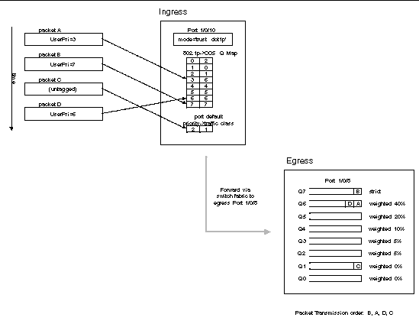
Continuing this example, you configured the egress Port 1/0/8 for strict priority on queue 6, and a set a weighted scheduling scheme for queues 5-0. Assuming queue 5 has a higher weighting than queue 1 (relative weight values shown as a percentage, with 0% indicating the bandwidth is not guaranteed), the queue service order is 6 followed by 5 followed by 1. Assuming each queue unloads all packets shown in the diagram, the packet transmission order as seen on the network leading out of Port 1/0/8 is B, A, D, C. Thus, packet B, with its higher user precedence than the others, is able to work its way through the device with minimal delay and is transmitted ahead of the other packets at the egress port.

FIGURE 23-2 CoS Configuration Example System Diagram
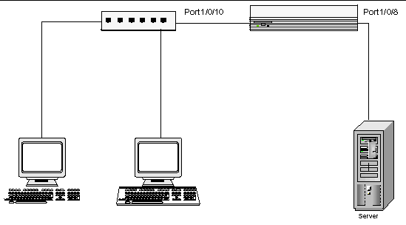
You will configure the ingress interface uniquely for all cos-queue and VLAN parameters.

CODE EXAMPLE 23-1 Configuring Ingress
configure
interface 0/10
classofservice trust dot1p
classofservice dot1p-mapping 6 3
vlan priority 2
exit
interface 0/8
cos-queue min-bandwidth 0 0 5 5 10 20 40
cos-queue strict 6
exit
exit

You can also set traffic shaping parameters for the interface. If you wish to shape the egress interface for a sustained maximum data rate of 80 Mbps (assuming a 100Mbps link speed), you would add a simple configuration line expressing the shaping rate as a percentage of link speed.

CODE EXAMPLE 23-2 Configuring Egress
configure
interface 0/8
traffic-shape 80
exit
exit

Configuring CoS Mapping and Queues via Web Interface
The following web pages are used for the Class of Service feature.
FIGURE 23-3 CoS Trust Mode Configuration Page
FIGURE 23-4 802.1p Priority Mapping Page

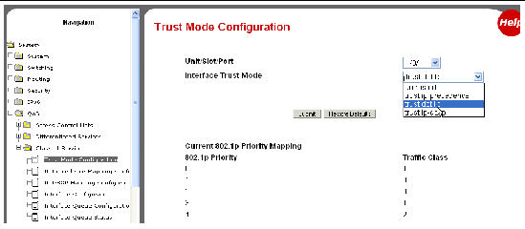

FIGURE 23-5 IP Precedence Mapping Configuration Page
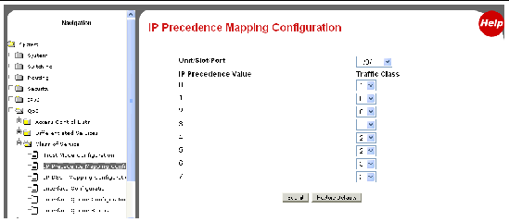
FIGURE 23-6 IP DSCP Mapping Configuration Page

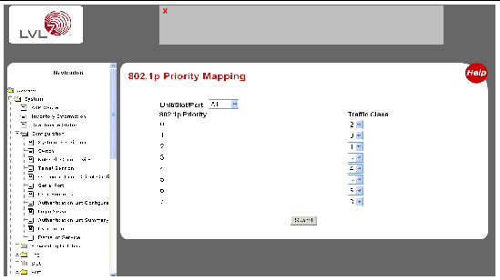

Note - Configure 802.1p Priority Mapping screen from the Switching ---> Class of Service menu.

FIGURE 23-7 CoS Interface Configuration Page
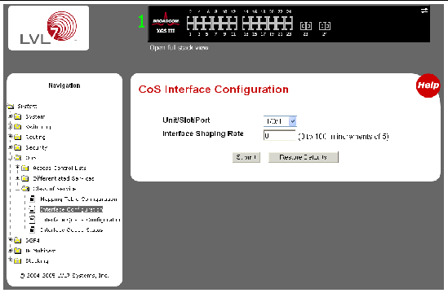

FIGURE 23-8 CoS Interface Queue Configuration Page
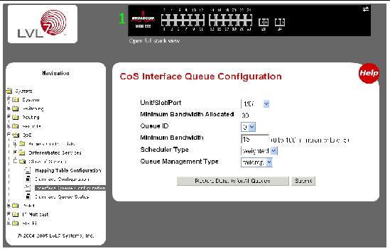

FIGURE 23-9 CoS Interface Queue Status Page
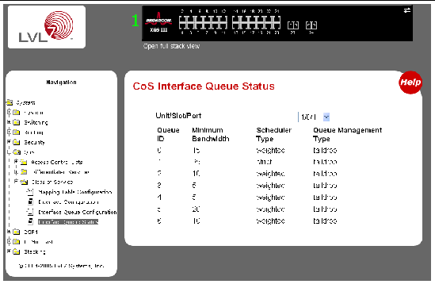

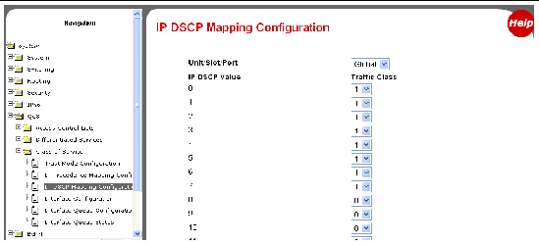

Setting up a VLAN

I need a bit of guidance. I understand VLANs, but I have never set one up in practice, and am a little unsure of a few things especially with our LEA managed network.
Politics/PAT testing/antivirus aside for a moment, we have been asked to look in to the possibility of setting up wireless access for after hours governors meetings, and students. I don't want these on our network as you would expect, so, I presume we would want to set up a VLAN to put them on a private network. Even if we don't implement this, I'd still like to try it out as a learning exercise.
Our main network switches are provided by and managed by our LEA, but we have a few HP1800-24G switches which we can control.
How do I go about setting this up? If I put a port on one of our switches on to a private VLAN in one area of the school, how do I route this to our network for internet access? We also run Censornet for filtering, so would I need a second Censornet box on this new VLAN to provide the filtering?
Any pointers welcome.
Far too big a subject for a single post.
Keep it simple to begin with and work your way up.
Every data packet on your network adheres to an addressing scheme all ports on all your switches belong to a Default VLan.
So start with the idea that all packets belong to the native VLan regardless of where they come from.
This is the "Green VLan" (0 or 1)
So by default all of your links are Green and all ports are Green Members.
I use colours because it's easier to visualize that numbers.
Lets make a new VLan call this the "Blue VLan" (10)
Use matching patch cords to help with the logic.
Now lets have another new VLan call it the "Red VLan" (20)
So I take my 24 +2 Port switch and I can make 1-12 Ports a member of the "Blue VLan" and 12-24 ports members of the "Red VLan"
Any body connected with a blue wire can see anyone else on the "Blue VLan" likewise with the "Red VLan"
Packets hop freely between members but are invisible to others on the same switch.
Thats where the simple port based VLan ends!
What happens when you want to link two switches together?
Well easy, just use a Red Uplink and a Blue uplink cable taken from either group of ports and connect the two switches together.
But what if I only have one uplink to join the switches together?
Now we enter the mysterious world of Tagged and Untagged VLans......
Imagine the uplink between two switches was a dual carraigeway.
We need all packets leaving the switches in either direction to be coloured either "Blue" or "Red" depending on the VLan they came from.
That way when the packet arrives at the other switch it can be immediately recognised by it's couterpart as either "Blue or Red"
Now we have two switches both divided into banks of 12 ports all of the Reds see each other all of the Blues see each other.
Packets are "Tagged" Blue or Red as they leave the switches via the dual carraigeway.
Using this analogy you can divide your Physical single network of copper and fibre links into seperate networks.
Sketch your simple LAN topology and draw your VLans using a Red and Blue pen.
Remember to "Tag" uplinks with both VLan ID's
A Tagged port is not really a member of either VLan it just dabs each passing packet with the correct colour paint as it leaves the switch!
An uplink port needs to "Tag" all leaving packets so they can be recognised on "the other side"
Likewise any responding packet coming back will need to have been tagged the correct colour as it comes back the other way.
Remember, You only tag outbound packets!
Once you have grasped the basics you can move on, for instance put the Blue Vlan on a different IP Range.
You can have all you students on a Blue VLAN and your Admin on a Red one.
Two entirely seperate LANS but sharing the same topology and switches.
Keep it simple, use coloured pens and patch leads and your first VLan is a snip!
Remember, you always need a management VLan, this could just as easily be the Blue or the Red VLan it doesn't matter as long as you can reach all of the switches from wherever you may be plugged in!
Without any management you will be limited to console connections and serial cables!
To connect your VLans running different IP Ranges together you need to use a router.
Start with a simple ethernet cable router or a PC with two NIC's
Later you can look into Routing between VLans using L3 Switching to eliminate unwanted hardware.
A typical VLan Project for school is CCTV.
Put the school LAN on the Blue VLan put the CCTV on the Red VLAN
Blue = 10.x.x.x
Red = 192.x.x.x
On the CCTV server have 2 NIC's one connected to the RED Lan the other to the Blue one.
Like using a water analogy when studying electrical circuits, using colours to Visualise your VLANs is half the battle.
Document them in a way that you can see them easily on a drawing and suddenly managing them becomes easy too.

