**Software Requirements Specification**

*for*

***PetMatchMaking***

*/social network for pets - web application/*

**Prepared by:**

**Georgi Marinov**

**DevNetTeam**

**Version 3 /*approved*/**

**Version date: 10.03.2020**

***Software Requirements Specification for PetMatchMaking Web Application***

***Page ii***

**Table of Contents**

1. **Introduction 1**
   1. Purpose 1
   2. Document Conventions 1
   3. Project Scope 1
   4. References 1

**2.**

**Overall Description 2**

* 1. Product Perspective 2
  2. Product Features 2
  3. User Classes and Characteristics 2
  4. Operating Environment 2
  5. Design and Implementation Constraints 2
     1. Design 2
     2. Constraints 2
  6. User Documentation 3

**System Features and Functional requirements 3**

3.1 User Class 1 – Non-registered user functionalities 3

**3.**

3.1.1

3.1.2

3.1.3

3.1.4

3.1.5

3.2

3.2.1

3.2.2

3.2.3

3.2.4

3.2.5

3.2.6

3.2.7

ID: FR1 3

ID: FR2 3

ID: FR3 3

ID: FR4. Feature: Contact us form 3

ID: FR5. Feature: Create an account 3

User Class 2 – Logged-in User 3

ID: FR6. Feature: User log-in 4

ID: FR7. Feature: Profile page – edit account‘s information 4

ID: FR8. Feature: Search 4

ID: FR9. TITLE: Search result in a list view 4

ID: FR10. TITLE: Search result in a map view 4

ID: FR11. TITLE: Selecting the information link 4

ID: FR12. TITLE: Search by town 5

3.2.8

ID: FR13. TITLE: Search by request’s type 5

3.3 User Class 3 – Administrator 7

**4.**

**External Interface Requirements 7**

* 1. User Interfaces 7
     1. Login screen 7
     2. Sign-up screen 7
     3. Contact us screen – non-logged-in users view 8
     4. Request Section → All requests screen 8

*Navigation bar* 8

4.1.5

4.1.6

4.1.7

4.1.8

4.1.9

4.1.10

4.1.11

4.1.12

4.1.13

Request Section → Add a new request screen 9

Request Section → My requests screen 10

Request Section → View a request Overview screen 10

Request Section → View a request – Pets in the request screen 11

Request Section → View a request – Owner’s profile screen 11

My Pets Section → Add a Pet screen 12

My Pets Section → Pets List screen 12

My Pets Section → Edit pet screen 12

My Profile section → General screen 13

4.1.14

My profile section → Edit Profile screen 13

* 1. Hardware Interfaces 14
  2. Software Interfaces 14
  3. Communications Interfaces 14

***Software Requirements Specification for PetMatchMaking Web Application***

***Page iii***

1. **Other Nonfunctional Requirements 14**
   1. Performance Requirements 14
2. **Other Requirements 15**

**Revision History**

**Name**

**Date**

**Reason For Changes**

**Version**

SRS-DNT-V1.0

28.02.2020

Additional specification of functional requirements

Version 1

SRS-DNT-V2.0

06.03.2020

Adding actualized user interfaces

Version 2

SRS-DNT-V3.0_Approved

10.03.2020

Version 3

***Software Requirements Specification for PetMatchMaking Web Application***

***Page 1***

**1.**

**Introduction**

**1.1**

**Purpose**

The purpose of this document is to give a detailed description of the requirements for the “**PetMatchmaking**” web application (“**web app**”), a part of the “**PetMatchmaking**” application “**app**”. The latter is to consist of the above mentioned **web app** as well as of a mobile application (“**mobile app**”), which is going to be released at a later stage of the overall project and together with the web app will constitute the final long-term strategic product vision. The current document will illustrate the purpose and complete declaration for the development of the web app. It will also explain system constraints, interface and interactions with other external applications – прим. логване с фейсбук. This document is primarily intended to be proposed to the customer for his final approval and a reference for further developing the third version of the system for the development team.

**1.2**

**Document Conventions**

Wherever in the document a blue colored font is placed, the respective requirement / functionality specifies a high level of significance of the requirement / functionality. Wherever in the document a **blue bolded** colored font is placed, the respective requirement / functionality specifies a highest level of significance of the requirement / functionality.

For a reference of any non-defined currently definitions, acronyms, or abbreviations, please see Appendix A: Glossary.

**1.3**

**Project Scope**

The scope of the project is the “**PetMatchmaking**” web app, whose main focus is to help people establish communication on the basis of their love and affection towards pet-animals. There are 3 main directions to which the app is targeting:

1)

**matchmaking**, or finding the best pet-partner for users’ pets based on the users’ residence –

permanent or temporary location and other criteria like breed, age of their pet and more;

**meeting** with other people, who have relevant pets’ affection and/or similar interests connected with

animals; this could be common walks, common gatherings, chats, etc.;

searching for **help** from other people. This could be ask for help with temporary walking the pet, hosting the pet, buying special food for pet, taking care for pet (e.g. asking for help by elderly people being not able to take the full necessary care for their pet);

2)

3)

The criteria on which the users could potentially meet, match-make or help each other is defined in the app by

the definition of the user’ profile characteristics as well as on his/her pets’ description.

The app could also potentially help people to find the best pet to adopt, abiding by the same criteria. The web app is free-accessed via internet, (to be) based in a datacenter.

Logged-in users can provide their personal information and information about their pets using the web-portal. This information will act as the bases for the search results displayed to the user.

An administrator uses the app in order to administer the system and keep the information accurate. The administrator can, for instance, verify pet owners and manage user information.

The app needs internet connection to fetch and display results. The app does not need GPS connection, since the user information is not real time but predefined generally.

All system information is maintained in a database, which should be located on a web-server. The application also has the capability of representing both summary and detailed information about the pets, their owners and the perspective pet sitters / adopters.

**1.4**

**References**

[*https://seilevel.com/requirements/specifying-quality-requirements-with-planguage*](https://seilevel.com/requirements/specifying-quality-requirements-with-planguage)

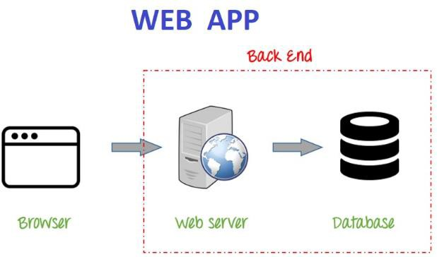

***Software Requirements Specification for PetMatchMaking Web Application***

***Page 2***

**2. Overall Description**

**2.1 Product Perspective**

The app is a new, self-contained product. The system will consist of web app and a database. The **web app** will be used to input, extract and manage information, including user information,

information about the pets, their owner(s), user-rights, as well as system features.

Since this is a data-centric product it will need somewhere to store the data. For that, a **database** will be used. The web app will communicate with the database. All of the database communication will go over the Internet.

**2.2 Product Features**

With the app, the users will be **able to** search for pets for mating purposes (matchmaking), look for event connected with pets, organize events connected with pets, ask for help connected with pets or offer help connected with pets.

The **result** will be based on the criteria the user inputs. There are several search criteria and it will be possible for the administrator of the system to manage the options for those criteria.

The result of the search will be viewed either in a **list view** or in a **map view** and will be accompanied by

**text** as well as by a **picture**, if such is stored.

**2.3 User Classes and Characteristics**

There are three types of users that interact with the system: Non-registered user, logged-in users and administrators. Each of these three types of users has different use of the system so each of them has their own requirements.

The **Non-registered users** can only use the application to see the Home page, see the Info page, read articles if such are placed there, use the Contact us form.

The **Logged-in users** will be able to use the functionalities accessed by Non-registered users, also to use the search features, to manage their account by placing and editing user data, see published requests, read the information in the requests including seeing the uploaded photos in the requests. In order for the users to get a relevant search result there are multiple criteria the users can specify.

The **administrators** are managing the overall system so there is no incorrect information within it. An administrator can manage the information for each request/announcement as well as to specify the drop- down menus by adding items there.

**2.4**

**Operating Environment**

The app operates via any kind of web browser.

**2.5 Design and Implementation Constraints**

**2.5.1**

**Design**

The system design consists of Front end and Back end,

including Database:

* The **Front end** includes HTML, Bootstrap and CSS;

•

The **Back end** includes PHP and MySQL.

**2.5.2**

**Constraints**

***Software Requirements Specification for PetMatchMaking Web Application***

***Page 3***

The app will be constrained by the **capacity of the database**. The database may be forced to queue lots of incoming requests and therefore increase the time it takes to fetch data.

The **Internet connection** is also a constraint for the application. Since the application fetches data from the database over the Internet, it is crucial that there is an Internet connection for the application to function.

The **legal constraints** for using the app are connected with the exposure of personal data in the app and the respective user consent that should be ensured regarding the local personal data legislation, as well as General Data Protection Regulation (GDPR).

**2.6**

**User Documentation**

The user documentation consists of the current SRS, as well as User manual.

**3. System Features and Functional requirements**

**3.1 User Class 1 – Non-registered user functionalities**

**Overview:** Non-registered users should be able to see the Home page, the Info section with all its pages and the Contact us page and to read the content of these sections and pages.

**3.1.1**

**ID: FR1**

**DESC:** Given the user has entered the app

Then the user should be able to see the Login form

**3.1.2**

**ID: FR2**

**DESC:** Given the user has entered the app

Then the user should be able to see a Sign-up link and the user should be able to enter a Sign-up form

**3.1.3**

**ID: FR3**

**DESC:** Given the user has entered the app

Then the user should be able to reach the Info section and the user should be able to read all the content of the Info section

**3.1.4**

**ID: FR4. Feature: Contact us form**

**Overview:** Non-registered users should be able to send messages using the Contact us form.

**DESC:** Given the user has entered the app and the user has entered the Contact us form When the user wants to send a message

And the user has entered Message title and Message content and Name and an e-mail address Then the user should be able to send a message and to see a text verifying the successful sending.

**3.1.5**

**ID: FR5. Feature: Create an account**

Scenario: Required information for registration Given the user wants to create an account

And the user does not have an account for the given username and/or e-mail address

When the user selects the sign up link And the user provides a first name And an e-mail address and a password And successfully confirms the correct password,

Then the user should be able to create an account and receive a verification message; Scenario: Confirmed registration

Given the user has receive a verification message

Then the user should be directed automatically to the Requests page of the app.

**3.2 User Class 2 – Logged-in User**

**Overview: Logged-in Users** should be able to see and use the above-described sections of the app which are visible and usable by non-registered users (see art. 3.2…..) except FR1, FR2 and FR5, as well as to see and use the below described functionalities applicable for Logged-in User.

***Software Requirements Specification for PetMatchMaking Web Application***

***Page 4***

**3.2.1**

**ID: FR6. Feature: User log-in**

**Overview:** In order to use all the functionalities of the app applicable for logged-in users, a user should be logged in to the app.

Scenario: Successful log-in Given the user wants to log in

When the user enters the app and the user provides a username And a password If the username and password are existing and corresponding and correct

Then the user should be logged in to his/her account and directed automatically to the Requests section.

**3.2.2**

**ID: FR7. Feature: Profile page – edit account‘s information**

**DESC:** In order to manage (add, edit or delete) information, a user Should be logged in to the app Given the user is logged in and the information exists

When the user wants to edit his/her account information Then the user should be able to edit the information in a form. **Scenario: Delete information in mandatory fields**

When the user deletes the information from a mandatory field

And the user does not enter another information in the mandatory field Then the user should NOT be able to submit the form.

**3.2.3**

**ID: FR8. Feature: Search**

**DESC**: Given that a user enters the app, And the users selects the Requests section

And the users selects the All Requests sub-section

then the user should be able to perform a search, according to 2 search criteria. The search criteria are location and type of the request. There should also be a free-of-choice/Show all search option. A user should be able to select one or more search criteria in one search.

**3.2.4**

**ID: FR9. TITLE: Search result in a list view**

**DESC**: The default view of the search results is a list. Search results can be viewed in a list.

Each element in the list represents a specific user request.

Each element in the list should include the type of request, date of request, pet species, pet name, request/pet town, name of the user who requested, short subject of the request, pet photo and an information link/**button**.

**3.2.5**

**ID: FR10. TITLE: Search result in a map view**

**DESC**: Search results can be viewed on a map. On the map, the location, according to the user’s request, is shown.

A specific pin will represent the request’s location. On each pin there should be a short information according to what is specified in the corresponding request.

The map view should have a default zoom.

**3.2.6**

**ID: FR11. TITLE: Selecting the information link**

**DESC**: A user should be able to select the information link/**button**, which is included on each of the result items in the list view.

When the user selects the information link/**button** then the link/**button** should disclose to the user

1)

the whole information of the request provided by the pet’s owner, including additional information if added by the pet’s owner

pets in the request section, including all the information of the pet, added by the pet’s owner;

pet owner data section, including all the information of the pet’s owner, added by the pet’s owner;

a map view, showing the location of the address in the request, shown on a map.

2)

3)

4)

***Software Requirements Specification for PetMatchMaking Web Application***

***Page 5***

**3.2.7**

**ID: FR12. TITLE: Search by town**

**DESC**: A user should be able to select a town from a drop-down menu. When the user selects the town and the user clicks the search button,

then the result fetched is a list consisting of only the requests, for which (an address and/or neighborhood in) the selected town is specified.

**3.2.8**

**ID: FR13. TITLE: Search by request’s type**

**DESC**: A user should be able to select a requests’ type from a drop-down menu. When the user selects

the requests’ type and the user clicks the search button,

then the result fetched is a list consisting of only the requests for which the selected type is specified.

**ID: FR14 – TITLE: Search by multiple criteria**

DESC: A user should be able to select both a town and a request’s type from the separate drop-down

lists.

When the user selects the town and the user selects a request’s type and the user clicks the search

button,

then the result fetched is a list consisting of only the requests matching ALL of the selected criteria.

**ID: FR17 free-of-choice search**

DESC: A user should be able to conduct a search by not choosing neither filtering option. When the user does not choose a filtering option and the user clicks the search button, then the result fetched is a list of all the requests published in the app.

**ID: FR18 TITLE: No match found**

DESC: When the user selects the town and/or the user selects the breed and no match is found

then the user should see a message informing that the search finds no matching requests Then the user should be kept on the search page in order to get the possibility to conduct a new search right away.

**ID: FR…**

**Feature: Add new request**

DESC: The user should be able to add a new request. In order to add new request

A user should fill the mandatory fields In a form.

**Scenario: Filling in mandatory fields**

Given the user wants to fill the mandatory fields

When the user selects one or more of his/her added pets And the user selects location And the user selects type of the request And the user selects Start date And the user enters About information And the user enters a phone number

Then the user has filled the mandatory fields of the form.

**Scenario: Filling in optional fields**

Given the user wants to fill in optional fields in the form

When the user provides End date And the user checks the Offering payment option Then the user has filled in optional fields in the form

**Scenario: Adding a new request with mandatory fields** Given the user has filled in the mandatory fields of the form When the user submits the form

Then the new request containing the data filled in the mandatory fields should be added.

**Scenario: Adding a new request with mandatory And optional fields**

Given the user has filled in the mandatory fields of the form

And the user has filled in one or more optional fields of the form When the user submits the form

Then the new request containing the data filled in the mandatory And in the optional fields should be added.

***Software Requirements Specification for PetMatchMaking Web Application***

***Page 6***

**ID: FR…**

**Feature: Edit a request**

DESC: The user should be able to edit each one of his request, one at a time. Given the user wants to edit a request

When the user selects one of his/her requests And the user edits, adds or deletes information And the user submits the form

Then the request should be edited.

**Scenario: Delete information in mandatory fields**

If the user deletes the information from a mandatory field Then the user should NOT be able to submit the form

**ID: FR…**

**Feature: Delete a request**

DESC: The user should be able to delete each one of his request. Given the user wants to delete a request

When the user selects one of his/her requests And the user selects a delete option Then the request should be deleted.

**ID: FR…**

**Feature: Add a new Pet**

DESC: The user should be able to add a new pet. In order to add new pet

A user should fill the mandatory fields In a form.

**Scenario: Filling in mandatory fields**

Given the user wants to fill the mandatory fields

When the user enters a name And the user selects species And the user enters About info Then the user has filled the mandatory fields of the form.

**Scenario: Filling in optional fields**

Given the user wants to fill in optional fields in the form

When the user provides pet’s sex and birthday And the user enters Food habits And the user uploads a

photo of the pet

Then the user has filled in optional fields in the form

**Scenario: Adding a new pet with mandatory fields**

Given the user has filled in the mandatory fields of the form When the user submits the form

Then the new pet containing the data filled in the mandatory fields should be added.

**Scenario: Adding a new pet with mandatory And optional fields**

Given the user has filled in the mandatory fields of the form

And the user has filled in one or more optional fields of the form When the user submits the form

Then the new pet containing the data filled in the mandatory And in the optional fields should be added.

**ID: FR…**

**Feature: Edit a pet**

DESC: The user should be able to edit each one of his pets, one at a time. Given the user wants to edit a pet

When the user selects one of his/her pet

And the user edits, adds or deletes information And the user submits the form

Then the pet should be edited.

**Scenario: Delete information in mandatory fields**

If the user deletes the information from a mandatory field Then the user should NOT be able to submit the form

**ID: FR…**

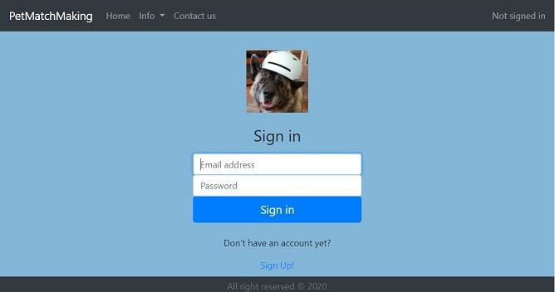

***Software Requirements Specification for PetMatchMaking Web Application***

***Page 7***

**Feature: Delete a pet**

DESC: The user should be able to delete each one of his pets. Given the user wants to delete a pet

When the user selects one of his/her pets And the user selects a delete option Then the pet should be deleted.

**3.3 User Class 3 – Administrator**

**ID: FR26 Feature: Administrator log in**

**ID: FR28 Feature: Manage листа с градовете и**

**ID: FR29 Feature: Manage листа с породите**

**ID: FR30 Feature: Manage restaurant information – да внимавам да не се припокрие с 31**

**ID: FR31 Feature: Manage users**

**4.**

**External Interface Requirements**

**4.1**

**User Interfaces**

**4.1.1**

**Login screen**

A non-registered user of the app should see the home page with a log-in and sign-up options when he/she opens the app. If the user has not registered, he/she should be able to do that on the sign-up page.

On the Login page there should be the following items:

1.

Link to “Info” section on the

Navigation bar

Link to “Contact us” form on the

navigation bar

Title “Sign in”,

input field “Email address” input field “Password”

Button named “Sign in” Link named “Sign up”

2.

3.

4.

5.

6.

7.

**4.1.2**

**Sign-up screen**

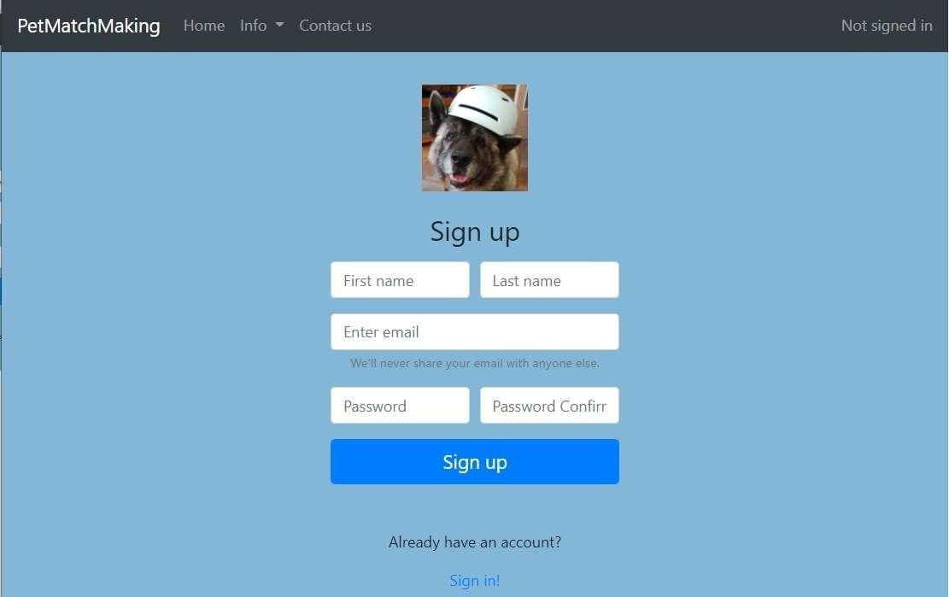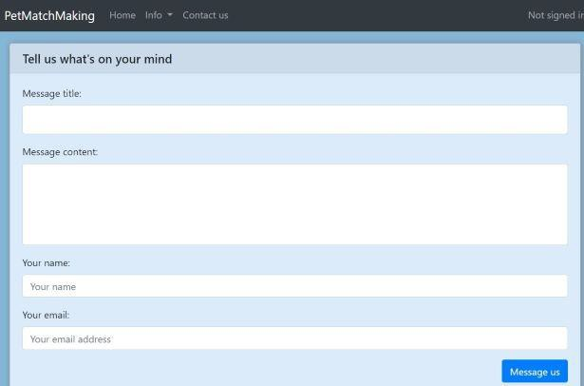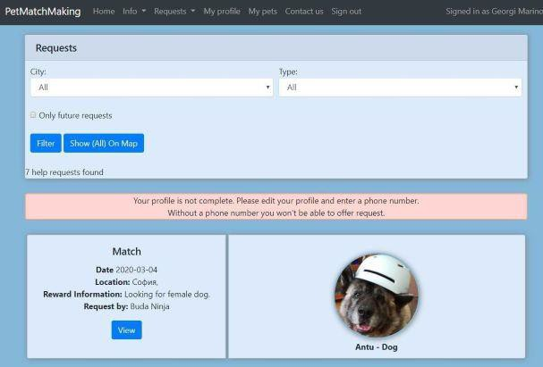

***Software Requirements Specification for PetMatchMaking Web Application***

***Page 8***

When selecting the Sign up link, a user should be directed to a sign up form

In the sign up form there should be the following items:

1.

2.

on the Navigation bar – Company’s logo on the Navigation bar - Link to “Info” section

on the Navigation bar - Link to “Contact us” form

Title “Sign in”,

Input field “First name” Input field “Last name” Input field “Enter e-mail”

Text “We will never share your e-mail with anyone else”

Input field “password”

3.

4.

5.

6.

7.

8.

9.

10. Input field “confirm password”

1. Submit Button named “Sign up”
2. Text “Already have an account?”
3. Link to “Sign in” form

**4.1.3**

**Contact us screen – non-logged-in users view**

1.

2.

3.

4.

5.

6.

7.

8.

9.

on the Navigation bar – Company’s logo

on the Navigation bar - Link to “Info” section on the Navigation bar - Link to “Home” page Title “Tell us what's on your mind”,

Input field “Message title” Input field “Message text” Input field “Your name”

Input field “Your e-mail address”

Submit Button named “Message us”

**4.1.4 Request Section** → **All requests screen**

***Navigation bar:***

1.

2.

3.

4.

5.

6.

7.

Link to “Info” page

Link to “Requests” page Link to “My profile” page Link to “My pets” page

Link to “Contact us” page Link to “Sign out” option

Text “Signed in as <*First and Second name of the user*>”

**Below the Navigation bar – Filtering interface section**

Text “Requests”

Drop down list Filter for location, named

“City”

8.

9.

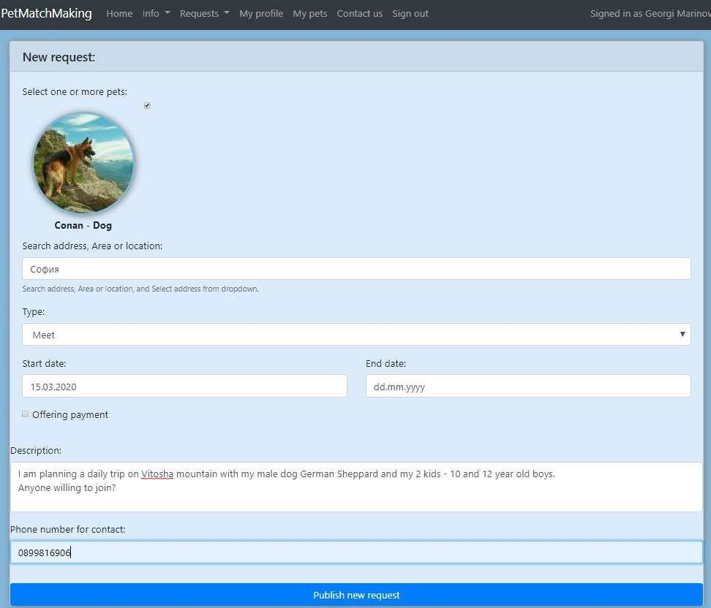

***Software Requirements Specification for PetMatchMaking Web Application***

***Page 9***

1. Drop down list Filter for type of requests, named “Type”
2. Check box named “Only future requests”
3. Button named “Filter”
4. Button named “Filter all on a map”

**Results section**

1. RESULTS LIST showing
   * ON THE LEFT: the type of request, date of requested event, Location of request, Reward

information (if any), Name of requested user, button named “View”,

•

ON THE RIGHT: Picture of the pet in the request (if any);

**4.1.5 Request Section** → **Add a new request screen**

**Navigation bar:**

Link to “Info” page

Link to “Requests” page Link to “My profile” page Link to “My pets” page

Link to “Contact us” page Link to “Sign out” option

Text “Signed in as <*First and Second name of the user*>” **Submit form section**

Text “New Request:”

Check box named “Select one or more pets for this request”

1.

2.

3.

4.

5.

6.

7.

8.

9.

1. Drop down list Filter for location, named “Search address, area or location”
2. Drop down list Filter for type of request, named “Type”
3. Date-type input field, named

“Start date”

1. Date-type input field, named

“End date”

1. Check box named “Offering reward”
2. Text Input field, named

“Description”

1. Text Input field, named “Phone number for contact”
2. Submit button named “Publish the request”

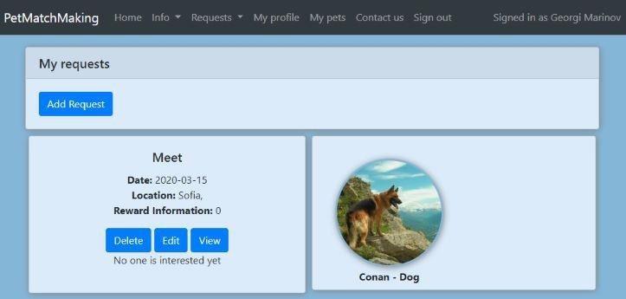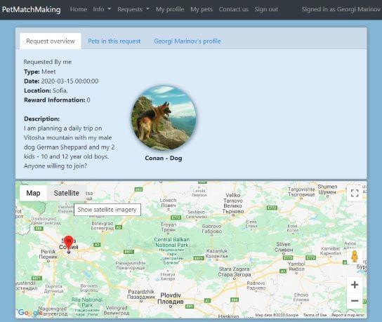

***Software Requirements Specification for PetMatchMaking Web Application***

***Page 10***

**4.1.6 Request Section** → **My requests screen**

**Navigation bar:**

Link to “Info” page

Link to “Requests” page Link to “My profile” page Link to “My pets” page

Link to “Contact us” page Link to “Sign out” option

*Text “Signed in as <First and Second name of the user>”*

**Results section**

RESULTS LIST showing for each result:

* ON THE LEFT: the type of request, date of requested

event, Location of request, Reward information (if any), button named “Delete”, button named

“Edit”, button named “View”,

1.

2.

3.

4.

5.

6.

7.

8.

•

ON THE RIGHT: Picture of the pet in the request (if any);

**Request Section** → **View a request Overview screen**

**4.1.7**

**Navigation bar:**

Link to “Info” page

Link to “Requests” page Link to “My profile” page Link to “My pets” page

Link to “Contact us” page Link to “Sign out” option

*Text “Signed in as <First and Second name of the user>”*

**View section** /below navigation bar/:

**Button named Request Overview**

→ **when pressed exposes:**

Text: “Requested by <Names of the

user requested>”

Text: “Type of request: <Type of the request>”

1.

2.

3.

4.

5.

6.

7.

8.

9.

10. Text: “Date of request: <Date of the request>”

1. Text: “Location: < Location of the request >”
2. Text: “Reward information:

<Description of the terms with regard to the reward if any>”

1. Text: “Description <Description of the request if any>”
2. Photo of the pet if any

**Map** /below View section/:

1. Pin on the map pointing to the location /town, neighborhood/ of the request

**Button named Pets in the request**

**Button named <Names of the user requested>’s profile**

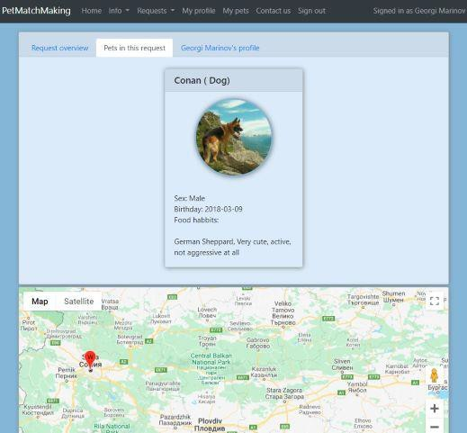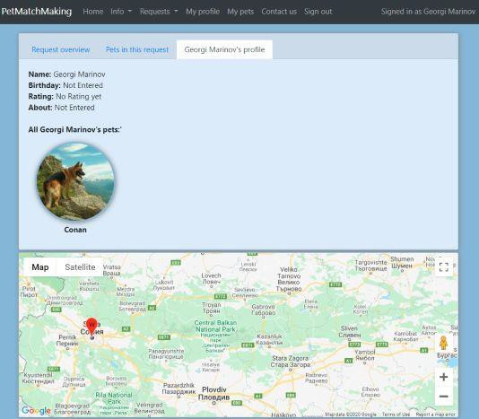

***Software Requirements Specification for PetMatchMaking Web Application***

***Page 11***

**4.1.8 Request Section** → **View a request – Pets in the request screen**

**Navigation bar:**

Link to “Info” page

Link to “Requests” page Link to “My profile” page Link to “My pets” page

Link to “Contact us” page

6. Link to “Sign out” option *Text “Signed in as <First and Second name of the user>”*

**View section** /below navigation bar/: **Button named Request Overview Button named Pets in the request** → **when pressed exposes:**

Text: “Sex: <Pet’s sex>”

Text: “Birthday<Pet’s birthday>” if any

1.

2.

3.

4.

5.

7.

8.

9.

1. Text: “Food habits: <Food habits if any>”
2. Text: “About: <Description of the request if any>”

**Button named <Names of the user requested>’s profile**

**Map** /below View section/: Pin on the map pointing to the location /town, neighborhood/ of the request

**Request Section** → **View a request – Owner’s profile screen**

**4.1.9**

**Navigation bar:**

Link to “Info” page

Link to “Requests” page Link to “My profile” page Link to “My pets” page

Link to “Contact us” page

Link to “Sign out” option

*Text “Signed in as <First and Second name of the user>”*

**View section** /below navigation bar/:

**Button named Request Overview Button named Pets in the request Button named <Names of the user requested>’s profile** → **when pressed exposes:**

Text: “Name: <First and Last names of the user requested>”

Text: “Birthday<User’s birthday>” if any

1.

2.

3.

4.

5.

6.

7.

8.

9.

1. Text: “Rating: <User’s rating >” if any
2. Text: “About: <Description of the user>” if any
3. Text “All <First and Last names of the user requested>’s pets”
4. Photos, resp. names of the user’s pets if any

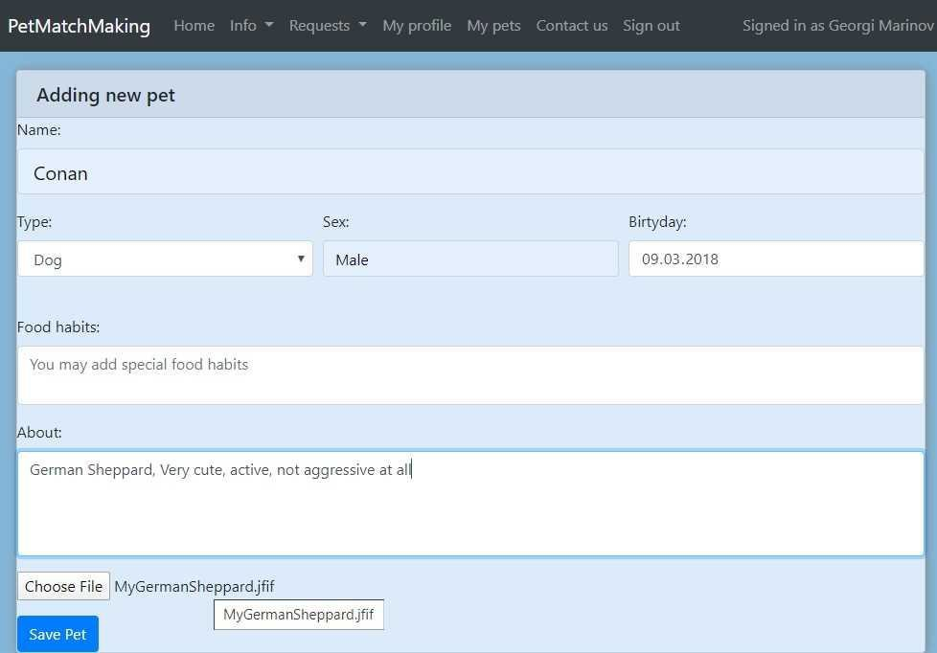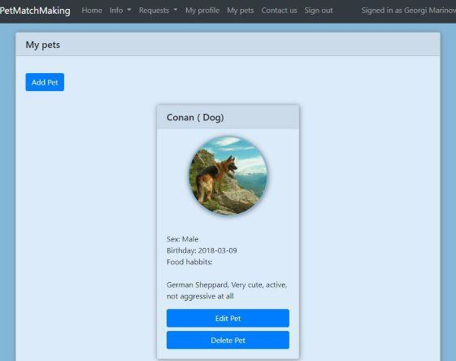

***Software Requirements Specification for PetMatchMaking Web Application***

***Page 12***

**Map** /below View section/: Pin on the map pointing to the location /town, neighborhood/ of the request

**4.1.10 My Pets Section** → **Add a Pet screen**

**Navigation bar:**

Link to “Info” page

Link to “Requests” page Link to “My profile” page Link to “My pets” page

Link to “Contact us” page

Link to “Sign out” option

Text “Signed in as <*First and Second name of the user*>”

**Adding new pet Form section**

Text “Adding new pet” Text “Name”

1.

2.

3.

4.

5.

6.

7.

8.

9.

1. Drop-down list Filter named “Type”
2. Drop-down list Filter named “Sex”
3. Date-type input field, named

“Birthday”

1. Text Input field, named “Food habits:”
2. Text Input field, named “About:”
3. FileUpload Button named “Choose File”
4. Submit button named “Save pet”

**4.1.11 My Pets Section** → **Pets List screen**

**Navigation bar:**

1.

2.

3.

4.

5.

6.

7.

Link to “Info” page

Link to “Requests” page Link to “My profile” page Link to “My pets” page

Link to “Contact us” page Link to “Sign out” option

Text “Signed in as <*First and Second name of the user*>”

**Below Navigation bar and above Result section:**

Button named “Add a pet”

**Results section**

14. Text “My pets”

1. RESULTS LIST showing for each result:
   * UP: Name of the pet, Species of the pet

•

DOWN: Sex, Birthday, Food habits Description if any inputted in About section, button named

“Delete”, button named “Edit”

**4.1.12 My Pets Section** → **Edit pet screen**

The screen is the same as “My Pets Section → Add a Pet screen” except the following difference: The title name is: “Edit <name of the pet>” instead of “Adding new pet”

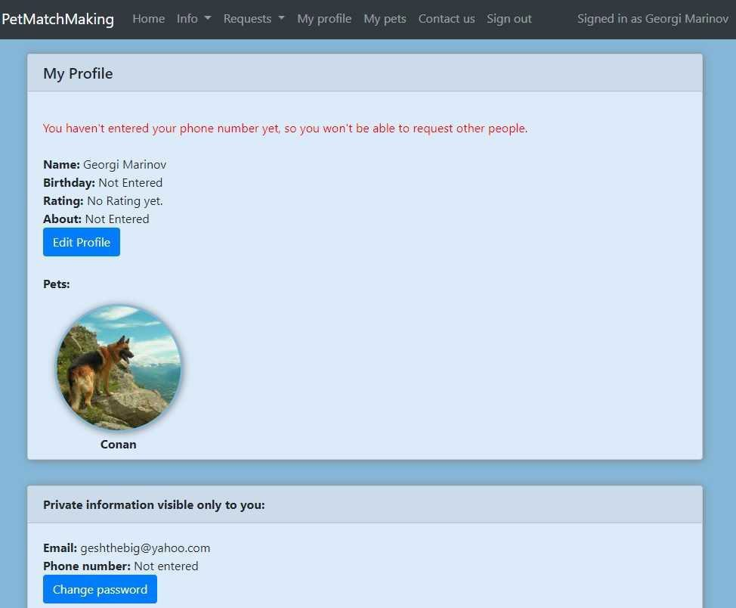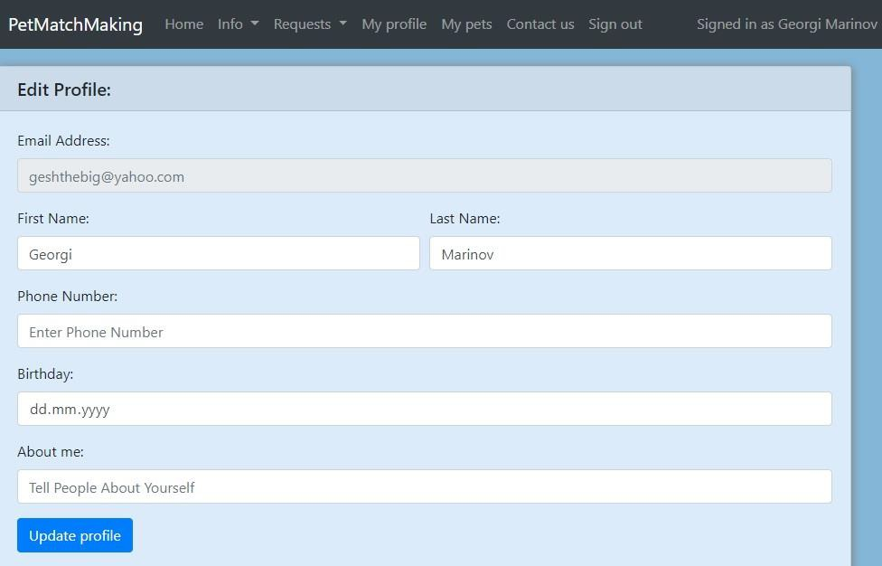

***Software Requirements Specification for PetMatchMaking Web Application***

***Page 13***

**4.1.13 My Profile section** → **General screen**

**Navigation bar:**

1.

2.

3.

4.

5.

6.

7.

Link to “Info” page

Link to “Requests” page Link to “My profile” page Link to “My pets” page

Link to “Contact us” page Link to “Sign out” option

Text “Signed in as <*First and Second name of the user*>”

**Below Navigation bar and above Pets added by the:**

Page title with text “My Profile”

INFO ABOUT THE USER SECTION:

* Name of the user

8.

9.

•

•

•

Birthday if entered Rating if received About if entered

10. Button named “Edit profile” directing to

Edit profile form

1. A LIST SECTION, with pets added by the user containing:
   * Photo of the pet if added

•

Name of the pet

1. OTHER INFORMATION ABOUT THE USER SECTION:
   * e-mail address
   * Phone number if entered
   * Button named “Change password” directing to Change password form

**4.1.14 My profile section** → **Edit Profile screen**

**Navigation bar:**

1.

2.

3.

4.

5.

6.

7.

Link to “Info” page

Link to “Requests” page Link to “My profile” page Link to “My pets” page

Link to “Contact us” page Link to “Sign out” option

Text “Signed in as <*First and Second name of the user*>” **Below Navigation bar:**

Page title with text “Edit Profile”

Input field named “e-mail address” – inactive; The user will not be able to change the e-mail address

8.

9.

1. Text Input field named “First name”
2. Text Input field named “Last name”
3. Text Input field named “Phone number”
4. Date input field named “Birthday”
5. Text Input field named “About me”

***Software Requirements Specification for PetMatchMaking Web Application***

***Page 14***

15. Submit Button named “Update profile”

Every user should have a profile page where they can edit their username, e-mail address, phone number and password, as well as optional additional data, like does the user want to offer a pet for matchmaking or/and to offer a pet for adoption, breed of the pet, years of the pet, to add additional information as text up to 200 symbols, to upload a picture of the pet - see Figure 4. Also, the user can set the app to his/her preferred language.

Anyways, no matter logged-in/sighed-up or not, the user should be able to see the two sections of the app – Matchmaking and Adoption, as well as additional information and to choose by clicking then enter in any of them. When entering a section, a respective search menu appears - see Figure 3. Here the user should be able to choose the criteria of the search he/she wants to conduct.

In Figure 5, the list view for the results is shown.

In both sections when a user searches by breed, this view should be the default one. Each result item includes information about the pet - breed of the pet, years of the pet, additional information as text, the picture of the pet if any.

A logged-in user should be able to perform the same actions as the non-logged-in user and additionally to upload announcement for matchmaking or adoption in any of the two sections (Matchmaking and Adoption).

An administrator should be able to log in to the web-portal where he/she can administer the system by for instance editing an announcement, or user information, or banning an announcement if inappropriate.

The section Additional information (see Figure …) should contain headings hyperlinked to another page, with pictures next to the headings. When clicking a heading, the user should be transferred to the page with the whole text of the respective article, to which the heading is hyperlinked (see Figure …).

**4.2 Hardware Interfaces**

Since neither the web or mobile apps have any designated hardware, it does not have any direct hardware interfaces.

**4.3 Software Interfaces**

The communication between the database and the web portal and mobile app consists of operation concerning both reading and modifying the data.

**4.4 Communications Interfaces**

The communication between the different parts of the system is important since they depend on each other. However, in what way the communication is achieved is not important for the system and is therefore handled by the underlying operating systems for both the mobile application and the web portal.

**5. Other Nonfunctional Requirements**

**5.1 Performance Requirements**

**ID: QR1 TITLE**: Prominent search feature

DESC: The search feature should be prominent and easy to find for the user.

**ID: QR2 TITLE:** Usage of the search feature

DESC: The different search options should be evident, simple and easy to understand.

**ID: QR3 TITLE:** Usage of the result in the list view

**DESC:** The results displayed in the list view should be user friendly and easy to understand. Selecting an element in the result list should only take one click.

***Software Requirements Specification for PetMatchMaking Web Application***

***Page 15***

**ID: QR4 TITLE**: Usage of the result in the map view

**DESC**: The results displayed in the map view should be user friendly and easy to understand. Selecting a pin on the map should only take one click.

**ID: QR5 TITLE**: Usage of the information link **/button**

**DESC**: The information link **/button** should be prominent and it should be evident that it is a usable link

**/button**. Selecting the information link **/button** should only take one click.

**ID: QR6 TAG: ResponseTime**

GIST: The fastness of the search SCALE: The response time of a search METER: Measurements obtained from 1000 searches during testing. MUST: No more than 2 seconds 100% of the time. WISH: No more than 1 second 100% of the time.

**6.**

**Other Requirements**

*<Define any other requirements not covered elsewhere in the SRS. This might include database requirements, internationalization requirements, legal requirements, reuse objectives for the project, and so on. Add any new sections that are pertinent to the project.>*

**Appendix A: Glossary**

**Term**

**Definition**

The app

The application specified in the current document

The system

All the components making possible the functioning of the app, incl. front end and back end

User

Someone who interacts with the app

Non-registered user

Someone who interacts with the app without having a user account

Registered user

Someone who interacts with the app and has a user account

Logged-in user

A Registered user who interacts with the app after he/she has logged-in with their username/e-mail and password

Non-Logged user

A Registered user who interacts with the app without having logged-in with their username/e-mail and password

Admin/Administrator

System administrator who is given specific permission for managing and controlling the system

Stakeholder

Any person who has interaction with the system who is not a developer.

DESC

Description