Fan 8 Bit PUZZLE ZONE

Here

GENRE:

A traditional matching puzzle game with a 8 bit twist. Genre falls under puzzle game that has be consistently reinvented throughout the years.

Bibliography :

CREDITS:

ART by: Nhat Ho

Music: Half Bit by Kevin MacLeod is licensed under a Creative Commons Attribution license (https://creativecommons.org/licenses/by/4.0/)

Sound effects from Kenny's World

Source: http://incompetech.com/music/royalty-free/?keywords=%22half+bit%22

Artist: http://incompetech.com/

With Help From:

Steven Price

Learning C# by Developing Games with Unity 3D Unity Beginner's Guide by Terry Norton

[Brackeys]. (2020, April 10). *Start Menu in Unity*[Video]. Youtube

<https://www.youtube.com/watch?v=zc8ac_qUXQY&t=686s>

[Mister Taft Creates:]. (2020, April 10). *Find a Match Part*

[Video]. Youtube

<https://www.youtube.com/watch?v=va2kbdu5z6E&list=PL4vbr3u7UKWrxEz75MqmTDd899cYAvQ_B&index=4>

“Unity 2D Tetris Tutorial.” *Noobtuts*, 2020, noobtuts.com/unity/2d-tetris-game/.

<https://noobtuts.com/unity/2d-tetris-game/>

“Unity 2D Tetris Tutorial.” *Noobtuts*, 2020, noobtuts.com/unity/2d-tetris-game/.

CODING MY OWN TETRIS (Unity)

[Valem]. (2020, April 10). *CODING MY OWN TETRIS (Unity)*

[Video]. Youtube

<https://www.youtube.com/watch?v=T5P8ohdxDjo>

***‘SOLVE AMATEUR FAN ART PUZZLES*** – Nhat Ho

This page: Table of Contents and Team Member Listing

|  |  |  |
| --- | --- | --- |
| Table of Contents  [1 Game Overview](https://n-xovwktmtjsnaxyc2mwes2xu7pohqedmdm6zjw5q-2lu-script.googleusercontent.com/userCodeAppPanel)  [2 High Concept](https://n-xovwktmtjsnaxyc2mwes2xu7pohqedmdm6zjw5q-2lu-script.googleusercontent.com/userCodeAppPanel)  [3 Unique Selling Points](https://n-xovwktmtjsnaxyc2mwes2xu7pohqedmdm6zjw5q-2lu-script.googleusercontent.com/userCodeAppPanel)  [4 Platform Minimum Requirements](https://n-xovwktmtjsnaxyc2mwes2xu7pohqedmdm6zjw5q-2lu-script.googleusercontent.com/userCodeAppPanel)  [5 Competitors / Similar Titles](https://n-xovwktmtjsnaxyc2mwes2xu7pohqedmdm6zjw5q-2lu-script.googleusercontent.com/userCodeAppPanel)  [6 Synopsis](https://n-xovwktmtjsnaxyc2mwes2xu7pohqedmdm6zjw5q-2lu-script.googleusercontent.com/userCodeAppPanel)  [7 Game Objectives](https://n-xovwktmtjsnaxyc2mwes2xu7pohqedmdm6zjw5q-2lu-script.googleusercontent.com/userCodeAppPanel)  [8 Game Rules](https://n-xovwktmtjsnaxyc2mwes2xu7pohqedmdm6zjw5q-2lu-script.googleusercontent.com/userCodeAppPanel)  [9 Game Structure](https://n-xovwktmtjsnaxyc2mwes2xu7pohqedmdm6zjw5q-2lu-script.googleusercontent.com/userCodeAppPanel)  [10 Game Play](https://n-xovwktmtjsnaxyc2mwes2xu7pohqedmdm6zjw5q-2lu-script.googleusercontent.com/userCodeAppPanel)  [10.1 Game Controls](https://n-xovwktmtjsnaxyc2mwes2xu7pohqedmdm6zjw5q-2lu-script.googleusercontent.com/userCodeAppPanel)  [10.2 Game Camera](https://n-xovwktmtjsnaxyc2mwes2xu7pohqedmdm6zjw5q-2lu-script.googleusercontent.com/userCodeAppPanel)  [10.2.1 HUD](https://n-xovwktmtjsnaxyc2mwes2xu7pohqedmdm6zjw5q-2lu-script.googleusercontent.com/userCodeAppPanel)  [10.2.2 Maps](https://n-xovwktmtjsnaxyc2mwes2xu7pohqedmdm6zjw5q-2lu-script.googleusercontent.com/userCodeAppPanel)  [11 Players](https://n-xovwktmtjsnaxyc2mwes2xu7pohqedmdm6zjw5q-2lu-script.googleusercontent.com/userCodeAppPanel)  [11.1 Characters](https://n-xovwktmtjsnaxyc2mwes2xu7pohqedmdm6zjw5q-2lu-script.googleusercontent.com/userCodeAppPanel)  [11.2 Metrics](https://n-xovwktmtjsnaxyc2mwes2xu7pohqedmdm6zjw5q-2lu-script.googleusercontent.com/userCodeAppPanel)  [11.3 States](https://n-xovwktmtjsnaxyc2mwes2xu7pohqedmdm6zjw5q-2lu-script.googleusercontent.com/userCodeAppPanel)  [11.4 Weapons](https://n-xovwktmtjsnaxyc2mwes2xu7pohqedmdm6zjw5q-2lu-script.googleusercontent.com/userCodeAppPanel)  [12 Player Line-up](https://n-xovwktmtjsnaxyc2mwes2xu7pohqedmdm6zjw5q-2lu-script.googleusercontent.com/userCodeAppPanel)  [13 NPC](https://n-xovwktmtjsnaxyc2mwes2xu7pohqedmdm6zjw5q-2lu-script.googleusercontent.com/userCodeAppPanel)  [13.1 Enemies](https://n-xovwktmtjsnaxyc2mwes2xu7pohqedmdm6zjw5q-2lu-script.googleusercontent.com/userCodeAppPanel)  [13.1.1 Enemy States](https://n-xovwktmtjsnaxyc2mwes2xu7pohqedmdm6zjw5q-2lu-script.googleusercontent.com/userCodeAppPanel)  [13.1.2 Enemy Spawn Points](https://n-xovwktmtjsnaxyc2mwes2xu7pohqedmdm6zjw5q-2lu-script.googleusercontent.com/userCodeAppPanel)  [13.2 Allies / Companions](https://n-xovwktmtjsnaxyc2mwes2xu7pohqedmdm6zjw5q-2lu-script.googleusercontent.com/userCodeAppPanel)  [13.2.1 Ally States](https://n-xovwktmtjsnaxyc2mwes2xu7pohqedmdm6zjw5q-2lu-script.googleusercontent.com/userCodeAppPanel)  [13.2.2 Ally Spawn Points](https://n-xovwktmtjsnaxyc2mwes2xu7pohqedmdm6zjw5q-2lu-script.googleusercontent.com/userCodeAppPanel)  [14 Art](https://n-xovwktmtjsnaxyc2mwes2xu7pohqedmdm6zjw5q-2lu-script.googleusercontent.com/userCodeAppPanel)  [14.1 Setting](https://n-xovwktmtjsnaxyc2mwes2xu7pohqedmdm6zjw5q-2lu-script.googleusercontent.com/userCodeAppPanel)  [14.2 Level Design](https://n-xovwktmtjsnaxyc2mwes2xu7pohqedmdm6zjw5q-2lu-script.googleusercontent.com/userCodeAppPanel)  [14.3 Audio](https://n-xovwktmtjsnaxyc2mwes2xu7pohqedmdm6zjw5q-2lu-script.googleusercontent.com/userCodeAppPanel)  [15 Procedurally Generated Content](https://n-xovwktmtjsnaxyc2mwes2xu7pohqedmdm6zjw5q-2lu-script.googleusercontent.com/userCodeAppPanel)  [15.1 Environment](https://n-xovwktmtjsnaxyc2mwes2xu7pohqedmdm6zjw5q-2lu-script.googleusercontent.com/userCodeAppPanel)  [15.2 Levels](https://n-xovwktmtjsnaxyc2mwes2xu7pohqedmdm6zjw5q-2lu-script.googleusercontent.com/userCodeAppPanel)  [15.3 Artificial Intelligence NPC](https://n-xovwktmtjsnaxyc2mwes2xu7pohqedmdm6zjw5q-2lu-script.googleusercontent.com/userCodeAppPanel)  [15.4 Visual Arts](https://n-xovwktmtjsnaxyc2mwes2xu7pohqedmdm6zjw5q-2lu-script.googleusercontent.com/userCodeAppPanel)  [15.5 Audio](https://n-xovwktmtjsnaxyc2mwes2xu7pohqedmdm6zjw5q-2lu-script.googleusercontent.com/userCodeAppPanel)  [15.6 Minimum Viable Product (MPV)](https://n-xovwktmtjsnaxyc2mwes2xu7pohqedmdm6zjw5q-2lu-script.googleusercontent.com/userCodeAppPanel)  [16 Wish List](https://n-xovwktmtjsnaxyc2mwes2xu7pohqedmdm6zjw5q-2lu-script.googleusercontent.com/userCodeAppPanel)   |  | | --- | |  | | Game Development Team Members    PRODUCER  You    PRODUCTION MANAGER  You    PRODUCTION COORDINATOR  You  GAME DESIGNERS  You  SYSTEMS/IT COORDINATOR  You  PROGRAMMERS  You  TECHNICAL ARTISTS  You  AUDIO ENGINEERS  You  UX TESTERS  You |

|  |
| --- |
|  |

# 1 Game Overview

Title: Fan 8 Bit PUZZLE ZONE

Platform: PC Standalone + iOS & Android,

Genre: Puzzle

Rating: (10+) ESRB

Target: Casual gamer (aging from 12 - 30)

Serious games

Release date: TBD

Publisher: Nhat Ho

Description: 8 Bit Puzzle Zone creates an environment to solve visual a simple visual puzzle. Match the 8-bit art with each other and watch it get blasted and continue as long you can. Beat the developers high score and beat the payer’s own personal high score for a challenge. It trains the player to solve problems while having fun.

# 2 High Concept

Classic match making game but with 8 bit art. The game is to beat the developer at his own game and beat the player’s own personal goal. It helps stimulate the brain and improve problem solving skills.

# 3 Unique Selling Points

* Custom 8 bit art
* Unique Particle effects
* Easy to play
* Multiplatform

# 4 Platform Minimum Requirements

PC, Mac and Linux

OS: Windows XP and up, Mac OS X 10.8+, Ubuntu 12.04

Graphics card: DX9 capabilities.

Android:

OS 2.3.1 or later

ARMv7 (cortex) CPU with NEON support or Atom CPU;

OpenGL ES 2.0 or later

# 5 Competitors / Similar Titles

Bejeweled by Electronic Arts

Candy Crush by King

Match Land by Race Cat

BONBON by Bandai Namco

# 6 Synopsis

Enter the developer’s 8 bit world. Solve the matching puzzle and beat him at his own game. Develop your problem solving skills by beating your high score.

# 7 Game Objectives

The objective of the game is to beat the developers score.

# 8 Game Rules

Find a potentially match of 3 in a roll. Click on the icon where the player thinks the 8 will match and either drag it left, right, up or down. If it matches, the 3 bits will be removed, and the board will add more icons. After each 3 bits are matched the score will be increased.

# 9 Game Structure

# 10 Game Play

## 10.1 Game Controls

Game Controls (PC)

Left Click Mouse and hold it on the 8-bit icon. Drag it either left, right, up and down and release. To cheat press right click on the icon to turn in to a bomb.

Game Controls (Mobile)

With touch controls, just one finger to slide either right, left, up or down on the 8 bit icon. It will move the icon in the direction the player chooses

## 10.2 Game Camera

Fixed 2d camera that will show the game board.

### 10.2.1 HUD

No Hud in this game

### 10.2.2 Maps

No maps in this game.

# 11 Players

## 11.1 Characters

No player just cute 8-bit icons.

## 11.2 Metrics

Each match will increase the score by 10. If there is a combo the score will by 1.

## 11.3 States

Idle: The icons won’t move and will wait for the player to move it.

Move: The icon will slide in the player’s designated direction. In this period, the player won’t be able to move any other icon.

Reset: If the player can’t see any more potentially moves, he would press reset.

## 11.4 Weapons

N/A

# 12 Player Line-up

N/A

# 13 NPC

## 13.1 Enemies

N/A

### 13.1.1 Enemy States

N/A

### 13.1.2 Enemy Spawn Points

N/A

## 13.2 Allies / Companions

N/A

### 13.2.1 Ally States

N/A

### 13.2.2 Ally Spawn Points

# 14 Art

## 14.1 Setting

The game takes place in the developers dream where he imaginations are represented in pixel art.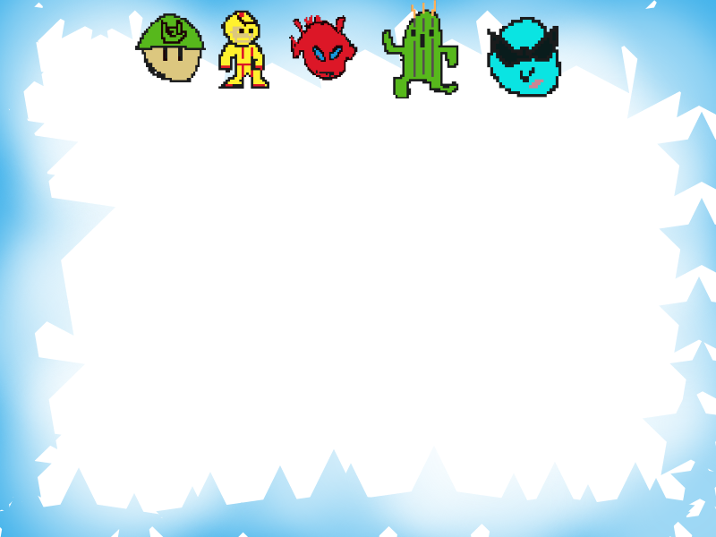

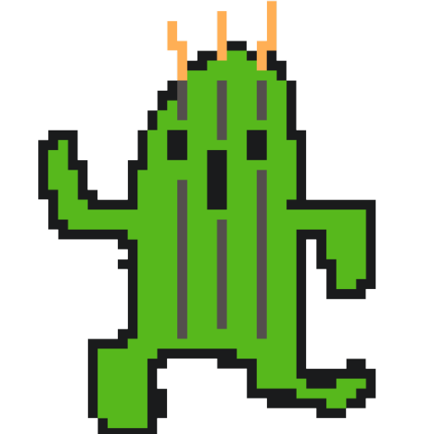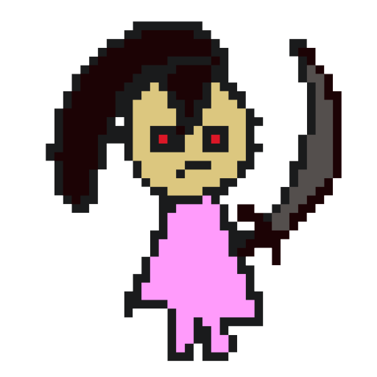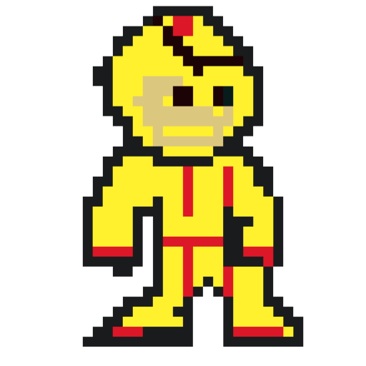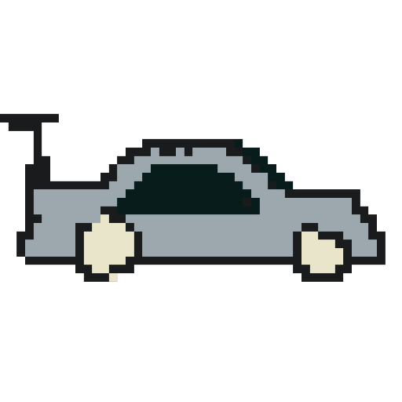

## 14.2 Level Design

The level is designed in a 2d plane with a 7x10 matrix.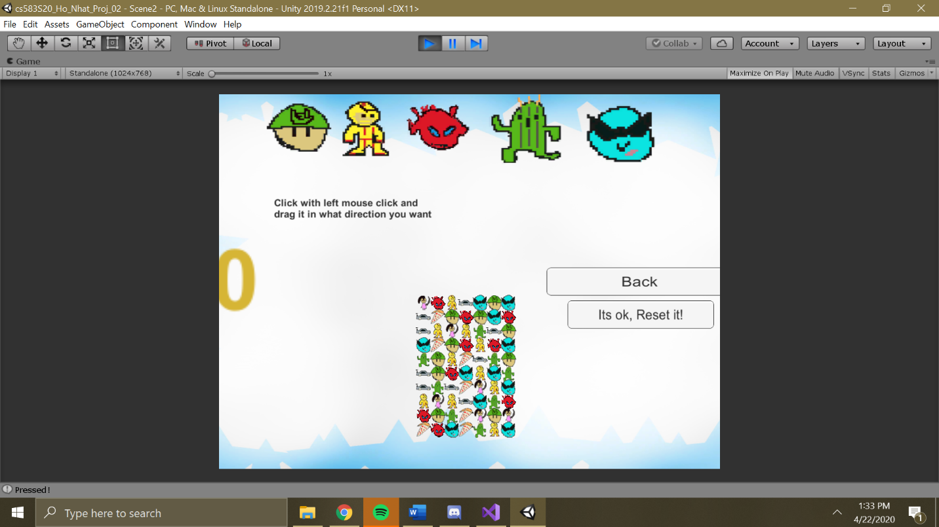

## 14.3 Audio

Back ground music :

Half Bit by Kevin MacLeod is licensed under a Creative Commons Attribution license (https://creativecommons.org/licenses/by/4.0/)

Source: http://incompetech.com/music/royalty-free/?keywords=%22half+bit%22

Artist: <http://incompetech.com/>

Name:

HandleCoins FX When icons swipes

KnifeSlice FX When Icon Swipes

Switch27 FX When Icon matches

www.kenney.nl

# 15 Procedurally Generated Content

## 15.1 Environment

N/A

## 15.2 Levels

N/A

## 15.3 Artificial Intelligence NPC

N/A

## 15.4 Visual Arts

N/A

## 15.5 Audio

Back ground music :

Half Bit by Kevin MacLeod is licensed under a Creative Commons Attribution license (https://creativecommons.org/licenses/by/4.0/)

Source: http://incompetech.com/music/royalty-free/?keywords=%22half+bit%22

Artist: <http://incompetech.com/>

Name:

HandleCoins FX When icons swipes

KnifeSlice FX When Icon Swipes

Switch27 FX When Icon matches

www.kenney.nl

## 15.6 Minimum Viable Product (MPV)

* Built for any PC

# 16 Wish List

Add feature to help assist players when stuck.

Add more 8 bit art work.

Add more a different dimension board.

Add more particle Effects.

Add a multiplayer battle feature.

Add custom skins.

Add a dancing 8 bit character.