This document gives details of the code distribution which is available as part of download along with the book “OpenCL Programming by Example” from the PACKT Publishers.

Code Layout
The code distribution provides implementation of each and every sample discussed in the book. Though the actual code may differ from the code provided in the book, the logic and idea behind each implementation is explained in detail in the book. Below is the list of examples chapter wise:
|-chapter1
|-saxpy - Hello World example of OpenCL. Single precision, AX + Y.
|-chapter2
|-getDeviceProperty - Example to print the device properties
|-getPlatformProperty - Example to print the platform properties
|-chapter3
|-bufferRectangularReads - Example to show the creation of OpenCL buffers
and demonstrate rectangular and cuboidal
reads.
|-copyRectangular - Example to demonstrate the copy of buffers
between two OpenCL buffers
|-histogram - Computes the pixel histogram of a BMP image.
|-chapter4
|-getSupportedImageFormats - Prints all the supported image formats
by a device
|-histogram_image - Computes the pixel histogram of a BMP image.
|-image_sampler - Demonstrate the use of samplers and
Illustrates the different types of samplers
and there explanation
|-chapter5
|-create_binary - Creates a kernel Binary for the CPU and GPU device.
|-saxpy_binary - Uses the binary created in the create_binary
example to implement saxpy. This demonstrates the
use of clCreateProgramWithBinary.
|-chapter6
|-profiling_saxpy - Illustrates a mechanism to profile OepnCL
applications.
|-chapter7
|-sizeof - Describes the difference between Host Compiler and
OpenCL device compiler. Illustrates a restriction of
OpenCL C standard and means to overcome those
restrictions.
|-chapter8
|-histogram - IMplements an Optimized histogram calculation.
|-histogram_cu - Second implementation of the histogram calculation
|-MatrixMultiplication - 5 different ways to implement Matrix
Multiplication.
|-chapter9
|-gaussian - Gaussian Image Filter
|-median - Median Image Filter
|-sobel - Sobel Image Filter
|-jpeg_decoder - JPEG Decoder example.
|-chapter11
|-bitonic_sort - Bitonic Sort case study.
|-knn_classification - KNN Classification case study.
|-linear_regression - Linear regression example
|-parabolic_regression - Parabolic regression example
|-common - Contains files common to all projects
|-include - Contains common header files and OpenCL macros used
throughout the project
|-input_images – contains sample input images used by the examples here.

Building samples
The distribution comes with CMAKE scripts. You will need CMAKE 2.8 and above for building the samples. CMakeLists.txt file in the root folder provides the build script source file for the CMAKE utility. This CMAKE build utility allows building on any given platform. This file is accompanied by FindOpenCL.cmake file which finds the OpenCL implementation available in the platform. It is the readers responsibility to choose the appropriate OpenCL implementation. Note NVIDIA provides only GPU runtimes. AMD and Intel provide both CPU and GPU OpenCL runtimes for their respective hardware. Assume you have all the samples downloaded to the folder D:\OpenCLByExamples. The input CMAKE utility file CMakeLists.txt is present in this folder.

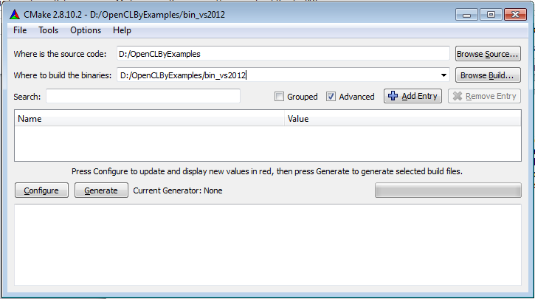

Press Configure. It will ask for a generator. On Windows choose “Visual Studio 11 Win64” or any other Visual Studio generator. On Linux chose “Unix Makefiles”.
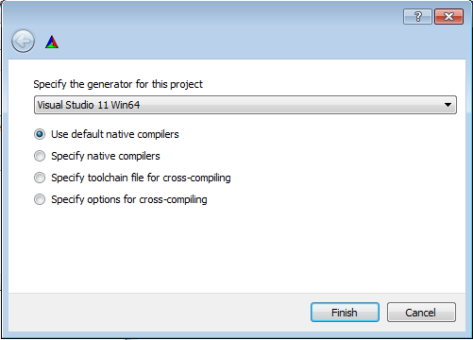
Below is the snapshot when the configure step is completed:
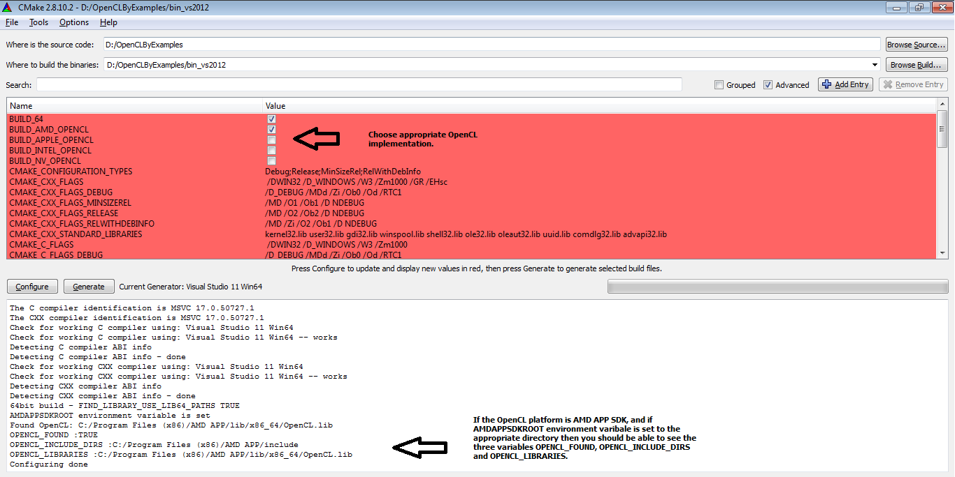

Select the appropriate checkbox, either of BUILD_AMD_OPENCL, BUILD_APPLE_OPENCL, BUILD_INTEL_OPENCL or BUILD_NV_OPENCL. Only one can be selected, by default BUILD_AMD_OPENCL is selected.
BUILD_AMD_OPENCL needs AMDAPPSDKROOT environment variable to be defined.
BUILD_NV_OPENCL needs NVSDKCOMPUTE_ROOT environment variable to be defined.
BUILD_INTEL_OPENCL needs INTELOCLSDKROOT environment variable to be defined.

After selecting the appropriate OpenCL implementation, make sure to run Configure again. Finally complete the build by clicking on the Generate button. Below is the snapshot. Make sure the variables OPENCL_INCLUDE_DIRS and OPENCL_LIBRARIES are set to the appropriate values as shown in the below snapshot.

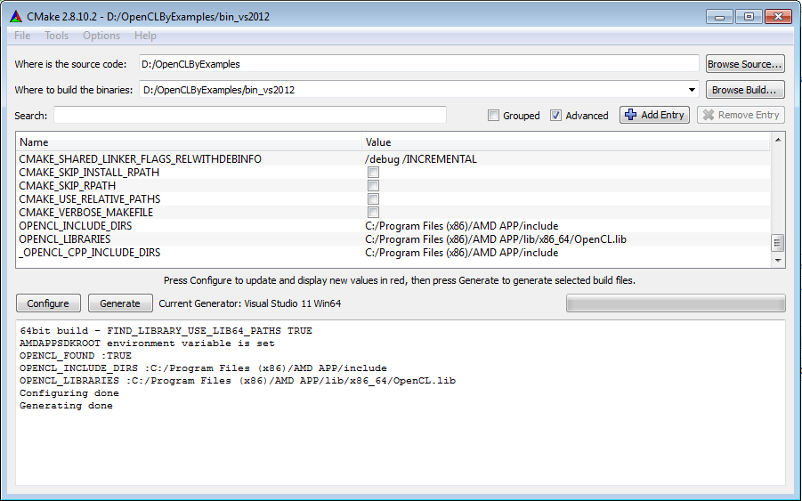

Once the CMAKE configure is complete, you will be able to see a OpenCL_By_Example.sln Visual Studio solutions files. Open this file to build all the examples in the Visual Studio project.
In Linux, the CMAKE utility creates Makefiles. The “make” command should build all the projects successfully.

Contributors
- Ravishekhar Banger
- Koushik Bhattacharya
- Erik Rainey.

