**18.AWS-SystemsManager**



--- we mainly used Systems manager for Administration purpose only.

**RUN COMMAND**

You want to run install or run some commands on servers. For running these commands, you have to login in to the servers but now you don’t have to do that instead of login in to the servers we will use run command.

We need to use role for running commands

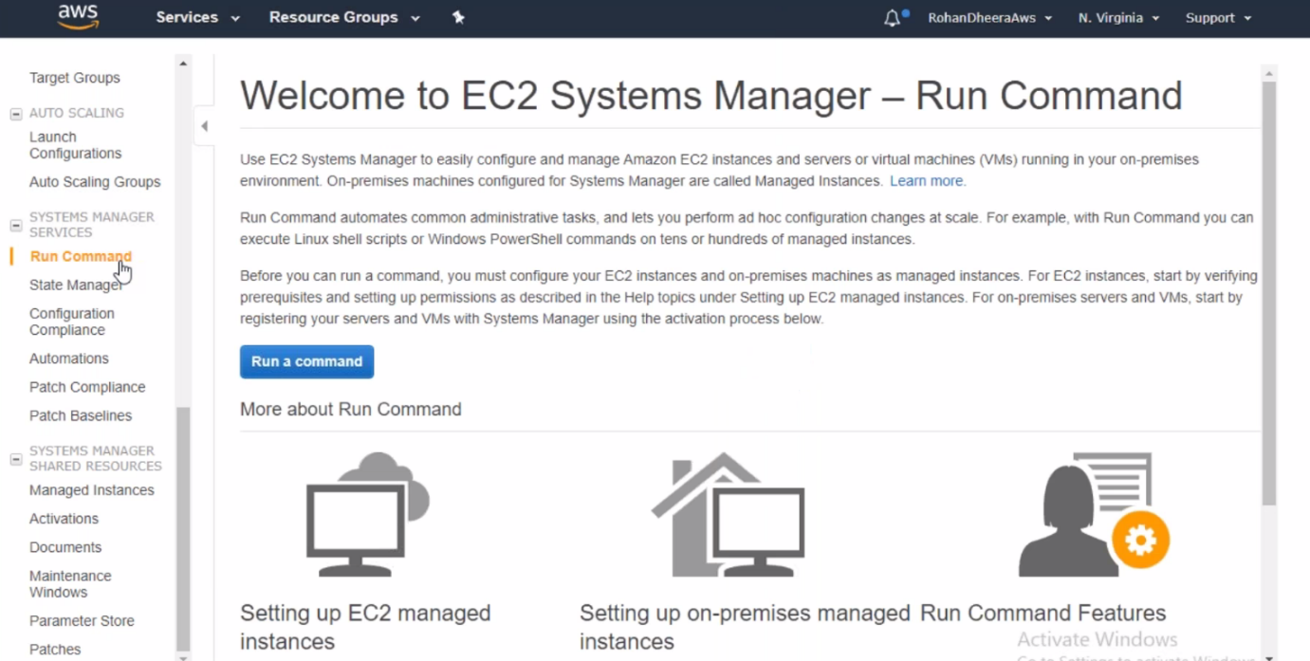

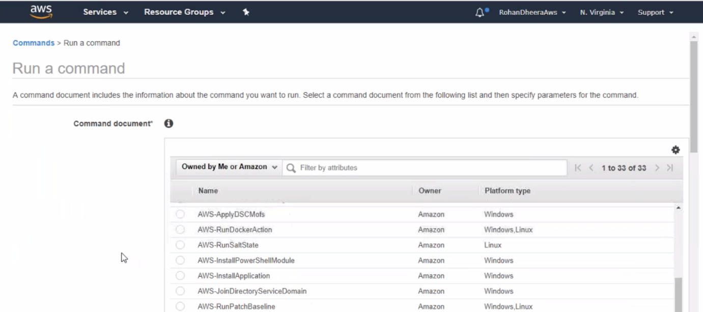

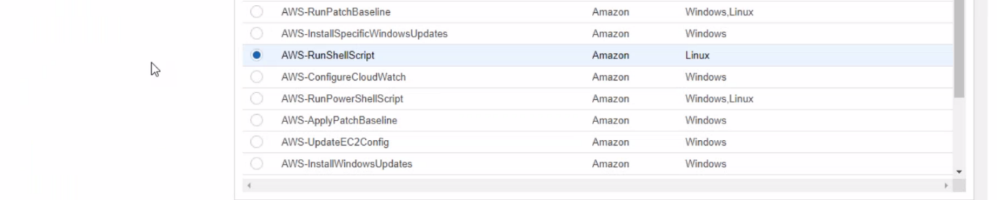

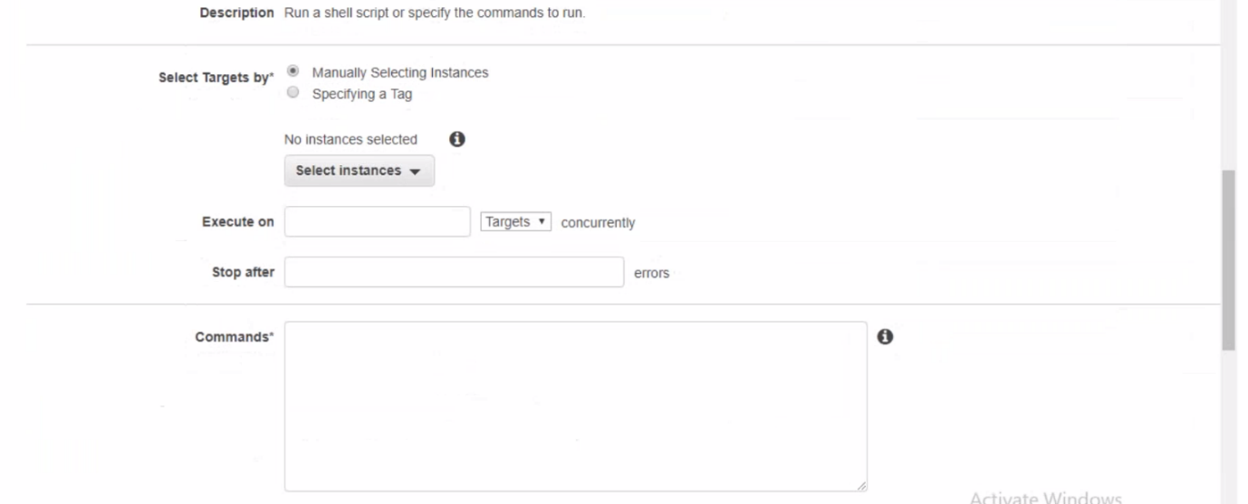

--- select the instance.

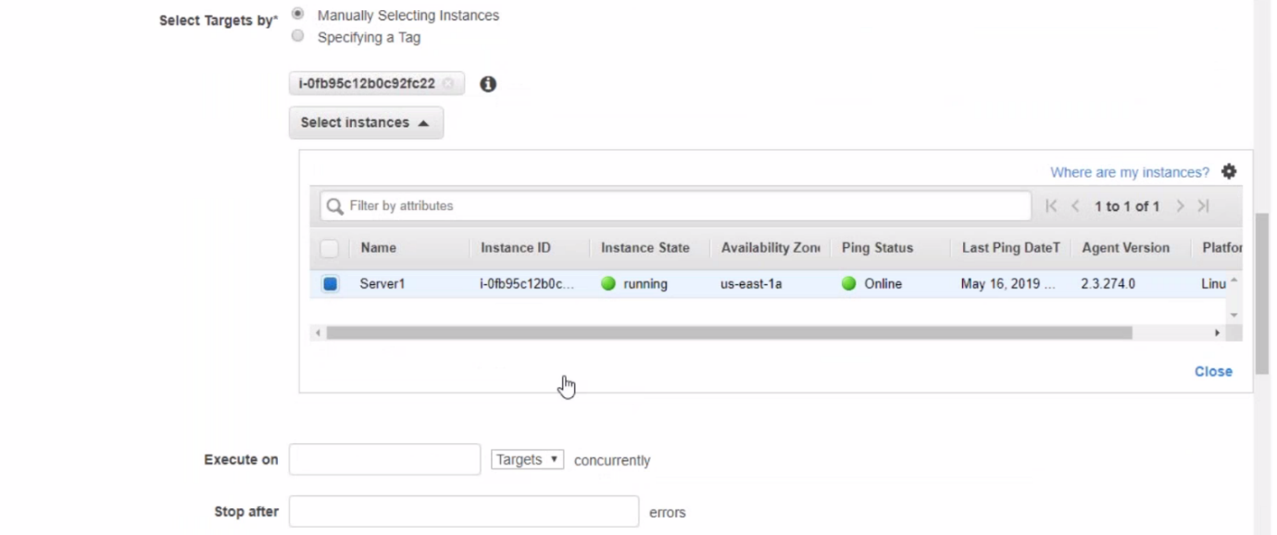

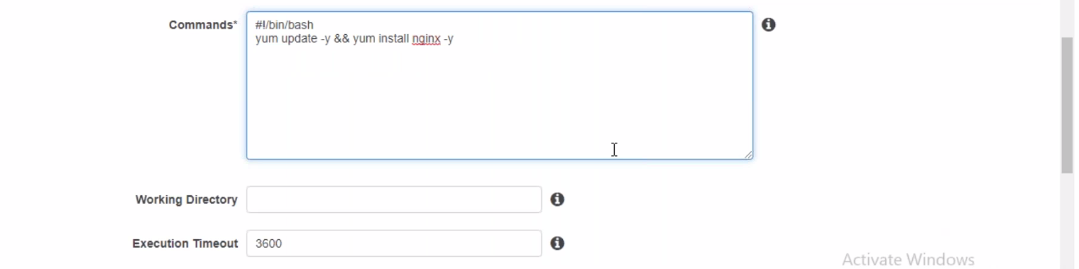

**Selectins instance’s based on server tag**

For this we must assign role and give tag to the servers so we can run command based on server tags

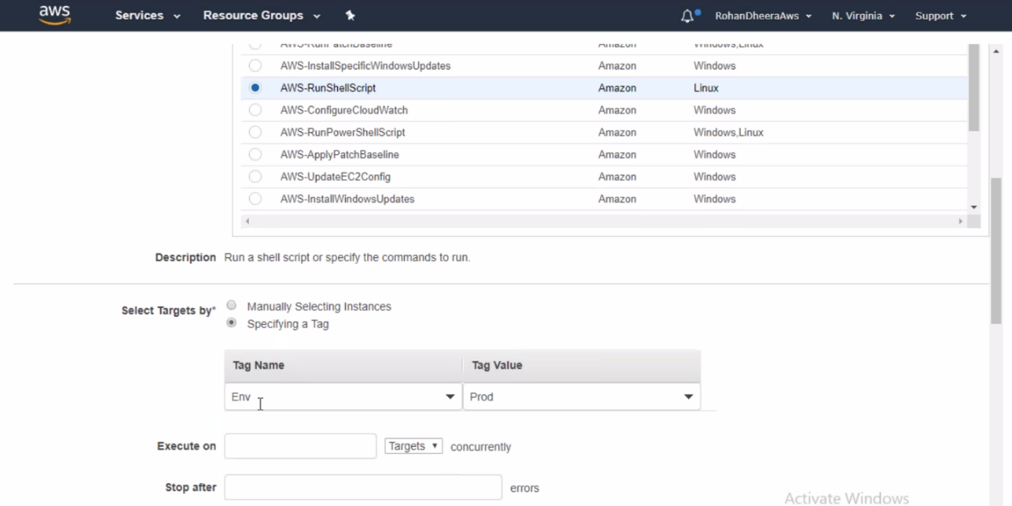

**SESSSION MANAGER**

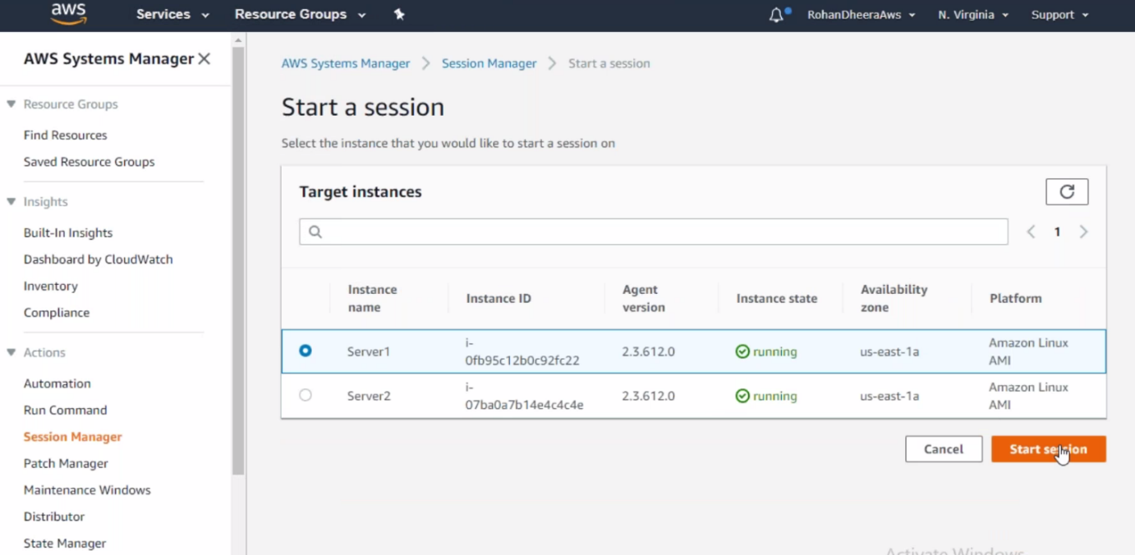

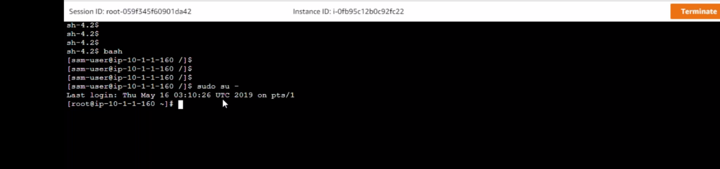

--- You can login as root user and run your commands.

**Creating a role for RUN COMMAND**

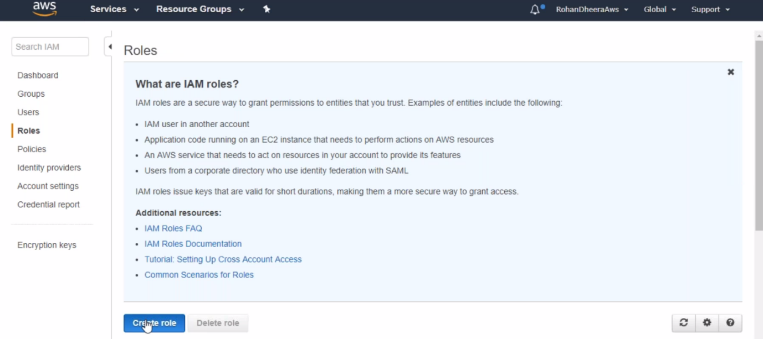

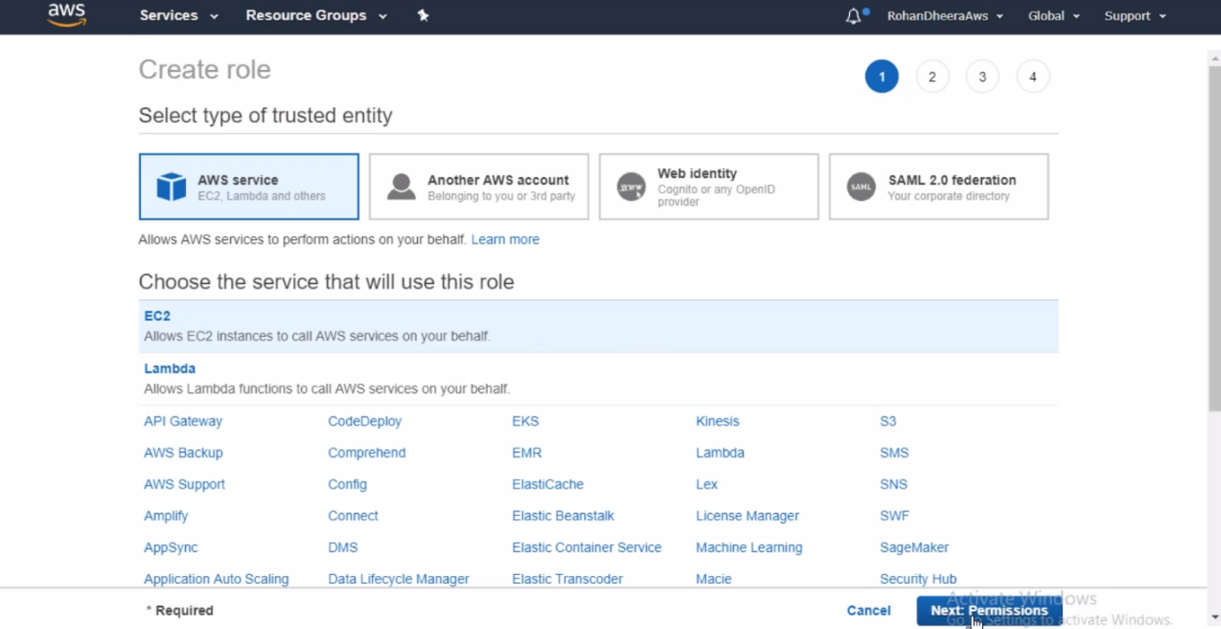

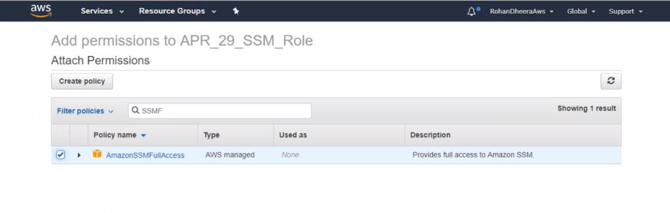

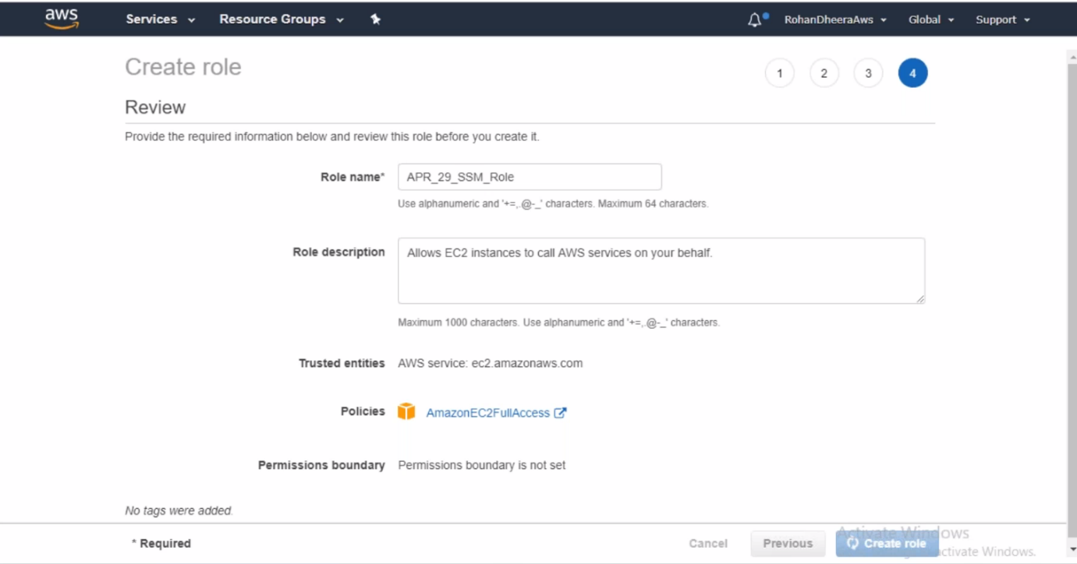

--- Assign role to the instance

**Assigning role to instance**

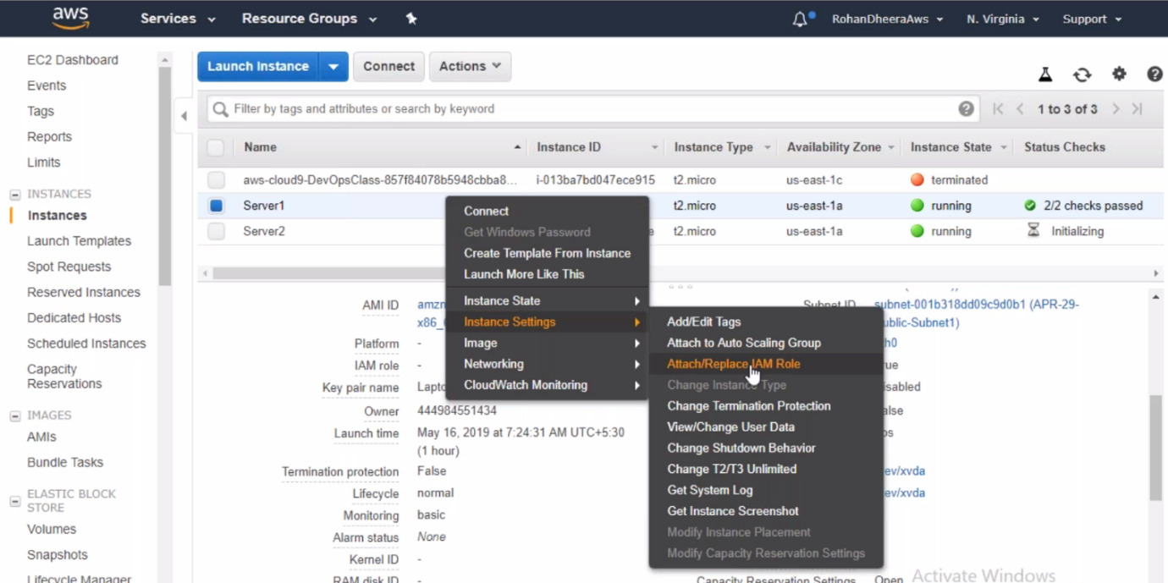

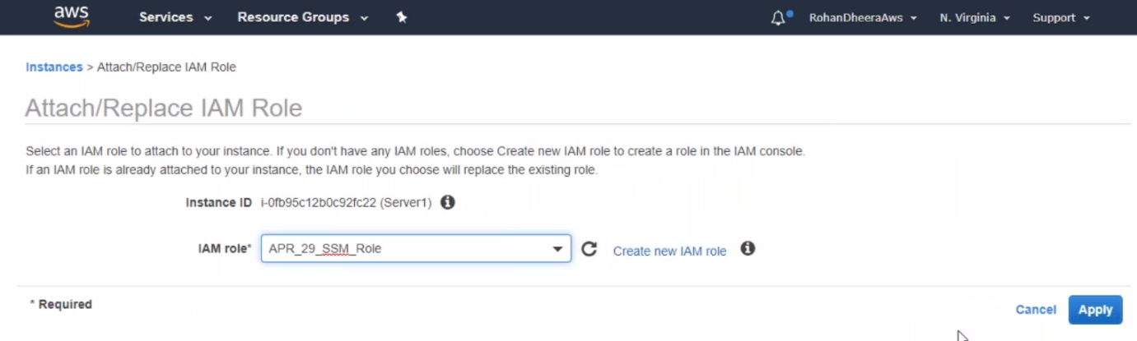

--- **System Manager**

--- **RUNCOMMAND** – using this feature to access the ec2 instance. In order to access we have to create a role and assign that role to ec2 instance.

--- **AmazonSSMFFullAcess** – select this policy name in the making of role.

--- **AWS-Runshellscript** – for linux we have to select this feature.

--- **choose instances manually**

--- **Creating encrypted password in instances…?**

--- **openssl passwd -1** – type the password and get the encrypted password.

--- **How to give user name and password in command line…?**

--- **sudo** **useradd -m testuser1 -p $1$6gYNhWQM$n3e77RaFwt2Z2mrOJ3J.J1**

--- **sudo usermod -aG root testuser1** – adding user to the wheel group.

--- **ps -ef** – ( /usr/bin/amazon-ssm-agent ) this agent needs run.

--- **cat /etc/passwd** – user creation location.

--- **State Manager** – it works as a equivalent to ansible, cheff,puppet

--- configure a server to available this feature only.

--- in order configure a server, we have to give a document.

--- **Session Manager** -session manager is very important. Some times level 1 team don’t have the putty access so we will access instance by using session manager.

--- bash – run this bash command then you will come to the ssm user

--- **AmazonEC2RoleforSSM –** attach this policy in role.

--- IAM (identity and access management)- IAM is true global. It can applied for all regions.