**31.AWS-CloudFormation-Params-Updates-NestedStacks-Stackpolicy**

**AWS-CloudFormation**

The cloud formation is for repeated work. If you are doing same work repeatedly then you can use AWS- CloudFormation.

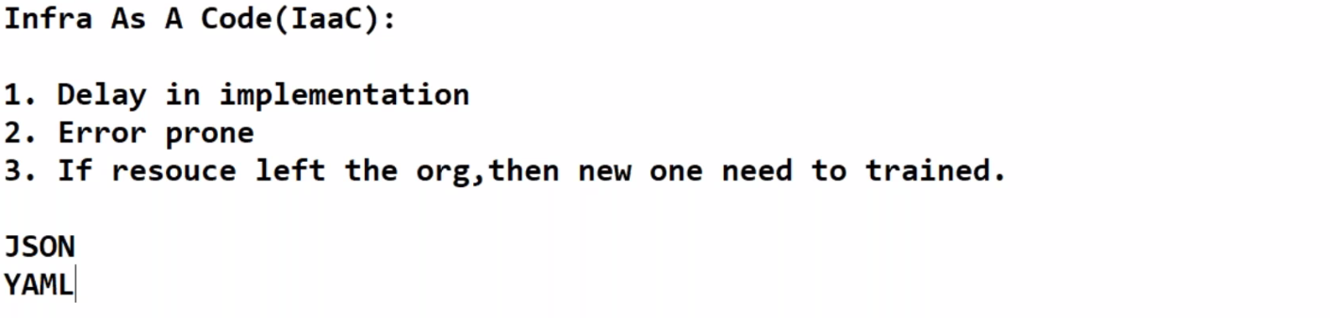

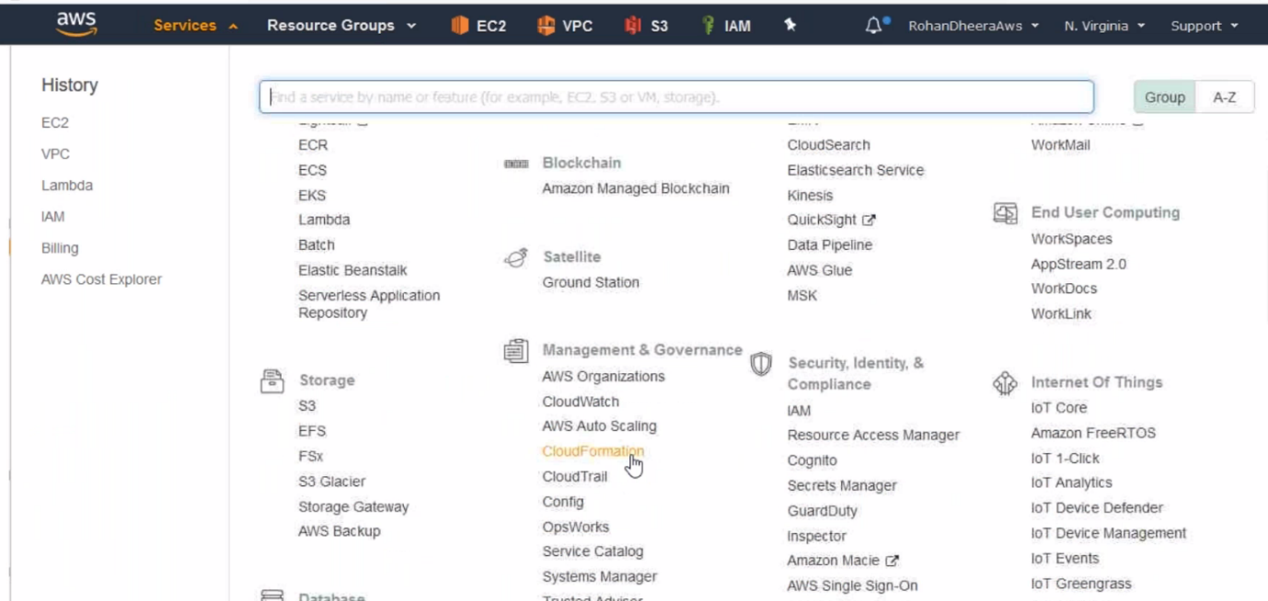

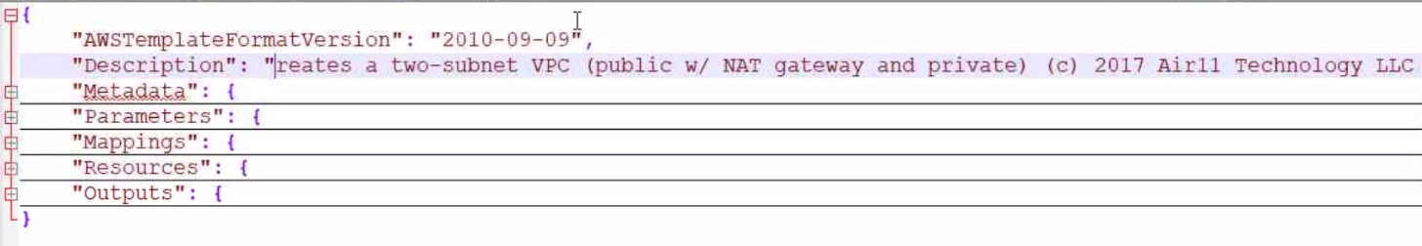

--- the cloud formation will have 1.metadata 2.parameters 3.mapping 4.Resources 5.outputs