**7.AWS-EndPoints-SecurityGroups-NACL**

**End Points**

connecting one service from another service with out using internet. And connecting internally from one service to other

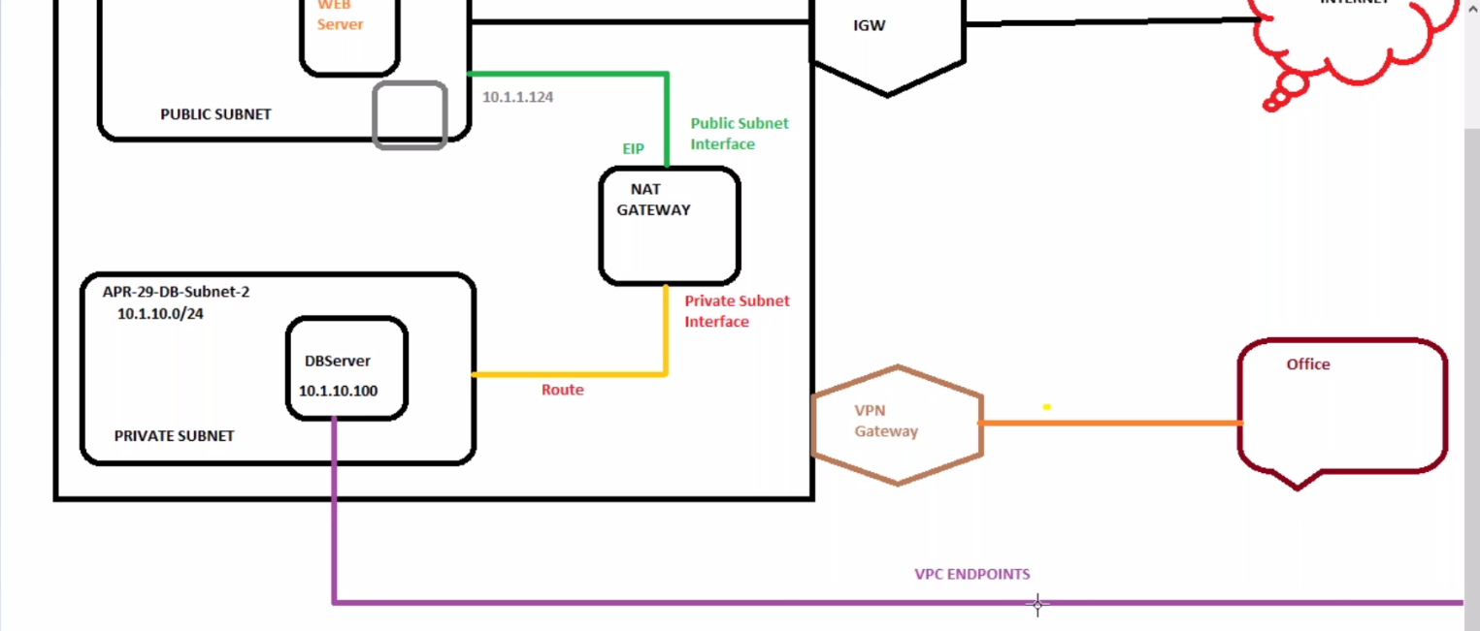

If you want to access a file in s3 from private data base. There will be a charges if you use Nat Gateway. In this case we use end point.

**Creating End Point for S3**

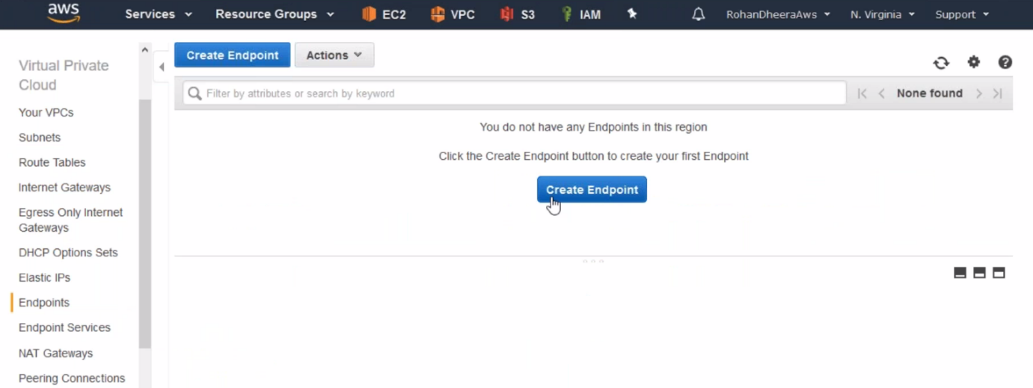

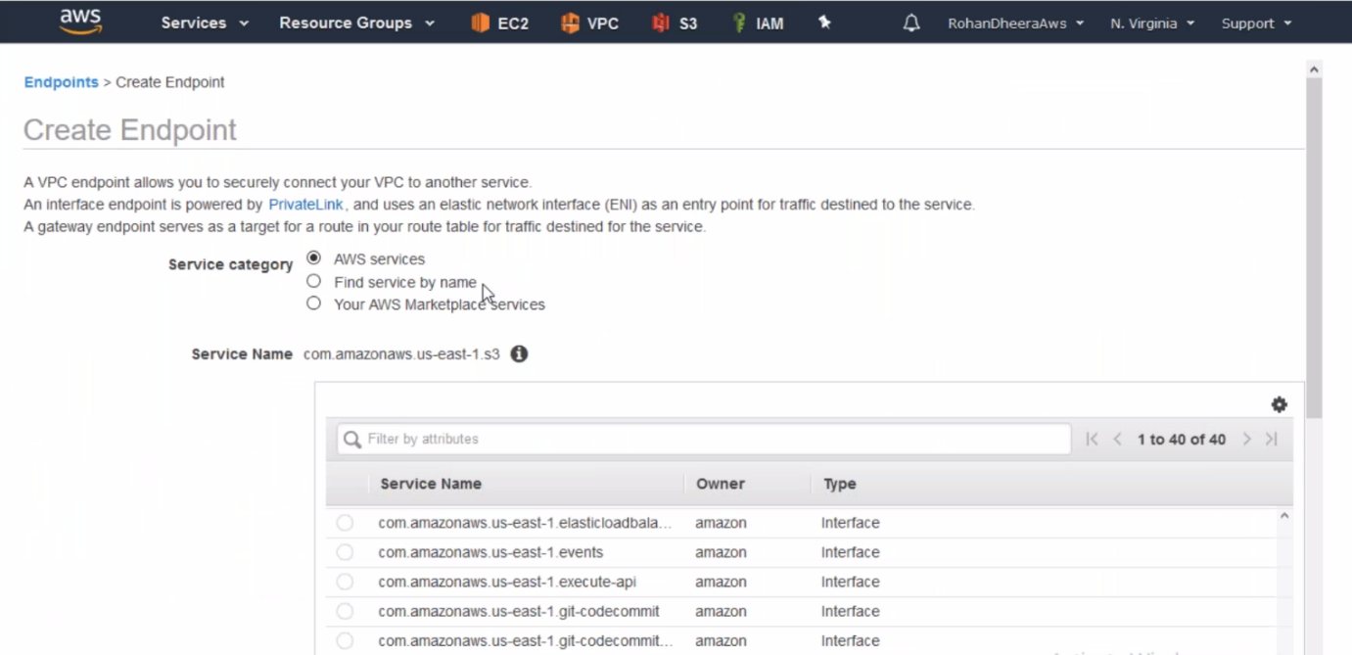

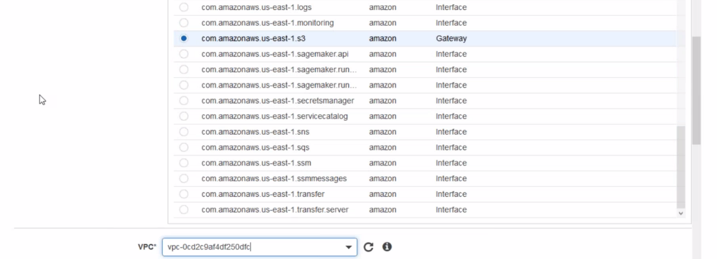

--- select private subnet here.

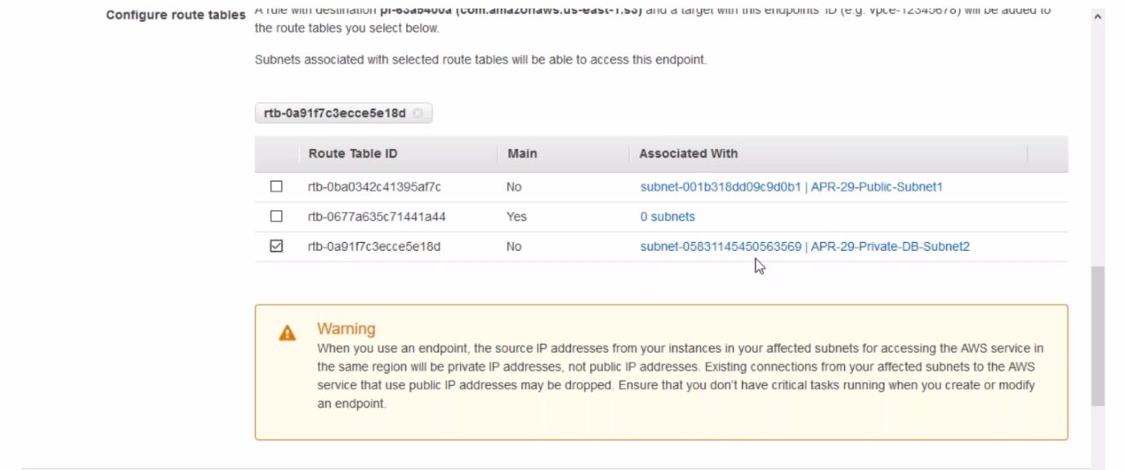

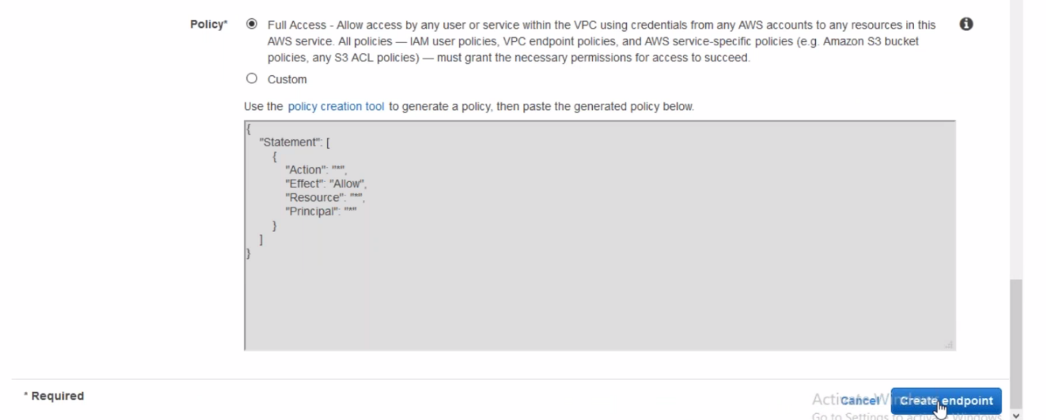

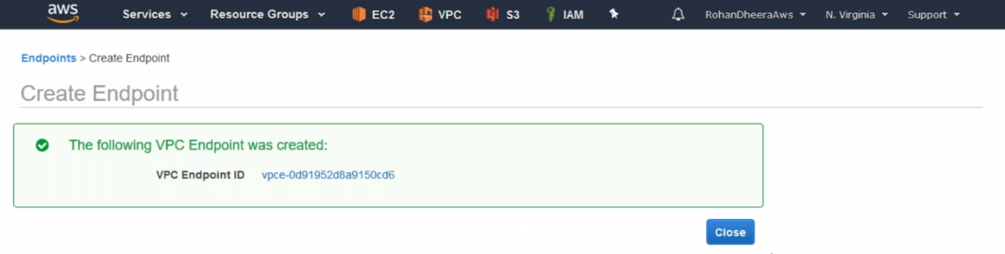

--- now the connection between private data base and s3 is established.

--- it is region-based service.

**Out bound**

the traffic from server to out side

**In bound**

the traffic from outside to server.

**Difference Security Group and Network Access Control List (NACL)**

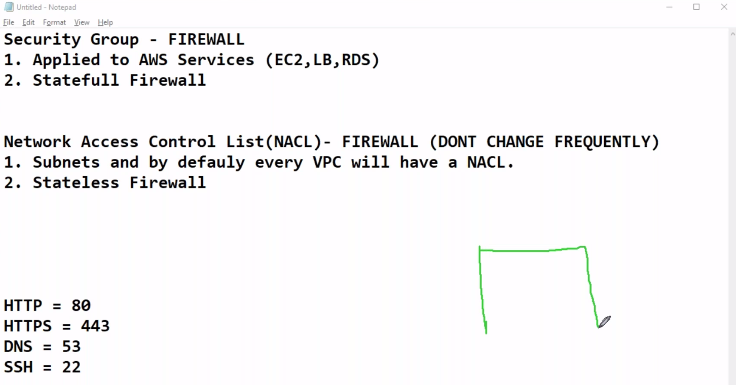

**Security Group Creating**

