**9.AWS-EC2-Part-1**

Elastic cloud computing

**Ec2 instance creating**

--- cluster – all the VM’S will create in same region.

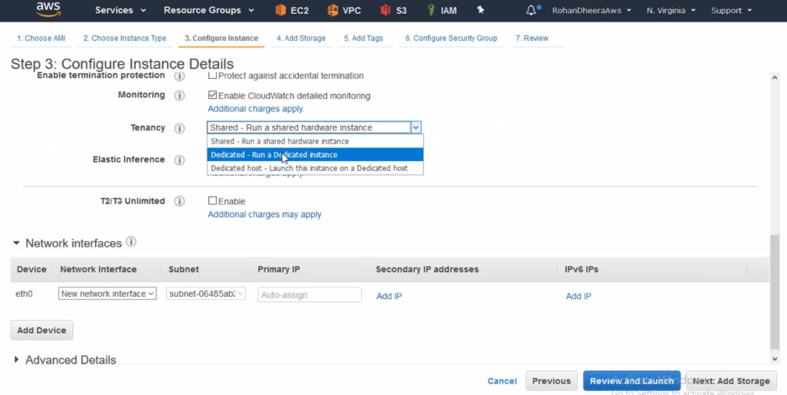

--- **Tenancy** – shared – **Run a shared hardware instance**

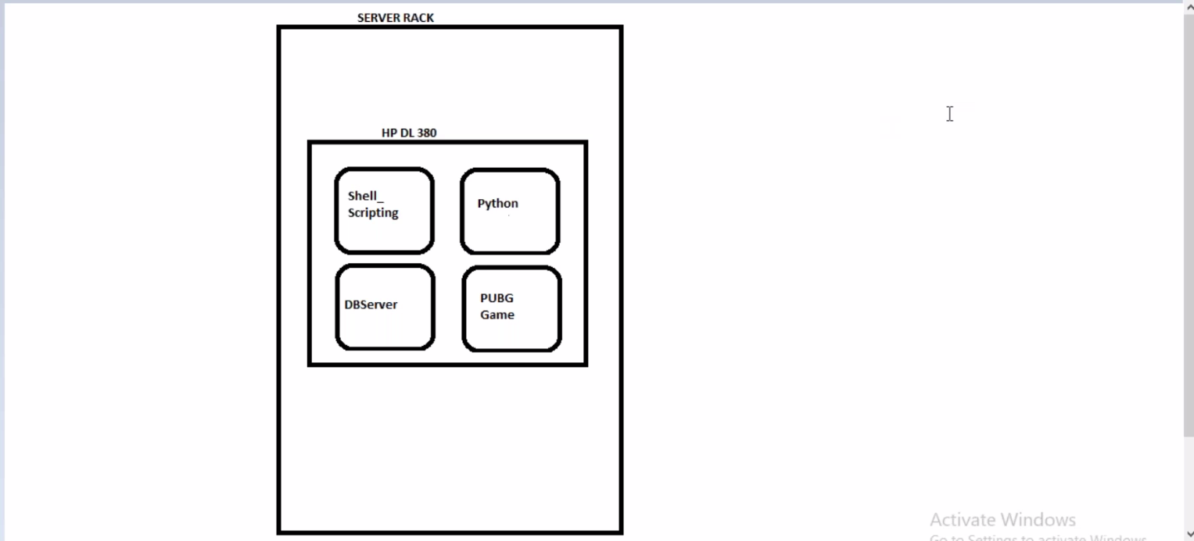

Hard ware server rack is same but here 4 customers VMS will run

--- **Tenancy –** Dedicated – **Run a dedicated instance.**

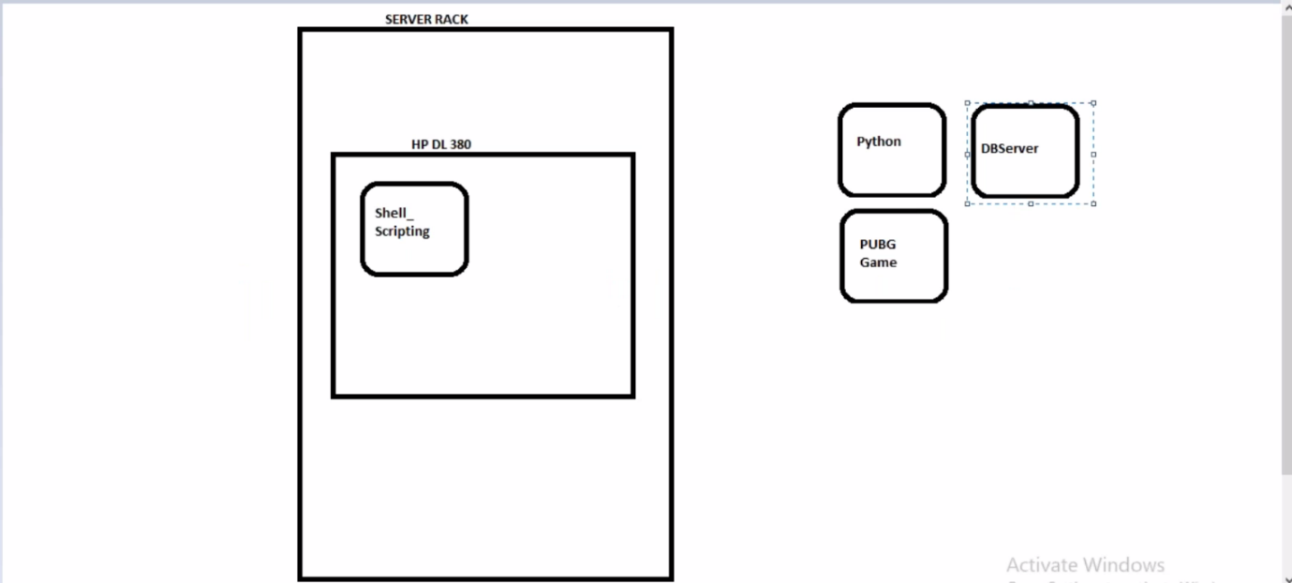

--- In hard ware server rack only your instance will run means the entire rack dedicated for you.

--- **Tenancy –** Dedicated host – **run instance on dedicated host**

AWS will give you entire server so you can use the entire sever.

--- **T2/T3** **UNLIMITED –** when burst occurs suddenly means when application gets visited unlimited users. This feature will give you unlimited CPU and RAM but extra charges may apply.

This feature only for T2/T3