**02.AWS-B30-DatacenterArch-IPAddressing**

**What is present in region**

**Data center architecture**

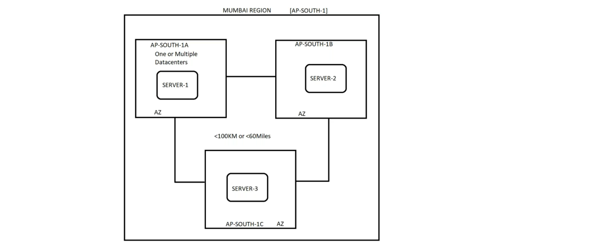

--- **what is region and availability zones…?**

For example, lets take an example of Hyderabad, in hyd we have multiple availability zones present across the city. These availability zones together form a region.

--- all availability zones are internally connected with each other.

--- the distance between 2 availabilities zones is 100km or 60miles.

--- in single availabilities zone have 1 or 2 data centres.

--- **why we need availabilities zones…?**

If we deploy our application in different availabilities zones then even if the one zone goes down, still our application will work. Therefore, we need different availabilities zones.

**What is present in availability zones**

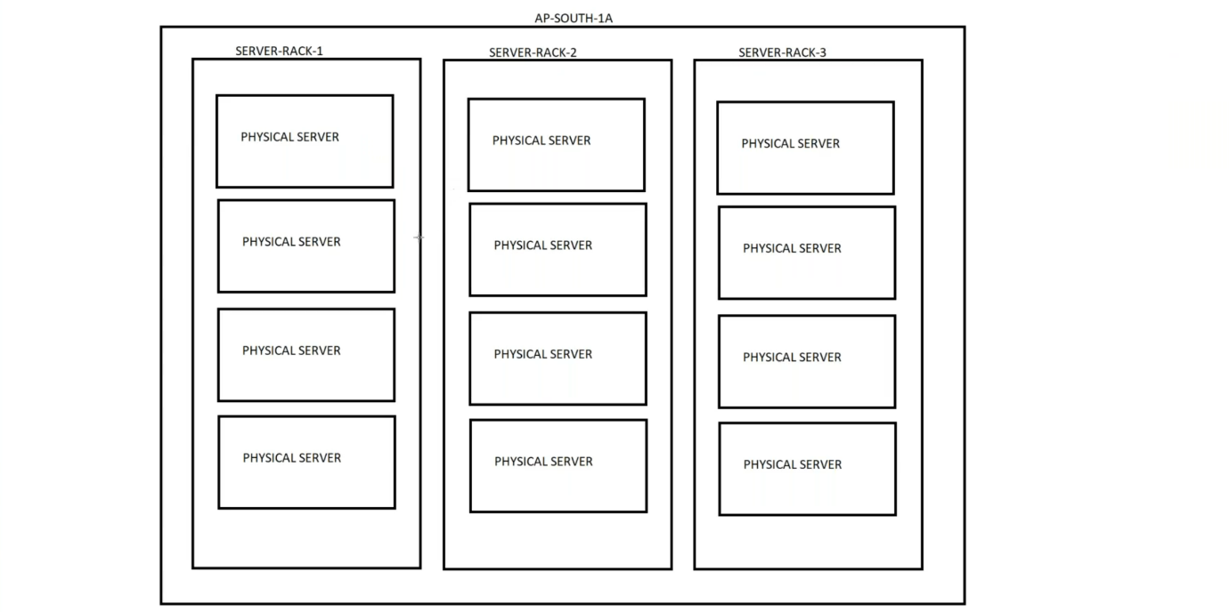

--- in availability zones, we have data centres. In data centres we have server racks. There will be hundreds of racks present in data center. In each server rack we have physical servers.

**What is present in physical server**

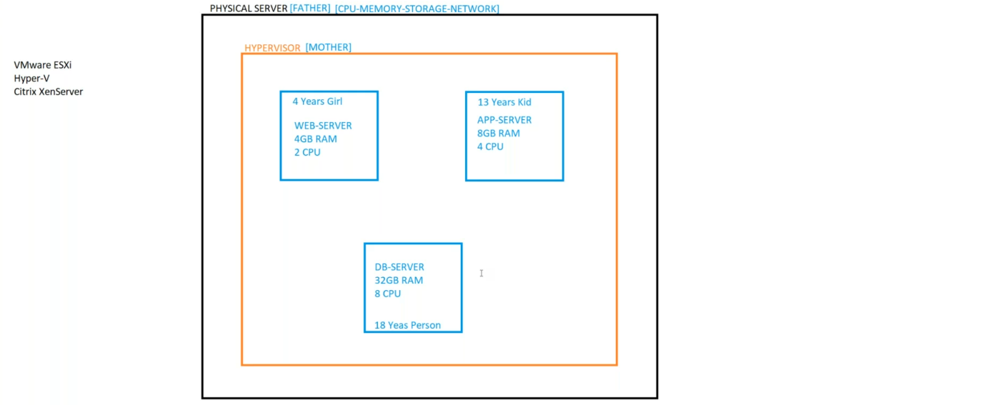

--- in physical server, they will install one type of operating system. The operating system is called hypervisor.

There are different types of hypervisors

1. Vmware ESXI
2. Hyper-V
3. Citrix xenServer

**IPAddressing**

--- IPV4 => the total IP range - **0.0.0.0** to **255.255.255.255**

**IP Header Classes**

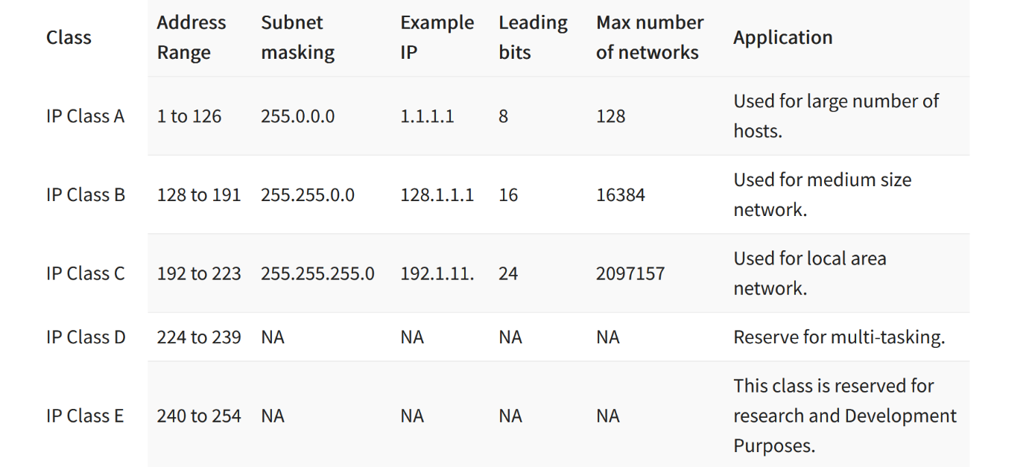

--- **Class A** => 1.0.0.0 to 126.255.255.255

--- **Class B** => 128.0.0.0 to 191.255.255.255

--- **Class C** => 192.0.0.0 TO 223.255.255.255 – **we will use this ip range.**

--- **important** - 127.0.0.0 to 127.255.255.255 – it is a loopback address.