**04.AWS-B30-VPC-Class-Repeat**

**VPC architecture**

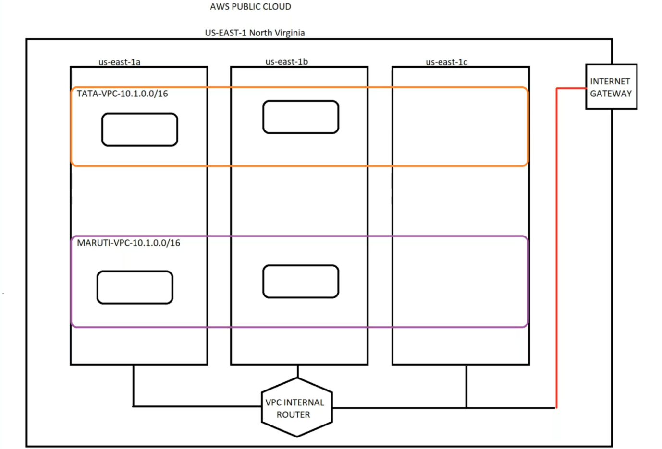

--- when we create vpc, by default an VPC internal router will be created and all the availability zones are connected through this vpc inter router. We do not have access to this vpc internal router.

--- the VPC internal router is connected with VPC internet gateway.

**Private IP range**

--- 10.0.0.0/16 to 10.255.255.255

--- 172.16.0.0. to 172.16.255.255

--- 192.168.0.0 to 192.168.255.255

--- **note** – in enterprise level, we must take private ip range from above level.

**Private VPC creating steps draft**

--- Create VPC with a private address space /16(65,000 IP’S) and /28(14 IP’S). and VPC name tag and enable dns hostname.

--- Create subnets 1,2,3 in 1a, 1b and enable auto-assign public ipv4 address.

--- Create IGW and attach to VPC.

--- Create routing table and subnets and configure routes.

--- create security group and allow all traffic.

--- create a keypair and save the pem file. Convert pem file to ppk file for putty usage.

--- deploy a EC2 server and check the connectivity.

**Create VPC**

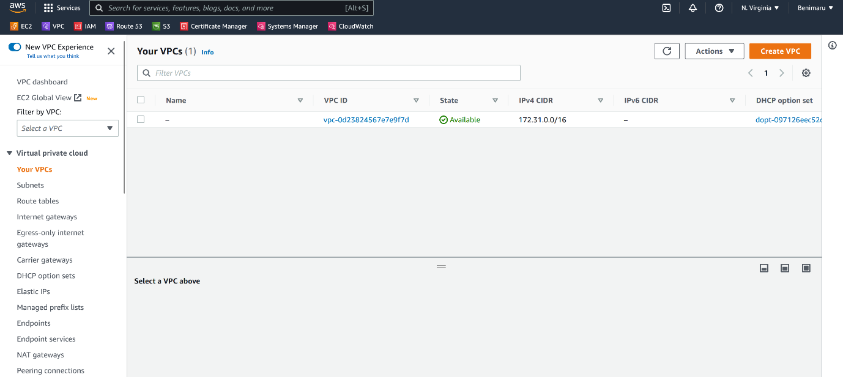

--- Click on create VPC.

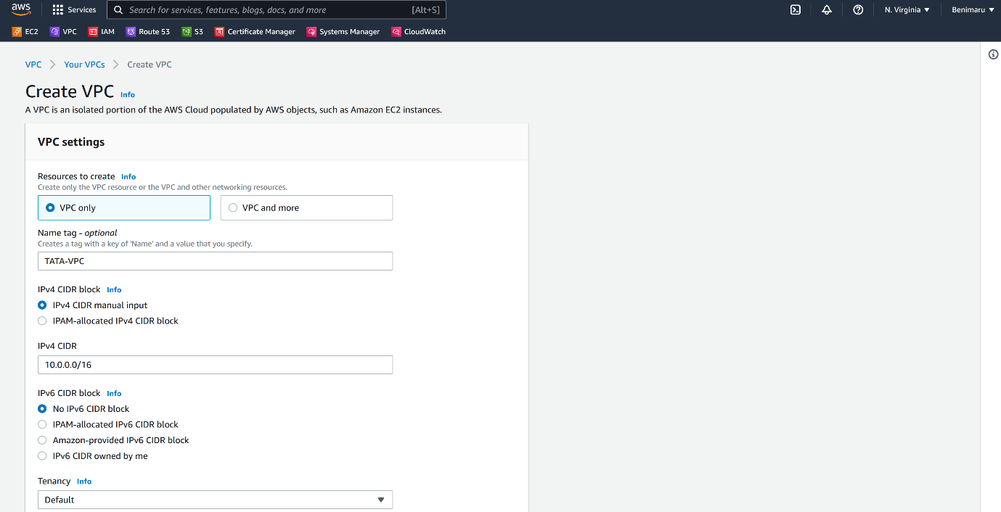

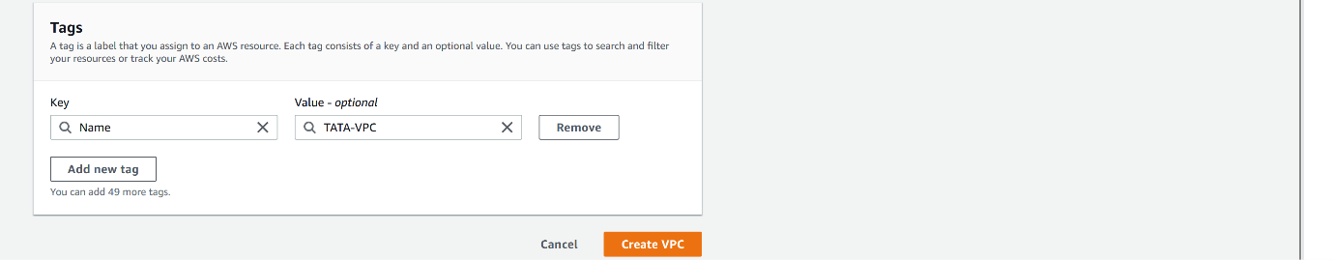

--- Click on create VPC.

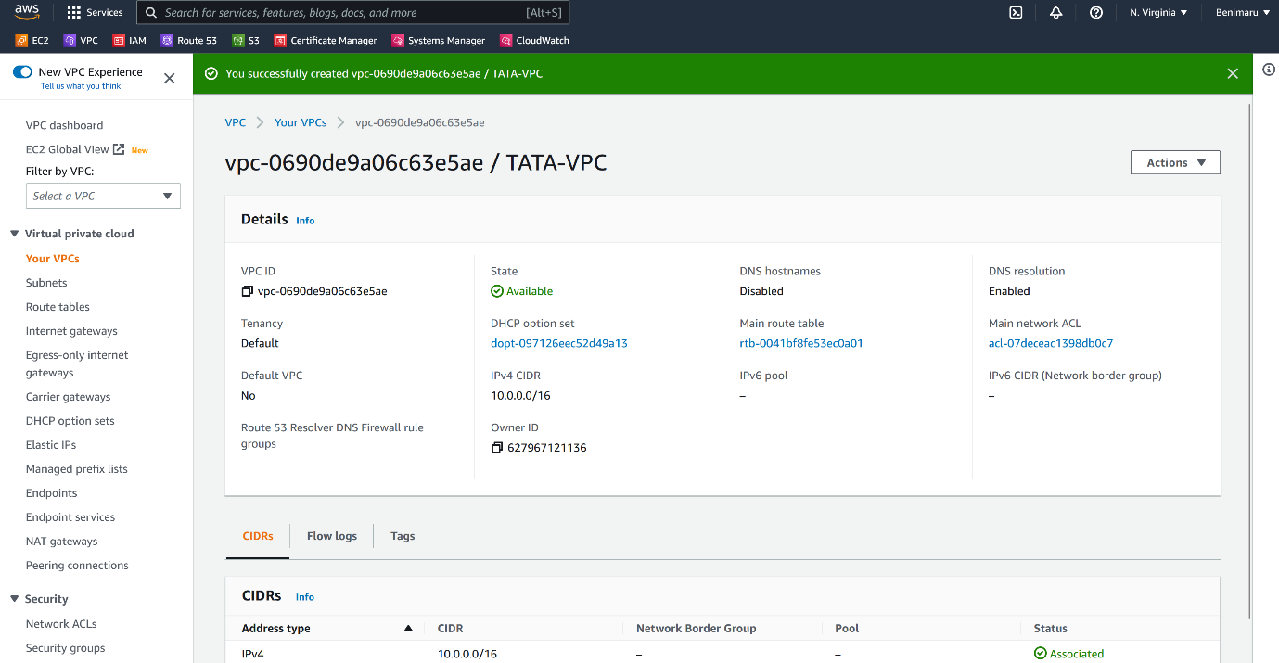

--- **note** – our vpc is created successfully.

--- **important** – if you want to use the VPC then we need to create subnets from the VPC.

**Enable dns hostname**

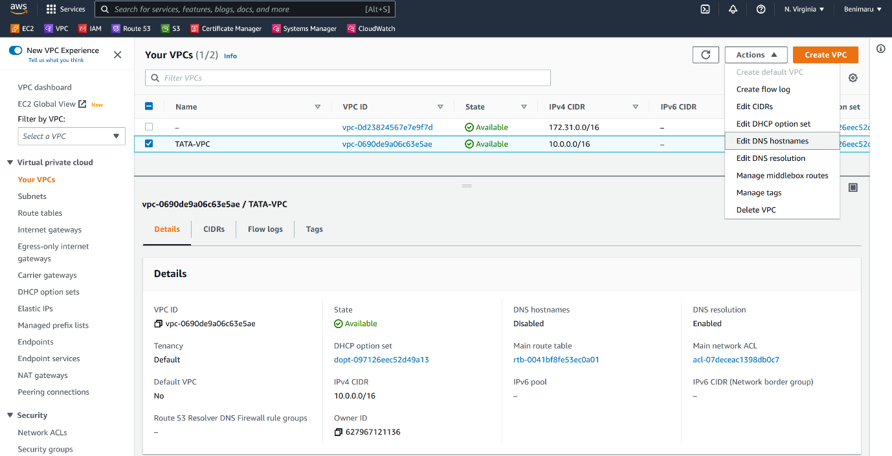

--- click on edit DNS hostname.

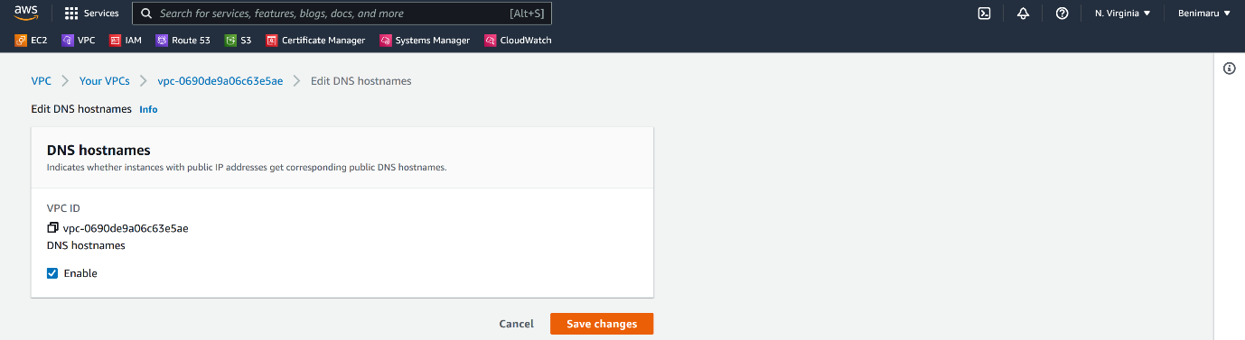

--- click on save changes.

**Flow logs**

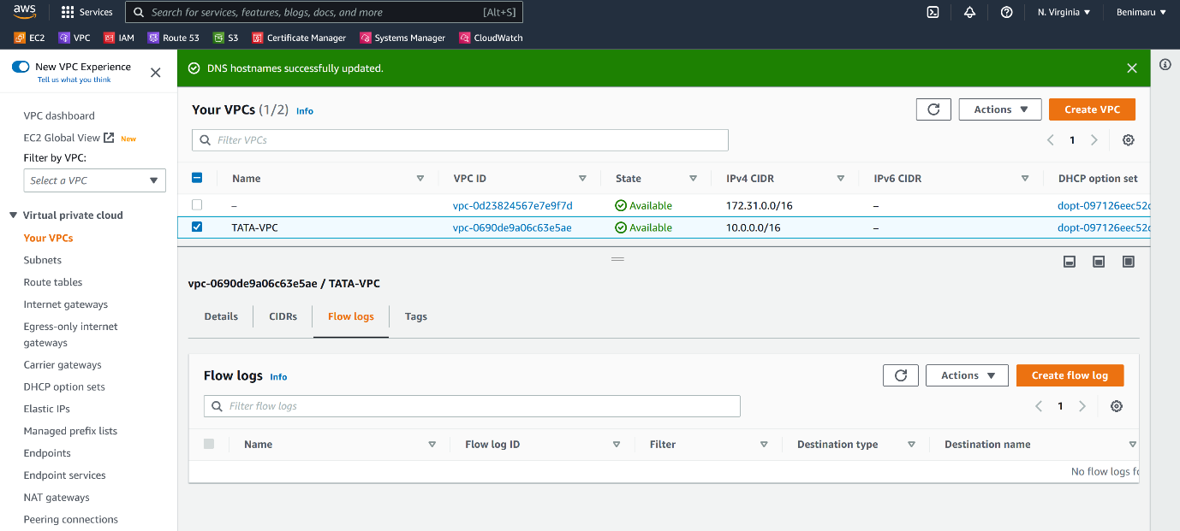

--- note – we can create flow log for VPC. We can configure inbound and outbound traffic.

**Subnet creating**

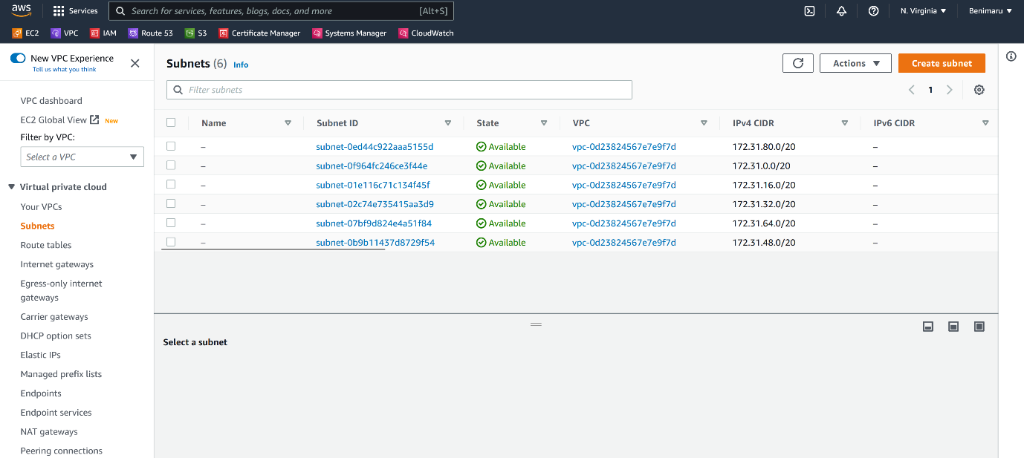

--- Click on create subnet.

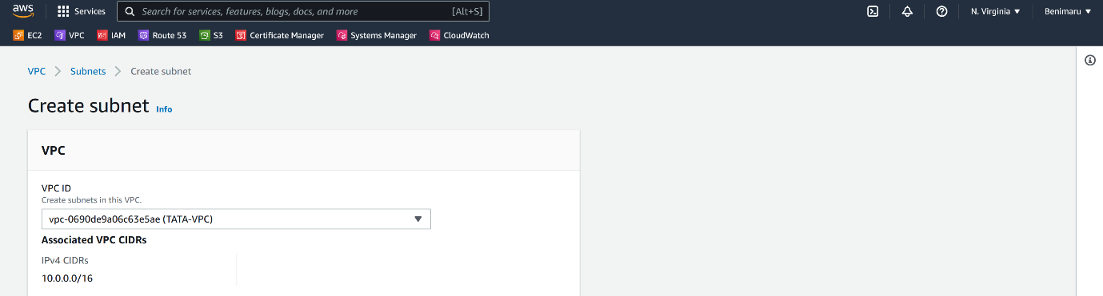

--- Select the VPC.

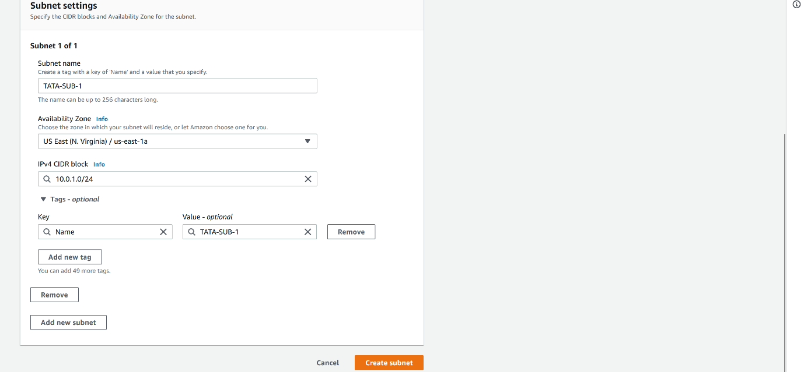

--- click on create subnet.

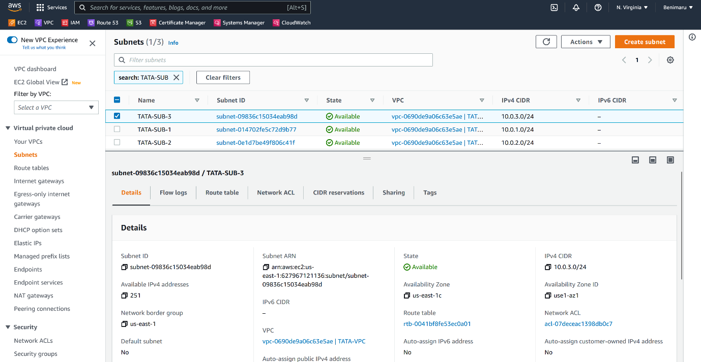

--- **note** – I have created 3 subnets.

--- **important** – you can create multiple subnets in single availability zone.

**Modify auto assign ip setting**

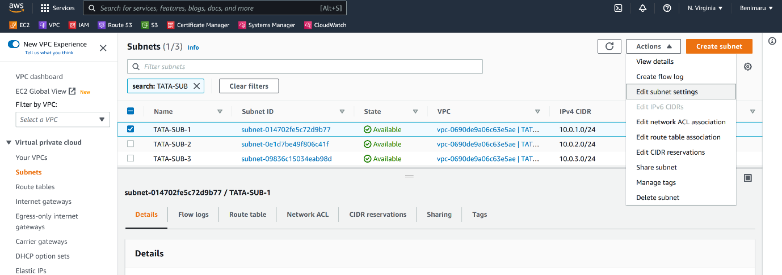

--- click on edit subnet setting.

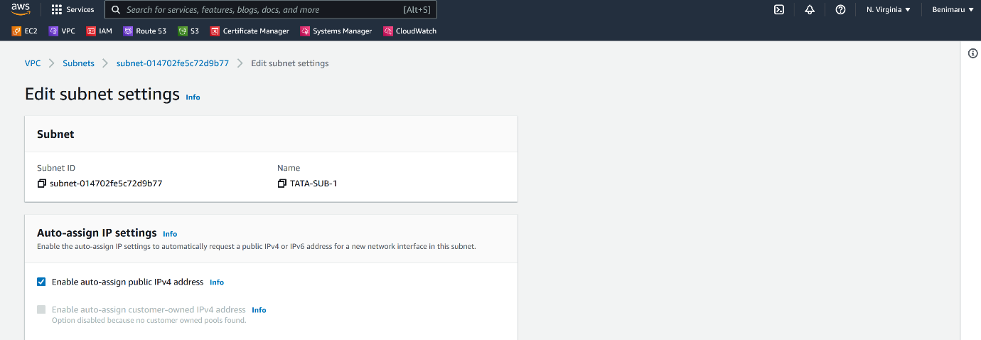

--- check the enable auto-assign public ipv4 address.

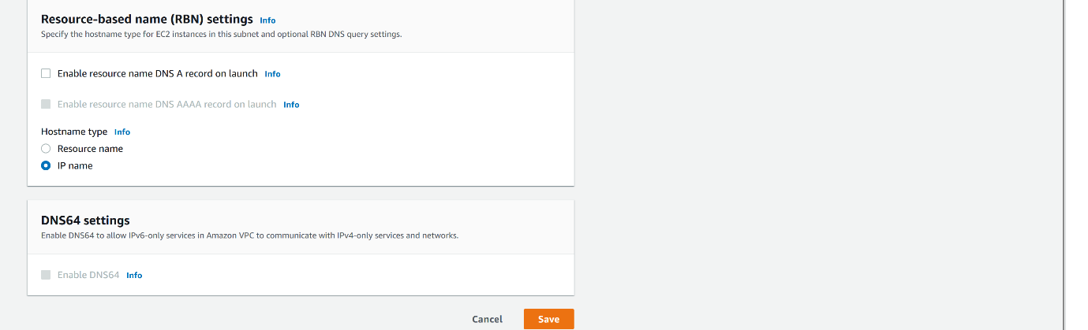

--- click on save.

**Create internet gateway**

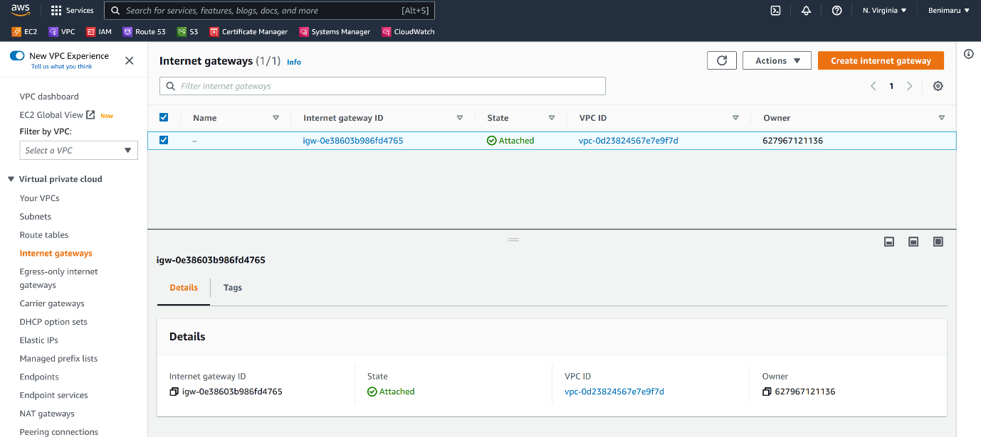

--- Click on create internet gateway.

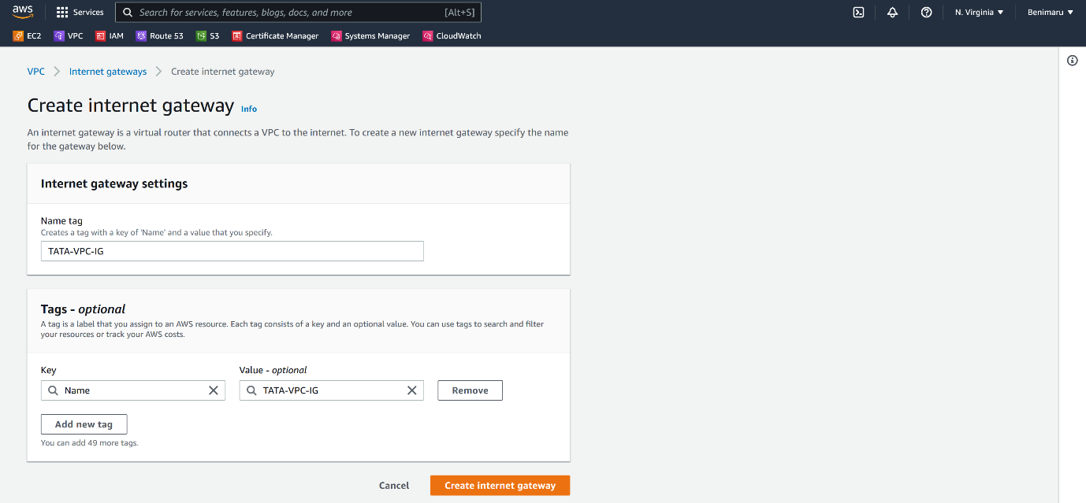

--- click on create internet gateway.

**Attach the internet gateway to vpc**

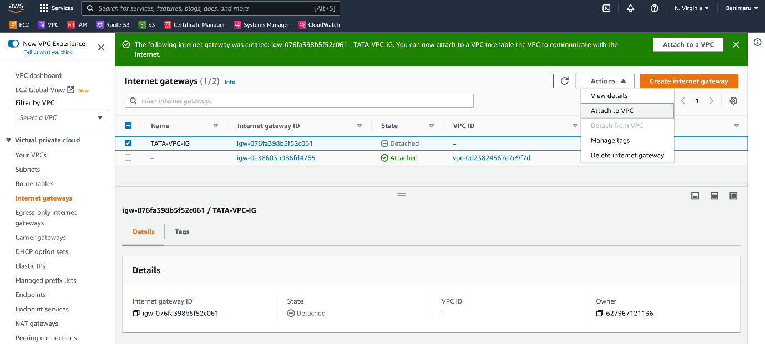

--- **note** – click on attach to vpc.

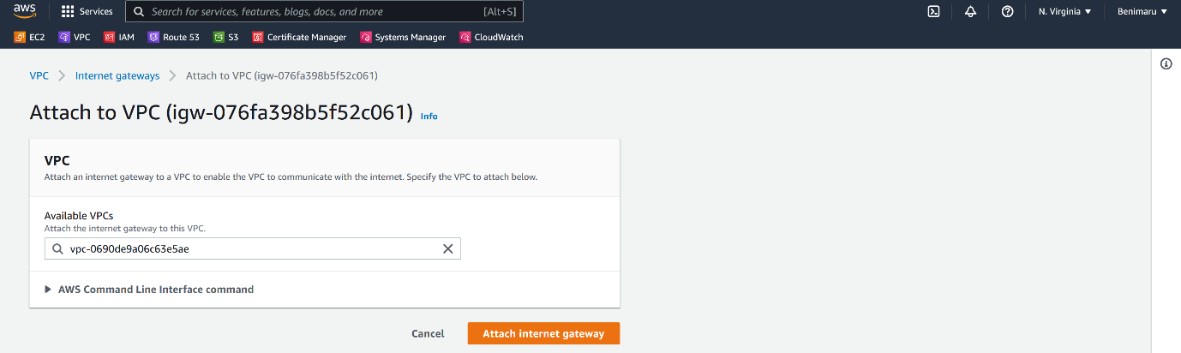

--- **note** – please select the vpc that you want to attach it to and click on attach internet gateway.

**Route tables.**

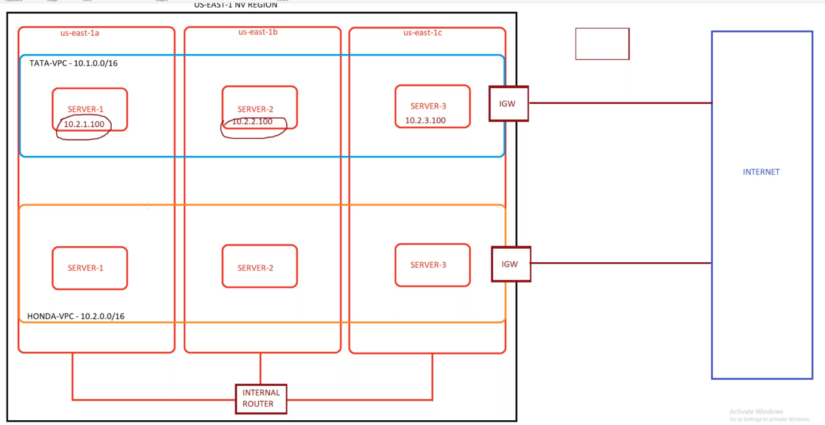

--- **note** – route table will route the traffic to outside and it will guide the traffic.

**Create route table**

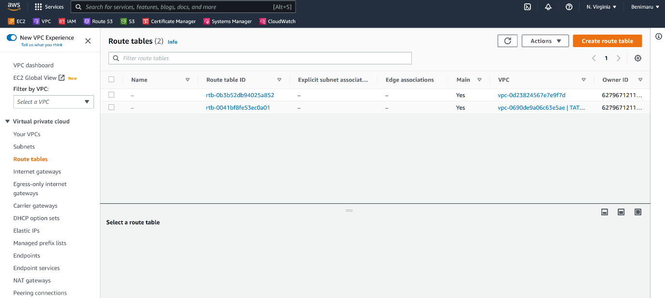

--- click on create route table.

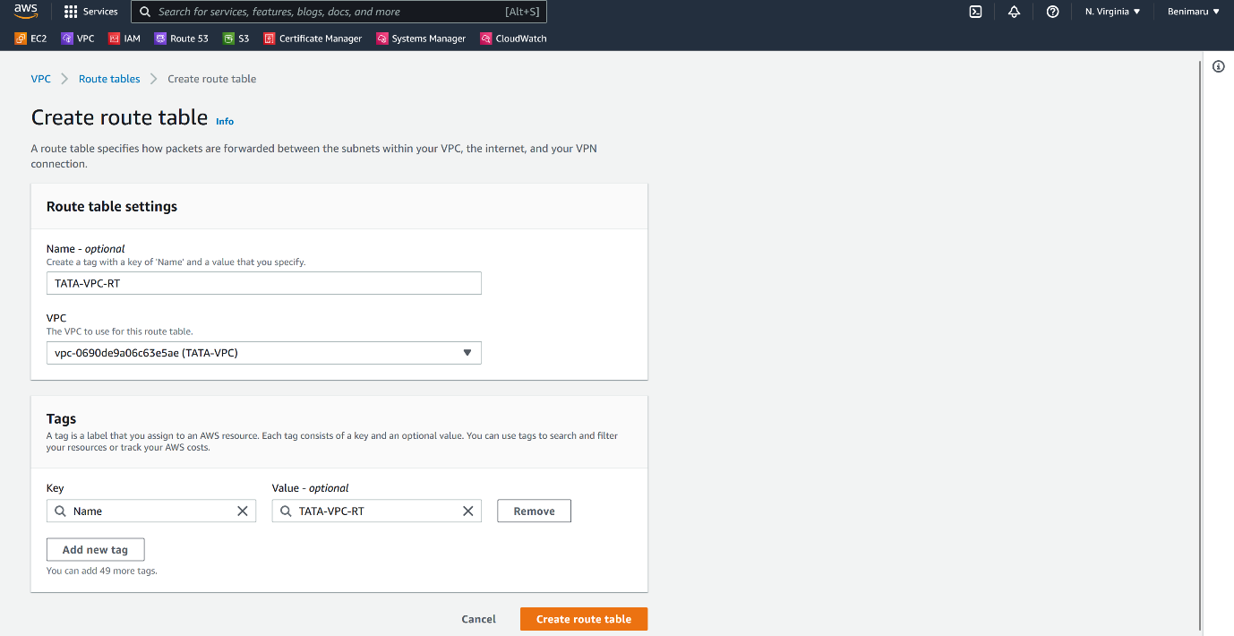

--- click on create route table

**Subnet association**

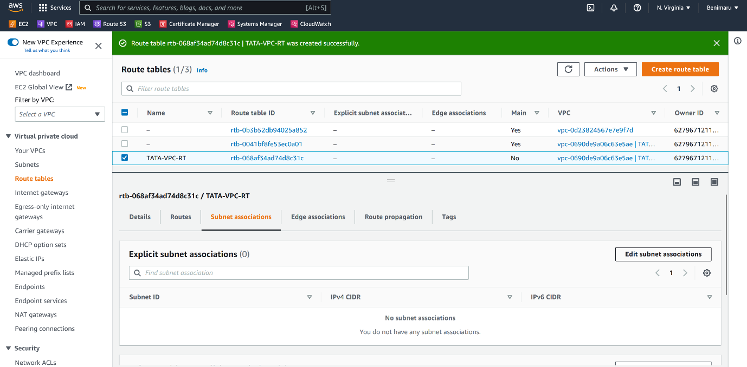

--- **note** – click on edit subnet associations.

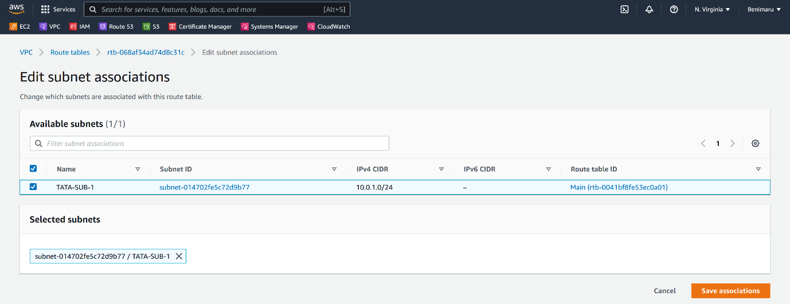

--- select the subnets and save associations.

**Routes**

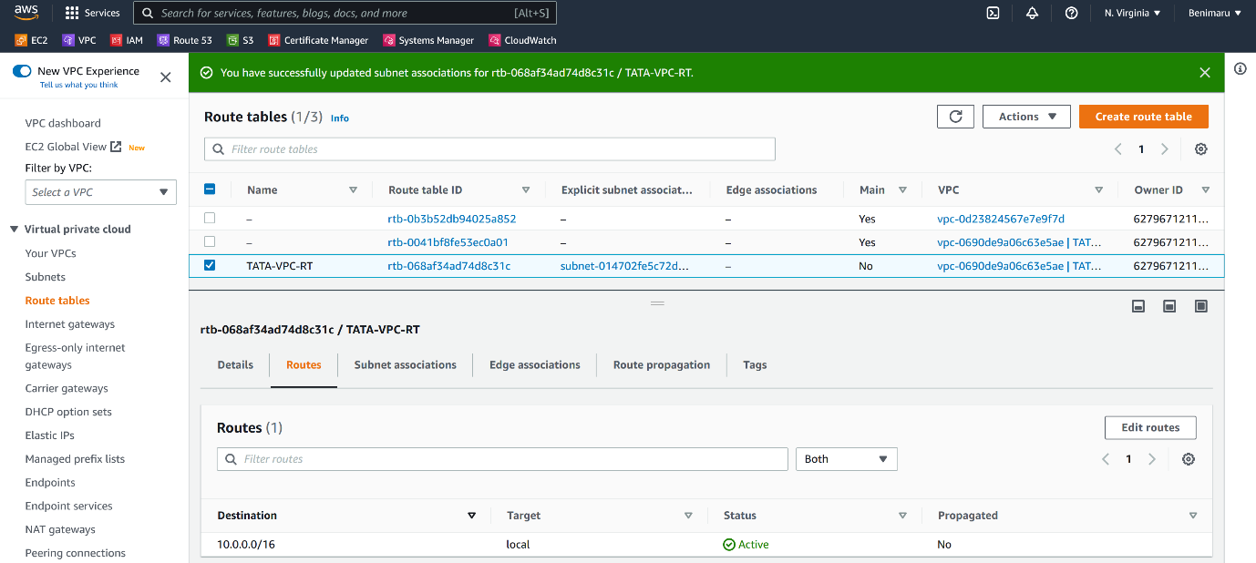

--- click on edit routes.

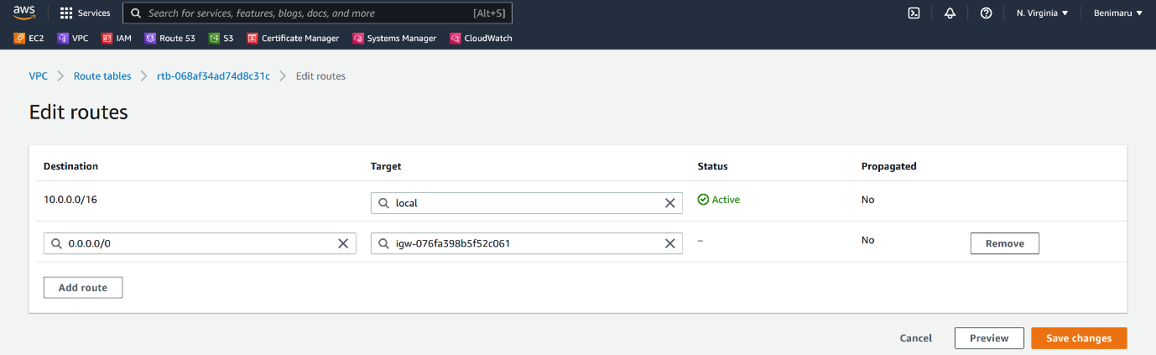

--- click on save changes.

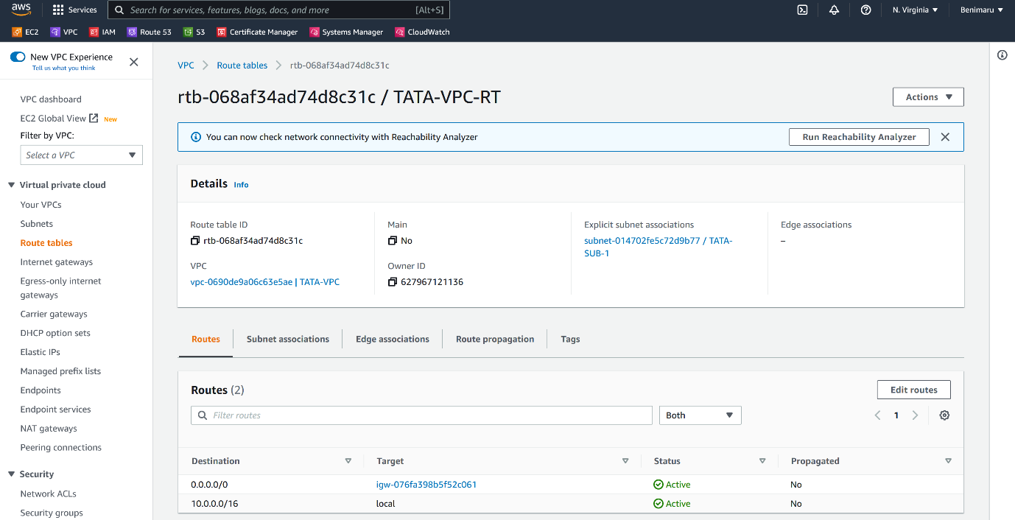

--- **note** – if the destination is 10.0.0.0/16 then establish a communication internally.

--- **note** – if the destination 0.0.0.0/16 then use the internet gateway route.

**Security group creating**

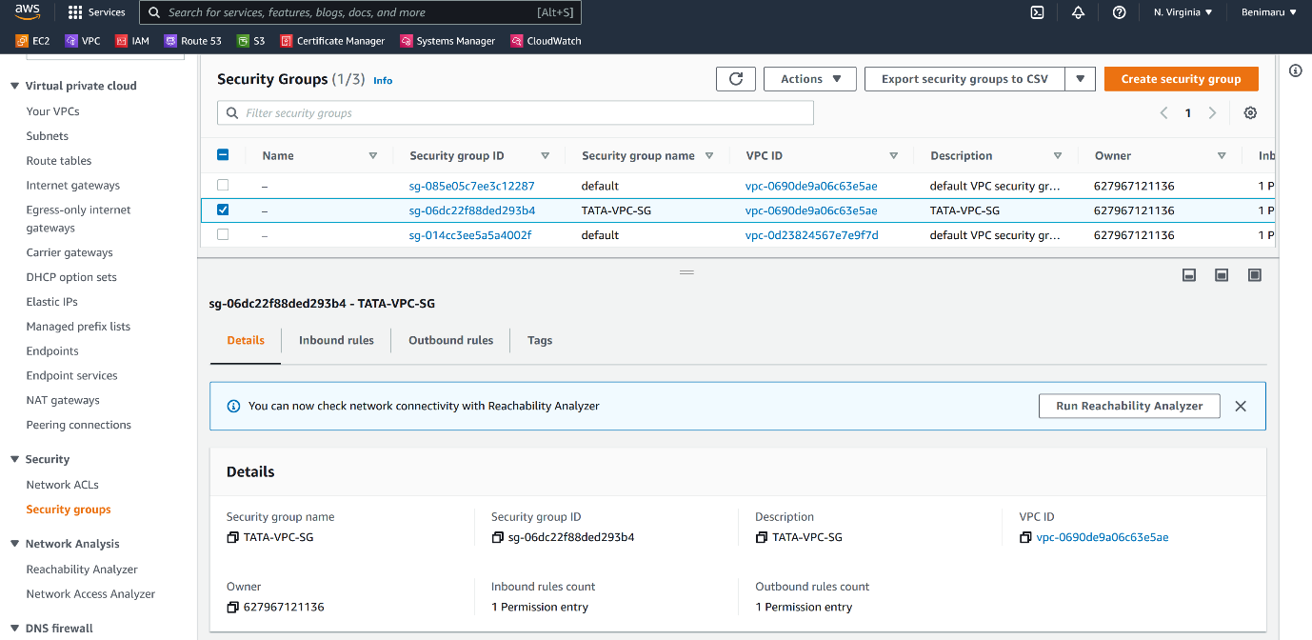

--- click on create security group.

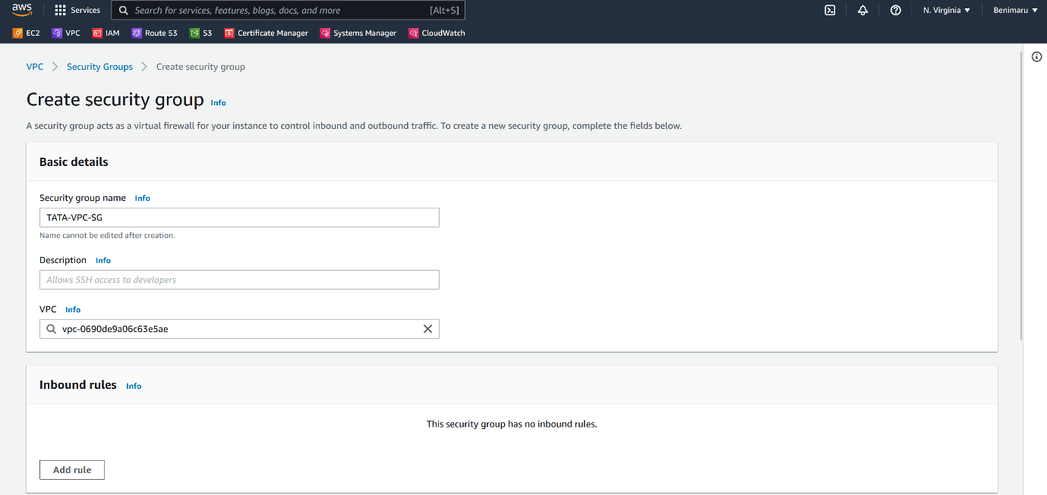

--- note – select the vpc that you want to attach this security group and please give the Description.

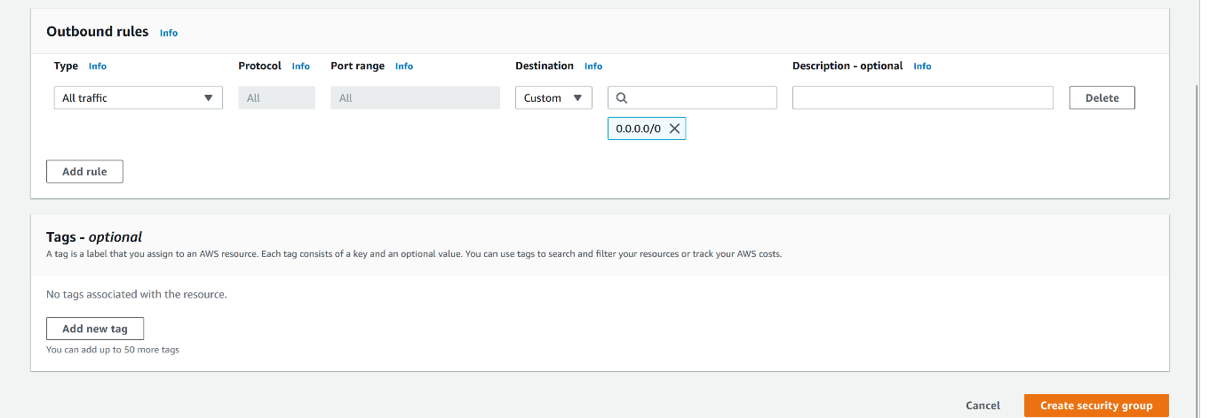

--- click on create security group.

