**05.AWS-B30-VPC-Peering**

--- **what is VPC peering…?**

Enable communication between 2 vpc’s is vpc peering.

--- **note** – by default there is no communication between VPC’S

**VPC Peering steps**

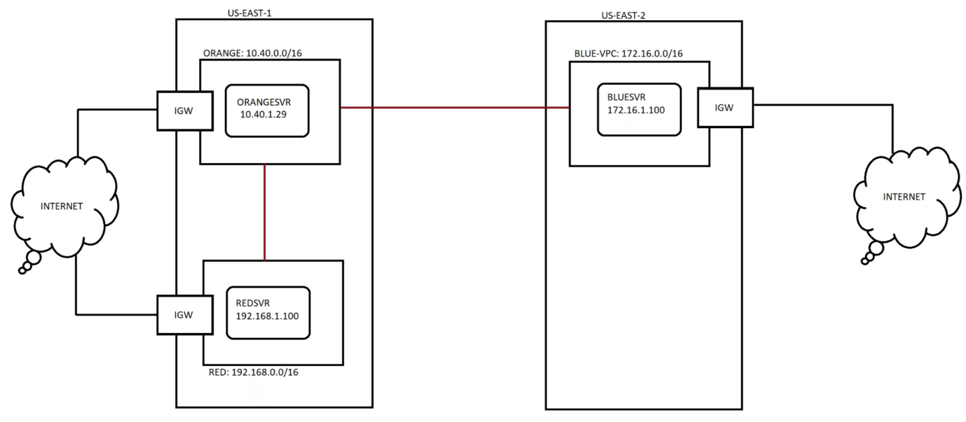

--- No IP address overlapping.

--- after creating vpc peering, it will be in pending state. Accept the pending state request.

--- in my case I am trying to establish vpc peering connection between orange to red. Go to orange vpc route table and add route to words red and do the same thing in red vpc route table and add route to words orange.

--- after establish VPC peering between 2 different VPC’S, use private IPs of the instance to ping one with another.

--- vpc peering do not support transit.

**Create vpc peering connection between orange and red (same region)**

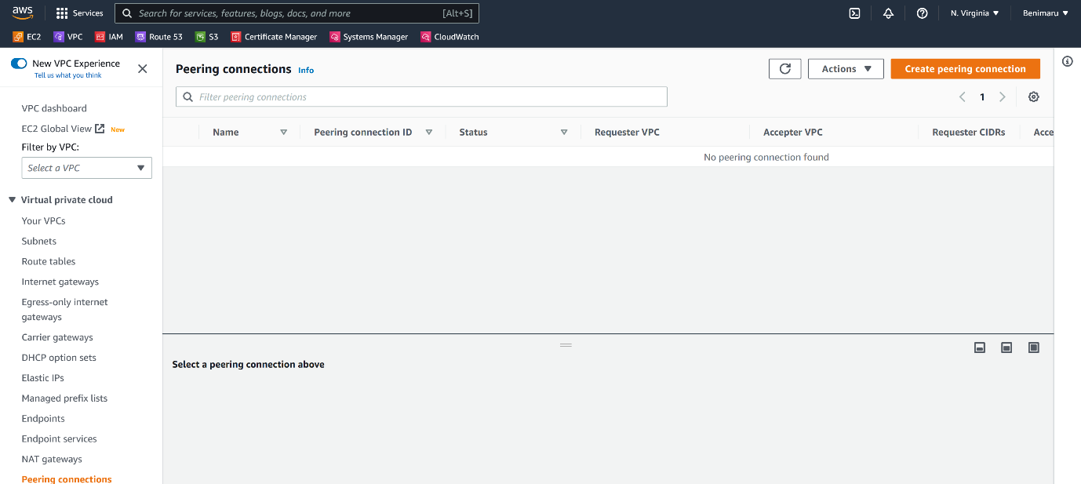

--- click on create peering connection.

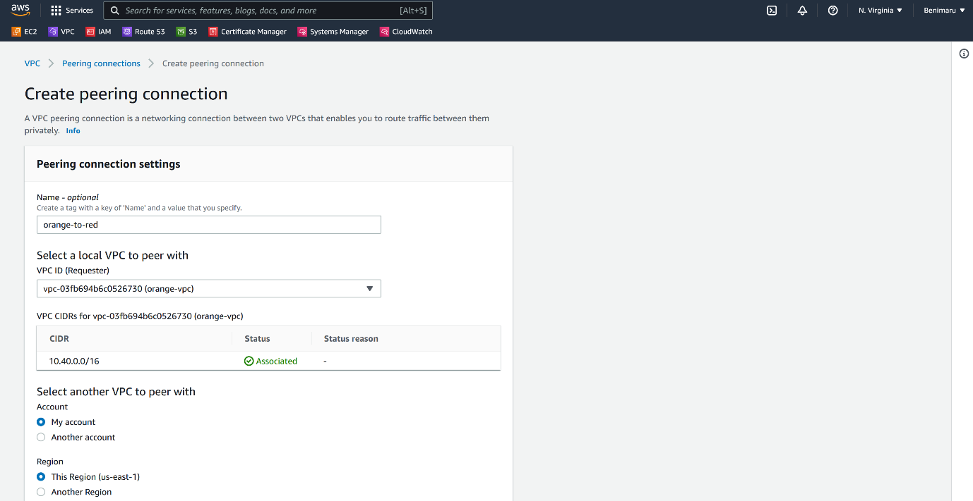

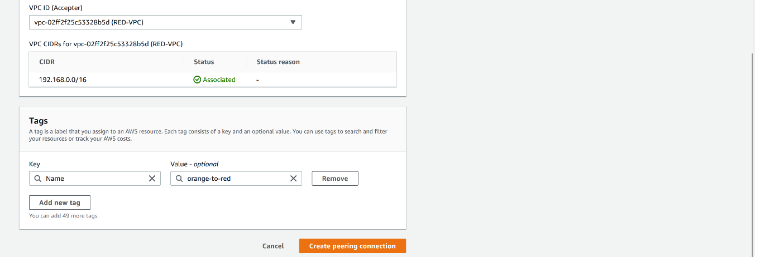

--- click on create peering connection.

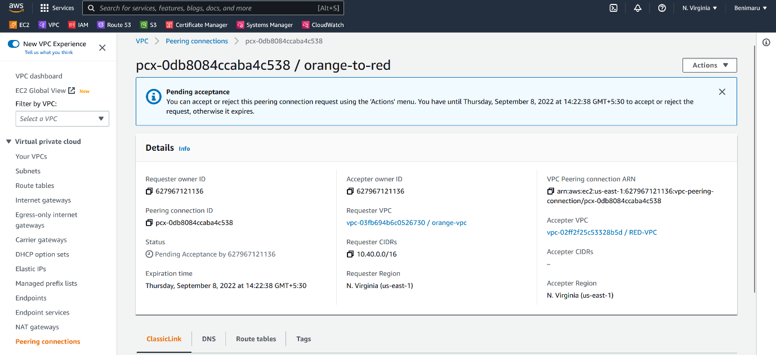

--- **note** – you can see that it is in pending acceptance state.

**Accept request**

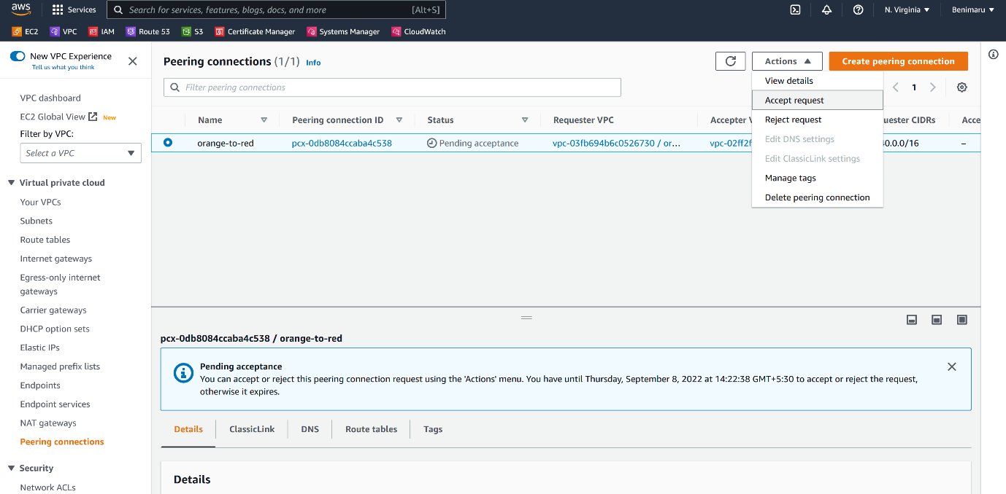

--- click on accept request.

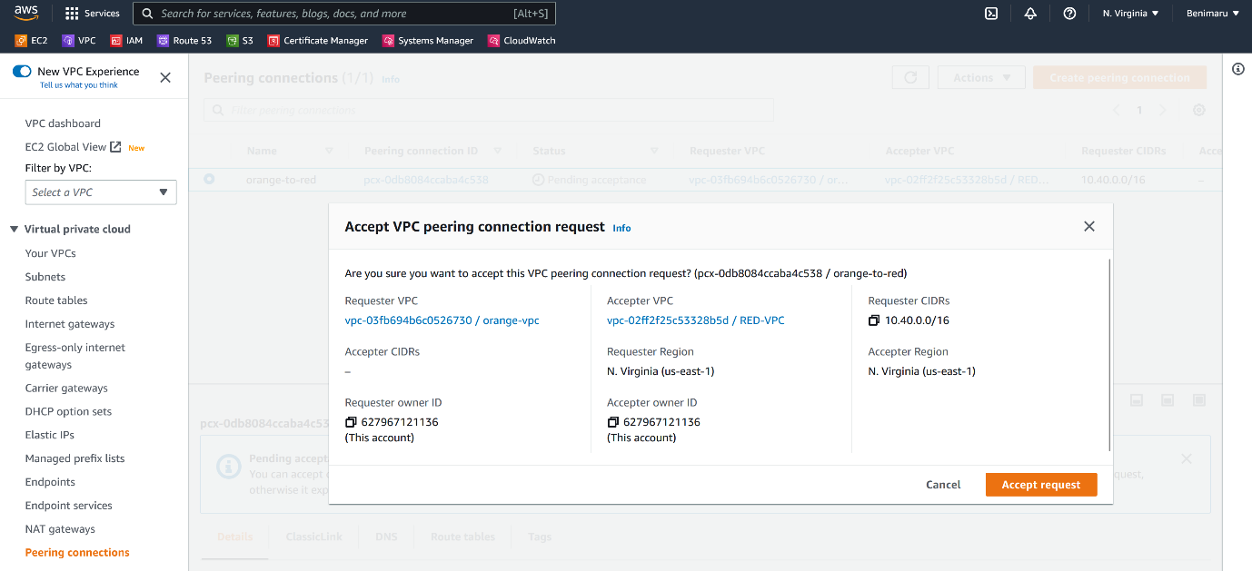--- click on accept request.

**Add route in orange route table**

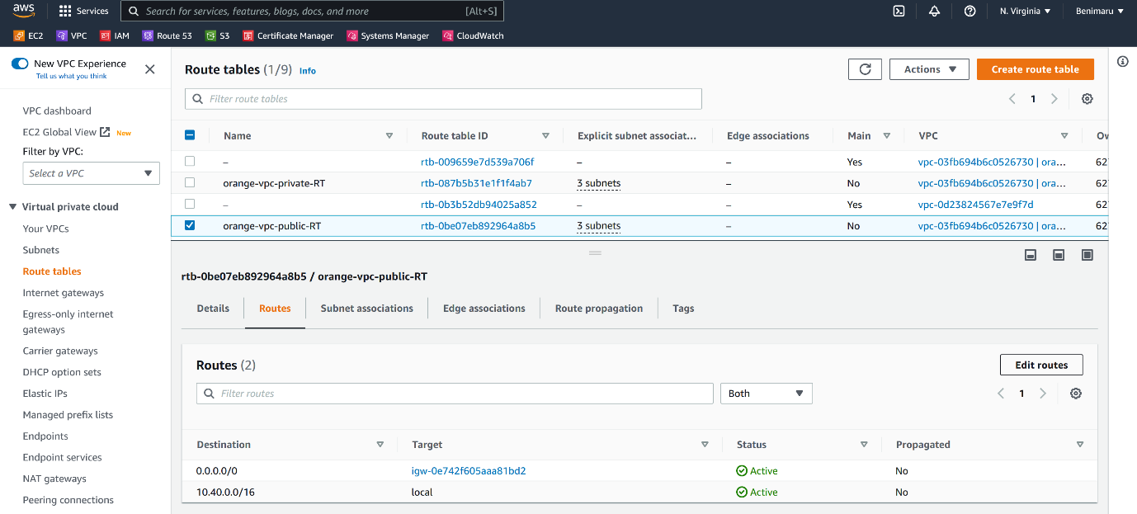--- click on edit routes

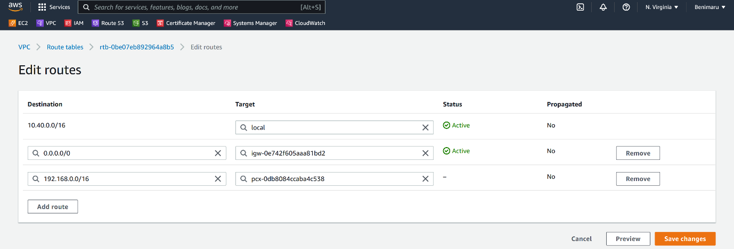

--- **note** - now add red vpc cider block in the destination. Because of this now route table route the traffic.

**Add route in red route table**

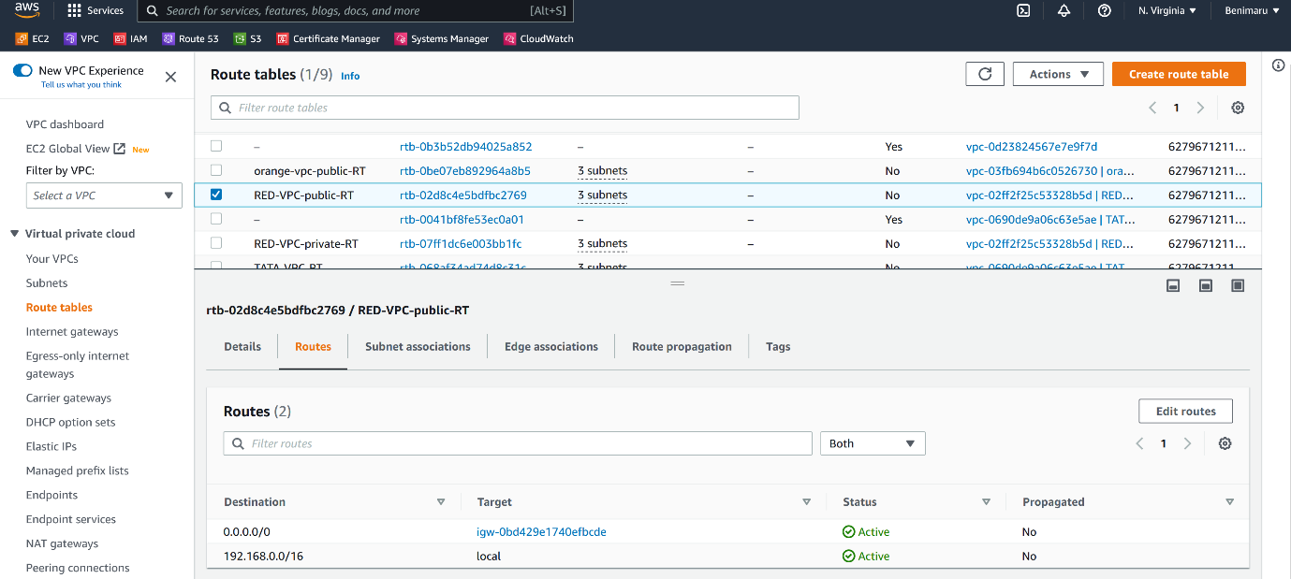

--- click on edit routes.

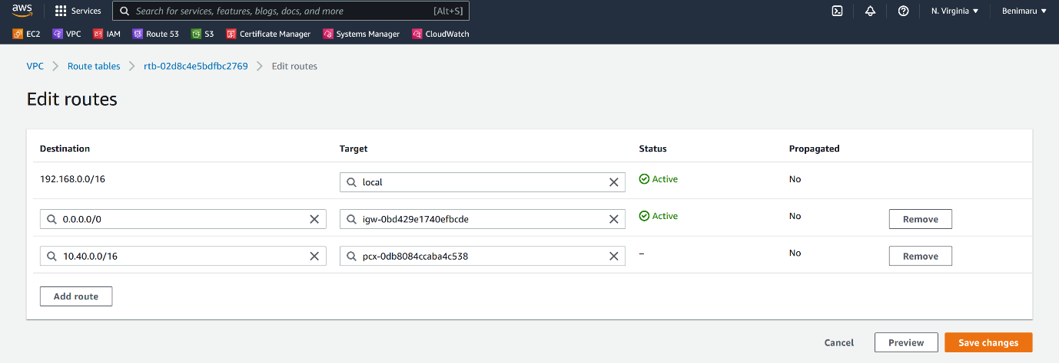

--- click on save changes.

**Create vpc peering connection between orange and blue (diff region)**

--- here we are establishing vpc peering between 2 vpc’s, these 2 vpc’s are in different region.

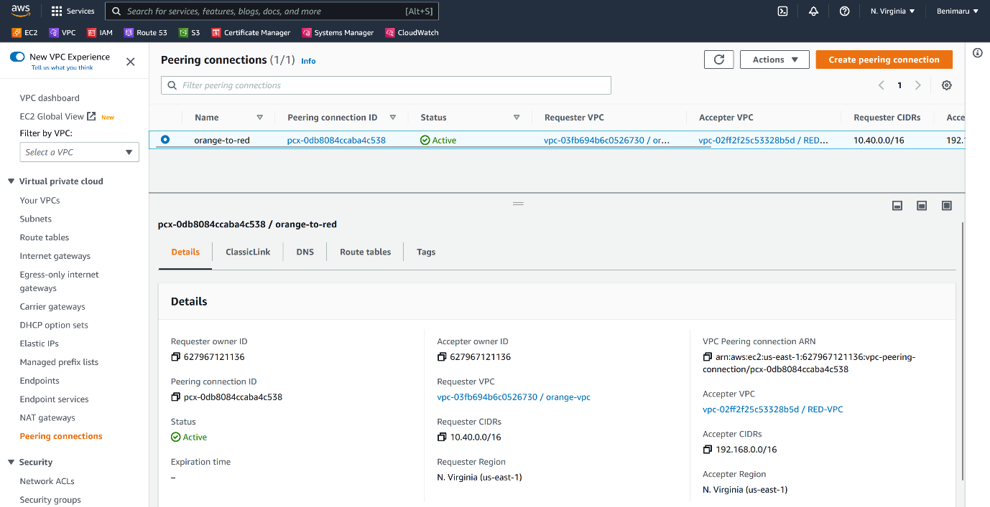

--- click on create peering connection.

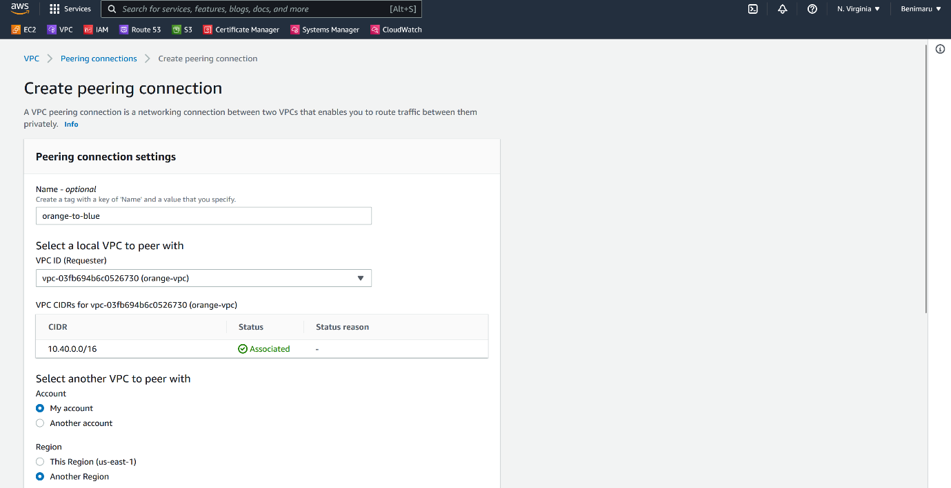

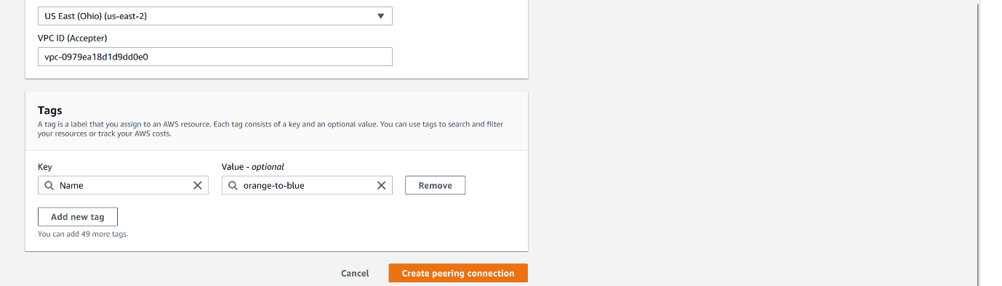

--- click on create peering connection.

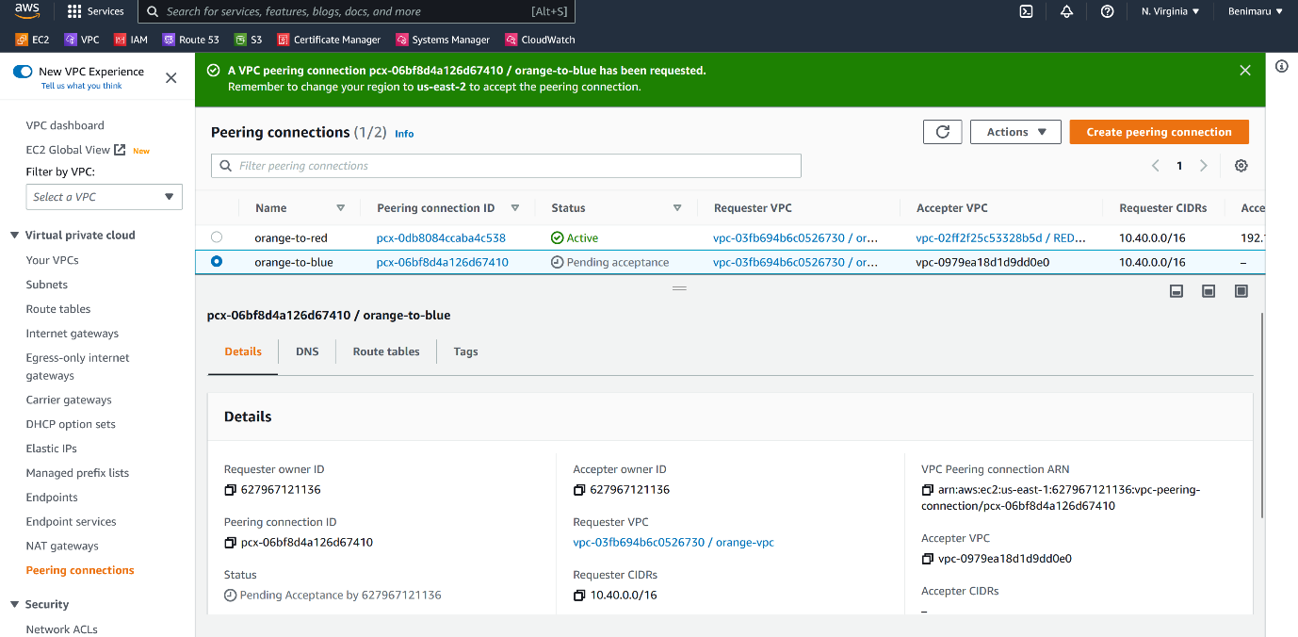

--- **important** - now it is in the pending state, we must go to the us-east-2 for accept the request.

**Accept request**

--- go to us-east-2 for accept the request.

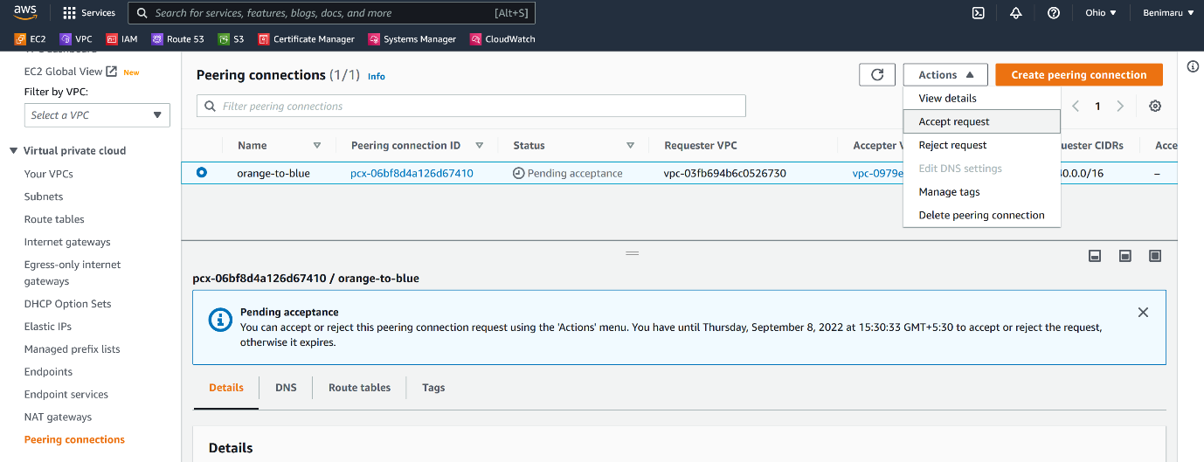

--- click on accept request.

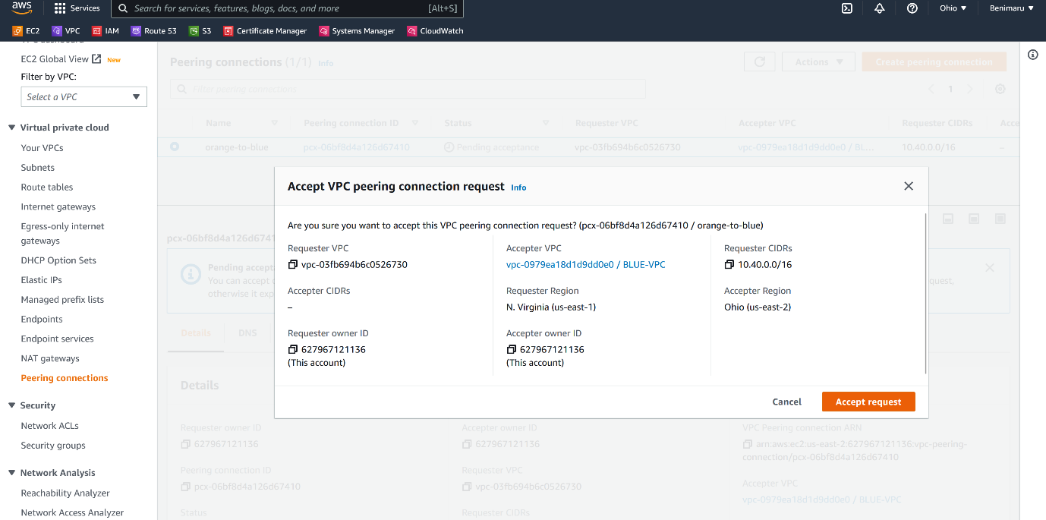

--- click on accept request.

**Add route in orange**

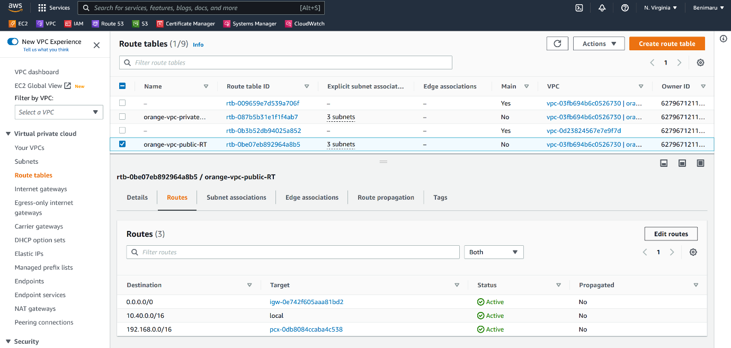

--- click on edit routes.

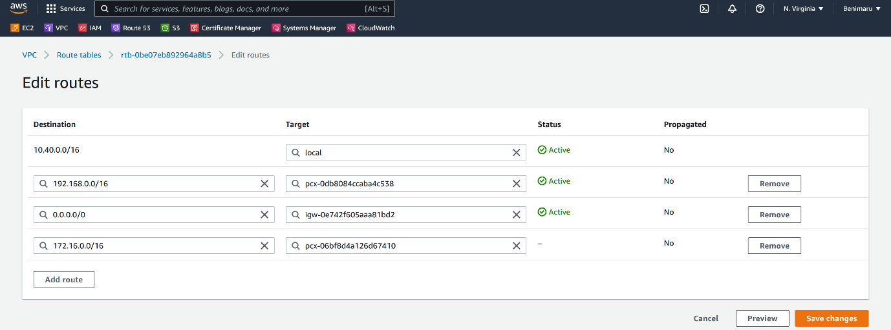

--- click on save changes.

**Add route in blude**

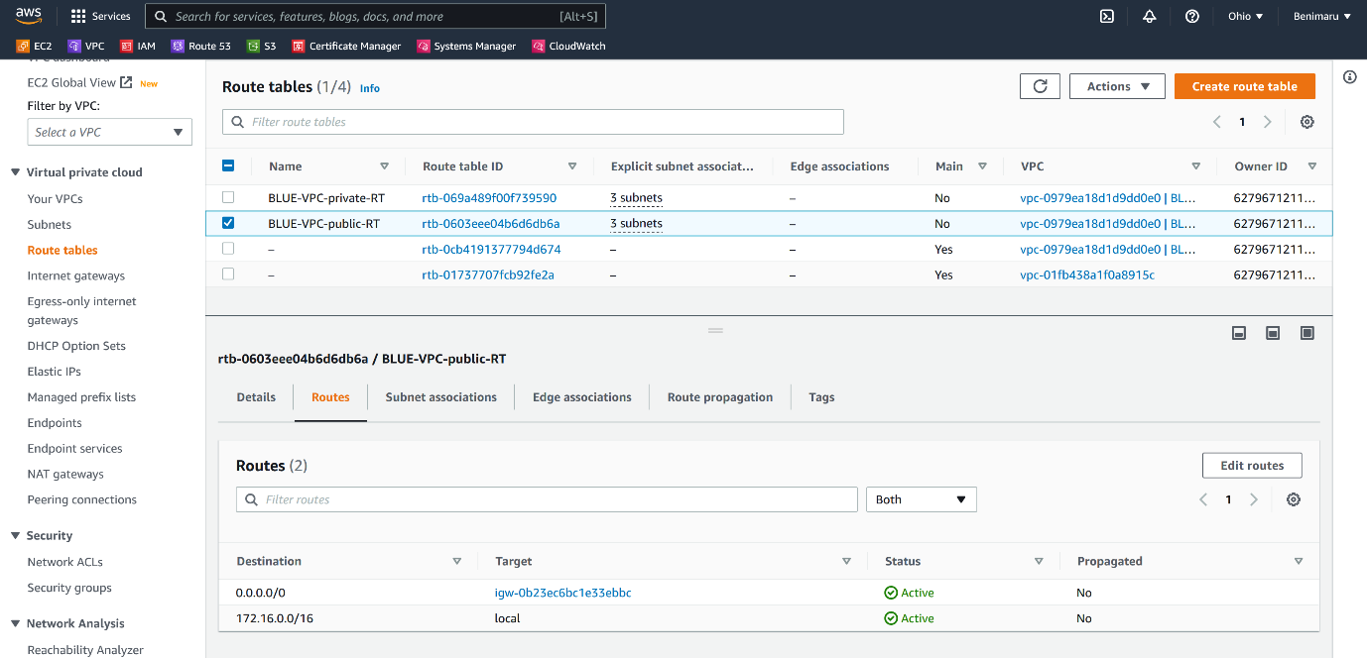--- click on edit route.

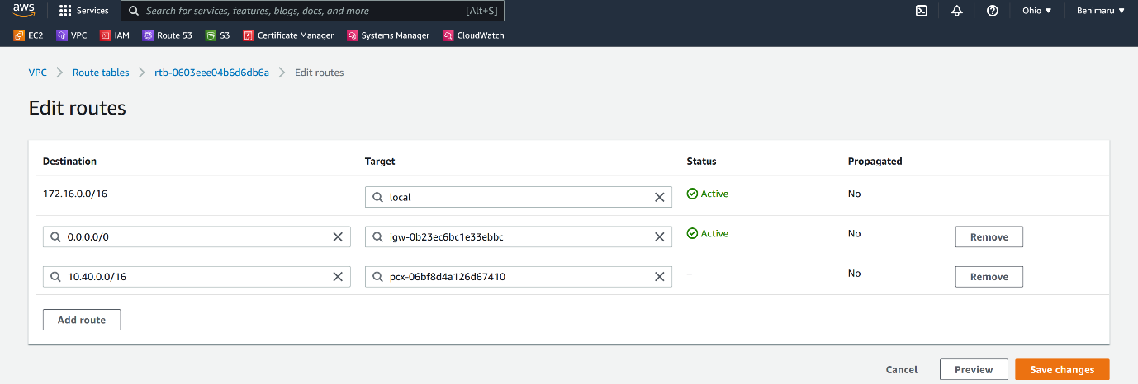

--- click on save changes.

**VPC HUB-SPOKE Architecture**

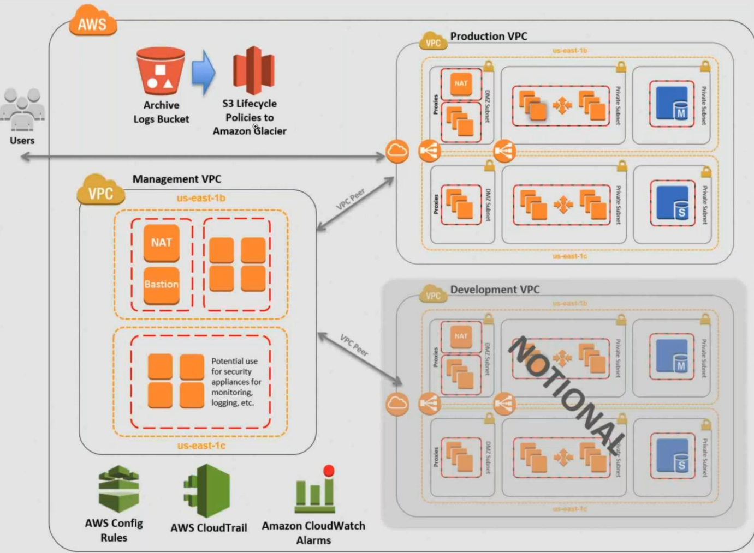

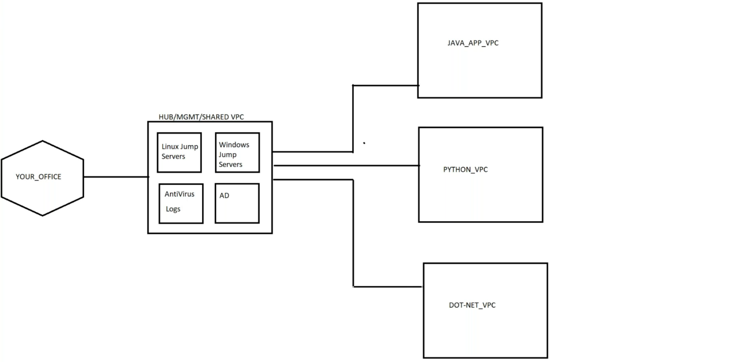

--- we have management or hub or shared VPC. We will connect to this vpc using vpn form office. In this vpc we will have linux and windows jump servers, antivirus servers, logging servers. We will create separate VPC ‘s for every project we have. We will manage every VPC form the management VPC.