**06.AWS-B30-EIP-NAT-Gateway**

--- in this session, we will discuss about below topics.

1. public and private subnets.
2. Internet access for private subnets
3. Elastic IP
4. NAT Gateway.

--- what is the difference between public and private subnet…?

What ever the subnet directly has connectivity towards internet gateway is called public subnet.

**Elastic IP address creating**

--- **important** – reboot will not change the ip address of the instance.

--- **note** – if you stop and start an instance then the ip of that instance will be changed.

--- **what is static ip and public ip…?**

Both are public ip’s. static ip created manually and assigned to instance where as dynamic created automatically and assigned to instance. Static ip will not change even if you shutdown you instance but dynamic ip will change if you shut down your Instance.

**Create elastic ip**

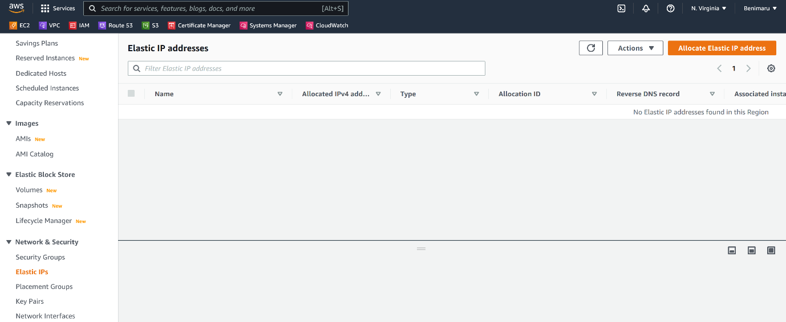

--- click on create allocate elastic IP address.

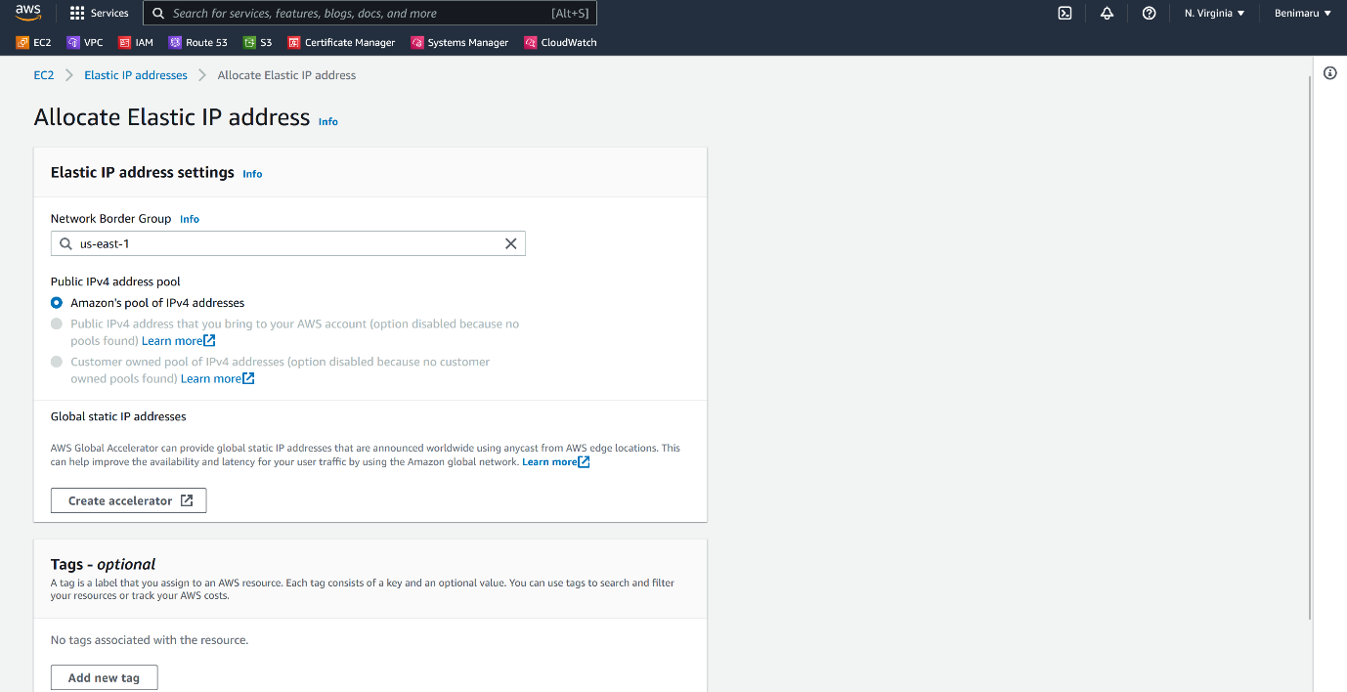

--- click on allocate.

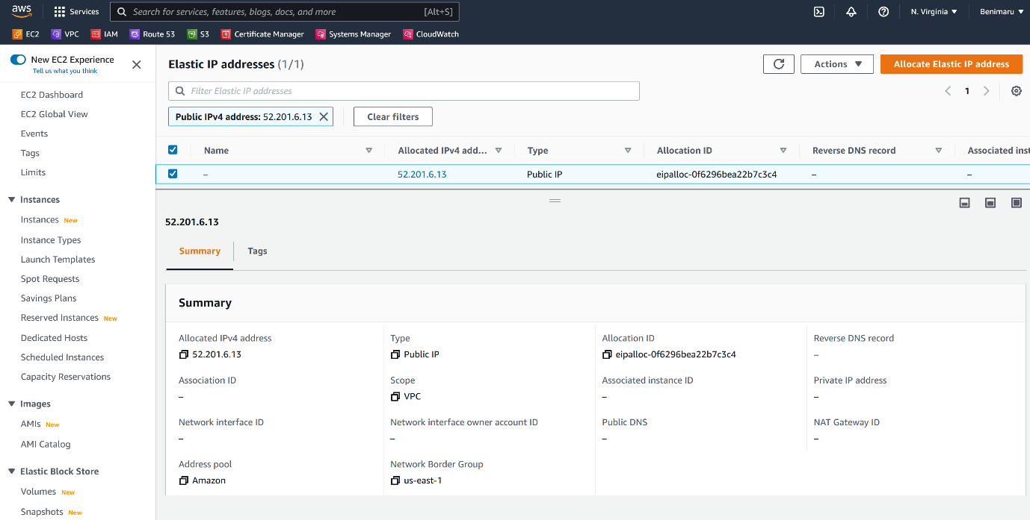

--- our elastic ip address got created.

**Create private subnet**

--- go to the subnets.

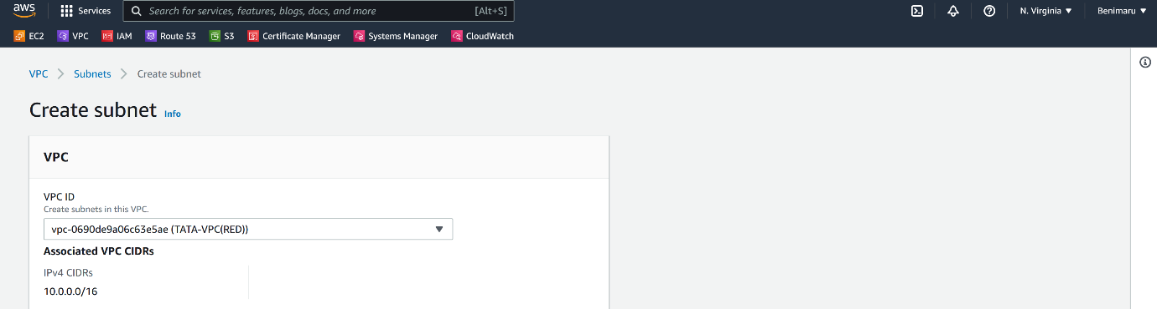

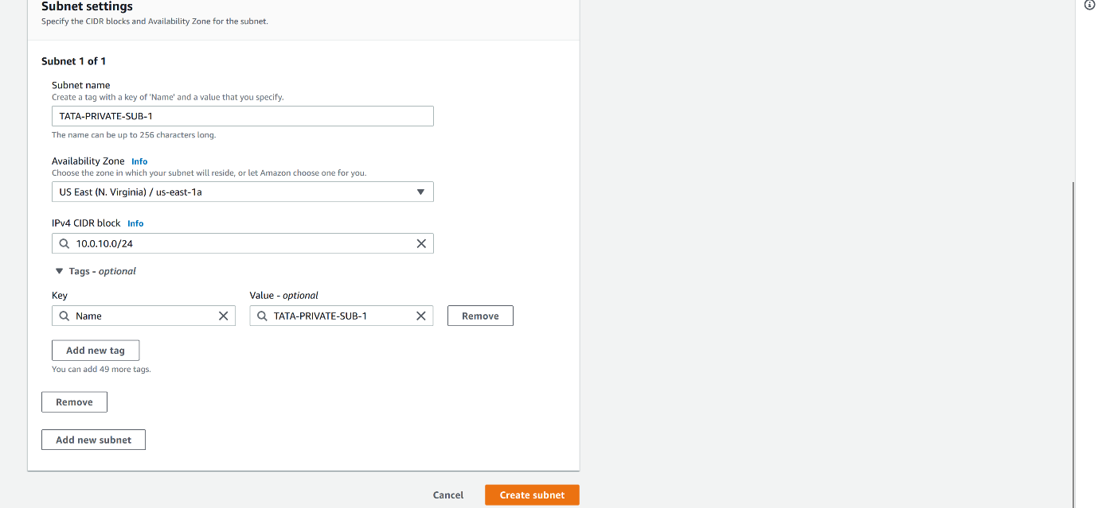

--- click on create subnet.

--- **important** – this is not actually a private subnet. In order to make it private subnet, we need to create a separate route table for this subnet and that route table should not have any route to internet.

**Create private route table and add this subnet**

--- go to route table

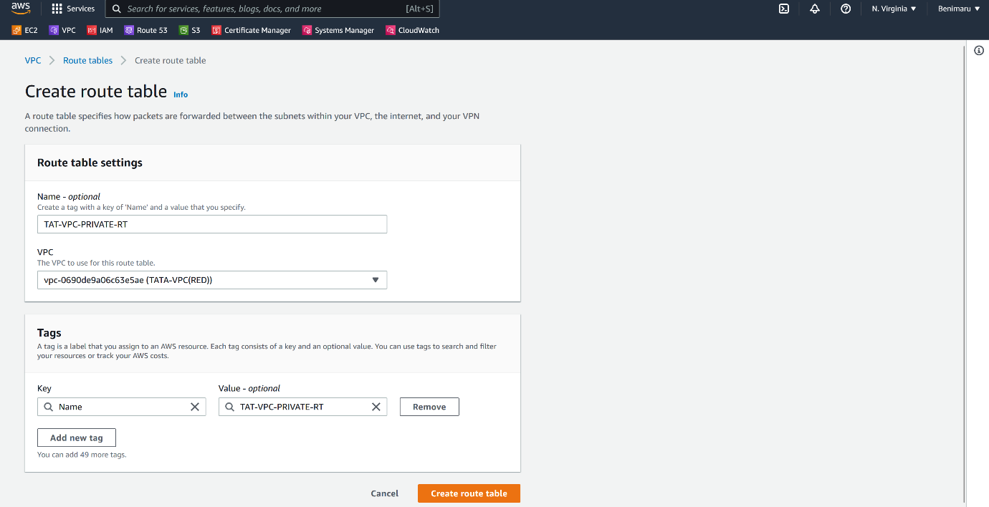

--- click on create route table.

--- now add the subnet to this route table.

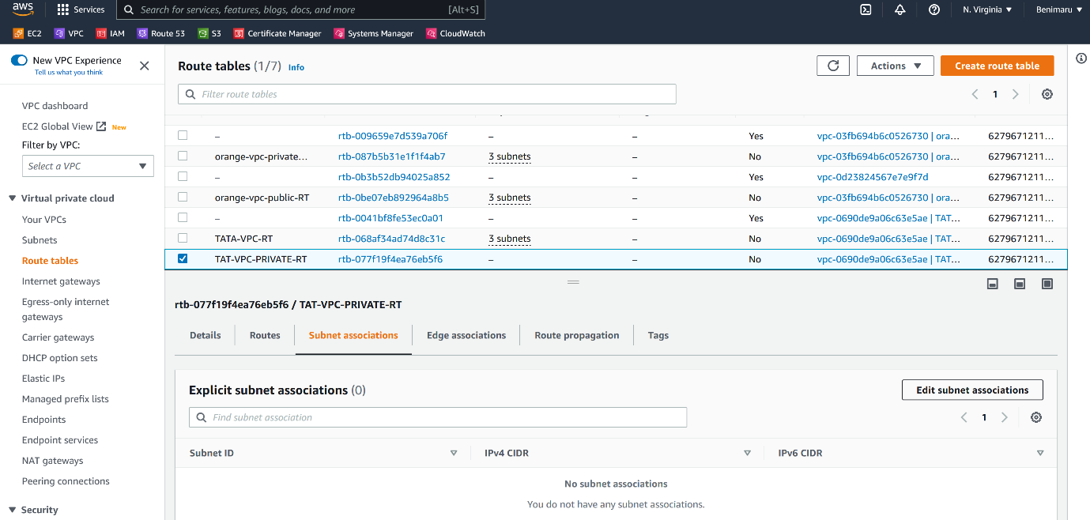

--- click on edit subnet association.

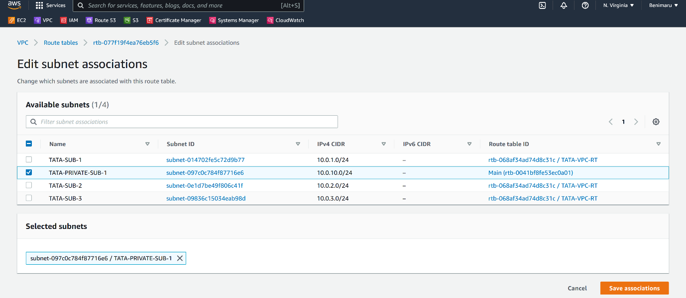

--- select the subnet you want to add and click on save associations.

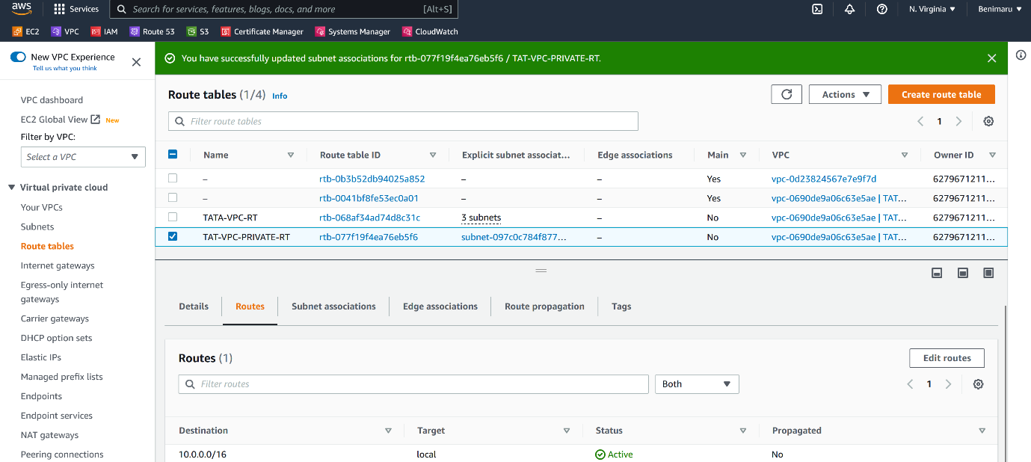

--- this route table does not have route to words internet.

**How do we connect instance that is present inside of private subnet**

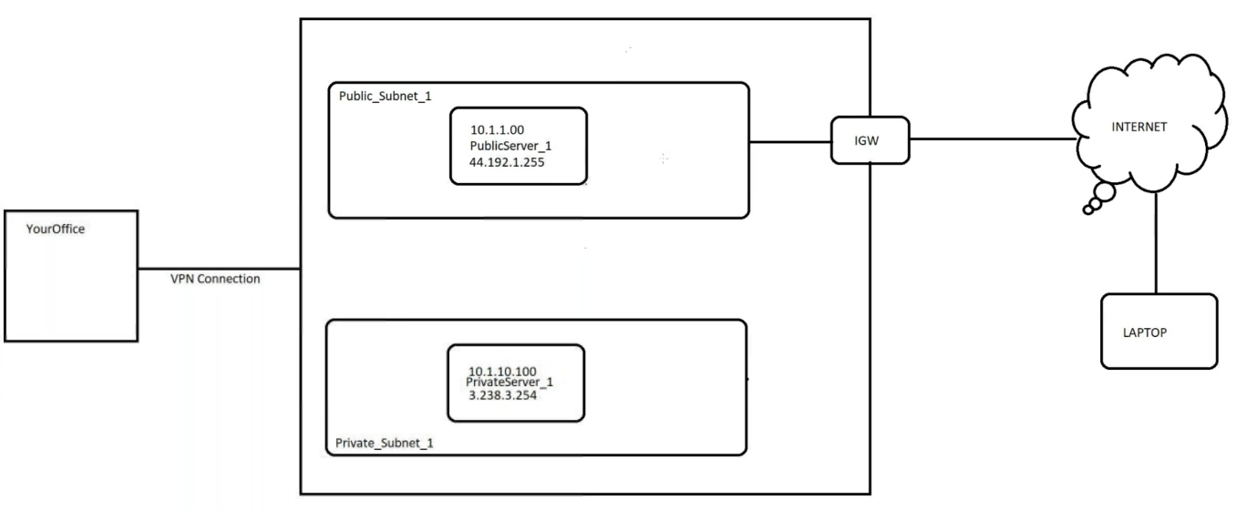

--- if you look at here, I deployed an instance in private subnet and now I want to login to that instance.

--- we can connect the private instance using 2 ways.

1. Login public server and form there we can login to private server.
2. Using office VPN. Using office VPN, we can connect to VPC.

**Give internet access private server (nat gateway)**

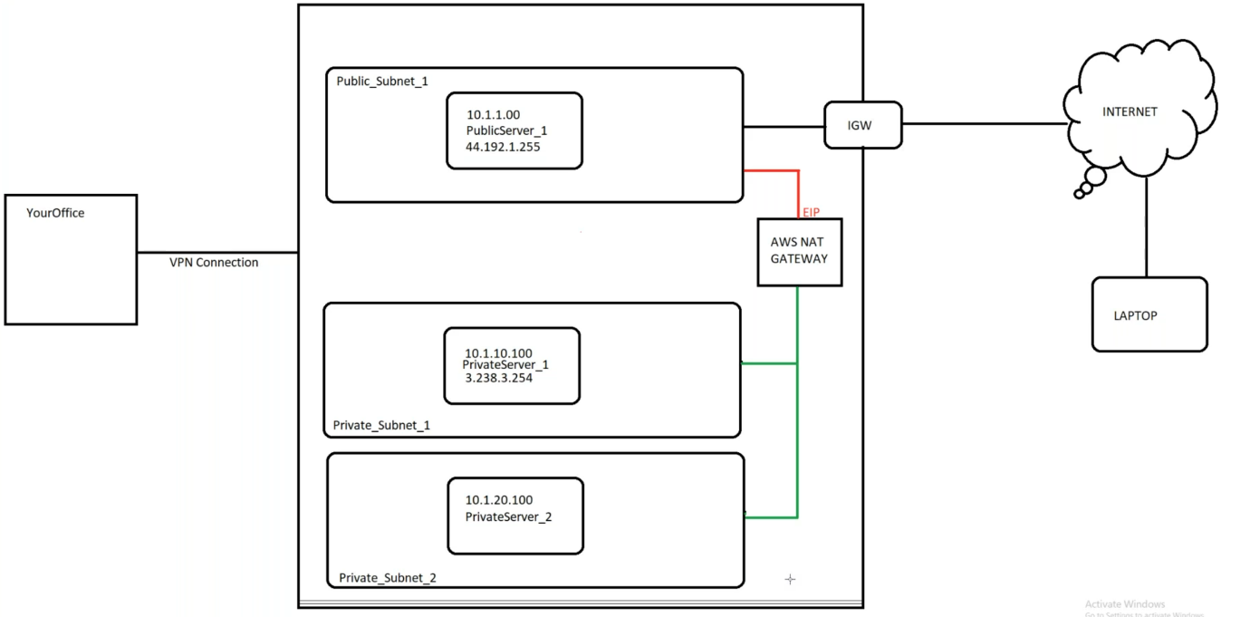

--- **note** – we will use nat gateway to give internet access to the private instance.

--- we will deploy nat gateway in public subnet.

--- if you want to create nat gateway then we need elastic ip.

--- after nat gateway creation is completed, add route in private subnet route table to words nat gateway.

--- **important** - nat gateway allows the application request form inside to outside and outside to inside. It will not allow a request form internet to inside.

**Create nat gateway**

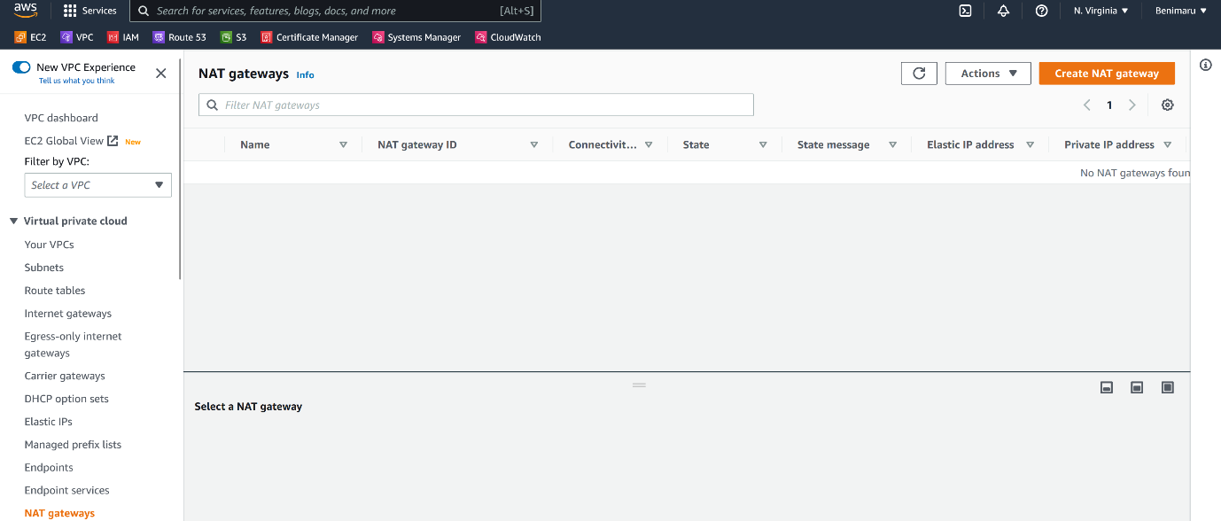

--- click on create NAT gateway.

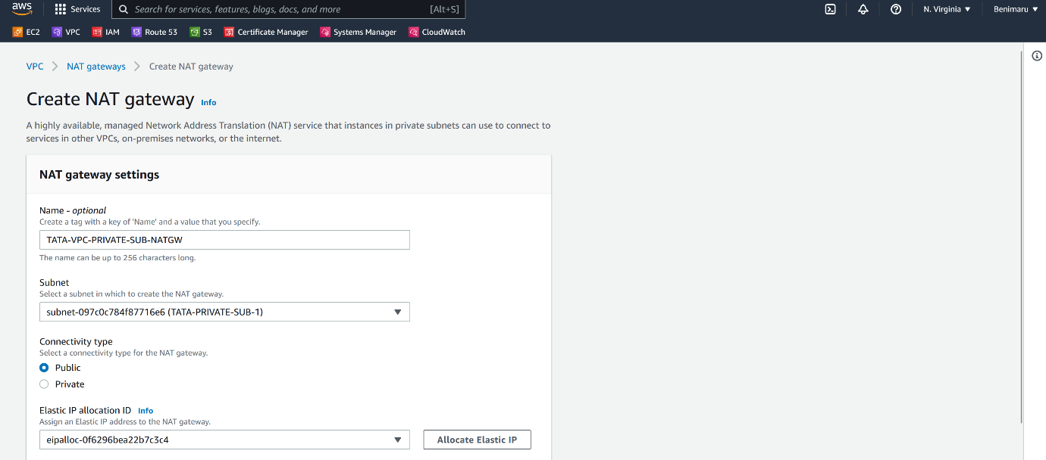

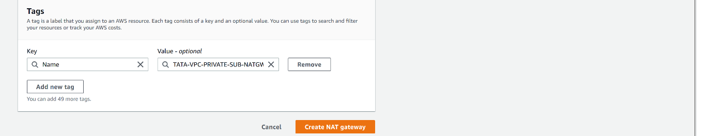

--- Click on create NAT gateway.

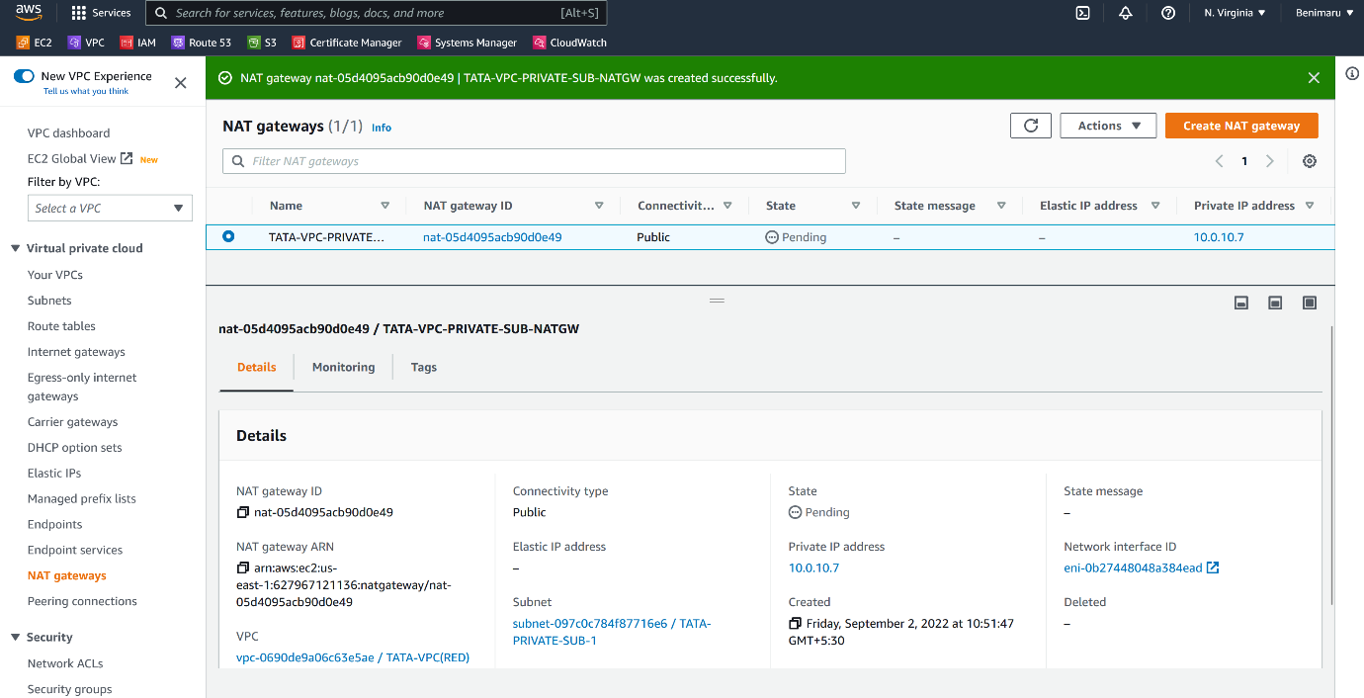

--- nat gateway got created.

--- **important** – go to the private subnet route table and add a route to words nat gateway.

**Add a route to words private subnet to words nat gateway**

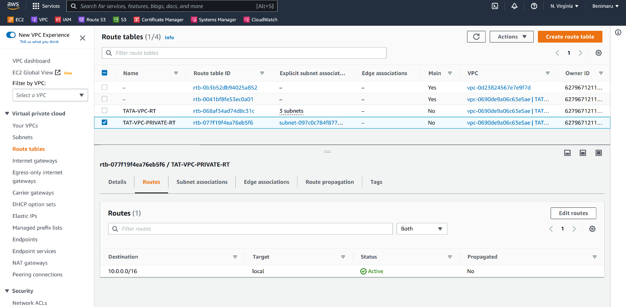

--- click on edit routes.

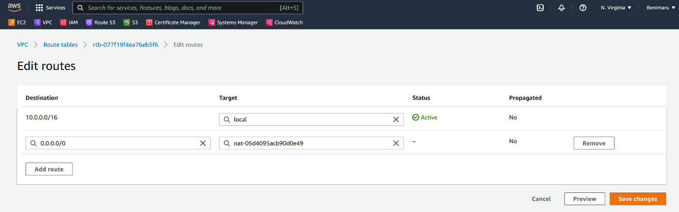

--- click on save changes.

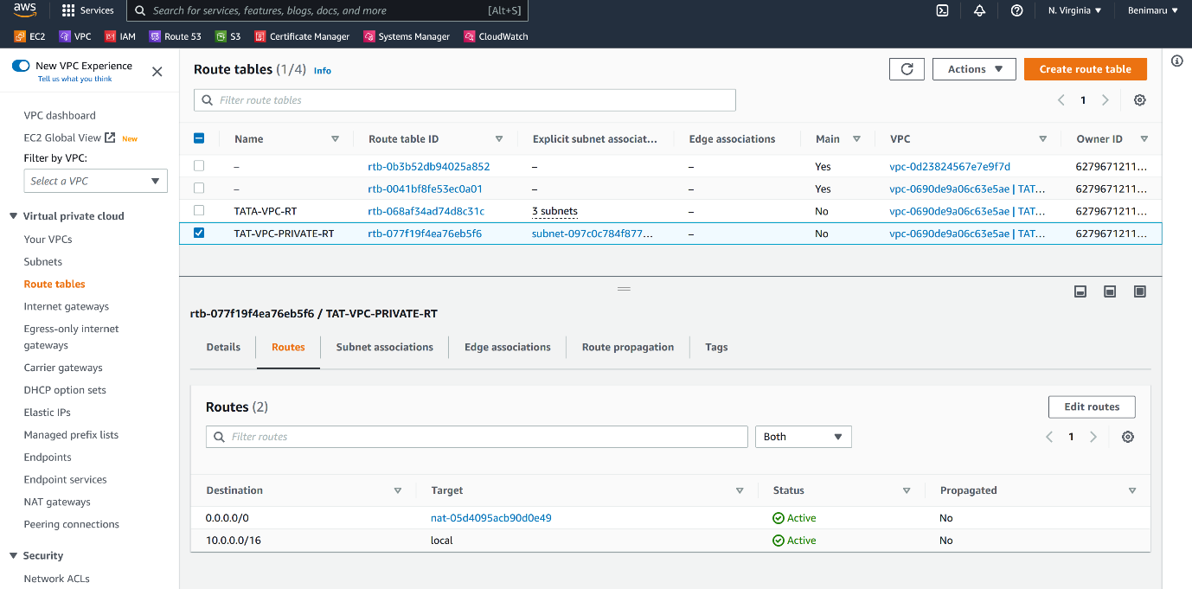

--- route added successfully.

**Interview question**

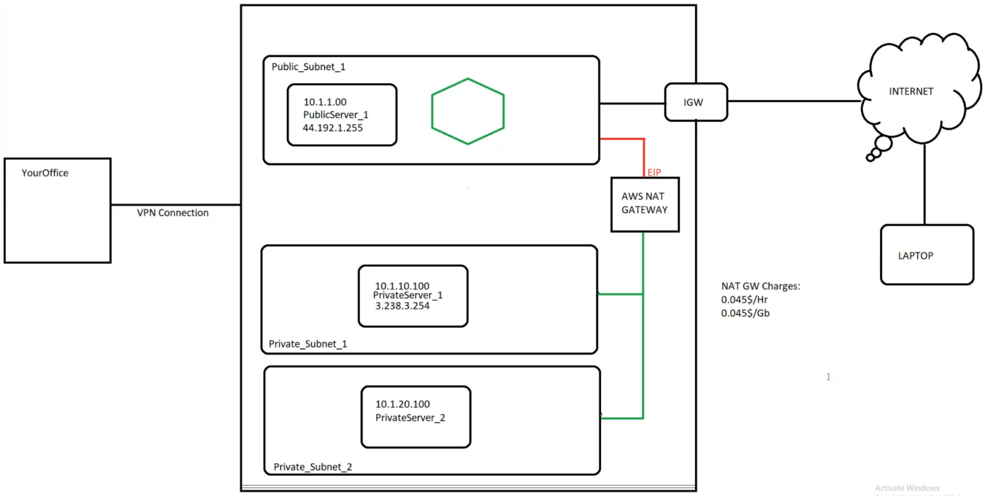

--- we have web servers, App servers and db servers. We need to deploy all these servers in private subnet. In real time we will not deploy any servers in public subnets. We will deploy these servers in private subnet.

--- **note** – if we deploy all our servers in private subnets then how customers will connect to our websites…?

--- we will deploy the load balancer in public subnet and the private instance added as targets in load balancer. This way customers can connect to our application.

--- **important** – we need to patch our servers every month, for patching we need to connect internet. This time we will use nat gateway for patching our servers.