**12.AWS-Organizations**

**AWS account architecture**

--- **could you tell me your project…?**

We will talk about the requirements when we have the project.

1. Environments we need for our project is
2. Dev platform
3. Qa platform
4. UAT platform (user acceptance testing)
5. Production platform
6. We will create 2 AWS account for this project
7. 1st aws account for Dev, Qa and UAT
8. 2nd aws account for production
9. SQL database (14 DB)
10. Redis server
11. Apache solar
12. AWS secret manager
13. Application load balancer
14. Kubernetes cluster
15. SSL certificate.

--- **what will achieve by creating aws account or invite existed aws account…?**

It will provide centralized billing.

--- **important** – we use aws organization for account management, for every new project there will be a new aws account created. In general, there will be 2 account 1st one is for dev and qa, 2nd one is for uat and production.

**Master account**

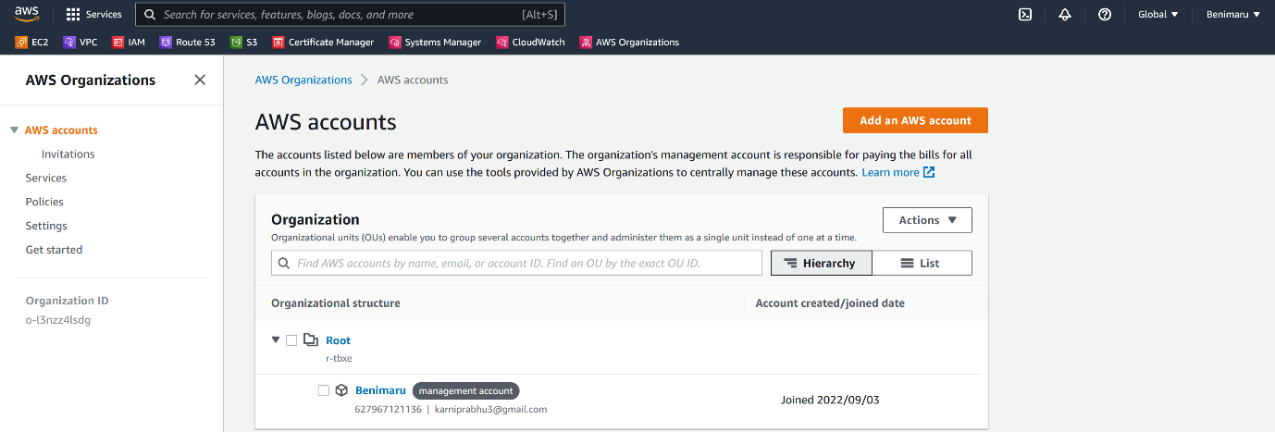

--- under master account, we can create multiple account.

**Create aws account**

--- prerequisites

1. You are creating aws account for new project then ask them their email address.



--- click on add an aws account.

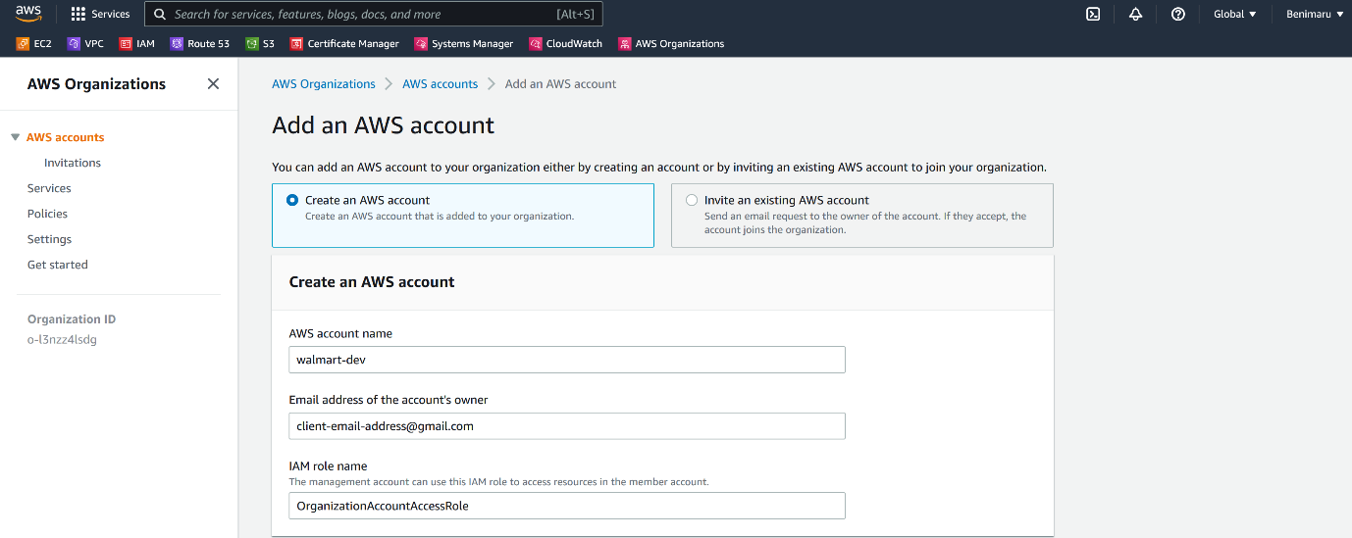

--- **note** – from here, you can create a new aws account or you can invite existed aws account.



--- click on create AWS account.

--- **important** - after the above step, the client will receive a email form amazon and he will use that email to sign up into aws console.

**Organizational unit**

--- **note** – after creating 2 new accounts for Walmart project, we can create a Walmart organizational unit and move the accounts which we have created for Walmart under Walmart organizational unit.

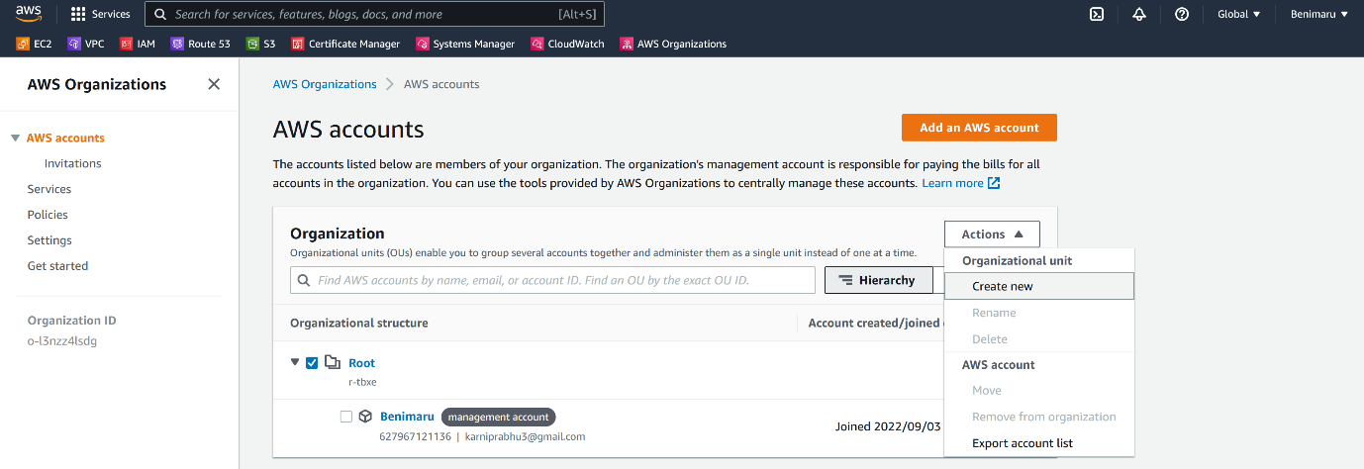

--- click on create new.

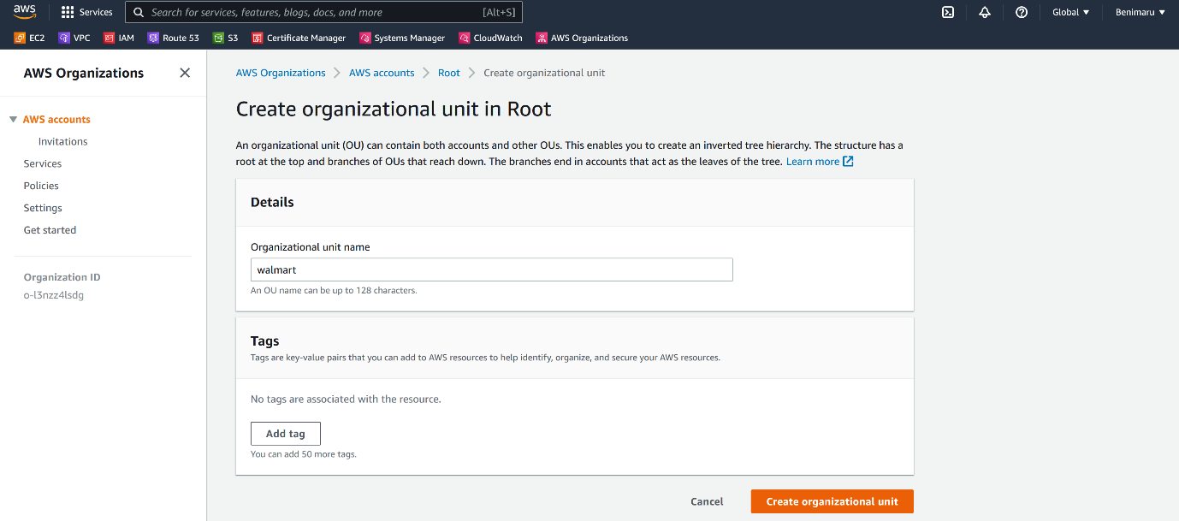

--- click on create organizational unit.

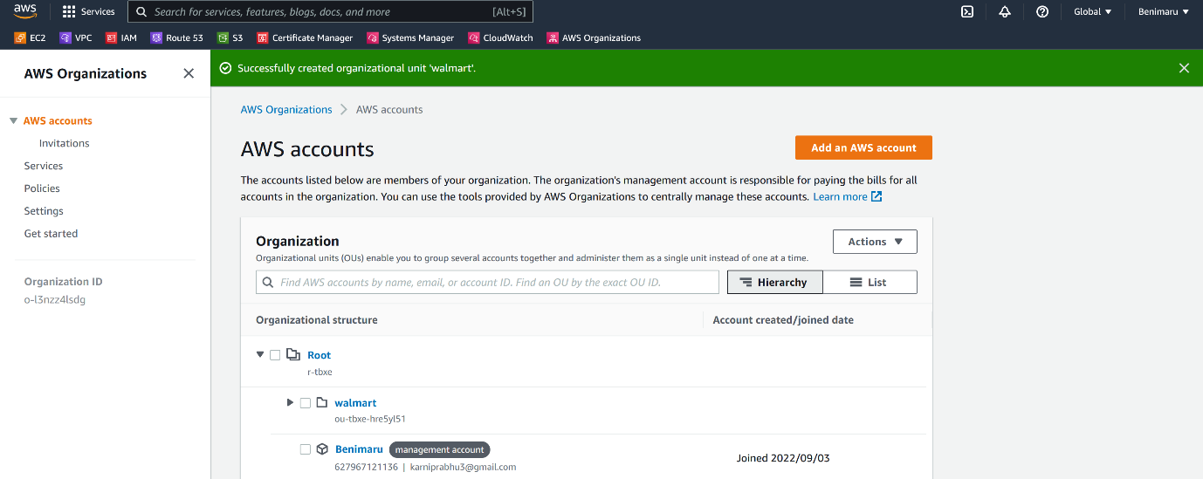

--- Walmart organizational unit got created successfully.

**Move AWS account under Walmart organizational unit**

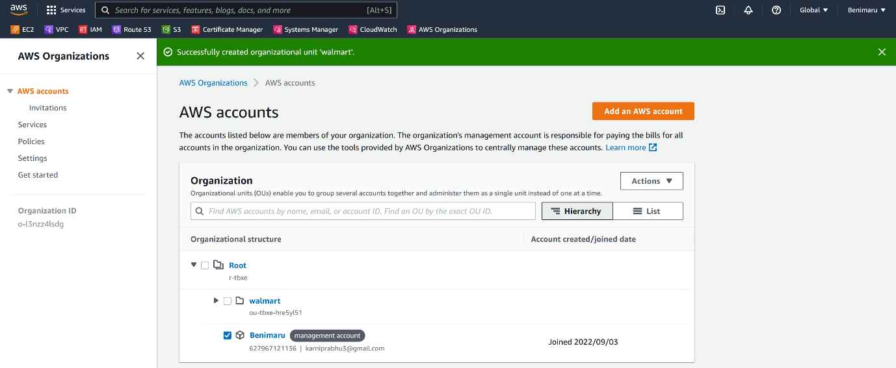

--- **note** - select account that you want to move under Walmart organizational unit. In my case I want to move my benimaru account under Walmart organization unit. So, I selected benimaru account.

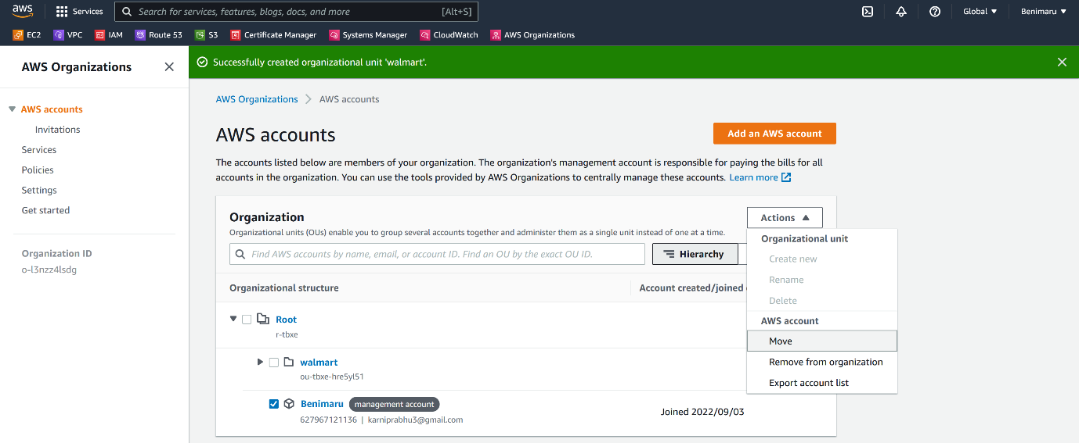

--- click on move.

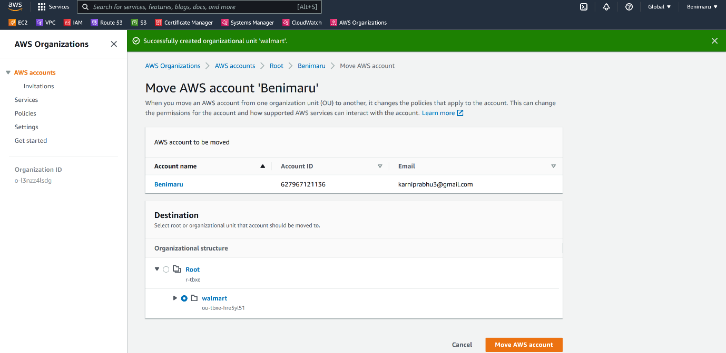

--- **note** – select the organization unit that you want to your aws account into.

--- click on move AWS account.



