**18.AWS-NetworkLoadBalancers**

--- **note** – in this session we will discuss about network load balancer.

--- **note** – you need high performance for gaming then we can use network load balancer.

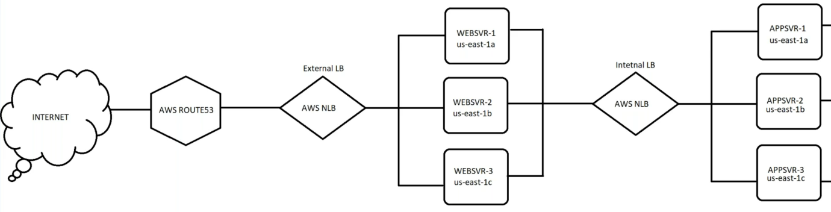

--- note – based on above diagram, 1st I will create target group and will attach that target group to load balancer.

**Target group creating**

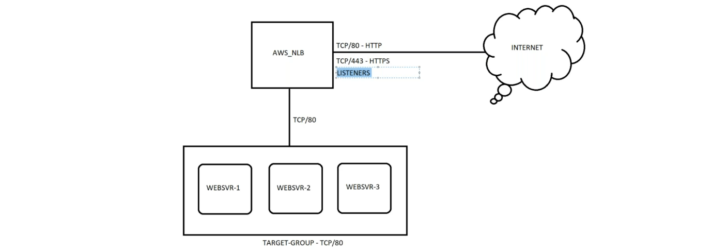

--- **target group** – the target group is nothing but a set of machines.

--- **key points**:

1. Load balancer will route the traffic to the servers on tcp/80. Because the application is working on port 80.
2. We can add multiple target groups to the load balancer.
3. We will use tcp, if this is an application load balancer then we will use http and https.
4. All the application will work on the http port 80, we can convert http to https in the load balancer listeners.

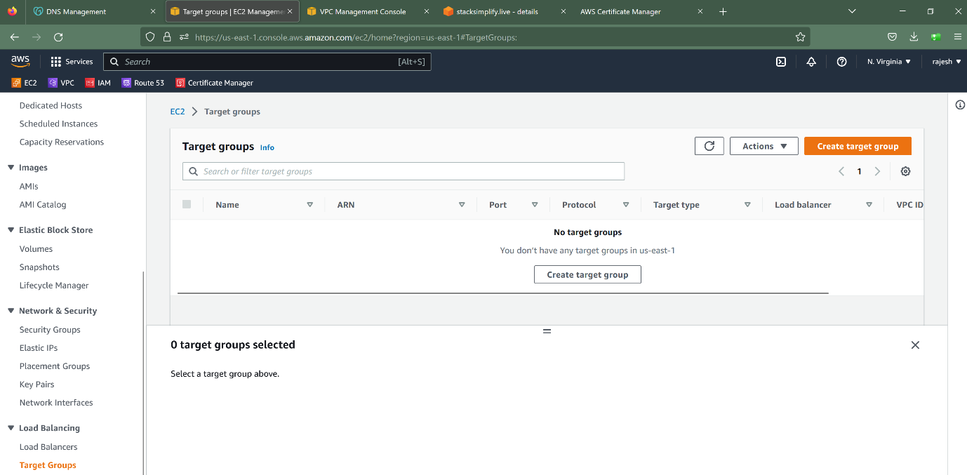

--- click on target groups.

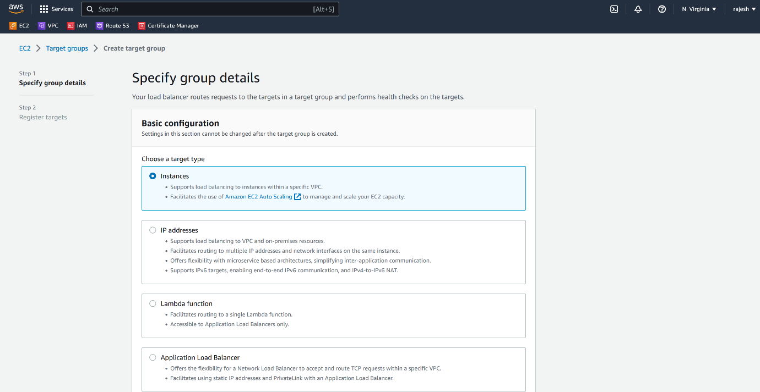

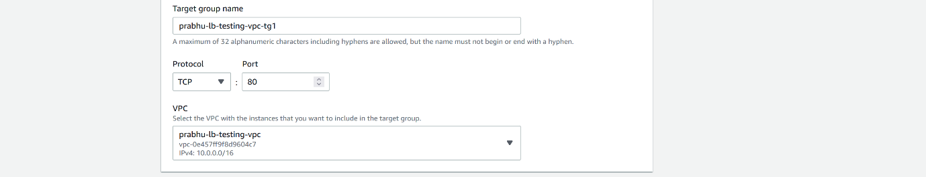

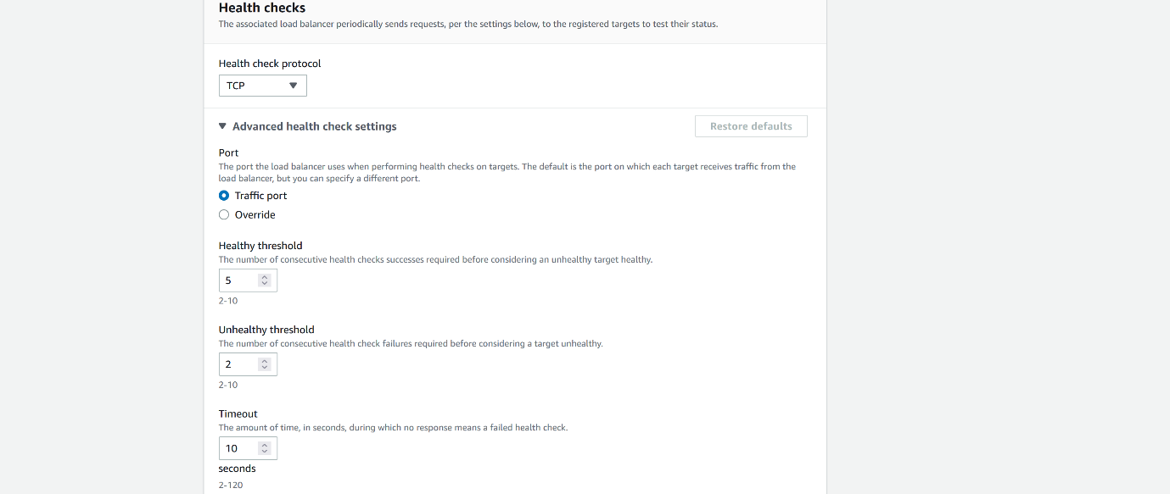

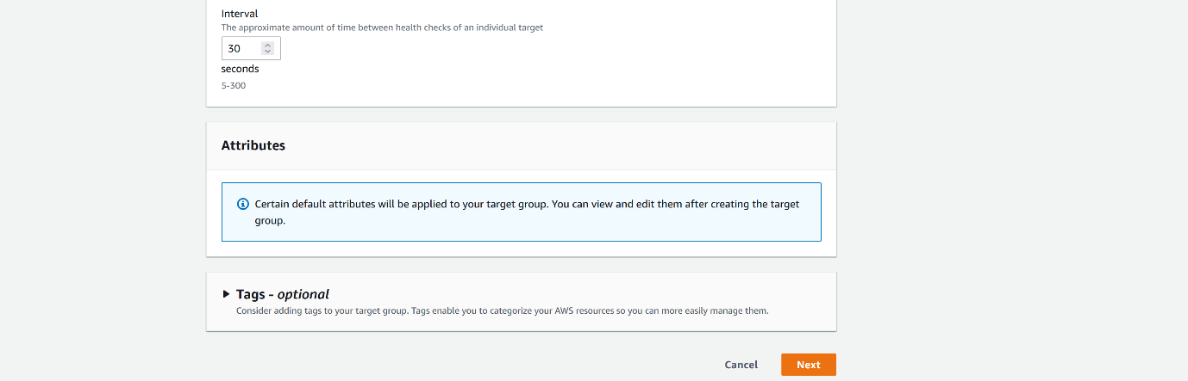

--- click on next.

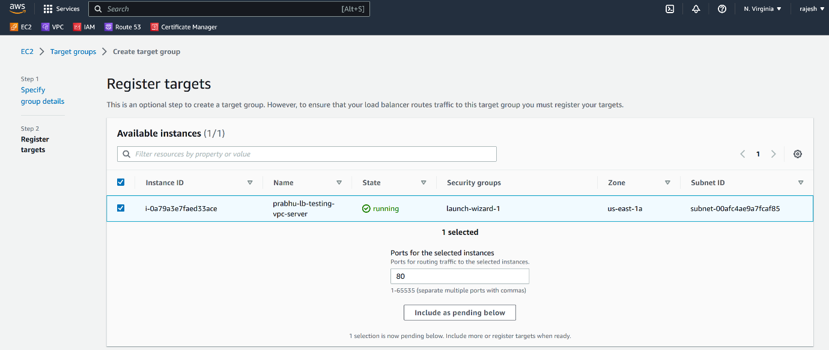

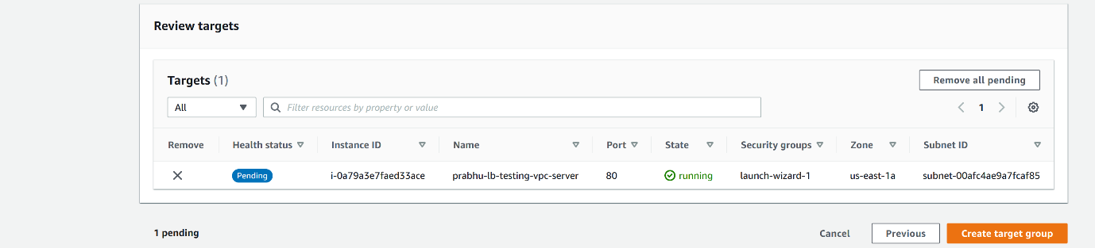

--- click on create target group.

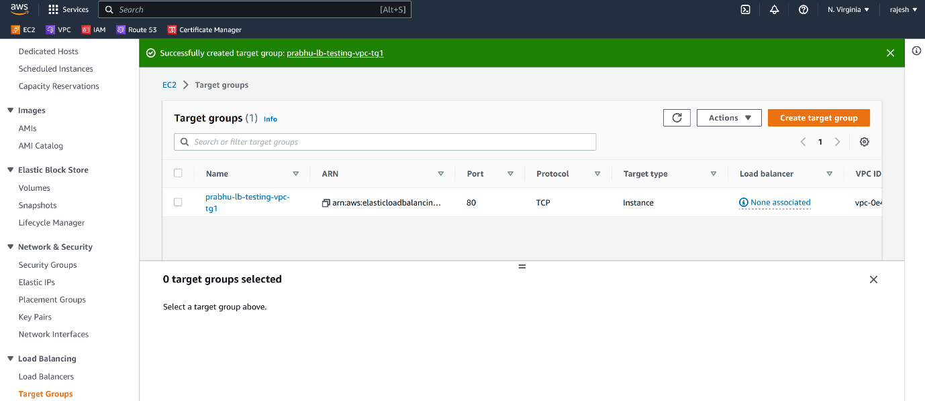

--- **note** – target group got created.

**Load Balancer creating**

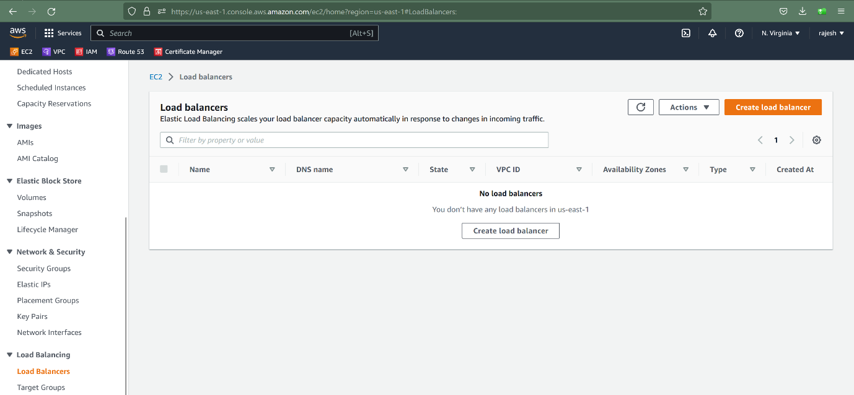

--- click on Load Balancer.

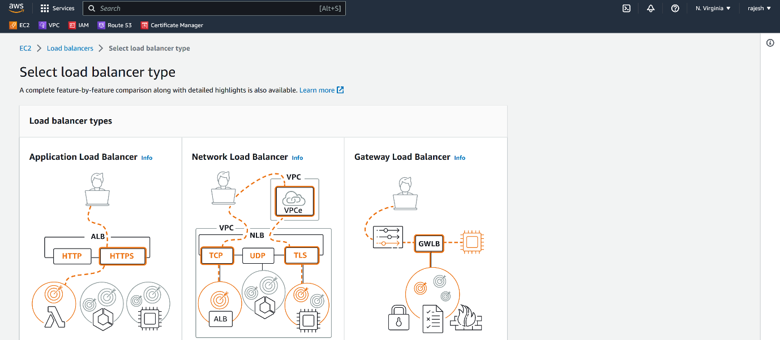

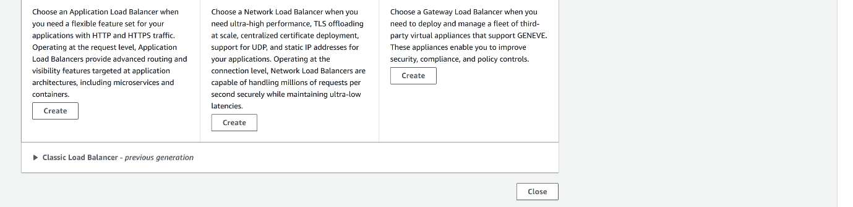

--- click on create network load balancer.

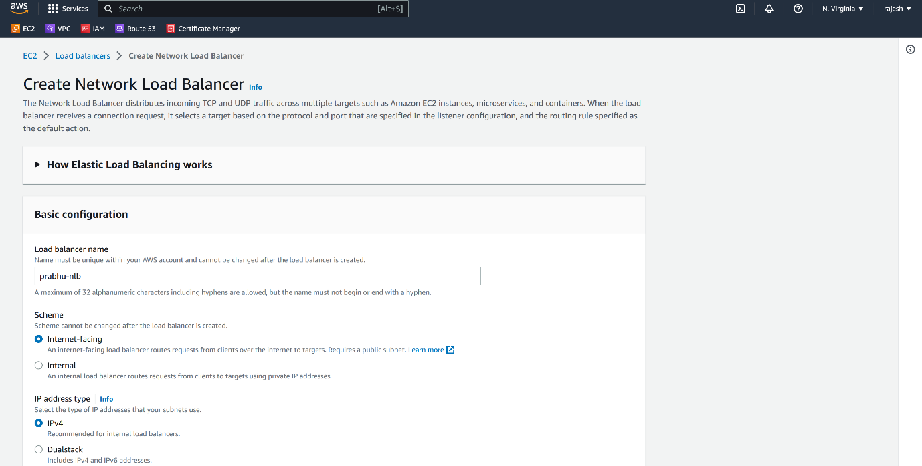

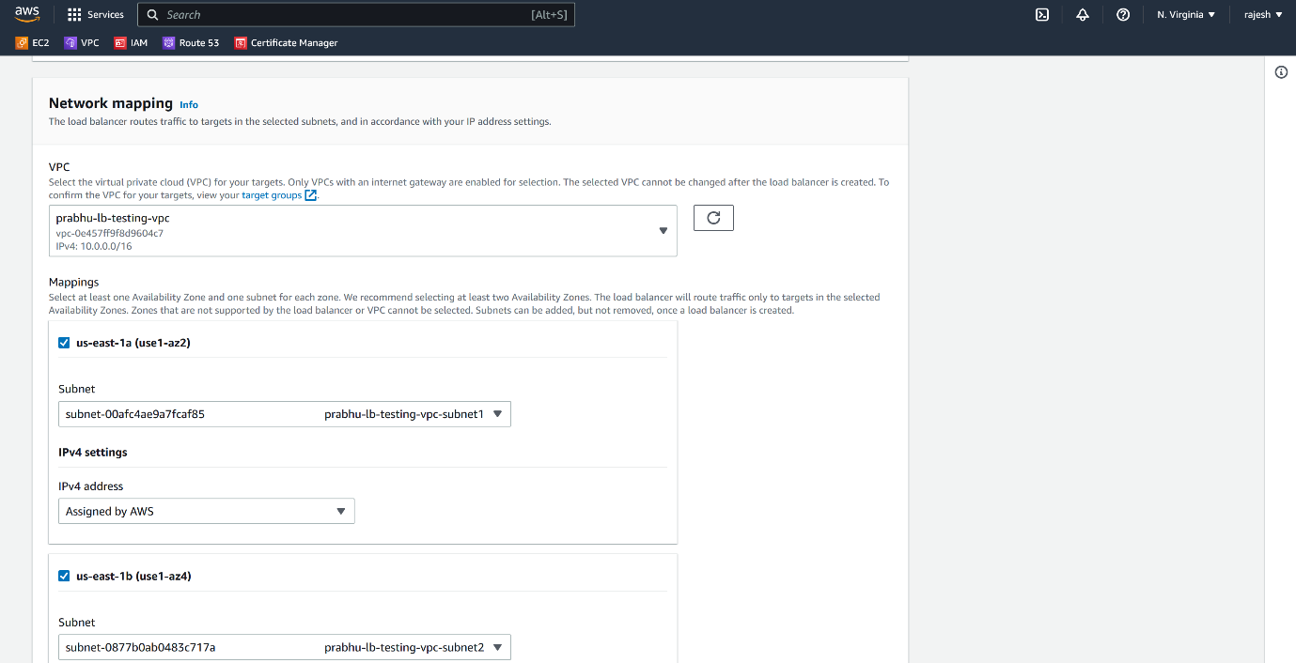

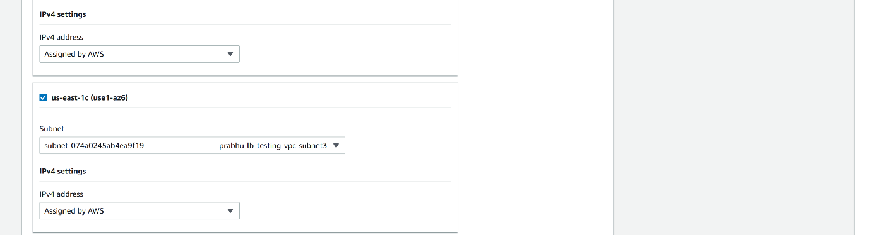

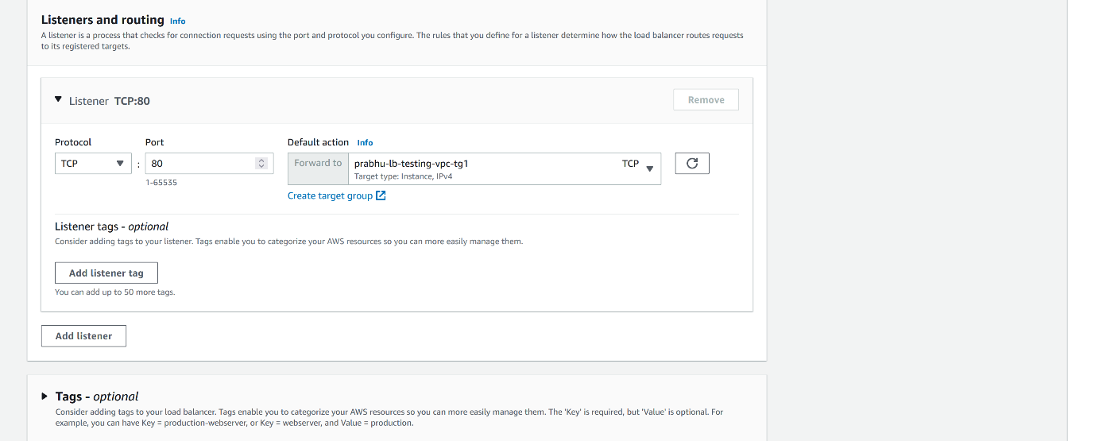

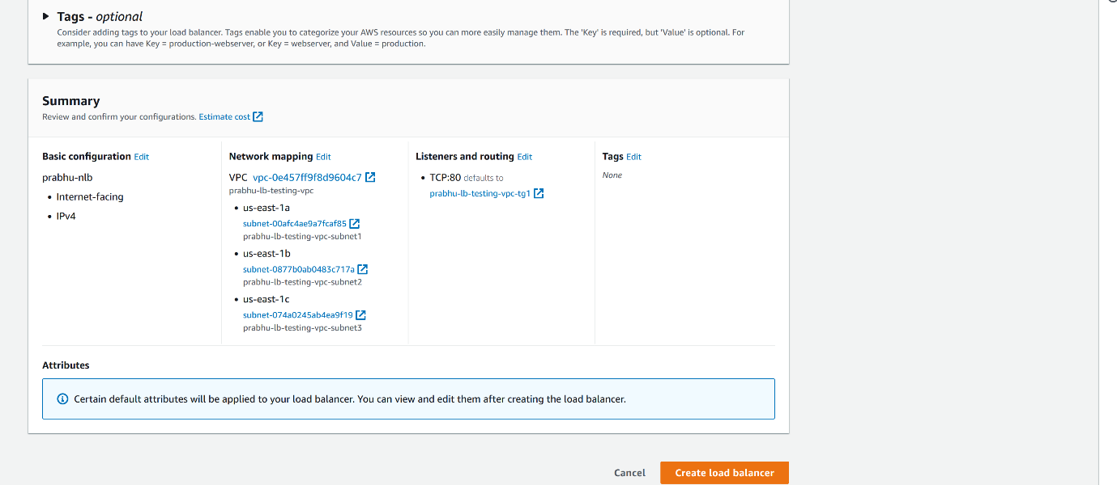

--- **note** – click on create load balancer then it will create load balancer for us.

**Add listeners to the load balancer**

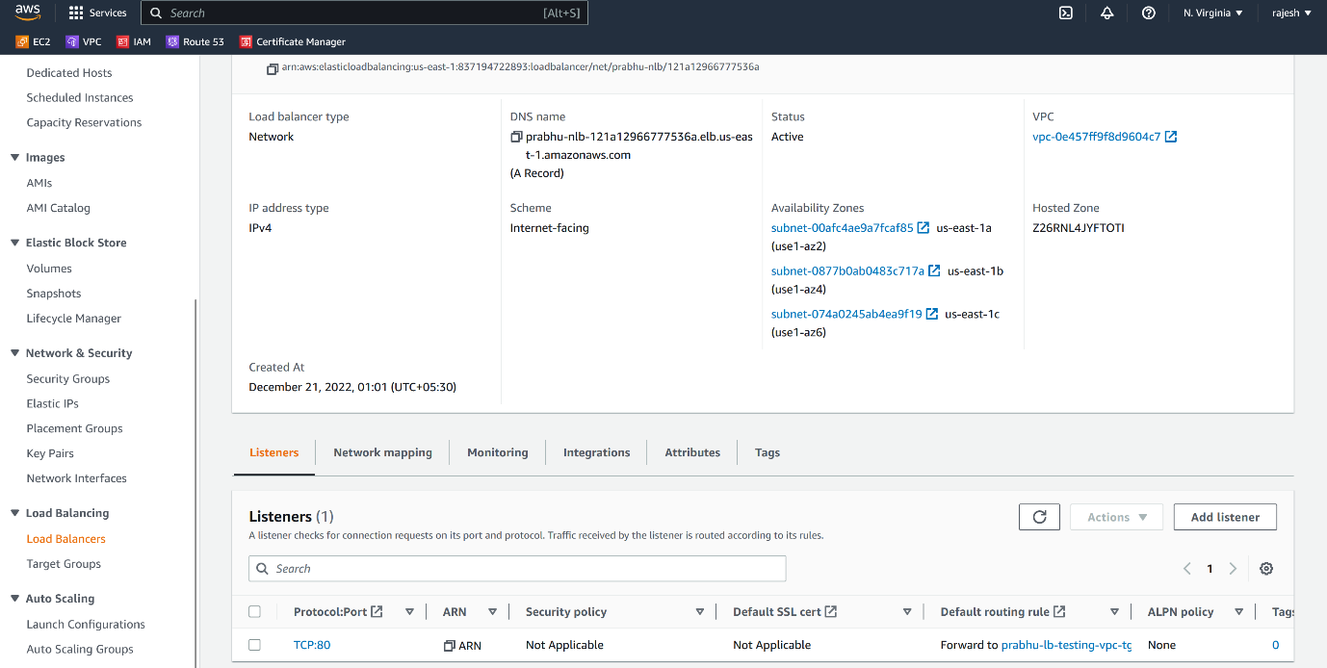

--- click on add listener.

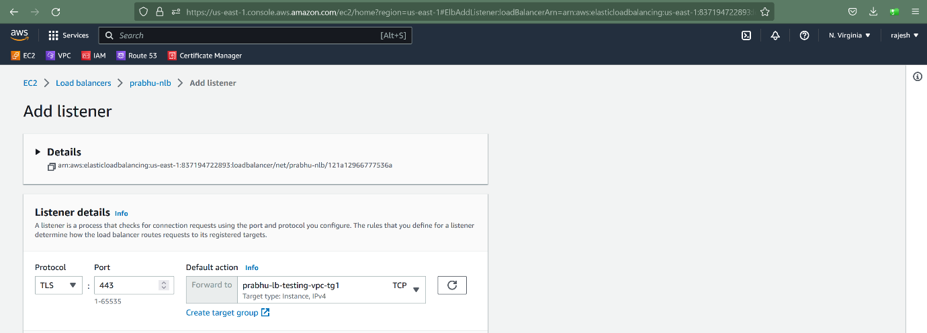

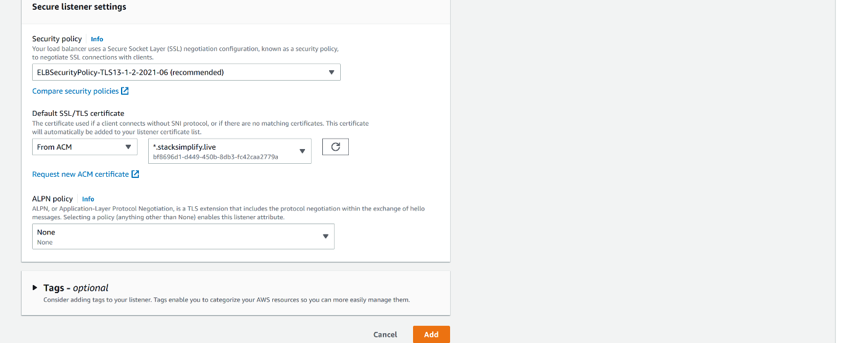

--- **note** – please select the TSL.

--- click on add.

**Add multiple target groups to the load balancer**

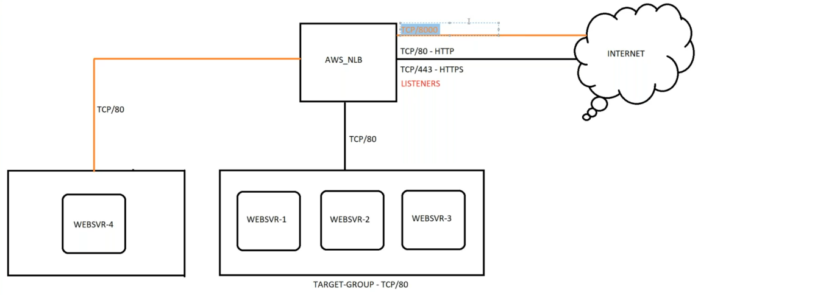

--- **note** – I have already used 80 and 443 for my first group so I cannot use this, instead I can create a listener with 8443 or 8000 and forward the request to the 2nd target group.

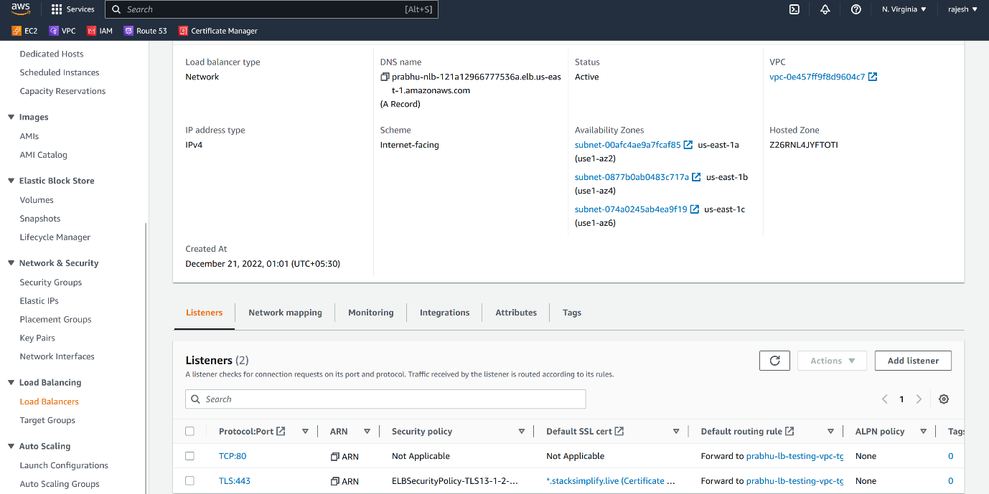

--- click on add target group.

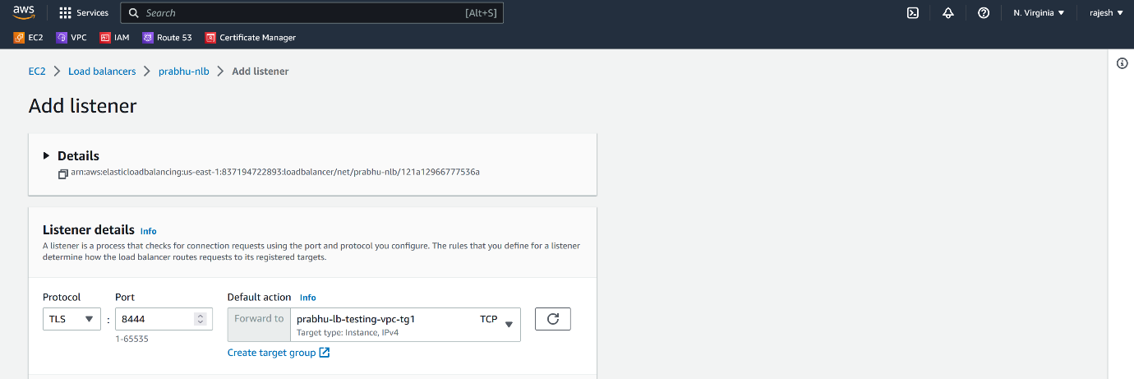

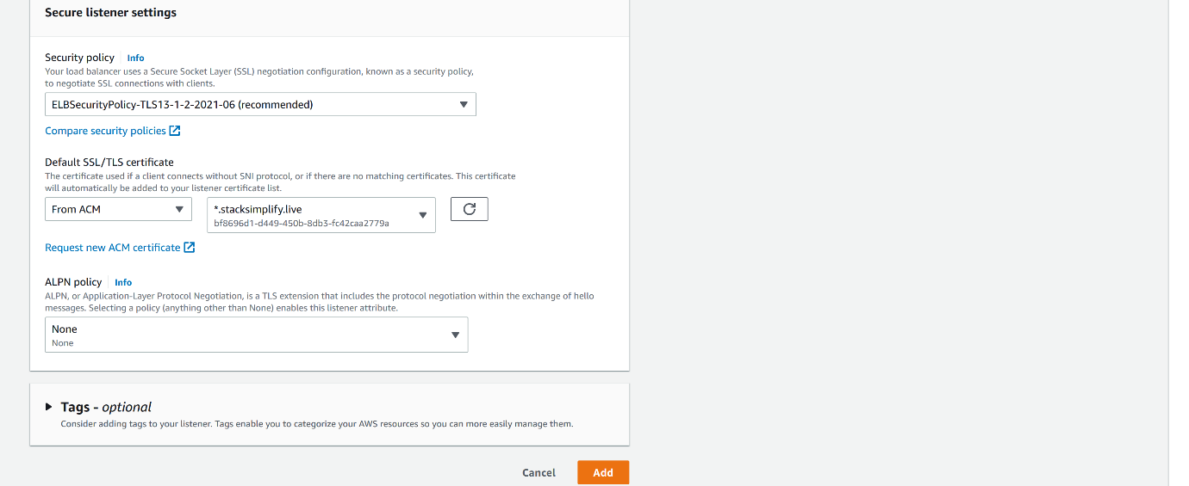

--- click on add

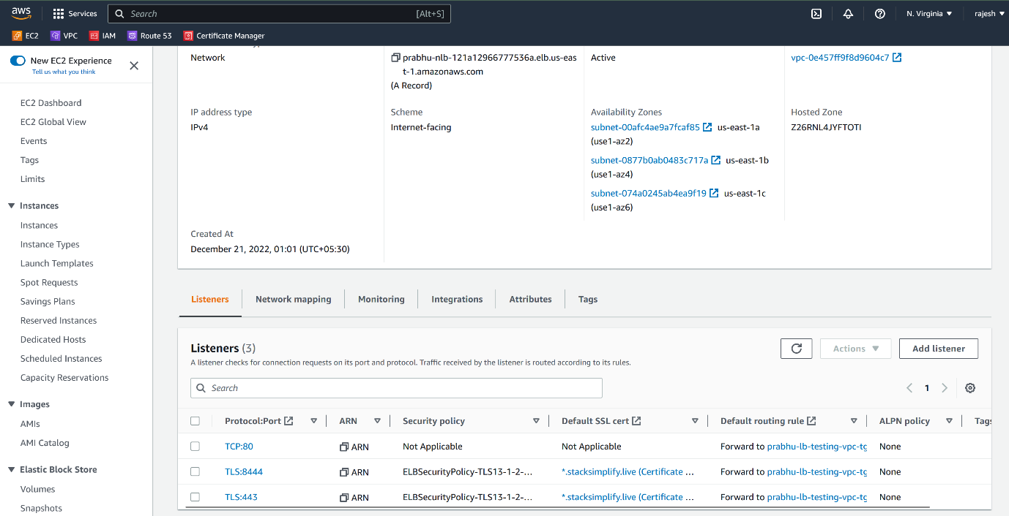

--- the listener is added successfully. Now copy the dns name of the load balancer and create a A record in the route53.