**19.AWS-B30-AWS-ApplicationLoadBalancers**

--- Application load balancer key points:

1. HTTP to HTTPS redirection.
2. URL or path-based routing to multiple target groups.
3. It is mainly for applications.

**Target group creating**

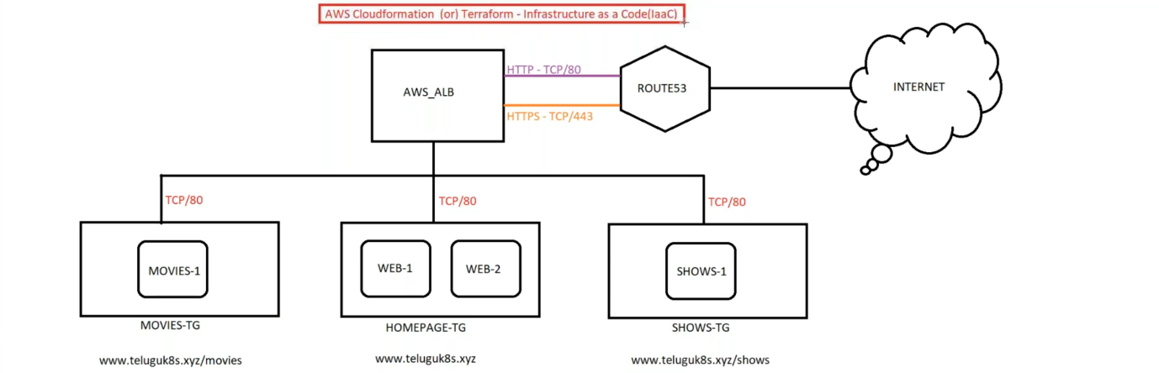

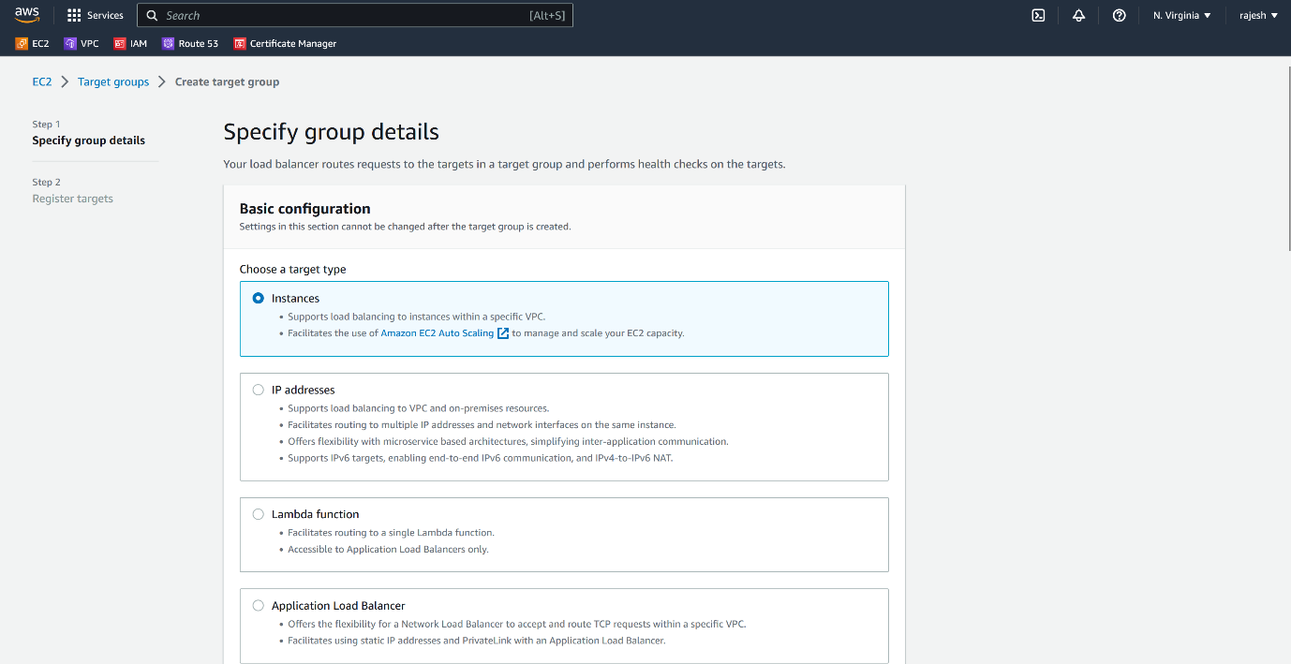

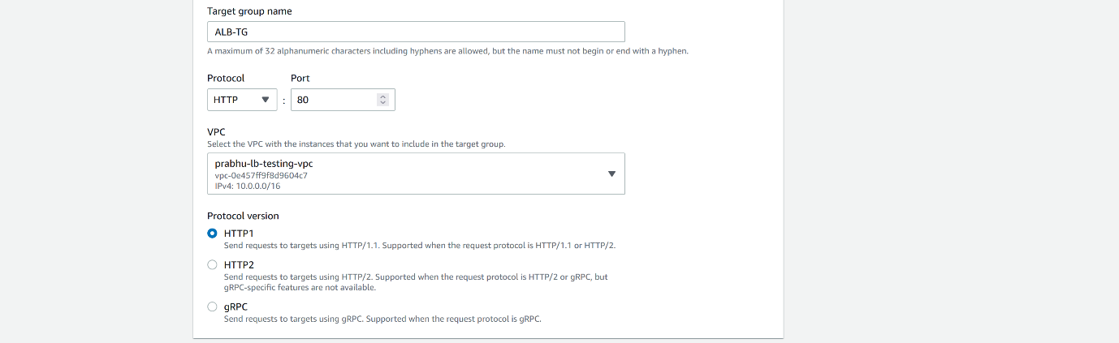

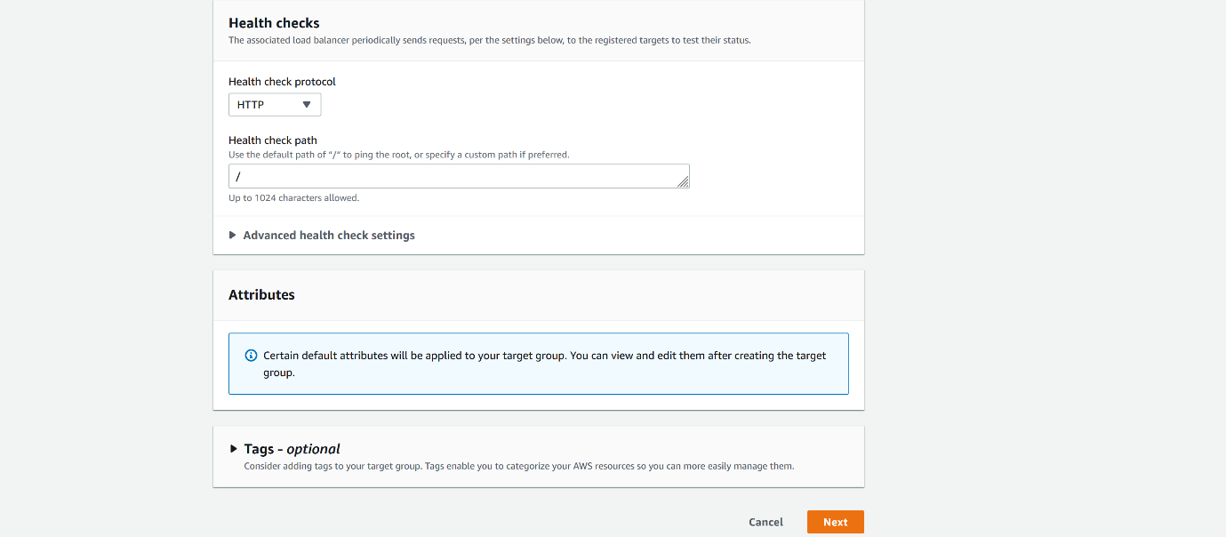

--- Click on next.

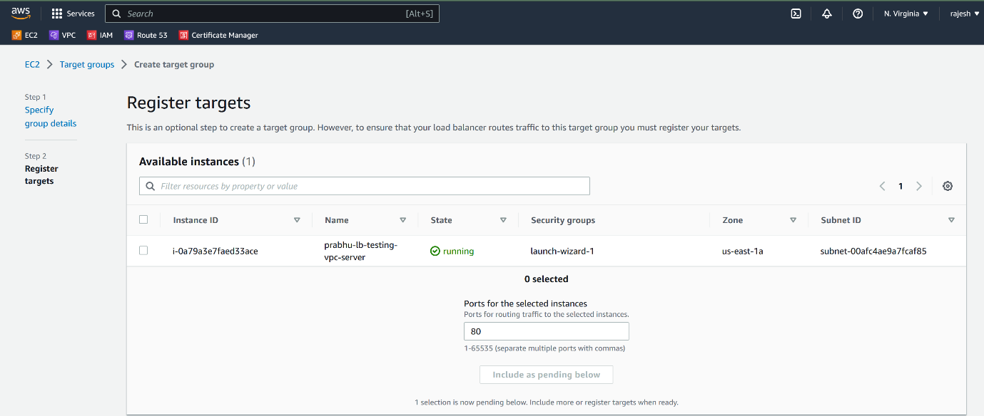

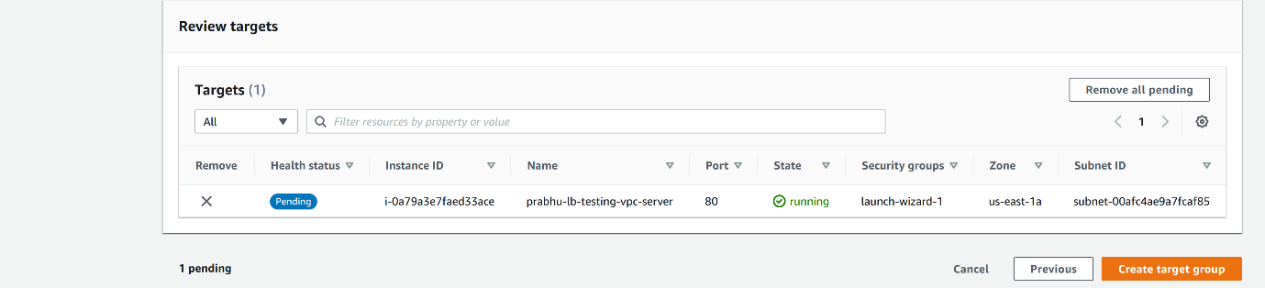

--- click on create target group.

**Application Load balancer creating**

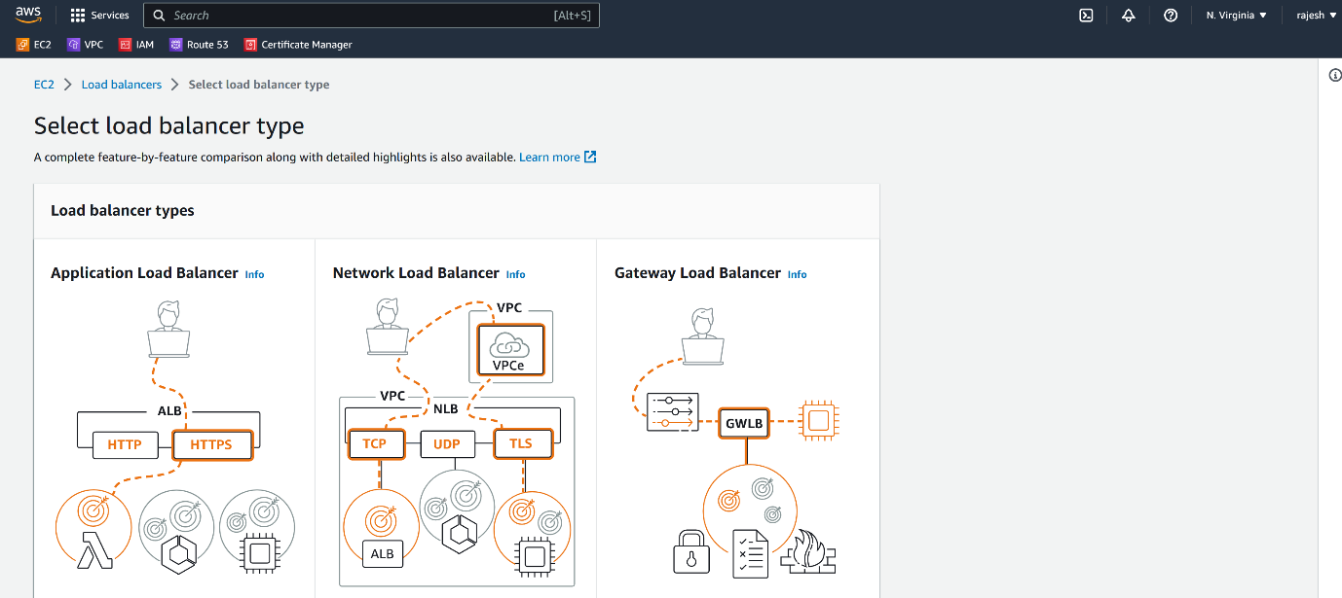

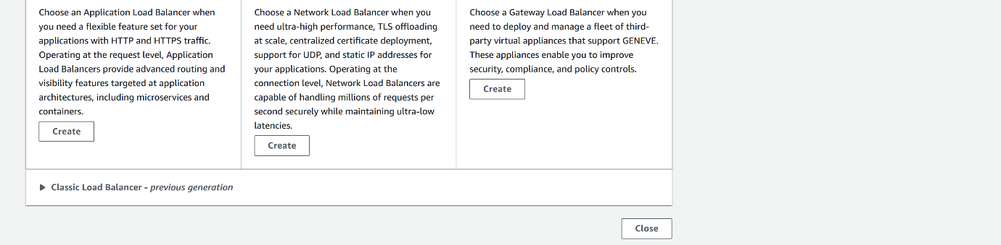

--- create Application Load balancer.

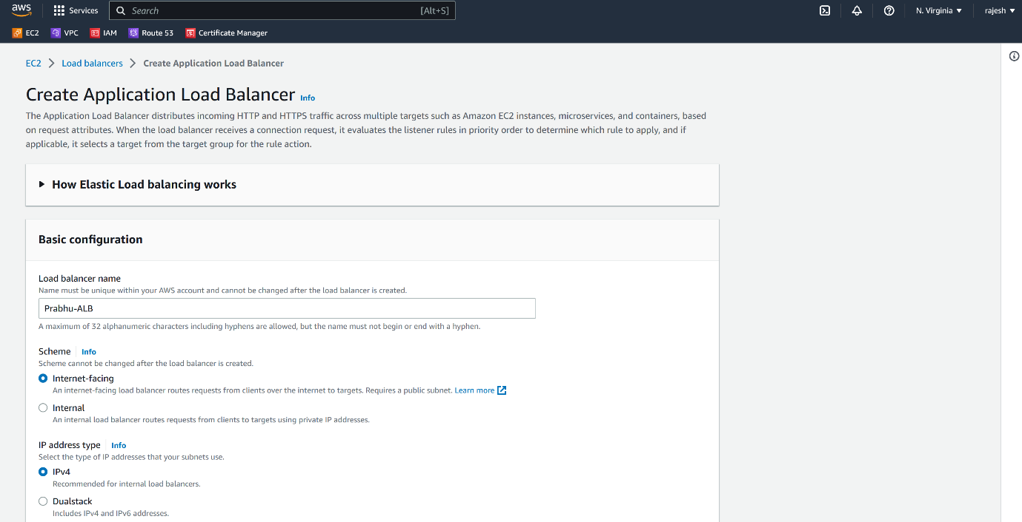

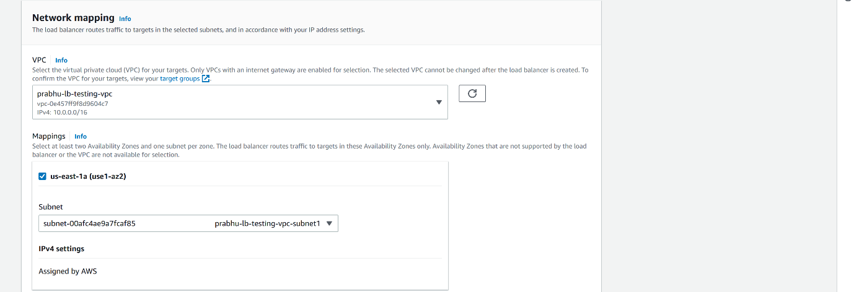

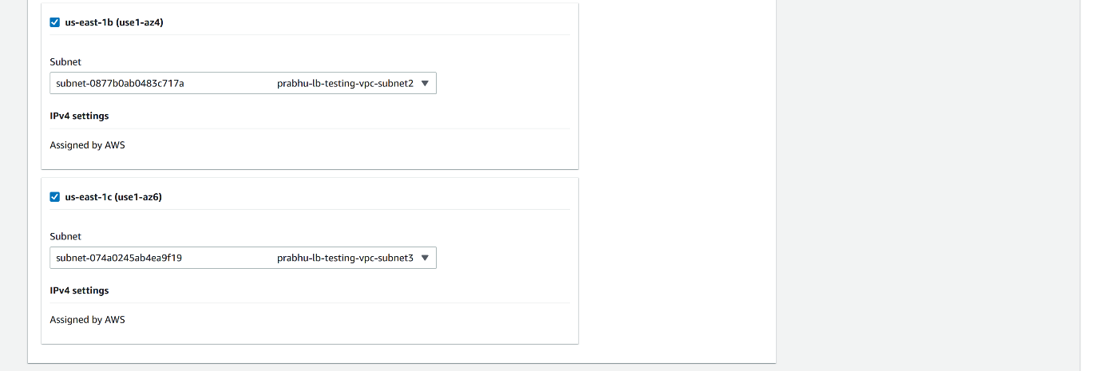

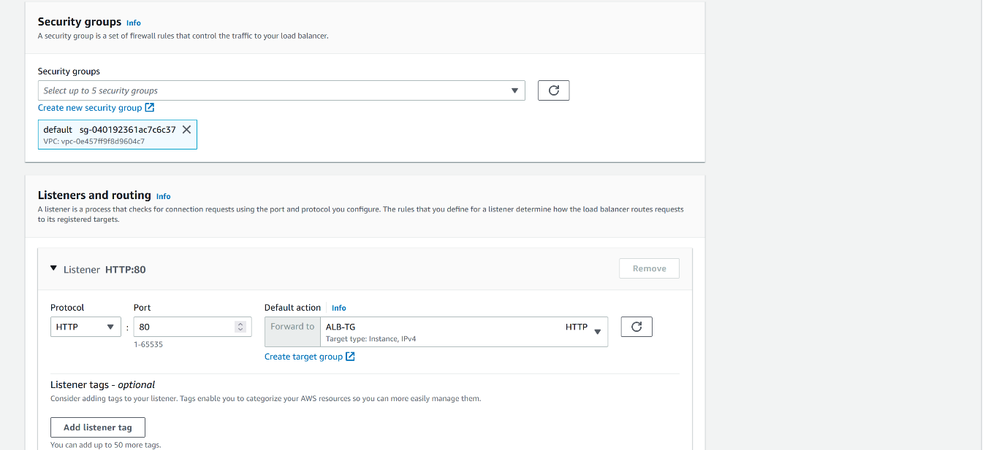

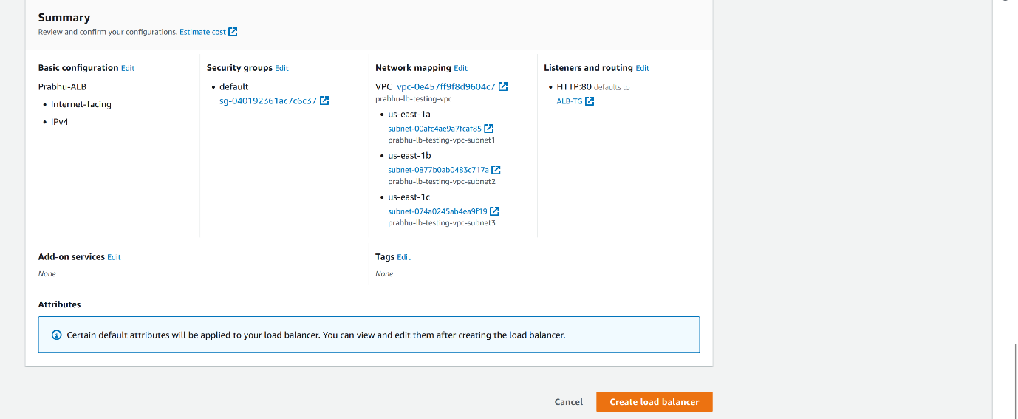

--- Click on create Load balancer.

**Add listener to load balancer**

--- click on the load balancer.

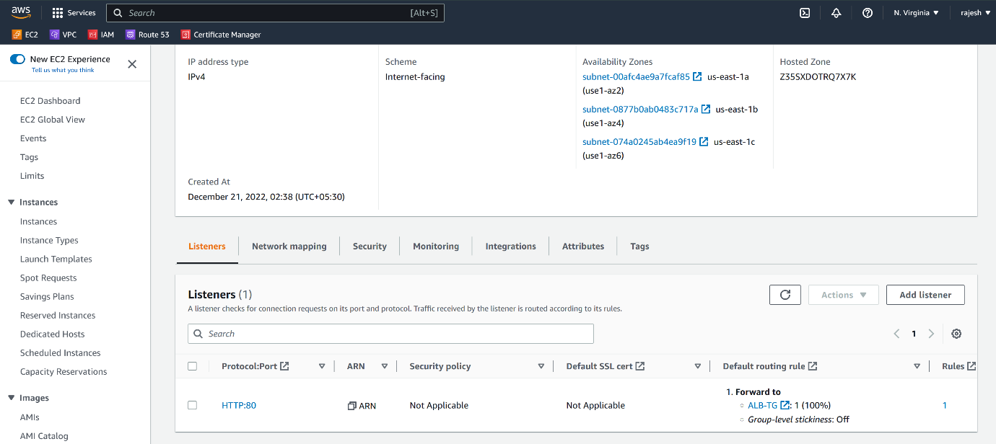

--- click on add listener.

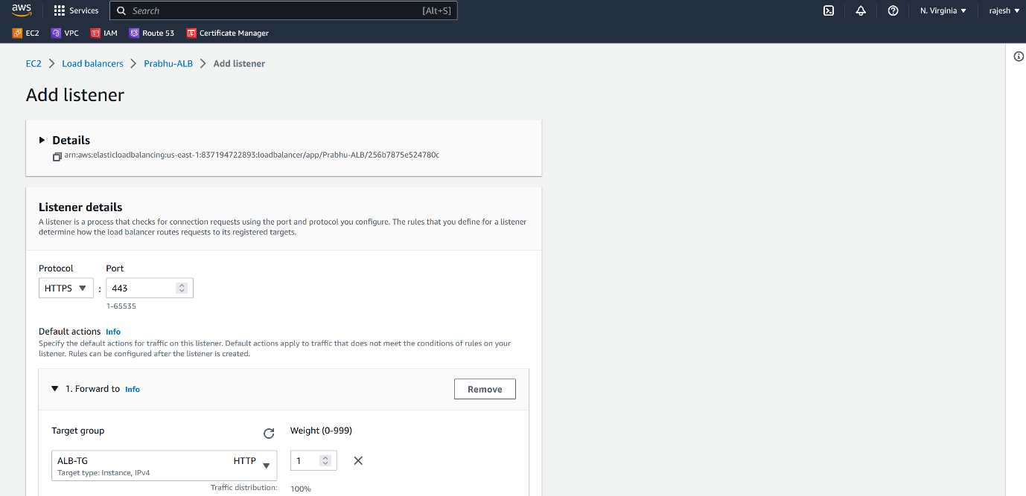

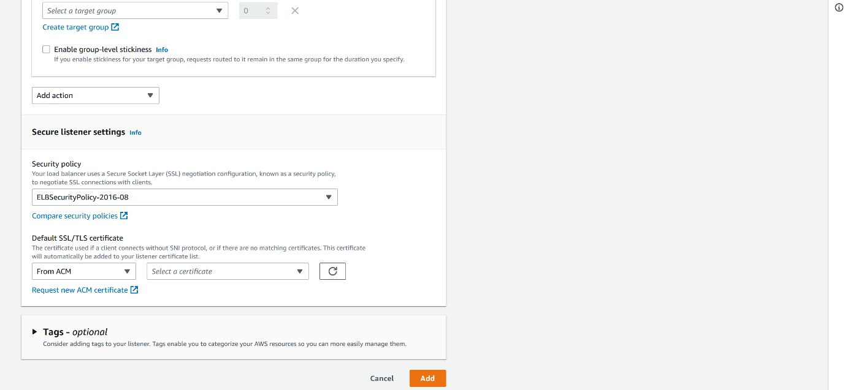

--- click on add.

**http to https redirection**

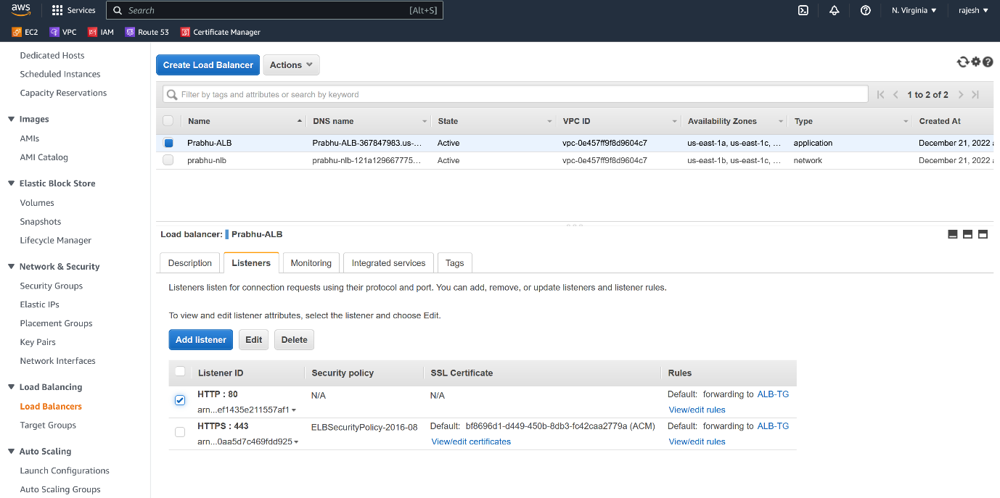

--- click on view and edit rules.

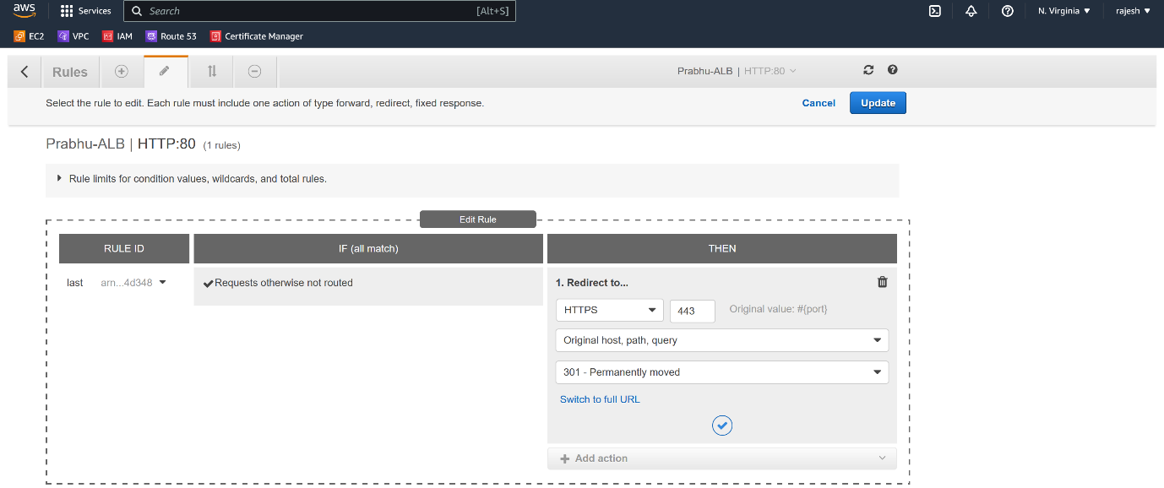

--- click on right icon.

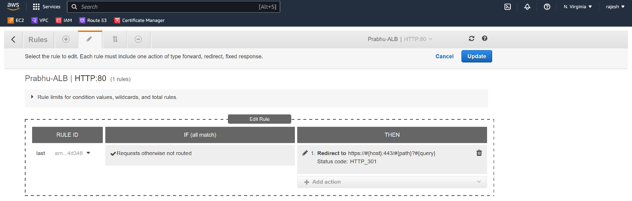

--- **note** – now we successfully redirected from http to https.

**Allow 80 and 443 in application security group**

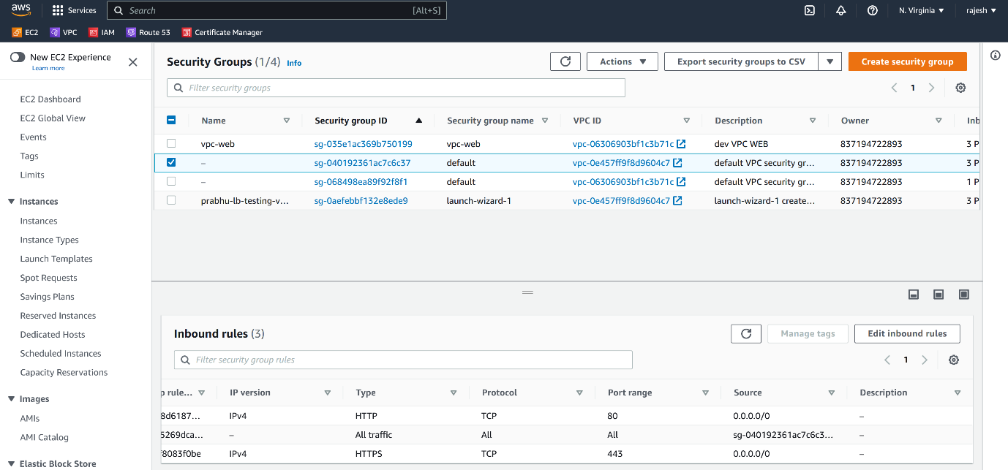

--- **note** - here I am allowing http and https ports in application security group. If you opened another port in listeners then please open that port in application load balancer group as well.