**33.AWS-B30-RDS-MySQL**

--- **note** – we will create RDS -> MYSQL multi-AZ database.

--- we will db in multiple availability zones.

**RDS Architecture**

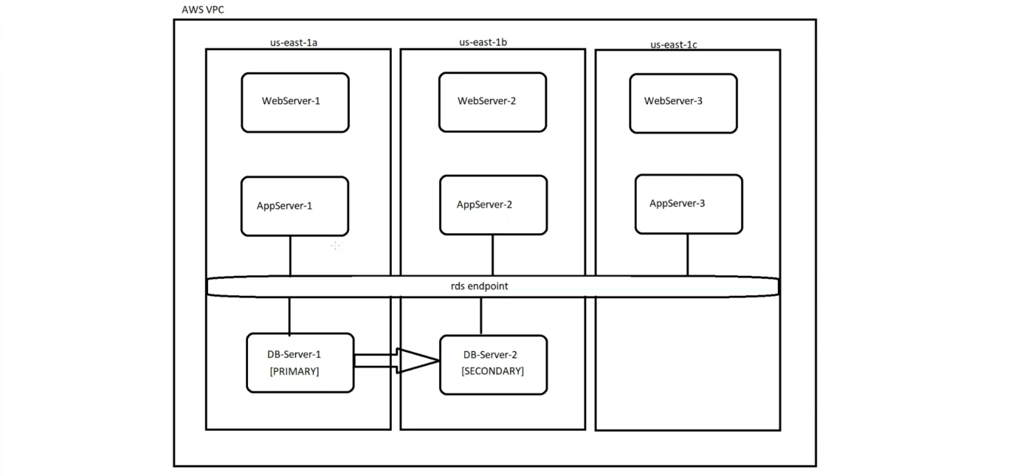

--- I will deploy the RDS in multi az. It will be deployed in 2 availability zones.

--- the request will come from webservers to app servers and from app server, the request will go to the primary db server. The primary server will sync data to secondary db server.

--- **note** – if something happened to primary server then aws will route the traffic to secondary server.

**AMAZON RDS Creating**

--- go to amazon RDS.

**Subnet groups creating**

--- click on subnet groups

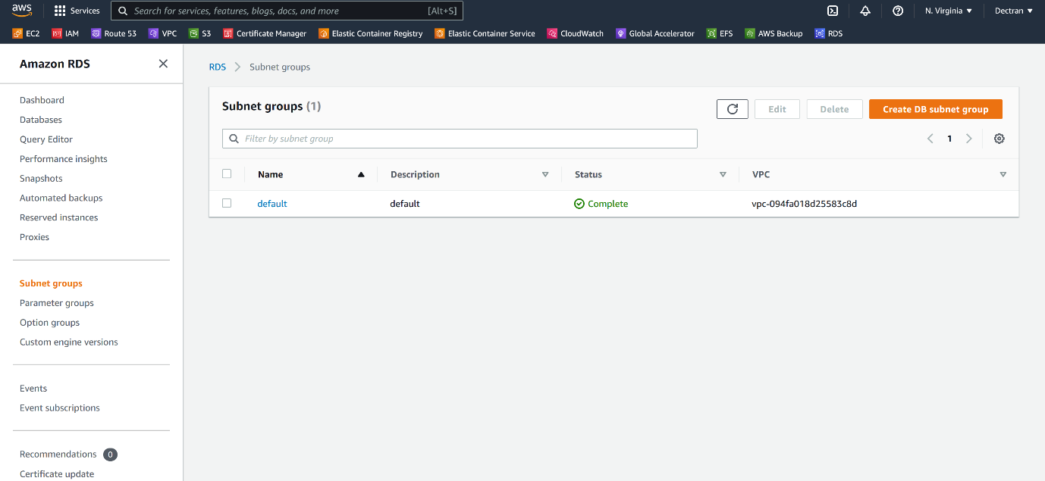

--- click on create DB subnet group.

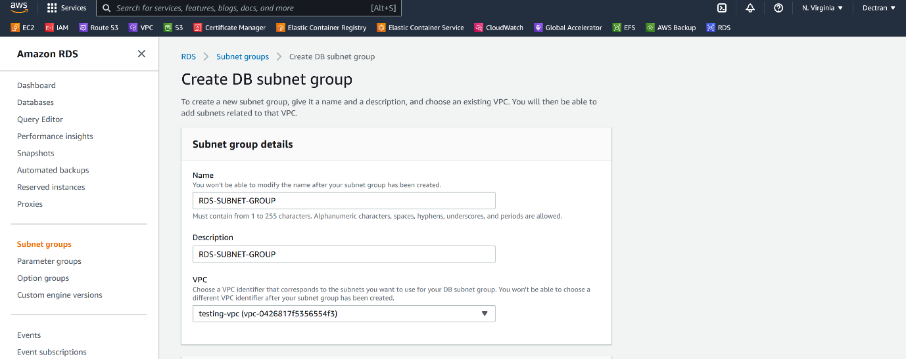

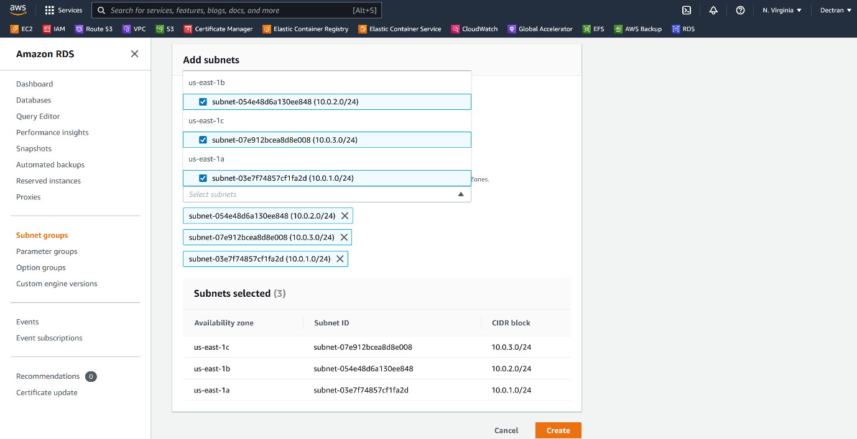

--- click on create.

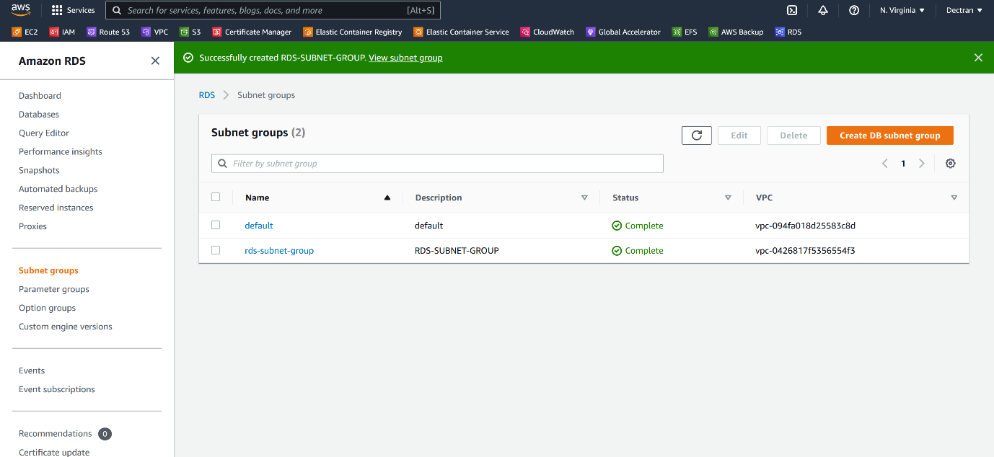

--- subnet groups created.

**Create RDS**

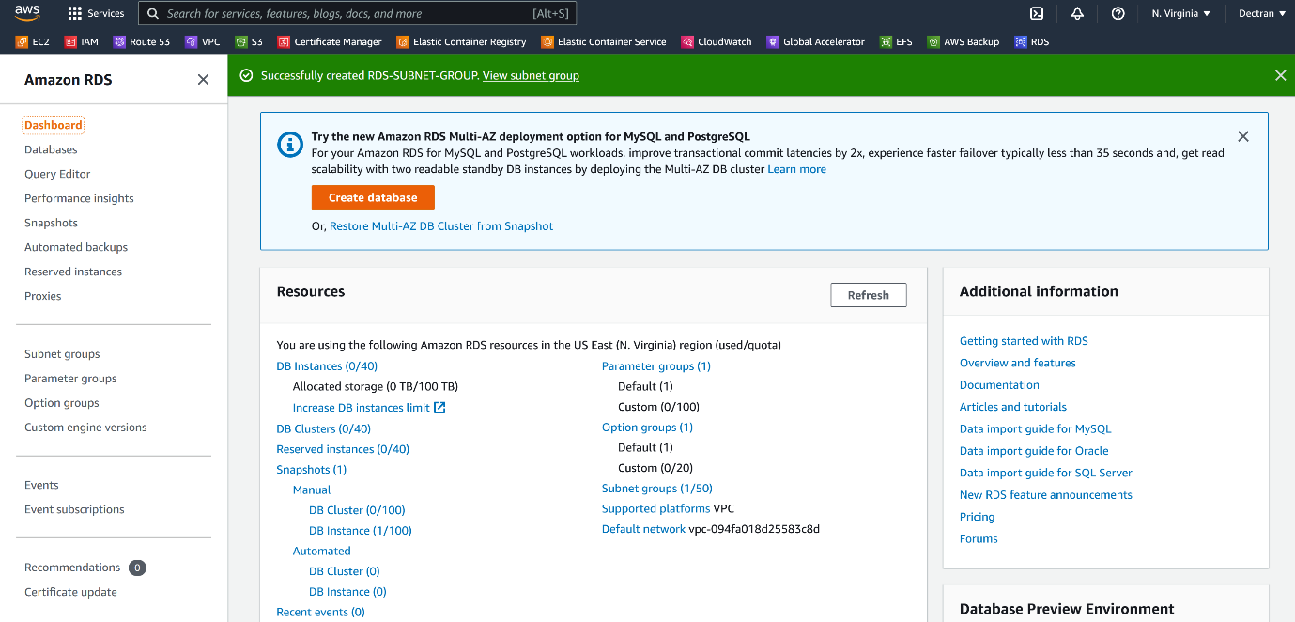

--- click on create database.

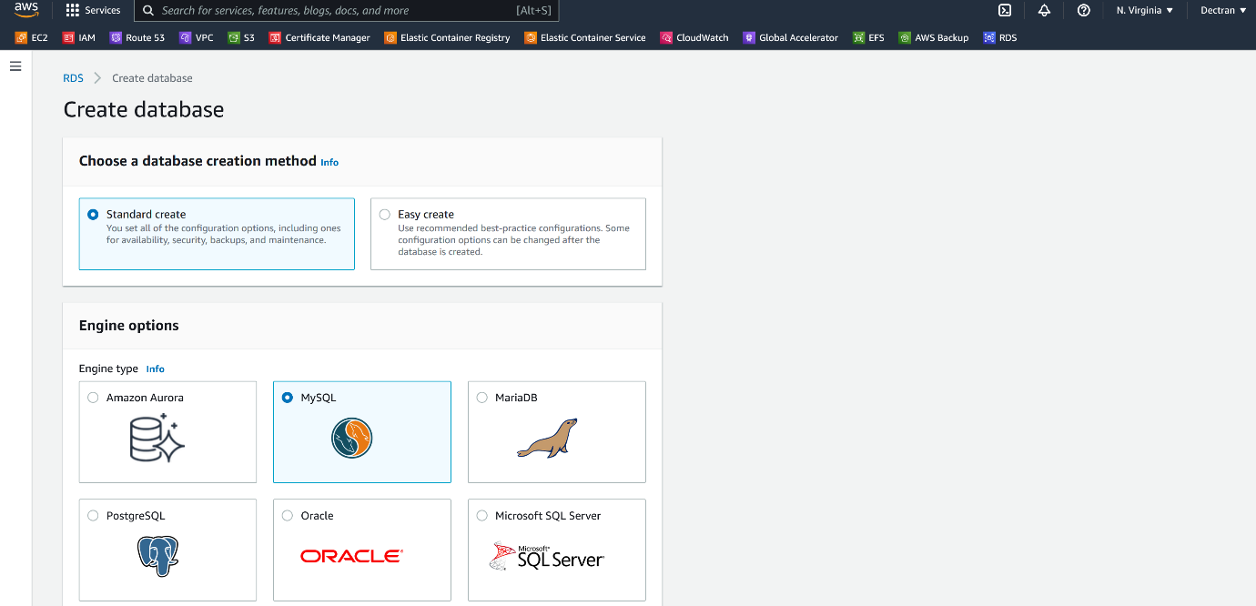

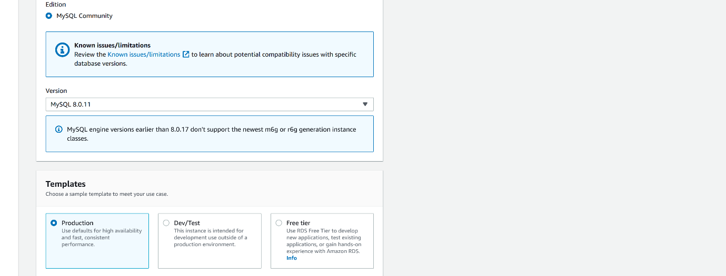

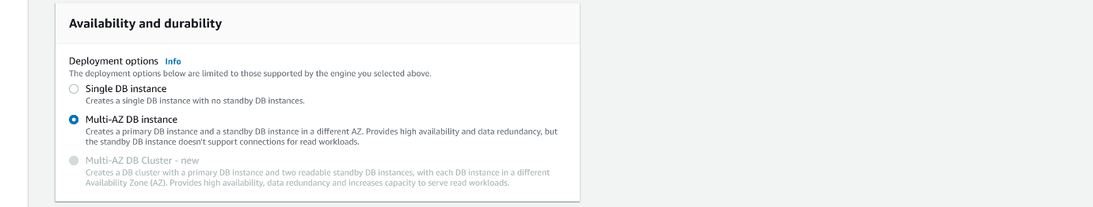

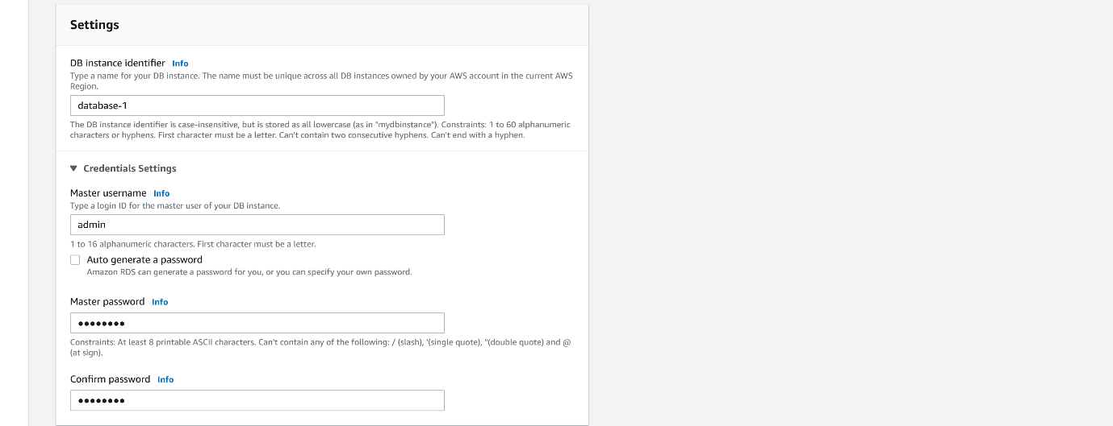

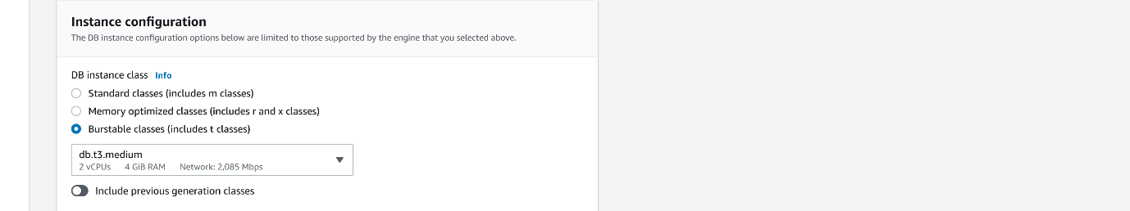

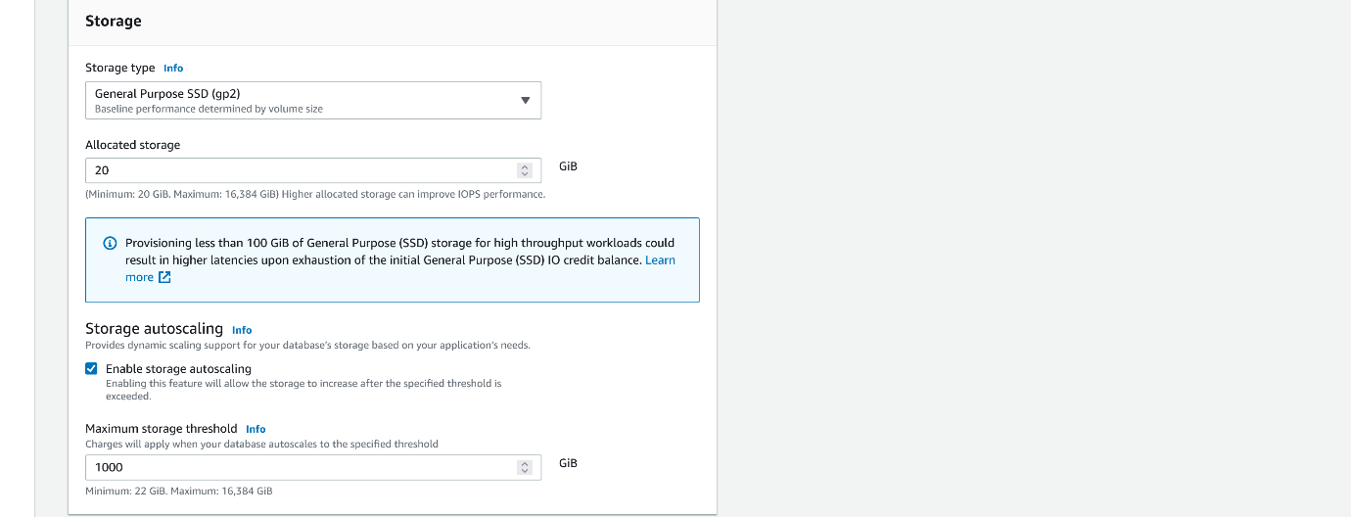

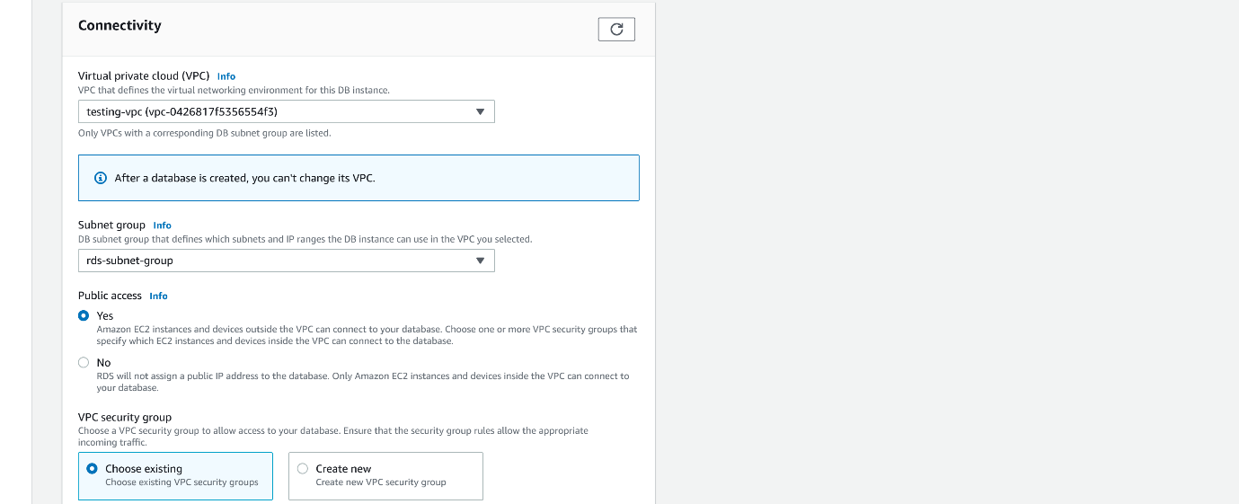

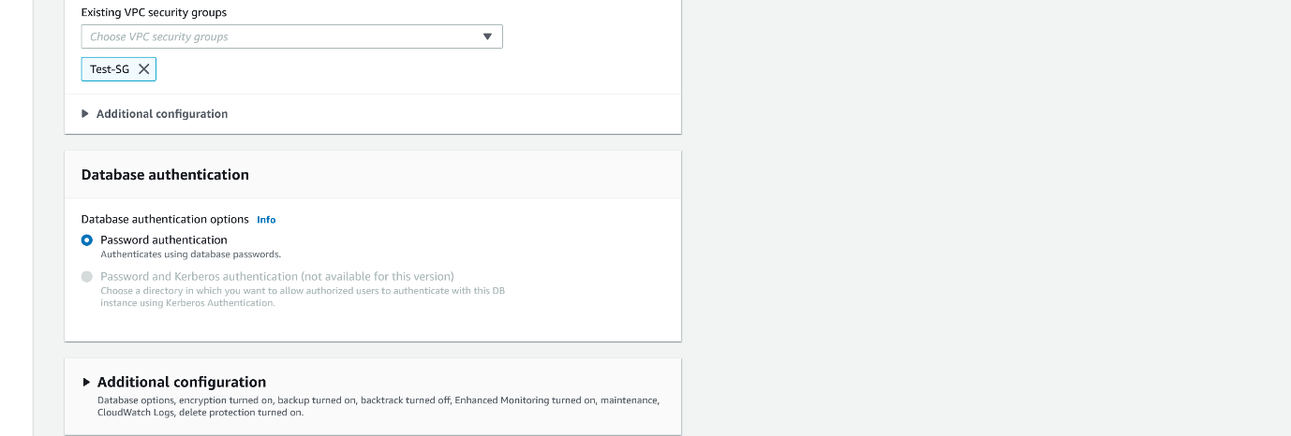

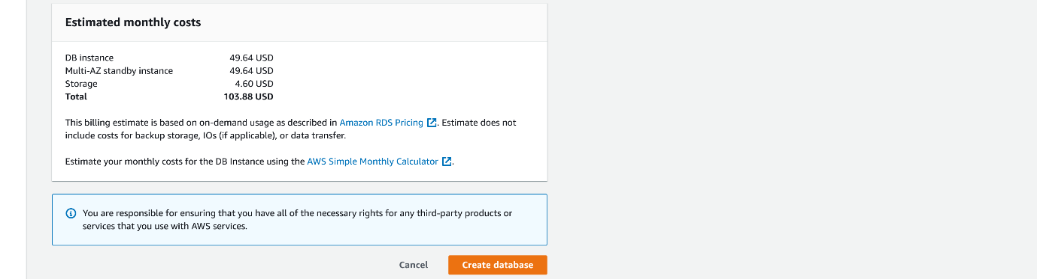

--- click on create database.

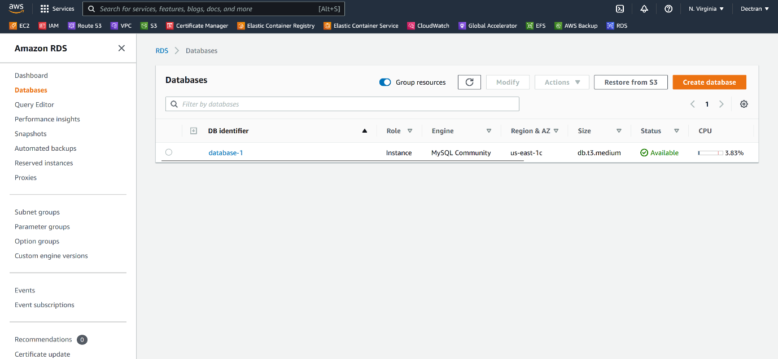

--- our db is created. Click on db name.

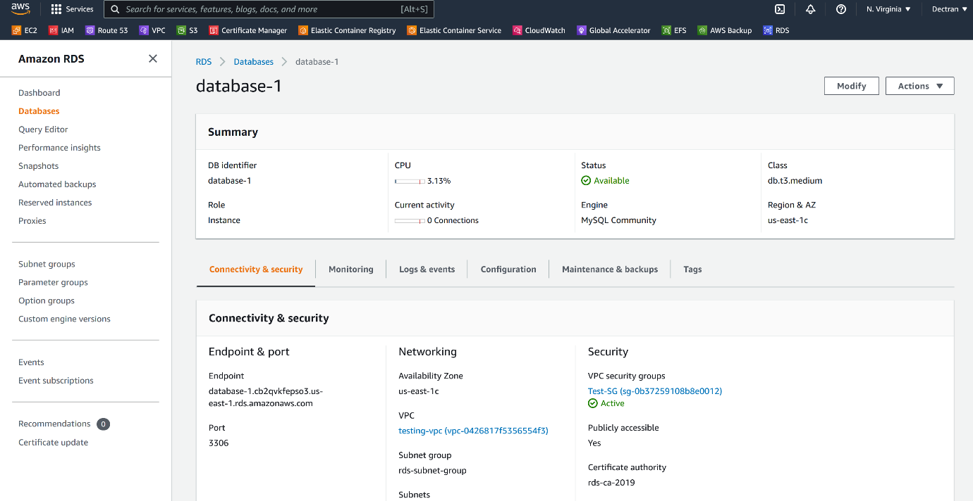

--- click on configuration.

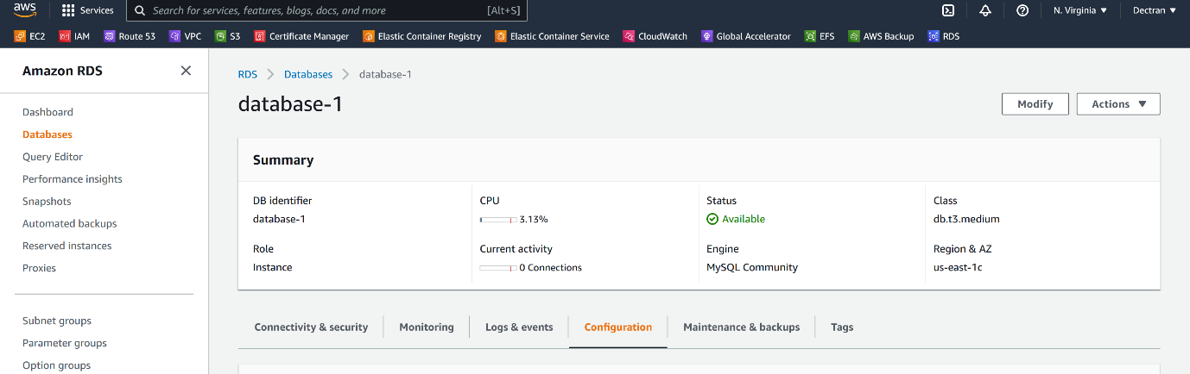

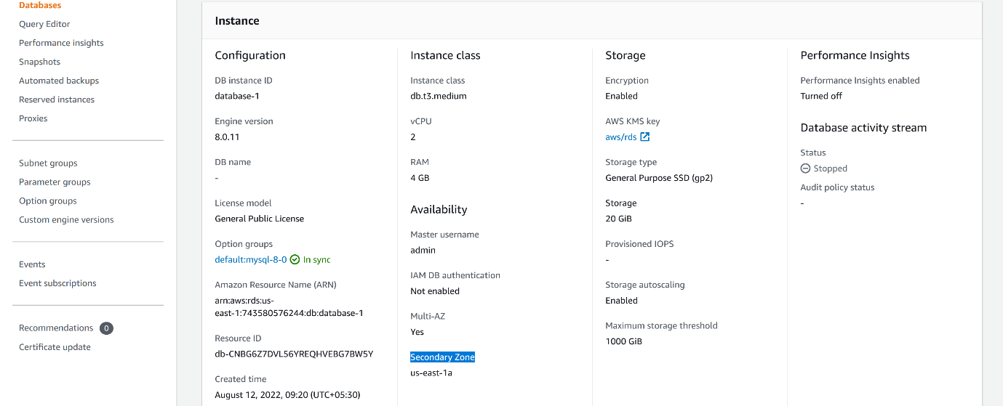

--- **note** – the db is deployed in multi available zones. The primary zone is us-east-1c and the secondary zone is us-east-1a.

**Connecting amazon mysql db**

**prerequisites**

# Install Microsoft .NET framework

--- <https://dev.mysql.com/downloads/workbench/>

# Install Microsoft Visual C++ Redistributable

--- <https://aka.ms/vs/17/release/vc_redist.x64.exe>

# Download mysql work bench

--- <https://dev.mysql.com/downloads/workbench/>

**Connecting to amazon RDS using mysql bench**

--- open mysql work bench

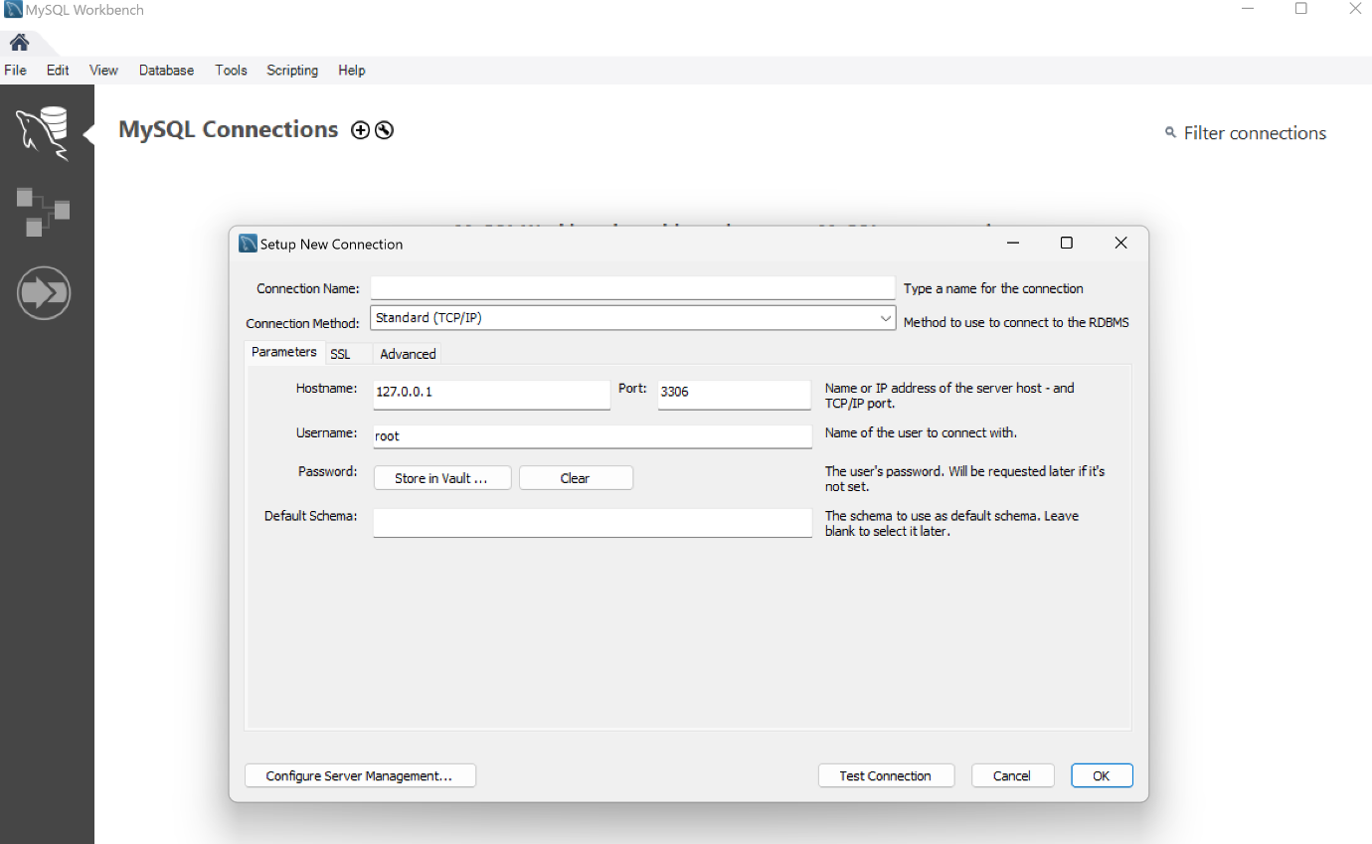

--- give the connection details.

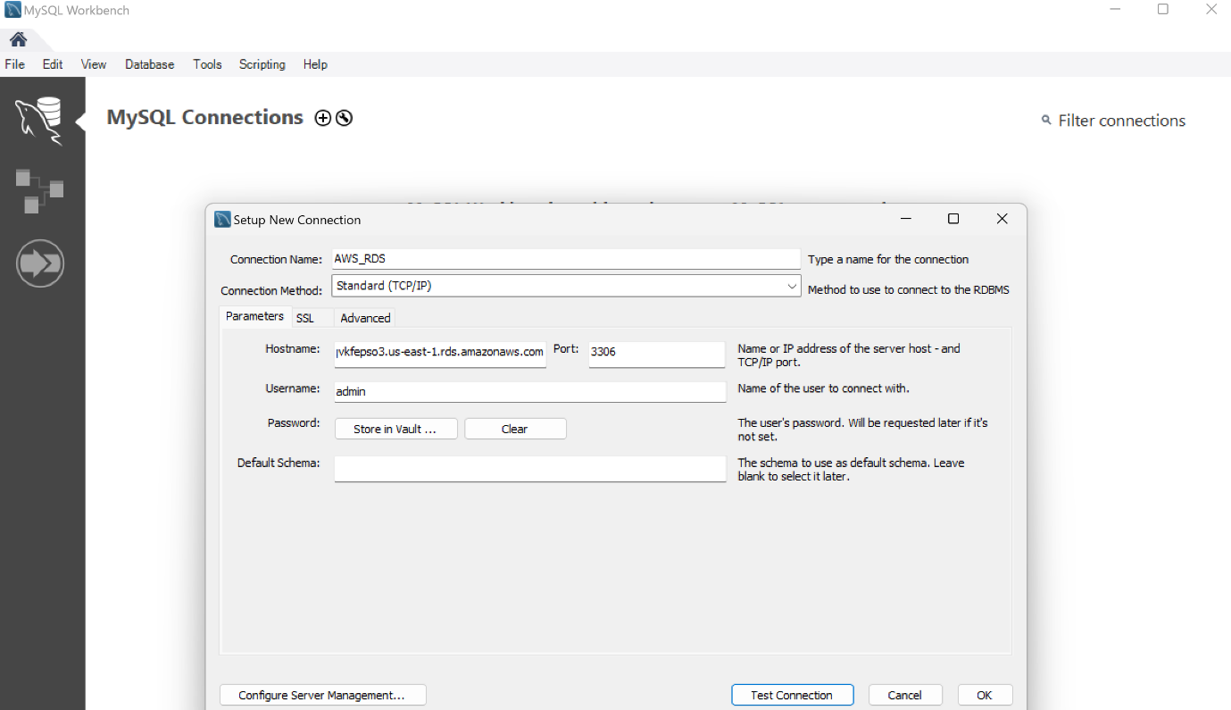

--- now I have given the connection details. Click on test connection.

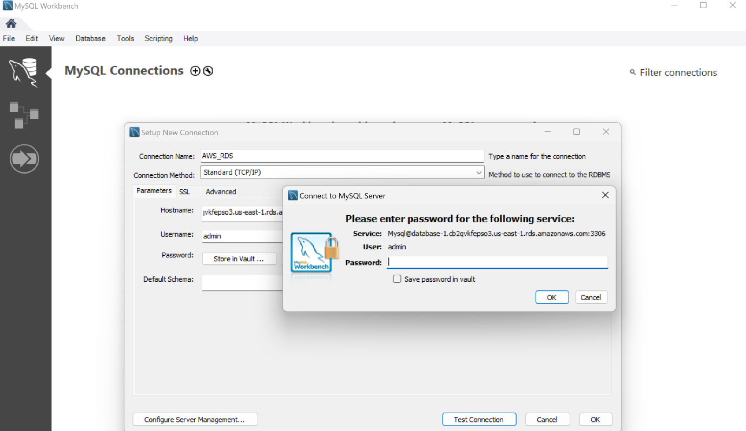--- now enter the password and click on ok.

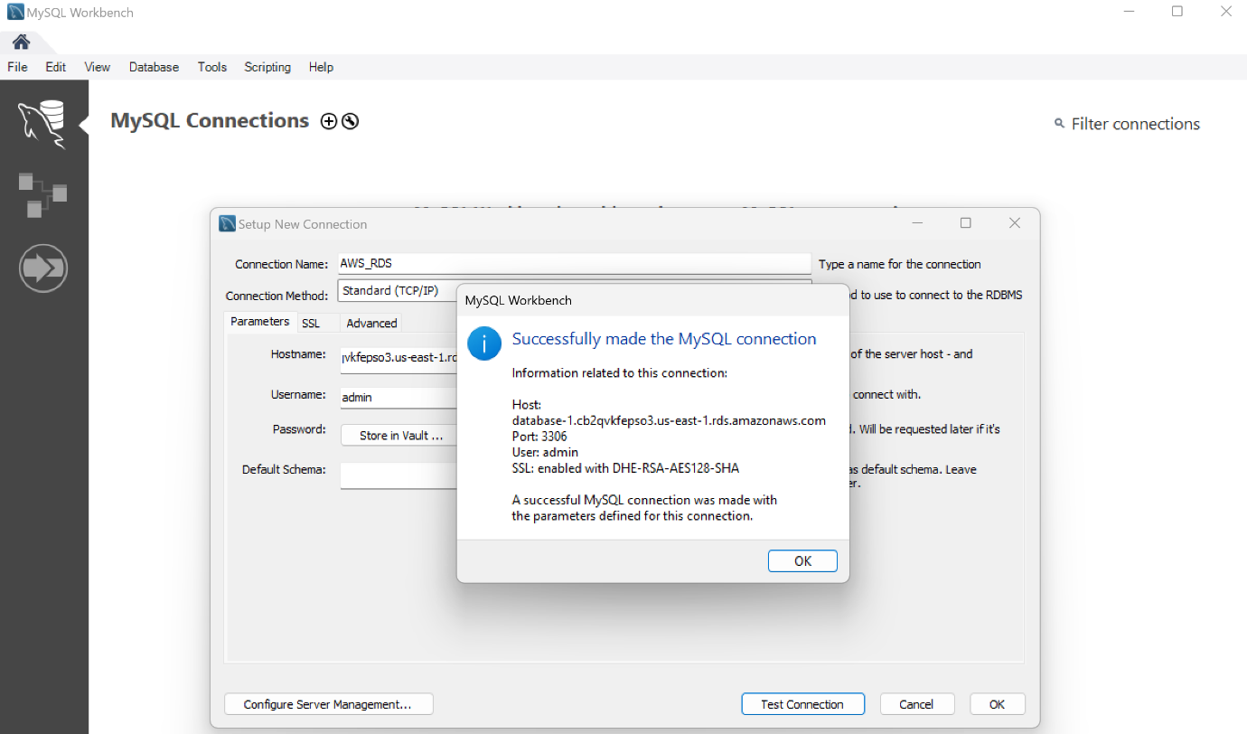

--- **note** – now the connection successfully established. Now click on ok.

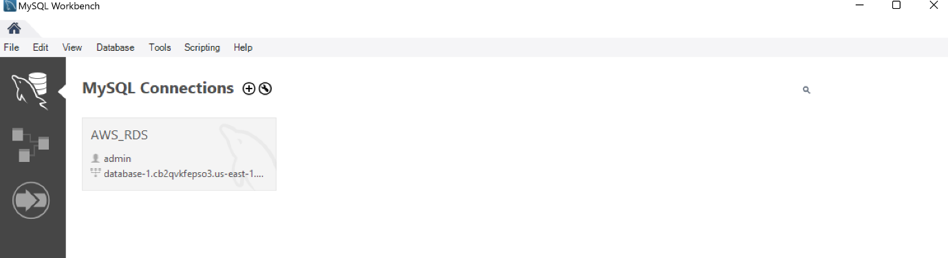

--- click on db to get inside of the db.

**DB failover architecture**

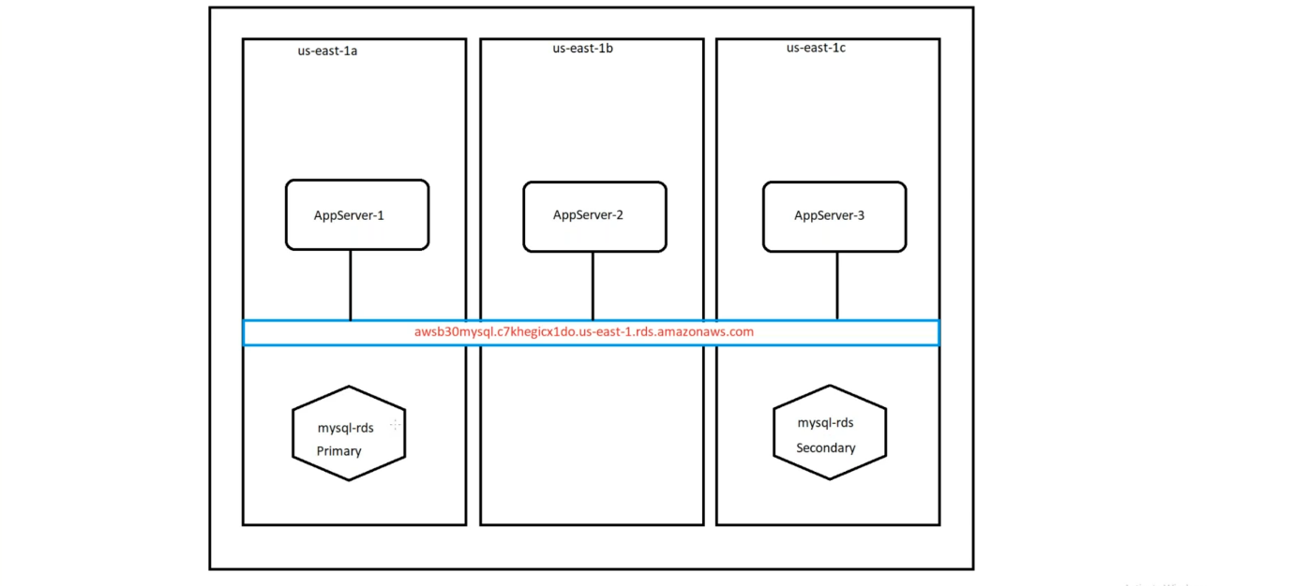

--- **note** - our application is deployed in 3 availability zones, all our applications are connected to db endpoint. The traffic from applications is routed to primary mysql-db if something happened to mysql db then the secondary db promoted to primary db and it will create another copy of itself in another availability zone.

--- the newly promoted db available to applications in 2 minutes and server the traffic request form applications.

**Create read replica**

**Read replica architecture**

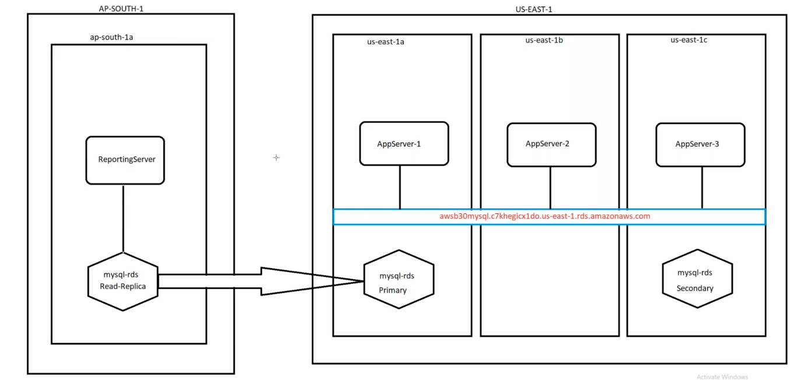

--- **note** – I am going to create read replica in another region,

--- **scenario-1** – if you want to write some data to primary db using some Reporting server then our primary db under stress because it is already serving traffic to our application and needs to do another work. In this case we will create read replica of our primary db in another region and we write the data to this read replica. In the backend read replica db data will be synced to primary mysql db.

--- **scenario-2** – testing wants to do some test on our primary db then we cannot allow them to do test our db so in that case also we will create a read replica of our db.

--- go to the primary db.

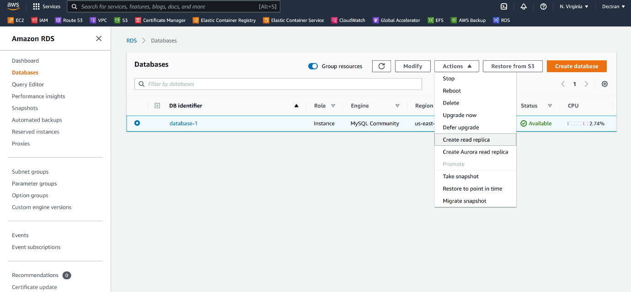

--- click on create read replica.

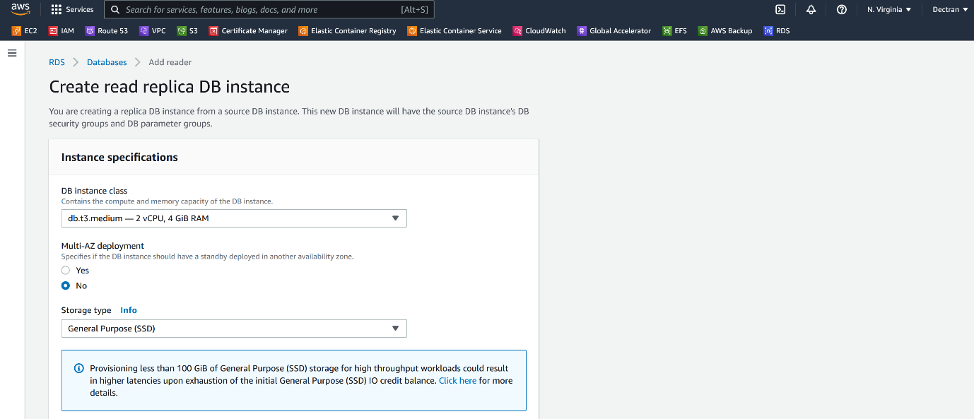

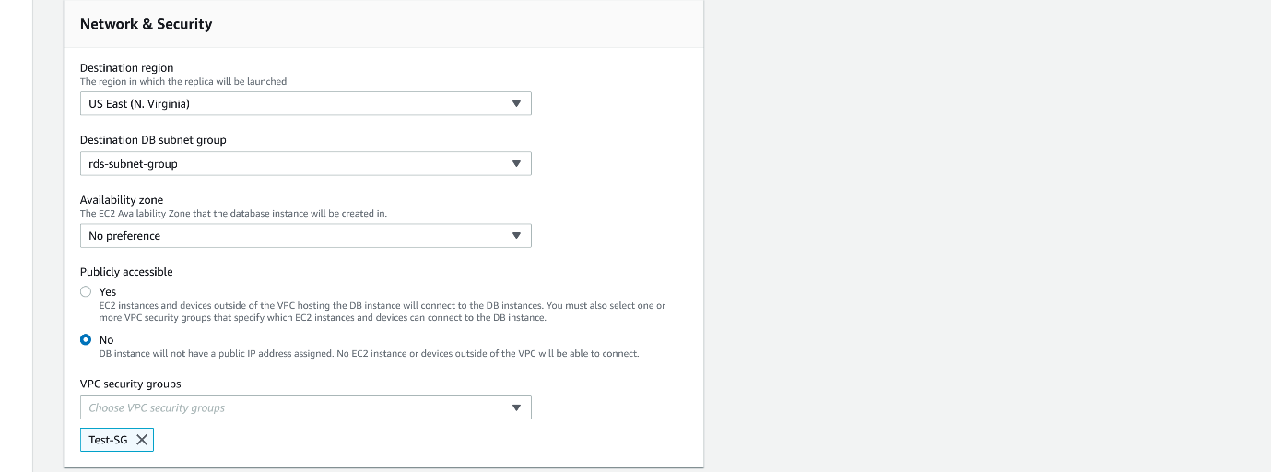

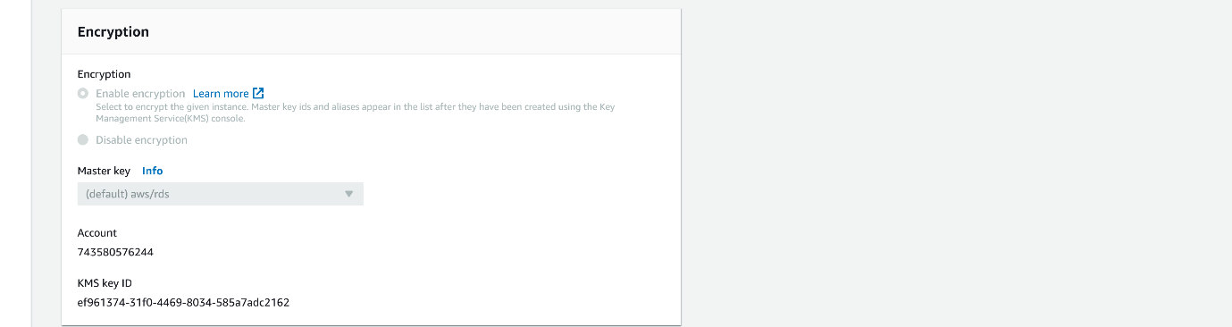

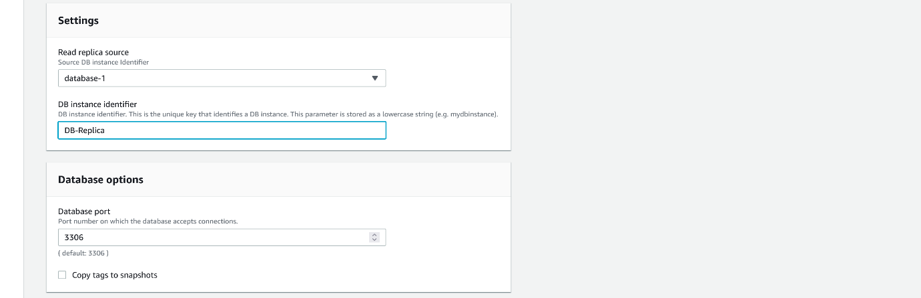

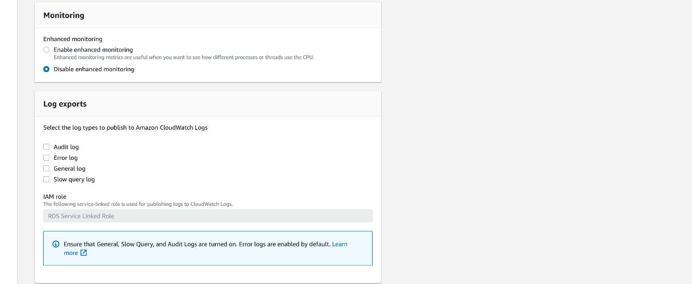

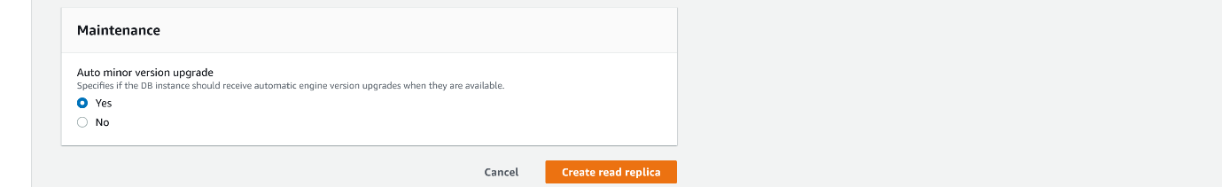

--- click on create read replica.

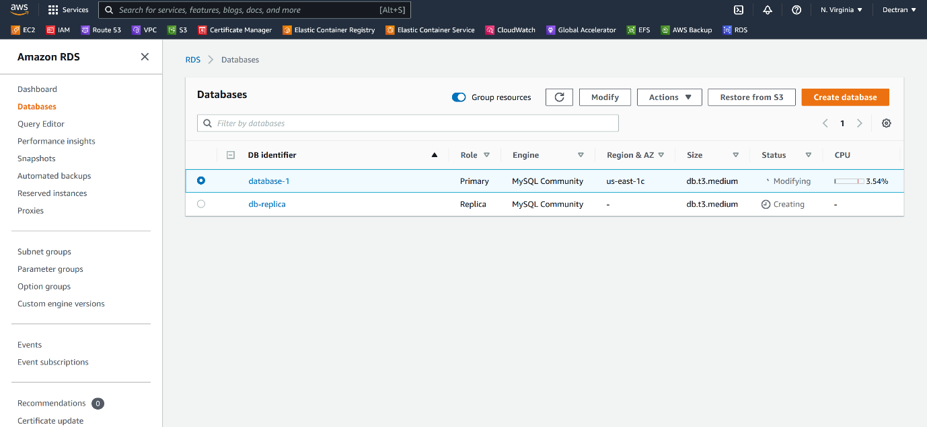

--- our read replica got created.