**42.AWS-B30-Fargate-EKS**

--- Fargate json profiles Reference - <https://github.com/aws-samples/aws-containers-task-definitions/tree/master/nginx>

--- click on the nginx_fargate.json.

**Fargate cluster creating**

--- go to AWS ECS.

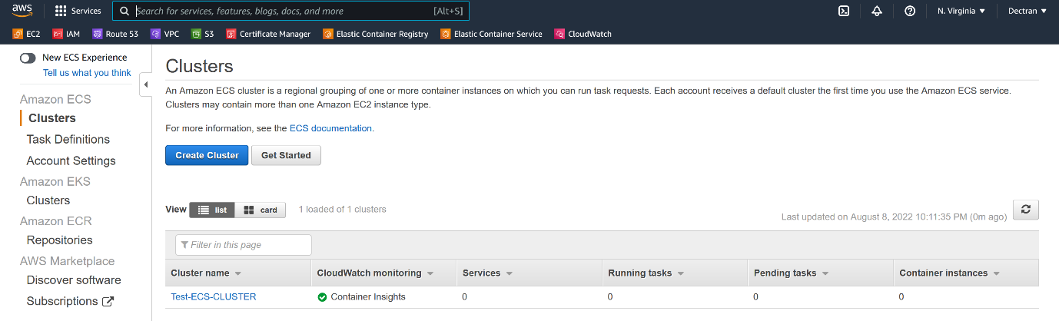

--- click on create a cluster.

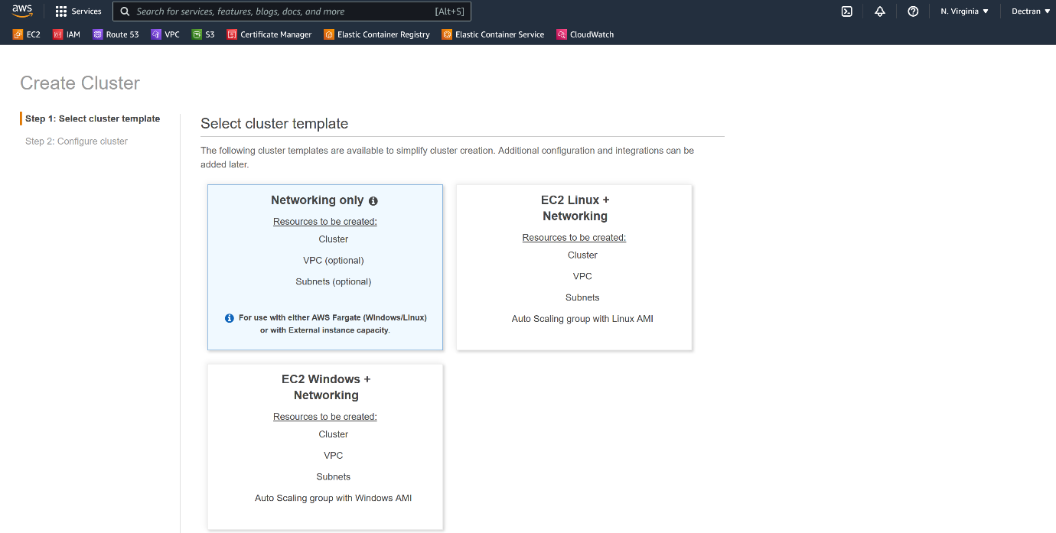

--- select the fargate profile.

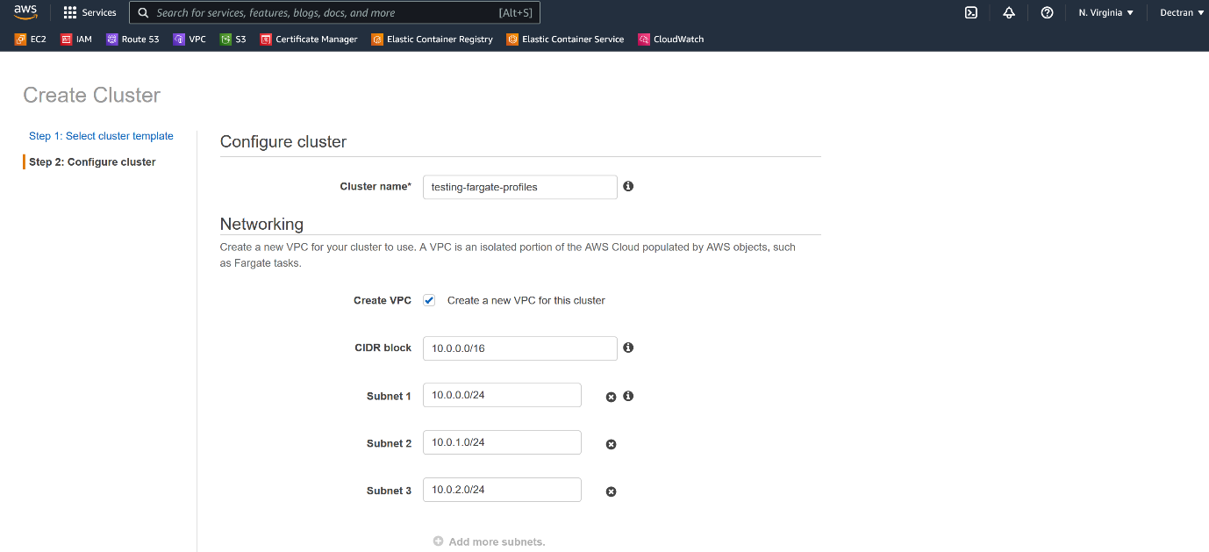

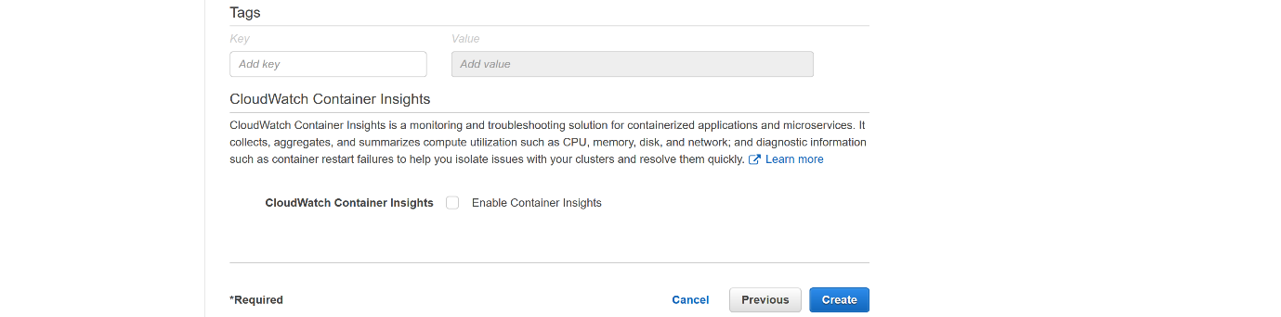

--- click on create.

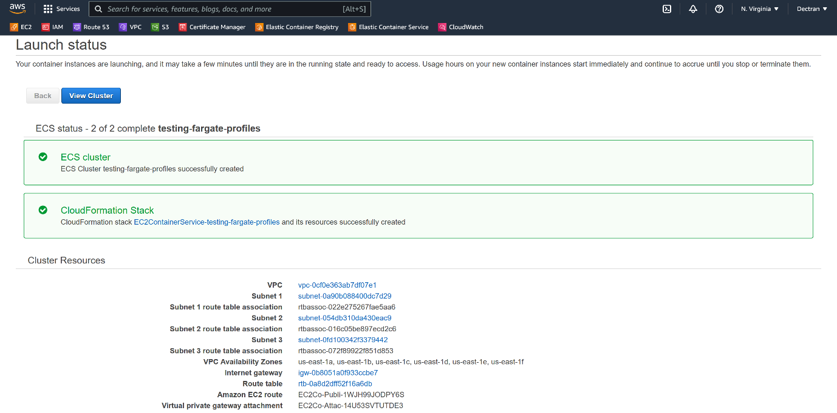

--- click on view cluster.

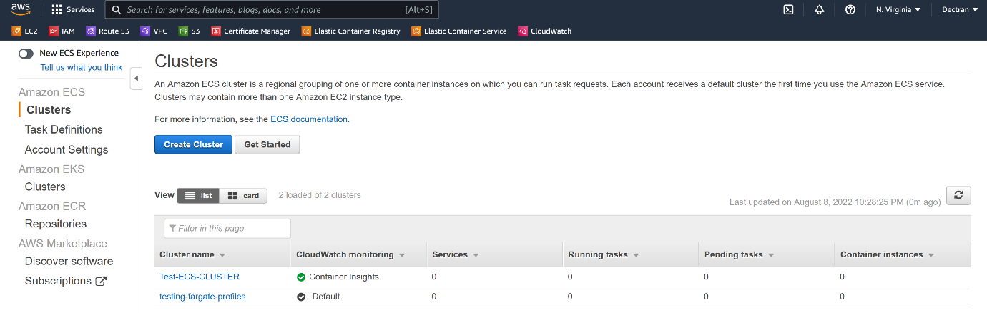

--- our cluster got created.

**Task definition creating**

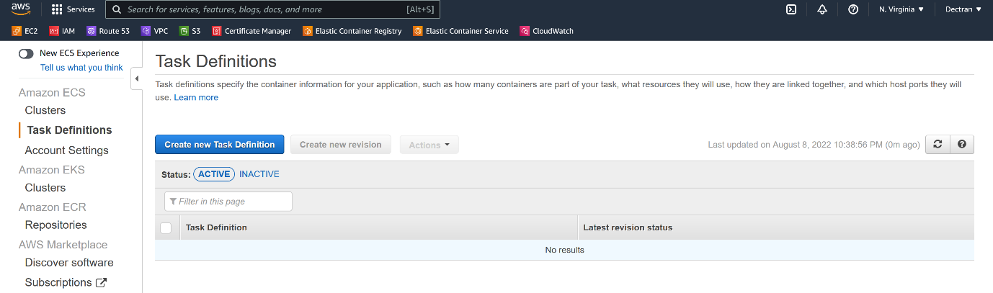

--- click on create task definition.

--- scroll down, click on configure via json.

--- **nginx_fargate.json**

{

  "requiresCompatibilities": [

    "FARGATE"

  ],

  "containerDefinitions": [

    {

      "name": "nginx-fargate-testing",

      "image": "743580576244.dkr.ecr.us-east-1.amazonaws.com/docker-testing-repository:v3",

      "memory": 256,

      "cpu": 256,

      "essential": true,

      "portMappings": [

        {

          "containerPort": 80,

          "protocol": "tcp"

        }

      ],

      "logConfiguration":{

            "logDriver":"awslogs",

            "options":{

               "awslogs-group":"awslogs-nginx-ecs",

               "awslogs-region":"us-east-1",

               "awslogs-stream-prefix":"ecs"

            }

      }

    }

  ],

  "volumes": [],

  "networkMode": "awsvpc",

  "placementConstraints": [],

  "family": "nginx",

  "memory": "512",

  "cpu": "256"

}

---