- Difference between GIT and GITHUB? Git is a distributed version control system and GitHub is a platform that uses Git as its core technology.

- What are GitHub teams: It's a group of GitHub users from the same organization.

- What are the different available options for adding issues and pull requests to a GitHub Project board? The correct option is to add issues and pull requests to a GitHub Project board individually, automatically, or in bulk. This flexibility allows users to choose the most suitable method based on their workflow and the number of items to be added.

- Inner Source: Inner Source involves applying open source principles, such as transparency, collaboration, and community-driven development, within an organization's internal projects. It aims to foster a culture of sharing and collaboration among teams, similar to how open source projects operate.
- A strategy that applies open source practices to proprietary code to enhance collaboration.

- Where can you disable repository features such as issues, wikis or projects on a repository that you own? In the repository settings

- What is CodeQL? A code analysis tool

- What are the use cases for labels? Categorizing issues and pull requests

- If you stop your GitHub Codespace environment can you come back to the changes later if you haven't committed them? Yes, that's the default behavior when stopping and then starting a GitHub Codespace

- Why would a repository owner want to use milestones?
  - To have an overview of how much work is left to complete a project phase
  - To associate issues and pull requests with specific project phases

- What is the purpose of a `CODEOWNERS` file? The CODEOWNERS file allows you to define individuals or teams that are responsible for specific areas of the codebase or its entirety.

- Which of these is true regarding custom fields for items in GitHub Projects? Custom fields enable the addition of metadata beyond the built-in options, such as target dates and iteration fields.

- What GitHub feature allows the creation of preconfigured development environments where all necessary tools and dependencies to contribute to a repository are installed? GitHub Codespaces

- What is the GitHub Marketplace? GitHub Marketplace is a place where developers can find tools that help build software right alongside their code.

- What is the role of an organization security manager? Security managers are organization members who can view security alerts and manage settings for code security across your organization, as well as read permissions for all repositories in the organization.

- What is the role of an organization moderator? Moderators are organization members who, in addition to their permissions as members, are allowed to block and unblock non-member contributors, set interaction limits, and hide comments in public repositories owned by the organization.

- Which of these statements about `saved replies` are true?
- Saved replies are comments that you can reuse in issues and pull requests.
- You can create, edit and delete them in your GitHub account settings in the Saved replies section.

- What GitHub features allow repository contributors to work on simple code changes directly through the web browser?
  - GitHub Codespaces
  - github.dev editor

- Your project requires appropriate hardware to run. Can you customize the amount of CPU cores that will be allocated to your GitHub Codespace environment? Yes, you can choose an alternative machine type either when you create a codespace or at any time after you've created a codespace.

- What is a GitHub Codespace deep link? It's a link that points to a specific GitHub.com Page that allows you to create a new GitHub Codespace and select specific configuration

- Which of these actions will make sure that prior to any push to the `main` branch, the changes have been approved by at least two people?
- On the branch protection rule, require at least 2 approvals before merging a pull request
- On the branch protection rule, require a pull request before merging
- Create a branch protection rule for main branch

- If you face yourself often writing the same set of comments on issues or pull requests, what GitHub feature would you use to save time? Saved replies

- What are the different options that allow you to automate operations in your GitHub Project?
- Project workflows
- GitHub GraphQL API
- GitHub Actions

- How can you customize the environment that is run in GitHub Codespaces? By creating a .devcontainer/devcontainer.json configuration file

- What is a pull request template? Pull request template is a file that defines the default pull request structure that project contributors will automatically see when they open a pull request.

- What are GitHub Wikis? Wikis is repository feature for hosting documentation.

- What feature is unique to GitHub Desktop compared to github.com? Visualize branch histories in a graphical interface

- What is the GitHub Flow? It refers to a branch-based workflow where developers create a branch for each new change they're working on, and then open pull requests to get their code reviewed, tested, and merged into the main branch.

- Which information can be found in the Pulse section in the Insights tab of a repository?
- List of unresolved conversations
- Pull requests open/merged ratio
- Summary of repository activity
- Amount of code line additions and deletions

- Which search query finds all open issues labeled `test` that mention 'fix' in their body text? is:issue is:open label:test "fix"

- Which of the following Git commands allow you to create a new branch and start working on it in one line?
- git checkout -b <new_branch_name>
- git switch -c <new_branch_name>

- What are GitHub's slash commands? It's a way to quickly insert complex Markdown into your pull request or issue comments and descriptions.

- What is the minimum permission a user must have to directly push commits to a repository owned by an organization? Manage issues and pull requests

- What is one of the main benefits for using a Personal Access Token (PAT) instead of a standard username and password for GitHub authentication? PAT can be used for authentication to GitHub when using the GitHub API or the command line. Users generate a token via the GitHub's settings option, and tie the token permissions to a repository or organization.

- What happens when you choose to close a Project? The content is retained and you have the ability to reopen it later.

- GIST:
- A Gist on GitHub is a simple way to share small pieces of code, text, or data — like snippets, notes, or single-file projects — with others.
- Can you change a gist from public to secret after creating it? No

- Which of these is a repository feature that is used as a community forum to have conversations, ask questions, post announcements and share ideas? Discussions

- What is the effect of adding a line `Closes #11` to the pull request's description? Once that pull request is merged, the issue #11 will be closed automatically.

- Which Markdown element is not correctly paired with its syntax? Inline code - '''code'''

- In GitHub a proposal to merge a set of changes from one branch into another branch is called a: Pull Request

- Which of these files can customize your GitHub profile? a profile README.md file

- What are draft pull requests? Draft pull requests are pull requests that are not ready to be reviewed yet.

- How can you link a pull request to an issue?
- Manually from either the pull request or the issue view.
- By using a keyword in the pull request description and referencing the issue number.

- Which of these statements about GitHub Enterprise deployment options are true?
- GitHub Enterprise Server is a self-hosted platform that runs on the company's infrastructure
- GitHub Enterprise Cloud is a set of advanced functionality on GitHub.com

- What are the two available options when you no longer need to use a Project? Close and delete

- What is a GitHub Pro plan? GitHub Pro is a paid plan for personal accounts that offers additional features in addition to the free plan.

- What improvement do issue forms bring over issue templates? Issue form is a tool for creating issues that only contain form fields for title and description, simplifying the process but not necessarily improving the information quality compared to issue templates.

========================================================================================================================
PART - B

- Meg, a software developer, wants to provide additional context within an issue discussion in her GitHub repository. She is exploring options for creating collapsible detail areas to hide supplementary information. How can she create it in a GitHub comment or description?
- By using the /details slash command and providing a title and content for the collapsible section.

- Which of the following options are available to define the visibility of teams on GitHub?
- Visible and Secret

- What distinguishes internal repositories from other repositories on GitHub?
- Internal repositories are accessible to all enterprise members.

- Peter has starred several repositories and topics on GitHub over time but now wants to revisit them to see if there are any updates. However, he's not sure where to find his starred content. How can users access all the repositories and topics they have starred on GitHub?
- By accessing their stars page at https://github.com/stars.

- How can you ensure that the CODEOWNERS file itself is protected against unauthorized changes?
- Define the repository owner as the owner of the CODEOWNERS file.

- Peter is managing a large repository on GitHub, and he's noticed that the CODEOWNERS file size is exceeding the limit. What approach should Peter take to address this issue effectively?
- Peter should use wildcard patterns to consolidate multiple entries into a single entry in the CODEOWNERS file.

- Michael is managing a large GitHub repository with numerous contributors. He wants to ensure that the CODEOWNERS file is within the size limit to avoid issues with loading and requesting code owner reviews. What is the maximum size limit for a CODEOWNERS file on GitHub?
- 3MB

- Meg wants to set up code owners in her GitHub repository. Where should she place the CODEOWNERS file to ensure that it assigns the code owners for a specific branch?
- In the .github/, root, or docs/ directory of the repository.

- What is the purpose of github.dev? A lightweight web-based editor

- As a repository owner, what actions can you restrict on GitHub Actions? You can disable GitHub Actions for a repository, or set a policy that configures which Actions and reusable Workflows can be used in the repository.

- Which of the following describes the primary states a file can be in within a Git repository?
- Untracked and Tracked

- Which of the following options helps you search for issues with the "404 error" string in repositories owned by the QuizExperts organization?

- What advantages do GitHub issue forms offer?
- People can be automatically assigned to issues created.
- Labels can be automatically added to issues created.

- What is the advantage of using a wiki alongside a README file for a GitHub repository?
- README files quickly tell what a project can do, while wikis can provide additional long-form detailed documentation.

- Who can create repository a template on GitHub?
- Anyone with admin permissions to a repository.

- What happens if someone discovers the URL of a secret gist on GitHub?
- They can view the gist regardless of the author's permissions

- What happens if Lois places the README file in the root directory of her repository and also in the .github directory?
- Only the README file in the .github directory will be shown.

- The involves qualifier is a logical OR between the author, assignee, mentions, and commenter qualifiers for a single user. True

- Which of the following is a default category for discussions when you enable discussions in a repository? Show and tell

- The actions you use in your workflow can be defined in:
- The same repository as your workflow file
- Any public repository
- A published Docker container image on Docker Hub

- What is a security policy in GitHub?
- Define guidelines for reporting security vulnerabilities.
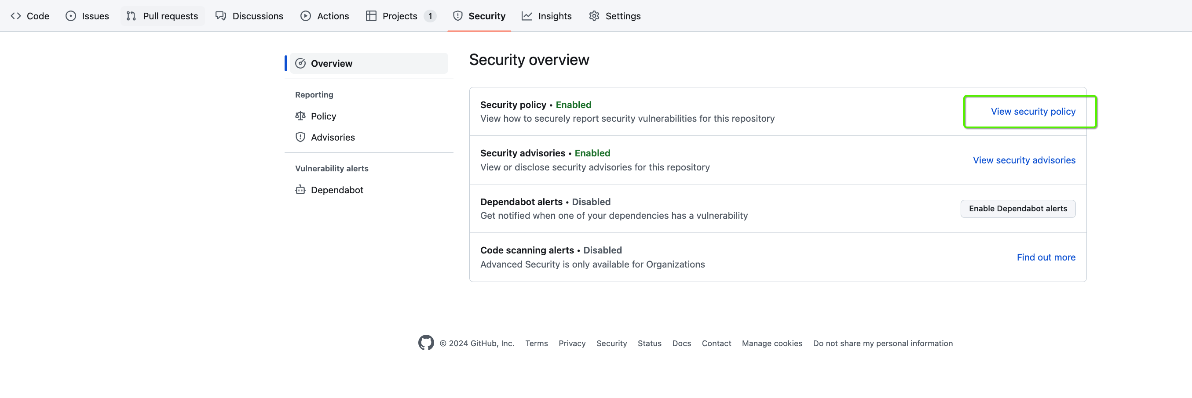

- Chris Griffin just pushed his latest changes to GitHub but realizes that one of the commits contains a critical error. He wants to undo that specific commit. What should Chris do to undo the mistaken commit while keeping the commit history intact?
- git revert <SHA>

- What label does a maintainer use to indicate that they require assistance with an issue or pull request?
- help wanted

- What information can you see on a user profile on GitHub?
- You can see the profile photo, bio, and interests you have that other people may like to know about.
- You can view repositories you own or contribute to, as well as repositories you've starred and organized into lists.

========================================================================================================================

PART - C

- Can you configure GitHub Copilot Individual to exclude certain files from being available to GitHub servers? No

- Peter Griffin wants to ignore certain files in his Git repository without creating a .gitignore file to share with others. What approach should he use? - Edit the .git/info/exclude file in the root of his repository.

- What is the significance of adding labels to a pull request?
- To provide visual clues for the purpose of the pull request.
- It categorizes the nature of the changes being proposed.

- How does innersource promote code reuse within an organization?
- By enabling teams to discover, customize, and reuse existing internal projects.

- What is the purpose of a pull request in an open-source project?
- To propose changes to the project.

- Which of the following accurately describes the different statuses of a pull request?
- Merged
- Draft
- Closed

- What are the three types of GitHub accounts?

- What is a function you can execute on GitHub Mobile?
- Manage, triage, and clear notifications from github.com.

- Which deployment option provides 50,000 GitHub Actions minutes per month and 50 GB GitHub Packages storage?
-GitHub Enterprise Cloud

- Peter is reviewing a pull request for a project on GitHub. He notices a section of code in one of the files that he has a question about. Which of the following actions can Peter take to address his question?
-Peter can comment on specific files or sections of a file in the pull request's Files changed tab.

- Lois is a project manager on GitHub managing discussions in a repository. She notices that one of the discussions in a category that accepts answers has received a helpful response from a community member. What action can Lois take to highlight the helpful response?
- Lois can mark the response as an answer to the discussion.
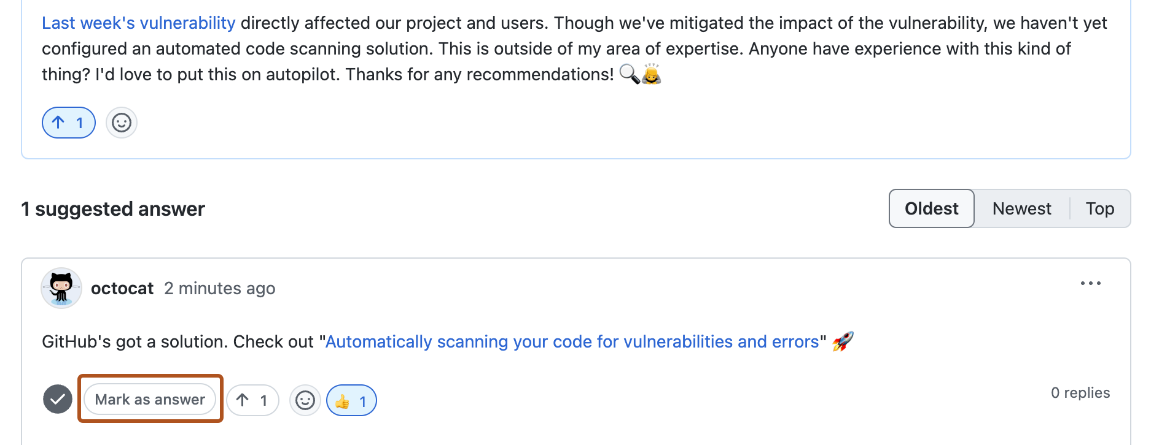

- Meg is a developer who has been actively contributing to a GitHub repository, but she notices that her contributions are not showing up in the contributors graph. She wants to troubleshoot the issue. What could be a possible reason why Meg's contributions are not appearing in the repository's contributors graph?
- If you don't appear in a repository's contributors graph, it may be because:
- You aren't one of the top 100 contributors.
- Your commits haven't been merged into the default branch.
- The email address you used to author the commits isn't connected to your account on GitHub.

- What feature of GitHub Discussions allows community members to gauge interest in new ideas and project direction?
- Polls

- Which of the following describes the state of a tracked file within a Git repository?
- Staged and Modified

- What does GitHub's secret scanning feature do?
- It looks for known secrets or credentials committed within the repository.

- What feature of GitHub allows repository maintainers to privately discuss and fix security vulnerabilities?
- GitHub Security Advisories

- Lois wants to analyze the performance of tasks within her GitHub project using insights. However, she wonders: What does Insights for Projects on GitHub not track?
- Items that have been archived or deleted.

- Which of the following statements about secret teams on GitHub is NOT true?
- Secret teams cannot be nested under parent teams or have child teams. They exist independently within the organization's structure.
Team visibility
Teams can be visible or secret:
- Visible teams can be viewed and @mentioned by every organization member.
- Secret teams are only visible to the people on the team and people with owner permissions. They're great for hiding teams with sensitive names or members, such as those used for working with external partners or clients. Secret teams cannot be nested under parent teams or have child teams.

- Which command is used to create an issue with GitHub CLI?
- gh issue create

- Who can create a new discussion in a GitHub repository or organization?
- Any authenticated user who can view the repository or organization.

- What is the purpose of personal access tokens (PATs) in GitHub?
- To authenticate to GitHub API or command line.

- Which of the following authentication methods is considered the most secure way to authenticate with 2FA on GitHub Enterprise?
- Security keys

- How can you authenticate GitHub CLI commands for managing projects via the GraphQL API?
- Run gh auth login --scopes "project"

- How many default workflows are enabled when a project initializes in GitHub Projects? Two
- How many levels of workflows can be connected together? Up to four levels
- What does the github.dev editor use to carry out most of its functionality? GitHub Repositories extension

- How can you unlink an issue that was linked using a keyword?
- By editing the pull request description and removing the keyword.

- How does SAML SSO work with GitHub Enterprise?
- Users are redirected to the Identity Provider (IdP) to authenticate.

- Peter is working on a project and has created a pull request (PR) to fix an issue. However, the PR is on a feature branch and not the default branch. What will happen to the special keywords in the PR description in this case?
- The special keywords will be ignored, and no links will be created.

- How can you clone a wiki from a GitHub repository to your local computer?
- Using the "git clone" command with the repository's URL followed by ".wiki.git".

- Stewie is working on a software project hosted on GitHub and wants to share a specific line of code from a file in the project with his colleague, Meg. However, Stewie wants to ensure that the link he shares remains valid even if changes are made to the file in the future. Which of the following options should Stewie use to create a link to the specific line of code?
- Stewie should use the "Permalink" option provided by GitHub to create a permanent link and share it with Meg.

- What does the search qualifier "review-requested: [USERNAME]" allow you to find?
- Pull requests where the specified user is requested for review.

========================================================================================================================
PART - D

  - Which of the following is NOT a default label provided by GitHub in every new repository?
- Feature

  - What is the name of the section where you can edit the section where you change the visibility of your Project and delete or close your Project?
- Danger Zone

  - Lois wants to configure an auto-add workflow to add new issues to their project board when they are labeled as "urgent." However, she is concerned about the limitations of auto-add workflows. Which plan allows a maximum of 20 auto-add workflows?
- GitHub Enterprise

  - Why would a project manager want to automatically archive items in a GitHub project?
- To help stay below the limit of 1,200 items in the project and manage clutter.

  - Which of the following can help you create an AI-generated description for a pull request?
    - GitHub Copilot Enterprise

  - Which protocol allows synchronization of user identity information between an identity provider (IdP) and GitHub?
    - SCIM

  - What two-factor authentication method supports the secure backup of your authentication codes in the cloud?
    - Time-based One-time Password (TOTP)

