Terraform POC

Prerequisites:
  - Create terraform cloud account
  - Install Jenkins
  - Create GitHub repositories
  - AWS account

Steps:
- Create terraform cloud workspaces
  - Terraform-test-main (for all resources ex:vm1/vm2)
  - Terraform-test-common (only common resources)
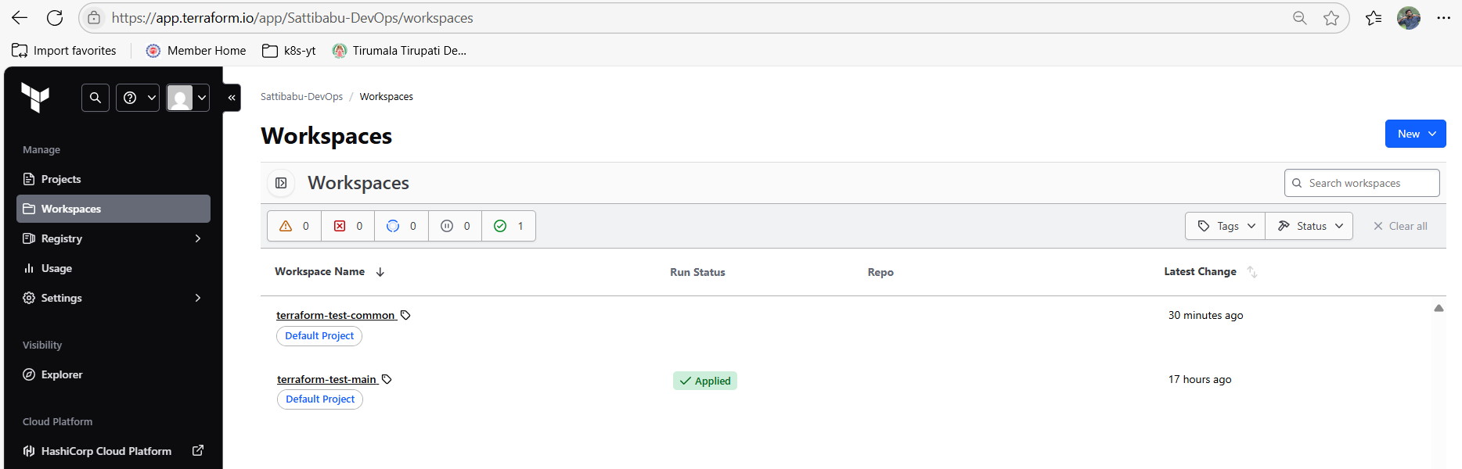
- Create Jenkins pipelines
  - Infra-provision (provision resources)
  - Terraform-test-common-job (pipeline to import state file/separate common resources)
  - Terraform-test-main-job (pipeline to remove common resources)
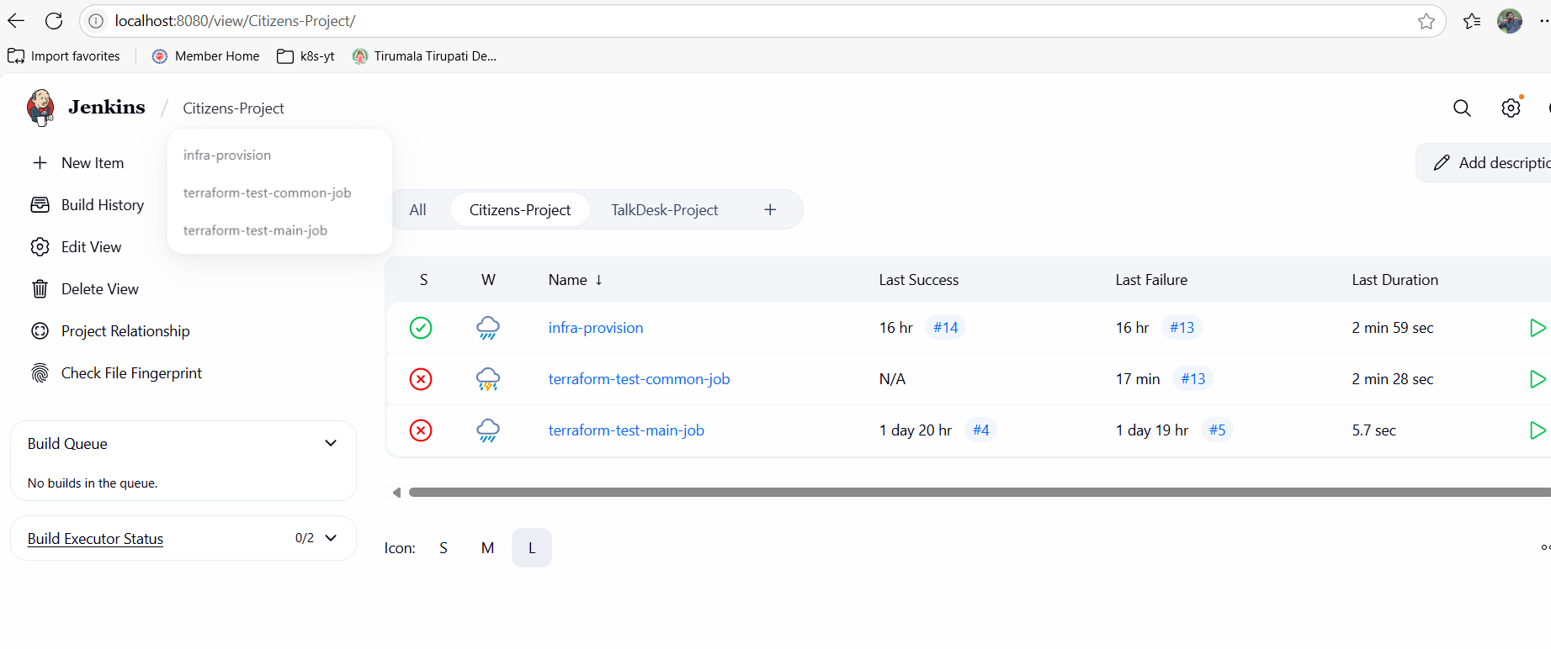
- Create GitHub repositories.
  - Terraform-test-main (all recourses in one repo ex:ec2 vm1 and vm2 instances)
  - Terraform-test-common (new repo for all common resources only ex:vm2)
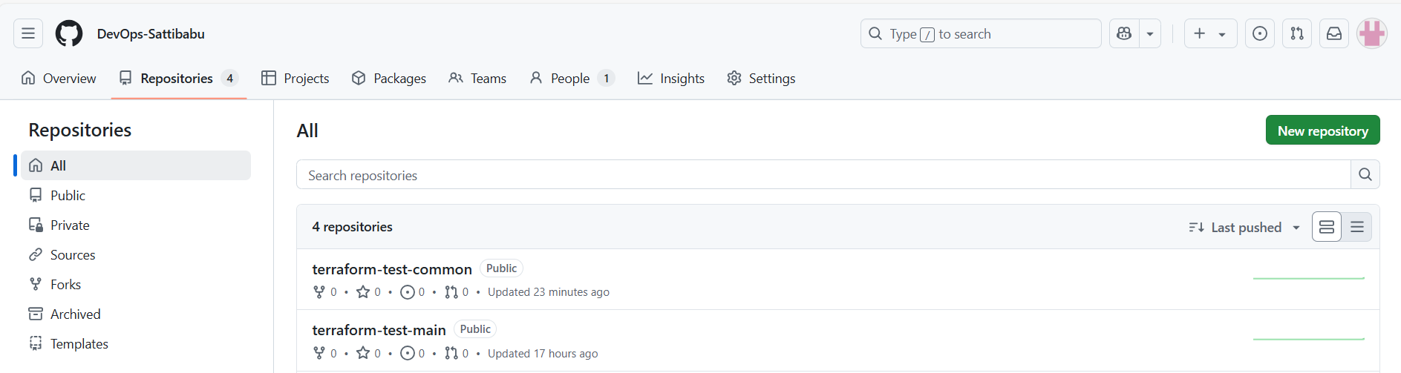
- Create 2 resources using Jenkins pipeline infra-provision

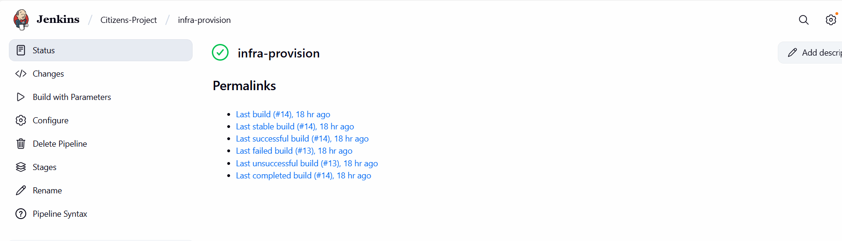
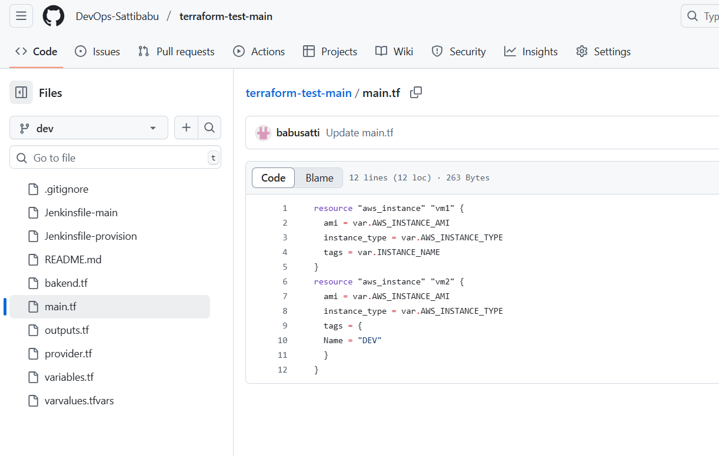

"outputs": {
"instance_id": {
"value": "i-03157fd645eda3d3d",
"type": "string"
},
"instance_ids": {
"value": "i-044d301c9bcbf7a06",
"type": "string"
},

- Trigger terraform-test-common-job for import common resources from terraform-test-main workspace state file to terraform-test-common state file workspace using Jenkins parameterized pipeline.
- Need to pass the resource address and instance id from terraform-test-main state file.
- This pipeline will separate the resources from main workspace using address and ID and will be moved to common workspace.

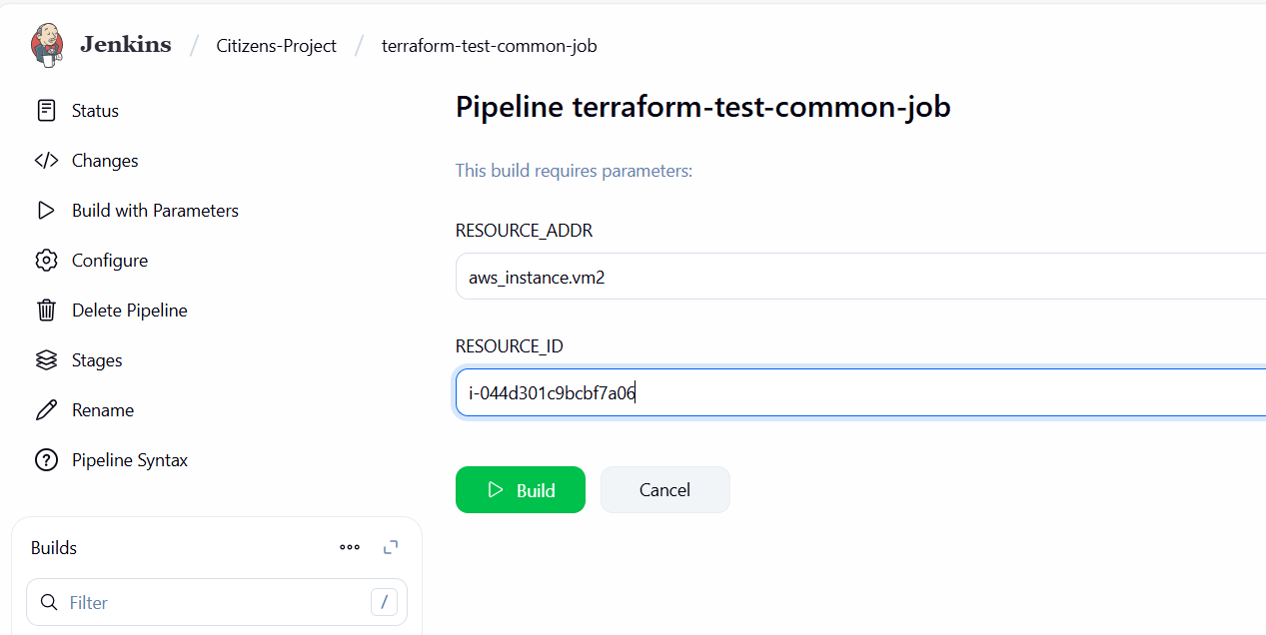

- Trigger terraform-test-main-job for remove the common resources from terraform-test-main workspace state file using Jenkins parameterized pipeline.
  - Need to pass the resource address from terraform-test-main state file.
  - This pipeline will remove the resources from main workspace.
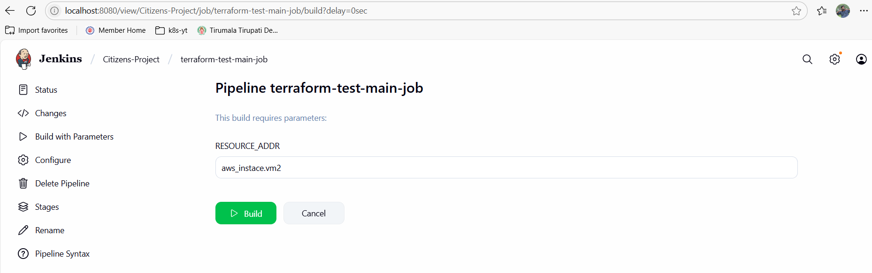

- Verify the terraform-test-common workspace have only one resource(vm2) after ran the terraform-test-common-job Jenkins pipeline.
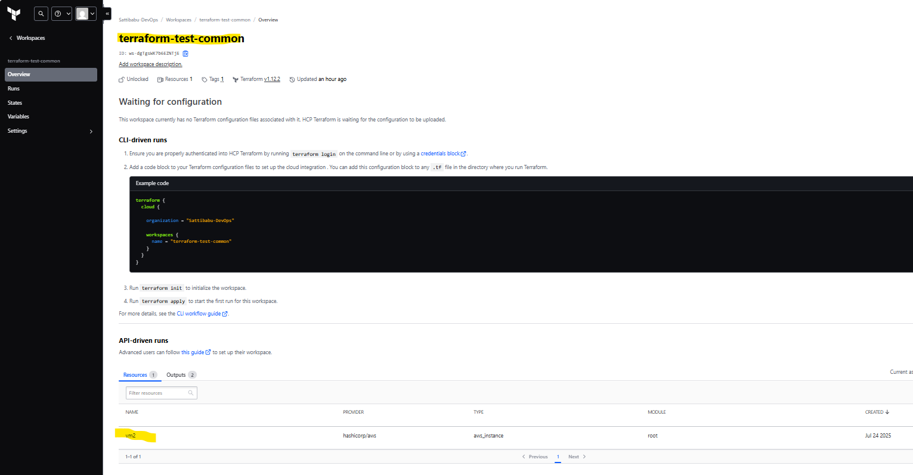
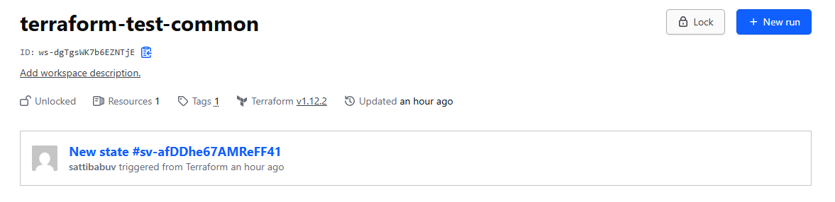
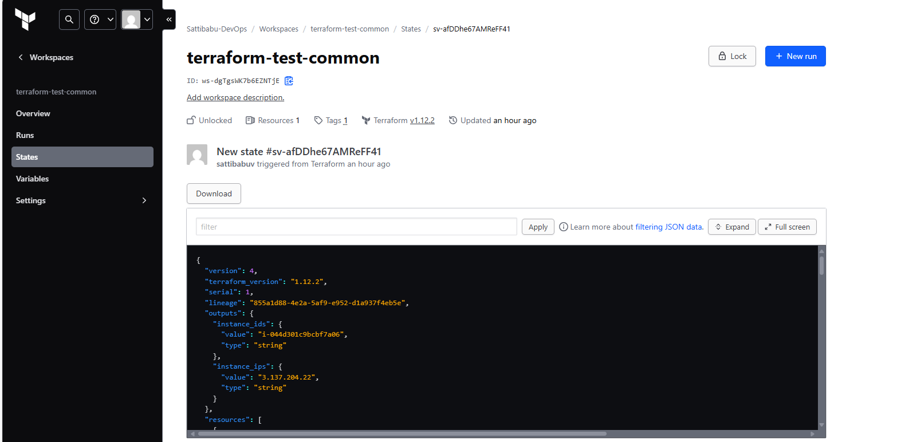

- Verify the terraform-test-main workspace have only one resource(vm1) after ran the terraform-test-main-job Jenkins pipeline.
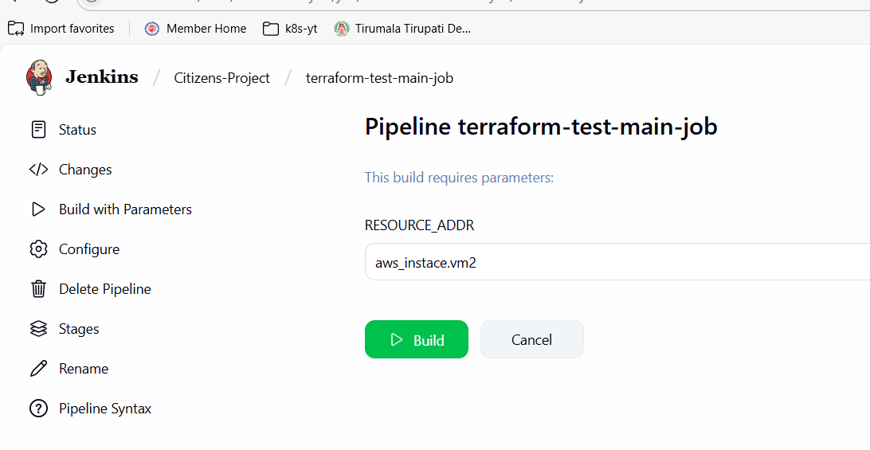
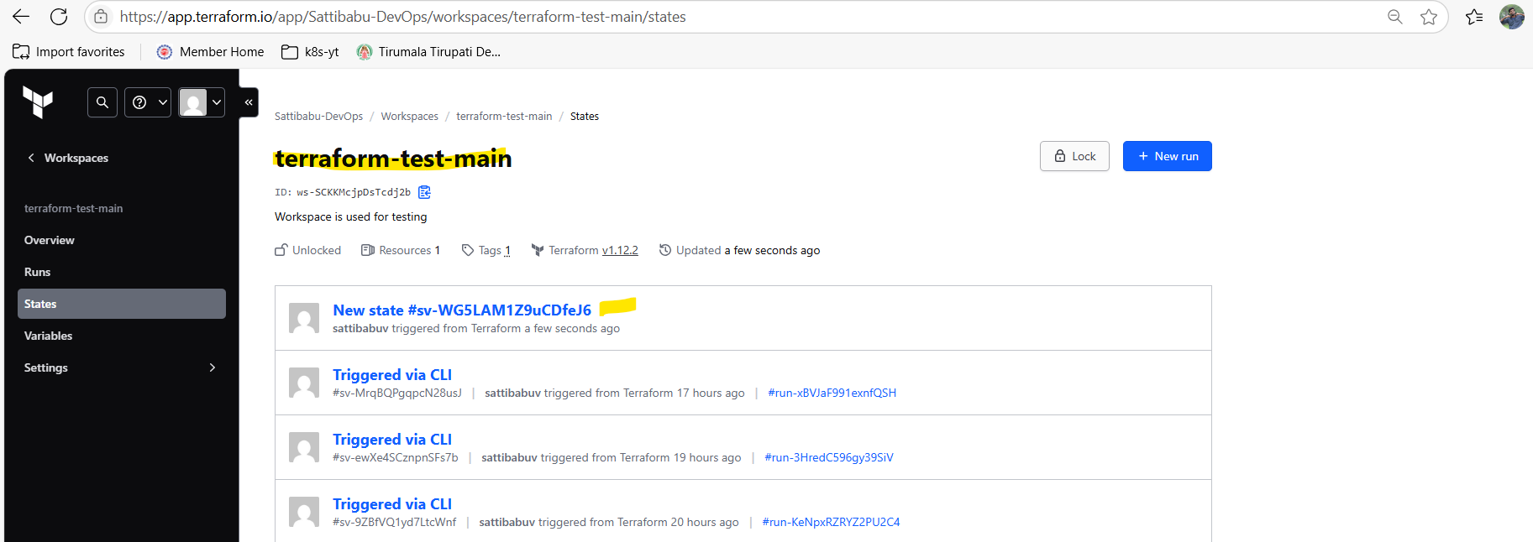
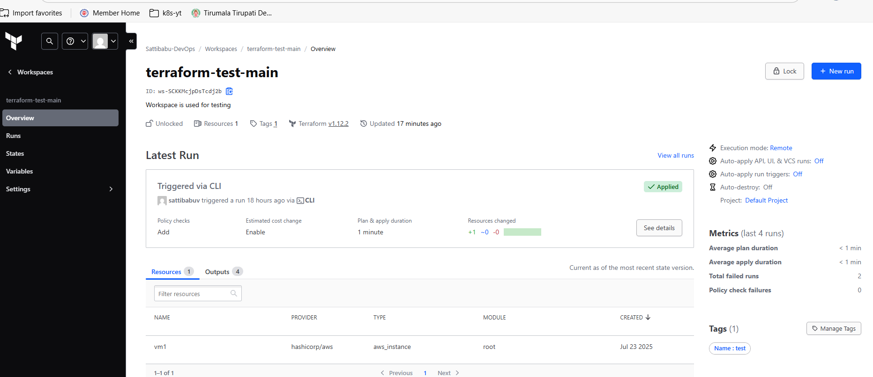
GitHub Urls:
Terraform-test-common: DevOps-Sattibabu/terraform-test-common at dev
Terraform-test-main: DevOps-Sattibabu/terraform-test-main at dev
Jenkins file: All Jenkins files for all jobs are in respective repositories.
============END==========

