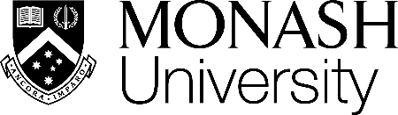

SOFTWARE ANALYTICS   
TUTORIAL



A Hands-on Tutorial on Mining, Analyzing, Modelling, and Explaining Software Data  
  
https://github.com/awsm-research/tutorial

DR. CHAKKRIT (KLA) TANTITHAMTHAVORN  
FACULTY OF INFORMATION TECHNOLOGY

MONASH UNIVERSITY, MELBOURNE, AUSTRALIA