**GIT/Github**

**What is GIT?**

**Git** (/ɡɪt/) is a version control system for tracking changes in computer files and coordinating work on those files among multiple people. It is primarily used for source code management in software development, but it can be used to keep track of changes in any set of files.

**Note:** Git is a software and this is used for Version Control. Its free and open source.

**Version Control System:**

Version Control is the management of changes to documents, computer programs, large websites and other collection of information. There are 2 types of VCS. They are –

* Centralized Version Control System (CVCS)
* Distributed Version Control System (DBVS)

**CVCS:** Centralized version control system (CVCS) uses a central server to store all files and enables team collaboration. It works on a single repository to which users can directly access a central server.

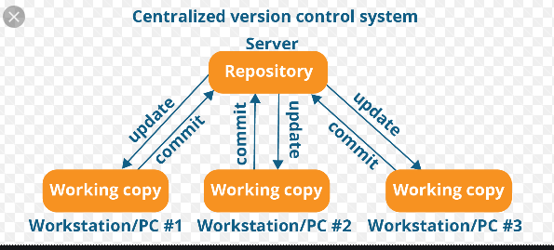

**Note:** The repository in the above diagram indicates a central server that could be local or remote which is directly connected to each of the programmer’s workstation.

Every programmer can extract or update their workstations with the data present in the repository or can make changes to the data or commit in the repository. Every operation is performed directly on the repository.

Even though it seems pretty convenient to maintain a single repository, it has some major drawbacks.

**Some of them are:**

It is not locally available; meaning you always need to be connected to a network to perform any action.

Since everything is centralized, in any case of the central server getting crashed or corrupted will result in losing the entire data of the project.

This is when Distributed VCS comes to the rescue.

**DVCS:** These systems do not necessarily rely on a central server to store all the versions of a project file.

In Distributed VCS, every contributor has a local copy or “clone” of the main repository i.e. everyone maintains a local repository of their own which contains all the files and metadata present in the main repository.

You will understand it better by referring to the diagram below:

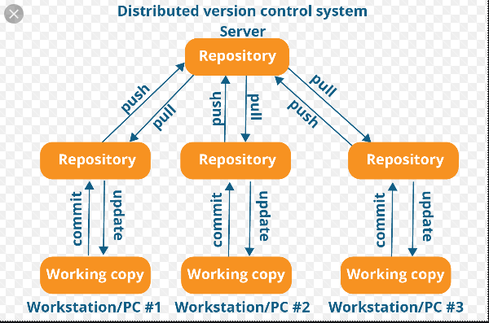

As you can see in the above diagram, every programmer maintains a local repository on its own, which is actually the copy or clone of the central repository on their hard drive. They can commit and update their local repository without any interference.

They can update their local repositories with new data from the central server by an operation called “pull” and affect changes to the main repository by an operation called “push” from their local repository.

* The act of cloning an entire repository into your workstation to get a local repository gives you the following advantages:
* All operations (except push & pull) are very fast because the tool only needs to access the hard drive, not a remote server. Hence, you do not always need an internet connection.
* Committing new change-sets can be done locally without manipulating the data on the main repository. Once you have a group of change-sets ready, you can push them all at once.
* Since every contributor has a full copy of the project repository, they can share changes with one another if they want to get some feedback before affecting changes in the main repository.
* If the central server gets crashed at any point of time, the lost data can be easily recovered from any one of the contributor’s local repositories.

Note: Git is a DVCS.

