1. Follow the guide below to configure an AD domain on VM01 - <https://blogs.technet.microsoft.com/canitpro/2017/02/22/step-by-step-setting-up-active-directory-in-windows-server-2016/>
2. Don’t forget to configure DNS settings on the VM02 and VM03 as per screenshot below. Note that the first IP should be the local IP of the domain controller. It has to bet set to static in Azure portal.

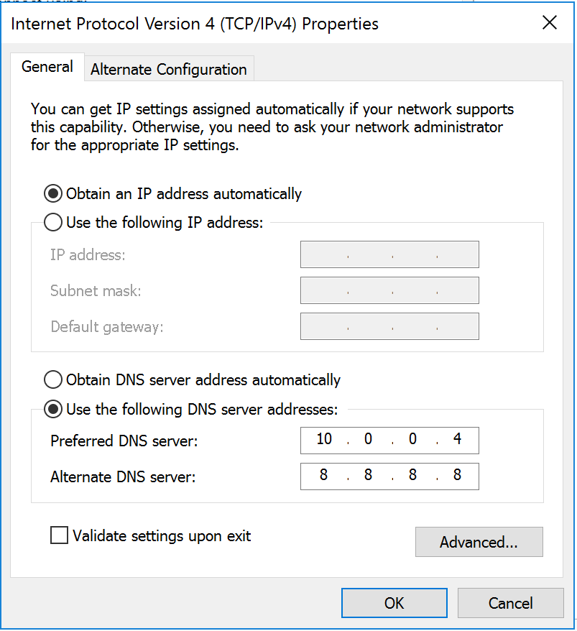

1. Join VM02 and VM03 to domain as per screenshot below (name of the domain should be the one you gave it in step 1)

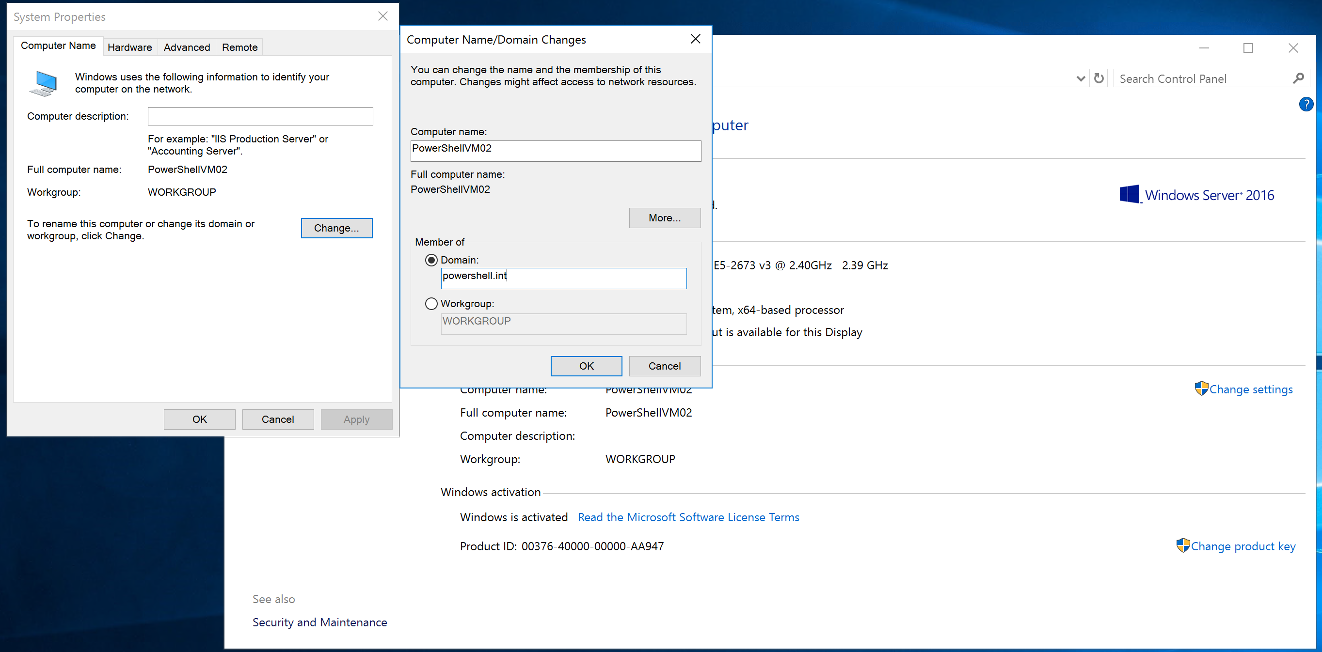

1. Turn Windows Firewall off on all 3 virtual machines. It’s not something I recommend doing in the production environment, obviously. But it is outside of this course scope to show you how to configure PowerShell remoting in detail, so we will just turn the firewall off for now.

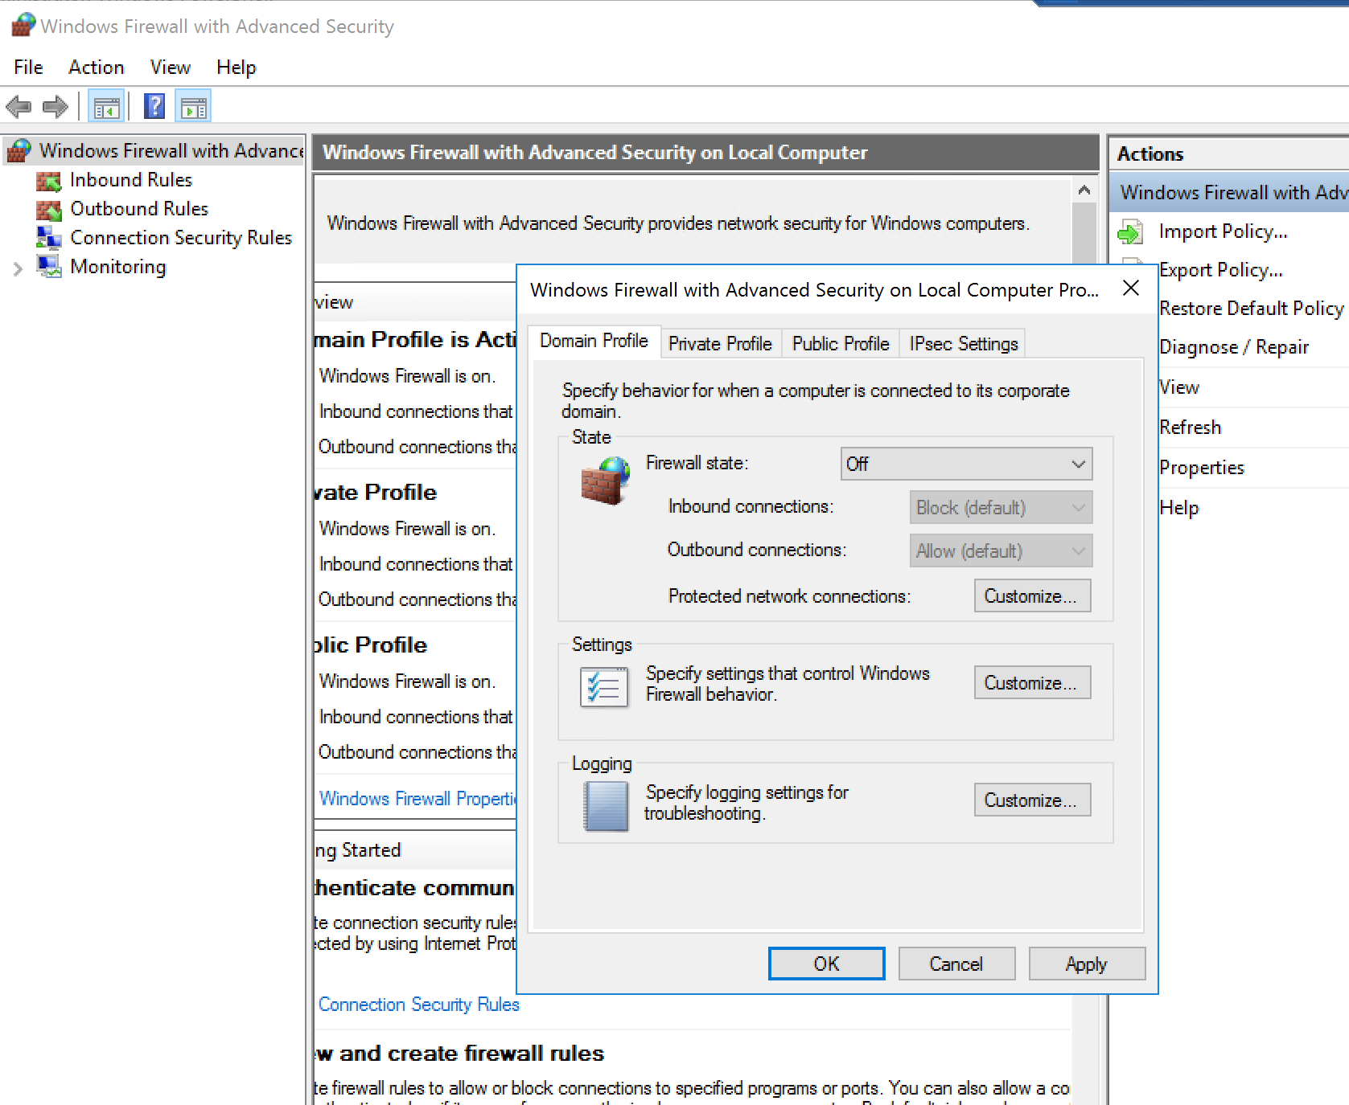5. Run Enable-PSRemoting on each machine.

6. Following section 1, set-up VSCode on PowerShellVM01.