Load Balancer
- Distributes traffic based on IP and Port.
Application Gateway
- Distributes traffic based on URL, Hostname, HTTP headers, SSL certificates, etc.
What is Azure Application Gateway?
Definition:
Application Gateway is a Layer 7 (Application Layer) Load Balancer that distributes HTTP/HTTPS traffic to web applications.
Usage:
It understands:
- URLs (/app, /api)
- Host names (app.company.com, api.company.com)
- HTTP headers
- HTTPS certificates
Based on these details, it can route traffic to different backend servers.
If not used:
A normal Load Balancer can only look at IP addresses and ports. It cannot make routing decisions based on URLs or host names.
Example:
User
↓
company.com/app
↓
Application Gateway
↓
App Servers
User
↓
company.com/api
↓
Application Gateway
↓
API Servers

Why do we need Application Gateway?
Imagine a company has:
company.com/app
company.com/api
company.com/admin
Without Application Gateway:
- Separate load balancers may be needed.
- Routing becomes complex.
- SSL certificate management becomes difficult.
With Application Gateway:
Single Entry Point
↓
Application Gateway
↓
App Servers
API Servers
Admin Servers
One gateway can intelligently route requests.

Real Project Example
Internet Users
↓
Application Gateway
↓
-----------------------
| | |
App API Admin
VMs VMs VMs
Requests:
company.com/app
↓
App VMs
company.com/api
↓
API VMs
company.com/admin
↓
Admin VMs
This is a very common enterprise architecture.

Key Point
Load Balancer
- Layer 4
- Works with TCP/UDP
- Doesn't understand URLs
Application Gateway
- Layer 7
- Works with HTTP/HTTPS
- Understands URLs and host names
- Supports SSL termination
- Supports WAF

Application Gateway - Notes
Definition
- Application Gateway is a Layer 7 (Application Layer) load balancer for HTTP/HTTPS traffic.
- It can inspect URLs, host names, headers, and SSL information before routing requests.
- It provides intelligent routing to the appropriate backend servers.
Usage
- Routes requests based on URL paths (/app, /api, /admin).
- Routes requests based on host names (app.company.com, api.company.com).
- Supports SSL termination and Web Application Firewall (WAF).
- Provides a single entry point for multiple web applications.
If Not Used
- Routing can only be done using IP addresses and ports.
- Users may need different ports for different applications.
- URL-based and host-based routing are not possible.
- SSL certificate management becomes more complex.
Example
company.com/app → App Servers
company.com/api → API Servers
company.com/admin → Admin Servers
Application Gateway reads the URL and forwards the request to the correct backend pool.
Understanding Layers
When we say Layer 4 or Layer 7, we are referring to the OSI Model.
Layer 7 - Application
Layer 6 - Presentation
Layer 5 - Session
Layer 4 - Transport
Layer 3 - Network
Layer 2 - Data Link
Layer 1 - Physical
For Azure traffic management, you mainly need to focus on Layer 4 and Layer 7.

Layer 4 (Transport Layer)
Definition
- Handles communication using TCP and UDP protocols.
- Uses source IP, destination IP, and port numbers to forward traffic.
Usage
- Used by Azure Load Balancer.
- Suitable for generic network traffic.
What It Can See
Source IP : 1.1.1.1
Destination IP : 10.0.0.10
Port : 80
Protocol : TCP
What It Cannot See
/app
/api
/admin
Host Names
HTTP Headers
SSL Information
Example
User
↓
Load Balancer
↓
VM1
VM2
VM3
Traffic is distributed without understanding the application request.

Layer 7 (Application Layer)
Definition
- Handles HTTP and HTTPS traffic.
- Understands application-level information inside the request.
Usage
- Used by Application Gateway.
- Suitable for web applications and APIs.
What It Can See
URL Path
/app
/api
Host Name
api.company.com
HTTP Headers
SSL Certificates
Example
User
↓
Application Gateway
↓
-------------------
/app → App Servers
/api → API Servers
/admin → Admin Servers
Application Gateway inspects the request and sends it to the appropriate backend.

Interview Difference
Feature | Load Balancer | Application Gateway
OSI Layer | Layer 4 | Layer 7
Protocols | TCP/UDP | HTTP/HTTPS
URL Routing | No | Yes
Host-based Routing | No | Yes
SSL Termination | No | Yes
WAF Support | No | Yes
Understands Application Requests | No | Yes
One-Line Summary
Load Balancer = "I know IPs and Ports."
Application Gateway = "I understand the web request and can intelligently route it."

The closest AWS equivalent of Azure Application Gateway is:
AWS Application Load Balancer (ALB)
Azure | AWS
Application Gateway | AWS Application Load Balancer (ALB)
Load Balancer | AWS Network Load Balancer (NLB)
WAF | AWS WAF
Front Door | AWS CloudFront + Global Accelerator (rough equivalent)

Simple Comparison
Azure Load Balancer asks:
Which IP?
Which Port?
Which Protocol?
Application Gateway asks:
Which Domain?
Which URL?
Which HTTP Request?
Which SSL Certificate?
Memory Trick
Load Balancer
--------------
IP
Port
TCP/UDP
Application Gateway
-------------------
Domain
URL
HTTP/HTTPS
SSL
----------------------------------------------------------------------------------------------------------------------------------------------------------------------------------------------------------------------------------------------------------------------------
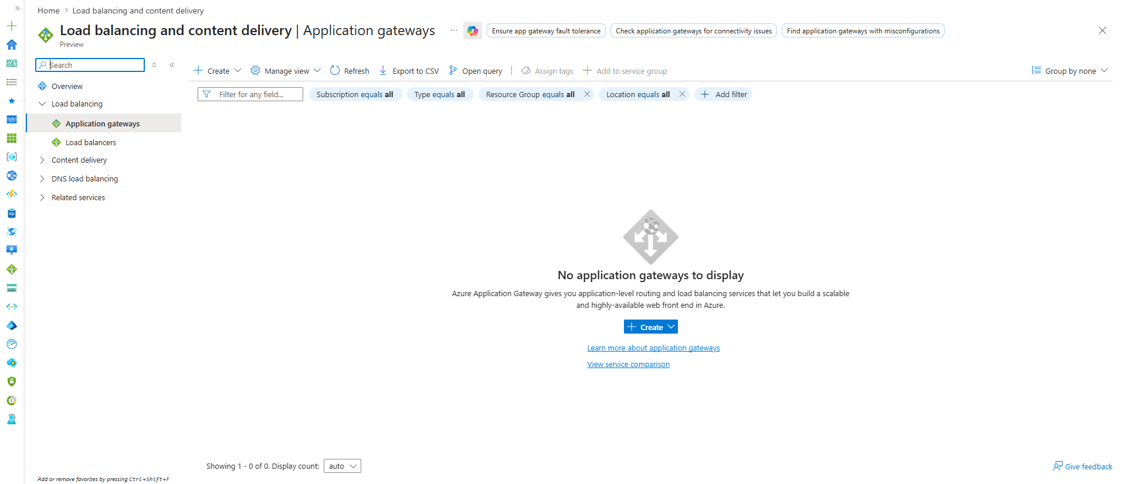1. Frontend IP
Definition
- The public or private IP where users send requests.
Example
https://company.com
↓
Frontend IP
Think of it as the entry gate of the Application Gateway.

2. Backend Pool
Definition
- Collection of backend targets that receive traffic.
Can contain
- VMs
- VM Scale Sets
- App Services
- Private IPs
Example
Backend Pool
-------------
VM1
VM2
VM3
Think of it as the group of servers behind the gateway.

3. Listener
Definition
- Waits for incoming requests on a specific protocol and port.
Example
HTTPS
Port 443
company.com
The listener says:
"I am listening for HTTPS requests on port 443."

4. Backend Settings (HTTP Settings)
Definition
- Tells the gateway how to talk to the backend servers.
Example
Protocol = HTTP
Port = 80
Cookie-based affinity = Off
Think of it as the communication rules between Gateway and Backend.

5. Routing Rule
Definition
- Connects everything together.
It links:
Listener
↓
Backend Settings
↓
Backend Pool
Without a routing rule, traffic doesn't know where to go.

Complete Flow
User
↓
Frontend IP
↓
Listener
↓
Routing Rule
↓
Backend Settings
↓
Backend Pool
↓
VMs / App Servers
This flow is the most important thing in Application Gateway.

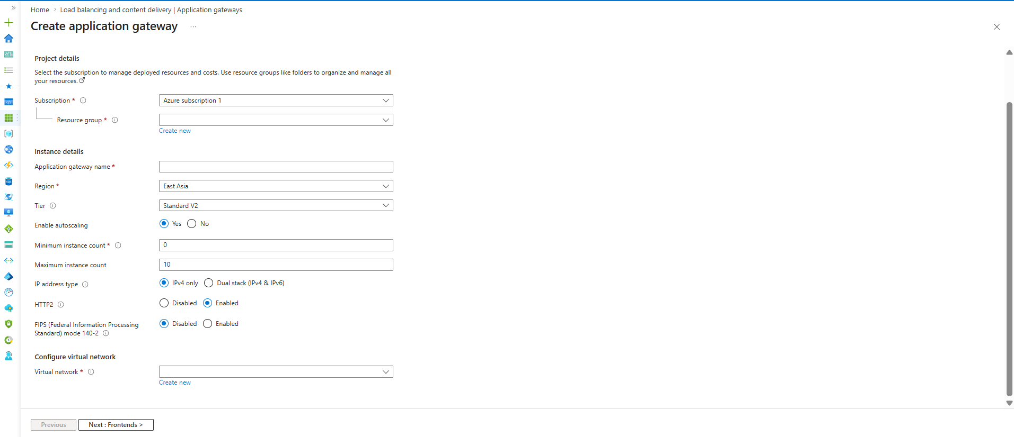

Subscription
Definition
- Azure account under which the Application Gateway is created.
Usage
- Billing, quotas, and resource ownership are managed here.
If not selected
- Azure cannot determine where to deploy the resource.
Example
Azure Subscription 1
Production Subscription
Dev Subscription

Resource Group
Definition
- Logical container that stores related Azure resources.
Usage
- Helps manage, monitor, and delete related resources together.
If not selected
- Resource creation is not possible.
Example
rg-dev
rg-test
rg-prod

Application Gateway Name
Definition
- Unique name assigned to the Application Gateway.
Usage
- Used for identification and management.
If not provided
- Resource cannot be created.
Example
agw-dev
agw-prod
agw-web

Region
Definition
- Azure datacenter location where the gateway will run.
Usage
- Determines latency and resource placement.
If chosen incorrectly
- Increased latency and cross-region traffic costs may occur.
Example
Central India
East Asia
East US

Tier
You have:
Standard V2
and sometimes:
WAF V2
Standard V2
- Normal Application Gateway.
- Supports autoscaling.
- Recommended for labs.
WAF V2
- Includes Web Application Firewall.
- Protects web applications from attacks.
Real Projects
Production → WAF V2
Testing/Learning → Standard V2

Enable Autoscaling
Definition
- Automatically increases or decreases gateway instances based on traffic.
Usage
- Handles sudden traffic spikes.
If disabled
- Fixed number of instances are used.
Example
Traffic increases
↓
Azure adds more Application Gateway instances

Minimum Instance Count
Definition
- Minimum number of gateway instances Azure keeps running.
Usage
- Ensures capacity is always available.
Current Value
0
Meaning Azure can scale down when traffic is very low.

Maximum Instance Count
Definition
- Maximum number of instances Azure can create during heavy traffic.
Usage
- Prevents unlimited scaling and unexpected costs.
Current Value
10
Meaning Azure can scale up to 10 gateway instances.

IP Address Type
IPv4 Only
Definition
- Gateway accepts only IPv4 traffic.
Usage
- Most commonly used option.

Dual Stack (IPv4 + IPv6)
Definition
- Supports both IPv4 and IPv6.
Usage
- Required when applications must support IPv6 clients.

HTTP/2
Definition
- Enables HTTP/2 protocol support between client and Application Gateway.
Usage
- Faster web performance.
- Multiplexing multiple requests over a single connection.
If disabled
- Uses traditional HTTP/1.1.
Interview Answer
HTTP/2 improves performance and reduces latency.

FIPS 140-2
Definition
- Uses cryptographic modules that comply with U.S. government security standards.
Usage
- Required in highly regulated industries.
If disabled
- Standard encryption is used.
Example
Government
Defense
Banking
Healthcare
Usually left Disabled unless compliance requires it.

Virtual Network (Very Important)
Definition
- Network in which Application Gateway is deployed.
Usage
- Application Gateway must be deployed inside a VNet.
Important Interview Point
Application Gateway requires a dedicated subnet.
Example:
VNet
├─ AppGatewaySubnet
│ └─ Application Gateway
│
├─ WebSubnet
│ └─ VM1
│ └─ VM2
│
└─ DatabaseSubnet
This is one of the first architecture concepts interviewers ask about.

So Microsoft's recommendation is:
VNet
├── AppGatewaySubnet
│ └── Application Gateway
│
├── WebAppSubnet
│ └── VM1
│ └── VM2
│
└── DatabaseSubnet
└── SQL Server

Memory Trick
For Azure networking:
Load Balancer
-------------
No dedicated subnet required
Application Gateway
-------------------
Dedicated subnet required
Frontend IP in Application Gateway
Definition
- Frontend IP is the entry point through which users access the Application Gateway.
Usage
- Receives HTTP/HTTPS requests from users before forwarding them to backend servers.
Flow
User
↓
Internet
↓
Frontend IP (Public/Private)
↓
Application Gateway
↓
HTTPS / Domain / URL Inspection
↓
Listener
↓
Routing Rule
↓
Backend Pool
↓
Web Servers
---------------------------------------------------------------------------------------------------------------------------------
Public Frontend IP
Definition
- Assigns a public IP address to the Application Gateway.
- Makes the gateway accessible from the Internet.
Usage
- Public websites
- Public APIs
- Customer-facing applications
If not used
- Internet users cannot access the Application Gateway.
Example
Internet Users
↓
Public IP
↓
Application Gateway
↓
Backend Servers

Private Frontend IP
Definition
- Assigns a private IP address from the VNet to the Application Gateway.
- Accessible only within the VNet or connected networks.
Usage
- Internal company applications
- Intranet portals
- Internal APIs
If not used
- Internal users cannot access the gateway using a private address.
Example
Corporate Users
↓
10.0.1.10
↓
Application Gateway
↓
Backend Servers

Both (Public + Private)
Definition
- Assigns both a public IP and a private IP to the same Application Gateway.
Usage
- When both Internet users and internal users need access.
- Hybrid application architectures.
If not used
- You must choose either internal-only or external-only access.
Example
Internet Users
↓
Public IP
↓
Internal Users
↓
Private IP
↓
Application Gateway
↓
Backend Servers

Interview Question
Q: When should we choose Public, Private, or Both?
Public
Public website
Public API
E-commerce application
Private
HR Portal
Internal Dashboard
Internal API
Both
Employees access internally
Customers access externally
Same Application Gateway

Easy Memory Trick
Public
------
Internet Access
Private
-------
Internal Access
Both
----
Internet + Internal Access
Real-World Architecture
Internet User
↓
Public IP
↓
Application Gateway
↓
Web Servers
Internal Employee
↓
Private IP
↓
Application Gateway
↓
Web Servers

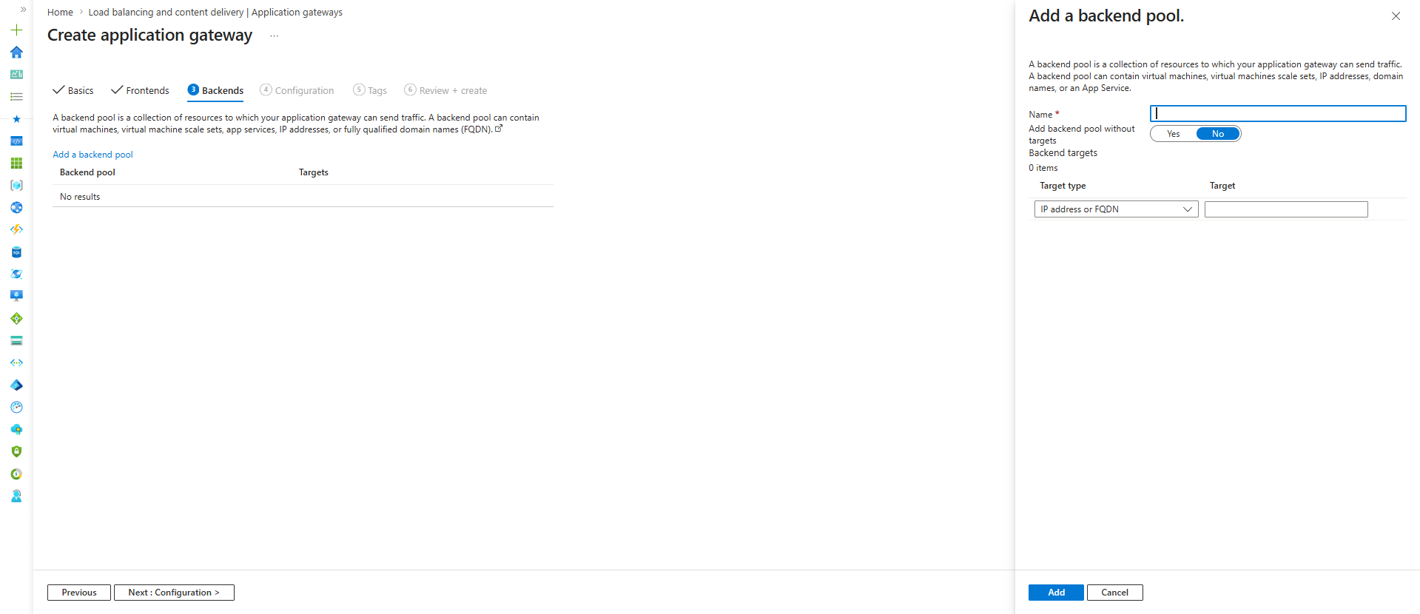
Backend Pool
Definition
- Backend Pool is a collection of destinations where Application Gateway forwards traffic.
- These destinations can be:
  - Virtual Machines
  - VM Scale Sets
  - App Services
  - Private IP Addresses
  - FQDNs (Domain Names)

Usage
Application Gateway receives requests from users and sends them to resources configured in the Backend Pool.
User
↓
Application Gateway
↓
Backend Pool
↓
VM1
VM2
VM3

If Not Configured
- Application Gateway can receive traffic.
- But it won't know where to send the traffic.
- Requests will fail.

Flow with Backend Pool
User
↓
Internet
↓
Frontend IP
↓
Application Gateway
↓
Backend Pool
↓
Backend Servers

Name
Definition
- Logical name for the backend pool.
Example
web-backend-pool
api-backend-pool
app-backend-pool

Add Backend Pool Without Targets
Yes
Meaning
Create Backend Pool First
Add Servers Later
Useful during initial setup.

No
Meaning
Create Backend Pool
Add Servers Immediately
This is the option selected in your screenshot.

Backend Targets
This is where we define the actual servers.

Target Type
You currently see:
IP Address or FQDN

IP Address
Example:
10.0.2.4
10.0.2.5
10.0.2.6
Application Gateway forwards traffic directly to these IPs.

FQDN
FQDN means:
Fully Qualified Domain Name
Example:
api.company.com
app.company.com
web.company.com
Instead of an IP, Application Gateway uses DNS resolution.

Real Project Example
Suppose:
VM1 = 10.0.2.4
VM2 = 10.0.2.5
Backend Pool:
web-backend-pool
├─ 10.0.2.4
└─ 10.0.2.5
Flow:
User
↓
Application Gateway
↓
web-backend-pool
↓
VM1 / VM2

Difference from Load Balancer Backend Pool
Actually very similar.
Load Balancer
Backend Pool
↓
VM1
VM2
VM3

Application Gateway
Backend Pool
↓
VM1
VM2
VM3
App Services
FQDNs
The main difference is:
Load Balancer
-------------
Routes based on IP + Port
Application Gateway
-------------------
Routes based on URL/Domain
Then sends traffic to Backend Pool

Backend Pool
- Backend Pool is a collection of backend resources that receive traffic from the Application Gateway.
- It can contain VMs, VM Scale Sets, App Services, IP addresses, or FQDNs.
- Application Gateway forwards requests to the resources configured in the Backend Pool.
- Without a Backend Pool, Application Gateway cannot deliver traffic to backend applications.

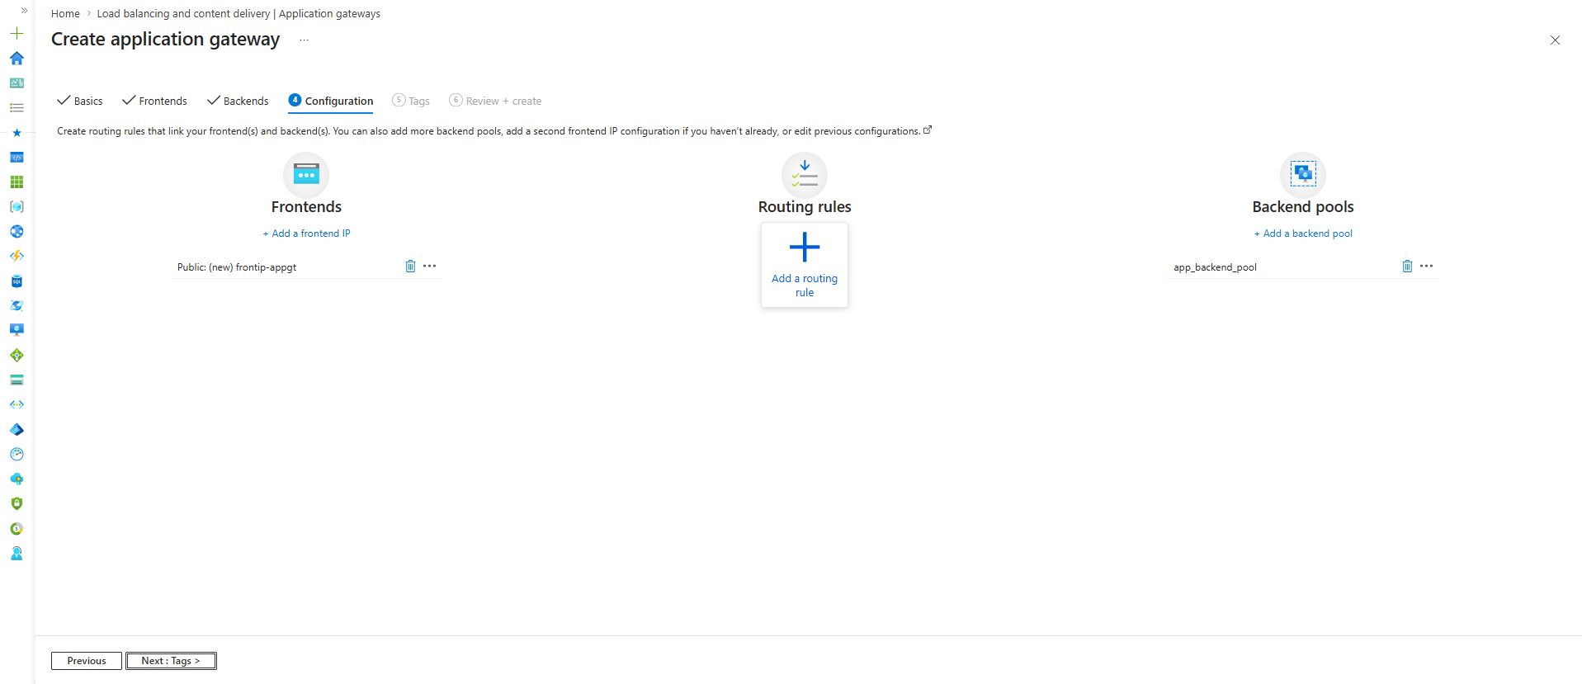
Until now we created:
Frontend IP ✅
Backend Pool ✅
But they are not connected yet.
That's why Azure is asking for:
Routing Rule

Why Routing Rule?
Think of it like this:
User
↓
Frontend IP
↓
???
↓
Backend Pool
Azure is asking:
"Traffic arrived on Frontend IP. Which Backend Pool should I send it to?"
That's what a Routing Rule answers.

What happens when you click "Add a routing rule"?
You'll see three major concepts:
Listener
↓
Backend Settings
↓
Routing Rule
These are the heart of Application Gateway.

Listener
Definition
Listener waits for incoming requests.
Usage
It checks:
Protocol
HTTP or HTTPS
Port
80 or 443
Hostname
company.com
api.company.com
Example
HTTPS
Port 443
company.com
Listener says:
"I am listening for HTTPS traffic
on port 443 for company.com"

Backend Settings (HTTP Settings)
Definition
Tells Application Gateway how to communicate with backend servers.
Usage
Defines:
HTTP or HTTPS
Port Number
Cookie Affinity
Timeout
Example
Protocol = HTTP
Port = 80
Meaning:
Gateway
↓
HTTP:80
↓
Backend VM

Routing Rule
Definition
Connects Listener to Backend Pool.
Usage
Tells Application Gateway:
If request comes through Listener A
↓
Send traffic to Backend Pool A

Complete Flow
This is the architecture you must remember:
User
↓
Internet
↓
Frontend IP
↓
Listener
↓
Routing Rule
↓
Backend Settings
↓
Backend Pool
↓
VM

Comparison with Load Balancer
Load Balancer flow:
Frontend IP
↓
Load Balancing Rule
↓
Backend Pool
Application Gateway flow:
Frontend IP
↓
Listener
↓
Routing Rule
↓
Backend Settings
↓
Backend Pool
That's why Application Gateway is smarter—it has extra layers that understand HTTP, HTTPS, domains, and URLs.
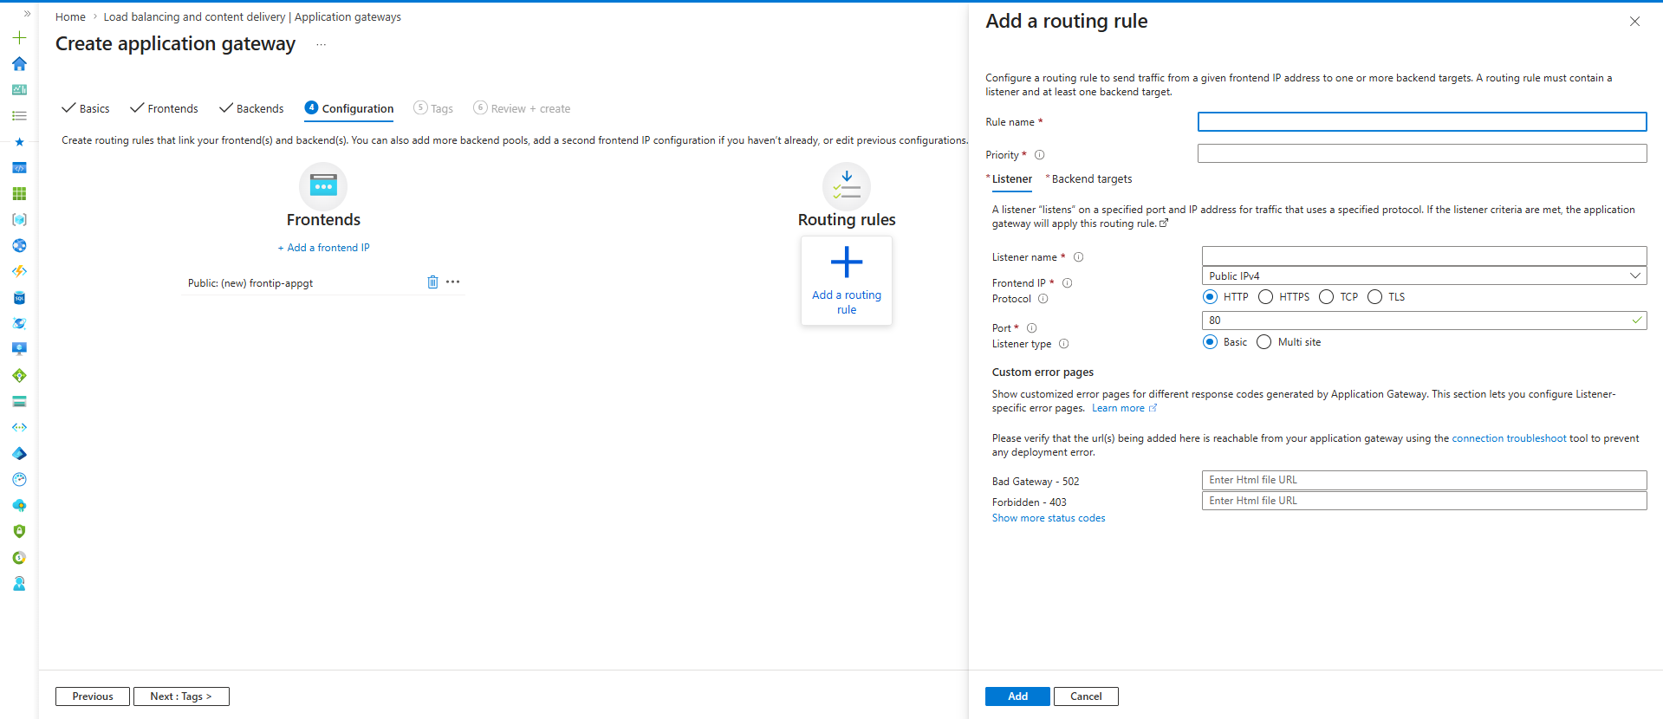
Rule Name
Definition
- Name of the routing rule.
Usage
- Identifies the routing configuration.
Example
web-rule
api-rule
app-rule

Priority
Definition
- Determines which rule gets evaluated first.
Usage
- Lower number = higher priority.
Example
100
200
300
If two rules can match a request:
Priority 100
wins over
Priority 200

Listener (Most Important)
Think of a Listener as a security guard at the gate.
When traffic arrives:
User
↓
Frontend IP
↓
Listener
The listener checks:
Protocol
Port
Hostname
before allowing traffic further.

Listener Name
Definition
- Name of the listener.
Example
http-listener
https-listener
web-listener

Frontend IP
Currently:
Public IPv4
Meaning:
Internet Users
↓
Public IP
↓
Application Gateway
This listener will use that Frontend IP.

Protocol
You see:
HTTP
HTTPS
TCP
TLS

HTTP
Usage
Port 80
Traffic is not encrypted.
Example:
http://company.com

HTTPS
Usage
Port 443
Traffic is encrypted using SSL/TLS.
Example:
https://company.com
Most production websites use HTTPS.

TCP
Usage
- Layer 4 traffic.
- Non-web applications.
Example:
Database
Custom Application

TLS
Usage
- Encrypted TCP traffic.
Less common for beginner labs.

Port
Currently:
80
Meaning:
HTTP Traffic
Common values:
80 → HTTP
443 → HTTPS

Listener Type
You see:
Basic
Multi Site

Basic
Usage
One Website
Example:
company.com

Multi Site
Usage
Multiple domains on same gateway.
Example:
app.company.com
api.company.com
admin.company.com
Application Gateway routes based on hostname.

Backend Targets
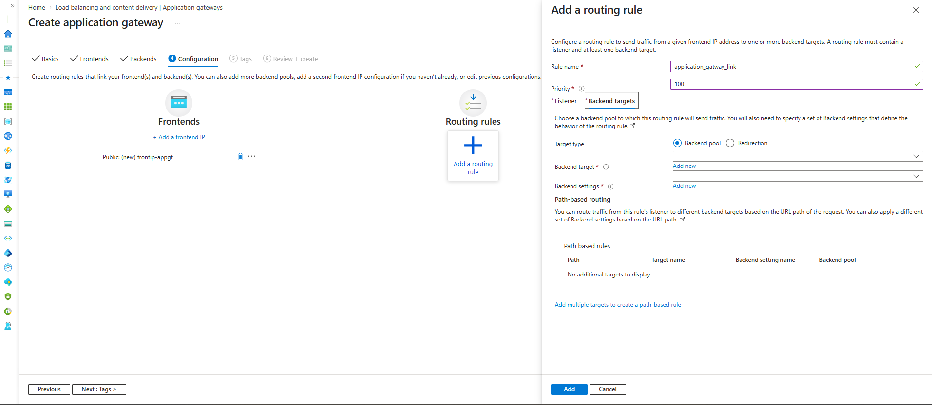
This is where you connect:
Listener
↓
Backend Pool
and define how Application Gateway talks to the backend servers.

Target Type
Backend Pool
Definition
- Sends traffic to backend servers.
Usage
- Most common option.
- Used for websites, APIs, App Services, VMs.
Flow
User
↓
Application Gateway
↓
Backend Pool
↓
VM1
VM2

Redirection
Definition
- Redirects users to another URL or listener.
Usage
Example:
http://company.com
↓
Redirect
↓
https://company.com
Commonly used for HTTP → HTTPS redirection.

Backend Target
Definition
- Selects the backend pool that receives traffic.
Usage
- Connects the listener to a backend pool.
Your Example
app_backend_pool
When selected:
Listener
↓
app_backend_pool
↓
VM

Backend Settings
This is one of the most important Application Gateway components.
Think:
Application Gateway
↓
How should I talk
to the VM?
Backend Settings answers that.

It defines:
Protocol
HTTP or HTTPS
Port
80 or 443
Cookie Affinity
Timeout

Example
Protocol = HTTP
Port = 80
Meaning:
Application Gateway
↓
HTTP:80
↓
Backend VM

Another Example
Protocol = HTTPS
Port = 443
Meaning:
Application Gateway
↓
HTTPS:443
↓
Backend VM

Very Important Difference
Many beginners think:
Listener Port = Backend Port
Not necessarily.
Example:
Client
↓
HTTPS 443
↓
Application Gateway
↓
HTTP 80
↓
Backend VM
This is called:
SSL Termination
We'll learn it later.

Path-Based Routing Section
This is the feature that makes Application Gateway famous.
Example:
/app/*
↓
App Servers
/api/*
↓
API Servers
/admin/*
↓
Admin Servers
Application Gateway reads the URL path and sends traffic to different backend pools.
We'll cover this separately after completing the basic setup.
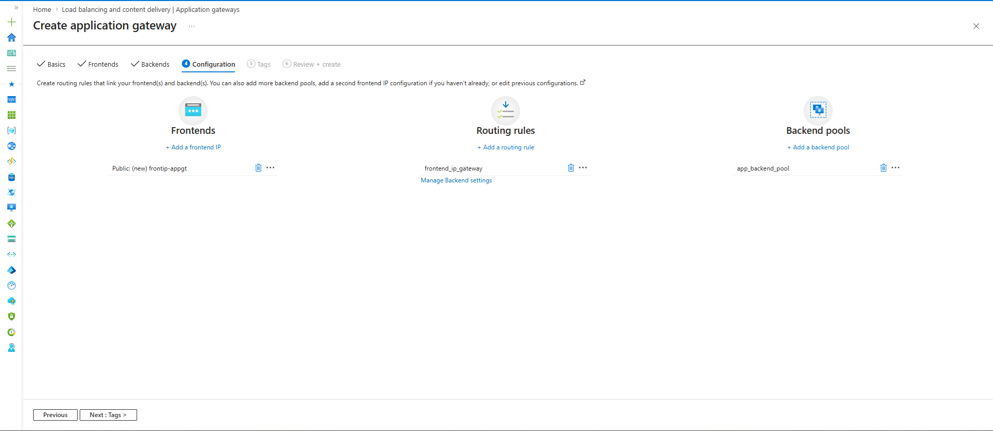

One-Line Story
User enters through Frontend IP,
Listener validates the request,
Routing Rule decides the destination,
Backend Settings define communication,
Backend Pool contains the actual servers.

Path-Based Architecture
User
↓
https://company.com/app
↓
Application Gateway
↓
app_backend_pool

User
↓
https://company.com/api
↓
Application Gateway
↓
api_backend_pool

User
↓
https://company.com/admin
↓
Application Gateway
↓
admin_backend_pool

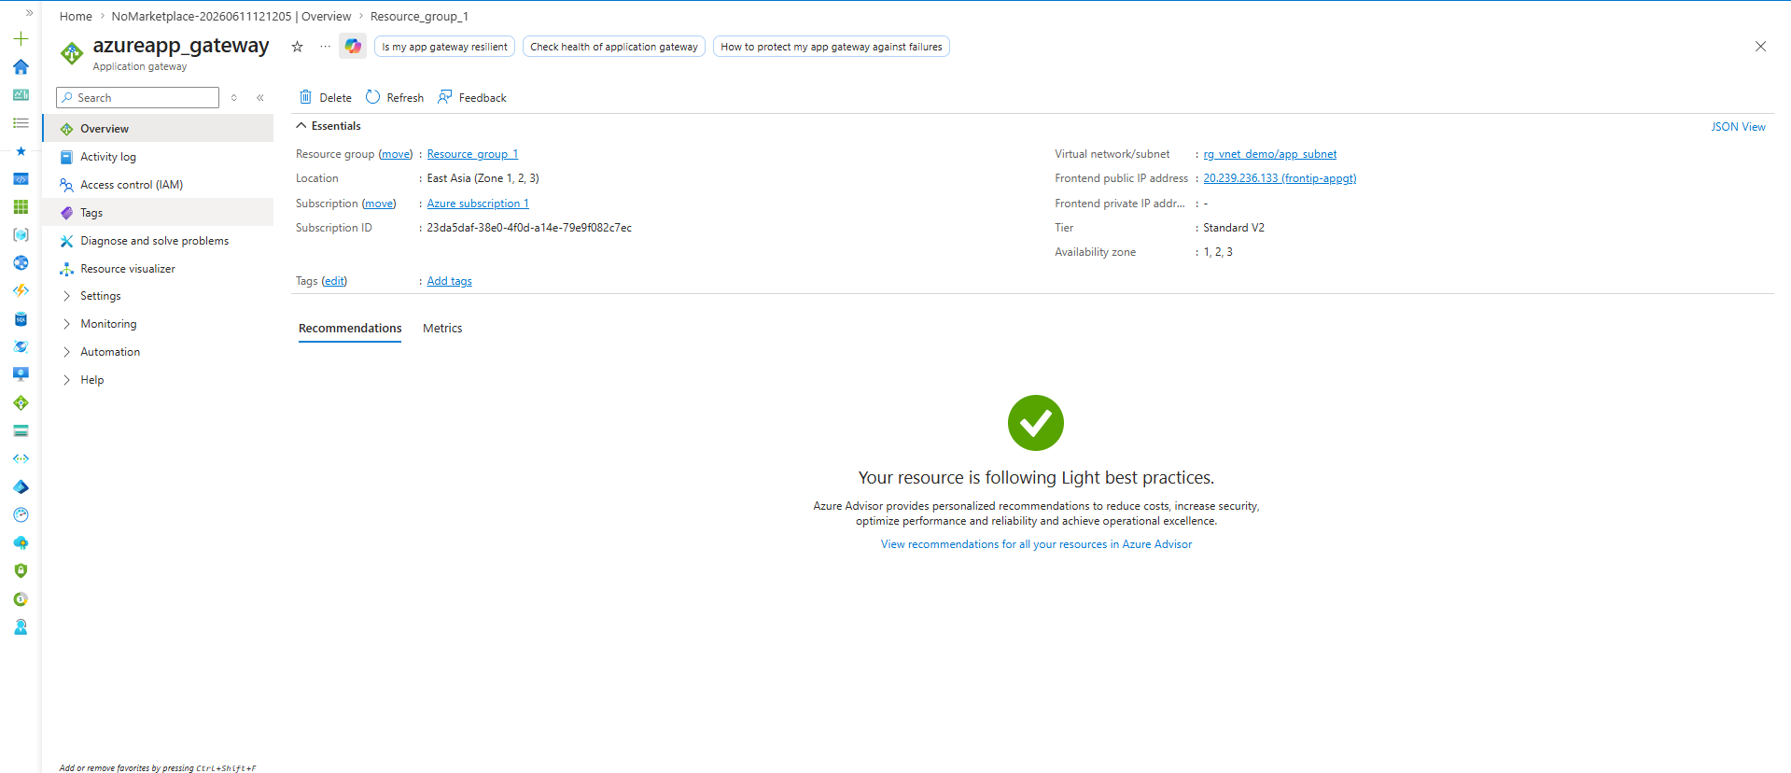
Application Gateway : azureapp_gateway
Status : Created Successfully
Frontend Public IP : 20.239.236.133
Subnet : app_subnet
Tier : Standard V2
So your Application Gateway deployment is successful.

look at the architecture you built:
User
↓
Internet
↓
20.239.236.133
(Frontend Public IP)
↓
Application Gateway
↓
Listener
(HTTP Port 80)
↓
Routing Rule
↓
Backend Settings
(HTTP Port 80)
↓
Backend Pool
(app_backend_pool)
↓
VM Private IP
(10.0.1.4)
This is the complete end-to-end flow.
SSL Termination
Definition
- SSL Termination is the process where Application Gateway decrypts incoming HTTPS traffic and forwards it to backend servers using HTTP or HTTPS.
Usage
- Centralizes SSL certificate management.
- Reduces SSL processing load on backend servers.
- Simplifies certificate renewal and maintenance.
If Not Used
- Every backend server must have its own SSL certificate.
- Certificate management becomes complex.
- Backend servers handle encryption and decryption.
Example
Without SSL Termination:
User
↓
HTTPS
↓
VM1
User
↓
HTTPS
↓
VM2
Certificate required on every VM.
With SSL Termination:
User
↓
HTTPS (443)
↓
Application Gateway
↓
HTTP (80)
↓
Backend Servers
Certificate installed only on Application Gateway.
Real Project Usage
- Public websites.
- E-commerce applications.
- Enterprise web applications.
- API gateways.
Interview Point
- SSL Termination improves manageability by handling SSL certificates at the Application Gateway instead of individual backend servers.

Web Application Firewall (WAF)
Definition
- WAF is a security feature that inspects HTTP and HTTPS requests before they reach the application and protects against common web attacks.
Usage
- Protects websites and APIs from malicious traffic.
- Detects and blocks web-based attacks.
- Provides application-layer security.
If Not Used
- Malicious requests reach backend applications directly.
- Applications become more vulnerable to web attacks.
Architecture
User
↓
Internet
↓
Application Gateway + WAF
↓
Backend Pool
↓
Application

SQL Injection Protection
Definition
- Detects malicious SQL commands embedded in user requests.
Usage
- Prevents unauthorized database access.
Example
Attack Request:
https://company.com/login?id=1' OR '1'='1
Without WAF:
Request
↓
Application
With WAF:
Request
↓
WAF
↓
Blocked

Cross-Site Scripting (XSS) Protection
Definition
- Detects malicious scripts injected into web requests.
Usage
- Prevents execution of harmful JavaScript code.
Example
Attack Payload:
<script>alert('hack')</script>
Without WAF:
Request
↓
Application
With WAF:
Request
↓
WAF
↓
Blocked

WAF Modes
Detection Mode
Definition
- Detects attacks and generates logs but allows traffic.
Usage
- Testing and monitoring environments.
If Not Used
- Administrators cannot analyze attack patterns before enabling blocking.
Example
Attack Detected
↓
Logged
↓
Request Allowed

Prevention Mode
Definition
- Detects attacks, generates logs, and blocks traffic.
Usage
- Production environments.
If Not Used
- Malicious traffic may reach applications.
Example
Attack Detected
↓
Logged
↓
Request Blocked

Standard V2 vs WAF V2
Standard V2
Features
- Load Balancing
- URL Routing
- SSL Termination
- Autoscaling
WAF V2
Features
- Load Balancing
- URL Routing
- SSL Termination
- Autoscaling
- SQL Injection Protection
- XSS Protection
- Web Application Security Rules

Interview Difference
NSG / Firewall
Works on:
IP Address
Port
Protocol
WAF
Works on:
HTTP Requests
HTTPS Requests
URLs
Headers
Cookies
Attack Signatures
One-Line Summary
SSL Termination = Handles HTTPS encryption at Application Gateway.
WAF = Protects web applications from attacks such as SQL Injection and Cross-Site Scripting before reques

