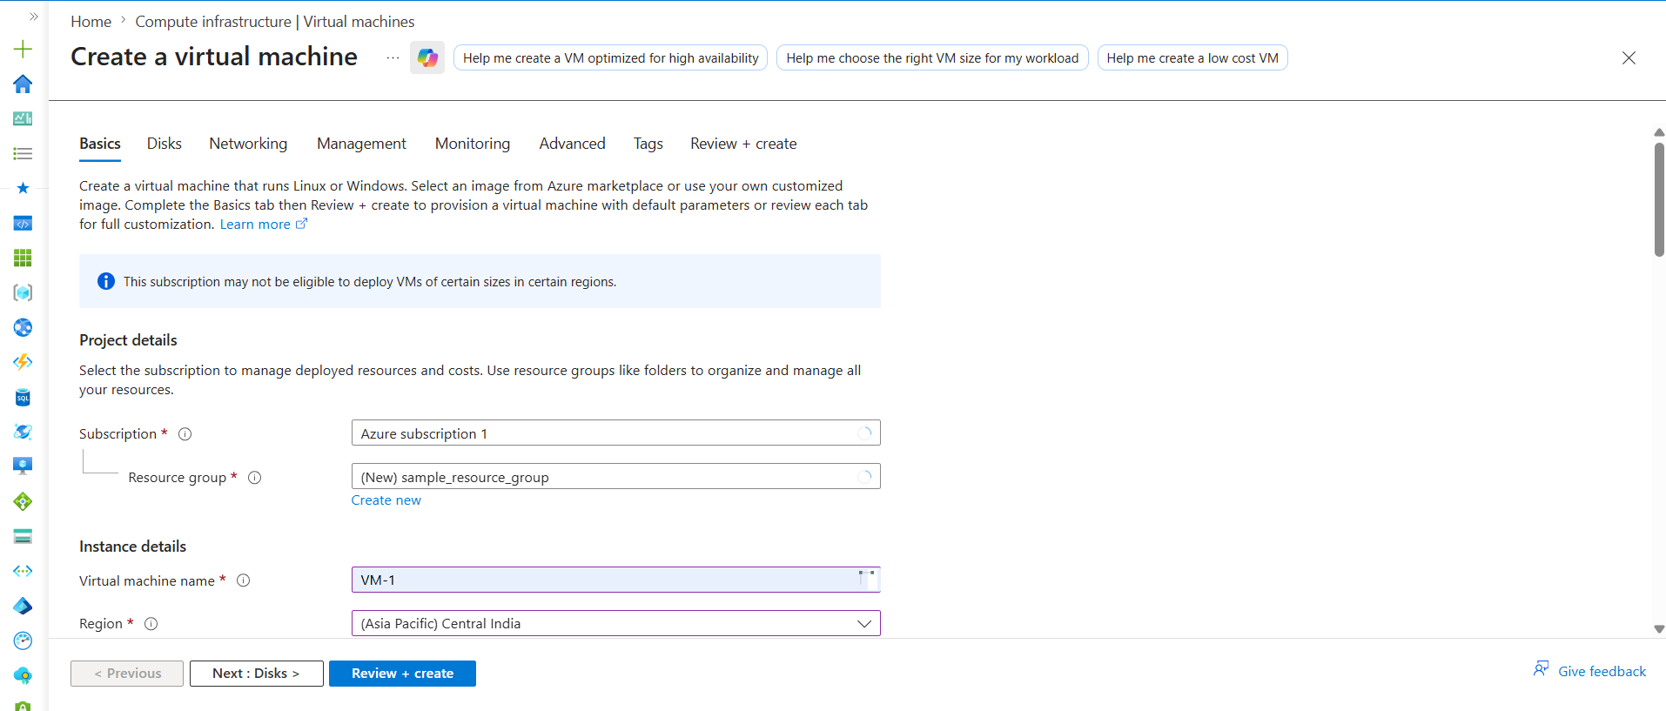
Subscription
Billing + ownership boundary
It controls:
- Payment
- Limits
- Quotas
- Access control
Everything must belong to one subscription.

Resource Group
Your understanding is correct.
Think like:
Folder / container / repository of resources
Azure uses Resource Group to organize resources logically.

Real Example
Resource Group : RG-DEV
--------------------------------
VM
VNet
NSG
Storage Account
Public IP
All related resources stored together.
1. Virtual Machine Name
From your screenshot:
VM-1

What is Virtual Machine Name?
It is simply:
The name/identity of your server
Exactly like:
- Your laptop name
- Hostname in Linux

Why VM Name Important?
Because in enterprise there are:
- Hundreds of VMs
- Thousands sometimes
So proper naming is VERY important.
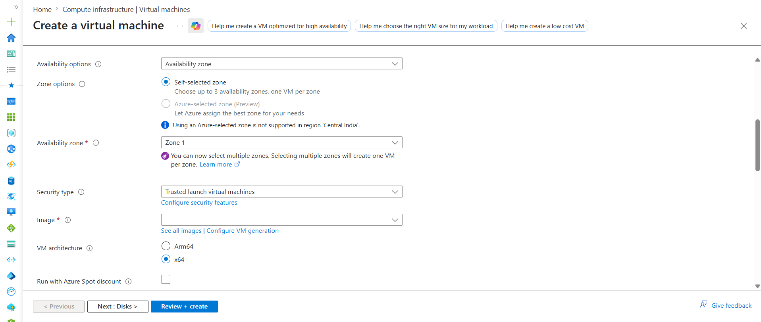
What is Region?
Region means:
Physical Azure datacenter location
Microsoft has datacenters worldwide.
Examples:
- Central India
- East US
- West Europe
- Southeast Asia

Real-World Meaning
If you select:
Central India
Your VM will physically run in:
Microsoft datacenter located in Central India region

Why Region Important?
Because it affects:
- Latency
- Cost
- Compliance
- Availability

What is Availability?
Availability means:
Keeping applications running even if failures happen
Failures can happen:
- Datacenter failure
- Power issue
- Hardware issue
- Rack failure
Azure provides HA (High Availability) features.

Availability Options in Azure
You saw:
- Availability Zone
- Availability Set
- No Infrastructure Redundancy

Simplest Understanding
Option | Purpose
No redundancy | Single VM only
Availability Set | Protect within datacenter
Availability Zone | Protect across datacenters

For Beginners
Usually use:
No infrastructure redundancy
because:
- simple
- cheaper

4. Availability Zones
This is VERY important.

What is Availability Zone?
Inside one Azure Region:
Multiple separate datacenters exist
These are called:
Availability Zones

Example
Central India region may contain:
Zone 1
Zone 2
Zone 3
Each zone:
- Separate building
- Separate power
- Separate cooling
- Separate networking

Real Architecture
Central India Region
---------------------
Zone 1 → Datacenter A
Zone 2 → Datacenter B
Zone 3 → Datacenter C

Why Zones Needed?
Suppose:
Zone 1 fails
due to:
- power issue
- fire
- network outage
Then:
VM in Zone 2 still works
This provides:
High Availability

Zone Options:
Zone options
with:
- Self-selected zone
- Azure-selected zone

First Understand Why This Exists
Earlier we discussed:
Region
↓
Contains multiple zones
Example:
Central India
├── Zone 1
├── Zone 2
└── Zone 3
Now Azure asks:
Who should decide the zone placement?
You?
OR
Azure?
That is called:
Zone Options

1. Self-Selected Zone
From your screenshot:
Self-selected zone
Meaning:
YOU manually choose the zone
Example:
Zone 1
Then Azure creates VM specifically in:
Zone 1 datacenter

Why Use Self-Selected?
Used when:
- Architecture planning needed
- High availability setup
- Multi-zone deployments

VERY IMPORTANT Difference
Term | Meaning
Availability Option | High Availiabilty strategy
Availability Zone | Actual datacenter
Zone Option | Who chooses the zone
Azure VM — Security Type & Image
1. Security Type
What is Security Type?
Security Type defines:
- How securely the VM should boot
- What security protections Azure should enable
- Whether advanced security features are needed
Simple Meaning:
Security Type = VM protection level

Available Options
1. Standard
Basic/default VM security.
Used for:
- Learning
- Practice
- Normal workloads
Azure creates:
- Normal VM
- Standard boot process
Best for beginners.
Example:
Ubuntu VM with standard security

2. Trusted Launch Virtual Machine
Advanced enterprise security option.
Provides:
- Secure Boot
- TPM support
- Boot protection
- Malware/rootkit protection
Used in:
- Banking projects
- Production environments
- Security-sensitive workloads

Simple Analogy
Option | Analogy
Standard | Normal house lock
Trusted Launch | Advanced security system

Important Point
Security Type is NOT firewall/security rules.
Firewall/network protection is handled by:
NSG (Network Security Group)
Security Type only protects:
VM startup and operating environment

Beginner Recommendation
For learning:
Use Standard Security Type

Interview Definition
Security Type defines the security protections enabled for a virtual machine during boot and runtime.

2. Image
What is Image?
Image is:
A preconfigured Operating System template used to create VMs
Simple Meaning:
Before creating VM, Azure asks:
Which Operating System should be installed?
Image provides that OS template.

Common Images
Examples:
- Ubuntu Server 22.04
- Ubuntu Server 24.04
- Windows Server 2022
- RedHat Linux
- Debian

AWS Equivalent
Azure | AWS
Image | AMI

Real Example
If you select:
Ubuntu Server 24.04 LTS
Azure creates:
Linux VM with Ubuntu OS installed

What Image Contains
Image already includes:
- Operating System
- Default packages
- System configuration

Why Ubuntu is Common in DevOps
Because:
- Lightweight
- Free
- Stable
- Kubernetes friendly
- Most DevOps tools support Linux
Most DevOps engineers prefer:
Ubuntu Server LTS

What is LTS?
LTS means:
Long Term Support
Provides:
- Long security support
- Stability
- Enterprise reliability

Important Point
Image is NOT the VM itself.
Image is:
Template used to create VM

Simple Analogy
Concept | Example
Image | Cake mold/template
VM | Actual baked cake

One Image → Multiple VMs
Example:
Ubuntu Image
↓
VM-1
VM-2
VM-3
All are separate servers.

Real DevOps Example
Ubuntu Image
↓
Create VM
↓
Install Jenkins
Install Docker
Install kubectl

Interview Definition
An Image is a preconfigured operating system template used to create virtual machines.
Azure VM Architecture & Spot VM
1. VM Architecture
VM Architecture means:
Processor type used by the VM
Types:
- x64
- Arm64

x64
Most common architecture.
Used for:
- Jenkins
- Docker
- Kubernetes
- Terraform
- Linux servers
Best for:
DevOps and enterprise workloads
Recommended for beginners.

Arm64
ARM processor-based architecture.
Advantages:
- Cost efficient
- Lower power usage
Disadvantages:
- Some software compatibility issues

Simple Difference
x64 | Arm64
Most compatible | More efficient
Enterprise standard | Newer architecture

Recommendation
For learning:
Use x64

2. Run with Azure Spot Discount
Azure Spot VM means:
Using unused Azure servers at lower cost

Important Point
Azure can:
Stop the VM anytime
when resources are needed elsewhere.
This is called:
Eviction

Benefits
- Very cheap
- Cost saving

Good For
- Testing
- Practice
- Temporary workloads
- CI/CD jobs

Not Good For
- Production applications
- Important servers
- Databases

AWS Equivalent
Azure | AWS
Spot VM | EC2 Spot Instance

Recommendation
For beginners:
Do NOT enable Spot VM initially
Use normal stable VM.

Interview Definitions
VM Architecture defines the processor type used by the virtual machine.
Azure Spot VM is a low-cost VM that uses unused Azure capacity and can be interrupted anytime by Azure.
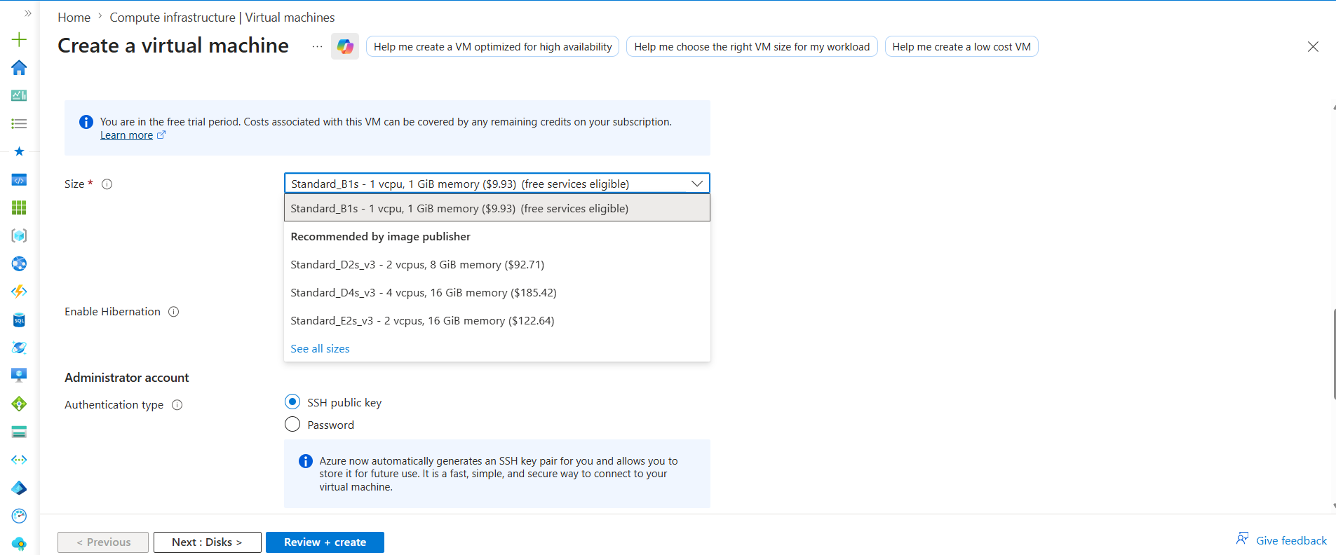
Azure VM Size & Enable Hibernation
1. VM Size
VM Size defines:
CPU and RAM configuration of the VM
Simple Meaning:
How powerful the VM should be

Example
Standard_B2s
May provide:
- 2 vCPU
- 4 GB RAM

VM Size Affects
- Performance
- Speed
- Cost
- Workload capacity

Small Sizes
Used for:
- Practice
- Small servers
- Testing
Example:
B1s
B2s

Large Sizes
Used for:
- Production
- Databases
- Heavy applications
Example:
D-series
E-series

Real DevOps Usage
Use Case | Recommended Size
Jenkins Practice | B2s
Docker Testing | B2s
Production Apps | D-series

Recommendation
For learning:
Use B2s VM
because:
- Cheap
- Enough for DevOps practice

2. Enable Hibernation
Hibernation means:
Pause VM and save current state to disk

Simple Meaning
Instead of completely shutting down VM:
VM sleeps and remembers everything
When restarted:
- Applications reopen
- Processes continue
- Session restored

Real-Life Analogy
Shutdown | Hibernation
Full power off | Sleep mode

Benefits
- Faster restart
- Resume work quickly

Disadvantages
- Extra storage needed
- Not supported for all VM sizes

Real Usage
Useful for:
- Personal development VMs
- Temporary pause
Not very common in production DevOps environments.

Recommendation
For beginners:
Keep hibernation disabled

Interview Definitions
VM Size defines the CPU and memory capacity allocated to a virtual machine.
Hibernation saves the VM state to disk and allows it to resume later from the same state.

Azure VM — Administrator Account
What is Administrator Account?
Administrator Account means:
The main login user for the VM
This account is created during VM creation.

Purpose
Used to:
- Login into VM
- Install software
- Run admin commands
- Manage server

Linux VM Example
While creating Ubuntu VM:
Username : azureuser
Then login using:
ssh azureuser@<public-ip>

Windows VM Example
Used for:
- RDP login
- Windows administration

Authentication Methods
Two methods available:
1. SSH Public Key (Recommended)
More secure method.
Uses:
- Private key
- Public key
Best for:
Linux DevOps servers

Flow
Private Key → Your Laptop
Public Key → Azure VM
Then SSH connection works securely.

2. Password Authentication
Uses:
Username + Password
Simpler but less secure.

Beginner Recommendation
For learning:
Password authentication is easier
For real DevOps projects:
SSH Key authentication is preferred

Important Point
Administrator Account is:
NOT the Azure portal account
It is:
Login account INSIDE the VM

Real DevOps Usage
After VM creation:
Login into VM
↓
Install Docker
Install Jenkins
Install kubectl
All done using administrator account.

Interview Definitions
Administrator Account is the primary user account used to access and manage the virtual machine.
SSH Key authentication uses public and private keys for secure VM access.

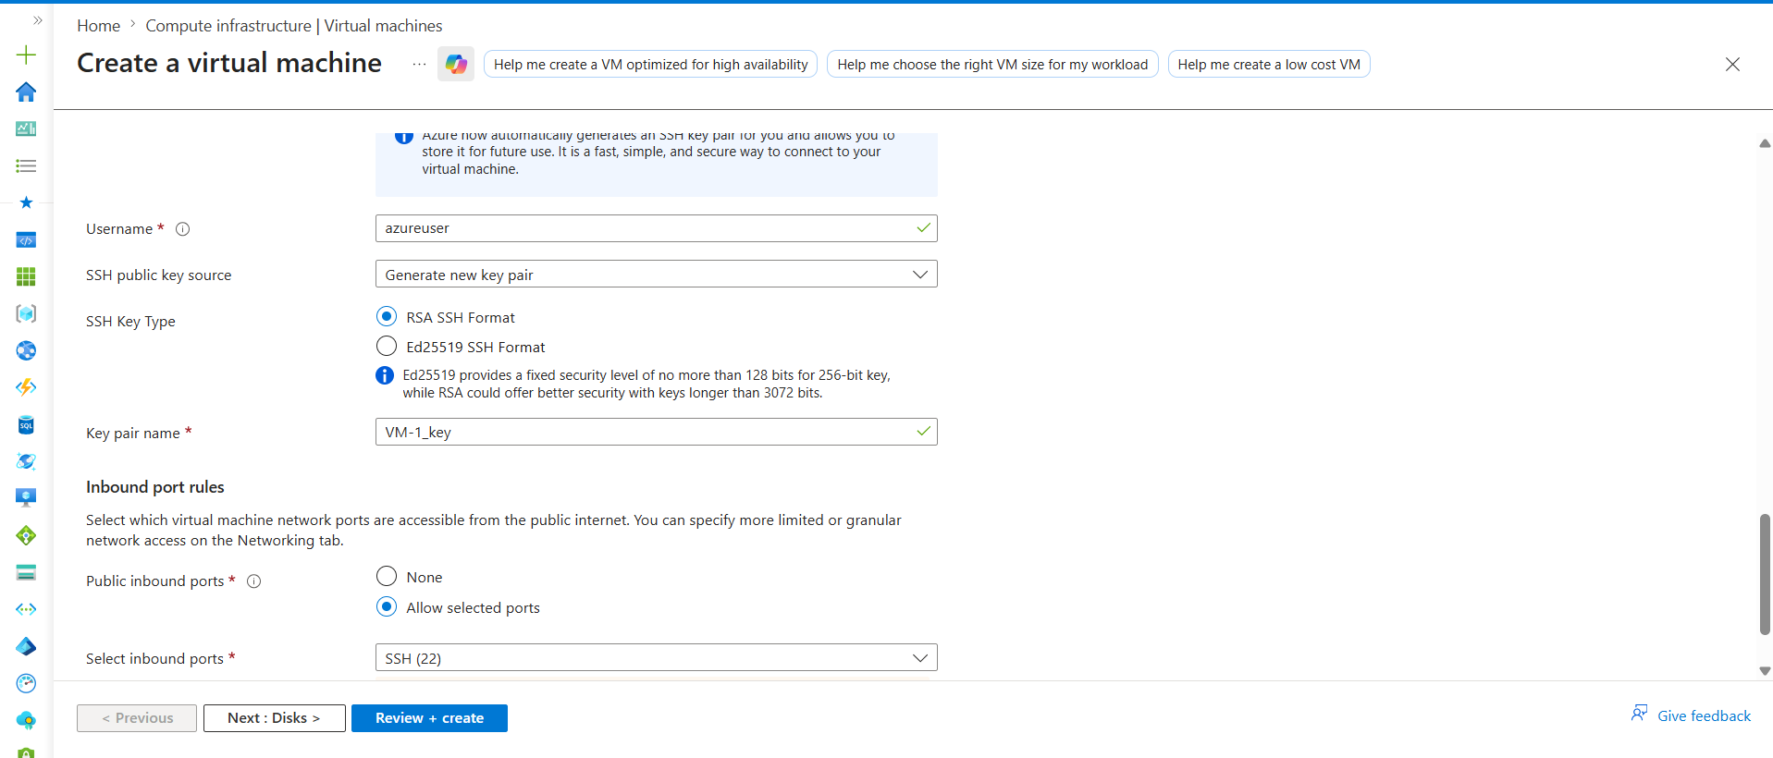

Azure VM — SSH Key Types (RSA vs Ed25519)
While creating VM, Azure asks which SSH key format to use:
- RSA SSH Format
- Ed25519 SSH Format
These are:
Different cryptographic algorithms used for SSH authentication

1. RSA SSH Format
MOST common and widely supported format.
Used in:
- Linux servers
- Jenkins
- Older systems
- Enterprise environments
Advantages:
- Highly compatible
- Supported everywhere
- Industry standard for many years
Disadvantages:
- Larger key size
- Slightly slower than Ed25519

2. Ed25519 SSH Format
Newer modern SSH algorithm.
Advantages:
- Faster
- Smaller keys
- Strong security
- Better performance
Disadvantages:
- Some older systems/tools may not support it

Simple Difference
RSA | Ed25519
Older standard | Modern standard
More compatible | Faster & smaller
Enterprise widely used | Newer environments

Beginner Recommendation
For learning and compatibility:
Use RSA SSH Format
because:
- Works everywhere
- Easier for beginners
- Most tutorials use RSA

Real DevOps Usage
Most enterprise DevOps projects still commonly use:
RSA keys
though Ed25519 adoption is growing.

Important Point
Both are:
Secure SSH authentication methods
Difference is mainly:
- Algorithm
- Speed
- Compatibility

Interview Definitions
RSA and Ed25519 are SSH key algorithms used for secure virtual machine authentication.
RSA provides broad compatibility, while Ed25519 offers faster performance and smaller keys.

Azure VM — Inbound Port Rules
What are Inbound Port Rules?
Inbound Port Rules define:
Which traffic is allowed to enter the VM
Simple Meaning:
Which ports/users can access your server

Why Needed?
By default:
VM should not allow all traffic
for security reasons.
Inbound rules control:
- SSH access
- Website access
- Application access

Common Ports
Port | Purpose
22 | SSH
80 | HTTP
443 | HTTPS
8080 | Jenkins

Example
If you allow:
Port 22
You can SSH into VM:
ssh azureuser@<public-ip>

SSH (22)
Used for:
Linux remote login
MOST IMPORTANT for DevOps engineers.

HTTP (80)
Used for:
Websites/applications

HTTPS (443)
Used for:
Secure encrypted web traffic

Jenkins Port (8080)
Used for:
Accessing Jenkins UI
Example:
http://<public-ip>:8080

Your Current VM
You selected:
Allow selected ports → SSH (22)
Meaning:
Only SSH access is allowed from internet
Good and safe for beginners.

Where Are These Rules Stored?
Inbound rules are actually configured inside:
NSG (Network Security Group)

Simple Flow
Internet User
↓
NSG checks port rules
↓
Allowed traffic reaches VM

Security Best Practice
Never open unnecessary ports.
Example:
Open only required ports
Production companies restrict access heavily.

Beginner Recommendation
For learning:
Allow only SSH (22)
Later:
- 8080 for Jenkins
- 80/443 for applications

AWS Equivalent
Azure | AWS
NSG Inbound Rules | Security Group Inbound Rules

Interview Definitions
Inbound Port Rules define which incoming network traffic is allowed to access the virtual machine.
Port 22 is commonly used for SSH access to Linux virtual machines.
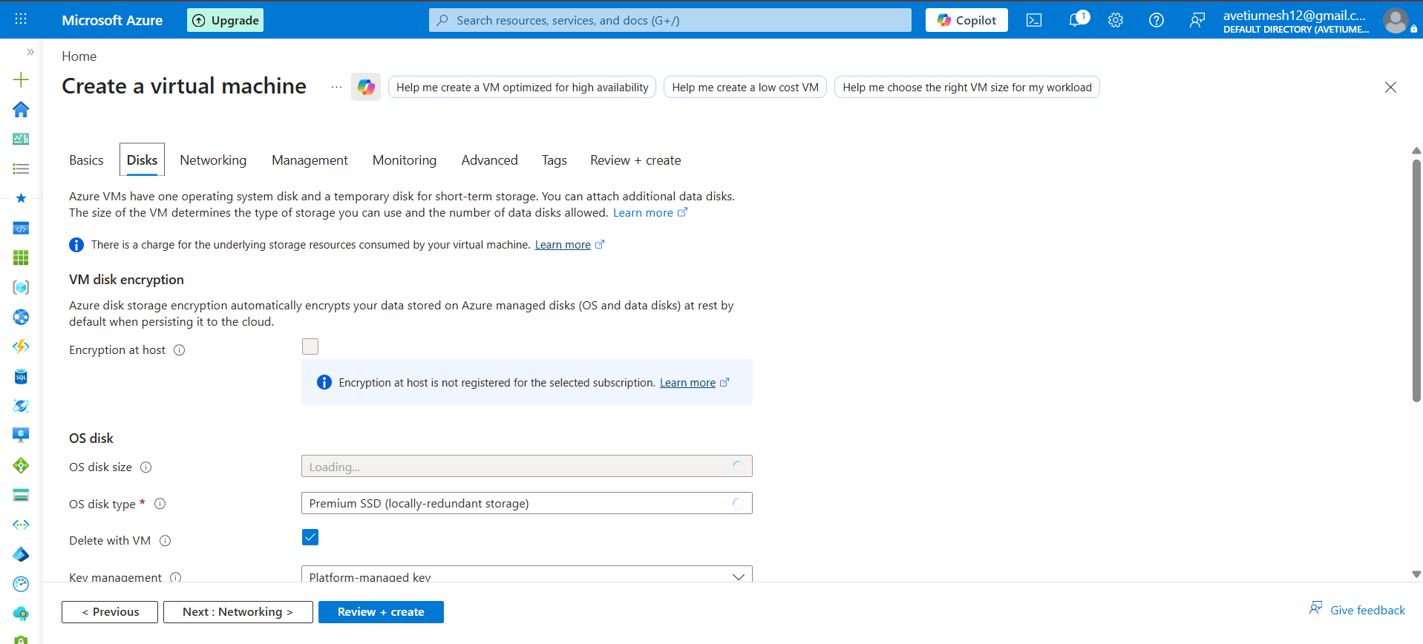
Azure VM — Disks Tab
What is Disks Tab?
Disks tab is used to configure:
Storage for the virtual machine
VM requires storage to keep:
- Operating System
- Applications
- Files
- Logs

1. OS Disk
OS Disk means:
Main storage where Operating System is installed
Example:
Ubuntu Linux installed inside OS Disk
Simple Analogy:
OS Disk = Hard Disk / SSD of computer

What Stored Inside OS Disk?
- Ubuntu/Linux OS
- Docker
- Jenkins
- kubectl
- Configuration files
- Application files

2. OS Disk Size
Defines:
How much storage space VM gets
Examples:
- 30 GB
- 64 GB
- 128 GB

Beginner Recommendation
For practice:
Default disk size is enough
Usually:
30–64 GB sufficient

3. OS Disk Type
Defines:
Storage performance type

Common Disk Types
Disk Type | Speed | Cost
HDD | Slow | Cheap
Standard SSD | Fast | Medium
Premium SSD | Very Fast | Expensive

Your Current Selection
Premium SSD
Meaning:
High-performance fast storage

Beginner Recommendation
For learning:
Standard SSD is enough
because:
- Good speed
- Lower cost
- Suitable for DevOps practice

4. Delete with VM
If enabled:
Deleting VM also deletes the disk

Why Important?
Prevents:
- Unused disks
- Extra billing charges

Beginner Recommendation
Keep:
Delete with VM = Enabled

Advanced Options (Skip for Now)
You can ignore currently:
- Encryption at host
- Key management
- Data disks
- Ultra disks
- Disk redundancy
These are advanced enterprise topics.

Simple Understanding
VM = Computer
OS Disk = Storage/SSD inside that computer

Recommended Beginner Settings
Setting | Recommendation
OS Disk Size | Default
OS Disk Type | Standard SSD
Delete with VM | Enabled

Interview Definitions
OS Disk is the primary storage disk where the operating system of the virtual machine is installed.
Disk Type defines the performance and speed characteristics of the VM storage.

Azure VM — Key Management
What is Key Management?
Key Management defines:
Who manages the encryption keys used for VM disks
Azure encrypts VM disks for security.
Key Management controls:
Which encryption keys are used

Why Encryption Needed?
Encryption protects:
- OS Disk
- Data
- Files
- Applications
from unauthorized access.

Beginner Understanding
Azure automatically encrypts VM disks.
You usually do NOT need to configure anything manually for learning.

Common Options
1. Platform-Managed Keys (Default)
Azure manages encryption keys automatically.
Simple and recommended for beginners.
Azure handles:
- Key creation
- Rotation
- Security

Beginner Recommendation
Use:
Platform-managed key
because:
- Easy
- Secure
- No manual management required

2. Customer-Managed Keys (Advanced)
Company manages its own encryption keys.
Usually stored in:
Azure Key Vault
Used in:
- Banking
- Enterprise security environments
- Compliance-heavy projects

Why Companies Use Customer-Managed Keys?
For:
- Full control
- Compliance requirements
- Security policies

Simple Difference
Option | Managed By
Platform-managed key | Azure
Customer-managed key | Company/User

Real Beginner Scenario
For practice VM:
Leave default settings
No need advanced key configuration.

Important Point
Key Management is related to:
Disk encryption security
NOT:
- SSH login
- Passwords
- Network access

Simple Analogy
Concept | Example
Encryption Key | Locker key
Platform-managed | Hotel manages key
Customer-managed | You manage your own key

Interview Definitions
Key Management controls how encryption keys are managed for virtual machine disks.
Platform-managed keys are encryption keys automatically managed by Azure.

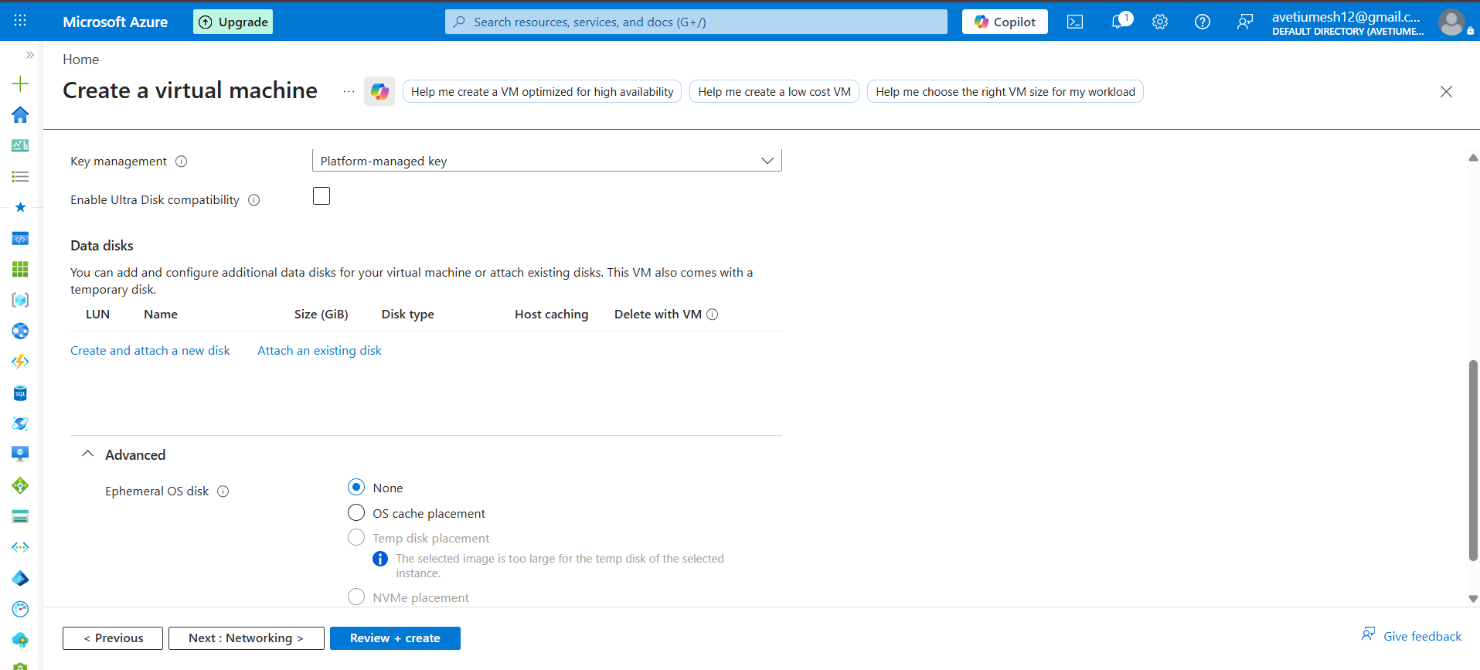

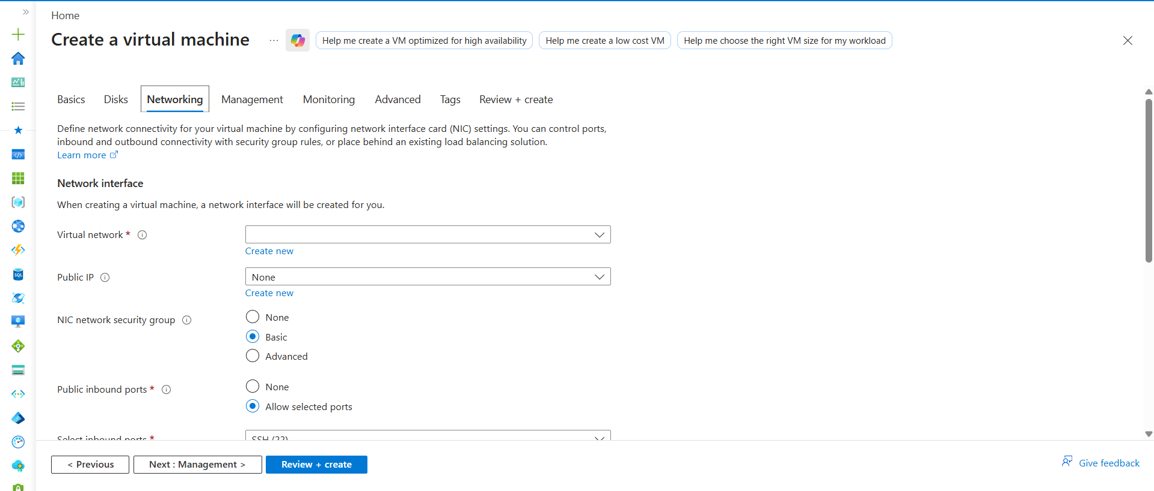

Azure VM — Networking Tab (Practical Beginner Notes)
1. Virtual Network (VNet)
VNet means:
Private network for Azure resources
Equivalent in AWS:
VPC

Purpose
VNet allows resources to communicate securely.
Resources inside VNet:
- VM
- AKS
- Databases
- Storage
can communicate privately.

Beginner Recommendation
Create new VNet using default settings

2. Public IP
Public IP means:
Internet-accessible IP address for VM

Why Needed?
Used for:
- SSH login
- Accessing applications
- Internet communication

Example
ssh azureuser@20.x.x.x

Important Point
Without Public IP:
You cannot access VM directly from internet

Beginner Recommendation
Enable Public IP
for easy VM access.

3. NIC Network Security Group (NSG)
NSG means:
Firewall for VM networking
Controls:
- Allowed traffic
- Blocked traffic

Options
None
No firewall rules attached.
Not recommended.

Basic
Azure automatically creates simple NSG rules.
Best for beginners.

Advanced
Used for custom enterprise security rules.
Advanced topic.

Beginner Recommendation
Use Basic NSG

4. Public Inbound Ports
Controls:
Which ports are accessible from internet

Current Selection
Allow selected ports → SSH (22)
Meaning:
Remote SSH login allowed

Common Ports
Port | Purpose
22 | SSH
80 | HTTP
443 | HTTPS
8080 | Jenkins

Warning Message Meaning
Azure warning says:
All IP addresses can access your VM on port 22
Meaning:
SSH is publicly reachable from internet

Beginner Recommendation
For learning:
Allow only SSH (22)

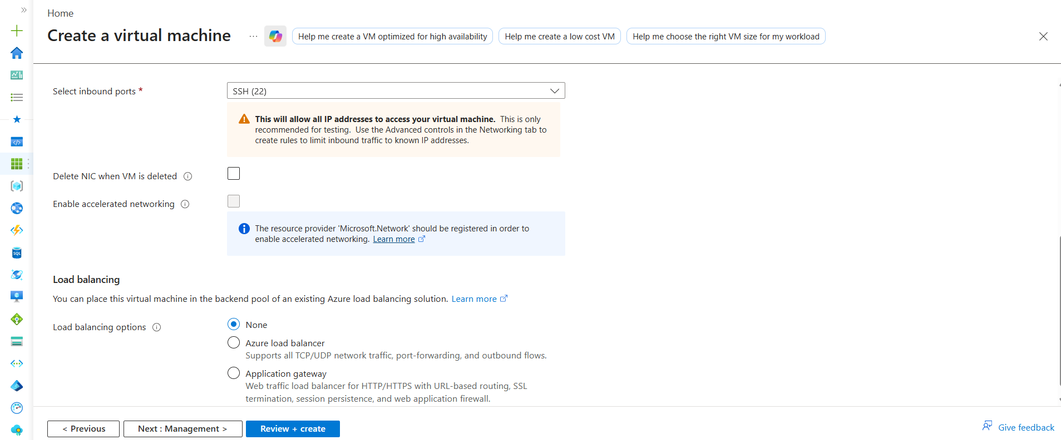

5. Delete NIC when VM is Deleted
NIC means:
Network Interface Card
Virtual network adapter attached to VM.

If Enabled
Deleting VM also deletes NIC
Prevents unused resources.

Beginner Recommendation
Enable Delete NIC with VM

6. Enable Accelerated Networking
Advanced networking optimization feature.
Improves:
- Network speed
- Latency
- Performance
Mostly used for:
- High-performance workloads
- Enterprise applications

Beginner Recommendation
Keep disabled

7. Load Balancing
Load Balancer distributes traffic across multiple servers.

Options
None
Single VM setup.
Best for beginners.

Azure Load Balancer
Used for:
TCP/UDP traffic distribution

Application Gateway
Advanced web traffic load balancer.
Supports:
- HTTP/HTTPS routing
- SSL
- Web Application Firewall (WAF)

Beginner Recommendation
Use None
No load balancer needed for single VM.

Simple Networking Flow
Internet
↓
Public IP
↓
NSG checks rules
↓
NIC
↓
VM

Beginner Recommended Settings
Setting | Recommendation
VNet | Default
Public IP | Enabled
NSG | Basic
Inbound Ports | SSH (22)
Delete NIC | Enabled
Accelerated Networking | Disabled
Load Balancer | None

AWS Equivalent
Azure | AWS
VNet | VPC
NSG | Security Group
Public IP | Public IP
NIC | ENI
Load Balancer | ELB/ALB

Interview Definitions
VNet is a private Azure network used for secure communication between resources.
NSG is a firewall that controls inbound and outbound traffic for Azure resources.

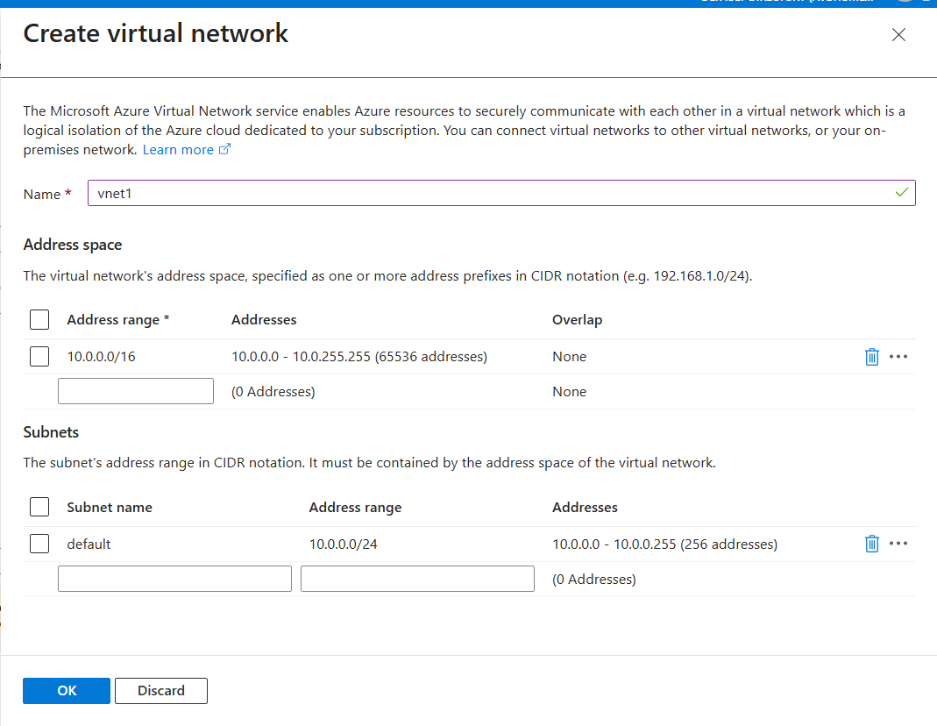
Azure VM — Load Balancing Options
What is Load Balancing?
Load Balancing means:
Distributing traffic across multiple servers/VMs

Why Needed?
Suppose:
1000 users access application
If only one VM handles everything:
VM may become overloaded
Load Balancer distributes traffic.

Simple Example
Without Load Balancer:
Users
↓
Single VM
Problem:
If VM fails → Application down

With Load Balancer
Users
↓
Load Balancer
↓
VM1
VM2
VM3
Traffic distributed equally.

Benefits
- High Availability
- Better performance
- Fault tolerance
- Scalability

Load Balancing Options in Azure
1. None
No load balancing.
Single VM setup.

Beginner Recommendation
For learning:
Use None
because:
- Only one VM exists
- No traffic distribution needed

2. Azure Load Balancer
Works at:
Network level (TCP/UDP)
Used for:
- VM traffic distribution
- Port forwarding
- Backend server balancing

Real Example
Users
↓
Azure Load Balancer
↓
Multiple Application VMs
If one VM fails:
Traffic goes to healthy VMs

Common Usage
Used for:
- VM clusters
- AKS nodes
- Backend services
- High availability apps

AWS Equivalent
Azure | AWS
Azure Load Balancer | Network Load Balancer (NLB)

3. Application Gateway
Advanced web traffic load balancer.
Works at:
Application level (HTTP/HTTPS)

Supports
- URL-based routing
- SSL termination
- Web Application Firewall (WAF)
- Session persistence

Real Example
example.com/api → Backend VM
example.com/shop → Frontend VM
Application Gateway routes traffic based on URL.

Common Usage
Used for:
- Web applications
- HTTPS traffic
- Secure enterprise apps

AWS Equivalent
Azure | AWS
Application Gateway | ALB (Application Load Balancer)

Simple Difference
| Feature | Azure Load Balancer | Application Gateway |
|---|---|
| Works on | TCP/UDP | HTTP/HTTPS |
| Layer | Network Layer | Application Layer |
| URL Routing | No | Yes |
| SSL Offloading | No | Yes |
| WAF Support | No | Yes |

Beginner Recommendation
For your first VM:
Choose None
because:
- Single VM enough
- No need HA/load balancing now

Real Enterprise Usage
Scenario | Service Used
VM traffic balancing | Azure Load Balancer
Web application routing | Application Gateway

Important Beginner Understanding
Load Balancer distributes traffic between multiple servers.
Single VM setups usually do NOT need load balancing.

Interview Definitions
Azure Load Balancer distributes network traffic across multiple virtual machines.
Application Gateway is an HTTP/HTTPS load balancer that supports advanced web routing and security features.
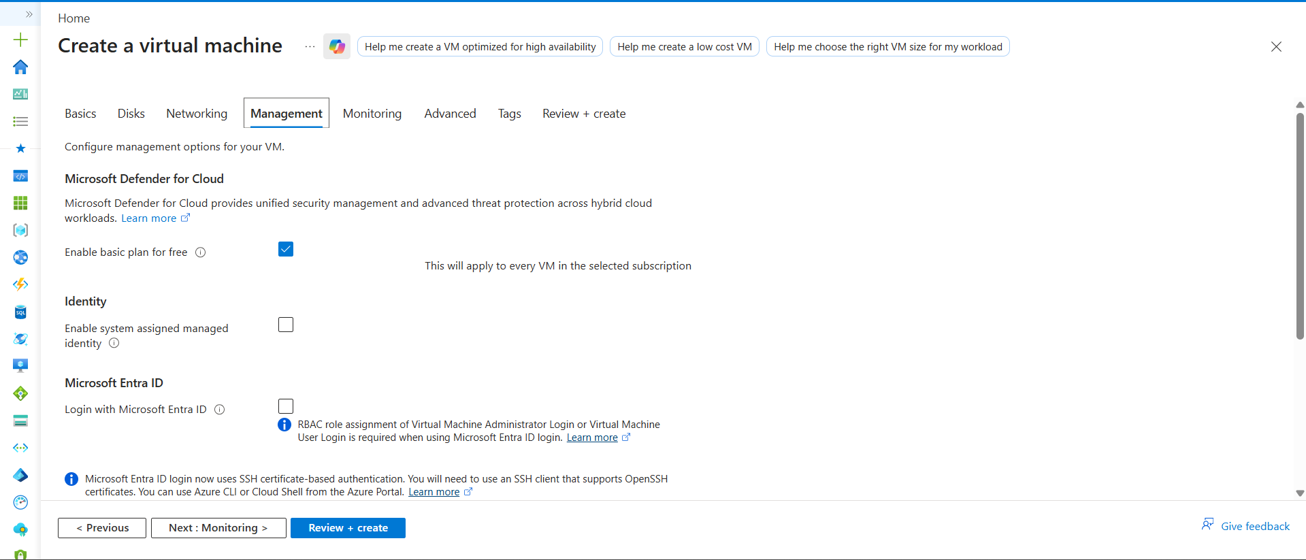

Azure VM — Management Tab Quick Notes
Field | What is it? | Used For
Microsoft Defender for Cloud | Azure security monitoring service | Detects threats, vulnerabilities, and security issues in VMs
Managed Identity | Azure-generated identity for VM | Securely access Azure services without storing passwords
Microsoft Entra ID Login | Azure AD-based VM authentication | Login to VM using company/Azure accounts
Auto Shutdown | Automatically stops VM at scheduled time | Saves cloud cost and free-tier credits
Backup | VM recovery and restore feature | Protects against data loss or accidental deletion
Guest OS Updates | Operating system patch management | Keeps Linux/Windows VM updated and secure
Patch Orchestration | Controls how updates are installed | Manages automatic/manual OS patching process

Beginner Recommendation
Field | Beginner Action
Defender for Cloud | Keep Default
Managed Identity | Disabled
Entra ID Login | Disabled
Auto Shutdown | Enable
Backup | Disabled
Guest OS Updates | Default
Patch Orchestration | Default

Important Beginner Understanding
Management tab mainly contains security, identity, update, and maintenance-related VM settings

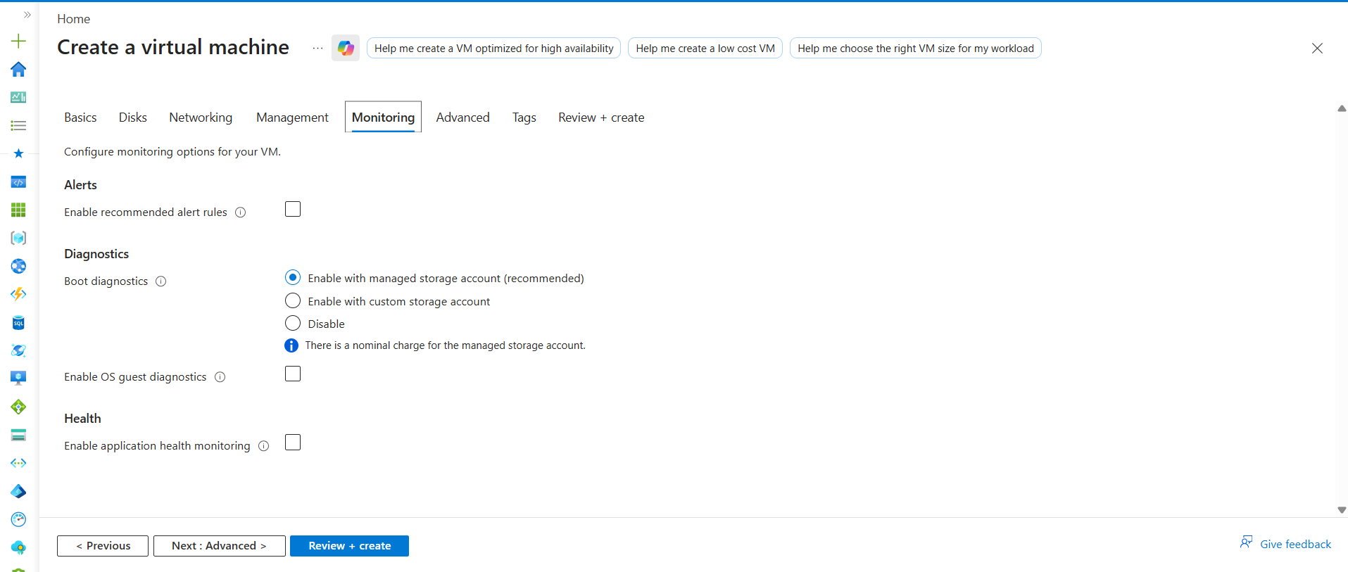

Azure VM — Monitoring Tab Quick Notes
Field | What is it? | Used For
Recommended Alert Rules | Azure monitoring alerts | Sends alerts for CPU, memory, VM issues, etc.
Boot Diagnostics | VM startup troubleshooting logs/screenshots | Helps debug VM boot failures and startup issues
Custom Storage Account | Store diagnostics logs in custom storage | Advanced enterprise logging setup
Disable Boot Diagnostics | Turns off startup diagnostics | Reduces monitoring/log collection
OS Guest Diagnostics | Collects detailed OS metrics/logs | Advanced VM monitoring and troubleshooting
Application Health Monitoring | Tracks application/service health | Detects whether application inside VM is healthy

Beginner Recommendation
Field | Beginner Action
Recommended Alert Rules | Disabled
Boot Diagnostics | Keep default enabled
Custom Storage Account | Not required
OS Guest Diagnostics | Disabled
Application Health Monitoring | Disabled

Most Important Beginner Understanding
Monitoring tab mainly contains VM monitoring, diagnostics, logging, and health tracking features.
For beginners, default Boot Diagnostics is enough. No other changes are required.

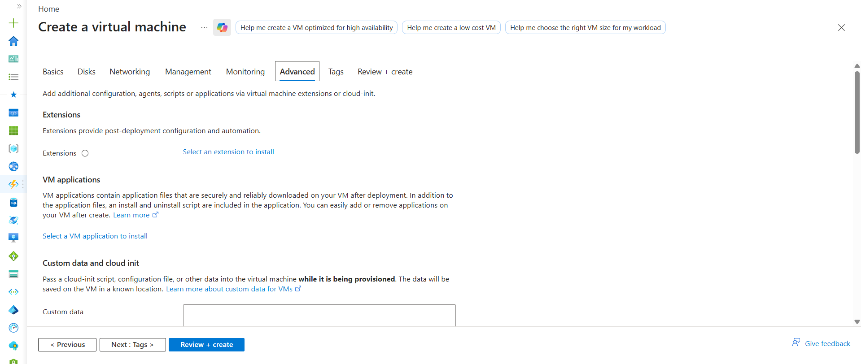
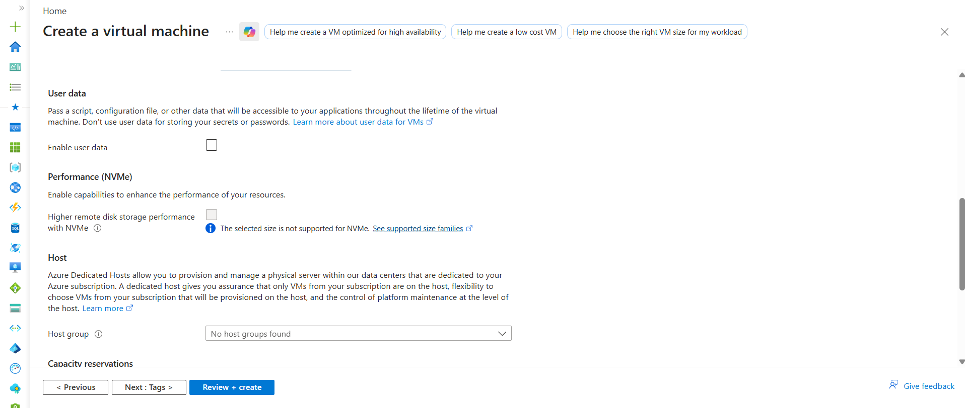
Azure VM — Advanced Tab (Beginner Notes)
Required Changes for Beginners
NO major changes required in Advanced tab
You can mostly keep:
Default settings

Optional Beginner Action
Setting | Recommendation
Extensions | No changes
VM Applications | No changes
Custom Data / Cloud-init | Leave empty
User Data | Disabled
NVMe Performance | Disabled
Host Group | None
Capacity Reservations | None
Proximity Placement Group | None

Quick Explanation of Each Field
Field | What is it? | Used For
Extensions | Extra Azure plugins/tools for VM | Installs monitoring/security/automation agents
VM Applications | Predefined application packages | Auto-install applications during deployment
Custom Data / Cloud-init | Startup automation script | Automatically configure VM during creation
User Data | Pass data/scripts to VM | Used by applications after VM creation
NVMe Performance | High-speed storage optimization | Improves storage performance
Host Group | Dedicated physical Azure server | Enterprise isolation/compliance
Capacity Reservations | Reserve VM capacity in advance | Guarantees VM availability
Proximity Placement Group | Place VMs physically closer | Reduces network latency

Important Beginner Understanding
1. Extensions
Used for:
Installing Azure agents/plugins
Example:
- Monitoring agent
- Security agent
Beginner:
No changes required

2. Cloud-init / Custom Data
VERY important in DevOps later.
Used to:
Run automation scripts during VM creation
Example:
Install Docker automatically
Install Jenkins automatically
But for beginners:
Leave empty

3. Capacity Reservations
Enterprise feature.
Used to:
Reserve Azure compute resources beforehand
Useful during:
- High demand
- Production scaling
Beginner:
Use None

4. Proximity Placement Group
Used to:
Keep VMs physically closer inside Azure datacenter
Improves:
- Low latency
- Faster communication
Used in:
- High-performance apps
- Trading systems
Beginner:
Ignore for now

Final Beginner Recommendation
No changes needed in Advanced tab.
Simply:
Click Next → Tags

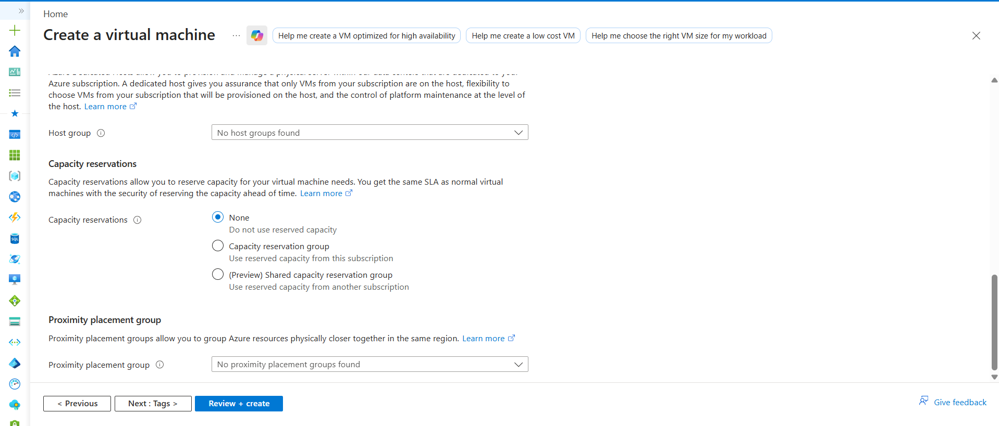

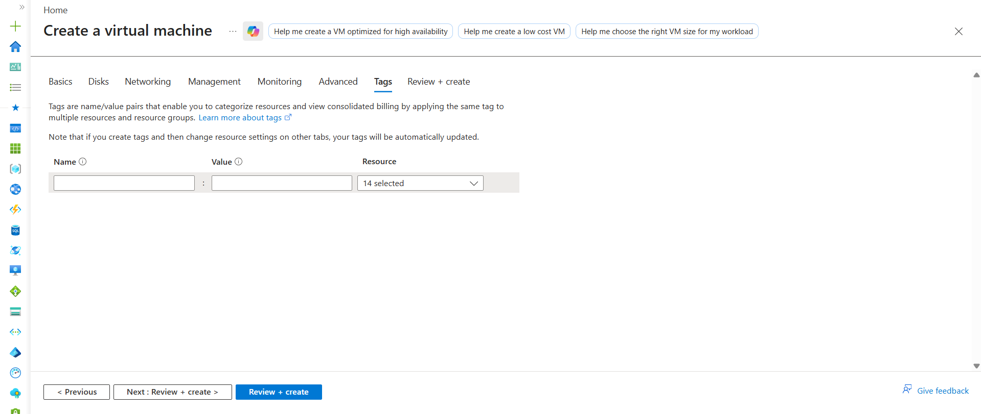

Azure VM — Tags Tab Quick Notes
What are Tags?
Tags are:
Key-value labels attached to Azure resources
Used to:
- Organize resources
- Track billing
- Identify environments/projects

Example
Name | Value
Environment | Dev
Project | Jenkins
Owner | Umesh

Real Usage
Companies use tags for:
- Cost tracking
- Team ownership
- Environment identification
- Automation

Example Scenario
Environment = Production
helps identify:
Production resources

AWS Equivalent
Azure | AWS
Tags | Tags
Same concept.

Beginner Recommendation
No tags required for practice VM
You can leave everything empty.

Real Enterprise Practice
Tags are VERY important in companies.
Example:
- Dev
- QA
- UAT
- Prod
- Team names
- Billing groups

Important Beginner Understanding
Tags are mainly used for organization and billing management.

Final Beginner Action
No changes required.
Click Review + Create.

VM Created
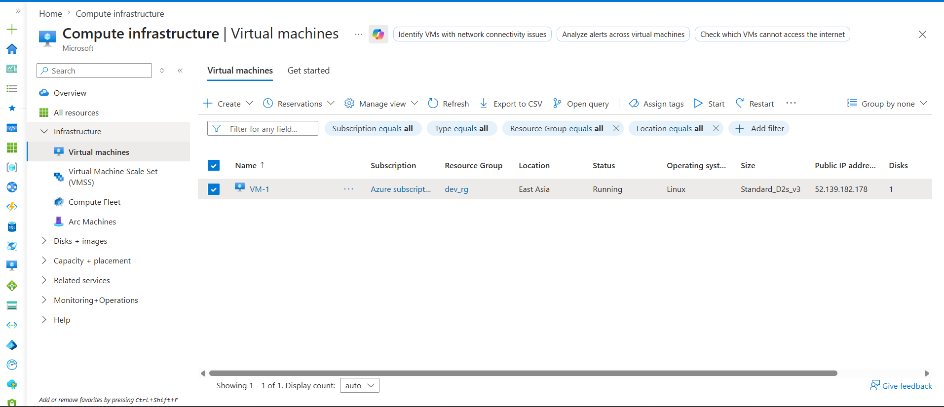

Pem key downloaded in downloads folder

$ chmod 444 azureuserkkey.pem
Change permission

Connected through terminal(git bash)
