VNet Networking Topics
----------------------
VNet
Subnet
NIC
NSG
Route Tables
NAT Gateway
VNet Peering
Bastion
Private Endpoint

Why was VNet created?
Imagine Azure had no VNet.
You create:
- VM1
- VM2
- SQL Database
- Storage Account
Questions arise:
- Which resources can talk to each other?
- How do they get IP addresses?
- How do we isolate one application from another?
- How do we block unauthorized traffic?
- How do we connect Azure to our company network?
Azure needed a networking layer to solve these problems.
That networking layer is Virtual Network (VNet).

What exactly is a VNet?
A VNet is a logical private network in Azure.
When you create a VNet, Azure reserves a range of IP addresses for you.
Example:
VNet Name : Production-VNet
Address Space : 10.0.0.0/16
Now Azure says:
"All IPs from 10.0.0.0 to 10.0.255.255 belong to your private network."
What does Azure give us when we create a VNet?
- Private IP Addressing
- Network Isolation
- Routing
- Resource Communication
- Security Integration (NSG, Firewall, etc.)
- Connectivity to On-Premises Networks
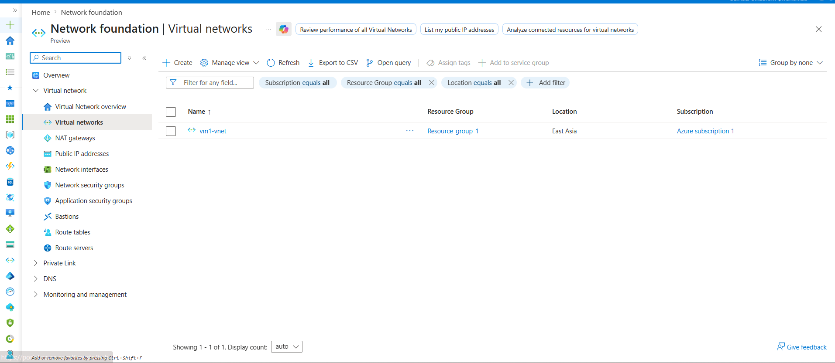
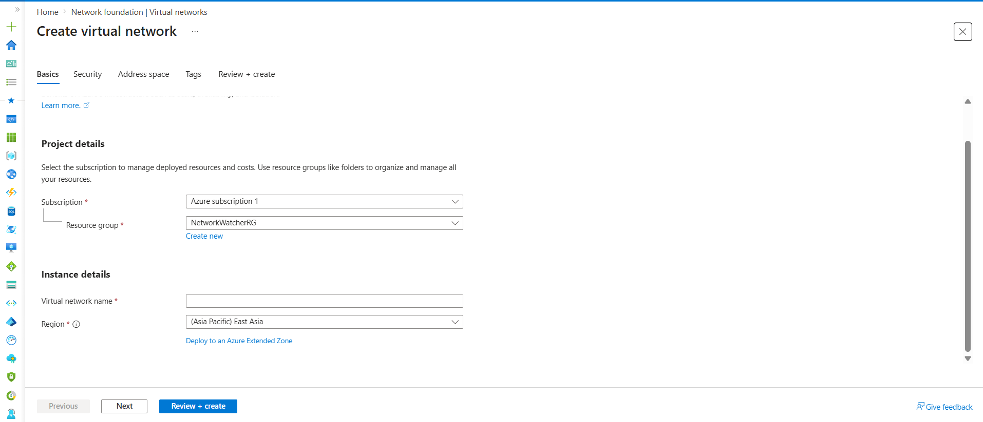
Subscription
Definition
A subscription is the billing and ownership boundary in Azure. Every resource created in Azure must belong to a subscription.
Usage
It determines who owns the resource, where the costs are charged, and what quotas and permissions apply.
If not selected
Azure cannot create the resource because it does not know which account should own and pay for it.
Example
Azure Subscription 1

Resource Group
Definition
A Resource Group is a logical container used to organize and manage related Azure resources.
Usage
Resources belonging to the same application, environment, or project are typically grouped together for easier management, monitoring, and deletion.
If not used properly
Resources become difficult to manage, track, and maintain. Accidentally deleting a Resource Group can delete all resources inside it.
Example
rg-vnet-demo
rg-dev-environment
rg-production-network
Recommended Value
rg-vnet-demo

Virtual Network Name
Definition
The unique name assigned to the Virtual Network (VNet).
Usage
Used to identify the VNet when connecting VMs, AKS clusters, Load Balancers, Bastion hosts, Private Endpoints, and other Azure resources.
If not provided
Azure will not allow the VNet to be created.
Example
enterprise-vnet
vnet-demo
production-vnet
Recommended Value
enterprise-vnet

Region
Definition
The Azure datacenter location where the VNet is created.
Usage
Resources deployed in the same region can be attached to the VNet with lower latency and better performance.
If selected incorrectly
Resources may experience higher latency, additional costs, or deployment limitations due to regional restrictions.
Example
East Asia
Central India
East US
West Europe
Recommended Value
East Asia

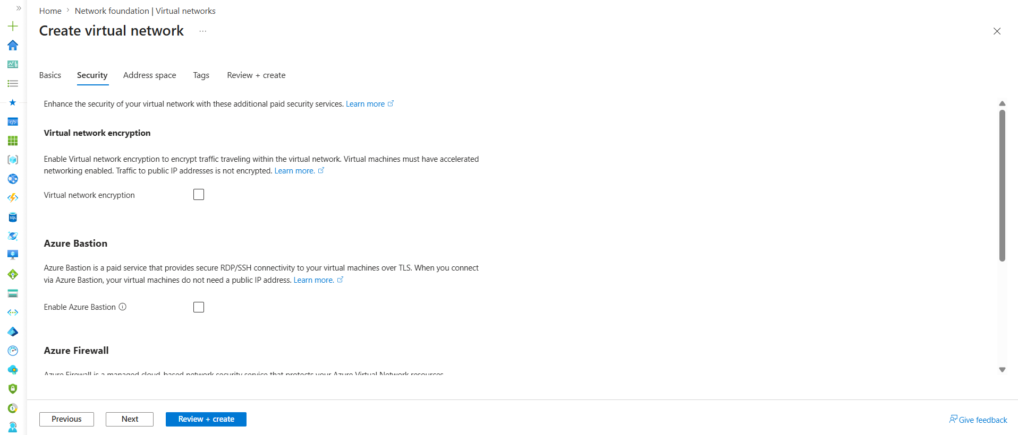

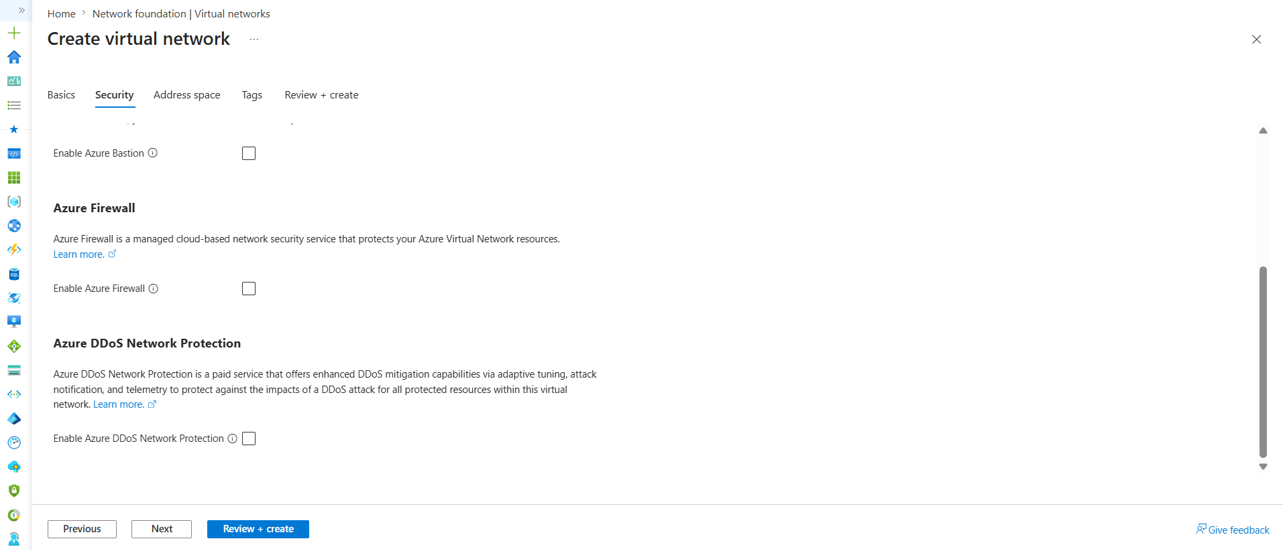
Virtual Network Encryption
Definition
Encrypts traffic flowing between supported resources inside the VNet.
Usage
Used in highly secure environments where internal network traffic must also be encrypted.
If not enabled
Traffic still flows normally inside the VNet. Azure networking remains secure, but additional encryption is not applied at the VNet layer.
Example
Banking Applications
Government Projects
Healthcare Systems
For our lab
Leave Unchecked

Azure Bastion
Definition
A managed service that allows RDP/SSH access to VMs through the Azure Portal without exposing public IP addresses.
Usage
Securely connect to Linux and Windows VMs.
If not enabled
You can still access VMs using public IPs and SSH/RDP.
Example
Administrator
↓
Azure Bastion
↓
Private VM
For our lab
Leave Unchecked
We'll learn Bastion separately later.

Azure Firewall
Definition
A managed Layer 3–7 firewall that filters and controls network traffic entering or leaving Azure resources.
Usage
Centralized security control for VNets.
If not enabled
Traffic can still be controlled using NSGs, but advanced firewall features won't be available.
Example
Internet
↓
Azure Firewall
↓
Web Subnet
↓
App Subnet
↓
DB Subnet

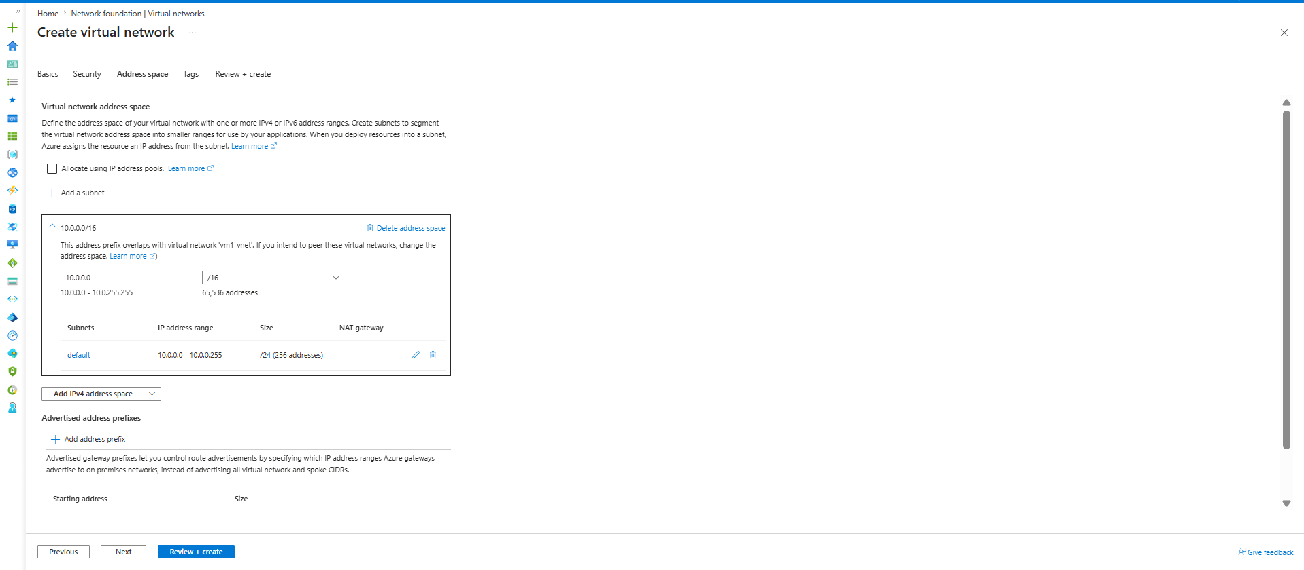

Address Space Tab
Virtual Network Address Space
Definition
Defines the total IP address range available for the Virtual Network (VNet).
Usage
All subnets must be created from this address space.
If not planned properly
Future subnet expansion and VNet peering may become difficult due to IP conflicts.
Example
VNet Address Space: 10.10.0.0/16
This provides 65,536 IP addresses for the entire VNet.

CIDR Range (/16)
Definition
CIDR notation determines the size of the network and the number of available IP addresses.
Usage
Used to reserve sufficient IP space for current and future resources.
If chosen too small
The VNet may run out of IP addresses, requiring redesign.
Example
/24 = 256 IPs
/23 = 512 IPs
/22 = 1024 IPs
/16 = 65,536 IPs

Subnet
Definition
A subnet is a smaller network created from the VNet address space.
Usage
Azure resources such as VMs, AKS clusters, databases, and load balancers are deployed into subnets.
If subnet is not created
Resources cannot be attached to the VNet.
Example
VNet: 10.10.0.0/16
Web Subnet : 10.10.1.0/24
App Subnet : 10.10.2.0/24
DB Subnet : 10.10.3.0/24

Important Understanding
At this screen, we are only defining the total IP range for the VNet.
Example:
VNet = 10.10.0.0/16
This does not create Web, App, or DB subnets.
It only reserves the complete IP range for the VNet.
Subnets will be created later from this address space based on application requirements.

Lab Configuration
VNet Address Space : 10.10.0.0/16
Planned Subnets:
Web Subnet : 10.10.1.0/24
App Subnet : 10.10.2.0/24
DB Subnet : 10.10.3.0/24

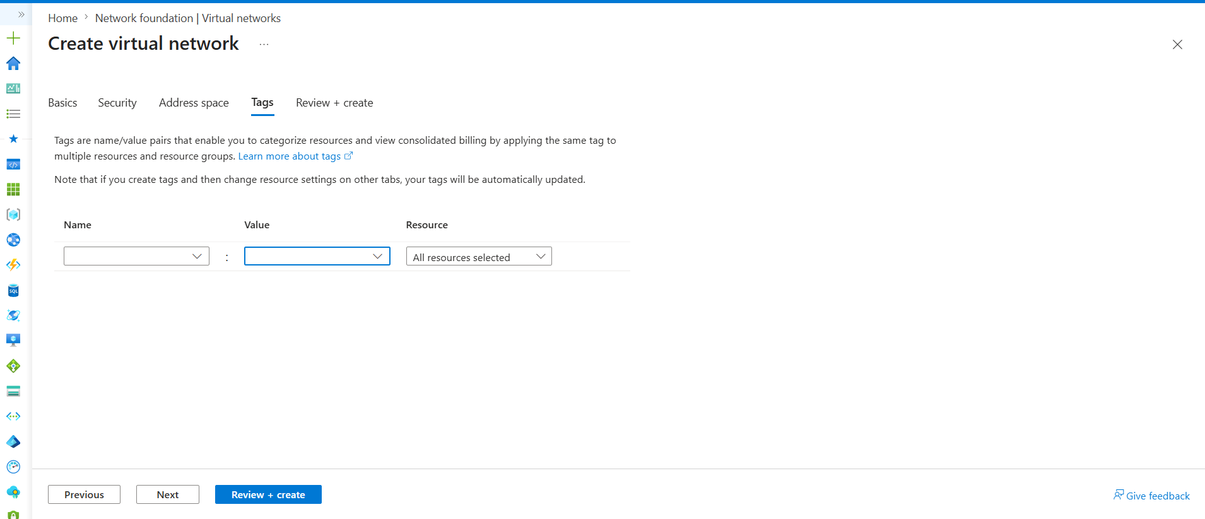
Tags: which is additional information about vnet
Tags
Definition
Tags are key-value pairs used to organize, categorize, and manage Azure resources.
Usage
Used for cost tracking, resource grouping, reporting, automation, and governance.
If not configured
The resource works normally. You simply lose the ability to easily categorize and filter resources.
Virtual Network created
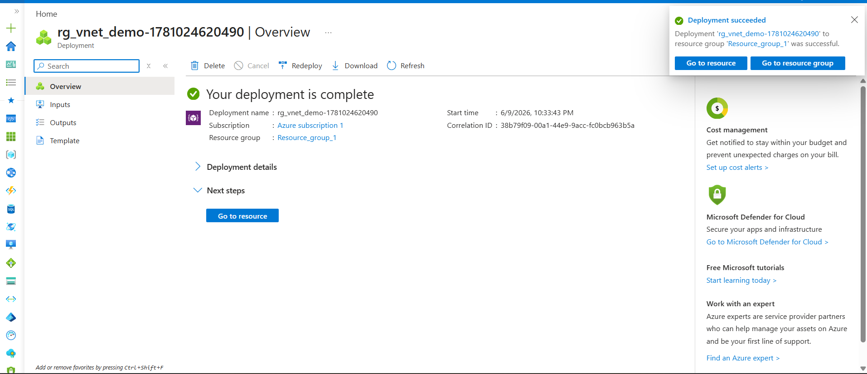

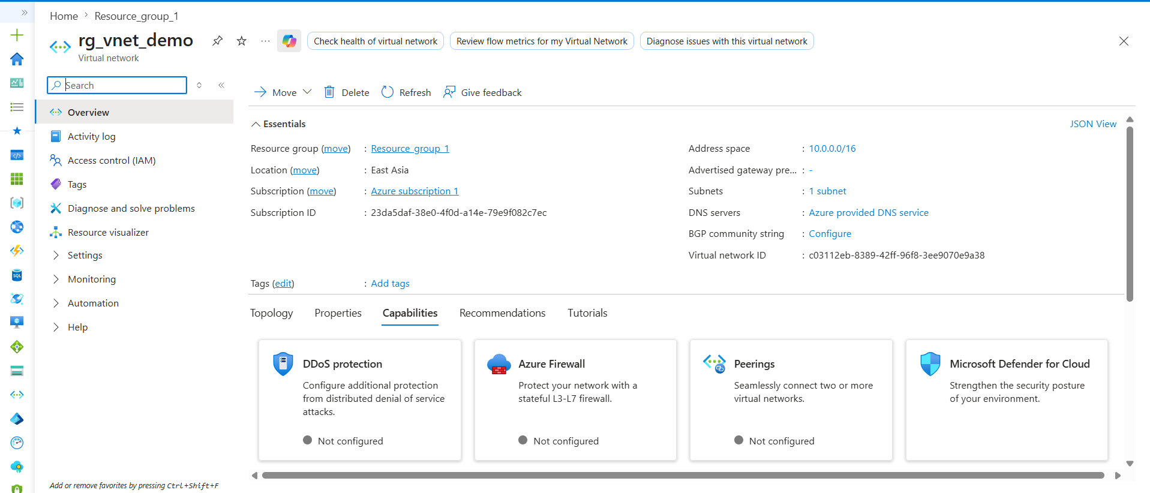
Virtual Network Overview
Resource Group
Definition
Logical container that holds Azure resources.
Usage
Used to organize and manage related resources together.
Current Value
Resource_group_1

Location
Definition
Azure region where the VNet exists.
Usage
Resources deployed in this region can connect to the VNet.
Current Value
East Asia

Subscription
Definition
Billing and ownership boundary for Azure resources.
Usage
Determines who owns and pays for the VNet.
Current Value
Azure Subscription 1

Address Space
Definition
Total IP range reserved for the Virtual Network.
Usage
All subnets are created from this address space.
Current Value
10.0.0.0/16
Available IPs
65,536

Subnets
Definition
Smaller networks created from the VNet address space.
Usage
Resources such as VMs, AKS clusters, databases, and load balancers are deployed into subnets.
Current Value
1 Subnet

DNS Servers
Definition
Provides name resolution inside the Virtual Network.
Usage
Converts hostnames into IP addresses.
Current Value
Azure Provided DNS
Meaning Azure manages DNS automatically.

Virtual Network ID
Definition
Unique identifier assigned to the VNet by Azure.
Usage
Used internally by Azure services and APIs.
Current Value
Automatically generated by Azure.
Most Important Things on This Screen
Address Space : 10.0.0.0/16
Subnets : 1
DNS : Azure Provided DNS
Everything else is mostly metadata.

Next Subnet
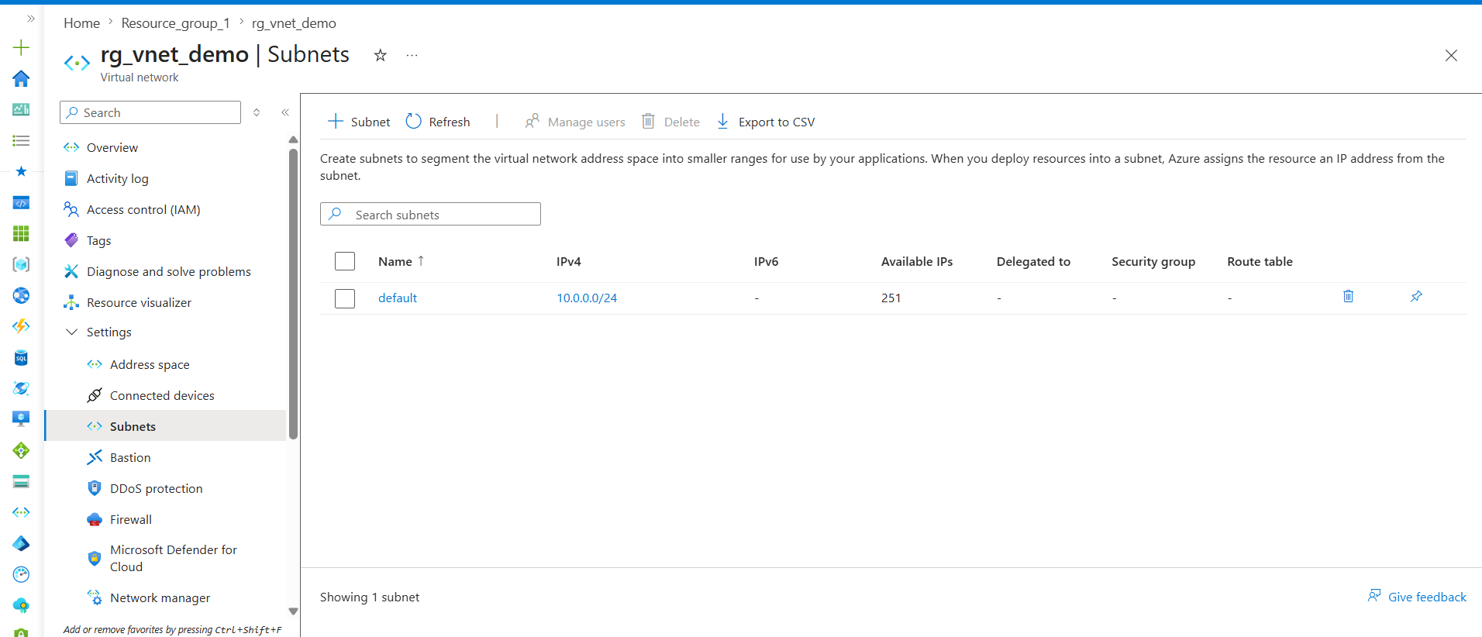

Subnet
Definition
A Subnet is a smaller network created from the Virtual Network (VNet) address space. It divides a large network into multiple logical sections.

Why Do We Need a Subnet?
Subnets help organize resources based on their function and security requirements.
Instead of placing all resources in one network, we separate them into different subnets.

Usage
Subnets are used to:
- Organize resources logically.
- Improve security by separating application layers.
- Apply different NSG and Route Table rules.
- Manage IP addresses efficiently.
- Isolate workloads from each other.

If We Don't Use Multiple Subnets
All resources will be placed in a single network.
Example:
VNet
10.0.0.0/16

└── Subnet
10.0.0.0/24

Web VM
App VM
DB VM
Problems:
- Difficult to secure resources.
- Difficult to manage traffic.
- No separation between application layers.
- Not suitable for enterprise environments.

Real Project Design
VNet
10.0.0.0/16 -- we divide them into small subnets

Traffic Flow
User
↓
Web Server
↓
Application Server
↓
Database Server
Each layer is placed in a separate subnet.

Security Benefit
Different security rules can be applied to each subnet.
Example:
Web-Subnet
Allow HTTP/HTTPS
App-Subnet
Allow traffic only from Web-Subnet

DB-Subnet
Allow traffic only from App-Subnet
This prevents direct access to the database from the internet.

Example
VNet Address Space:
10.0.0.0/16
Subnets:
Web-Subnet : 10.0.1.0/24
App-Subnet : 10.0.2.0/24
DB-Subnet : 10.0.3.0/24
All subnet ranges are created from the parent VNet address space.

Key Point
A VNet defines the total available IP range.
A Subnet divides that IP range into smaller networks where Azure resources are deployed.
Resources such as VMs, AKS clusters, databases, load balancers, and private endpoints are always deployed into a subnet.
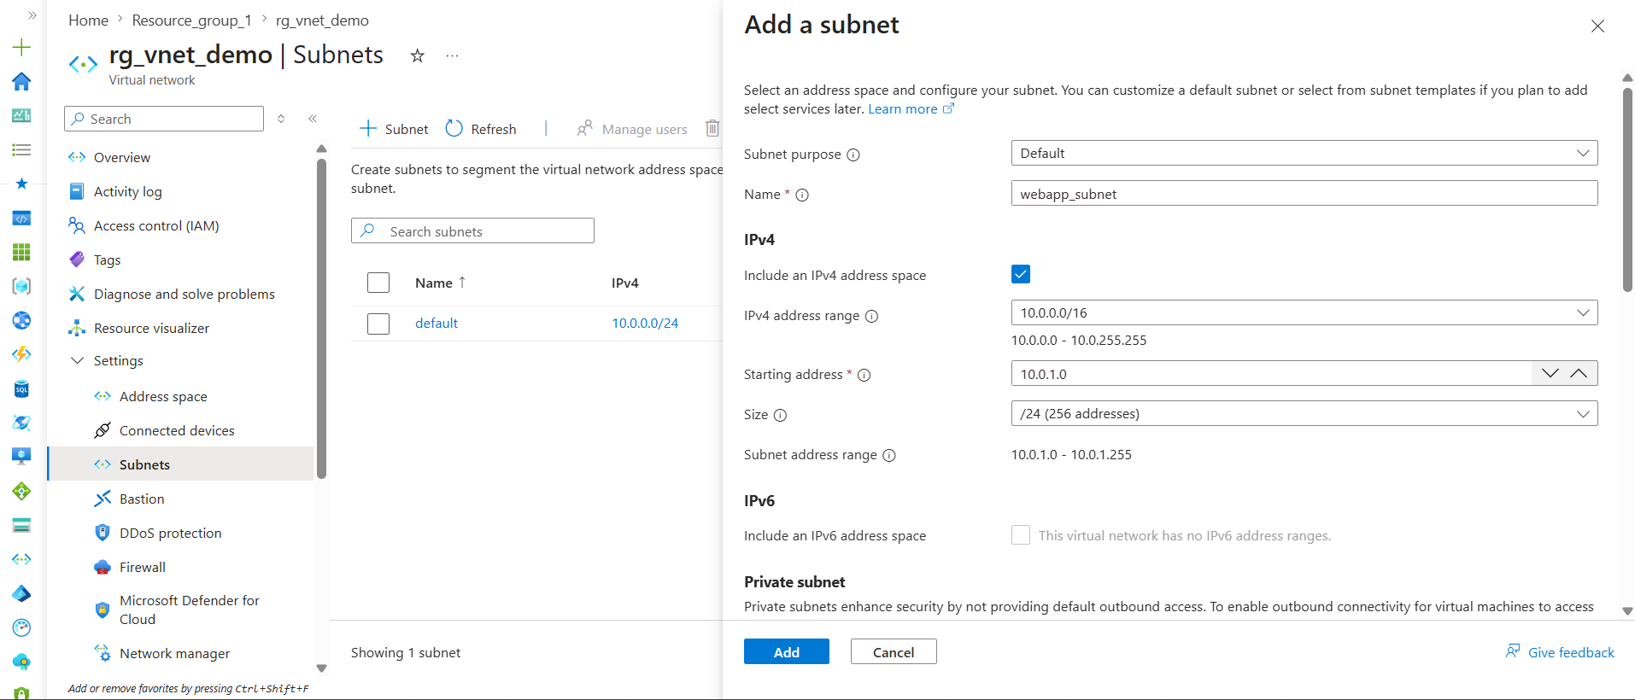
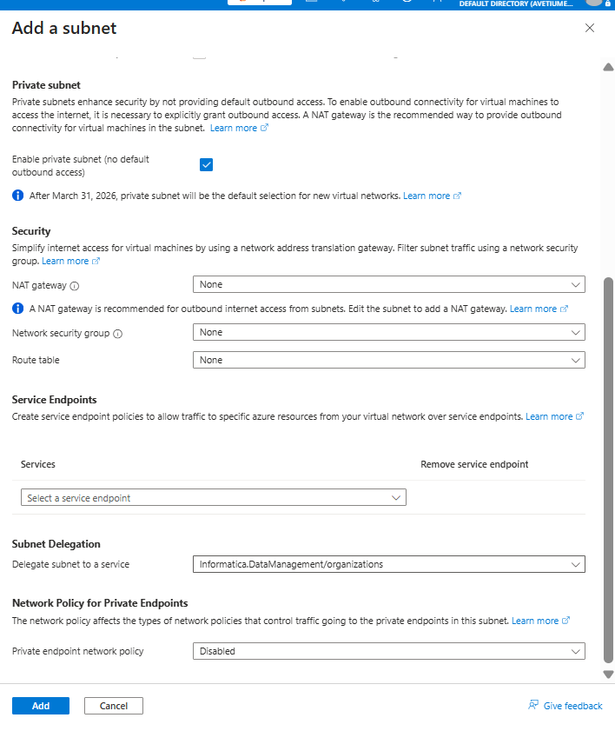

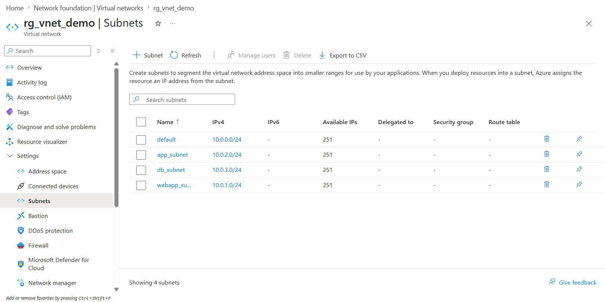
Name
Definition
Name of the subnet.
Usage
Used to identify where resources are deployed.
If not used properly
It becomes difficult to understand the purpose of the subnet.
Example
webapp_subnet
app_subnet
db_subnet

IPv4
Definition
IP range allocated to the subnet.
Usage
Resources deployed in the subnet receive IPs from this range.
Current Values
default 10.0.0.0/24
webapp_subnet 10.0.1.0/24
app_subnet 10.0.2.0/24
db_subnet 10.0.3.0/24

IPv6
Definition
IPv6 address range assigned to the subnet.
Usage
Used when applications require IPv6 communication.
If not configured
Subnet uses only IPv4.
Current Value
-
Meaning IPv6 is not enabled.

Available IPs
Definition
Number of usable IP addresses remaining in the subnet.
Usage
Shows how many more resources can be deployed.
Current Value
251
Why 251?
/24 = 256 IPs
Azure Reserved = 5
Usable = 251

Delegated To
Definition
Indicates whether the subnet is delegated to a specific Azure service.
Usage
Some Azure services require exclusive control of a subnet.
If not required
-
Leave it empty.
Examples
Azure App Service
AKS
Azure Container Apps

Security Group
Definition
Network Security Group (NSG) attached to the subnet.
Usage
Controls inbound and outbound traffic.
If not attached
Azure default rules apply.
Example
Allow HTTP
Allow HTTPS
Deny RDP
Current Value
-
No NSG attached.

Route Table
Definition
Collection of custom routing rules.
Usage
Controls where network traffic should travel.
If not attached
Azure system routes are used.
Examples
Internet
Firewall
VPN Gateway
NVA
Current Value
-
No Route Table attached.

Delete Icon 🗑️
Definition
Deletes the subnet.
Usage
Used when the subnet is no longer needed.
Restriction
Cannot delete if resources exist inside the subnet.
All four subnets currently have:
IPv6 : Disabled
Delegation : None
NSG : None
Route Table : None
Available IPs : 251

Internet Gateway in Azure
Point 1
Azure does not require a separate Internet Gateway resource like AWS. Internet connectivity is provided through Azure platform-managed routing.
Point 2
A Virtual Machine can communicate with the internet by using a Public IP address and appropriate NSG rules.
Point 3
For controlled outbound internet access from private subnets, Azure recommends using a NAT Gateway instead of an Internet Gateway.
AWS vs Azure
AWS:
Internet → Internet Gateway → Subnet → EC2
Azure:
Internet → Azure Platform Routing → Public IP → NIC → VM
Key Takeaway
Internet Gateway is mandatory in AWS VPCs,
but a separate Internet Gateway resource does not exist in Azure VNets.

Next creating virtual machine -----------and observe how subnet provide ip address from out of 251 Ips
While creating VM in networking section we selected our Virtual network and webapp_subnet

Definition
Azure automatically assigns a private IP address from the subnet address range to a resource.
Usage
Used for communication between resources inside the VNet.

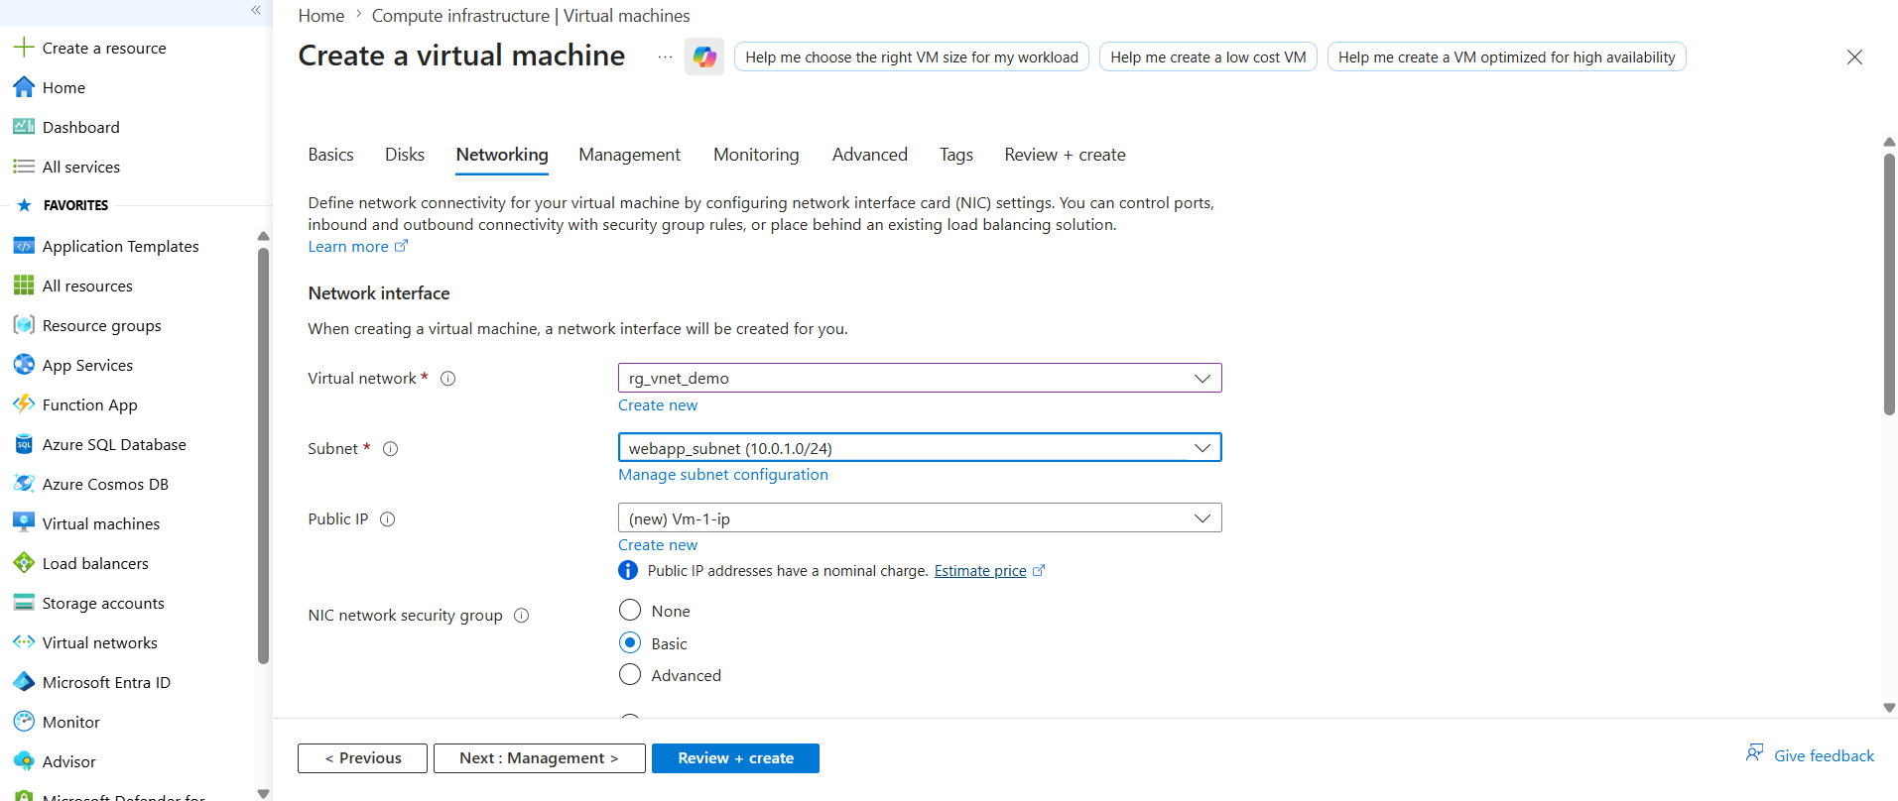
After VM is created
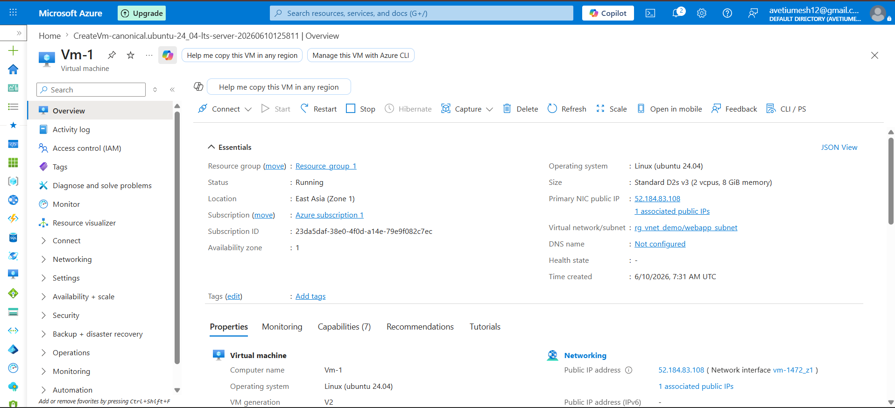We can clearly observe that 1ip is reduced from 251 Ip in webapp_subnet
Subnet : 10.0.1.0/24
Available IPs Before VM : 251
VM Created
Assigned IP : 10.0.1.4
Available IPs After VM : 250
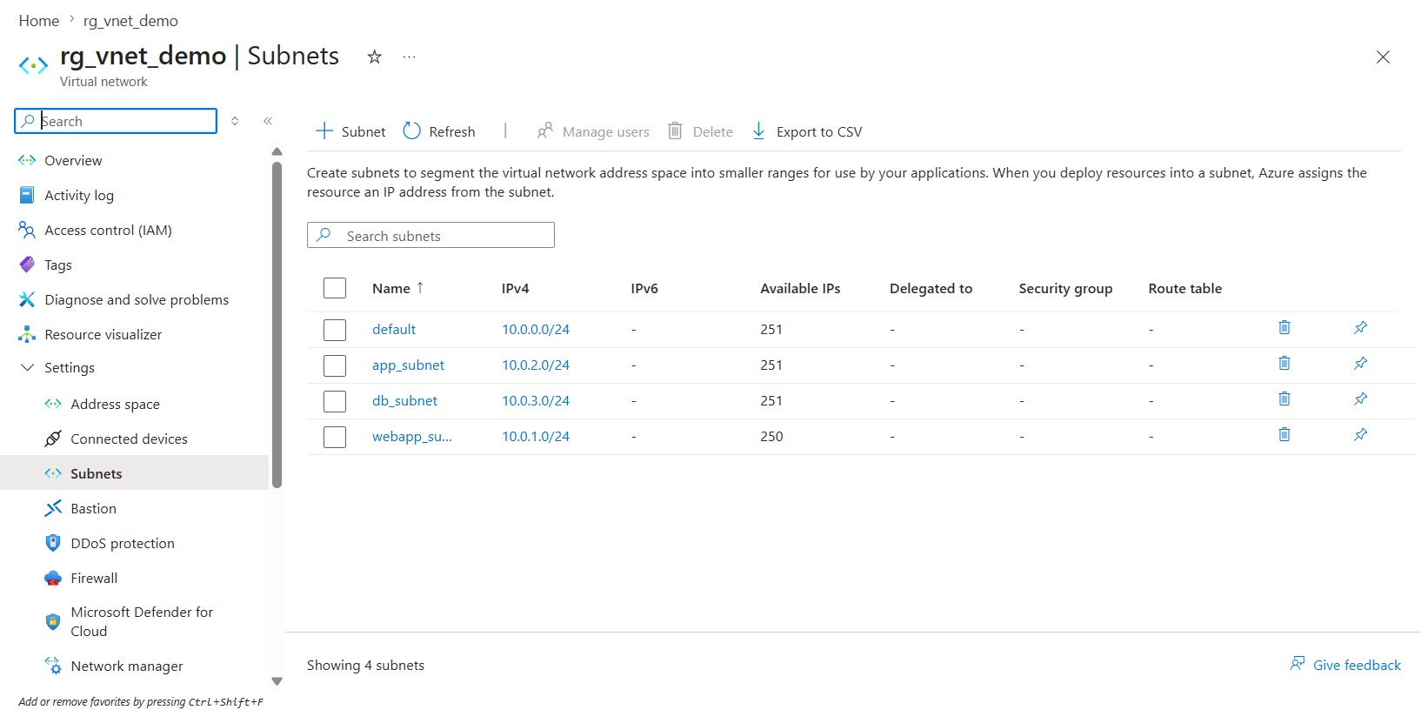
What is NIC?
Definition
A Network Interface Card (NIC) is a virtual network adapter that connects a VM to a subnet.
Usage
Used to provide network connectivity, private IP addresses, public IP addresses, and NSG associations.
If NIC does not exist
The VM cannot communicate with any network.
Example
VM
↓NIC
↓Subnet
↓VNet

What happens when we create a VM?
Azure automatically creates:
web-vm
│
└── web-vm-nic
│
├── Private IP
├── Public IP (optional)
├── NSG (optional)
└── Connected Subnet

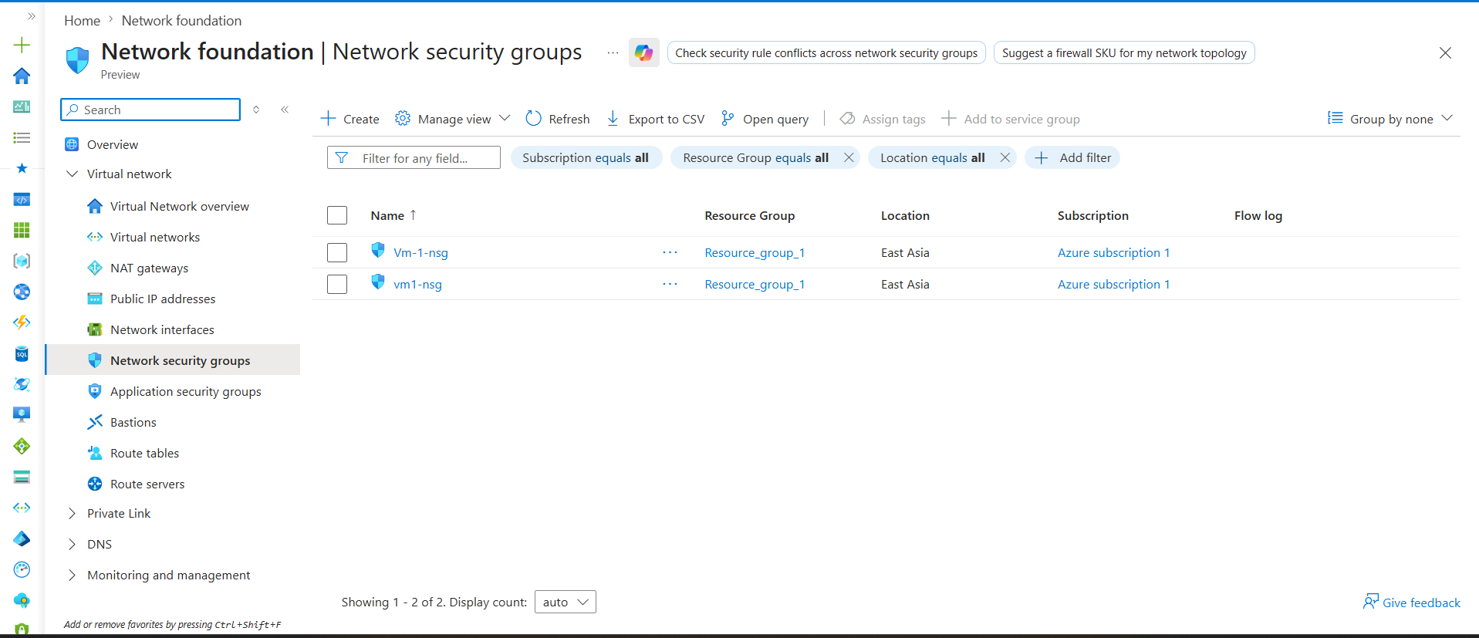What is an NSG?
Definition
Network Security Group (NSG) is a virtual firewall that controls inbound and outbound traffic.
Usage
Used to allow or deny traffic based on:
- Source
- Destination
- Port
- Protocol
AWS Equivalent
Azure NSG ≈ AWS Security Group
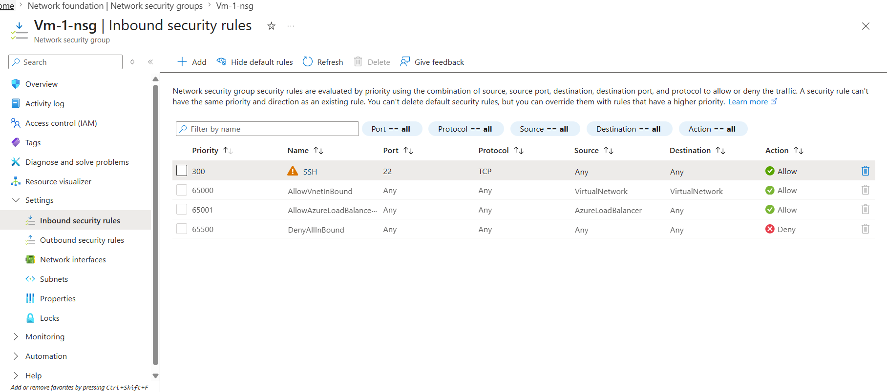
This NSG was automatically created for your VM and already has the required SSH rule.
What you should learn from this screen
Custom Rule
SSH
Port 22
Allow
Priority 300
This allows you to connect to the Linux VM.
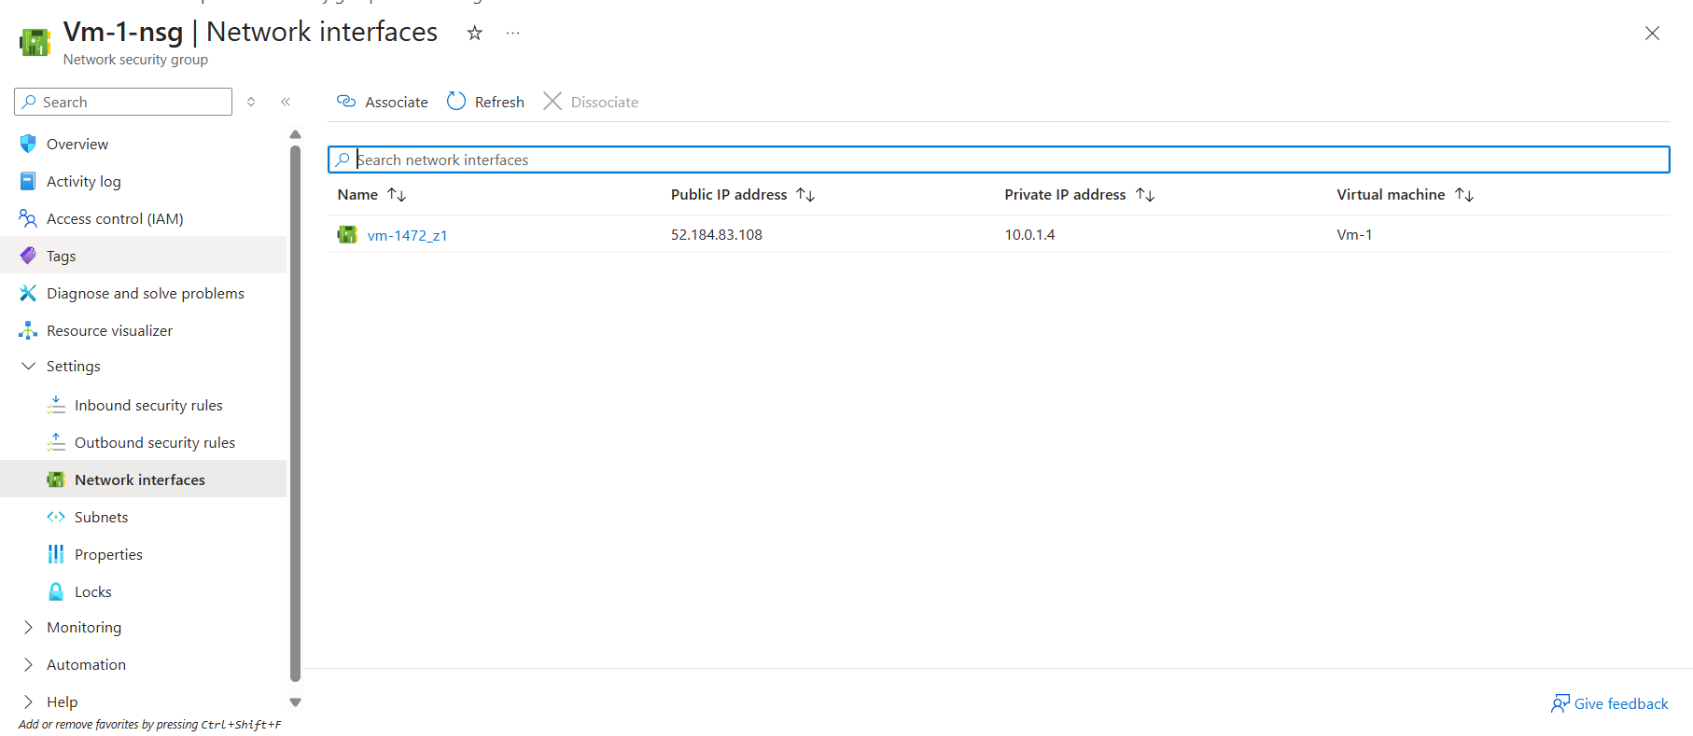
What this screen tells us
NSG Name : Vm-1-nsg
Attached NIC : vm-1472_z1
VM : Vm-1
Private IP : 10.0.1.4
Public IP : 52.184.83.108

Internet
↓
52.184.83.108 (Public IP)
↓
vm-1472_z1 (NIC)
↓
10.0.1.4 (Private IP)
↓
webapp_subnet (10.0.1.0/24)
↓
VNet (10.0.0.0/16)

Traffic flow:
Internet
↓
NSG
↓
NIC
↓
VM

Why attach to NIC?
Because the NIC is the actual network component.
The VM itself doesn't have networking capabilities. Azure gives networking through the NIC.
Think:
VM = Computer
NIC = Network Card
NSG = Firewall
So Azure places the firewall in front of the network card

Azure does not have a separate NACL service.
Azure uses Network Security Groups (NSGs) for both subnet-level and NIC-level traffic filtering.
Unlike AWS NACLs, Azure NSGs are stateful, meaning return traffic is automatically allowed when a connection is permitted.

So, think of Azure NSG as:
AWS Security Group
+
Some subnet-level capabilities of NACL
That's the closest comparison. This is why Azure networking feels simpler than AWS networking in many projects.

Route Table
Definition
A Route Table contains routing rules that determine where network traffic should be sent.
Usage
Used to override Azure's default routing behavior.
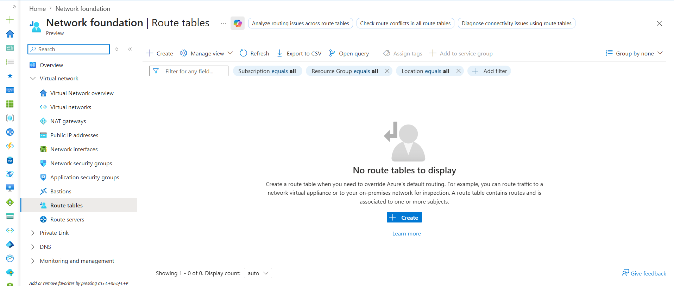
AWS Equivalent
Azure Route Table = AWS Route Table
Route Table (UDR)
Definition
A Route Table contains routing rules that determine where network traffic should be sent.
Usage
Used to override Azure's default system routing.
If not configured
Azure automatically uses system routes for communication between subnets, VNets, and the internet.
AWS Equivalent
Azure Route Table = AWS Route Table

What should we do?
Don't create a Route Table yet.
First remember:
NSG = Controls whether traffic is allowed or denied.
Route Table = Controls where traffic goes.
This single line is the most important difference.

AWS Comparison
In AWS:
VPC
↓
Subnet
↓
Route Table
Route Tables are mandatory and visible from the start.
In Azure:
VNet
↓
Subnet
↓
System Routes (Automatic)
Custom Route Tables are optional.

AWS → Local route is visible inside Route Tables.
Azure → System routes are managed automatically by Azure.
NAT Gateway
Definition
A managed Azure service that provides outbound internet connectivity for resources in private subnets.
Usage
Used when VMs require internet access but should not have public IP addresses.
Benefits
Secure
Scalable
Managed by Azure
AWS Equivalent
Azure NAT Gateway = AWS NAT Gateway

Public IP vs NAT Gateway
Public IP:
Internet ↔ VM
Inbound and outbound.

NAT Gateway:
VM → Internet
Outbound only.
Internet cannot initiate connections to the VM.

Notice:
NAT Gateway is attached to a Subnet

NAT Gateway Configuration Steps
Step 1: Create NAT Gateway
Create a NAT Gateway resource in Azure.
Purpose:
Provides outbound internet connectivity for private resources.

Step 2: Create or Select a Public IP
Create a new Public IP or choose an existing one.
Purpose:
The NAT Gateway uses this Public IP for internet communication.

Step 3: Associate Public IP with NAT Gateway
Attach the Public IP to the NAT Gateway.
Purpose:
Enables the NAT Gateway to translate private IP addresses into a public IP.

Step 4: Attach NAT Gateway to a Subnet
Associate the NAT Gateway with a subnet.
Example:
app_subnet
10.0.2.0/24
Purpose:
All resources in the subnet can use the NAT Gateway.

Step 5: Outbound Internet Access
Traffic flow:
VM
↓
Subnet
↓
NAT Gateway
↓
Public IP
↓
Internet
Result:
VMs can access the internet without having individual Public IP addresses.

Key Point
NAT Gateway → Attached to Subnet
Public IP → Attached to NAT Gateway
VM → Uses NAT Gateway through the Subnet
AWS Equivalent:
Azure NAT Gateway = AWS NAT Gateway

Why is VNet Peering required?
Answer:
VNet Peering is used when resources deployed in different Virtual Networks need private communication without using the internet, VPN, or public IP addresses.
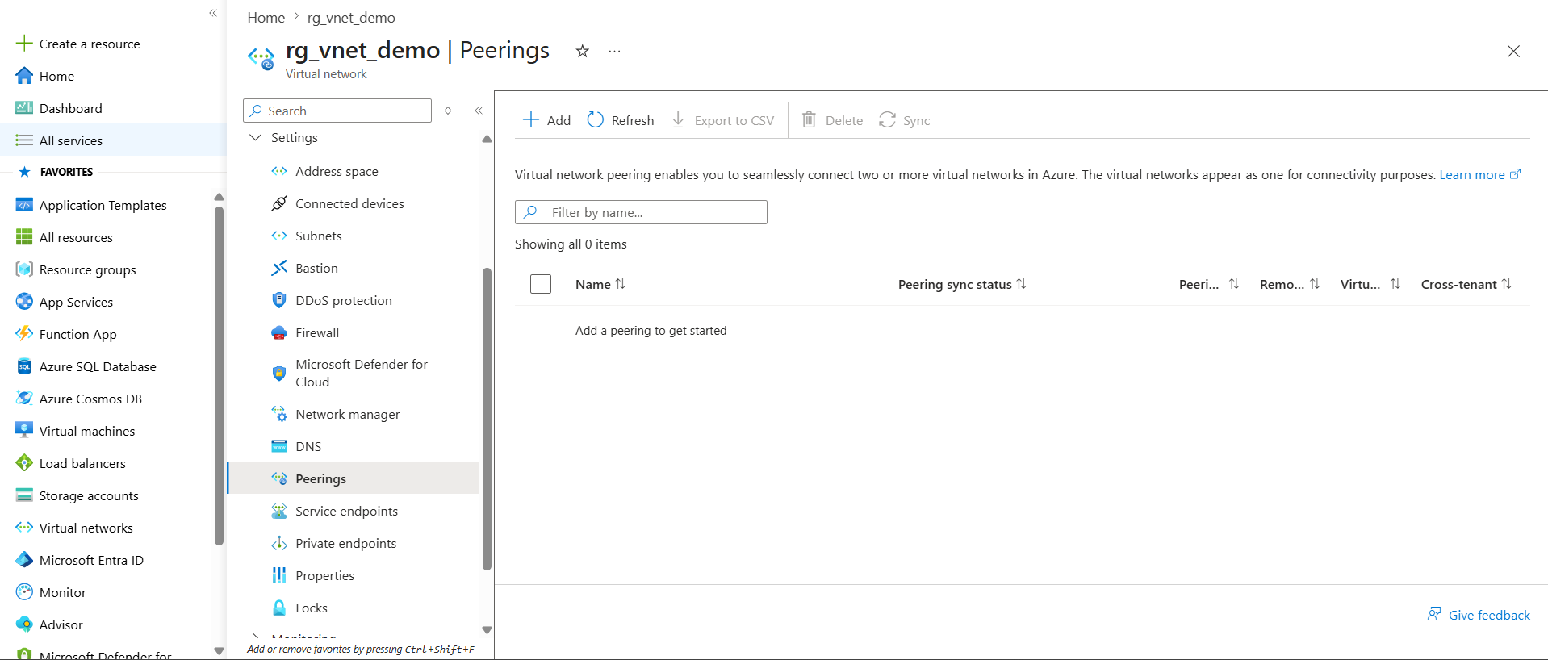
VNet Peering
Definition
VNet Peering is a networking feature that allows two Azure Virtual Networks (VNets) to communicate with each other using private IP addresses.

Why Do We Need VNet Peering?
Organizations often create multiple VNets for different environments, teams, or applications.
Example:
Dev-VNet
10.0.0.0/16
Prod-VNet
10.1.0.0/16
By default, these VNets cannot communicate.
VNet Peering enables private communication between them.

Usage
Used to:
- Connect multiple VNets.
- Share common services such as DNS, Bastion, Monitoring, and Firewalls.
- Implement Hub-Spoke Architecture.
- Enable communication between applications hosted in different VNets.

If VNet Peering Is Not Configured
Communication between VNets is blocked.
Example:
Dev-VNet ❌ Prod-VNet
Resources cannot communicate using private IP addresses.

Communication Flow
VM-A
10.0.1.4
↓
VNet Peering
↓
VM-B
10.1.1.4
Traffic stays within Azure's private network.
No Internet, VPN, or Public IP is required.

Requirements
The address spaces of the VNets must not overlap.
Valid Example:
Dev-VNet
10.0.0.0/16

Prod-VNet
10.1.0.0/16
Invalid Example:
Dev-VNet
10.0.0.0/16

Prod-VNet
10.0.0.0/16
Peering cannot be established when address spaces overlap.

Benefits
- Private Communication
- Low Latency
- High Bandwidth
- No VPN Required
- Secure Connectivity

Hub-Spoke Architecture Example
Hub VNet
Firewall | Bastion

App VNet Data VNet
All VNets communicate through peering with the Hub VNet.

AWS Equivalent
Azure VNet Peering = AWS VPC Peering

Key Point
VNet Peering allows resources in different VNets to communicate securely using private IP addresses without traversing the public internet.
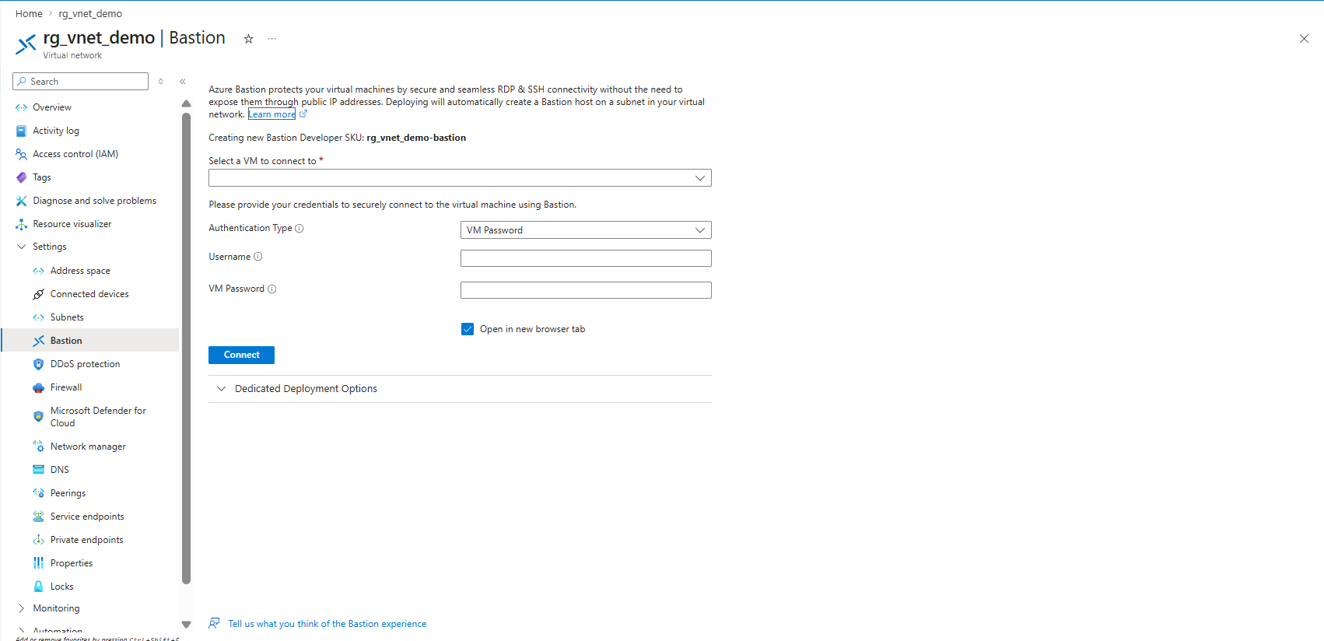

Azure Bastion
Definition
Azure Bastion is a managed Azure service that provides secure SSH and RDP access to virtual machines through the Azure Portal without requiring Public IP addresses on the VMs.

Why Do We Need Azure Bastion?
Private virtual machines cannot be accessed directly from the internet because they only have private IP addresses.
Traditionally, administrators assign Public IP addresses and open SSH (22) or RDP (3389) ports to access VMs.
This increases security risks.
Azure Bastion eliminates the need for Public IPs on VMs.
Azure Bastion Usage
- Deploy VMs with only Private IP addresses.
- Do not assign Public IPs to production VMs.
- Deploy Azure Bastion in a dedicated AzureBastionSubnet.
- Assign a Public IP to Azure Bastion.
- Connect to private VMs through Azure Bastion using the Azure Portal.
Traffic Flow
Administrator
↓
Azure Bastion
↓
Private VM
This is the most common and secure approach for accessing Azure VMs in production environments.
Architecture Without Bastion
Administrator
↓
Internet
↓
VM Public IP
↓
Virtual Machine
Requirements:
- Public IP on VM
- SSH Port 22 or RDP Port 3389 exposed

Architecture With Bastion
Administrator
↓
Azure Portal
↓
Azure Bastion
↓
Private IP
↓
Virtual Machine
Requirements:
- No Public IP on VM
- VM remains private
- Secure browser-based access

Azure Bastion is a managed Azure service that provides secure SSH/RDP access to private virtual machines without requiring Public IP addresses on the VMs. Bastion is deployed inside a dedicated AzureBastionSubnet and acts as a secure jump server.

Private Endpoint
Why Do We Need a Storage Account?
A Storage Account is an Azure service used to store files, blobs, backups, logs, application data, and other objects.
In real projects, applications and virtual machines frequently need to access storage services.
Examples:
- Application uploads files to Blob Storage.
- VM stores backups in Storage Account.
- AKS stores logs and artifacts.
- Applications read configuration files from storage.

Problem Without Private Endpoint
By default, Azure services are accessed through public endpoints.
Example:
VM
↓
Internet
↓
Storage Account
Even though the Storage Account belongs to Azure, traffic may leave the private network and use a public endpoint.
This increases security concerns because the service is exposed to the internet.

What is a Private Endpoint?
A Private Endpoint assigns a private IP address from your VNet to an Azure service.
This allows resources inside the VNet to access the service privately.
Example:
VM
↓
Private IP
↓
Private Endpoint
↓
Storage Account
Traffic remains inside the Azure network and does not traverse the public internet.

Benefits of Private Endpoint
- No public internet exposure.
- Communication stays within Azure's private network.
- Improved security.
- Reduced attack surface.
- Commonly used in enterprise environments.

Real Project Example
VNet
│
├── webapp_subnet
│ ↓
│ VM
│
└── private-endpoint-subnet
↓
Private Endpoint
↓
Storage Account
The VM accesses the Storage Account using a private IP instead of a public endpoint.

How We Will Implement in Our Lab
Step 1:
Create a Storage Account.
Step 2:
Create a dedicated subnet for Private Endpoints.
Example:
private-endpoint-subnet
10.0.4.0/24
Step 3:
Create a Private Endpoint.
Step 4:
Select the Storage Account as the target resource.
Step 5:
Azure creates a private IP inside the subnet.
Example:
10.0.4.4
Step 6:
VMs inside the VNet communicate with the Storage Account using this private IP.

Architecture Before Private Endpoint
VM
↓
Internet
↓
Storage Account
Architecture After Private Endpoint
VM
↓
VNet
↓
Private Endpoint
↓
Storage Account

Key Point
A Private Endpoint allows Azure services such as Storage Accounts, Key Vaults, Azure SQL Databases, and Cosmos DB to be accessed through private IP addresses within a VNet, eliminating the need for public internet access.

Private Endpoint gives an Azure service a private IP address inside your VNet so VMs can access the service privately without using its public endpoint.

Real Reason Enterprises Use It
To implement:
Defense in Depth
Multiple layers of security:
Layer 1 → NSG
Layer 2 → Private Endpoint
Layer 3 → Authentication
Layer 4 → RBAC Permissions
Even if one layer fails, other layers still protect the service.

Why Use Private Endpoints?
Private Endpoints are not a replacement for authentication. Azure services already provide authentication and authorization mechanisms. Private Endpoints add an additional network security layer by restricting access to Azure services through private IP addresses within a VNet. This ensures that only authorized resources inside the network can reach the service, while authentication continues to control who can access the data.

One-Line Interview Answer
Private Endpoint provides network-level isolation for Azure services, while authentication controls access to the service itself. Both are used together to achieve higher security.

Private Endpoint Implementation Steps
Step 1: Create a Storage Account.
Purpose:
The Storage Account will act as the target Azure service for the Private Endpoint.

Step 2: Open the Storage Account.
Navigate to:
Storage Account → Networking
Purpose:
Configure how the Storage Account can be accessed.

Step 3: Open Private Endpoint Connections.
Navigate to:
Networking → Private Endpoint Connections
Purpose:
Create a private connection between the VNet and the Storage Account.

Step 4: Create a Private Endpoint.
Click:
- Private Endpoint
Purpose:
Start the Private Endpoint creation process.

Step 5: Select Target Resource.
Choose:
Storage Account
Purpose:
Specify which Azure service should receive a private IP address.

Step 6: Select VNet and Subnet.
Choose:
VNet: rg_vnet_demo
Subnet: private-endpoint-subnet (or another subnet)
Purpose:
Specify where the Private Endpoint IP should be created.

Step 7: Enable Private DNS Integration.
Azure automatically creates or links a Private DNS Zone.
Purpose:
Allows VMs to resolve the Storage Account name to the private IP address.

Step 8: Review and Create.
Azure creates:
Private Endpoint
Private IP Address
Example:
10.0.4.4
Purpose:
Provides a private network path to the Storage Account.

Step 9: Verify Connectivity.
VMs inside the VNet access the Storage Account through the private IP instead of the public endpoint.
Purpose:
Traffic remains within the Azure private network.

Step 10: Restrict Public Access (Optional).
Disable Public Network Access on the Storage Account.
Purpose:
Allow access only through the Private Endpoint for enhanced security.

VNet Networking Topics
----------------------
VNet
Subnet
NIC
NSG
Route Tables
NAT Gateway
VNet Peering
Bastion
Private Endpoint

