RepoGuard AI
Executive Summary

1. Vision
RepoGuard AI is an AI-powered DevSecOps analysis platform that combines deterministic security scanners with AI reasoning to produce a single, actionable repository review. The platform is designed to improve security, code quality and developer productivity without permanently storing customer source code.

2. Problem Statement
Organizations typically rely on multiple independent tools such as SAST scanners, secret detection, dependency scanners and code quality analyzers. Findings are fragmented across different reports, making prioritization and remediation difficult.

3. Proposed Solution
The platform orchestrates multiple analysis engines, enriches the results with AI, and produces a unified report containing security findings, code-quality issues, risk scoring and remediation guidance.

4. Core Design Principles
- Full repository scanning using deterministic tools.
- AI augments scanners instead of replacing them.
- Ephemeral Kubernetes Job for every review.
- No persistent storage of customer source code.
- Plugin architecture for scanners and AI providers.
- Cloud-agnostic and AI-provider agnostic design.

5. High-Level Workflow
- Repository or Pull Request is submitted.
- Kubernetes creates an isolated Review Job.
- Repository is cloned into /tmp/repo_<job_id>.
- Semgrep, Gitleaks, Trivy and quality analyzers scan the entire repository.
- Relevant findings and snippets are sent to the AI Gateway.
- AI enriches findings with explanations and remediation.
- Only metadata and reports are stored; source code is deleted with the Pod.

6. High-Level Architecture
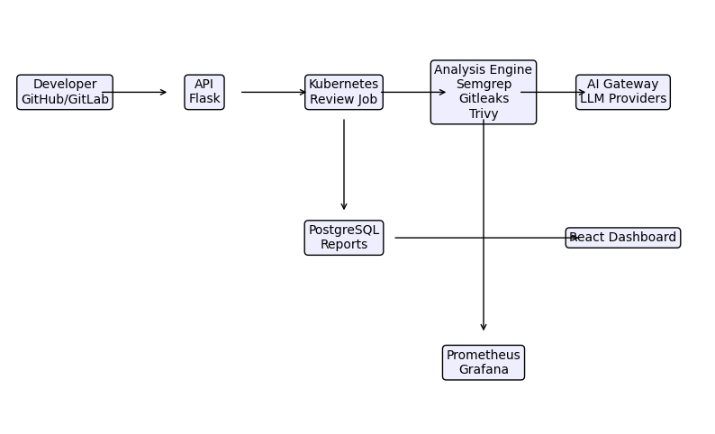

7. Business Value
- Single consolidated security and quality report.
- Reduced developer effort.
- Support for on-premises or cloud AI.
- Enterprise-ready modular architecture.
- Future support for additional scanners, AI providers and compliance frameworks.

8. Future Roadmap
- AI Router for dynamic model selection.
- Infrastructure as Code analysis (Terraform, Kubernetes manifests).
- License compliance.
- SBOM generation.
- GitHub App and GitLab App.
- Policy-as-Code integration.

