RepoGuard AI
High Level Design (HLD)
AI-Powered DevSecOps Repository Analysis Platform
Version 1.0 Draft | Architecture Design Package

Document Control
Field | Value
Document | 03 - High Level Design (HLD)
Project | RepoGuard AI
Status | Draft
Audience | Developers, DevOps Engineers, Security Engineers, Architects, Course Reviewers
Prepared For | DevSecOps Final Project

Version | Date | Description
1.0 | 2026-07-09 | Initial HLD draft with authorization model and ephemeral review execution

Table of Contents
1. Executive Architecture Overview
2. Architecture Goals
3. Scope
4. Actors and External Systems
5. System Context
6. High Level Component Architecture
7. Report and Authorization Model
8. Repository Review Workflow
9. Deployment View
10. Kubernetes Execution Model
11. AWS Architecture
12. Analysis Engine
13. AI Gateway and Provider Abstraction
14. Data Architecture
15. Security Architecture
16. Observability
17. CI/CD and GitOps
18. Key Design Decisions
19. Risks and Trade-offs
20. Open Questions

1. Executive Architecture Overview
RepoGuard AI is an AI-powered DevSecOps Repository Analysis Platform. It performs repository security and quality analysis by combining deterministic scanning tools with AI-assisted reasoning. The platform produces consolidated Summary and Deep Reports while enforcing source-code privacy and ownership-based authorization.
The architecture is based on isolated Kubernetes Jobs. Each review runs in a dedicated ephemeral Pod, clones the repository into a temporary workspace, scans the repository, generates findings and then destroys the workspace. Source code is not stored after the review completes.
The platform is designed to be modular: scanners, AI providers, repository providers and notification integrations can be replaced through adapters without changing the business workflow.

2. Architecture Goals
- Analyze complete repositories using deterministic security and quality tools.
- Use AI to enrich findings, explain impact and suggest remediation.
- Provide Summary Reports for public or unverified usage.
- Provide Deep Reports only after repository ownership or permission verification.
- Never persist customer source code after analysis.
- Support enterprise deployment on Kubernetes and AWS.
- Remain AI-provider agnostic and repository-provider agnostic.
- Expose measurable, auditable and observable operations.

3. Scope

3.1 In Scope
- GitHub repository analysis for MVP
- Summary and Deep report model
- OAuth-based repository permission verification
- Kubernetes Job based execution
- Semgrep, Gitleaks and Trivy scanning
- AI-assisted findings enrichment
- PostgreSQL findings and metadata storage
- React dashboard and REST API
- Monitoring with Prometheus and Grafana

3.2 Out of Scope for MVP
- AI Router
- Multi-agent AI orchestration
- Azure DevOps and Bitbucket providers
- SBOM generation
- License compliance
- IDE extensions
- Enterprise SSO
- Advanced compliance frameworks

4. Actors and External Systems
Actor / System | Description | Interaction
Developer | User who submits a repository or PR | Requests Summary or Deep report
Security Engineer | Reviews security findings | Uses dashboard and reports
Platform Administrator | Operates the platform | Configures policies, providers and infrastructure
GitHub / GitLab | Source-code hosting providers | OAuth, permission verification and repository access
AI Provider | Local or remote LLM provider | Receives selected context and returns structured analysis
Kubernetes | Execution platform | Runs API, dashboard and ephemeral review jobs
AWS | Cloud infrastructure provider | Hosts EKS, ALB, RDS, Secrets Manager and observability components

5. System Context
The platform sits between users, source-code hosting providers, scanners and AI providers. It receives repository requests, verifies access where required, orchestrates repository analysis and exposes reports through APIs and dashboards.
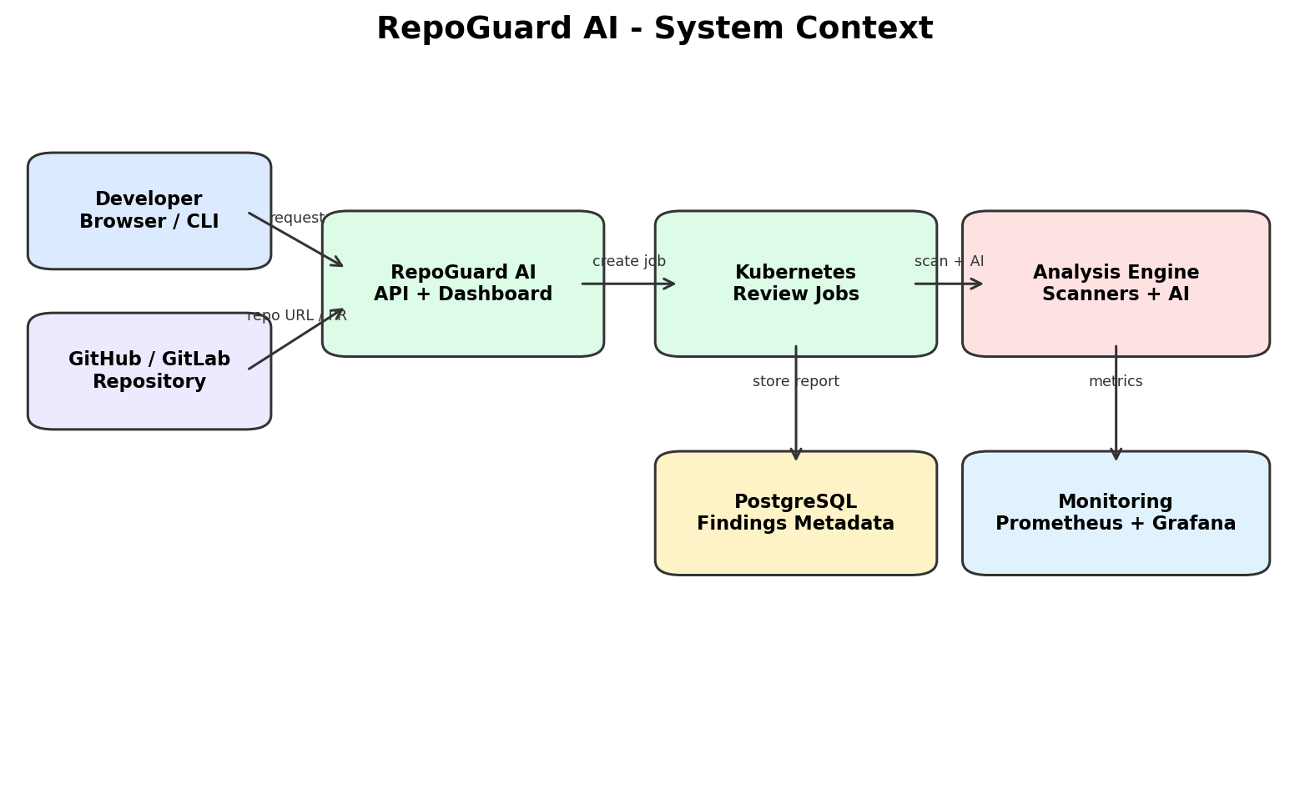

6. High Level Component Architecture
The system is divided into three major layers: Access Layer, Platform Layer and Execution plus AI Layer. The Access Layer provides user entry points and source-control integration. The Platform Layer contains API, authorization, review control and reporting. The Execution Layer performs isolated scanning and AI-assisted analysis.
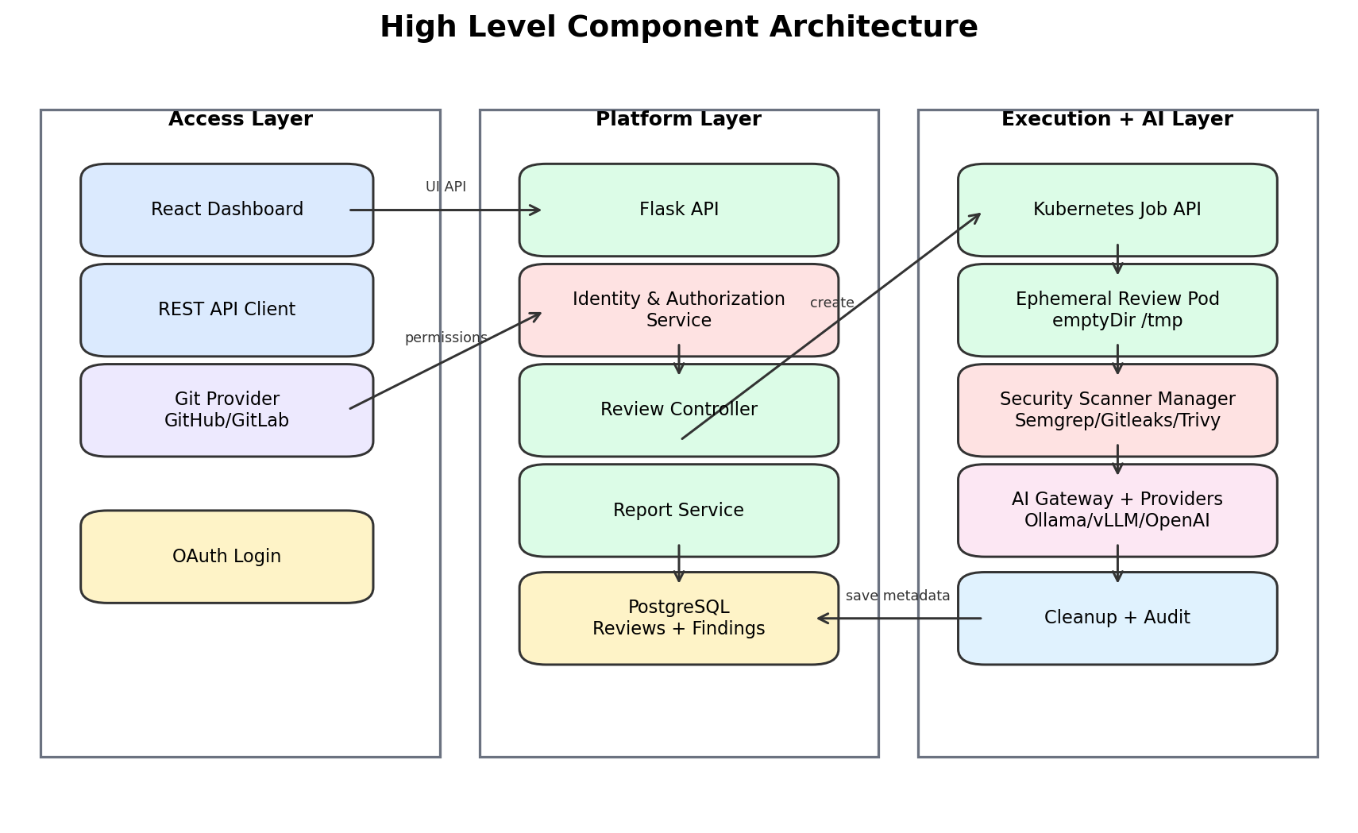
Component | Responsibility
Flask API | Receives review requests, exposes REST APIs and validates input
Identity & Authorization Service | Handles OAuth, permission checks and report access decisions
Review Controller | Creates Kubernetes Jobs and tracks review lifecycle
Ephemeral Review Pod | Clones repository, scans it and deletes workspace on completion
Scanner Manager | Runs Semgrep, Gitleaks, Trivy and quality scanners
AI Gateway | Provides a stable interface to local and cloud AI providers
Report Service | Creates JSON and Markdown reports and stores metadata
PostgreSQL | Stores reviews, findings, users, permissions, policies and audit logs

7. Report and Authorization Model
RepoGuard AI supports two report levels. Summary Reports provide high-level scores and public-safe findings. Deep Reports include sensitive details such as file names, line numbers, code snippets and remediation guidance. Deep Reports require repository ownership or collaborator verification through the repository provider.
User State | Summary Report | Deep Report | Notes
Anonymous | Allowed | Denied | Public-safe summary only
Authenticated but unverified | Allowed | Denied | Identity exists but repository permission not proven
Verified owner / collaborator | Allowed | Allowed | Minimum permission is configurable
Enterprise integration | Allowed | Allowed | Can use GitHub App or organization policy

Repository visibility alone is not sufficient for Deep Report authorization. The platform does not trust uploaded ZIP files, deleted .git folders, copied repositories or user claims as proof of ownership.

8. Repository Review Workflow
- User submits repository URL or Pull Request context.
- API validates the request and determines requested report level.
- For Deep Reports, the user authenticates using OAuth.
- Identity Service checks permissions through the repository provider API.
- Review Controller creates a Kubernetes Job.
- Ephemeral Pod clones the repository into /tmp/repo_<job_id>.
- Scanner Manager scans the entire repository using deterministic tools.
- AI Gateway receives prioritized findings and selected code snippets.
- Report Service generates JSON and Markdown outputs.
- Only findings and metadata are stored.
- The Pod terminates and temporary source code is deleted.

9. Authorization Flow
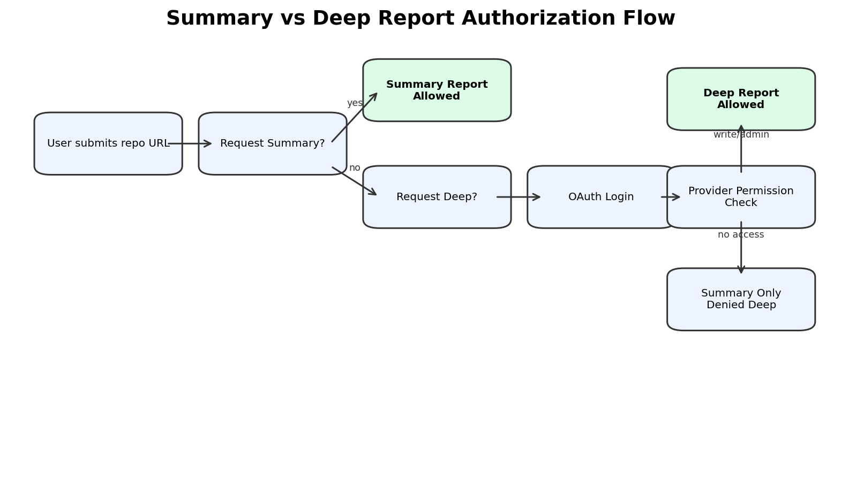
This model reduces the risk of exposing vulnerability details for repositories submitted by users who do not control the original source. Public Summary Reports remain useful, while Deep Reports are protected by identity and permission checks.

10. Deployment View
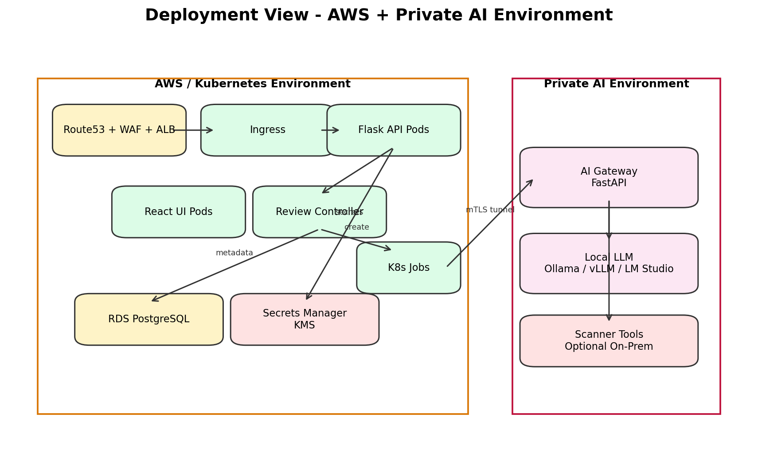
The production architecture separates public access from private execution. API and dashboard components run inside Kubernetes. Persistent storage is handled by managed services where possible. The AI environment can be local/on-premises or cloud-based, connected through a private secure channel.

11. Kubernetes Execution Model
The Review Execution Engine is built around Kubernetes Jobs. This approach provides isolation, scalability and automatic cleanup.
Object | Purpose
Namespace | Logical isolation for RepoGuard components
Deployment | Runs long-lived API, dashboard and controller services
Job | Runs one repository review
Pod | Isolated execution unit for each review
emptyDir | Temporary workspace for cloned repository
ConfigMap | Non-sensitive runtime configuration
Secret | Sensitive runtime configuration
NetworkPolicy | Restricts pod-to-pod and external traffic
RBAC | Limits what controllers and jobs can access

The temporary repository workspace is mounted as an emptyDir volume. Once the Pod is deleted, the workspace is removed with it. This makes source-code cleanup a platform-level guarantee rather than a manual script operation.

12. AWS Architecture
The AWS architecture should include a VPC with public and private subnets, ALB or Ingress Controller, EKS, RDS PostgreSQL, Secrets Manager, KMS, IAM roles and optional ElastiCache. Terraform will provision these resources and ArgoCD will deploy application components.
AWS Service | Usage
Route53 | DNS for public endpoints
AWS WAF | Optional request filtering and protection
ALB | HTTPS entry point
EKS | Runs platform workloads
RDS PostgreSQL | Stores reports and metadata
Secrets Manager | Stores tokens, DB passwords and provider credentials
KMS | Encrypts sensitive data
IAM | Least privilege permissions
ECR | Stores platform container images for deployment pipeline

ECR or a Docker Registry is part of the platform deployment pipeline, not part of customer repository analysis. It stores RepoGuard AI container images, not customer code.

13. Analysis Engine
The Analysis Engine coordinates deterministic scanners and AI reasoning. Deterministic scanners inspect the entire repository. The AI receives findings and relevant code context for reasoning and remediation.
Module | Responsibility
Clone Manager | Clones repository into temporary workspace
Security Scanner Manager | Runs Semgrep, Gitleaks and Trivy
Quality Analyzer | Runs linting, complexity and maintainability checks
Finding Normalizer | Converts tool outputs to a common schema
Prioritization Engine | Selects important findings and relevant snippets
Context Builder | Builds safe, bounded AI prompts
Report Generator | Produces JSON and Markdown outputs
Cleanup Manager | Ensures temporary data is removed

14. AI Gateway and Provider Abstraction
The AI Gateway hides provider-specific details from the rest of the system. It exposes one internal interface for analysis requests and can route them to local or cloud providers depending on configuration and future policies.
Provider | MVP Status | Notes
Ollama | Supported / planned | Simple local inference
vLLM | Supported / planned | Production-grade GPU inference
LM Studio | Development support | Useful for demos and local experimentation
OpenAI | Future / optional | Cloud provider adapter
Azure OpenAI | Future | Enterprise customer option
AWS Bedrock | Future | AWS-native customer option

Future AI Router functionality may choose different models for security analysis, quality analysis, executive summaries and remediation suggestions. This is intentionally outside the MVP scope.

15. Data Architecture
The platform stores metadata and findings, not source code. This supports auditability and reporting while preserving privacy.
Entity | Purpose
users | Authenticated users and identity-provider mapping
repositories | Repository metadata and provider details
reviews | Review jobs, status, scores and timestamps
findings | Normalized scanner and AI findings
reports | Generated report metadata and storage references
permissions | Cached authorization decisions and policy results
audit_logs | Security and operational events

Reports may be stored as database records or object-storage artifacts. Source-code content must not be stored in either location.

16. Security Architecture
- Authentication through OAuth for supported repository providers.
- Authorization based on provider permission APIs, not repository claims.
- Deep Reports gated by configurable permission policy.
- One isolated Kubernetes Job per review.
- Temporary source code stored only in emptyDir /tmp workspace.
- NetworkPolicies restrict review Pods from unnecessary network access.
- Secrets stored in Secrets Manager or Vault, not in ConfigMaps or environment files.
- mTLS for communication with private AI environments.
- Audit logs retained for review access and authorization decisions.
- Least-privilege IAM and Kubernetes RBAC.

17. Observability
Observability is required for operational safety. The platform should expose metrics for request rate, review duration, scanner failures, AI latency, authorization denials, job failures and cleanup outcomes.
Signal | Examples
Metrics | review_jobs_total, review_duration_seconds, scanner_failures_total, ai_latency_seconds
Logs | API requests, scanner outputs, authorization decisions, cleanup events
Alerts | Job failure spikes, AI gateway unreachable, cleanup failure, high error rate
Dashboards | Review trends, findings by severity, system health, AI provider performance

18. CI/CD and GitOps
CI/CD builds and deploys the RepoGuard AI platform. It does not build or deploy customer repositories submitted for review.
- Jenkins or GitLab CI runs tests and security gates.
- Docker images are built for API, dashboard, controller and scanner components.
- Images are pushed to ECR or another registry.
- ArgoCD deploys the platform to Kubernetes using Helm.
- Terraform provisions AWS infrastructure.

19. Key Design Decisions
Decision | Rationale
Kubernetes Jobs for reviews | Provides isolation, cleanup and scalability
No source-code persistence | Protects customer intellectual property
Summary vs Deep reports | Balances public usefulness with security protection
Provider permission verification | Prevents cloned or reuploaded code from being treated as ownership proof
AI Gateway abstraction | Avoids coupling the platform to one LLM provider
Plugin architecture | Allows adding scanners and providers without redesigning the platform

20. Risks and Trade-offs
Risk / Trade-off | Impact | Mitigation
AI hallucination | Incorrect findings or fixes | Use deterministic scanners as source of truth and validate JSON schema
Large repositories | Long runtime and high AI cost | Scan full repo deterministically; send only prioritized context to AI
OAuth permission complexity | Provider-specific differences | Use provider adapters and configurable policies
On-prem AI connectivity | Network and reliability complexity | mTLS tunnel and health checks
Scanner false positives | Developer fatigue | Normalize and prioritize findings; use AI for explanation, not blind trust
Malicious repository content | Execution risk | Run in isolated Pod with restricted permissions and network policy

21. Open Questions
- What is the minimum permission for Deep Reports: read, write, maintain or admin?
- Should Summary Reports include file names or only aggregate category counts?
- Should the MVP support only GitHub or also GitLab?
- Where should Markdown reports be stored: database, object storage or both?
- Should scanner tools run inside the same Review Pod or separate sidecar containers?

22. Appendix A - Suggested ADRs
- ADR-001: Ephemeral Repository Scanning
- ADR-002: Kubernetes Jobs for Review Execution
- ADR-003: Summary vs Deep Report Model
- ADR-004: Repository Ownership Verification
- ADR-005: AI Gateway Provider Abstraction
- ADR-006: Plugin Architecture for Scanners
- ADR-007: No Source-Code Persistence

