Q1. What command is there to initialize a Git Repository?



Q2. What is the command(s) to configure username and email?



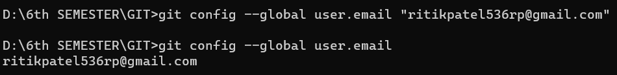

Q3. What commands are there to put file(s) into “Staging area”?



Q4. What is the command to check status of git repository?

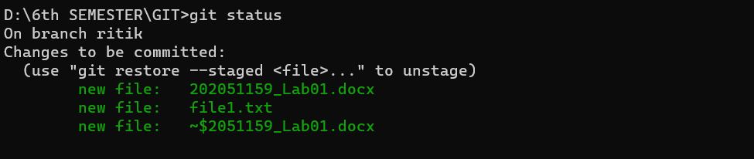

Q5. What is the command and flag to unstage file(s)?

Q6. What is the command to upload your repository to GITHUB?

Q7. What commands are there to get the list of commits on oneline?

Q8. What is “remote” and what is origin?

Q9. What command is there to change the branch name?

Q10. What is merge conflict?

Q11. What is the command to get changes from Remote Repository to Local repository and what is the command toapply those changes directly into Local Repository?

Q12. What is the command to merge given branch into current branch?

Q13. What is the command to take repository back to some previous state?

Q14. What is fork on github?

Q15. What is the command to copy or download repository from remote location?

Q16. What is the command to view the effect of a specific commit?

Q17. What is the command to create and switch branch?

Q18 What is the command to show last commit details?

Q19. What is a “Pull-Request” on github?

Q20. What is stashing?